**Ques: Difference Between /n and /r?**

**Ans:** \r is "Carriage Return", \n is "Line Feed".

Back in the days, we had two ASCII characters at the end of each line to tell a printer what to do - CR would tell the printer to go back to the left edge of the paper, LF would advance to the next line.

Operating systems still have different conventions as to what the end of a line looks like -- some of them have \n\r, some have \n, some have \r\n.

In Javascript, we mostly deal with \n - this is how strings are typically switching to the next line. However, depending on what strings we are working with, we may be encountering \r as well.

**Ques:**

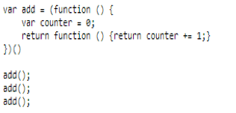

**Ans:** In the first call the counter variable is set to zero and then it will return and function expression . As per the javascript convention add will now become a function and can assess the variable counter in its parent scope. And hence after the second and third call the value of counter will be 1 and 2 .

add() //counter 1

add() //counter 2

add() //counter 3

so final ans would be 3.