**MYSQL-ASSIGNMENT**

**Ques 1: Create a database for the Hospital Management System based on your ER. Create appropriate tables & relationships.**

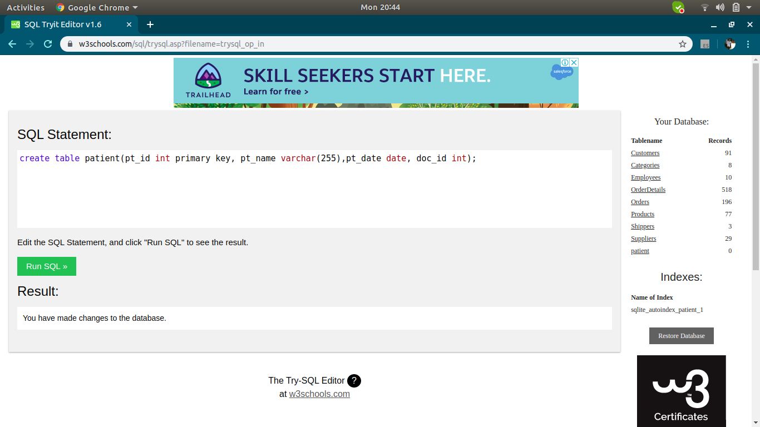Ans:1

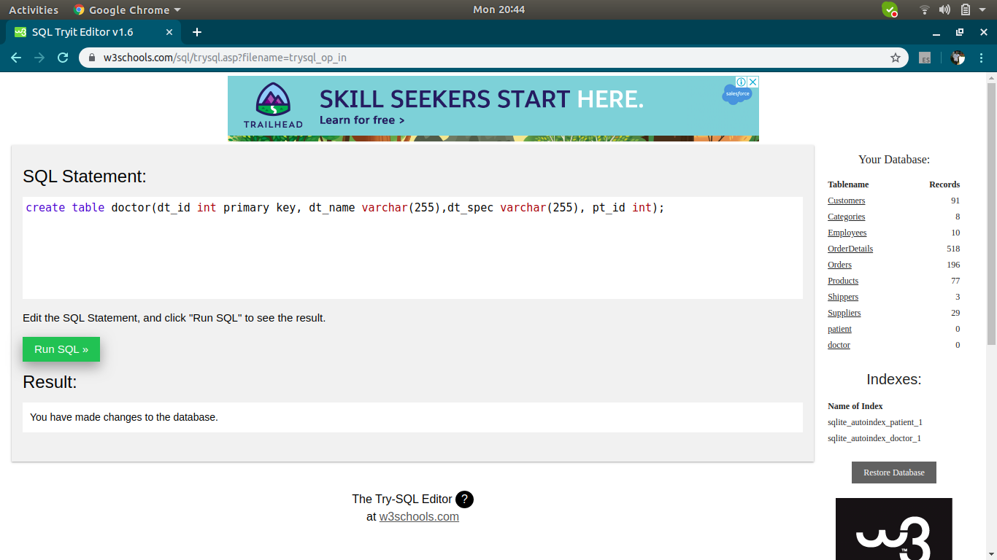

**Ques 2: Design a query to provide a list of doctors, which department they belong to and patients treated by them (if any).**

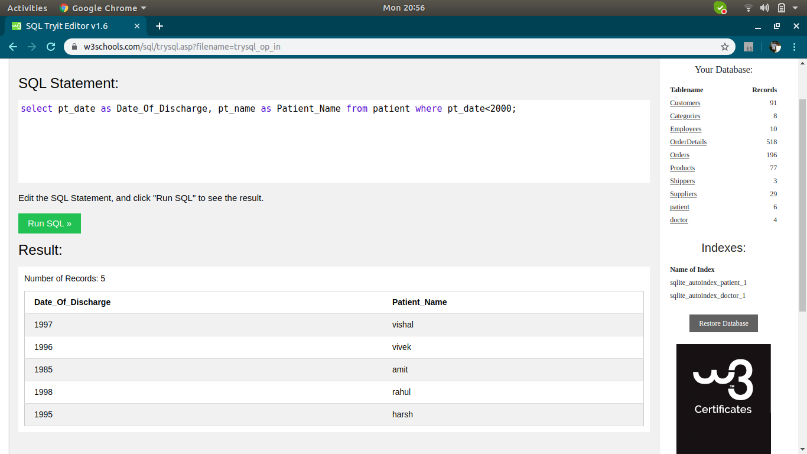

Ans2:

**Ques3: Query to provide the count of patients discharged per day in the last week?**

Ans3:

