**Maven Assignment**

1.Install Maven

1.Send the screenshot of "mvn -version":

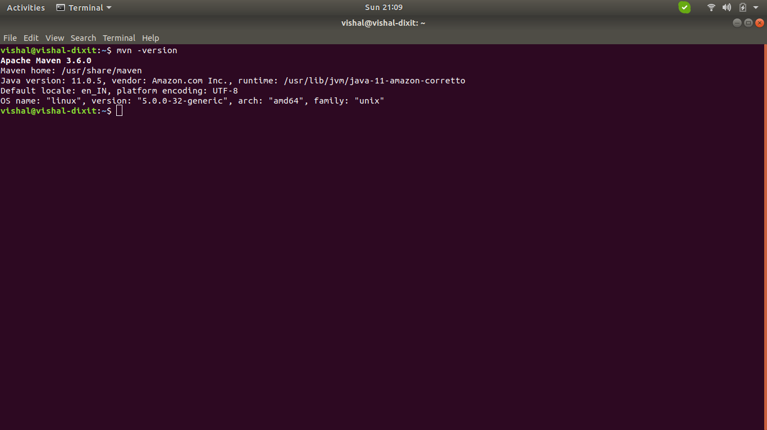

2.Create a sample maven project

1. Using archetype plugin and generate goal.

2. Give custom values for groupId, artifactId, version, package and execute "mvn install" and "mvn exec:java -Dexec.mainClass=your-fully-qualified-class-name".

3. Share zip of project and screenshot for "mvn install" and "mvn exec:java" command

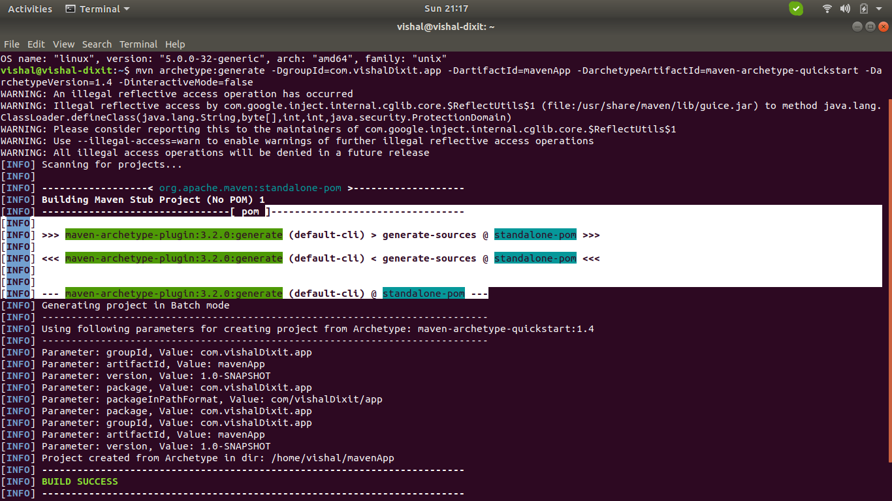

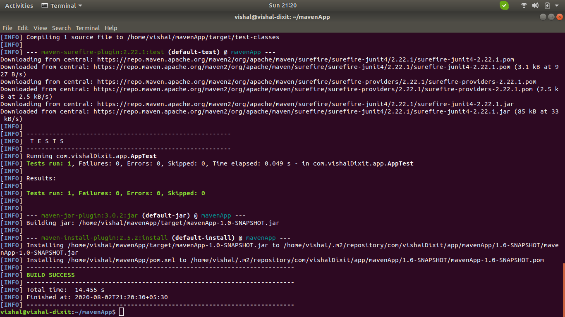

3.Create a maven web-app project

1. Using archetype plugin and generate goal.

2. Give custom values for groupId, artifactId, version, package and execute "mvn install" and "mvn exec:java -Dexec.mainClass=your-fully-qualified-class-name".

3. Share zip of project and screenshot for "mvn install"

