**CHAPTER 1**

**INTRODUCTION**

* 1. **INTRODUCTION**

The reliability and stability of a power system are crucial for ensuring uninterrupted power delivery. Faults in power systems, such as short circuits or line-to-ground faults, can cause severe disruptions, leading to equipment damage, power outages, and economic losses. Hence, the need for accurate and efficient fault detection methods is paramount.

The IEEE 9-bus system is a standard benchmark model widely used in power system studies. It represents a simplified yet realistic configuration of a power grid, encompassing generators, transmission lines, and load buses. This system serves as an ideal platform for analyzing various operational and fault scenarios due to its manageable complexity and representational accuracy.

Using MATLAB and Simulink for fault detection in the IEEE 9-bus system enables researchers and engineers to model, simulate, and analyze power system behavior under normal and fault conditions. MATLAB provides a versatile programming environment, while Simulink offers a graphical interface for dynamic system simulation. Together, they allow for:

**Modeling of Power System Components:** Accurate representation of generators, transformers, transmission lines, and loads.

**Fault Simulation:** Creation of various fault conditions, such as single-line-to-ground (SLG), double-line-to-ground (DLG), line-to-line (LL), and three-phase faults.

**Fault Detection Mechanisms:** Implementation of algorithms to identify fault types, locations, and severity based on voltage, current, and power measurements.

**System Response Analysis:** Evaluation of how the power system responds to faults, aiding in the design of protective relays and control strategies.

This project aims to develop a robust fault detection framework for the IEEE 9-bus system. By leveraging MATLAB & Simulink, it seeks to enhance understanding of fault dynamics and contributes to improved fault management in modern power systems.

* 1. **LITERATURE SURVEY**

**[1] Hardware Supported Fault Detection and Localization Method for AC Microgrids Using Mathematical Morphology with State Observer Algorithm : Faisal Mumtaz ,Kashif Imran, Habibur Rehman, Hammad Ali Qureshi**

The paper presents a novel hardware-supported fault detection and localization method for AC microgrids using a combination of Discrete Kalman Filter (DKF) and Mathematical Morphology (MM). This approach addresses protection challenges in microgrids operating in on-grids and is landed modes. The DKF estimates voltage and current signals, while MM generates a segregated energy signature (SES) for fault detection and classification. The cumulative energy signature (CES) is further utilized for fault localization. The proposed method was tested on the CIGRE microgrid benchmark and a dSPACE hardware setup, demonstrating a detection accuracy of 96.6% and response times under 15 ms. The system effectively handles low and high impedance faults across various operational conditions and topologies. With its computational efficiency and robust performance, the method provides a reliable solution for modern microgrid protection needs.

**[2] Analysis and design of connection between solar farm and IEEE 9 bus system : Xin Li, Kunheng Li**

This technical paper explores the integration of a 160 MW solar farm into the IEEE 9 Bus System, focusing on optimal connection strategies. After careful analysis, the researchers determined Bus5 as the most suitable connection point, considering factors like distance, voltage, and transmission line costs. They conducted a detailed investigation of conductor types, ultimately selecting a 16.33 mm AAC wire with a two-strand bundling configuration. Using Power World software, they simulated power flow and system stability under different conditions, finding that parallel transmission lines between Bus7-Bus5 and Bus4-Bus5 could enhance system safety. The study involved calculating equivalent impedance and admittance parameters, analyzing current transmission capacities, and evaluating system performance during day and night. By adding a 25 Mvar capacitor in parallel with Bus5, they reduced the risk of system overload. The total project cost was estimated at $1,405,398,400, with comprehensive considerations of transmission line infrastructure, parallel conductors, and additional equipment. The research provides a systematic approach to integrating large-scale solar farms into existing electrical grid systems, demonstrating the importance of detailed technical and economic analysis in power system design.

**[3] Simulation of Fault Detection in Photovoltaic System Based On SSTDR : Zhihua Li, Zhanfei Yang, Chunhua Wu**

This research explores the application of Spread Spectrum Time Domain Reflectometry (SSTDR) for fault detection in photovoltaic (PV) systems, addressing the growing need for reliable solar power infrastructure. By analyzing high-frequency equivalent circuits of PV system components, the researchers conducted comprehensive simulations to detect and characterize different types of faults, including ground faults, line-to-line faults, and approximate open-circuit faults caused by system aging. Using Matlab simulations, they investigated how SSTDR can effectively identify various electrical anomalies in PV strings by analyzing signal reflection characteristics and peak amplitudes. The study revealed distinct waveform patterns for different fault types, demonstrating SSTDR's potential as a non-invasive, real-time fault detection technique for photovoltaic systems. The research highlights the importance of early fault detection in maintaining solar power system efficiency, as photovoltaic array failures can significantly impact power generation and component longevity. While the method shows promising results in detecting fault types, the researchers acknowledge that precise fault location within PV strings requires further investigation. The study contributes to improving solar power system reliability by providing a novel diagnostic approach that can potentially reduce maintenance costs and prevent catastrophic system failures.

**[4] Protection Scheme based on Fault Detection and Fault Classification using Fuzzy inference system in IEEE-9 Bus System: Aditya Patel, M.V.S. Prashant, Jharna Sahu, Ancy Prerena Kujur**

This research paper proposes a novel protection scheme for electrical power networks using a Fuzzy Inference System (FIS) in an IEEE-9 bus system for fault detection and classification. The method utilizes Discrete Fourier Transform to analyze positive and zero sequence voltage and current signals collected from one end of a transmission line. The proposed approach develops four fuzzy modules to detect and classify 11 different types of symmetrical and unsymmetrical faults by varying parameters like fault location, resistance, inception angle, load characteristics, and generator supply conditions. Through extensive simulation in MATLAB/Simulink, the researchers demonstrated that their protection scheme can detect and classify faults within 20 milliseconds, with an overall accuracy of 96.50% and performance metrics like precision, sensitivity, and specificity indicating its reliability. The fuzzy logic-based technique proves to be more efficient and less complex compared to traditional neural network approaches, offering a practical solution for power system protection that can adapt to various fault scenarios and system variations. The study emphasizes the importance of rapid fault detection and classification in maintaining power system stability and reliability, showcasing the potential of fuzzy inference systems in advanced protective relaying strategies.

**[5] PSCAD/EMTDC-based Simulations for Fault Analysis and Fault Identification in 380V Ring DC Systems : Frank Gerdinand, Johann Meisner and Stephan Passon**

The paper investigates fault detection and protection strategies for 380V DC ring microgrids, addressing the growing interest in DC distribution systems. The researchers developed a novel credit point (CP) concept for identifying and isolating faults in a DC microgrid topology that includes sources like photovoltaic systems, batteries, and AC grid connections. By analyzing current derivatives and using a band-stop filter, the proposed protection scheme can detect faults with high precision, ranging from 0.06 to 1.07 milliseconds. The approach allows for selective fault isolation without disrupting the entire system, with the ability to distinguish between parallel and series faults in the ring topology. The method demonstrates robustness against variations in resistances, cable lengths, and load conditions. Implemented and tested using PSCAD/EMTDC simulations, the protection concept shows promise for future DC distribution grids by providing efficient fault detection and minimizing power interruptions. The research highlights the potential advantages of DC microgrids, such as higher efficiency, absence of reactive power, and improved power quality. Ultimately, the study contributes to developing advanced protection mechanisms for emerging DC power distribution systems.

**1.3 OBJECTIVE OF PROJECT**

* Develop Accurate Fault Detection Mechanisms: Implement algorithms to identify different types of faults such as single-phase-to-ground, line-to-line, and three-phase faults.
* Enhance System Reliability and Stability: Ensure the power system remains stable and reliable by identifying faults quickly and accurately.
* Model the IEEE 9-Bus System in MATLAB & Simulink: Create a realistic simulation environment for analyzing power system dynamics under normal and faulty conditions.
* Simulate and Analyze Fault Scenarios: Investigate the system's behavior under various fault conditions to understand their impact on system performance.
* Design Protective Strategies: Develop efficient methods for fault detection, classification, and localization to aid in the design of protective relays.
* Optimize System Response Time: Reduce the time required to detect and isolate faults, ensuring minimal disruption to power delivery.
* Evaluate Performance Metrics: Assess the effectiveness of fault detection algorithms in terms of accuracy, speed, and computational efficiency.
* Contribute to Power System Protection Studies: Provide insights and methodologies that can be used to improve fault detection in other power system models.

**1.4 OVERVIEW OF PROJECT**

**Chapter 1:** Background, Literature Survey, and Objective, This chapter includes the background, literature survey, and objectives of fault detection in the IEEE 9 bus system using MATLAB & Simulink.

**Chapter 2:** System Overview, It consists of the block diagram of the fault detection system for the IEEE 9 bus system using MATLAB & Simulink.

**Chapter 3:** Circuit Diagram, Schematic Diagram, and Working Principle, This chapter provides a detailed description of the circuit diagram, schematic diagram, and working principle of fault detection in the IEEE 9 bus system using MATLAB & Simulink**.**

**Chapter 4:** Component Specifications, This chapter details the specifications of all components used in fault detection for the IEEE 9 bus system using MATLAB & Simulink.

**Chapter 5:** Results, Conclusion, and Future Scope It presents the results, conclusions, and future scope of fault detection in the IEEE 9 bus system using MATLAB & Simulink.

**Chapter 6:** Advantages and Disadvantages This chapter covers the advantages and disadvantages of fault detection in the IEEE 9 bus system using MATLAB & Simulink.

**CHAPTER 2**

**HARDWARE OF FAULT DETECTION IN IEEE 9 BUS SYSTEM USING MATLAB & SIMULINK**

**2.1 BLOCK DIAGRAM**

TRANSMISSION LINES

VOLTAGE & CURRENT INDICATOR

230V AC SUPPLY

LOAD

RELAY

ARDUINO UNO

OLED DISPLAY

RECTIFIER

FAULTS

**Fig 2.1: Block Diagram Of Fault Detection In IEEE 9 Bus System Using MATLAB & Simulink**

This block diagram illustrates a fault detection system for an IEEE 9 bus power system using MATLAB and Simulink. The system begins with a 230V AC power supply that feeds into a rectifier for AC to DC conversion. The converted power then flows through transmission lines, which form the core component where potential faults may occur.

The transmission lines connect to multiple monitoring and control components. A voltage and current indicator monitor the electrical parameters, while an Arduino UNO microcontroller processes this information and controls the system's response. The Arduino manages a relay that can connect or disconnect the load based on detected conditions, and it displays relevant system information through an OLED display.

The fault detection module continuously monitors the transmission lines for any abnormalities or faults in the power system. When a fault is detected, the system can respond by triggering the relay to protect the load. This setup enables real-time monitoring, fault detection, and protective actions in the power distribution system, with the Arduino serving as the central control unit that processes inputs and manages outputs based on the system's conditions.

The entire system represents a practical implementation of power system protection, combining hardware components with MATLAB and Simulink software for simulation and control purposes. This integration allows for both theoretical analysis and practical demonstration of fault detection in power systems.

**2.2 COMPONENTS REQUIRED**

**2.2.1 ARDUINO**

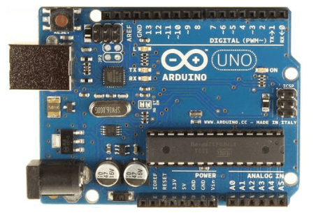

**Fig 2.2.1.1 :ARDUINO UNO**

The Arduino UNO is a standard board of Arduino. Here UNO means 'one' in Italian. It was named UNO to label the first release of Arduino Software. It was also the first USB board released by Arduino. It is considered as the powerful board used in various projects. Arduino.cc developed the Arduino UNO board. Arduino UNO is based on an ATmega328P [microcontroller](https://www.javatpoint.com/microcontroller). It is easy to use compared to other boards, such as the Arduino Mega board, etc. The board consists of digital and analog Input/Output pins (I/O), shields, and other circuits. The Arduino UNO includes 6 analog pin inputs, 14 digital pins, a [USB](https://www.javatpoint.com/usb-full-form) connector, a power jack, and an ICSP (In-Circuit Serial Programming) header. It is programmed based on IDE, which stands for Integrated Development Environment. It can run on both online and offline platforms.

* **ATmega328 Microcontroller**- It is a single chip Microcontroller of the ATmel family. The processor code inside it is of 8-bit. It combines **Memory (SRAM, EEPROM, and Flash), Analog to Digital Converter, SPI serial ports, I/O lines, registers, timer, external and internal interrupts, and oscillator.**
* **ICSP pin**- The In-Circuit Serial Programming pin allows the user to program using the
* **Power LED Indicator**- The ON status of LED shows the power is activated. When the power is OFF, the LED will not light up.
* **Digital I/O pins**- The digital pins have the value HIGH or LOW. The pins numbered from D0 to D13 are digital pins.
* **TX and RX LED's**- The successful flow of data is represented by the lighting of these LED's.
* **AREF-**The Analog Reference (AREF) pin is used to feed a reference voltage to the Arduino UNO board from the external power supply.
* **Reset button**- It is used to add a Reset button to the connection.
* **USB**- It allows the board to connect to the computer. It is essential for the programming of the Arduino UNO board.
* **Crystal Oscillator**- The Crystal oscillator has a frequency of 16MHz, which makes the Arduino UNO a powerful board.
* **Voltage Regulator**- The voltage regulator converts the input voltage to 5V.
* **GND**- Ground pins. The ground pin acts as a pin with zero voltage.
* **Vin**- It is the input voltage.
* **Analog Pins**- The pins numbered from A0 to A5 are analog pins. The function of Analog pins is to read the analog sensor used in the connection. It can also act as GPIO (General Purpose Input Output) pins.

**2.2.2 DC CURRENT & VOLTAGE INDICATOR**

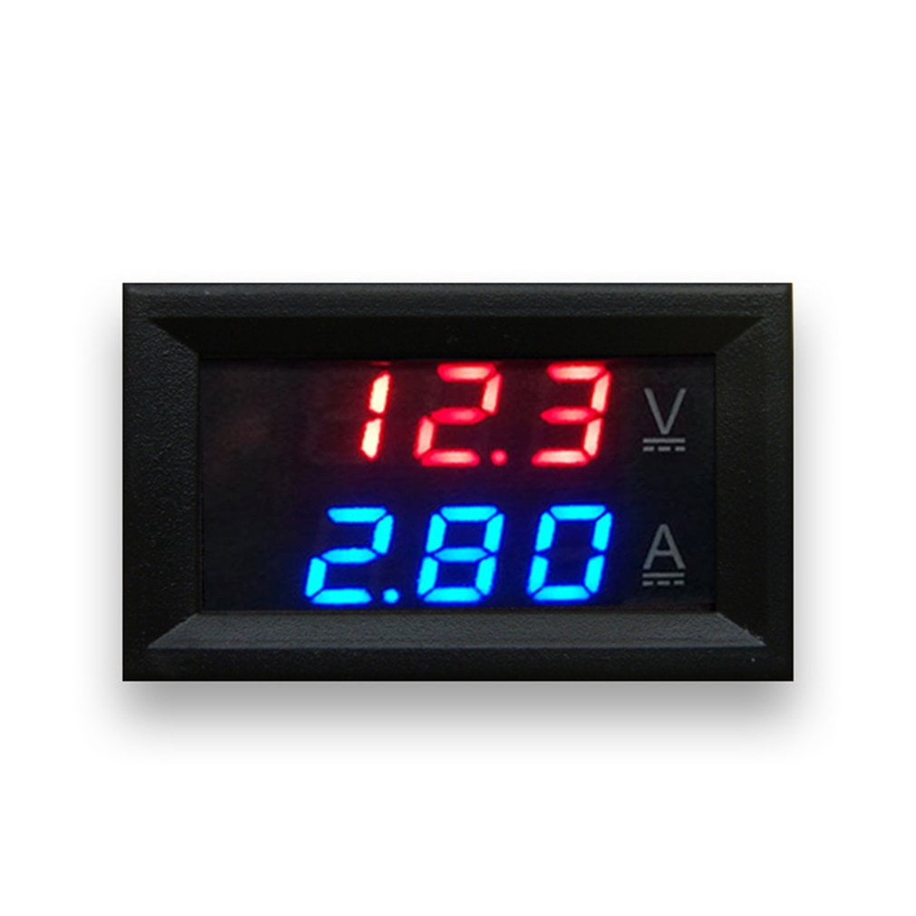

**Fig 2.2.2.1: DC CURRENT & VOLTAGE INDICATOR**

A DC Current & Voltage Indicator is a device designed to measure and display the electrical parameters of a direct current (DC) circuit, including voltage and current. It typically consists of a voltage sensor to measure DC voltage and a current sensor to measure current flow, either using a shunt resistor or Hall-effect sensor. A microcontroller, such as an Arduino, processes the sensor data and displays real-time values on a connected display unit like an LCD or OLED. This device is widely used in applications where monitoring of DC power systems, batteries, or electronic devices is essential to ensure efficient operation and safety. Additionally, it can be equipped with features such as alarms or automatic shutdowns when voltage or current thresholds are exceeded.

**2.2.3 4 CHANNEL RELAY MODULE**

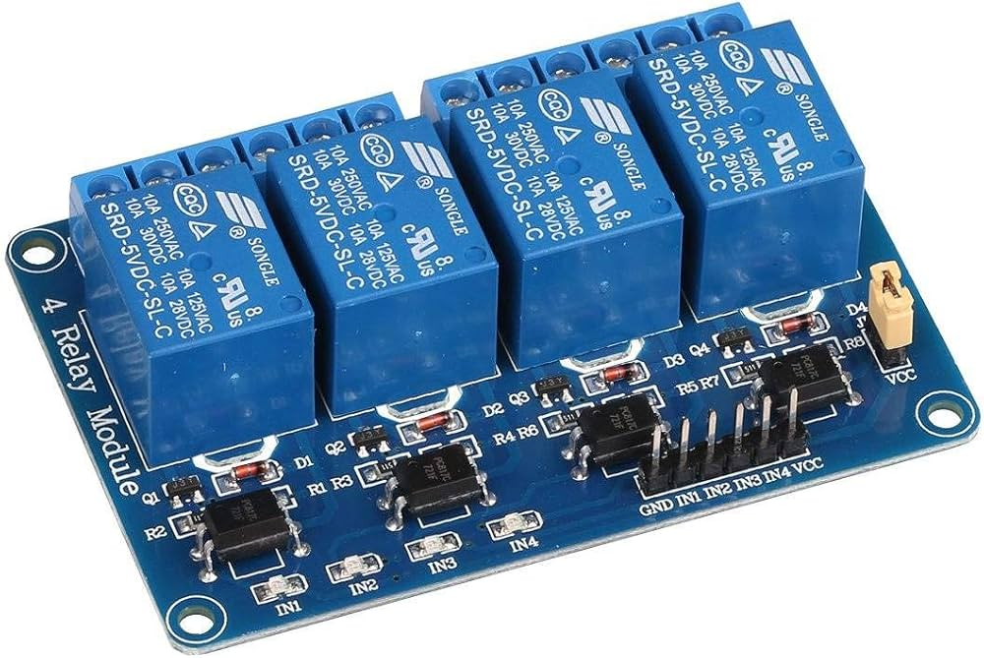

**Fig 2.2.3.1: 4 CHANNEL RELAY MODULE**

A 4-channel relay module allows you to control up to four different devices or appliances independently using a microcontroller, such as an Arduino or ESP8266. Each channel is equipped with its own relay, which acts as a switch to control the flow of electricity to the connected devices. These modules are commonly used in automation projects, home automation systems, and IoT applications to manage multiple high-power loads, like lights, motors, and sensors. The module communicates with the microcontroller via digital signals, making it versatile and easy to integrate into various electronic projects.

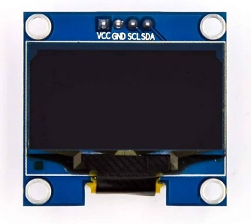**2.2.4 OLED DISPLAY**

**Fig 2.2.4.1: OLED DISPLAY**

An OLED (Organic Light Emitting Diode) display module is a type of screen technology that uses organic compounds to emit light when electricity is applied. These displays are known for their high contrast, vibrant colors, and wide viewing angles, making them ideal for displaying text, graphics, and images. OLED modules are commonly used in projects such as embedded systems, IoT devices, wearable electronics, and digital signage due to their low power consumption, flexibility, and ability to operate in various lighting conditions. They can be easily interfaced with microcontrollers like Arduino, ESP8266, and other similar platforms.

**2.2.5 RECTIFIER MODULE**

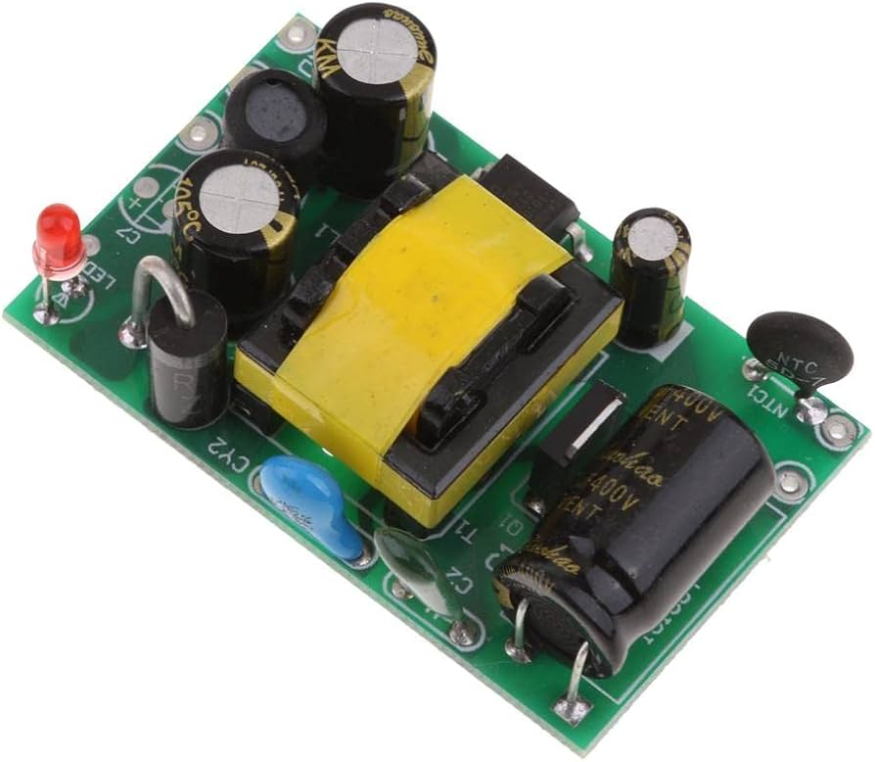

**Fig 2.2.5.1: RECTIFIER MODULE**

A rectifier module is an electronic device used to convert alternating current (AC) into direct current (DC). It typically consists of one or more diodes arranged in a bridge or half-wave configuration, allowing AC voltage from a power source to be rectified into DC voltage. Rectifier modules are commonly used in power supply circuits, battery charging systems, and DC motor drives, providing a stable DC output for various electronic devices and systems. They are available in different configurations and power ratings to suit different voltage and current requirements.

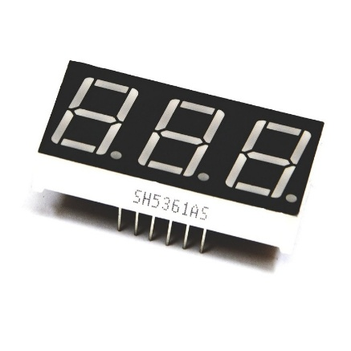**2.2.6 3 DIGIT SSD MODULE**

**Fig 2.2.6.1: 4 CHANNEL RELAY MODULE**

A 3-digit SSD (Seven-Segment Display) module is a compact electronic component used to display numerical values or characters. It features seven segments for each digit (A, B, C, D, E, F, and G), allowing it to display numbers from 0 to 9, as well as some common symbols like "-", ".", and "E". These modules are commonly used in digital clocks, temperature displays, timers, and other applications where numeric data needs to be visually represented. They are typically controlled through microcontrollers or other digital interfaces, making them versatile for various embedded systems projects.

**2.2.7 BULB HOLDER**

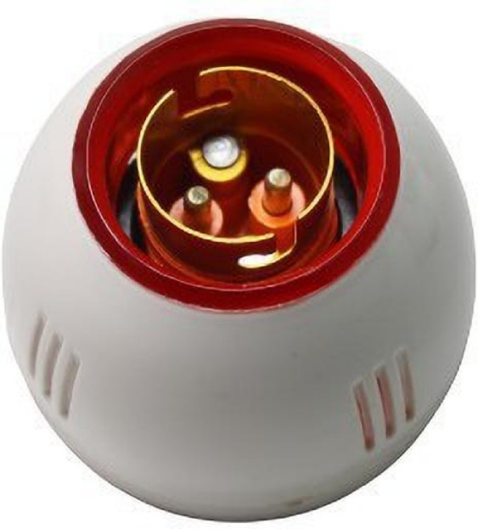

**Fig 2.2.7.1: BULB HOLDER**

A bulb holder, also known as a lamp holder or socket, is a component used to hold and provide electrical connections for light bulbs. It ensures a secure and safe connection between the bulb and the electrical circuit. Bulb holders come in various designs, including screw-in, bayonet, and twist-and-lock types, to accommodate different types of light bulbs such as incandescent, LED, CFL, and halogen bulbs. They are widely used in residential, commercial, and industrial lighting applications, and are available in various materials like ceramic, metal, and plastic for durability and safety.

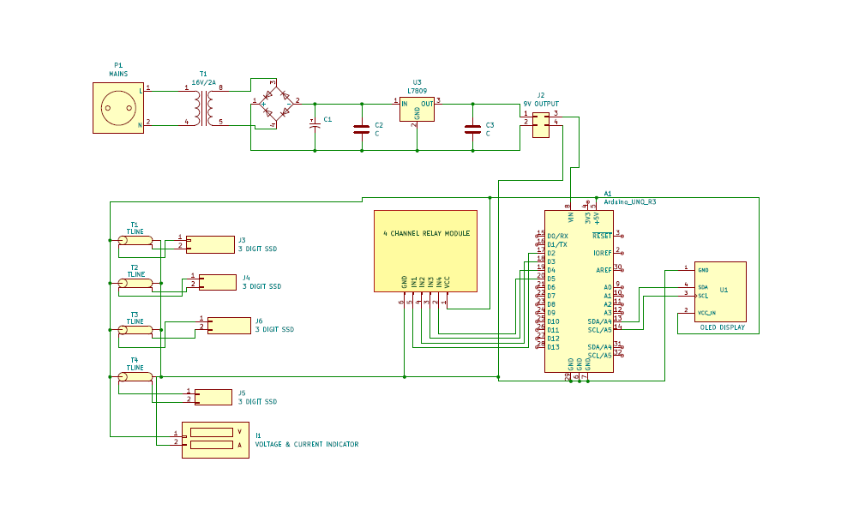**2.3 CIRCUIT DIAGRAM**

**Fig 2.3: Circuit diagram Fault Detection in 2 Bus System**

The system consists of two Arduino Uno boards working together to control and monitor eight AC light lines through relay modules. Each Arduino manages four relay modules, with Arduino Uno 1 controlling relays 1-4 and Arduino Uno 2 controlling relays 5-8. The setup is powered by a 9V DC supply derived from AC power through a rectifier circuit. Each Arduino board is equipped with an OLED display connected via I2C protocol (using pins A4 and A5) to show real-time voltage and current measurements of the monitored lines.

The core functionality revolves around power monitoring and protection. The system continuously monitors voltage (through pins A0-A3) and current (through pins A4-A7) for each line, comparing them against preset thresholds (10V for voltage and 2A for current). If voltage drops too low or current exceeds the safe limit, the corresponding relay switches off automatically, and the system activates the next relay in sequence. Each relay module connects to an AC light holder using a Normally Open (NO) configuration for the live wire and Common (COM) for the neutral wire, ensuring safe switching and electrical isolation between the control circuit and AC power lines.

**2.4 METHODOLOGY**

The methodology for implementing this fault detection system begins with the installation of voltage and current sensors along the transmission lines of the IEEE 9 bus system. These sensors continuously monitor the electrical parameters in real-time, feeding this data to the Arduino Uno microcontroller for processing. The Arduino is programmed to analyze these inputs against predetermined threshold values that indicate normal operating conditions. When deviations occur, the system triggers appropriate responses through its output devices. The installation phase also includes setting up OLED displays for data visualization and configuring LED indicators for quick status checks, while the relay component is integrated to provide protective isolation capabilities when necessary.

During operation, the system follows a sequential process where sensor readings are sampled at regular intervals by the Arduino. The collected data undergoes algorithmic analysis to detect any anomalies such as overcurrent, undervoltage, or phase imbalances. Upon detecting a fault condition, the system initiates several simultaneous actions: it activates relevant LED indicators, updates the OLED displays with fault information and electrical parameters, and can trigger the relay to disconnect the load if necessary. This comprehensive monitoring approach utilizes dual OLED displays - one for fault-specific information and another for real-time voltage/current measurements - ensuring operators have complete visibility into system status while maintaining protective functions through automated relay responses when fault conditions are detected.

**CHAPTER 3**

**SOFTWARE - MATLAB**

**3.1 MATLAB**

MATLAB (Matrix Laboratory) is a high-performance language and environment for numerical computation, visualization, and programming. Developed by MathWorks, it is widely used in academia, research, and industry for a variety of applications. MATLAB excels in matrix and vector computations, making it ideal for linear algebra, statistical analysis, and optimization problems. It offers powerful tools for visualizing data through 2D and 3D plots, histograms, and heat maps, aiding in data analysis and presentation.

It is used to design, implement, and test algorithms in a user-friendly environment, supporting rapid prototyping and experimentation. It is commonly used for simulating dynamic systems, such as control systems, signal processing, and financial models, using built-in functions and toolboxes. MATLAB provides a wide range of specialized toolboxes for various domains, including signal processing, image processing, machine learning, and robotics. It can generate C, C++, and HDL code from MATLAB code, enabling integration with other programming environments and hardware platforms.

MATLAB supports integration with other programming languages like Python, C/C++, Java, and .NET, allowing for flexible and extended functionality. Users can create custom graphical user interfaces (GUIs) to simplify interaction with programs and models. MATLAB is widely used in educational institutions for teaching mathematics, engineering, and science courses, as well as in research for developing and testing new theories and models.

In industry, MATLAB is used for tasks such as data analysis, system modeling, and automation in sectors like aerospace, automotive, finance, telecommunications, and biotechnology. Overall, MATLAB's combination of numerical computing power, versatile visualization capabilities, and extensive toolboxes makes it a valuable tool for a wide range of scientific and engineering applications.

**3.2 SIMULINK**

Simulink plays a critical role in the fault detection and analysis of the IEEE 9 bus system using MATLAB & Simulink. As a powerful simulation and modeling tool, Simulink provides a graphical environment where complex systems can be designed, tested, and analyzed systematically. In the context of the IEEE 9 bus system, Simulink allows for the creation of dynamic system models that can simulate various operating conditions, including normal and fault scenarios. By integrating mathematical models with real-world system data, Simulink facilitates the simulation of faults such as line outages, equipment malfunctions, and other disturbances, helping engineers understand the system’s behavior under stress.

Moreover, Simulink supports the use of block diagrams to model the system, enabling the easy representation of complex interactions between different components, such as generators, transformers, and load buses. This visual approach aids in quickly identifying and troubleshooting faults by providing real-time feedback and performance metrics. Additionally, Simulink's vast library of pre-built components and blocks allows for customization according to the specific requirements of the IEEE 9 bus system. Fault detection is enhanced through the use of advanced signal processing and diagnostic algorithms integrated into Simulink models, which can help pinpoint issues with high accuracy. Overall, Simulink's simulation capabilities significantly improve the reliability, efficiency, and effectiveness of fault detection in the IEEE 9 bus system.

**CHAPTER 4**

**RESULT AND DISCUSSION**

**4.1 RESULT**

**4.1.1 SOFTWARE RESULT**

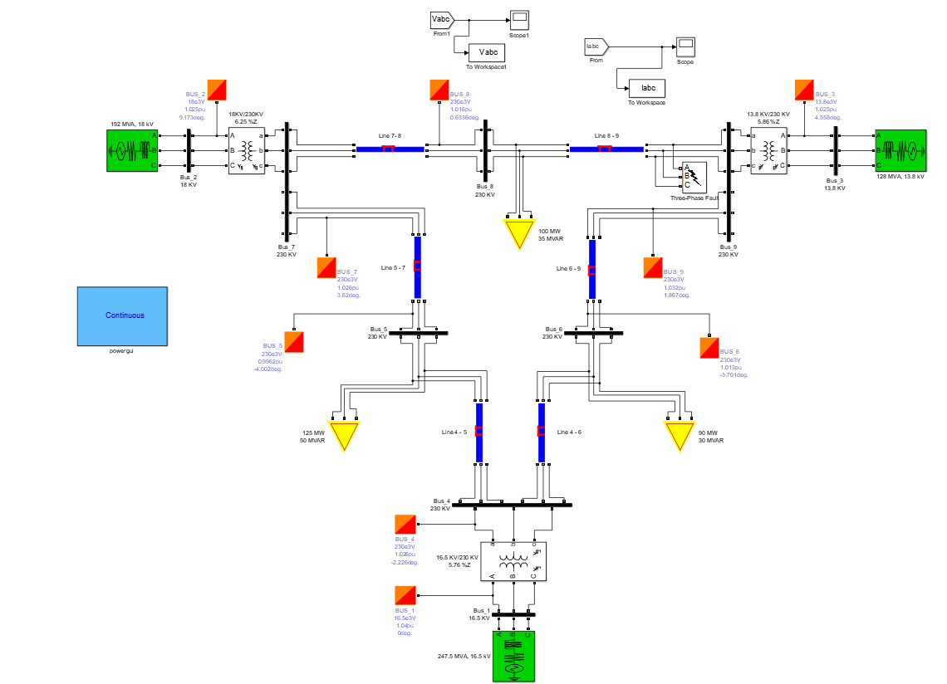

**FIG.4.1.1 IEEE 9 BUS SYSTEM**

This image represents a single-line diagram of the IEEE 9-bus system modeled in a simulation environment such as MATLAB/Simulink. The diagram includes various components of a power system: generators, transformers, transmission lines, loads, and buses. The system operates at different voltage levels, including 230 kV, 220 kV, 16.5 kV, and 13.8 kV, with the use of transformers for voltage regulation. It incorporates load flow data, represented by arrows showing power (MW and MVAR) and per-unit voltages with phase angles at each bus. Reactive power compensation devices are connected to maintain voltage stability. The model includes fault simulation capabilities, highlighted by a three-phase fault on one of the lines. The layout demonstrates the interaction of generators, loads, and transmission lines to analyze stability, fault detection, or power flow distribution.

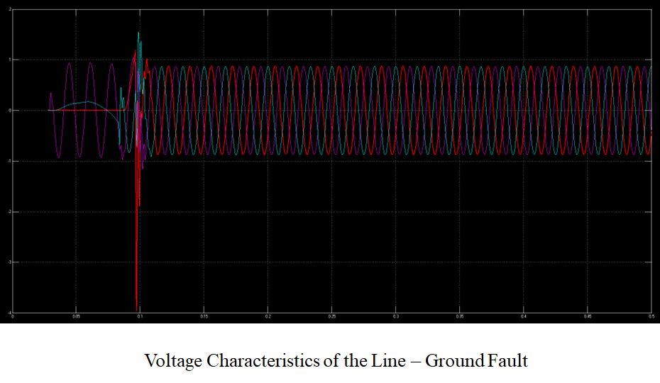

**Fig 4.1.2 Voltage Characteristics of the Line – Ground Fault**

This graph illustrates the voltage characteristics of a power system under a line-to-ground fault condition. The waveform shows the system's voltage behavior over time, with a noticeable disturbance occurring at the fault instant, typically around 0.1 seconds. Before the fault, the voltages are stable and sinusoidal. At the fault occurrence, a sharp drop or fluctuation is observed, followed by transient oscillations. These oscillations eventually dampen as the system stabilizes, depending on the protection scheme and system damping characteristics. The graph effectively captures the dynamic response of the voltage to a fault, making it useful for analyzing the system's transient stability and fault-clearing 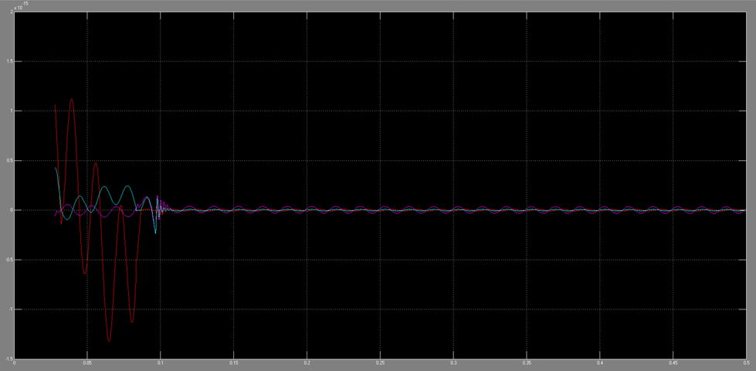mechanisms.

**Fig.4.1.3 Current Characteristics of the Line – Ground Fault**

The line-to-ground fault characteristics shown in the graph display a distinctive pattern of system response during a fault event. The most prominent feature is a significant initial disturbance, indicated by high-amplitude oscillations in the red waveform, followed by a period of damped oscillations across multiple traces (shown in red, blue, and cyan). These traces, which likely represent different electrical parameters such as phase currents or voltages, demonstrate how the system responds to and attempts to stabilize after the fault occurrence. The waveforms eventually settle into a steady-state condition after the initial transient period, with all traces converging to more stable values, illustrating the power system's natural response and potential protective measures taking effect during the fault condition.

**Fig.4.1.4 Voltage Characteristics of the Double Line – Ground Fault**

The plot illustrates the voltage characteristics of a double line-to-ground fault in an IEEE 9-bus system, highlighting the system's transient and steady-state behavior. A sharp spike at the onset indicates the transient response caused by the sudden imbalance in voltages due to the fault. This is followed by a stabilization phase where the voltages return to a steady state, reflecting the system's ability to recover from the disturbance. Such analysis is critical for understanding fault dynamics and designing effective protection schemes.

**Fig.4.1.5 Current Characteristics of the Double Line – Ground Fault**

This plot depicts the current characteristics of a double line-to-ground fault in an IEEE 9-bus system, showing both transient and steady-state responses. At the onset of the fault, the system exhibits sharp spikes in current due to the sudden disturbance and imbalance caused by the fault. Following this transient phase, the currents gradually settle into oscillations with a lower amplitude, indicating the system's stabilization and recovery. Such characteristics are vital for analyzing fault impacts and optimizing protection mechanisms in power systems.

**Fig.4.1.6 Current Characteristics of the Line-Line – Ground Fault**

This plot shows the current characteristics of a line-to-line ground fault in an IEEE 9-bus system. The waveform exhibits periodic oscillations, indicating the fault's impact on the system currents. The oscillatory nature reflects the dynamic response of the system under fault conditions, highlighting variations in the current magnitudes across phases. Such analysis is crucial for understanding the behavior of the power system during faults and designing appropriate protective measures to ensure system stability and reliability.

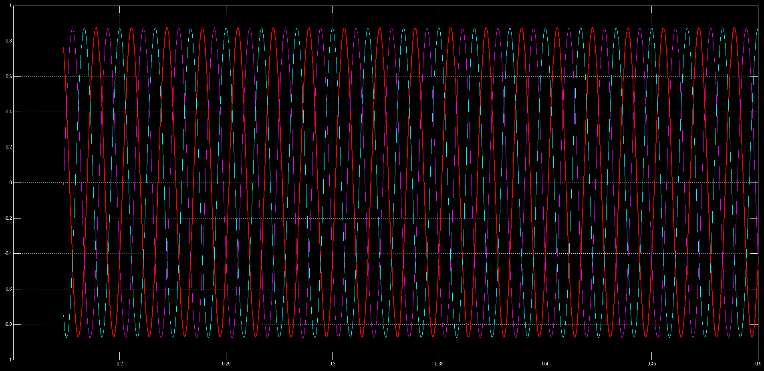**Fig.4.1.7 Voltage Characteristics of the Line – Ground Fault**

The graph illustrates the voltage behavior during a line-to-ground fault in a three-phase power system. It displays three sinusoidal waveforms in different colors (red, blue, and cyan) representing the voltages of each phase over time. During a line-to-ground fault, one phase comes in contact with the ground, causing voltage disturbances and imbalances across all phases. The waveforms show characteristic phase shifts and amplitude variations typical of such fault conditions, which can help engineers diagnose and analyze power system problems. Understanding these voltage characteristics is crucial for designing protective systems and maintaining power grid stability.

**4.1.2 HARDWARE RESULTS**

**Fig 4.1.8 Hardware Result**

This model represents fault detection in a 2-bus power system. It includes poles symbolizing transmission lines, sensors to measure electrical parameters, and digital displays showing voltage or current levels for each bus. The system is designed to identify faults, such as voltage drops or line failures, and visually display the affected parameters. The project demonstrates the operation of fault detection and response mechanisms in a simplified and educational framework, simulating real-world scenarios in power systems.

**Fig.4.1.9 Hardware Result of Line to Ground Fault**

The digital meter readings from a 2-bus system fault analysis show a voltage of 8.9V and current of 0.36A, indicating a line-to-ground fault condition. During this fault, there's an abnormal electrical path between the power line and ground, causing the voltage to drop substantially from its normal operating level while allowing fault current to flow. This measured voltage-current combination helps verify the presence and severity of the fault, which is essential for power system protection and maintenance.

**Fig 4.1.10 Hardware Result of Line- Line Fault**

The image depicts a digital multimeter displaying a voltage reading of 8.8 volts (V) and a current reading of 0.44 amperes (A). The color coding, with red for voltage and blue for current, aids in distinguishing the measurements. The caption, "Fig 4.1.5 Hardware Result of Line-Line Fault," indicates that this image is likely associated with an experiment or test focusing on line-line fault conditions, where a fault occurs between two electrical lines in a three-phase system.

**Fig.4.1.A group of small electronic devices with wires

Description automatically generated11 Fault detected in Bus 1**

The image displays two LCD screens. One indicates a ground fault on line 3 at section A in a 2-bus power system. The other confirms that all other lines are clear. This detection triggers the protection system, potentially leading to circuit breaker tripping, alarms, and system reconfiguration. The fault can cause voltage imbalances, power flow redistribution, and reduced system capacity. Operators must respond by analyzing the fault, isolating the faulty section, and restoring service after repairs.

**Fig.4.1.12 Fault detected in Bus 2**

The image shows two LCD displays. One confirms all lines are clear, while the other indicates a fault on line 2 at section B in a 2-bus power system. This triggers the protection system, potentially leading to circuit breaker tripping, alarms, and system reconfiguration. The fault can cause voltage imbalances, power flow redistribution, and reduced system capacity. Operators must analyze the fault, isolate the faulty section, and restore service after repairs.

**4.2 CONCLUSION**

The implementation and analysis of fault detection in the IEEE 9 bus system using MATLAB and Simulink has successfully demonstrated the effectiveness of digital simulation techniques in understanding power system behavior during fault conditions. Through comprehensive modeling and simulation, we analyzed various fault scenarios including line-to-ground, line-to-line, and three-phase faults, with the results validating the system's response characteristics and providing crucial insights for protection system design. The study effectively utilized MATLAB/Simulink's capabilities to model complex power system behavior, offering detailed visualization of transient responses and fault current magnitudes. The simulation results highlighted the system's robust stability characteristics during fault conditions, successful fault isolation mechanisms, and system recovery patterns. This research not only contributes to the field of power system protection by providing a comprehensive framework for fault analysis but also demonstrates the practical value of simulation-based studies in developing and optimizing protection schemes, making it an invaluable tool for ensuring reliable power system operation.

**4.3 FUTURE SCOPE**

* Integration of Artificial Intelligence and Machine Learning algorithms to enhance fault detection accuracy and speed, potentially implementing neural networks for real-time fault classification and location prediction.
* Development of adaptive protection schemes that can automatically adjust relay settings based on changing system conditions and varying fault scenarios, improving system reliability.
* Implementation of Wide Area Monitoring Systems (WAMS) with Phasor Measurement Units (PMUs) for enhanced real-time monitoring and faster fault detection across the entire bus system.
* Investigation of fault detection methods under high penetration of renewable energy sources, considering the impact of distributed generation on traditional protection schemes.
* Development of cyber-secure fault detection systems to protect against potential cyber-attacks, incorporating blockchain technology for secure data transmission and storage.
* Integration of digital twin technology for real-time system monitoring and predictive fault analysis, enabling proactive maintenance and reduced downtime.
* Enhancement of fault location accuracy using advanced signal processing techniques and optimization algorithms, particularly for complex network configurations.
* Investigation of the impact of energy storage systems on fault characteristics and protection requirements in the IEEE 9 bus system.

**CHAPTER 5**

**ADVANTAGES AND DISADVANTAGES**

**5.1 ADVANTAGES**

1. Cost-Effective Analysis: Enables comprehensive fault studies without the need for physical hardware, significantly reducing testing and development costs.
2. Safe Testing Environment: Allows simulation of severe fault conditions without risking damage to actual power system equipment or endangering personnel.
3. High Flexibility: Easy modification of system parameters and fault scenarios, enabling testing of multiple conditions and configurations quickly.
4. Detailed Visualization: Provides clear graphical representation of system behavior during faults through waveforms and measurements, enhancing understanding of system dynamics.
5. Real-Time Analysis: Enables observation of transient behaviors and system responses in real-time, helping in better understanding of fault characteristics.
6. Educational Value: Serves as an excellent teaching tool for students and engineers to understand power system behavior during fault conditions.
7. Reproducible Results: Ensures consistent and repeatable test conditions for validation of protection schemes and fault detection methods.
8. System Optimization: Helps in optimizing protection settings and coordination without disrupting the actual power system.
9. Performance Validation: Allows verification of protection schemes and fault detection algorithms before real-world implementation.
10. Comprehensive Data Analysis: Enables detailed post-fault analysis and data collection for improving system reliability and protection strategies.

**5.2 DISADVANTAGES**

1. Model Limitations: Simulated models may not perfectly represent real-world power system behaviours and complexities, leading to potential discrepancies between simulation and actual system performance.
2. Computational Requirements: Complex simulations demand significant computational resources and processing time, especially when analysing detailed fault scenarios and system responses.
3. Software Dependencies: The system relies heavily on specific versions of MATLAB/Simulink and associated toolboxes, which can be expensive and require regular updates to maintain compatibility.
4. Expertise Required: Implementation and analysis require deep knowledge of both power systems engineering and MATLAB/Simulink programming, creating a steep learning curve for new users.
5. Validation Challenges: Simulation results need verification against real-world data to ensure accuracy, but such data may not always be readily available, m aking it difficult to confirm the reliability of the simulated results.

**CHAPTER 6**

**APPLICATIONS**

1. Power System Protection: Design and testing of protection schemes for transmission lines, transformers, and generators to ensure reliable system operation during fault conditions.
2. Educational Training: Serves as an effective teaching tool for power engineering students and professionals to understand system behaviour during various fault scenarios.
3. Research and Development: Enables investigation of new protection algorithms and fault detection methods before real-world implementation.
4. System Planning: Assists in power system planning by analysing potential fault scenarios and their impact on system stability and reliability.
5. Grid Modernization: Supports the development of smart grid technologies by testing advanced protection and control strategies in a simulated environment.

**CONCLUSION**

Fault detection in an IEEE 9-bus system using MATLAB & Simulink involves simulating various fault scenarios and analyzing their impacts on the power system. By integrating power system analysis with advanced control techniques, MATLAB & Simulink offer a robust platform for evaluating system performance under fault conditions. Through detailed simulations, it becomes possible to identify the type and location of faults, assess the system's stability, and develop corrective actions to mitigate the impact of faults. This helps in improving the reliability and efficiency of power systems by ensuring prompt fault detection and reducing downtime.

Additionally, utilizing MATLAB & Simulink for fault detection provides a comprehensive understanding of system behavior under different fault conditions. The integration of simulation tools enables engineers to test various protection schemes, evaluate their effectiveness, and optimize system parameters. This process ultimately contributes to enhancing the overall performance of the power system, ensuring a more resilient and secure electricity supply for consumers.

**REFERENCES**

**[1]** Prof. Faisal Mumtaz, Hardware Supported Fault Detection and Localization Method for AC Microgrids Using Mathematical Morphology with State Observer Algorithm, 21 November 2023, IEEE

**[2]** Prof. Xin Li, Analysis and design of connection between solar farm and IEEE 9 bus system, 2021, IEEE

**[3]** Zhihua Li, Zhanfei Yang, Chunhua Wu, Simulation of Fault Detection in Photovoltaic System Based On SSTDR, 2020, IEEE

**[4]** Aditya Patel, M.V.S. Prashant, Jharna Sahu, Ancy Prerena Kujur, Protection Scheme based on Fault Detection and Fault Classification using Fuzzy inference system in IEEE-9 Bus System, 2018, IEEE

**[5]** Frank Gerdinand, Johann Meisner, Stephan Passon, PSCAD/EMTDC-based Simulations for Fault Analysis and Fault Identification in 380V Ring DC Systems, 2017, IEEE

**[6]** Sajjadi M, Seifi H, A new Approach for Parameter Estimation of Power System Equipment Models, 9-11 Dec 2019, Piscataway, NJ, USA, IEEE, 2019

**[7]** Shekar M C, Aarthi N, Contingency Analysis of IEEE 9 Bus System, 18-19 May 2018, IEEE International Conference on Recent Trends in Electronics, Information & Communication Technology, 2018

**[8]** <https://www.midalcable.com/sites/default/files/AAC-metric.PDF>

**[9]** Kaur R, Kumar D, Transient Stability Improvement of IEEE 9 Bus System Using Power World Simulator, 18-19 March 2016, France, EDP Sciences, 2016

**[10]** Kaur R, Kumar D, Transient Stability Improvement of IEEE 9 Bus System Using Power World Simulator, 18-19 March 2016, France, EDP Sciences, 2016

**[11]** <https://www.pscad.com/uploads/knowledge_base/ieee_9_bus_technical_note.pdf>

**[12]** A. Cagnano, E. De Tuglie, P. Mancarella, MicroGrids: Overview and guidelines for practical implementations and operation, Appl. Energy, vol. 258, Jan. 2020, IEEE, 2020

**[13]** N. Hussain, M. Nasir, J. C. Vasquez, J. M. Guerrero, Recent developments and challenges on AC microgrids fault detection and protection systems—A review, Energies, vol. 13, no. 9, p. 2149, May 2020, IEEE, 2020

**[14]** H. R. Baghaee, D. Mlakic, S. Nikolovski, T. Dragicevic, Support vector machine-based islanding and grid fault detection in active distribution networks, IEEE J. Emerg. Sel. Topics Power Electron., vol. 8, no. 3, Sep. 2020, IEEE, 2020

**[15]** R. Tiwari, R. K. Singh, N. K. Choudhary, Coordination of dual setting overcurrent relays in microgrid with optimally determined relay characteristics for dual operating modes, Protection Control Modern Power Syst., vol. 7, no. 1, Dec. 2022, IEEE, 2022

**[16]** F. Mumtaz, K. Imran, A. Abusorrah, S. B. A. Bukhari, Harmonic content-based protection method for microgrids via 1-dimensional recursive median filtering algorithm, Sustainability, vol. 15, no. 1, p. 164, Dec. 2022, IEEE, 2022

**[17]** F. Mumtaz, K. Imran, A. Abusorrah, S. B. A. Bukhari, An extensive overview of islanding detection strategies of active distributed generations in sustainable microgrids, Sustainability, vol. 15, no. 5, p. 4456, Mar. 01, 2023, IEEE, 2023

**[18]** S. Beheshtaein, R. Cuzner, M. Savaghebi, S. Golestan, J. M. Guerrero, Fault location in microgrids: A communication-based high-frequency impedance approach, IET Gener., Transmiss. Distrib., vol. 13, no. 8, Apr. 2019, IEEE, 2019

**[19]** M. Manohar, E. Koley, S. Ghosh, Microgrid protection against high impedance faults with robustness to harmonic intrusion and weather intermittency, IET Renew. Power Gener., vol. 15, no. 11, Aug. 2021, IEEE, 2021

**[20]** S. M. Malik, X. Ai, Y. Sun, C. Zhengqi, Z. Shupeng, Voltage and frequency control strategies of hybrid AC/DC microgrid: A review, IET Gener., Transmiss. Distrib., vol. 11, no. 2, Jan. 26, 2017, IEEE, 2017

**ANNEXURE**

#include <Wire.h>

#include <Adafruit_SSD1306.h>

#include <Adafruit_GFX.h>

#define SCREEN_WIDTH 128

#define SCREEN_HEIGHT 64

Adafruit_SSD1306 display1(SCREEN_WIDTH, SCREEN_HEIGHT, &Wire, -1);

Adafruit_SSD1306 display2(SCREEN_WIDTH, SCREEN_HEIGHT, &Wire, -1);

#define RELAY1 2

#define RELAY2 3

#define RELAY3 4

#define RELAY4 5

#define VOLTAGE_PIN1 A0

#define VOLTAGE_PIN2 A1

#define VOLTAGE_PIN3 A2

#define VOLTAGE_PIN4 A3

#define CURRENT_PIN1 A4

#define CURRENT_PIN2 A5

#define CURRENT_PIN3 A6

#define CURRENT_PIN4 A7

const float voltageThreshold = 10.0;

const float currentThreshold = 2.0;

void setup() {

pinMode(RELAY1, OUTPUT);

pinMode(RELAY2, OUTPUT);

pinMode(RELAY3, OUTPUT);

pinMode(RELAY4, OUTPUT);

digitalWrite(RELAY1, HIGH);

digitalWrite(RELAY2, HIGH);

digitalWrite(RELAY3, HIGH);

digitalWrite(RELAY4, HIGH);

display1.begin(SSD1306_I2C_ADDRESS, 0x3C);

display2.begin(SSD1306_I2C_ADDRESS, 0x3D);

display1.clearDisplay();

display2.clearDisplay();

display1.display();

display2.display();

}

void loop() {

float voltage1 = analogRead(VOLTAGE_PIN1) * (5.0 / 1023.0) * 11.0;

float voltage2 = analogRead(VOLTAGE_PIN2) * (5.0 / 1023.0) * 11.0;

float voltage3 = analogRead(VOLTAGE_PIN3) * (5.0 / 1023.0) * 11.0;

float voltage4 = analogRead(VOLTAGE_PIN4) * (5.0 / 1023.0) * 11.0;

float current1 = analogRead(CURRENT_PIN1) * (5.0 / 1023.0) / 0.185;

float current2 = analogRead(CURRENT_PIN2) * (5.0 / 1023.0) / 0.185;

float current3 = analogRead(CURRENT_PIN3) * (5.0 / 1023.0) / 0.185;

float current4 = analogRead(CURRENT_PIN4) * (5.0 / 1023.0) / 0.185;

if (voltage1 < voltageThreshold || current1 > currentThreshold) {

digitalWrite(RELAY1, LOW);

digitalWrite(RELAY2, HIGH);

} else {

digitalWrite(RELAY1, HIGH);

}

if (voltage2 < voltageThreshold || current2 > currentThreshold) {

digitalWrite(RELAY2, LOW);

digitalWrite(RELAY3, HIGH);

} else {

digitalWrite(RELAY2, HIGH);

}

if (voltage3 < voltageThreshold || current3 > currentThreshold) {

digitalWrite(RELAY3, LOW);

digitalWrite(RELAY4, HIGH);

} else {

digitalWrite(RELAY3, HIGH);

}

if (voltage4 < voltageThreshold || current4 > currentThreshold) {

digitalWrite(RELAY4, LOW);

} else {

digitalWrite(RELAY4, HIGH);

}

display1.clearDisplay();

display1.setCursor(0, 0);

display1.setTextSize(1);

display1.setTextColor(SSD1306_WHITE);

display1.print("V1: ");

display1.print(voltage1);

display1.print("V C1: ");

display1.print(current1);

display1.print("A");

display1.display();

display2.clearDisplay();

display2.setCursor(0, 0);

display2.setTextSize(1);

display2.setTextColor(SSD1306_WHITE);

display2.print("V2: ");

display2.print(voltage2);

display2.print("V C2: ");

display2.print(current2);

display2.print("A");

display2.display();

delay(1000);

}