SwiftShip Tracker – AI-Powered Parcel Booking & Tracking System (HTML, CSS & JavaScript Based)
Abstract
SwiftShip Tracker is a web-based application designed to let customers book parcels, track deliveries, and manage delivery preferences from a single interface. The frontend prototype is built using HTML, CSS, and JavaScript, and simulates the customer, delivery-agent, and admin experience of an AI-powered parcel tracking assistant. It reduces the need to call support or switch between multiple apps by bringing booking, live status tracking, and an assistant chat into one page. The application persists data in the browser, so a booked parcel, its status, and its full history remain available across the Track, Agent Console, and Admin views without a server round-trip, making it a self-contained demonstration of the full parcel lifecycle described in the original project brief.

Introduction
Customers often face delays and confusion while booking, tracking, and managing parcel deliveries because they need to call support or use multiple apps. SwiftShip Tracker simplifies this by allowing customers to book parcels, get live tracking updates, and interact with a conversational assistant in one place. The same interface also gives delivery agents a console to advance shipments through their lifecycle, and gives admins a dashboard to see the overall health of the operation at a glance.
Objectives:
- Design a responsive, single-page interface for booking and tracking parcels
- Visually represent the parcel lifecycle from booking to delivery
- Reduce the complexity of checking delivery status across channels
- Simulate a conversational tracking assistant using rule-based responses
- Give delivery agents a simple console to progress parcels through each stage
- Give admins visibility into operational counts without a separate reporting tool
- Provide a foundation for future backend and AI integration (e.g. Salesforce, AgentForce)

Literature Review
Existing courier and logistics platforms typically rely on full-stack systems with a database, backend APIs, and a live AI service for customer support. However, frontend technologies alone play an important role in:
- Structuring the booking, tracking, and dashboard screens (HTML)
- Styling a clear, role-appropriate layout for customers, agents, and admins (CSS)
- Driving interactivity — form handling, view switching, status updates (JavaScript)
Frontend-only prototypes like this one are useful for:
- Rapidly prototyping the end-to-end parcel journey
- Demonstrating UI/UX for booking, tracking, and admin flows
- Validating the interaction design of a conversational tracking agent before wiring it to a real AI backend
Comparable frontend-only academic prototypes (such as employee or student data managers built purely in HTML/CSS/JS) show that a well-structured client-side application can fully validate a data model and user flow before any backend investment is made. SwiftShip Tracker follows the same pattern, applied to a logistics domain: parcels, senders, and receivers stand in for the records typically drawn from a database, and localStorage stands in for a persistence layer.

System Architecture
The application is a single HTML file that behaves like a small single-page application (SPA). A persistent navigation bar switches between four views — Book, Track, Agent Console, and Admin — by toggling which <section> is visible; no page reload occurs at any point.
Layers:
- Presentation layer — semantic HTML sections styled with CSS custom properties for a consistent, theme-aware look (including a dark-mode palette).
- Interaction layer — vanilla JavaScript event listeners handle form submission, navigation clicks, status advancement, and chat input.
- Data layer — a single localStorage key (swiftship_parcels_v1) stores the full array of parcel records as JSON; every view reads from and writes to this same store, so updates in one view are immediately visible in another.
- Assistant layer — a lightweight rule-based function (agentReply) parses free-text messages for a tracking ID and an optional status keyword, then reads or writes the data layer accordingly, simulating how a real AgentForce/LLM-backed agent would call backend actions.
Because every view reads the same underlying array, the architecture already mirrors the shape of a real system: the Book view is analogous to a "create" operation on a Parcel record, Track is a "read" operation, Agent Console is an "update" operation, and Admin is an aggregate "report" over the same records.

Data Model
Each parcel is stored as a single JavaScript object with nested sender and receiver records, mirroring the Parcel__c / Sender__c / Receiver__c / Delivery__c relationship from the original Salesforce-based design.
Field | Type | Description
id | String | Generated tracking ID in the form SS-XXXXX
status | String (enum) | One of Booked, In Transit, Out for Delivery, Delivered
weight | Number | Parcel weight in kilograms
eta | Date | Estimated delivery date
booked | ISO DateTime | Timestamp the booking was created
sender | Object | name, address, phone, email
receiver | Object | name, address, phone, email
This flat, JSON-serialisable shape is what makes the object trivial to persist in localStorage and equally trivial to later replace with records fetched from a real Parcel__c object over a Salesforce REST or Apex endpoint — the rendering functions (renderTrackResult, renderAgent, renderAdmin) do not need to change, only the loadParcels()/saveParcels() functions would need to call an API instead of localStorage.

Methodology
- Requirement Analysis — Identified the core entities (Parcel, Sender, Receiver, Delivery) and the four user-facing flows: booking, tracking, agent updates, and admin oversight.
- Design Planning — Planned a single-page layout with a persistent navigation bar and four views, plus a kraft-label-inspired visual style suited to a shipping/logistics product.
- Data Modelling — Defined the parcel object schema (see Data Model above) and the four-stage status lifecycle shared by every view.
- Frontend Development — Built the structure in HTML5, styled it with CSS3 (custom properties, responsive grid), and implemented behaviour in vanilla JavaScript, including a rule-based chat simulation of the parcel tracking agent.
- Integration — Wired the Book, Track, Agent Console, and Admin views to the same localStorage-backed data layer so that a status change made in one view is reflected everywhere else.
- Testing — Checked responsiveness across screen widths, verified the booking-to-tracking data flow, and validated that status updates in the Agent Console are reflected immediately in Track and Admin views.

Implementation
Features:
- Parcel booking form capturing sender and receiver details and generating a tracking ID
- Live status timeline (Booked → In Transit → Out for Delivery → Delivered)
- Conversational "Parcel Tracking Agent" chat box for natural-language status queries and updates
- Agent Console for advancing a parcel's delivery status with one click
- Admin dashboard with status counts and a full parcel record table
- Sample-data loader and a clear-data control for quick demos and resets
- Responsive, theme-aware layout with a distinct logistics-inspired visual identity
Technologies Used:
- HTML5 — semantic structure for the nav bar and the four views
- CSS3 — custom properties, responsive grid/flexbox, light/dark theme support
- JavaScript (vanilla, no frameworks) — all interactivity and the agent simulation
- Browser localStorage — client-side persistence of parcel records
- Google Fonts — Barlow Condensed, IBM Plex Sans, IBM Plex Mono
Modules:
Book a Parcel — A two-column form captures the sender's and receiver's name, address, phone, and email, plus the parcel's weight and estimated delivery date. On submit, the module generates a tracking ID with genId(), builds a parcel object defaulted to "Booked", appends it to the stored array, and displays a confirmation with the new ID rendered as a barcode-style tag.
Track a Parcel — Given a tracking ID, this module renders a four-stage progress timeline with the current stage highlighted, along with a one-line summary of the shipment. It also hosts the "Ask the Parcel Tracking Agent" chat box, which lets the user type a free-text query or instruction instead of using the form.
Agent Console — Lists every parcel with its sender, receiver, and current status, and gives the agent a single button to advance each parcel to its next lifecycle stage. Advancing a parcel triggers a toast notification simulating an outbound email alert to the receiver.
Admin Dashboard — Aggregates the same data into four stage counters and a full record table, giving an operational snapshot without a separate reporting tool. It also exposes sample-data and clear-data controls for demonstration purposes.
Code Walkthrough:
The sections below explain the key functions before the full source listing that follows.
- genId() — builds a tracking ID in the form SS-##### using a random five-digit number, giving each booking a unique, human-readable reference.
- loadParcels() / saveParcels() — the only two functions that touch localStorage; every other function reads or writes through them, which is what makes it easy to swap localStorage for a real API later.
- renderTrackResult(p) — takes a parcel object and draws the four-stage timeline, marking stages before the current one as "done" and the current one as "current".
- agentReply(text) — the rule-based assistant. It looks for a tracking-ID pattern (ss-\d{4,6}) and an optional "to <status>" phrase in the user's message, then either reports the parcel's current status or updates it, mirroring how a real AgentForce topic/action pair would parse an utterance and call a Flow.
- renderAgent() — draws the Agent Console table and attaches a click handler to each "Advance to …" button that moves the parcel to STAGES[currentIndex+1] and re-saves the array.
- renderAdmin() — tallies how many parcels are in each of the four statuses and redraws both the counter row and the full record table.

Code Used
The full source of the SwiftShip Tracker prototype is listed below in three parts: the HTML structure, the CSS styling, and the JavaScript logic.
1. HTML Structure
<!DOCTYPE html>
<html lang="en">
<head>
<meta charset="UTF-8">
<meta name="viewport" content="width=device-width, initial-scale=1, viewport-fit=cover">
<title>SwiftShip Tracker</title>
<link rel="preconnect" href="https://fonts.googleapis.com">
<link href="https://fonts.googleapis.com/css2?family=Barlow+Condensed:wght@600;700&family=IBM+Plex+Sans:wght@400;500;600&family=IBM+Plex+Mono:wght@500;600&display=swap" rel="stylesheet">

</head>
<body>

<header class="top">
<div class="top-inner">
<div>
<div class="wordmark">Swift<span>Ship</span> Tracker</div>
<div class="tagline">Book, track and manage parcels in one place</div>
</div>
</div>
<nav id="nav">
<button data-view="book" class="active">Book a Parcel</button>
<button data-view="track">Track</button>
<button data-view="agent">Agent Console</button>
<button data-view="admin">Admin</button>
</nav>
</header>

<main class="wrap">

<!-- BOOK -->
<section id="view-book">
<h1 class="page-title">Book a parcel</h1>
<p class="page-sub">Enter sender and receiver details to generate a tracking ID.</p>
<div class="card">
<form id="bookForm">
<div class="grid2">
<fieldset>
<legend>Sender</legend>
<label for="sName">Full name</label>
<input id="sName" required placeholder="Aditi Rao">
<label for="sAddr">Address</label>
<input id="sAddr" required placeholder="14 MG Road, Coimbatore">
<label for="sPhone">Contact number</label>
<input id="sPhone" required placeholder="+91 90000 00000">
<label for="sEmail">Email</label>
<input id="sEmail" type="email" required placeholder="aditi@example.com">
</fieldset>
<fieldset>
<legend>Receiver</legend>
<label for="rName">Full name</label>
<input id="rName" required placeholder="Karan Shah">
<label for="rAddr">Address</label>
<input id="rAddr" required placeholder="88 Link Road, Mumbai">
<label for="rPhone">Contact number</label>
<input id="rPhone" required placeholder="+91 90000 11111">
<label for="rEmail">Email</label>
<input id="rEmail" type="email" required placeholder="karan@example.com">
</fieldset>
</div>
<div class="grid2">
<div>
<label for="weight">Parcel weight (kg)</label>
<input id="weight" type="number" step="0.1" min="0.1" required placeholder="2.5">
</div>
<div>
<label for="eta">Estimated delivery date</label>
<input id="eta" type="date" required>
</div>
</div>
<button class="btn stamp" type="submit">Book parcel</button>
</form>
<div class="confirm" id="bookConfirm">
<p style="margin-top:24px;margin-bottom:8px;font-size:13px;color:#8a8f94;">Booking confirmed — tracking ID</p>
<div class="id-tag" id="newIdTag"></div>
<p style="margin-top:14px;font-size:13.5px;">A booking confirmation email has been queued for the sender and receiver. Use this ID on the <strong>Track</strong> tab any time.</p>
</div>
</div>
</section>

<!-- TRACK -->
<section id="view-track" style="display:none;">
<h1 class="page-title">Track a parcel</h1>
<p class="page-sub">Enter a tracking ID, or ask the parcel agent below.</p>
<div class="card">
<div class="act-row" style="align-items:flex-end;">
<div style="flex:1;min-width:180px;">
<label for="trackId">Tracking ID</label>
<input id="trackId" placeholder="SS-10234">
</div>
<button class="btn" id="trackBtn" style="margin-bottom:14px;">Track</button>
</div>
<div id="trackResult"></div>

<div class="chat">
<p style="font-family:'Barlow Condensed',sans-serif;font-weight:700;font-size:16px;margin:0 0 2px;">Ask the Parcel Tracking Agent</p>
<p class="hint">Try: "track parcel SS-10234" or "update status of SS-10234 to Delivered"</p>
<div class="chat-log" id="chatLog"></div>
<div class="chat-row">
<input id="chatInput" placeholder="Type a message…">
<button class="btn small" id="chatSend">Send</button>
</div>
</div>
</div>
</section>

<!-- AGENT -->
<section id="view-agent" style="display:none;">
<h1 class="page-title">Agent console</h1>
<p class="page-sub">Update delivery status as parcels move through the network.</p>
<div class="card" id="agentTableWrap"></div>
</section>

<!-- ADMIN -->
<section id="view-admin" style="display:none;">
<h1 class="page-title">Admin dashboard</h1>
<p class="page-sub">Operational overview across all parcels.</p>
<div class="stat-row" id="statRow"></div>
<div class="card" id="adminTableWrap"></div>
<div class="act-row">
<button class="btn ghost small" id="seedBtn">Load sample data</button>
<button class="btn ghost small" id="resetBtn">Clear all data</button>
</div>
</section>

</main>

<div class="toast" id="toast"></div>

2. CSS Styling
<style>
:root{
--ink:#17161C; --paper:#EDEFF0; --card:#FFFFFF;
--navy:#1F2A44; --stamp:#C1442D; --kraft:#C7A17A; --kraft-d:#9C7B54;
--line:#D9DBDD; --green:#2E7D4F; --amber:#B7791F;
padding-top:env(safe-area-inset-top,0px); padding-bottom:env(safe-area-inset-bottom,0px);
}
@media (prefers-color-scheme: dark){
:root:not([data-theme="light"]){ --paper:#15171A; --card:#1E2124; --ink:#EDEDEE; --line:#33373C; }
}
:root[data-theme="dark"]{ --paper:#15171A; --card:#1E2124; --ink:#EDEDEE; --line:#33373C; }
*{box-sizing:border-box;}
html,body{margin:0;height:100%;}
body{
background:var(--paper); color:var(--ink); font-family:"IBM Plex Sans",sans-serif;
-webkit-font-smoothing:antialiased; min-height:100%;
}
.wrap{max-width:960px;margin:0 auto;padding:0 20px 60px;}
header.top{
background:var(--navy); color:#fff; padding:22px 20px 0;
padding-top:calc(22px + env(safe-area-inset-top,0px));
}
.top-inner{max-width:960px;margin:0 auto;display:flex;align-items:baseline;justify-content:space-between;flex-wrap:wrap;gap:8px;}
.wordmark{font-family:"Barlow Condensed",sans-serif;font-weight:700;font-size:30px;letter-spacing:.5px;}
.wordmark span{color:var(--kraft);}
.tagline{font-size:13px;color:#B9C2D4;margin-top:2px;}
nav{display:flex;gap:2px;max-width:960px;margin:18px auto 0;padding:0 20px;}
nav button{
flex:1; background:transparent; border:none; border-bottom:3px solid transparent;
color:#B9C2D4; font-family:"IBM Plex Sans",sans-serif; font-weight:600; font-size:14px;
padding:12px 8px; cursor:pointer; border-radius:6px 6px 0 0; transition:background .15s;
}
nav button:hover{background:rgba(255,255,255,.06);}
nav button.active{color:#fff; border-bottom-color:var(--stamp); background:var(--paper); color:var(--ink);}
main{padding-top:28px;}
h1.page-title{font-family:"Barlow Condensed",sans-serif;font-size:28px;font-weight:700;margin:0 0 4px;}
p.page-sub{color:#6b7076;margin:0 0 22px;font-size:14px;}
.card{
background:var(--card); border:1px solid var(--line); border-radius:4px;
padding:22px; margin-bottom:18px;
}
.grid2{display:grid;grid-template-columns:1fr 1fr;gap:16px;}
@media (max-width:640px){.grid2{grid-template-columns:1fr;}}
label{display:block;font-size:12.5px;font-weight:600;color:#666;margin:0 0 5px;}
input,select{
width:100%; padding:10px 11px; border:1px solid var(--line); border-radius:3px;
background:var(--paper); color:var(--ink); font-family:"IBM Plex Sans",sans-serif; font-size:14px;
margin-bottom:14px;
}
input:focus,select:focus,button:focus-visible{outline:2px solid var(--navy); outline-offset:1px;}
fieldset{border:1px dashed var(--line); border-radius:4px; padding:16px 16px 2px; margin:0 0 18px;}
legend{font-family:"Barlow Condensed",sans-serif; font-weight:700; font-size:16px; padding:0 8px; color:var(--navy);}
:root[data-theme="dark"] legend, body:not([data-theme="light"]) legend{color:#EDEDEE}
.btn{
background:var(--navy); color:#fff; border:none; padding:11px 20px; border-radius:3px;
font-weight:600; font-size:14px; cursor:pointer; font-family:"IBM Plex Sans",sans-serif;
}
.btn:hover{background:#152038;}
.btn.stamp{background:var(--stamp);}
.btn.stamp:hover{background:#a5361f;}
.btn.ghost{background:transparent;color:var(--navy);border:1px solid var(--navy);}
:root[data-theme="dark"] .btn.ghost{color:#EDEDEE;border-color:#EDEDEE;}
.btn.small{padding:6px 12px;font-size:12.5px;}
.parcel-id{
font-family:"IBM Plex Mono",monospace; font-weight:600; letter-spacing:1px;
background:repeating-linear-gradient(90deg, var(--ink) 0 2px, transparent 2px 4px);
-webkit-background-clip:text; background-clip:text; color:transparent; display:none;
}
.id-tag{
display:inline-flex; align-items:center; gap:10px; font-family:"IBM Plex Mono",monospace;
font-weight:600; font-size:18px; border:2px solid var(--ink); padding:8px 14px; border-radius:2px;
letter-spacing:1px;
}
.id-tag::before{content:"";width:14px;height:22px;background:
repeating-linear-gradient(90deg,var(--ink) 0 2px, transparent 2px 4px);}
.confirm{display:none;}
.confirm.show{display:block;}
.stage-track{display:flex;margin:18px 0 6px;}
.stage{flex:1;text-align:center;position:relative;padding-top:26px;}
.stage::before{
content:""; position:absolute; top:8px; left:-50%; width:100%; height:3px; background:var(--line); z-index:0;
}
.stage:first-child::before{display:none;}
.stage.done::before{background:var(--green);}
.stage .dot{
position:absolute; top:0; left:50%; transform:translateX(-50%); width:17px; height:17px;
border-radius:50%; background:var(--card); border:3px solid var(--line); z-index:1;
}
.stage.done .dot{border-color:var(--green); background:var(--green);}
.stage.current .dot{border-color:var(--stamp); background:var(--stamp); box-shadow:0 0 0 4px rgba(193,68,45,.18);}
.stage .lbl{font-size:12px;font-weight:600;color:#8a8f94;}
.stage.done .lbl,.stage.current .lbl{color:var(--ink);}
table{width:100%;border-collapse:collapse;font-size:13.5px;}
th{
text-align:left; font-family:"Barlow Condensed",sans-serif; font-weight:700; font-size:13px;
letter-spacing:.3px; color:#666; border-bottom:2px solid var(--ink); padding:8px 10px;
}
td{padding:10px;border-bottom:1px solid var(--line);}
td.mono{font-family:"IBM Plex Mono",monospace;font-size:12.5px;}
.badge{display:inline-block;padding:3px 9px;border-radius:20px;font-size:11.5px;font-weight:600;}
.badge.Booked{background:#E4E7F2;color:var(--navy);}
.badge.InTransit{background:#FBEEDC;color:var(--amber);}
.badge.OutforDelivery{background:#FDE7E0;color:var(--stamp);}
.badge.Delivered{background:#E1F1E7;color:var(--green);}
.stat-row{display:grid;grid-template-columns:repeat(4,1fr);gap:12px;margin-bottom:20px;}
@media (max-width:640px){.stat-row{grid-template-columns:1fr 1fr;}}
.stat{background:var(--card);border:1px solid var(--line);border-radius:4px;padding:16px;}
.stat .num{font-family:"Barlow Condensed",sans-serif;font-size:32px;font-weight:700;line-height:1;}
.stat .lbl{font-size:12px;color:#8a8f94;margin-top:4px;}
.empty{padding:30px;text-align:center;color:#8a8f94;font-size:14px;}
.chat{border-top:1px dashed var(--line);margin-top:22px;padding-top:16px;}
.chat-log{max-height:180px;overflow-y:auto;font-size:13.5px;margin-bottom:10px;}
.chat-log .msg{margin-bottom:10px;}
.chat-log .who{font-weight:600;font-size:11.5px;text-transform:uppercase;letter-spacing:.4px;color:#8a8f94;display:block;}
.chat-log .who.agent{color:var(--navy);}
:root[data-theme="dark"] .chat-log .who.agent{color:#8fa3d1;}
.chat-row{display:flex;gap:8px;}
.chat-row input{margin-bottom:0;}
.toast{
position:fixed; bottom:20px; left:50%; transform:translateX(-50%) translateY(100px);
background:var(--ink); color:var(--paper); padding:12px 20px; border-radius:4px; font-size:13.5px;
transition:transform .25s ease; z-index:50; bottom:calc(20px + env(safe-area-inset-bottom,0px));
}
.toast.show{transform:translateX(-50%) translateY(0);}
.act-row{display:flex;gap:8px;flex-wrap:wrap;}
.hint{font-size:12px;color:#8a8f94;margin-top:-8px;margin-bottom:14px;}
</style>

3. JavaScript Logic
<script>
const STAGES = ["Booked","In Transit","Out for Delivery","Delivered"];
const STORE_KEY = "swiftship_parcels_v1";

function loadParcels(){
try{ return JSON.parse(localStorage.getItem(STORE_KEY)) || []; }catch(e){ return []; }
}
function saveParcels(list){
try{ localStorage.setItem(STORE_KEY, JSON.stringify(list)); }catch(e){}
}
function genId(){
return "SS-" + Math.floor(10000 + Math.random()*89999);
}
function toast(msg){
const t = document.getElementById("toast");
t.textContent = msg; t.classList.add("show");
clearTimeout(toast._h);
toast._h = setTimeout(()=>t.classList.remove("show"), 3200);
}
function badgeClass(s){ return s.replace(/\s/g,""); }
function fmtDate(d){ return new Date(d).toLocaleDateString(undefined,{day:"numeric",month:"short",year:"numeric"}); }

// ---------- Nav ----------
const views = ["book","track","agent","admin"];
document.getElementById("nav").addEventListener("click", (e)=>{
const btn = e.target.closest("button[data-view]");
if(!btn) return;
views.forEach(v=>{
document.getElementById("view-"+v).style.display = (v===btn.dataset.view)?"":"none";
});
document.querySelectorAll("#nav button").forEach(b=>b.classList.toggle("active", b===btn));
if(btn.dataset.view==="agent") renderAgent();
if(btn.dataset.view==="admin") renderAdmin();
});

// ---------- Book ----------
document.getElementById("bookForm").addEventListener("submit", (e)=>{
e.preventDefault();
const parcels = loadParcels();
const id = genId();
const parcel = {
id, status: "Booked", weight: document.getElementById("weight").value,
eta: document.getElementById("eta").value,
booked: new Date().toISOString(),
sender: {
name: document.getElementById("sName").value, address: document.getElementById("sAddr").value,
phone: document.getElementById("sPhone").value, email: document.getElementById("sEmail").value,
},
receiver: {
name: document.getElementById("rName").value, address: document.getElementById("rAddr").value,
phone: document.getElementById("rPhone").value, email: document.getElementById("rEmail").value,
},
};
parcels.push(parcel);
saveParcels(parcels);
document.getElementById("newIdTag").textContent = id;
document.getElementById("bookConfirm").classList.add("show");
e.target.reset();
toast("Parcel " + id + " booked");
});

// ---------- Track ----------
function findParcel(id){
return loadParcels().find(p => p.id.toLowerCase() === id.trim().toLowerCase());
}
function renderTrackResult(p){
const box = document.getElementById("trackResult");
if(!p){ box.innerHTML = '<p class="empty">No parcel found with that tracking ID.</p>'; return; }
const curIdx = STAGES.indexOf(p.status);
box.innerHTML = `
<div class="stage-track">
${STAGES.map((s,i)=>`<div class="stage ${i<curIdx?'done':''} ${i===curIdx?'current':''}">
<div class="dot"></div><div class="lbl">${s}</div></div>`).join("")}
</div>
<p style="font-size:13px;color:#8a8f94;margin:18px 0 6px;">From ${p.sender.name} → To ${p.receiver.name} · Est. delivery ${fmtDate(p.eta)}</p>
`;
}
document.getElementById("trackBtn").addEventListener("click", ()=>{
renderTrackResult(findParcel(document.getElementById("trackId").value || ""));
});

// ---------- Agent chat (rule-based simulation of AgentForce) ----------
function chatAppend(who, text){
const log = document.getElementById("chatLog");
const div = document.createElement("div");
div.className = "msg";
div.innerHTML = `<span class="who ${who==='Agent'?'agent':''}">${who}</span>${text}`;
log.appendChild(div);
log.scrollTop = log.scrollHeight;
}
function agentReply(text){
const idMatch = text.match(/ss-\d{4,6}/i);
const id = idMatch ? idMatch[0].toUpperCase() : null;
const updateMatch = text.match(/to\s+(booked|in transit|out for delivery|delivered)/i);
if(!id) return "I can look up a parcel if you give me a tracking ID, like \"track SS-10234\".";
const parcels = loadParcels();
const p = parcels.find(x=>x.id===id);
if(!p) return `I couldn't find a parcel with ID ${id}. Double-check the ID and try again.`;
if(updateMatch){
const target = STAGES.find(s=>s.toLowerCase()===updateMatch[1].toLowerCase());
p.status = target;
saveParcels(parcels);
renderTrackResult(p);
return `Updated ${id} to "${target}". The receiver will get an email notification.`;
}
return `${id} is currently "${p.status}", heading to ${p.receiver.name} in ${p.receiver.address.split(",").pop().trim()}. Estimated delivery ${fmtDate(p.eta)}.`;
}
function sendChat(){
const input = document.getElementById("chatInput");
const text = input.value.trim();
if(!text) return;
chatAppend("You", text);
input.value = "";
setTimeout(()=>chatAppend("Agent", agentReply(text)), 250);
}
document.getElementById("chatSend").addEventListener("click", sendChat);
document.getElementById("chatInput").addEventListener("keydown", (e)=>{ if(e.key==="Enter") sendChat(); });

// ---------- Agent console ----------
function renderAgent(){
const parcels = loadParcels().slice().reverse();
const wrap = document.getElementById("agentTableWrap");
if(!parcels.length){ wrap.innerHTML = '<p class="empty">No parcels yet. Book one from the "Book a Parcel" tab.</p>'; return; }
wrap.innerHTML = `<table><thead><tr><th>ID</th><th>Sender</th><th>Receiver</th><th>Status</th><th></th></tr></thead>
<tbody>${parcels.map(p=>{
const idx = STAGES.indexOf(p.status);
const next = STAGES[idx+1];
return `<tr>
<td class="mono">${p.id}</td>
<td>${p.sender.name}</td>
<td>${p.receiver.name}</td>
<td><span class="badge ${badgeClass(p.status)}">${p.status}</span></td>
<td>${next ? `<button class="btn small advance" data-id="${p.id}">Advance to ${next}</button>` : "—"}</td>
</tr>`;
}).join("")}</tbody></table>`;
wrap.querySelectorAll(".advance").forEach(btn=>{
btn.addEventListener("click", ()=>{
const parcels = loadParcels();
const p = parcels.find(x=>x.id===btn.dataset.id);
const idx = STAGES.indexOf(p.status);
p.status = STAGES[idx+1];
saveParcels(parcels);
toast(`${p.id} → ${p.status} · email alert sent to ${p.receiver.email}`);
renderAgent();
});
});
}

// ---------- Admin ----------
function renderAdmin(){
const parcels = loadParcels();
const counts = {};
STAGES.forEach(s=>counts[s]=0);
parcels.forEach(p=>counts[p.status]=(counts[p.status]||0)+1);
document.getElementById("statRow").innerHTML = STAGES.map(s=>`
<div class="stat"><div class="num">${counts[s]}</div><div class="lbl">${s}</div></div>
`).join("");
const wrap = document.getElementById("adminTableWrap");
if(!parcels.length){ wrap.innerHTML = '<p class="empty">No parcel records yet.</p>'; return; }
wrap.innerHTML = `<table><thead><tr><th>ID</th><th>Sender</th><th>Receiver</th><th>Weight</th><th>ETA</th><th>Status</th></tr></thead>
<tbody>${parcels.slice().reverse().map(p=>`<tr>
<td class="mono">${p.id}</td><td>${p.sender.name}</td><td>${p.receiver.name}</td>
<td>${p.weight} kg</td><td>${fmtDate(p.eta)}</td>
<td><span class="badge ${badgeClass(p.status)}">${p.status}</span></td>
</tr>`).join("")}</tbody></table>`;
}
document.getElementById("seedBtn").addEventListener("click", ()=>{
const demo = [
{id:genId(),status:"Delivered",weight:"1.2",eta:new Date(Date.now()-86400000).toISOString().slice(0,10),booked:new Date().toISOString(),
sender:{name:"Aditi Rao",address:"14 MG Road, Coimbatore",phone:"+91 90000 00000",email:"aditi@example.com"},
receiver:{name:"Karan Shah",address:"88 Link Road, Mumbai",phone:"+91 90000 11111",email:"karan@example.com"}},
{id:genId(),status:"In Transit",weight:"3.4",eta:new Date(Date.now()+3*86400000).toISOString().slice(0,10),booked:new Date().toISOString(),
sender:{name:"Neha Verma",address:"21 Anna Salai, Chennai",phone:"+91 90000 22222",email:"neha@example.com"},
receiver:{name:"Rohit Iyer",address:"5 Park Street, Kolkata",phone:"+91 90000 33333",email:"rohit@example.com"}},
{id:genId(),status:"Out for Delivery",weight:"0.8",eta:new Date().toISOString().slice(0,10),booked:new Date().toISOString(),
sender:{name:"Farhan Ali",address:"9 Residency Rd, Bengaluru",phone:"+91 90000 44444",email:"farhan@example.com"},
receiver:{name:"Priya Nair",address:"32 MG Marg, Kochi",phone:"+91 90000 55555",email:"priya@example.com"}},
];
saveParcels(demo);
renderAdmin();
toast("Sample data loaded");
});
document.getElementById("resetBtn").addEventListener("click", ()=>{
localStorage.removeItem(STORE_KEY);
renderAdmin();
toast("All parcel data cleared");
});

// default ETA today+3
document.getElementById("eta").value = new Date(Date.now()+3*86400000).toISOString().slice(0,10);
</script>

Output:
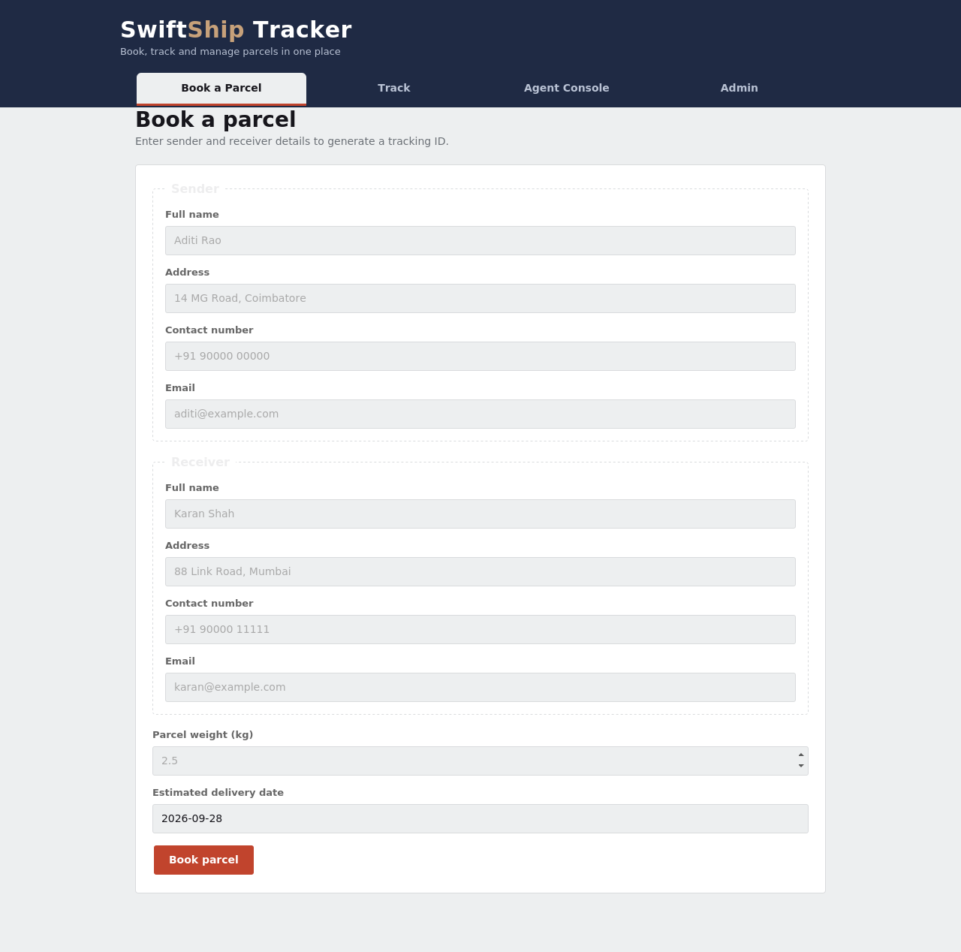
Screen 1 — Book a Parcel: sender/receiver form and tracking-ID generation
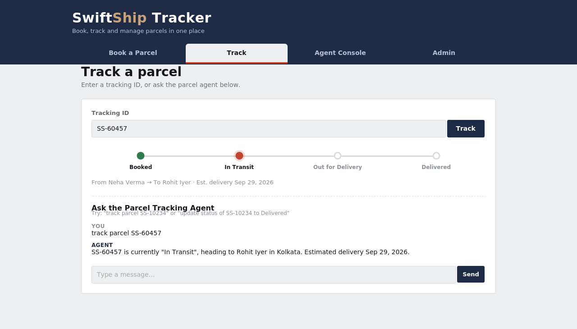
Screen 2 — Track a Parcel: status timeline and the Parcel Tracking Agent chat
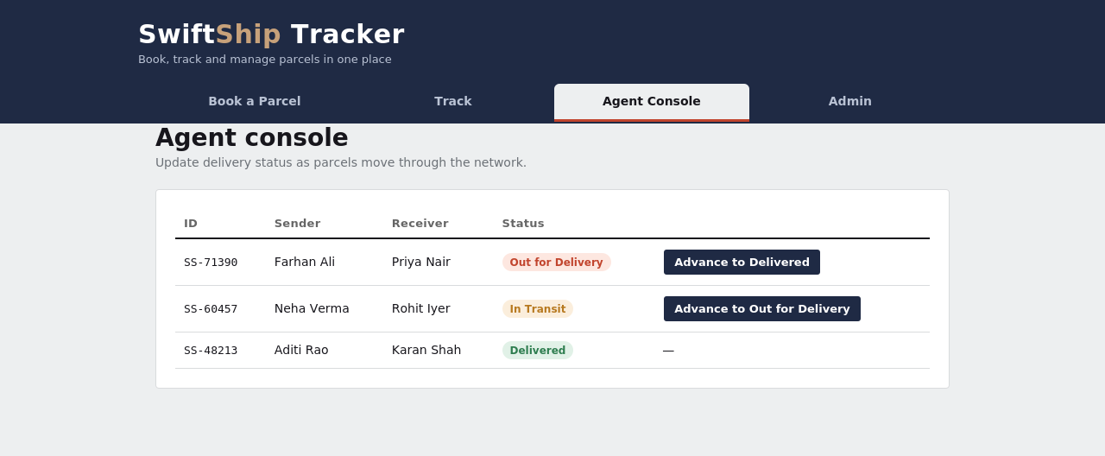
Screen 3 — Agent Console: advancing a parcel to its next delivery stage
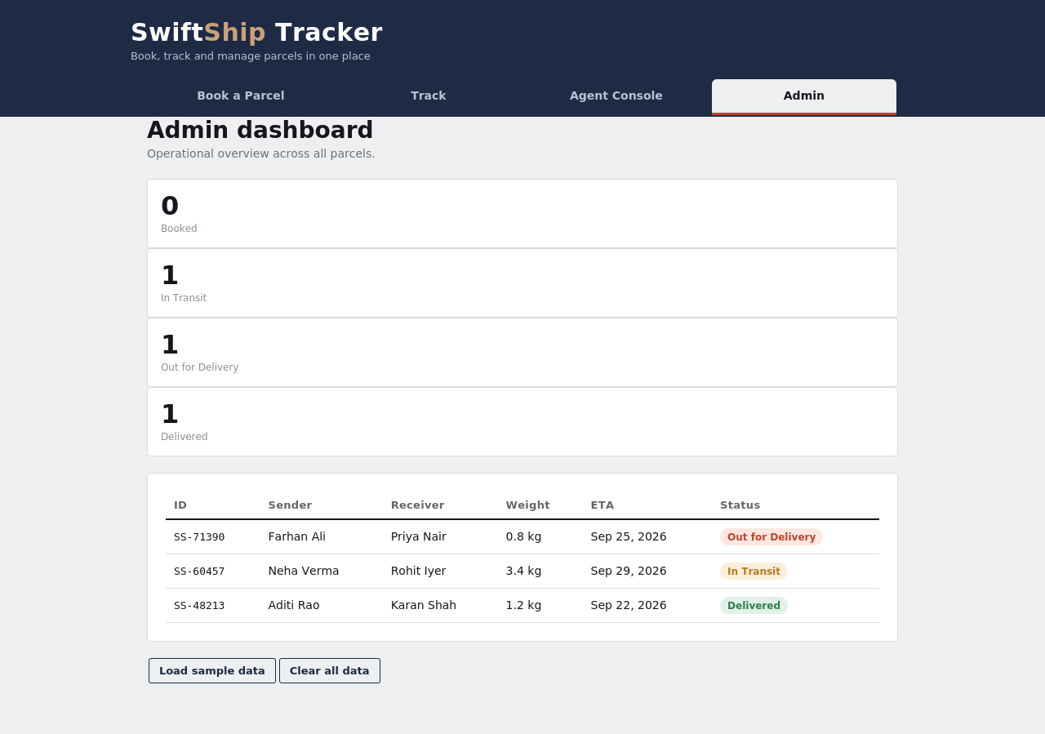
Screen 4 — Admin Dashboard: status counters and the full parcel record table

Testing
The prototype was tested manually across the four modules, focusing on data consistency between views and layout behaviour at different screen widths.
Test Case | Steps | Expected Result | Result
Book a parcel | Fill sender/receiver form and submit | New tracking ID generated and confirmation shown | Pass
Track a valid ID | Enter a booked parcel's ID and click Track | Timeline renders with correct current stage | Pass
Track an invalid ID | Enter a non-existent ID and click Track | "No parcel found" message shown | Pass
Agent chat — status query | Type "track parcel SS-xxxxx" | Agent replies with current status and ETA | Pass
Agent chat — status update | Type "update status of SS-xxxxx to Delivered" | Status updates and is reflected in Track/Admin | Pass
Advance status (console) | Click "Advance to …" in Agent Console | Status advances one stage; toast confirms alert | Pass
Admin counts | Open Admin after seeding sample data | Counters match the number of parcels per status | Pass
Responsive layout | Resize viewport to mobile width | Form and tables reflow to a single column | Pass
Clear data | Click "Clear all data" in Admin | All parcel records removed; empty states shown | Pass

Results
The project successfully demonstrates:
- A clean, structured interface covering booking, tracking, agent, and admin flows
- A believable simulation of an AI tracking assistant using simple rule-based text matching
- Responsive layout behaviour across different screen sizes
- Consistent status data shared across the Track, Agent Console, and Admin views
- A data model and code structure that maps cleanly onto the original Parcel/Sender/Receiver/Delivery design
Although it does not yet include a real backend, AI model, or database, it provides a working, end-to-end foundation for future development.

Advantages
- No installation or server required — runs entirely in the browser from a single HTML file
- Fast to demo — sample data can be loaded with one click to show all four modules populated
- Consistent single source of truth — every view reads and writes the same stored record set
- Easy to extend — the data-access functions are isolated, so swapping localStorage for a real API touches only two functions
- Accessible design — responsive layout, visible focus states, and light/dark theme support

Limitations
- Data is stored per-browser only; it is not shared between different users or devices
- The "AI agent" is a rule-based text matcher, not a true language model or a connected AgentForce agent
- Email and SMS notifications are simulated with an on-screen toast rather than actually sent
- There is no authentication, so the Book, Track, Agent, and Admin views are all open to whoever has the link
- Tracking IDs are generated randomly rather than sequentially, so a collision is possible (though unlikely) across a very large number of bookings

Conclusion
The project highlights how a frontend-only prototype can validate the full customer journey — booking, tracking, and status updates — before investing in backend and AI infrastructure. Using HTML, CSS, and JavaScript, we built an effective, single-page interface for managing parcel data and simulating a conversational tracking agent. The data model, module boundaries, and code structure were deliberately kept close to the original Parcel/Sender/Receiver/Delivery design, so this prototype can be extended into a full-stack application, potentially backed by Salesforce Flows, Prompt Builder, and AgentForce AI as originally scoped.

Future Scope
- Replace the rule-based chat with a real AI agent (e.g. Salesforce AgentForce or an LLM API)
- Connect the frontend to a backend and database (e.g. Salesforce custom objects, Node.js + MySQL/Postgres)
- Add authenticated login for customers, agents, and admins with role-based access
- Send real email/SMS notifications on each status change
- Add reporting and analytics for delivery performance across agents and regions
- Add a live map view showing the parcel's current location during transit
- Support multi-parcel shipments and bulk booking for business customers

Comparison with the Original Salesforce-Based Design
The original project brief scoped SwiftShip Tracker as a Salesforce solution built on custom objects, Flow Builder, and AgentForce AI. This HTML/CSS/JavaScript prototype mirrors that design at the interaction level so the two can be compared directly:
Concern | Salesforce-Based Design | This Web Prototype
Data storage | Parcel__c, Sender__c, Receiver__c, Delivery__c custom objects | A single JSON array in browser localStorage
Automation | Record-Triggered and Auto-Launched Flows | Plain JavaScript event handlers
AI assistant | AgentForce agent with Prompt Builder topics/actions | A rule-based agentReply() text matcher
Access control | Profiles, permission sets, sharing rules | None — all views are open in the browser
Notifications | Custom email alerts and templates | An on-screen toast simulating an email alert
Hosting | Salesforce Experience Cloud / Lightning App | A single static HTML file, hostable anywhere
This mapping is deliberate: every UI decision in the prototype (the four views, the status enum, the sender/receiver fields) was carried over from the Salesforce data model and security model described in the original phased plan, so migrating the prototype's logic into Salesforce Flows and Apex later is mostly a matter of moving where loadParcels()/saveParcels() read and write from, not redesigning the user experience.

File Structure & Deployment
The entire application ships as one self-contained file, which keeps deployment trivial:
- swiftship.html — contains the HTML structure, the <style> block, and the <script> block described in the Code Used section
- No build step, package manager, or server-side runtime is required
- The file can be opened directly in a browser, hosted on any static file host, or embedded in a Salesforce Experience Cloud page as a custom component in a later phase
- Fonts are loaded from Google Fonts over HTTPS; everything else — markup, styling, and logic — is inline in the one file

References
- HTML5 Documentation
- CSS3 Guides
- MDN Web Docs
- W3Schools Tutorials
- UI/UX Design Principles Resources
- Salesforce Trailhead — AgentForce and Prompt Builder documentation

