BIG DATA LAB

Vishal Jeeragi
1NT19IS188
C SEC

MONGO VERSION:

To start mongodb -

1)CREATE DATABASE ,

> use vishal
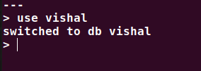

2)BASIC CRUD OPERATIONS,
creating a collection in database :
> db.createCollection("details")
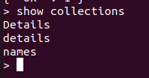

CRUD :CREATE
INSERT ONE
> db.details.insertOne({"name":"vishal","dept":"ISE"})

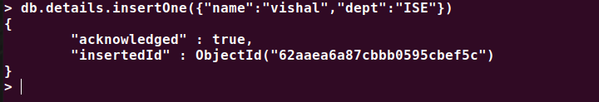

INSERT MANY
db.details.insertMany([{"name": "SUHAS" , "dept":"ISE" },{"name" : "VENKY" , "dept" :"EEE"},])

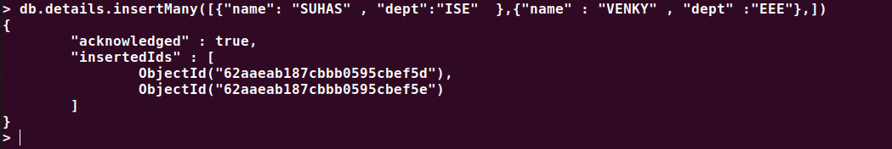

CRUD:Read

db.details.find()
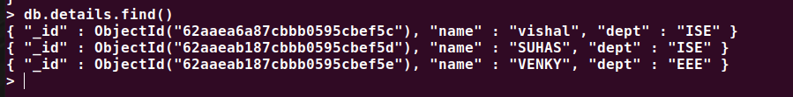
db.details.find().pretty()
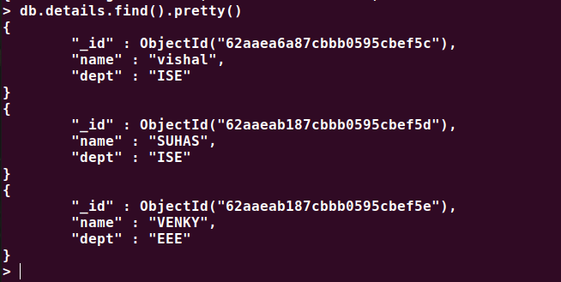

CRUD :UPDATE

Update One
db.details.updateOne({"name" : "Akash"},{$set : {"dept":"CSE"}})
Update Many -
db.details.updateMany({},{$set : {"college" : "NMIT" }})

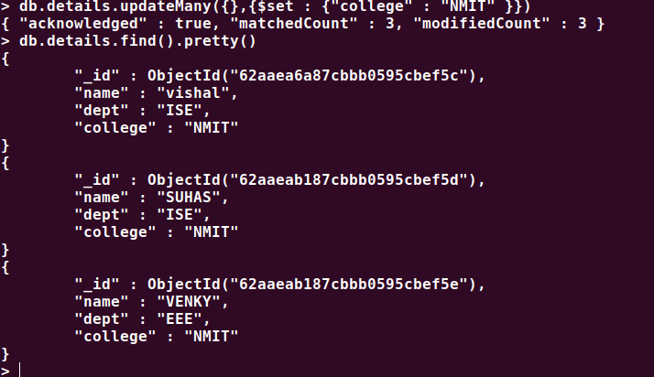

Using unset -
db.details.updateOne({"name" : "madhu"},{ $unset : { "dept" : ""}})

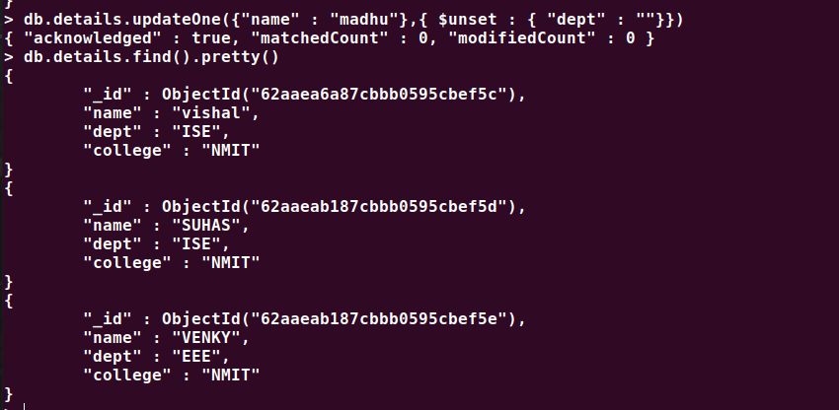

CRUD : DELETE
db.details.deleteOne( { "name": "VISHAL"} )
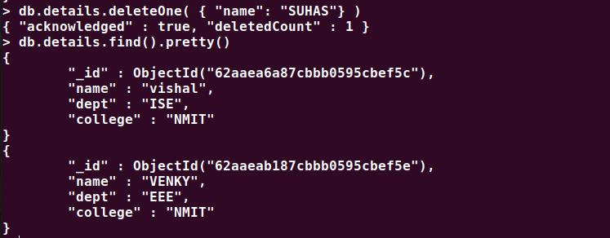

3 & 4) Aggregation and Pipeline :

db.details.insertOne({"name": "DHONI","dept": "ISE","college" : "NMIT","age" : 20,})

db.details.insertOne({"name": "VISHAL","dept": "ISE","college" : "NMIT","age" : 20})

db.details.updateOne({"name" : "VENKY"},{$set : {"age":24}})

db.details.updateOne({"name" : "suhas"},{$set : {"age":21},$set : {"dept":"ISE"}})

------------------------------------------------------------------------------------

AND
Using AND operator to display details of students with age greater 18 than and Department : ISE

db.details.find({$and:[{age:{$gte:20}},{dept:"ISE"}]}).pretty();

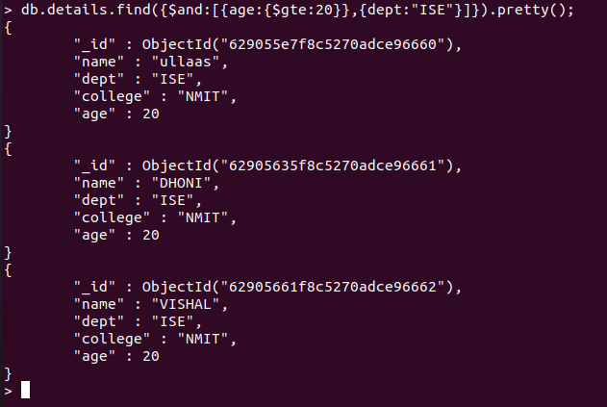

OR
Using OR operator to display details of students with age greater 20 than or Department :CSE
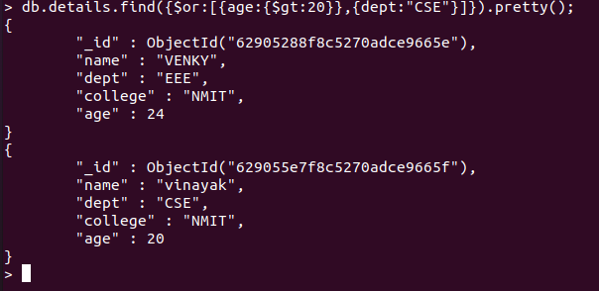
Displaying the total number of students in both the Departments and maximum age from both Departments ,,,,

db.details.aggregate([{$group: {_id:"$dept", total_st: {$sum:1}, max_age:{$max:"$age"} } }])

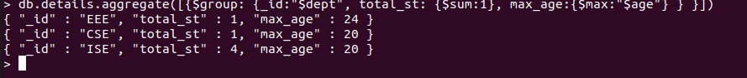
Displaying details of a student having the largest age in the Department – ISE

db.details.aggregate([{$match:{dept:"ISE"}},{'$sort': {'age': -1}},{$limit:1}]).pretty()

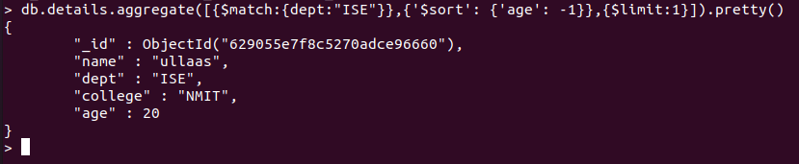

5) MapReduce :

AVERAGE:
var map=function(){emit(this.dept,this.age)};
var reduce=function(dept,age){return Array.avg(age);};
db.details.mapReduce(map,reduce,{out:"newcollection"});
db.newcollection.find()
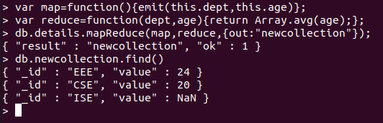

SUM:
var map=function(){emit(this.dept,this.age)};
var reduce=function(dept,age){return Array.sum(age);};
db.details.mapReduce(map,reduce,{out:"newcollection"});
db.newcollection.find()
