VISHAL JEERAGI
1NT19IS188
ISE 6 SEM C-2

1.Problem Statement & Dataset
Create a collection named "Employee" under the "EmployeeDB" database with each document in the format shown below Table
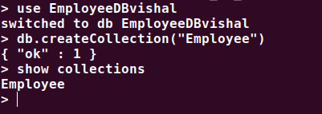

2. Queries

1. Populate the database with atleast 15 documents
db.Employee.insertMany([
{
Firstname: "Vishal",
Middlename: "R",
Lastname: "Jeeragi",
Age: 25,
Salary: 75000,
Designation: "Employee",
Role: ["Software developer","Tester"],
},
{
Firstname: "Vinayak",
Middlename: "P",
Lastname: "Bhupal",
Age: 26,
Salary: 75000,
Designation: "HR",
Role: ["Manager","UI Designer"],
},
{
Firstname: "T",
Middlename: "Nikitha",
Lastname: "Reddy",
Age: 27,
Salary: 45000,
Designation: "Employee",
Role: ["Tester","Software Developer"],
},
{
Firstname: "M",
Middlename: "Kumar",
Lastname: "Babu",
Age: 27,
Salary: 70000,
Designation: "Researcher",
Role: ["Team Lead","Tester", "UI Designer"],
},
{
Firstname: "Rajesh",
Middlename: "Patil",
Lastname: "N",
Age: 36,
Salary: 50000,
Designation: "Scientist",
Role: ["UI Designer","Tester"],
},
{
Firstname: "Ullaas",
Lastname: "M",
Age: 36,
Salary: 50000,
Designation: "Scientist",
Role: ["UI Designer","Team Lead"]
},
]);

db.Employee1NT19IS176.insertMany([
{
Firstname: "Prateek",
Middlename: "P",
Lastname: "Nayak",
Age: 30,
Salary: 45000,
Designation: "Employee",
Role: ["Team Lead","Manager"]
},
{
Firstname: "Wakada",
Middlename: "Sai",
Lastname: "Sanjeev",
Age: 30,
Salary: 40000,
Designation: "Employee",
Role: ["Junior Architect","Manager"],
},
{
Firstname: "T",
Middlename: "H",
Lastname: "Lakshana",
Age: 30,
Salary: 20000,
Designation: "Employee",
Role: ["Software developer","Tester"],
},
{
Firstname: "Vishal",
Middlename: "Kumar",
Lastname: "H K",
Age: 40,
Salary: 75000,
Designation: "Scientist",
Role: ["Research and Developer","Tester"],
},
{
Firstname: "V",
Middlename: "Mohan",
Lastname: "Babu",
Age: 38,
Salary: 750000,
Designation: "President",
Role: ["Software developer","Research and Developer"]
},
]);

db.Employee.insertMany([
{
Firstname: "Rakesh",
Middlename: "kumar",
Lastname: "K",
Age: 25,
Salary: 25000,
Designation: "Employee",
Role: ["Junior Lead","Junior Architect"],
},
{
Firstname: "Sohan",
Middlename: "M",
Lastname: "N",
Age: 33,
Salary: 60000,
Designation: "Employee",
Role: ["Junior Engineer","Software developer"],
},
{
Firstname: "Praneeth",
Middlename: "M",
Lastname: "J",
Age: 28,
Salary: 75000,
Designation: "Employee",
Role: ["Software developer","UI Designer"],
},
{
Firstname: "Lucky",
Middlename: "Sheika",
Lastname: "B",
Age: 29,
Salary: 50000,
Designation: "Scientist",
Role: ["Research and Developer","UI Designer"],
},
{
Firstname: "Ram",
Middlename: "Prasad",
Lastname: "Varma",
Age: 30,
Salary: 20000,
Designation: "System Engineer",
Role: ["Intern","Software developer"],
},
]);

2. List all the records having salary in the range of 20000 – 35000(Exclusive)

db.Employee.find({$and:[{Salary:{$gt:20000}},{Salary:{$lt:35000}}]}).pretty()

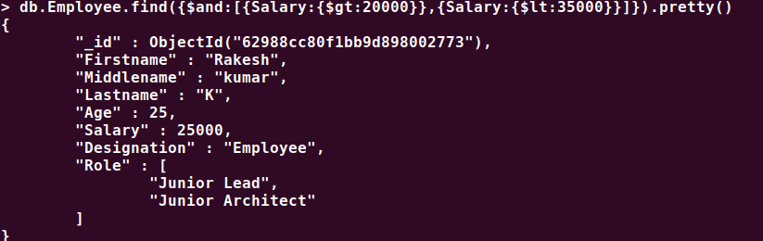
3. List all the Employee whose Middle name is "Kumar"

db.Employee.find({Middlename:"Kumar"}).pretty()
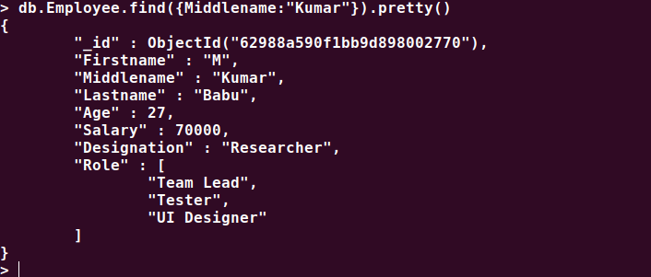

4. Count the number of Employees who has a role "Manager" in the Role field

db.Employee.count({Role:"Manager"}).pretty

5. Find out all the documents who have age < 35 and salary in the range of 30000-50000

db.Employee.find({$and:[{Salary:{$gt:30000}},{Salary:{$lt:50000}},{Age:{$lt:35}}]}).pretty()

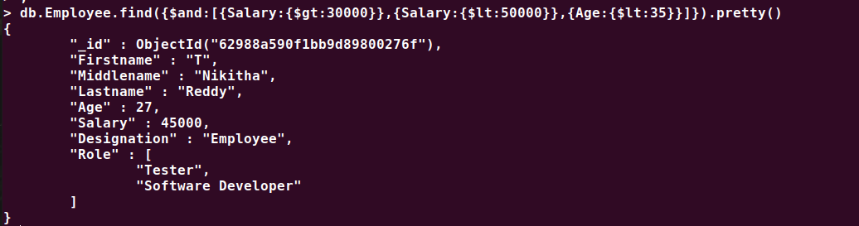

6. Delete an Employee whose "Firstname" is "Rajesh" and having the designation as "Scientist"

db.Employee.deleteOne({$and:[{Firstname:"Rajesh"},{Designation:"Scientist"}]})

db.Employee.find()

7. Update all the Employees whose role is "Team Lead" with a salary of 55650 INR

db.Employee.updateMany({Role:"Team Lead"},{$set:{Salary:55650}})
db.Employee.find()
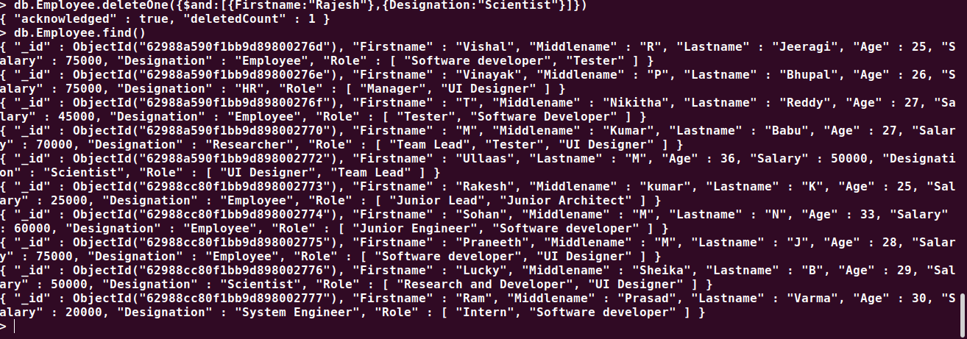

8. Group all the Employees by their age(common age should be there) and calculate the average salary obtained in the each group

db.Employee.aggregate([{$group:{_id:"$Age",Average:{$avg:"$Salary"}}}])
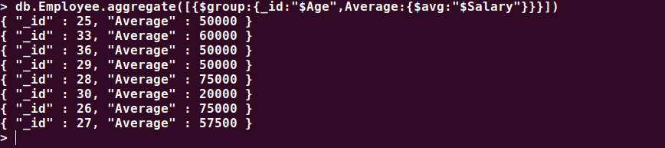
9. Apply the map-reduce to perform the above operation and obtain the results

var mapfunction=function(){emit(this.Age,this.Salary)}
var reducefunction=function(key,values){return Array.avg(values)}
db.Employee.mapReduce(mapfunction,reducefunction,{'out':'result'})
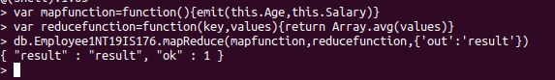
db.result.find()
