VISHAL JEERAGI
1NT19IS188
C2

Tasks To complete,

To start with hadoop
hadoop version
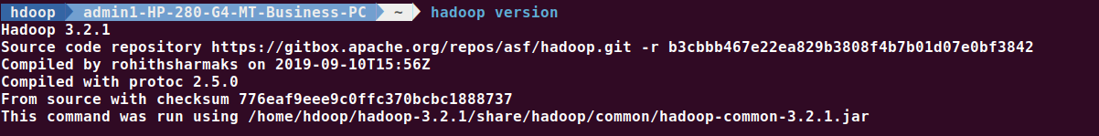

start-dfs.sh
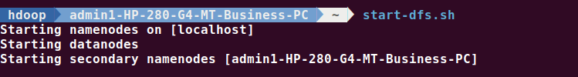
1. Create a directory named by your name
hadoop fs -mkdir /vishal
hadoop fs -ls /

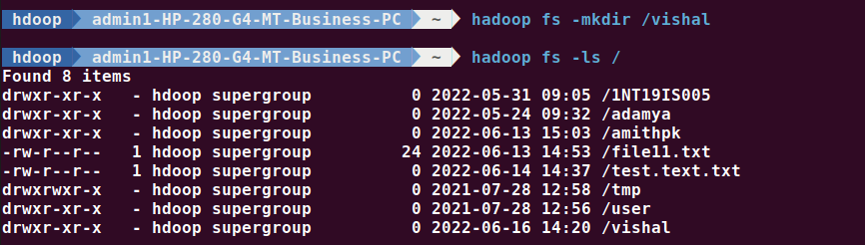

2. Add two empty files
hadoop fs -touchz /vishal/o.txt
hadoop fs -touchz /vishal/a.txt
3. List all the files in the directory that you have created
hadoop fs -ls /vishal

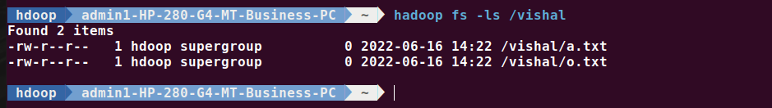
4. Create one more directory by your usn and put that inside the directory of your name
hadoop fs -mkdir /vishal/1NT19IS188
hadoop fs -ls /vishal
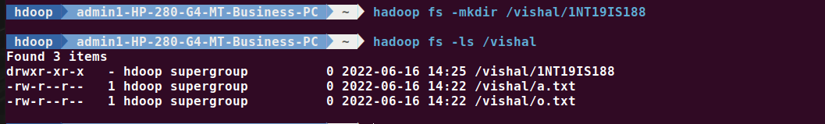
5. Create a file in your local system by the name_usn.txt and add the contents as "Syntax to list Is command is hadoop fs -Is "
cat > vishal_1NT19IS188.txt
"Syntax to list ls command is hadoop fs -ls"
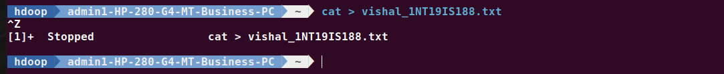

6. Put the file usn_name.txt in your hdfs directory called usn
hadoop fs -touchz /vishal/1NT19IS188/1NT19IS188_vishal.txt
hadoop fs -ls /vishal/1NT19IS188
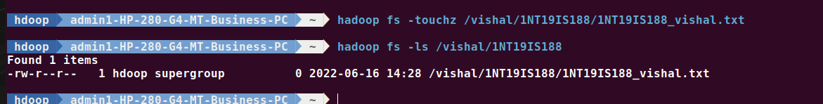
7. Put empty file of hdfs into the local file system
hadoop fs -copyToLocal /vishal/1NT19IS188/1NT19IS188_vishal.txt
ls
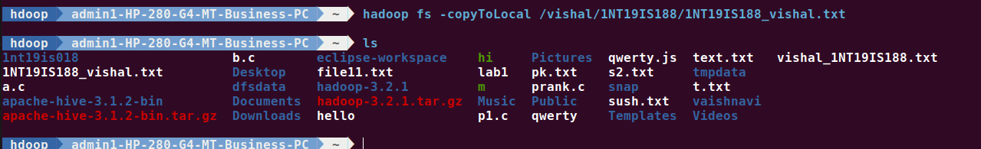

8. Use mv command to move files from local file system and hdfs file system
hadoop fs -mv /vishal/a.txt /vishal/1NT19IS188
hadoop fs -ls /vishal/1NT19IS188
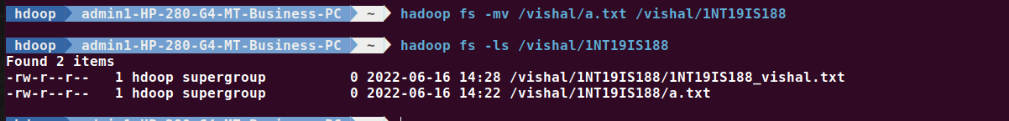
9. Experiment of cp command
hadoop fs -cp /vishal/o.txt /vishal/1NT19IS188
hadoop fs -ls /vishal/1NT19IS188
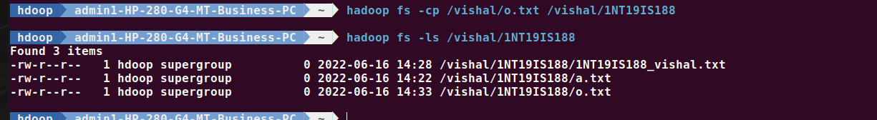

10. Display the total size of all the files in name directory
hadoop fs -moveFromLocal vishal_1NT19IS188.txt /vishal
hadoop fs -du /vishal
hadoop fs -du -s /vishal
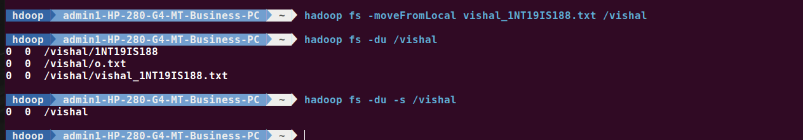
11. Display each file size in usn directory Use stat command on name and usn directories
hadoop fs -du /vishal/1NT19IS188

12. Illustrate the use of append command
cat > o.txt
hii
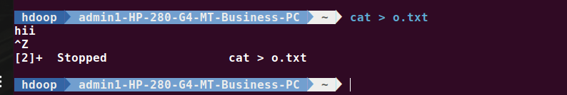

hadoop fs -appendToFile o.txt /vishal/1NT19IS188/a.txt
hadoop fs -cat /vishal/1NT19IS188/a.txt
