Assignment-2

Step-1

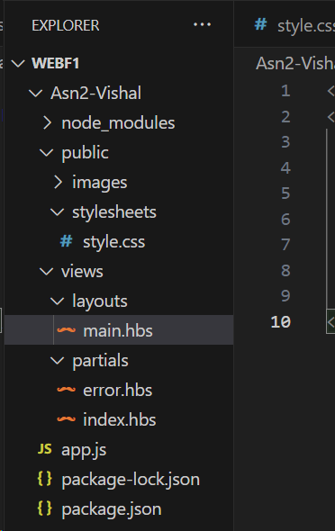

Step-2

Copied the code snippets

Step-3

Root route

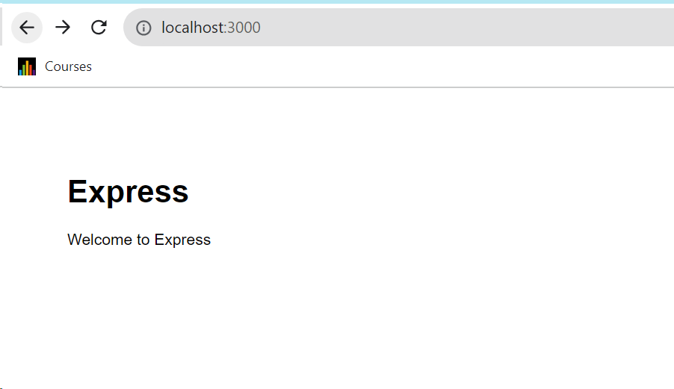

* <http://localhost:3000/users>

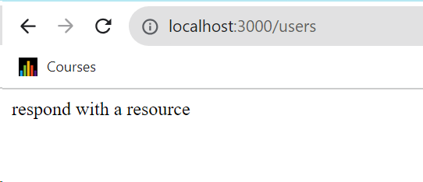

* <http://localhost:3000/notExist>

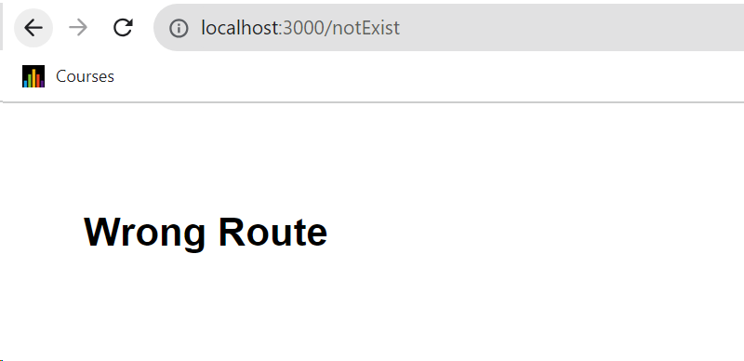

**Step 4**: Base on your observation, answer the following questions:

1. What is the role of “main.hbs”? How does it being used/called in the app?

"main.hbs" is a Handlebars template which serves as the main layout for this node js application. It defines the basic structure of an HTML page and includes common elements like the <head>, CSS styles, and the main content body. This layout template is used as a framework to structure the pages of this application.

When we render a specific page in this application, we use the "main.hbs" template as the layout for that page. In Express routes, we render the content for a particular page and insert it into the {{{body}}} placeholder in "main.hbs."

1. What is the role of “index.hbs” and “error.hbs”? How do these files being used/called in the app?

Index.hbs:

"index.hbs" is a Handlebars template for the main content of the home page or the root route "/" of this express js application.

When we access the root route ("/"), the code in "app.js" renders the "index.hbs" template and inserts it into the {{{body}}} in the "main.hbs" layout.

Error.hbs:

"error.hbs" is a Handlebars template for displaying error messages or pages. It's used when the server encounters a route that doesn't match any of the defined routes in our Express application. In this case, it will display an custom error message provided in the "message" property.

In "app.js," there is a catch-all route that matches any route that hasn't been defined earlier. When such a route is found, the code renders the "error.hbs" template and inserts it into the {{{body}}} in the "main.hbs" layout. The title is set to 'Error,' and the custom error message is Displayed.

1. In “app.js”, what is the role of the following line? What happen if you commend it out?

app.use(express.static(path.join(__dirname, 'public')));

The role of the line is to serve the static files in our application like CSS,Images, Javascript.

Path.join refers to generate the absolute path to the public directory by joining the current working directory

Then it will look for the respective static file in the public directory

If this line is commented then there is no access to the content of the static files therefore it will effect the role or performance of the applications

1. Try to add proper comments to each line/block in app.js
2. // Require necessary dependencies
3. var express = require('express');
4. var path = require('path');
5. var app = express();
6. const exphbs = require('express-handlebars');
7. // Define the port
8. const port = process.env.PORT || 3000;
9. // Serve static files (CSS, images) from the "public" directory
10. app.use(express.static(path.join(__dirname, 'public')));
11. // Configure Express to use Handlebars as the view engine
12. app.engine('.hbs', exphbs.engine({ extname: '.hbs' }));
13. app.set('view engine', 'hbs');
14. // Define a route to render the home page i.e "index"
15. app.get('/', function(req, res) {
16. res.render('partials/index', { title: 'Express' });
17. });
18. // Define a route for a resource that sends a simple response
19. app.get('/users', function(req, res) {
20. res.send('respond with a resource');
21. });
22. // Catch-all route for handling undefined routes or errors
23. app.get('*', function(req, res) {
24. res.render('partials/error', { title: 'Error', message: 'Wrong Route' });
25. });
26. // Start the Express application and listen on the specified port
27. app.listen(port, () => {
28. console.log(`Example app listening at http://localhost:${port}`);
29. });

Step-5

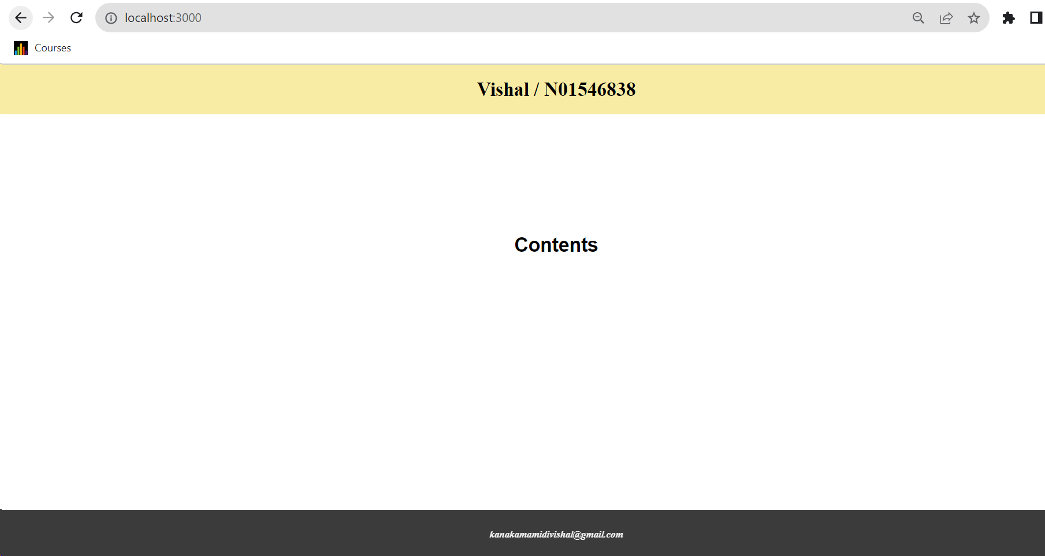

Step-6

/data

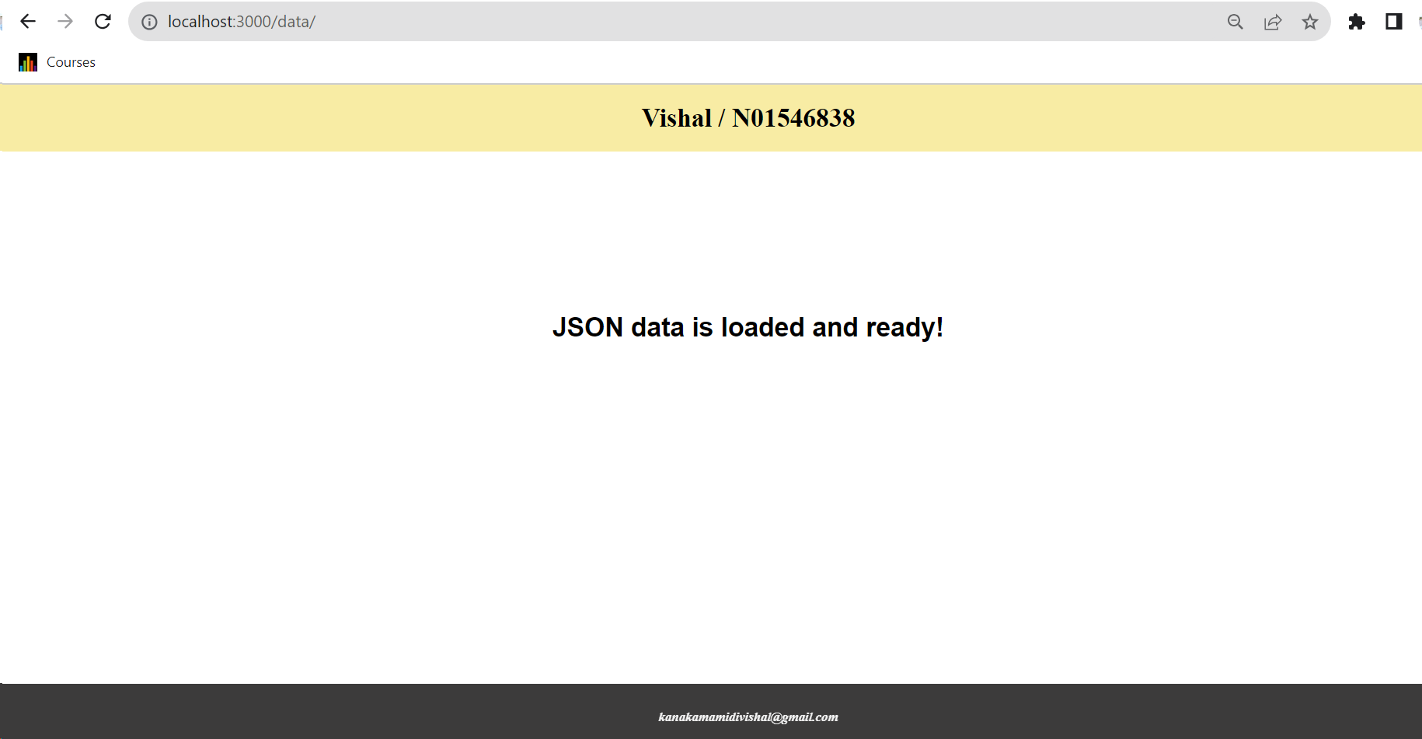

/data/invoiceNo/:index

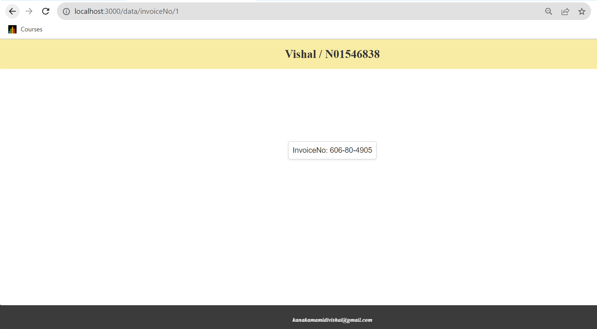

/search/invoiceNo

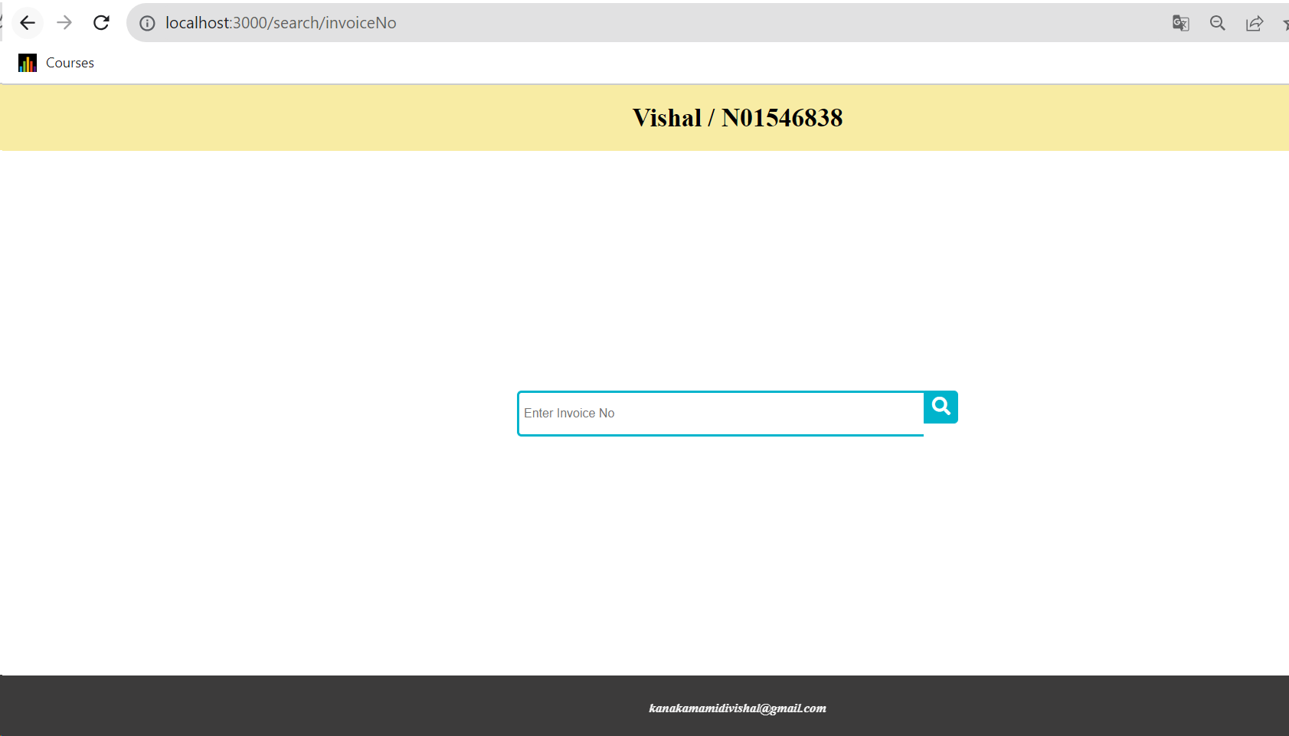

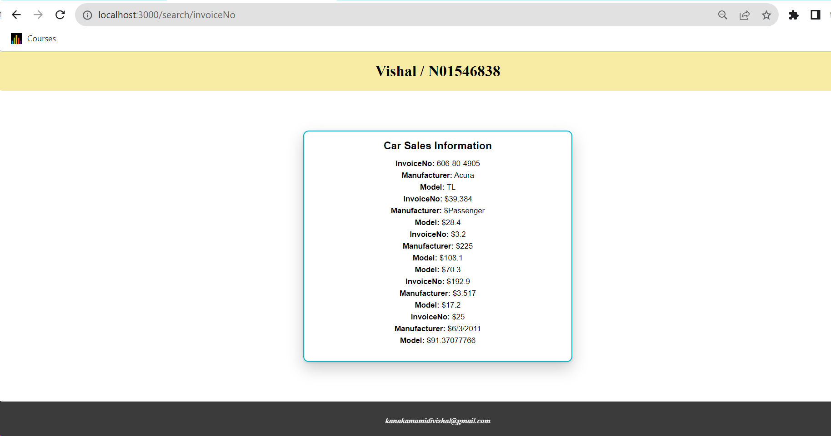

/search/Manufacturer

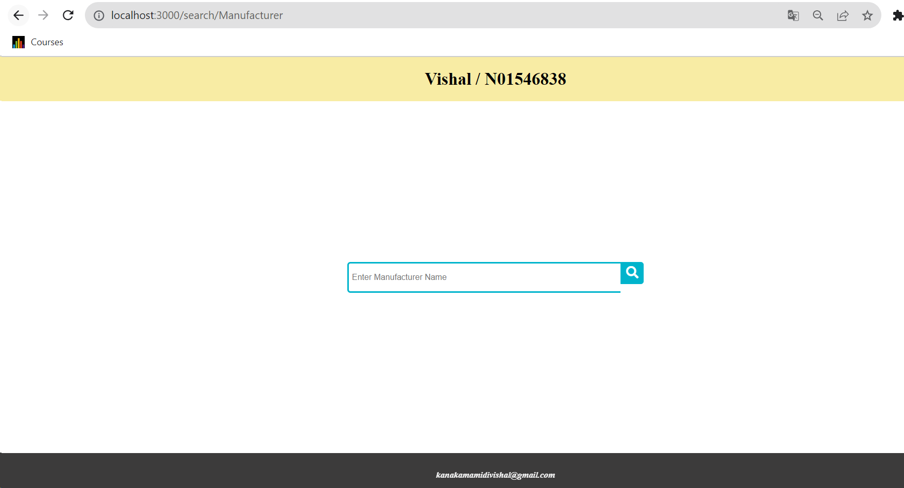

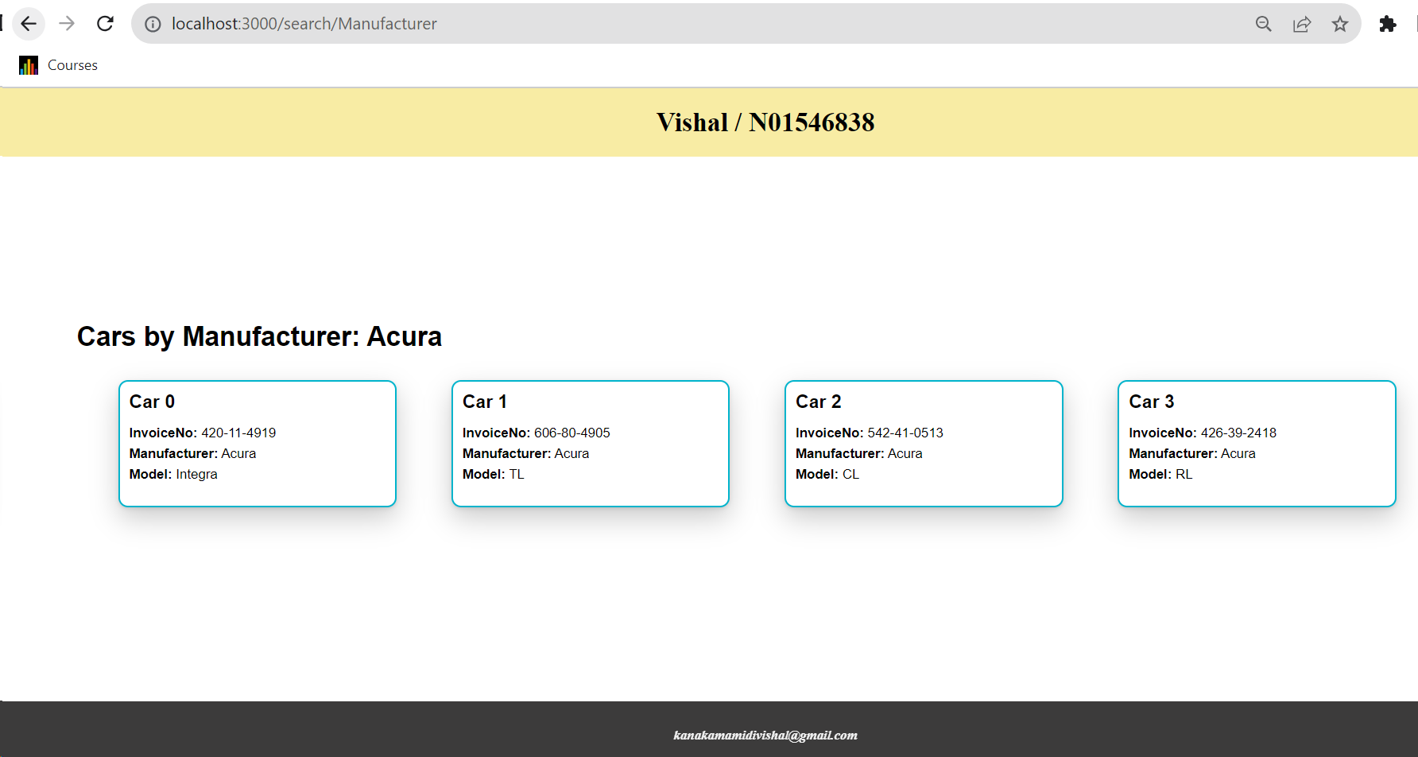

Step-7

/viewData

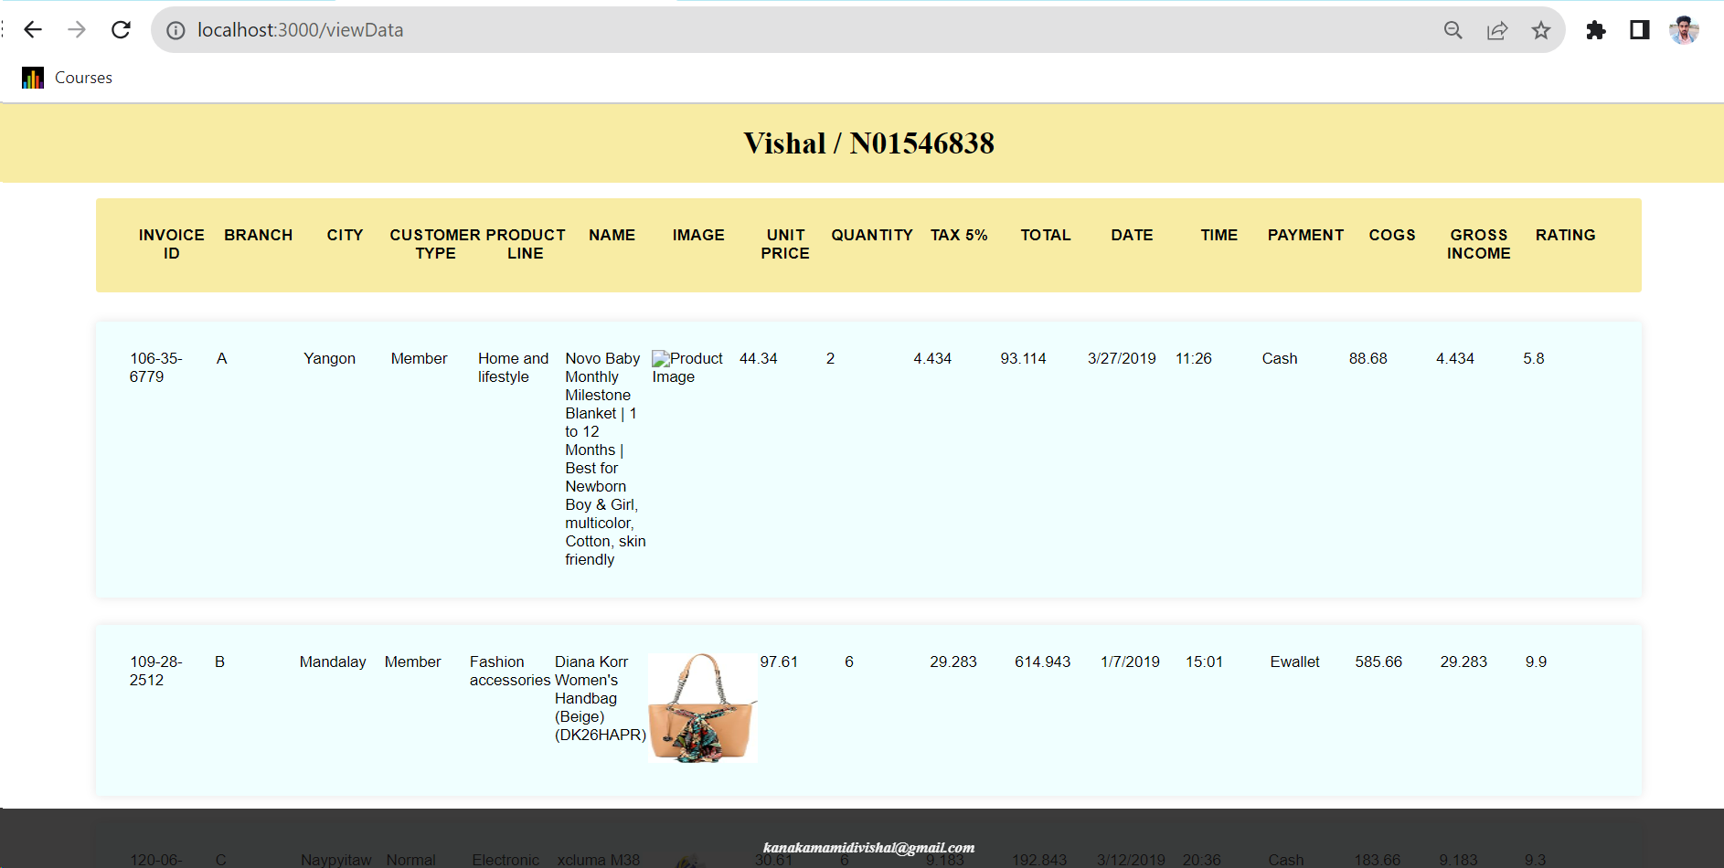

Step-8

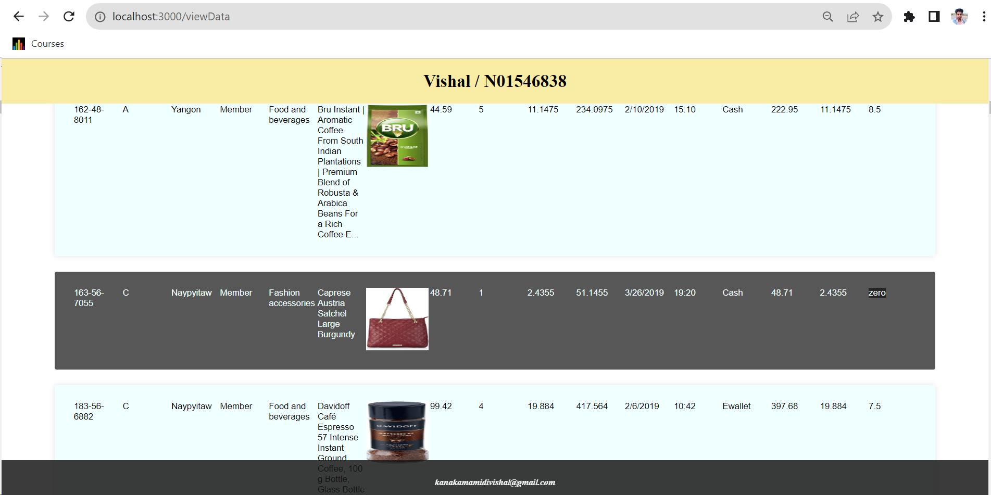

As you can see below zero rating row is removed

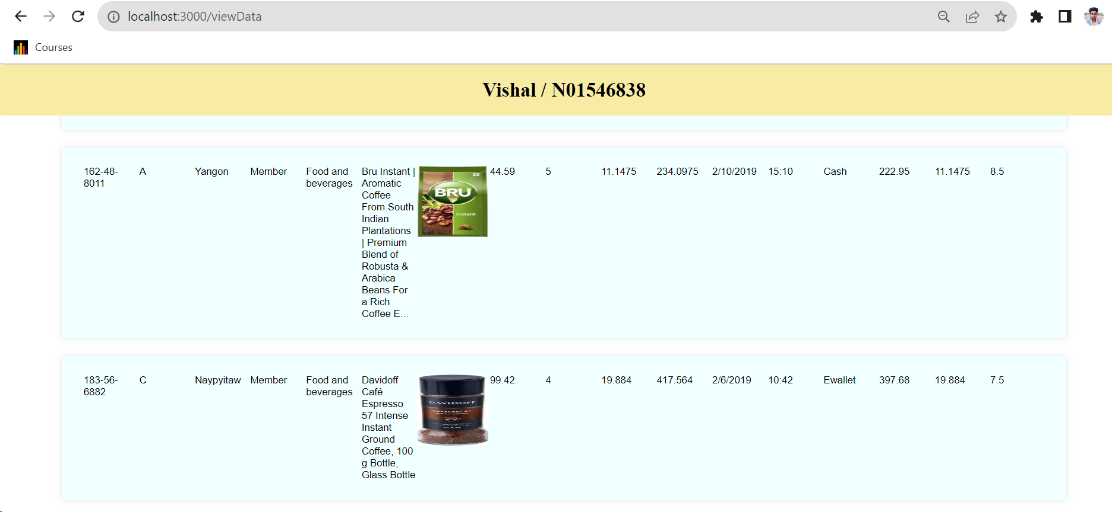

Step-9

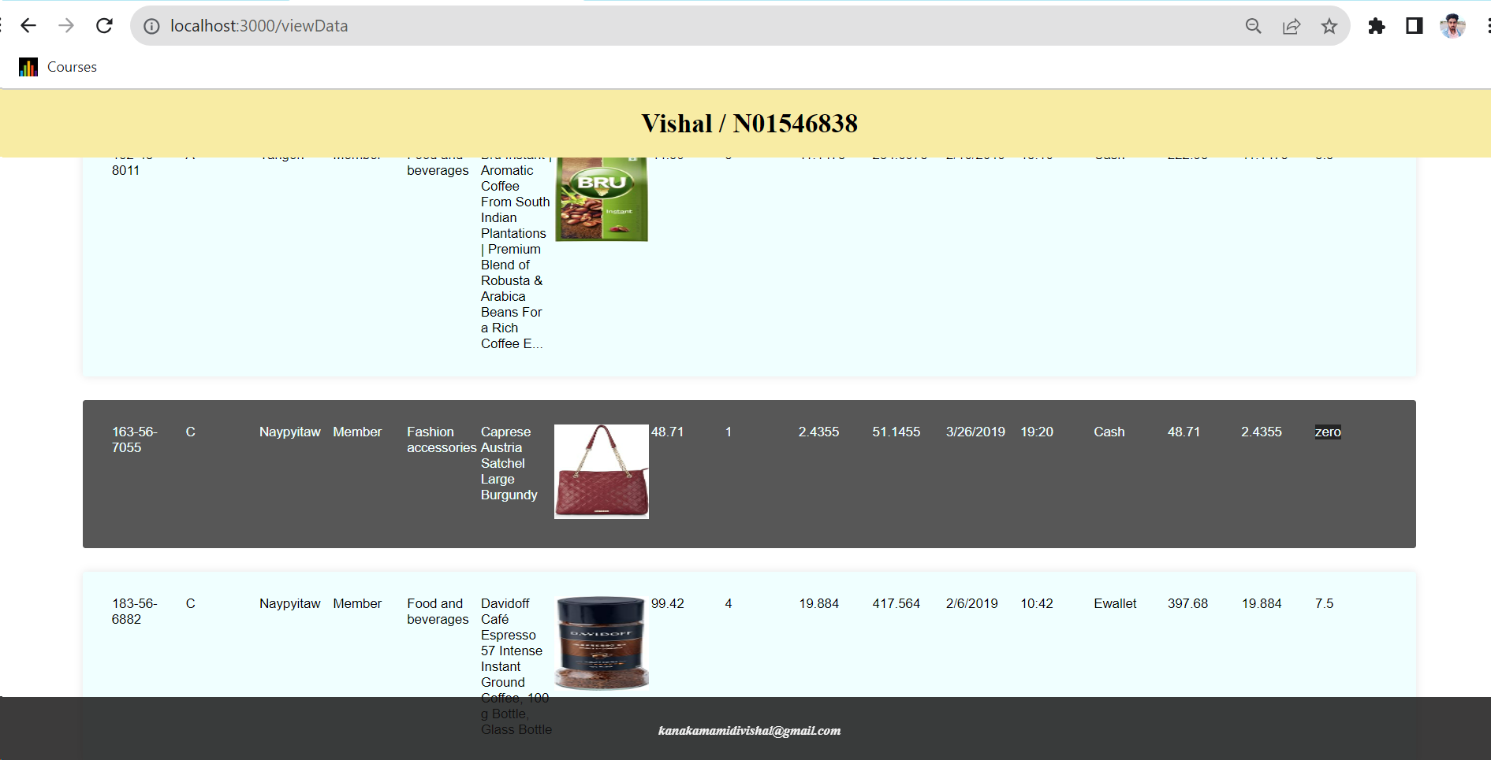

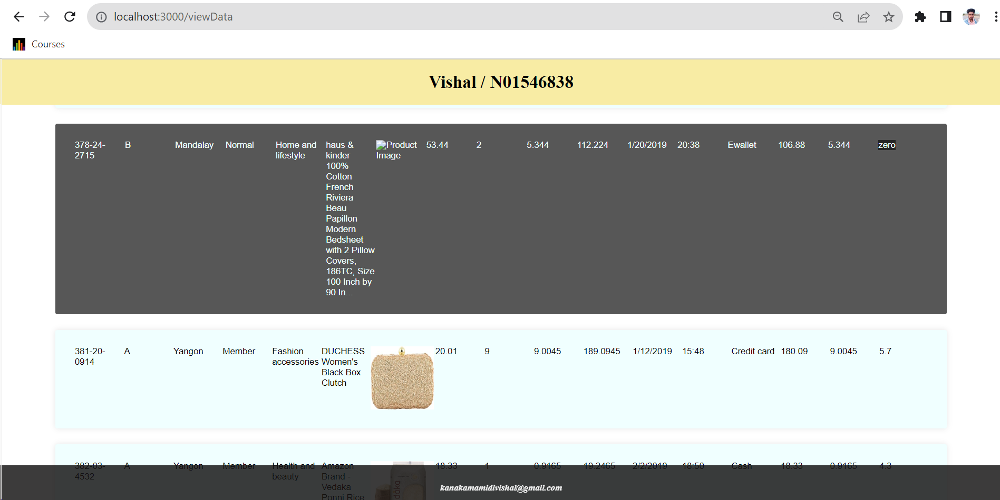

Step-10

**Step 10**: Any idea how to do any of the followings:

1. You want to change table row color for those records which “rating” is “0”. Any way that you can implement it using Template Engine?

* I have already used the handlebars and template engine to change the row color for rating “0” records by creating helper functions then applying css for the same.

1. In this app, do you find any use cause for utilizing “Partial” Templates? Explain your answer

* Partial templates can be used to generate the template for the repeated data display
* For example in step 7,8,9 we can use partial templates for the table
* For manufactuer search as well

Assignment Submission:

* Add the following declaration at the top of .js files

/****************************************************************************** ***

* + ITE5315 – Assignment 2
  + I declare that this assignment is my own work in accordance with Humber Academic Policy. * No part of this assignment has been copied manually or electronically from any other source * (including web sites) or distributed to other students.

*

* + Name: Vishal Kanakamamidi Student ID: N01546838 Date: 02-11-2023

*

*

******************************************************************************

**/

* Compress (.zip) the files in your Visual Studio working directory (this is the folder that you opened in Visual Studio to create your client side code).