Collections in Java

The **Collection in Java** is a framework that provides an architecture to store and manipulate the group of objects.

#### What is Collection in Java

A Collection represents a single unit of objects, i.e., a group.

#### What is a framework in Java

* It provides readymade architecture.
* It represents a set of classes and interfaces.
* It is optional.

### What is the Collection framework in Java?

Collection Framework is a combination of classes and interface, which is used to store and manipulate the data in the form of objects. It provides various classes such as ArrayList, Vector, Stack, and HashSet, etc. and interfaces such as List, Queue, Set, etc.

### Hierarchy of Collection Framework

Let us see the hierarchy of Collection framework. The **java.util** package contains all the [classes](https://www.javatpoint.com/object-and-class-in-java) and [interfaces](https://www.javatpoint.com/interface-in-java) for the Collection framework.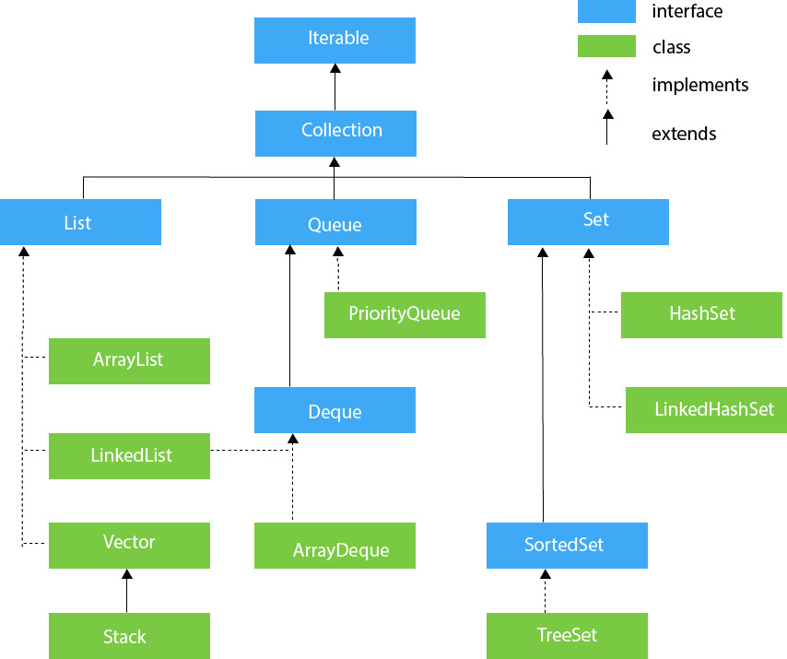

## Iterable Interface

The Iterable interface is the root interface for all the collection classes. The Collection interface extends the Iterable interface and therefore all the subclasses of Collection interface also implement the Iterable interface.

## Collection Interface

## The Collection interface is the interface which is implemented by all the classes in the collection framework.

## List Interface

List interface extends the Collection interface, and it is an ordered collection of objects. It contains duplicate elements. It also allows random access of elements.

List interface is implemented by the classes ArrayList, LinkedList, Vector, and Stack.

## ArrayList

The ArrayList class implements the List interface. It uses a dynamic array to store the duplicate element of different data types. The ArrayList class maintains the insertion order and is non-synchronized. The elements stored in the ArrayList class can be randomly accessed.

## LinkedList

LinkedList implements the Collection interface. It uses a doubly linked list internally to store the elements. It can store the duplicate elements. It maintains the insertion order and is not synchronized. In LinkedList, the manipulation is fast because no shifting is required.

## Vector

Vector uses a dynamic array to store the data elements. It is similar to ArrayList. However, It is synchronized and contains many methods that are not the part of Collection framework.

## Stack

The stack is the subclass of Vector. It implements the last-in-first-out data structure, i.e., Stack. The stack contains all of the methods of Vector class and also provides its methods like boolean push(), boolean peek(), boolean push(object o), which defines its properties.

## Queue Interface

Queue interface maintains the first-in-first-out order. It can be defined as an ordered list that is used to hold the elements which are about to be processed. There are various classes like PriorityQueue, Deque, and ArrayDeque which implements the Queue interface.

## PriorityQueue

The PriorityQueue class implements the Queue interface. It holds the elements or objects which are to be processed by their priorities. PriorityQueue doesn't allow null values to be stored in the queue.

## Deque Interface

Deque interface extends the Queue interface. In Deque, we can remove and add the elements from both the side. Deque stands for a double-ended queue which enables us to perform the operations at both the ends.

## ArrayDeque

ArrayDeque class implements the Deque interface. It facilitates us to use the Deque. Unlike queue, we can add or delete the elements from both the ends.

ArrayDeque is faster than ArrayList and Stack and has no capacity restrictions.

## Set Interface

Set Interface in Java is present in java.util package. It extends the Collection interface. It represents the unordered set of elements which doesn't allow us to store the duplicate items. We can store at most one null value in Set. Set is implemented by HashSet, LinkedHashSet, and TreeSet.

## HashSet

HashSet class implements Set Interface. It represents the collection that uses a hash table for storage. Hashing is used to store the elements in the HashSet. It contains unique items.

## LinkedHashSet

LinkedHashSet class represents the LinkedList implementation of Set Interface. It extends the HashSet class and implements Set interface. Like HashSet, It also contains unique elements. It maintains the insertion order and permits null elements.

## SortedSet Interface

SortedSet is the alternate of Set interface that provides a total ordering on its elements. The elements of the SortedSet are arranged in the increasing (ascending) order. The SortedSet provides the additional methods that inhibit the natural ordering of the elements.

## TreeSet

Java TreeSet class implements the Set interface that uses a tree for storage. Like HashSet, TreeSet also contains unique elements. However, the access and retrieval time of TreeSet is quite fast. The elements in TreeSet stored in ascending order.

|  |  |  |
| --- | --- | --- |
| **No.** | **Method** | **Description** |
| 1 | public boolean hasNext() | It returns true if the iterator has more elements otherwise it returns false. |
| 2 | public Object next() | It returns the element and moves the cursor pointer to the next element. |
| 3 | public void remove() | It removes the last elements returned by the iterator. It is less used. |

