**Date: 02/04/2024**

**Assignment No 9**

**PRN No : 2020btecs00092**

**Batch : T4**

**Title:** Install and deploy the following cloud databases on windows platform:

1. MongoDB
2. CassandraDB

**Objective/Aim:**

1. To install and deploy the given cloud databases on windows platform.
2. To create Python desktop application demonstrating the CRUD operation with above back end cloud databases.

**Introduction:**

NoSQL databases (aka "not only SQL") are non-tabular databases and store data differently than relational tables. NoSQL databases come in a variety of types based on their data model. The main types are document, key-value, wide-column, and graph. They provide flexible schemas and scale easily with large amounts of data and high user loads.

**Theory:**

MongoDB is an open-source document database and leading NoSQL database. MongoDB is written in C++. MongoDB is a [source-available](https://en.wikipedia.org/wiki/Source-available" \o "Source-available) [cross-platform](https://en.wikipedia.org/wiki/Cross-platform" \o "Cross-platform) [document-oriented database](https://en.wikipedia.org/wiki/Document-oriented_database" \o "Document-oriented database) program. Classified as a [NoSQL](https://en.wikipedia.org/wiki/NoSQL" \o "NoSQL) database program, MongoDB uses [JSON](https://en.wikipedia.org/wiki/JSON" \o "JSON)-like documents with optional [schemas](https://en.wikipedia.org/wiki/Database_schema" \o "Database schema).

Apache Cassandra is a highly scalable, high-performance distributed database designed to handle large amounts of data across many commodity servers, providing high availability with no single point of failure. It is a type of NoSQL database.

**Procedure:**

Added screenshots for the procedure followed:

Installation of MongoDB on windows:

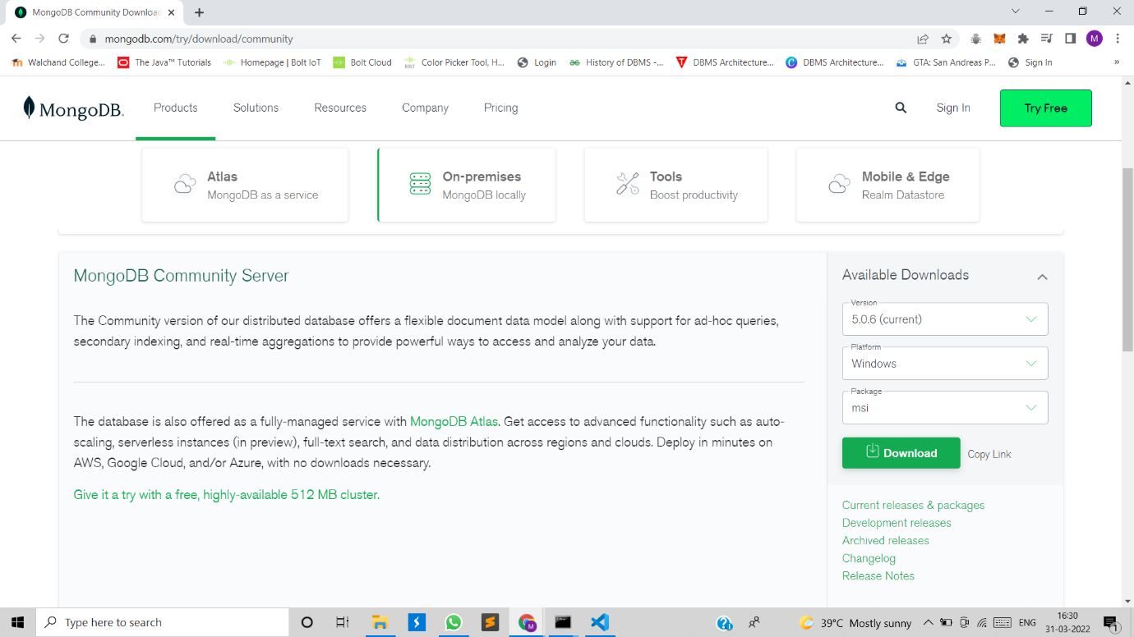

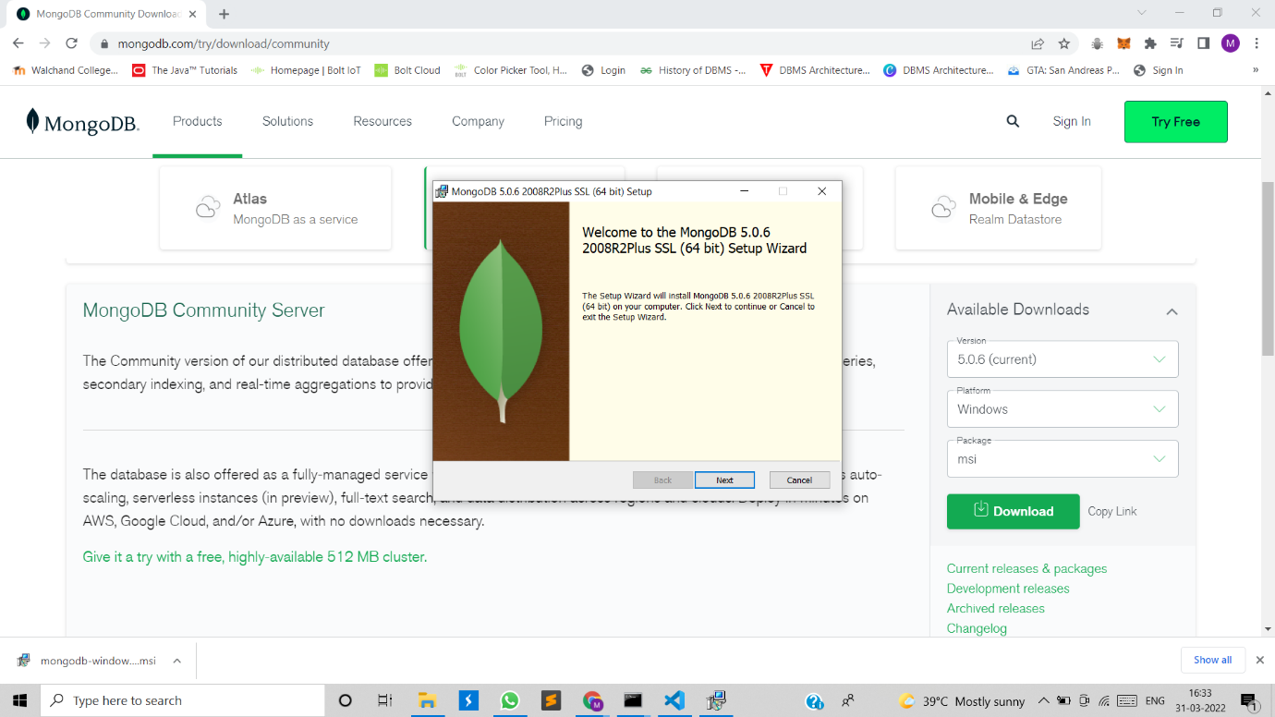

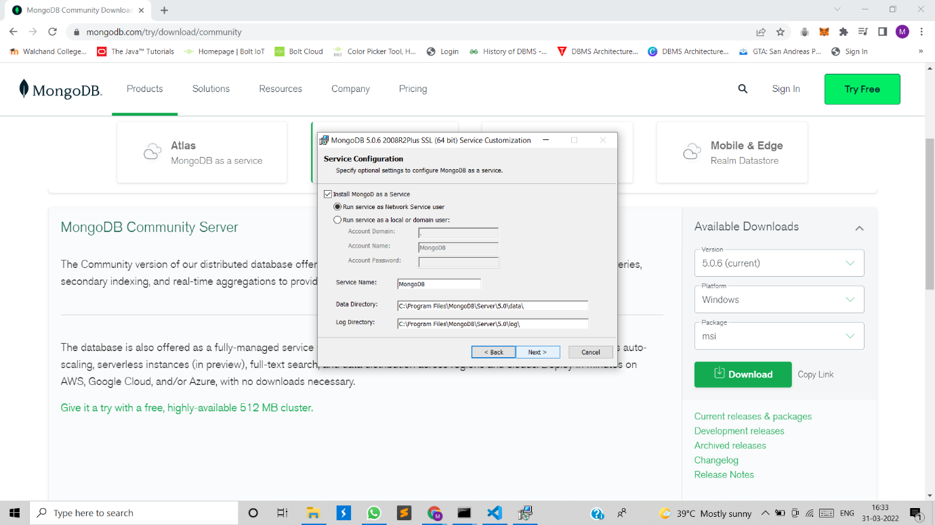

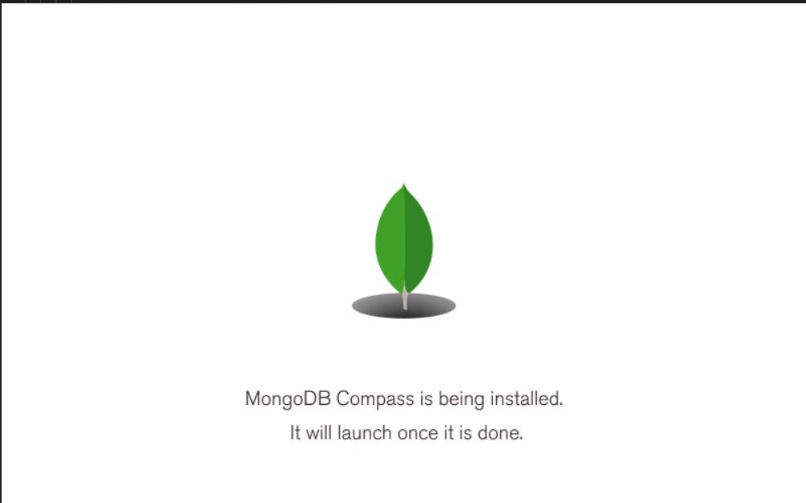

Setting up environment variable for mongodb

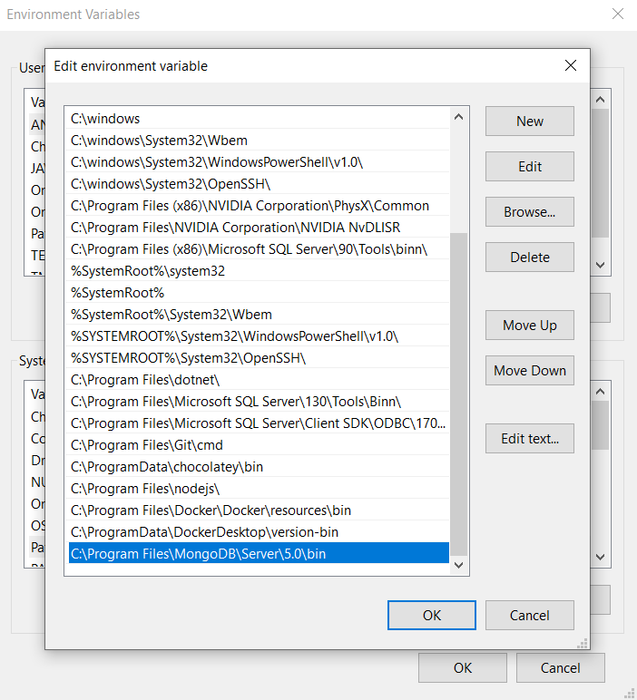

Executed Python Desktop application to demonstrate CRUD operations for MongoDB:

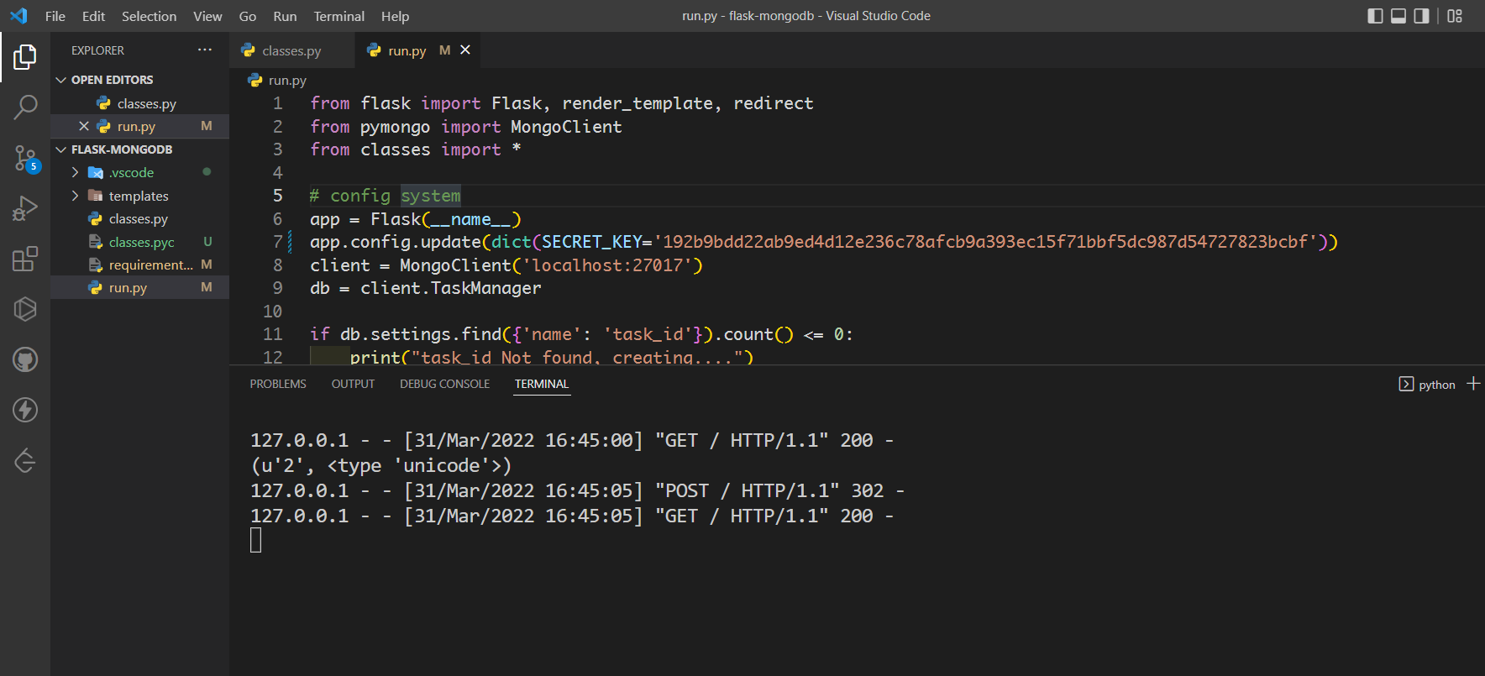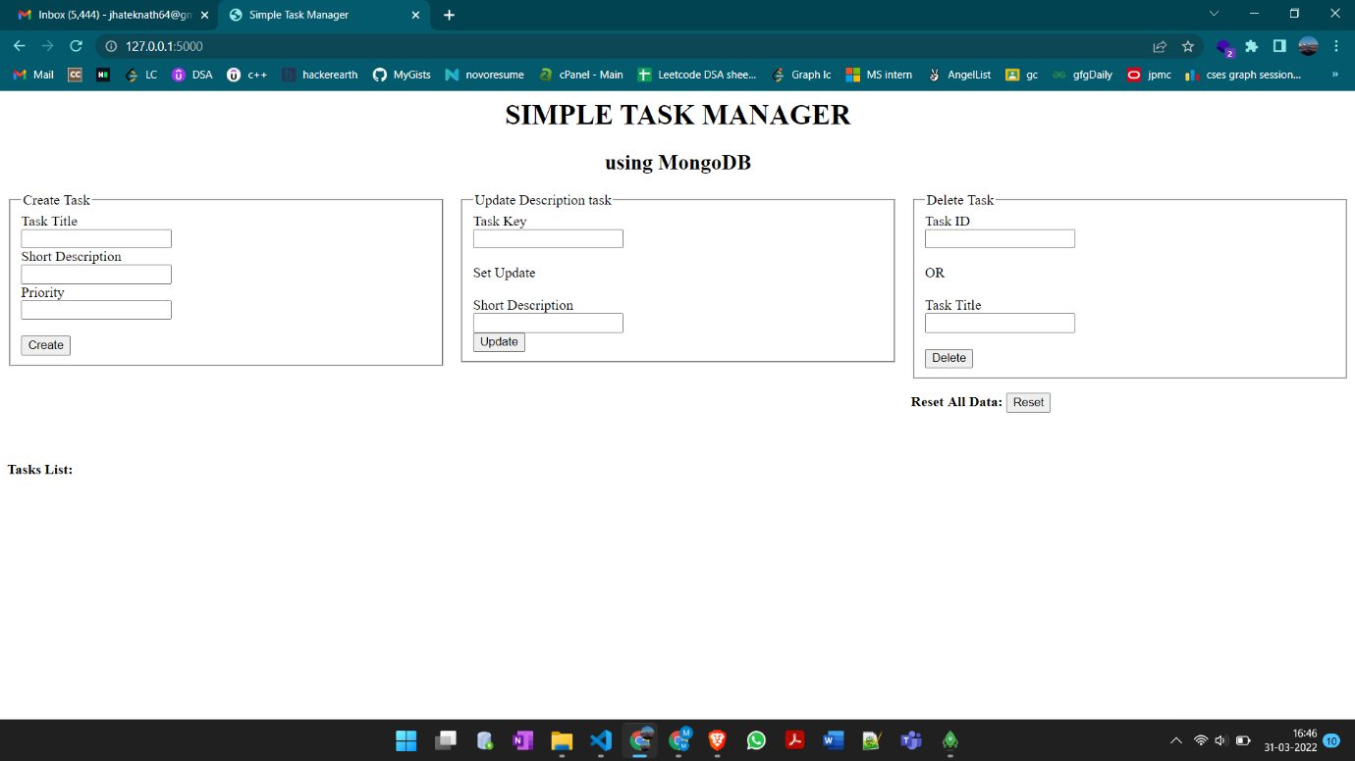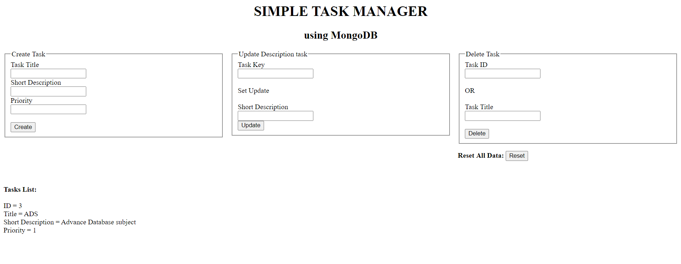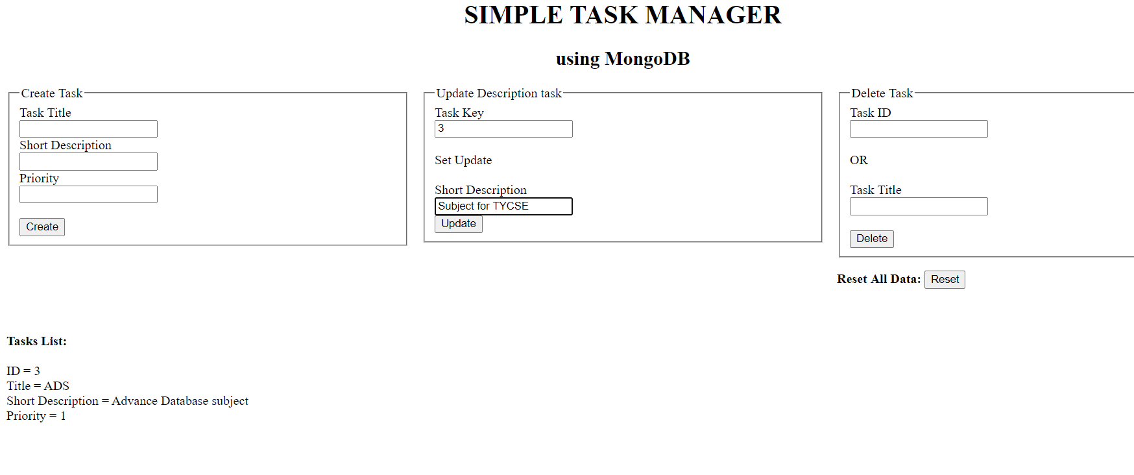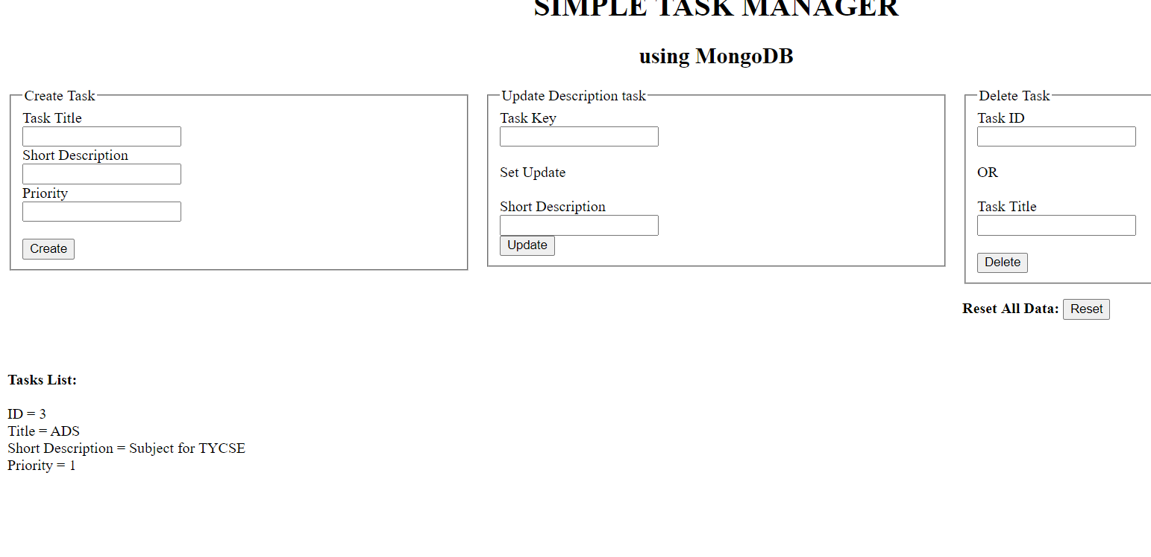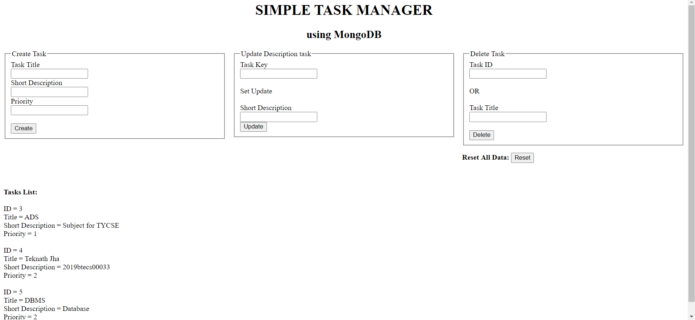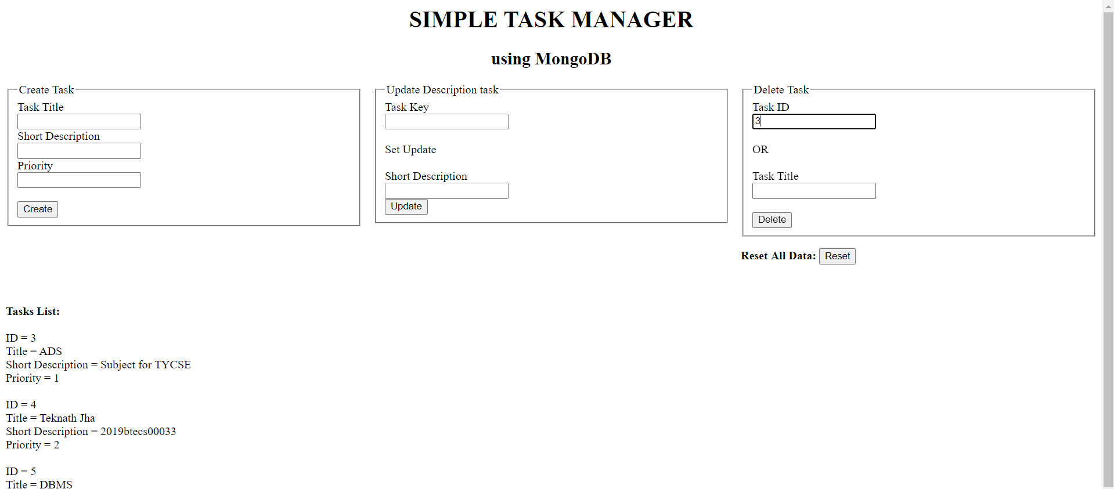

Installation of CassandraDB on windows:

Installed

1. python 2.7.18 64 bit.
2. JDK 8
3. Stable version of CassandraDB

Installation of python 2.7.18

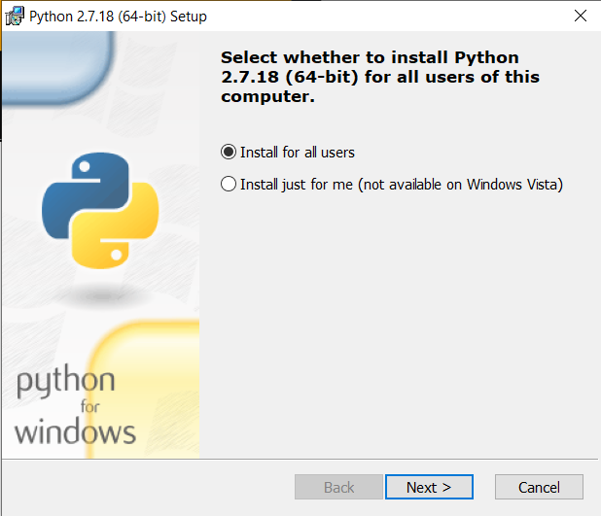

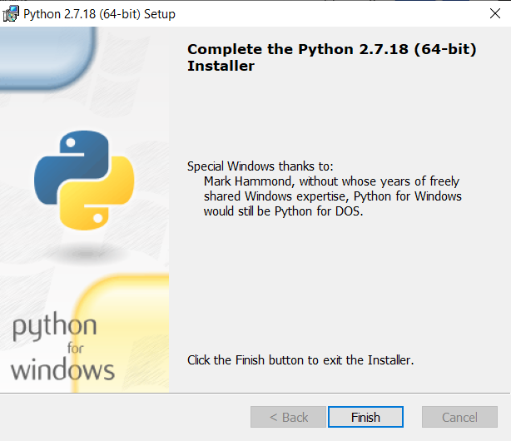

Installation of JDK 8

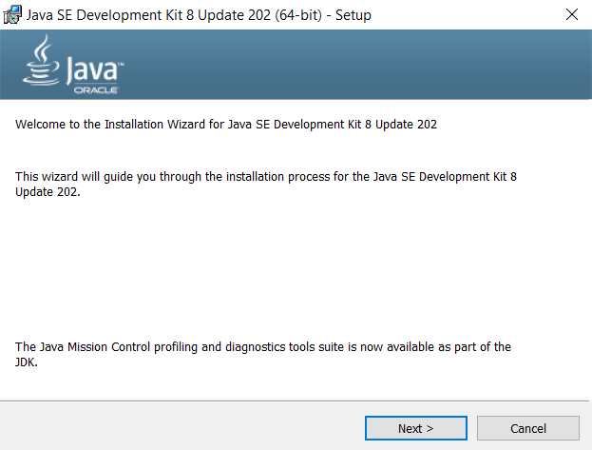

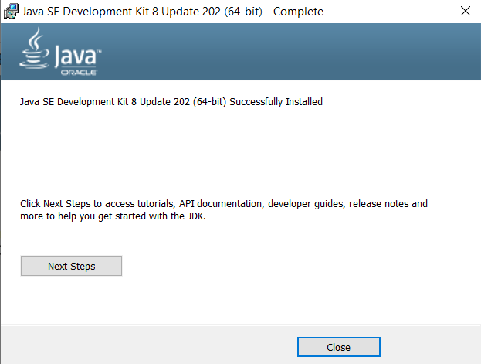

Setting-up environment variable for python, JDK and CassandraDB

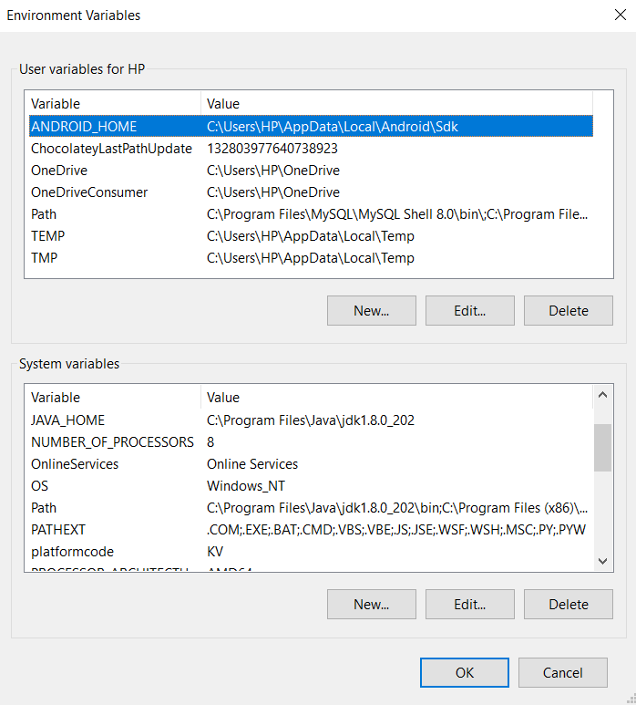

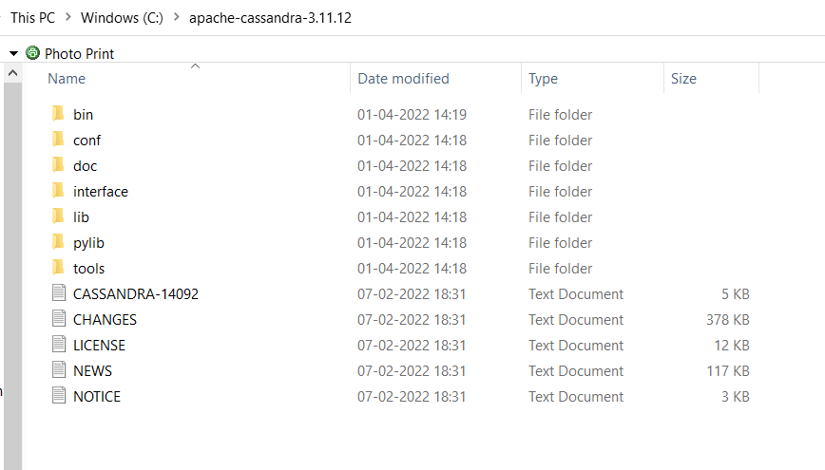

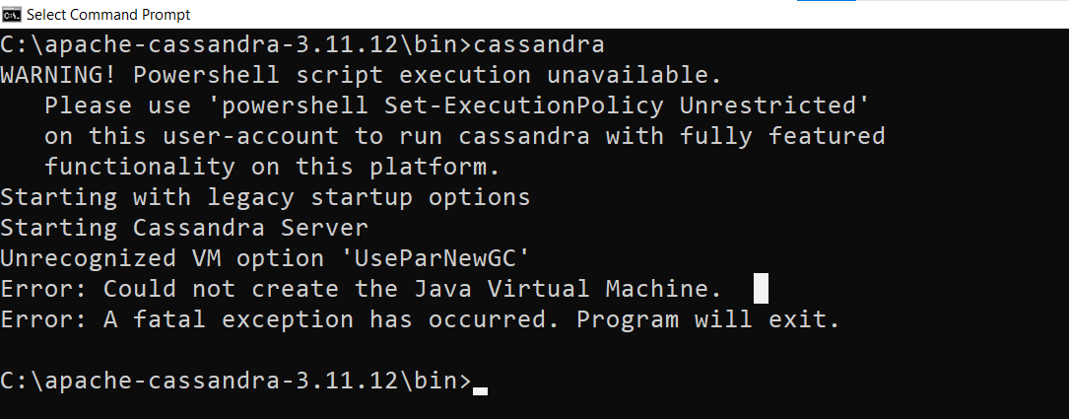

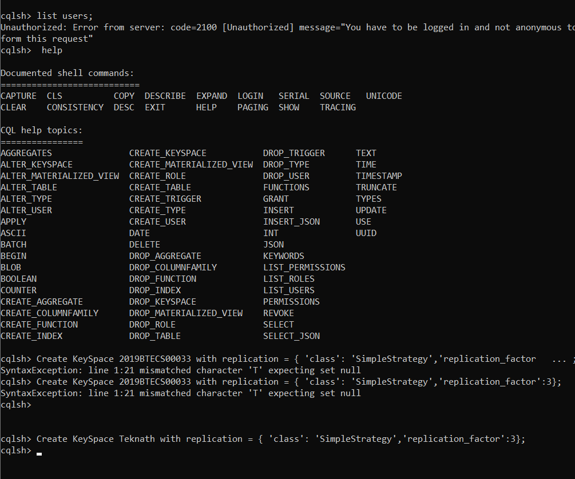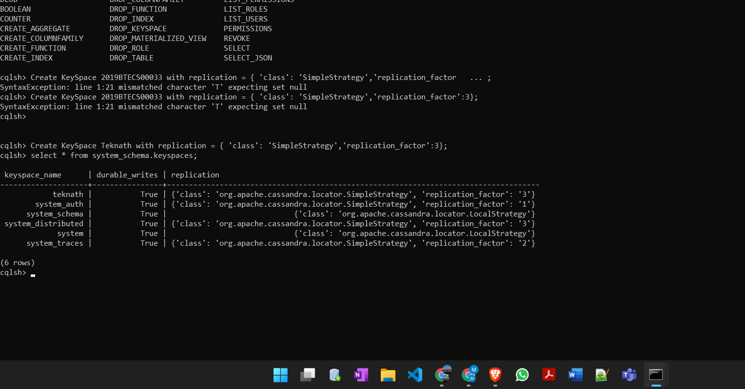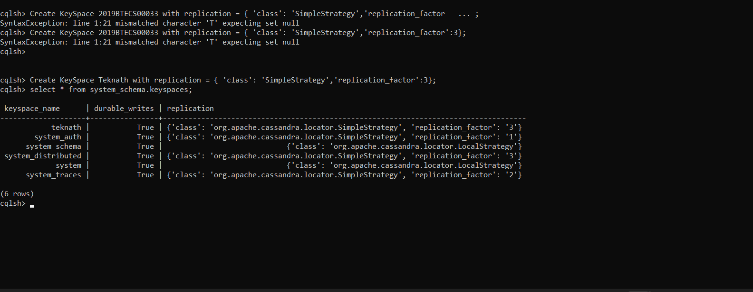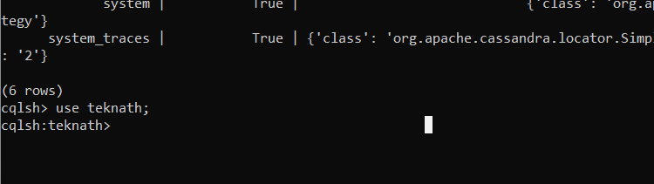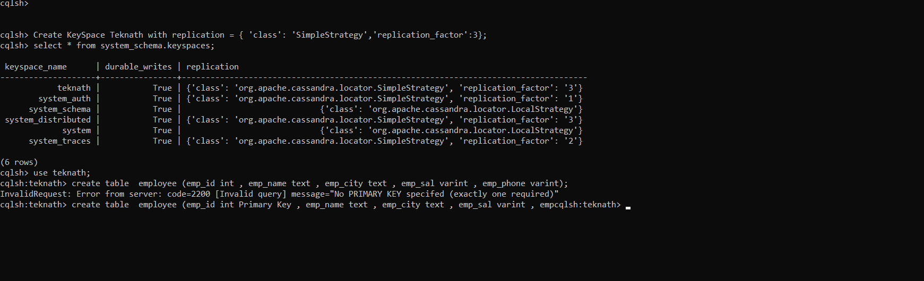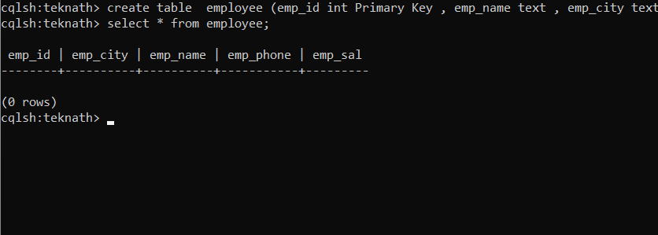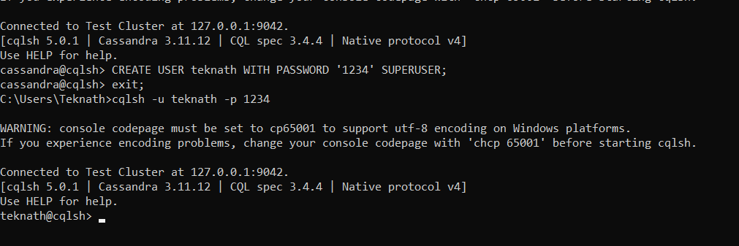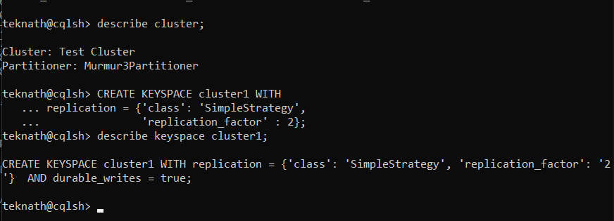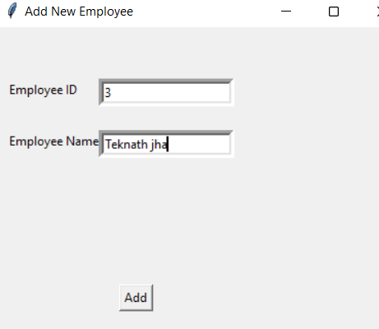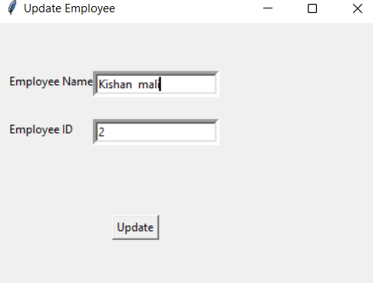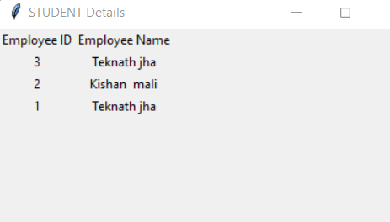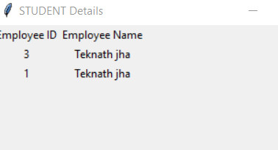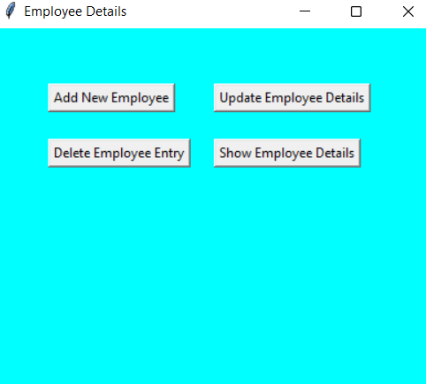

**Conclusion:**

Installed and configured NoSQL MongoDB and CassandraDB on windows and demonstrated respective CRUD operations using python desktop application.