**Assignment No 10**

**PRN No : 2020BTECS00092**

**Batch : T3**

**Title:** Setup a multi-node Cassandra Cluster (Take 3 machines in lab or

on single machine). Give your PRN as cluster name. Follow the

steps given in below link

**Procedure:**

Requirements :

1. We start by installing the Cassandra 3.11 software
2. We would also need Java8 and Python2.7
3. We need to add the locations to the PATH and as JAVA_HOME

* <https://extendit.us/steps-configure-multiple-nodes-cassandra-single-windows-machine>

step 1 :

SETUP AT NODE 1:

We change the conf/cassandra.yaml

We edit these 3 values on all 3 nodes : listen_address , rpc_address , seeds

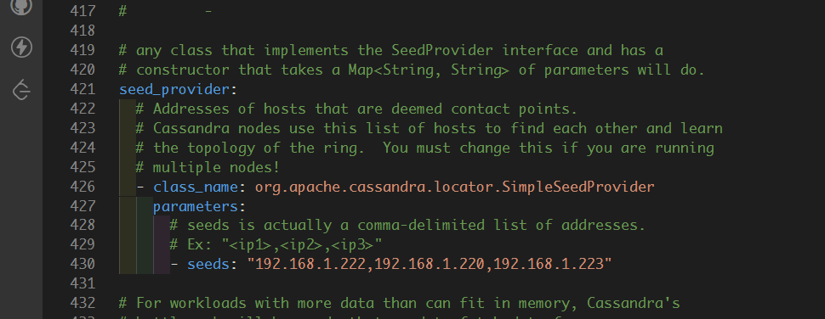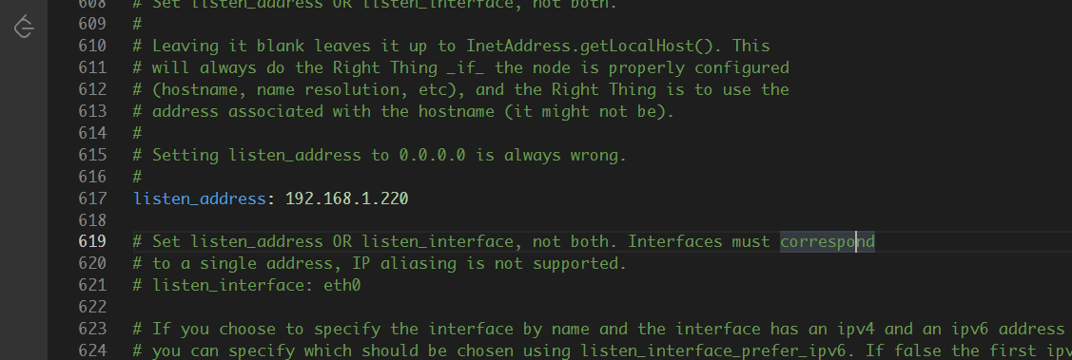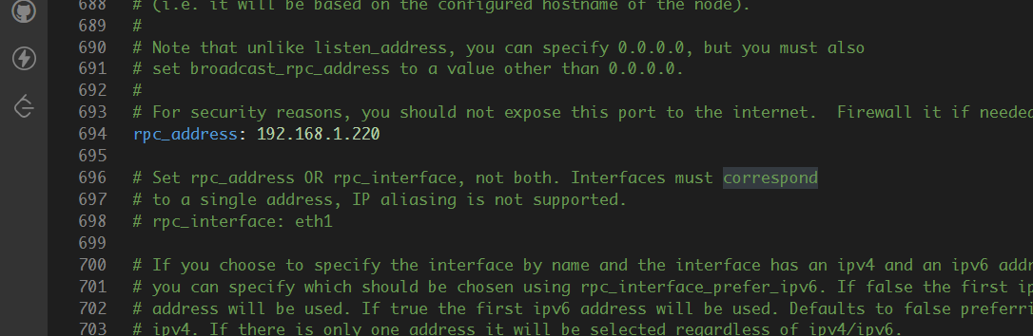

In Node 2:

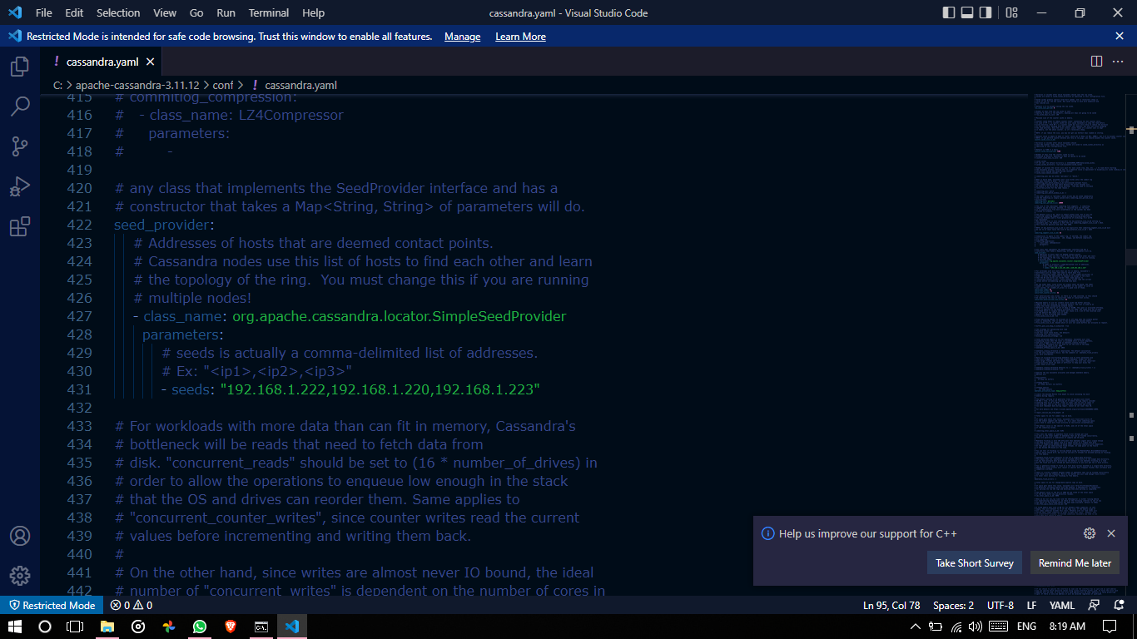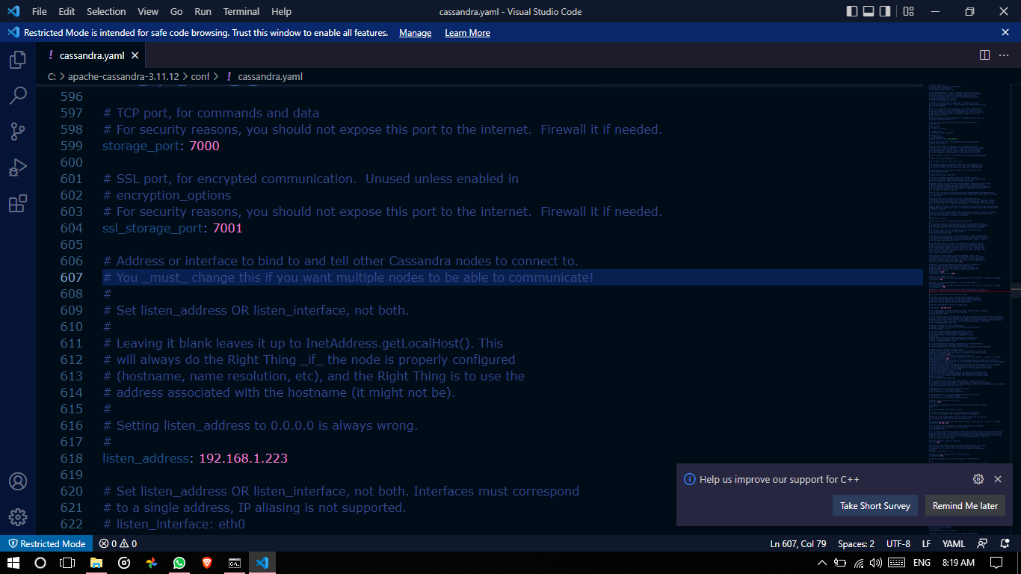

In Node 3 :

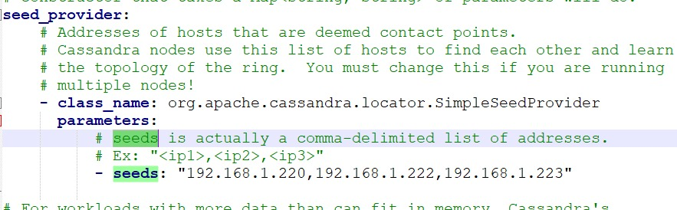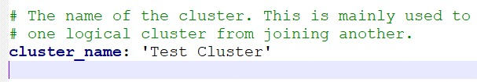

We can now start our cluster: Going to location: C:\Cassandra\apache-cassandra-3.11.12\bin

CMD : We run: cassandra.bat -f

If Java8 and Python 2.7 is installed, the cluster starts up.

Now we demonstrate by using

cqlsh 192.168.1.220 -u cassandra -p Cassandra

These are the default credentials over Node 1.

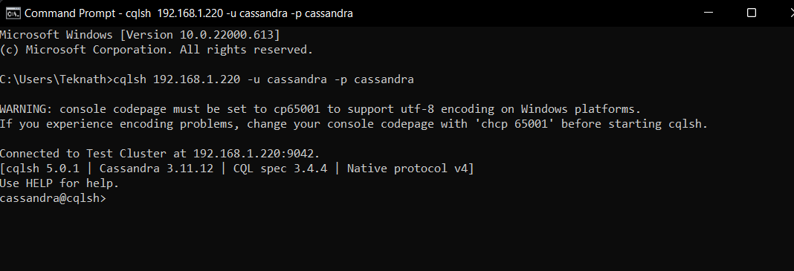

cassandra@cqlsh> CREATE KEYSPACE IF NOT EXISTS App_data WITH REPLICATION = { 'class' : 'NetworkTopologyStrategy', 'datacenter1' : 3, 'datacenter2': 2 };

At Node 1:

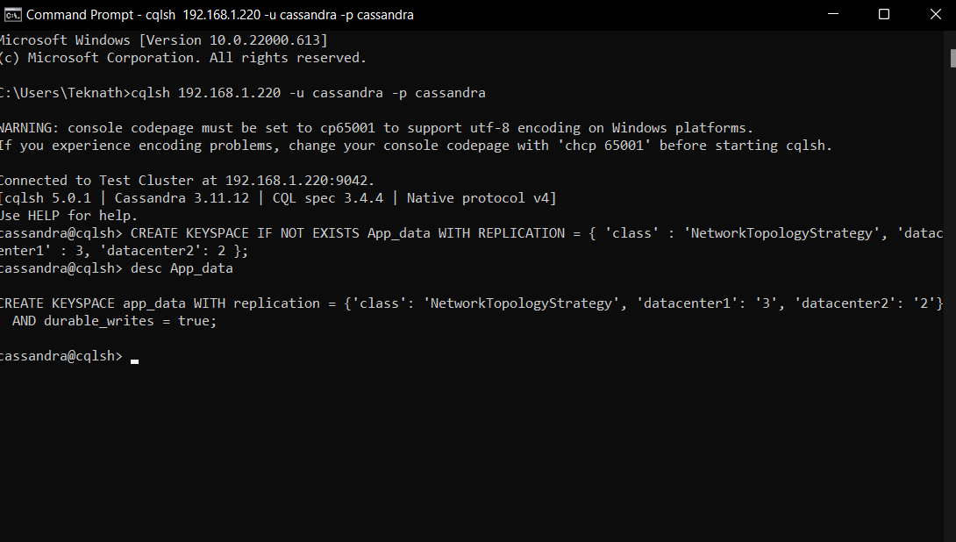

At node 2:

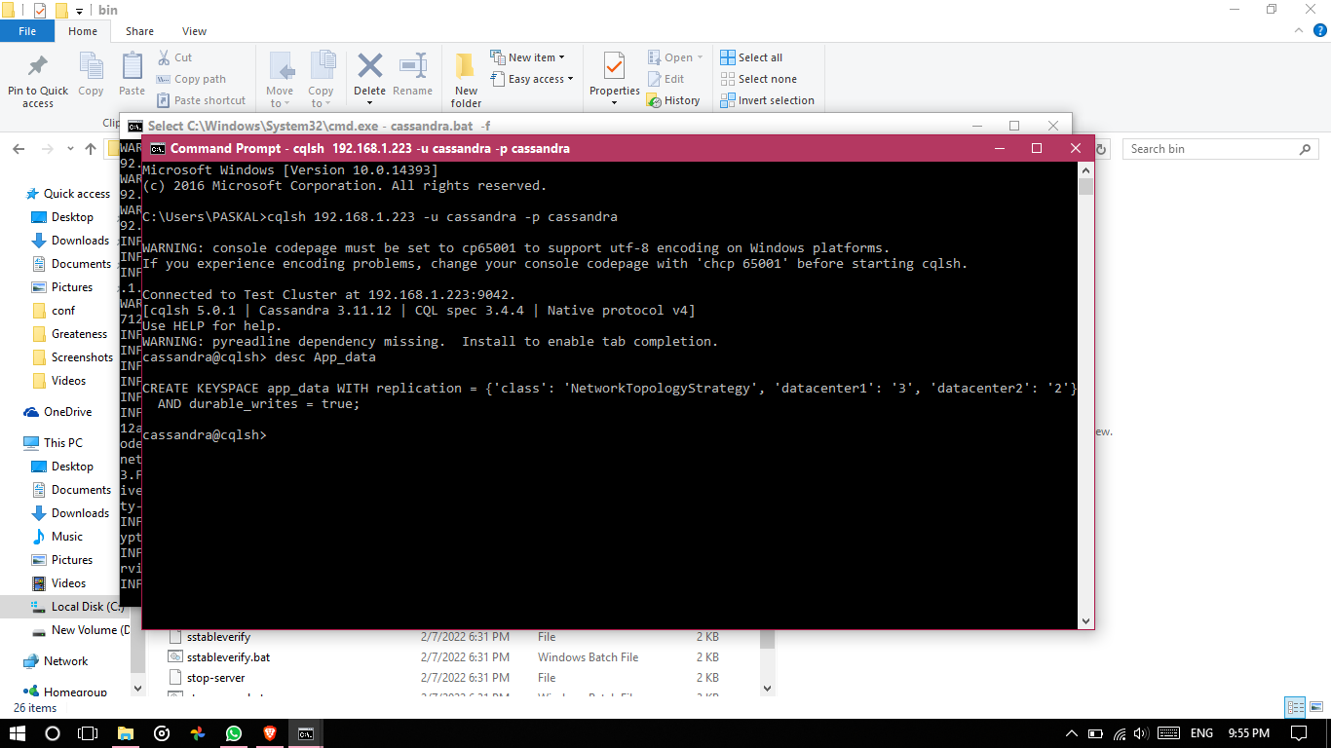

So our schema is replicated at all node 1,2,3.

Now, we build a Temperature-Webapp On a click, we get the current temperature and store it onto Cassandra. Further, we also show all the possible temperatures stored in it.

We would be interacting with Cassandra Cluster through Express Js and make APIs to interact

**Table schema:**

CREATE TABLE weather.weatherinfo ( id text PRIMARY KEY, dt text, lat text, long text, temp text, windspeed text

) WITH bloom_filter_fp_chance = 0.01 AND caching = {'keys': 'ALL', 'rows_per_partition': 'NONE'} AND comment = '' AND compaction = {'class':

'org.apache.cassandra.db.compaction.SizeTieredCompactionStrategy', 'max_threshold': '32', 'min_threshold': '4'}

AND compression = {'chunk_length_in_kb': '64', 'class':

'org.apache.cassandra.io.compress.LZ4Compressor'} AND crc_check_chance = 1.0 AND dclocal_read_repair_chance = 0.1 AND default_time_to_live = 0 AND gc_grace_seconds = 864000 AND max_index_interval = 2048 AND memtable_flush_period_in_ms = 0 AND min_index_interval = 128 AND read_repair_chance = 0.0 AND speculative_retry = '99PERCENTILE';

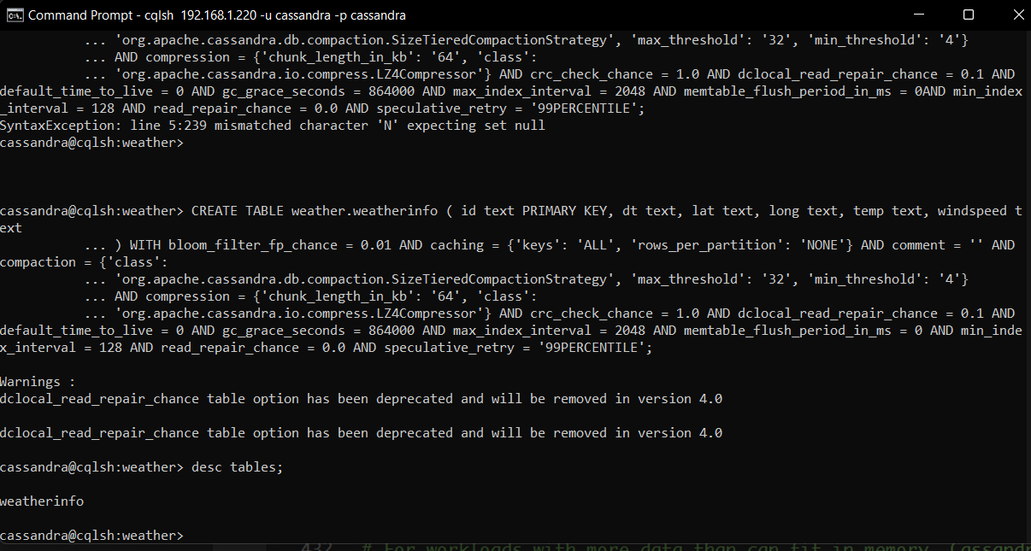

We connect and create a table through:

const cassandra = require('cassandra-driver');

const client = new cassandra.Client({ contactPoints: ["10.4.2.96","10.4.2.112","10.4.2.105"], localDataCenter: 'datacenter1', keyspace: 'weather', credentials: { username: 'cassandra', password: 'cassandra' }

});

After connection Api fetch data and insert into weatherinfo table

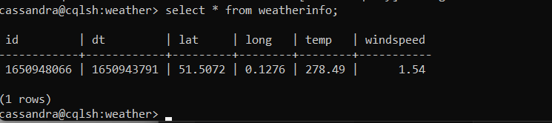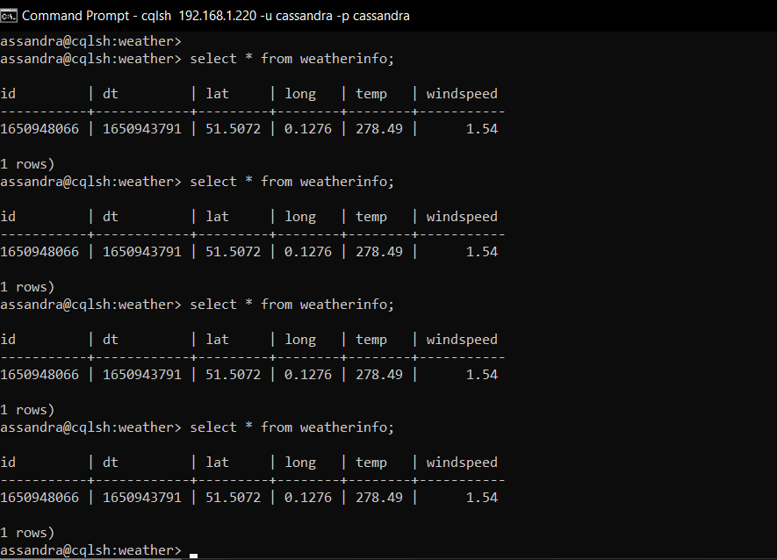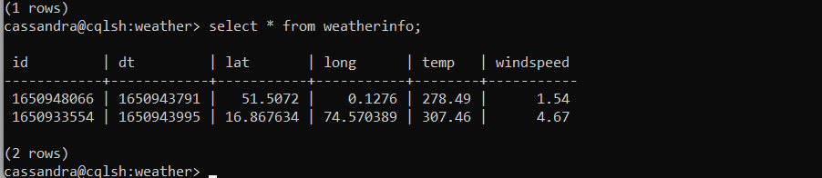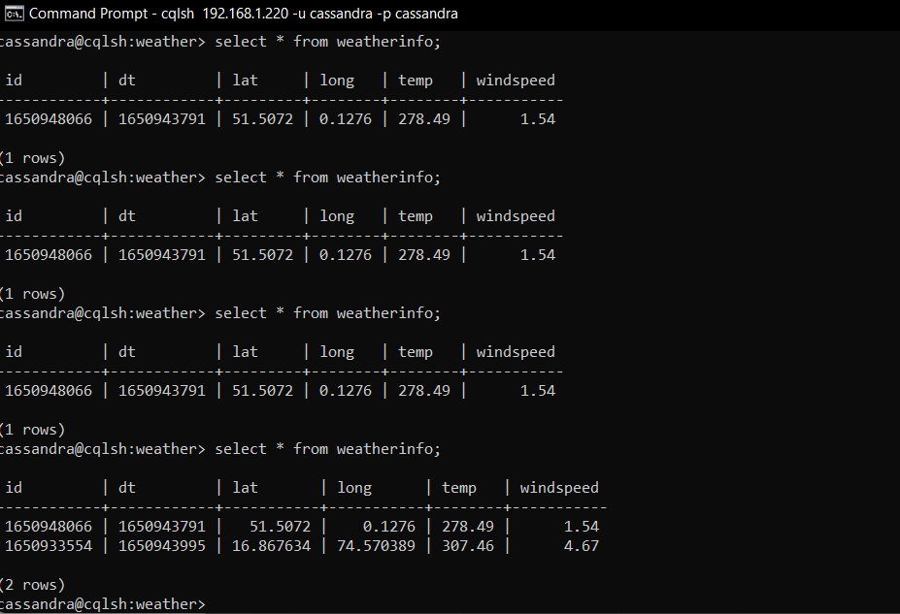

The Open Weather API to fetch current weather:

const express = require('express')

const app = express()

const axios = require('axios')

const cassandra = require('cassandra-driver');

const bodyParser=require('body-parser');

const urlencoded = require('body-parser/lib/types/urlencoded');

app.use(express.json());

app.use(bodyParser.urlencoded({ extended: true}));

const client = new cassandra.Client({

    contactPoints: ["192.168.1.222","192.168.1.220","192.168.1.223"],

    localDataCenter: 'datacenter1',

    keyspace: 'weather',

    credentials: { username: 'cassandra', password: 'cassandra' }

});

app.get('/', function (req, res) {

    const query = `

    CREATE TABLE emp(

        emp_id int PRIMARY KEY,

        emp_name text,

        emp_city text,

        emp_sal varint,

        emp_phone varint

        );

    `;

    client.execute(query, [ ])

      .then(result => console.log(result));

});

app.post('/add-report', async(req, res)=>{

    let lat= req.body.lat;

    let long= req.body.long;

    console.log(req.body);

    let body = {}

    axios.get(`https://api.openweathermap.org/data/2.5/onecall?lat=${lat}&lon=${long}&exclude=minutely,hourly,daily&appid=4fc57c093b1962e1f5db11a8b893119c`)

    .then((response)=>{

        let data = response.data;

        body["id"] = data["current"]["sunrise"]

        body["lat"] = data["lat"]

        body["long"] = data["lon"]

        body["dt"] = data["current"]["dt"]

        body["temp"] = data["current"]["temp"]

        body["windspeed"] = data["current"]["wind_speed"]

        const query = `

        insert into weather.weatherinfo(

            id, dt, lat, long, temp, windspeed

        ) values(

            '${String(body['id'])}', '${String(body['dt'])}', '${String(lat)}', '${String(long)}', '${String(body['temp'])}', '${String(body['windspeed'])}'

        );

        `;

        client.execute(query, [ ])

        .then(result => console.log(result));

        return res.status(201).json({

            message: "Added Successfully!"

        })

    })

    .catch((err)=>{

        console.log(err)

        return res.status(500).json({

            message: "Some Error Occurred!"

        })

    });

})

app.get('/all-reports', async(req, res)=>{

    let theRequired = []

    const query = `

        select * from weather.weatherinfo;

        `;

    client.execute(query, [ ])

    .then(result => {

        return res.json(result.rows)

    }).catch(err=>{

        console.log(err.message);

    });

})

app.listen(3000,()=>{

    console.log("server is running on port 3000");

})

POSTMAN REQUESTS:

