**ASSIGNMENT NO.2**

**Batch :** T6

**Roll no:** 2019BTECS00033

**Title:** Object Relational Databases.

**Name** : Teknath Krishna Jha

**Theory :**

An object type allows you to crate composite types. Using objects allow you

implementing real world objects with specific structure of data and methods for operating it.

Objects have attributes and methods. Attributes are properties of an object and are used for

storing an object's state; and methods are used for modeling its behaviors.

An **object-relational database** (**ORD**), or **object-relational database management system** (**ORDBMS**), is a database management systems (DBMS) similar to relational database, but with an object-oriented database model: objects, classes and inheritance are directly supported in database schemas and in the query-language. In addition, just as with pure relational systems, it supports extension of the data-models with custom data-types and methods.

**Program :**

1. **PL / SQL Review :**

**Q1**

1. **Create a table called test_table with 2 columns RecordNumber (type : Number(3)) and CurrentDate (type : Date)). Write PL/SQL block which will insert 50 records into test_table. Insert the current date value into the table.**

CREATE TABLE test_table (RecordNumber NUMBER(3), CurrentDate DATE);

--block for inserting 50 data in test_table

DECLARE

i number(2);

BEGIN

FOR i IN 1..50 LOOP

INSERT INTO test_table (RecordNumber, CurrentDate) VALUES (i, SYSDATE());

END LOOP;

END;

SELECT * FROM test_table;

**b) Create a products table products(ProductID number(4),category char(3),detail varchar2(30),price number(10,2),stock number(5)).**

**Insert the sample data.**

**Write PL/SQL procedure with two arguments X & Y which will increase price by X% for all products in category Y. X and Y will be given by user.**

--Q1- b

CREATE TABLE products (ProductID number(4),Cate_gory char(3),detail varchar2(30),price number(10,2),stock number(5));

insert into products (ProductID ,Cate_gory , detail , price , stock ) values (1 , 'ABC' , 'Product from MNCs' , 200000 , 52);

insert into products (ProductID ,Cate_gory , detail , price , stock ) values (2 , 'ABC' , 'Product from MNCs' , 600000 , 52);

insert into products (ProductID ,Cate_gory , detail , price , stock ) values (3 , 'XYZ' , 'Product from AMAZON' , 260000 , 59);

insert into products (ProductID ,Cate_gory , detail , price , stock ) values (4 , 'ABC' , 'Product from MNCs' , 500000 , 532);

insert into products (ProductID ,Cate_gory , detail , price , stock ) values (5 , 'XYZ' , 'Product from MNCs' , 204000 , 552);

insert into products (ProductID ,Cate_gory , detail , price , stock ) values (6 , 'XYZ' , 'Product from AMAZON' , 200000 ,152);

insert into products (ProductID ,Cate_gory , detail , price , stock ) values (7 , 'ABC' , 'Product from MNCs' , 200000 ,352);

insert into products (ProductID ,Cate_gory , detail , price , stock ) values (8 , 'XYZ' , 'Product from AMAZON' , 200000 , 532);

select * from products;

--procedure

CREATE OR REPLACE PROCEDURE IncreasePrice(X IN NUMBER, Y IN CHAR)

AS

BEGIN

UPDATE products SET price = (price + (price*(X/100))) WHERE Cate_gory = Y;

END;

DECLARE

X NUMBER(10,2);

Y CHAR(3);

BEGIN

IncreasePrice(&X, '&Y');

END;

**a)Create Object Table containing field “name” of size 50 characters and member function “countNoOfWords” which returns the no. of words in “name” field.**

**Demonstrate the working by entering different data.**

create type studentinfo as object(

name varchar(50),

map member function retWordCount return number

)not final;

create type body studentinfo as

map member function retWordCount return number is

no_word number(20) :=0;

s char;

begin

for i in 1..Length(name) Loop

s:=substr(name,i,1);

if s = ' ' or s='.' or s=',' then

no_word := no_word + 1;

end if;

end loop;

no_word:=no_word+1;

dbms_output.put_line('No. of words ' || no_word);

return no_word;

end;

end;

create table student of studentinfo;

insert into student values( 'Teknath jha' );

insert into student values( 'Pankaj jha' );

insert into student values( 'Kartik Arjun kabir singh gabbar Kalia' );

insert into student values( '2019btecs00033' );

insert into student values( 'HP DELL MAC LENOVO' );

insert into student values( 'Tarun' );

select * from student;

select value(st).name as student_name , value(st).retWordCount() as word_count

from student st

where value(st).retWordCount() < 5;

**b) Create an address type with the following attributes : address,city, state & pincode. Include the following methods**

**i. to extract the addresses based on given keyword.**

**j. to return the no. of words in each given field (method should accept the name of attribute/field)**

create type address as object (

short_address varchar2(50) ,

city varchar2(20),

state varchar2(20),

pincode varchar2(6),

member function getAddress( key_val varchar ) return number,

member function no_of_words(typ varchar ) return number

) not final;

create or replace type body address as

member function getAddress(key_val in varchar) return number is

no_word number(20) :=0;

s char := ' ';

str varchar(20):=' ';

flg number(1) :=0;

j number(10) :=0;

k number(10) :=0;

BEGIN

for i in 1..Length(short_address) Loop

s:= substr(short_address,i,1);

if s = ' ' or s='.' or s=',' then

str:= substr(short_address,j,k);

j:= i+1;

k:=-1;

if str=key_val then

DBMS_OUTPUT.PUT_LINE('Address :'||short_address);

flg :=1;

return flg;

end if;

end if;

k:= k+1;

end loop;

return flg;

end;

**/*to return the no. of words in each given field*/**

member function no_of_words(typ in varchar) return number is

no_word number(20) :=1;

s char;

len number(3):=0;

begin

if(typ='short_address') then

for i in 1..Length(short_address) Loop

s:= substr(short_address,i,1);

if s = ' ' or s='.' or s=',' then

no_word := no_word +1;

DBMS_OUTPUT.PUT_LINE('Address :');

end if;

end loop;

elsif(typ='city') then

for i in 1..Length(city) Loop

s:= substr(city,i,1);

if s = ' ' or s='.' or s=',' then

no_word := no_word +1;

DBMS_OUTPUT.PUT_LINE('Address :');

end if;

end loop;

else

for i in 1..Length(state) Loop

s:= substr(state,i,1);

if s = ' ' or s='.' or s=',' then

no_word := no_word +1;

DBMS_OUTPUT.PUT_LINE('Address :');

end if;

end loop;

end if;

return no_word;

end;

end;

create table address_table of address;

insert into address_table values('virar east mumbai','mumbai','maharashtra',401305);

insert into address_table values('phoolpada near hanuman mandir','vasai virar','maharashtra',416115);

insert into address_table values('ganpati mandir gaonbhag','mumbai','maharashtra',401305);

**/*to extract the addresses based on given keyword.*/**

select ad.short_address from address_table ad where value(ad).getAddress('near')=1;

**/*to return the no. of words in each given field ='city'*/**

select ad.city, value(ad).no_of_words('city')as wordCount from address_table ad;

**c)Create a user defined data type course_Type with 2 attributes course_id, description**

**i. Create an object table based on the type created. j. Insert rows into the table**

**/* Create a user defined data type course_Type with 2 attributes course_id, description */**

create type course as object

(

course_id varchar2(10),

description varchar(50)

);

**/*Create an object table based on the type created*/**

create type faculty as object

(

name varchar2(20),

experience number(2)

);

create table Course_table of course;

insert into Course_table values('3cs101','Algorithm');

insert into Course_table values('3cs103','CN');

insert into Course_table values('3cs104','ADS');

insert into Course_table values('3cs102','OS');

select * from Course_table;

create table Course_faculty

(

c course,

f faculty

);

insert into Course_faculty values(course('3cs102' ,'Web'),faculty('PQR',10));

insert into Course_faculty values(course('3cs112' ,'IAWP'),faculty('ABC',10));

insert into Course_faculty values(course('3cs132' ,'DACC'),faculty('XYZ',10));

insert into Course_faculty values(course('3cs122' ,'ADS'),faculty('LMN',10));

select * from teknath.Course_faculty;

**Results/Observation:**

**Question A**

**PL/SQL REVIEW :**

1. **Table creation**

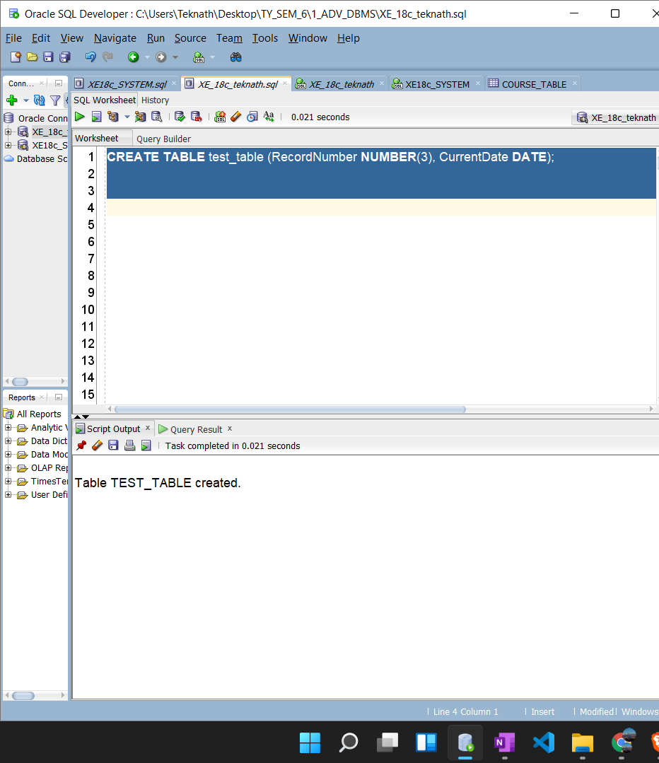

1. **Block creation**

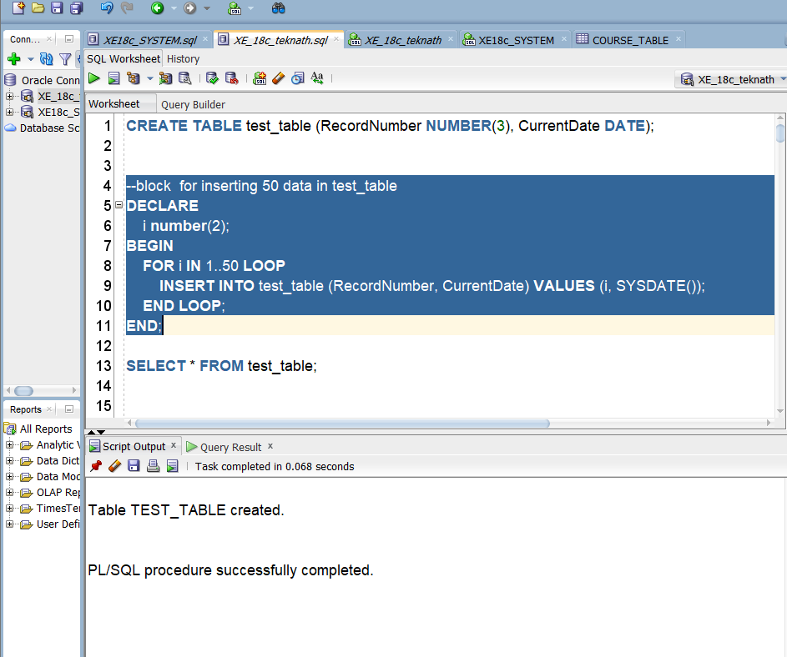

1. **Table with output**

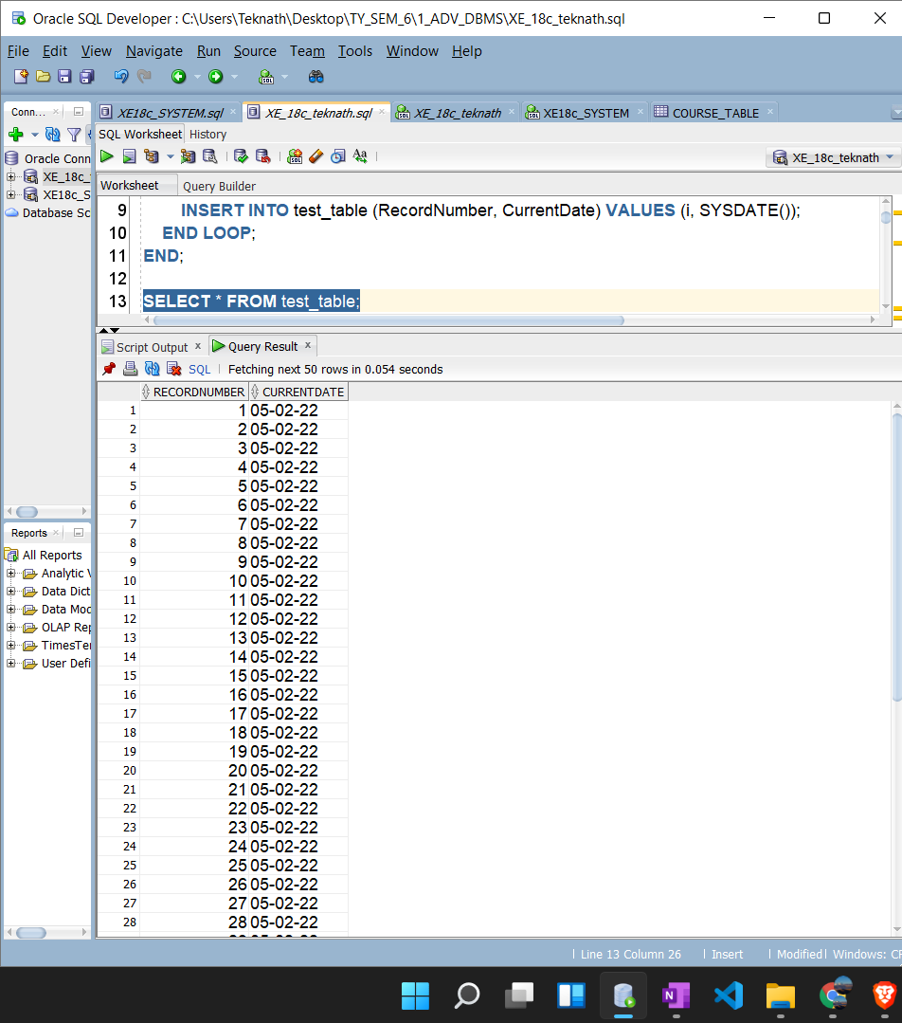

**Q1 b)**

1. **Table creation**

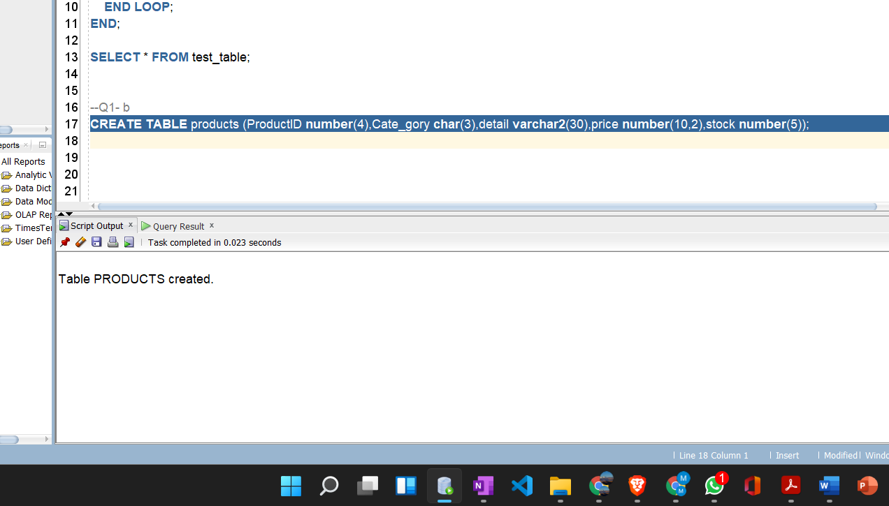

1. **Insertion data**

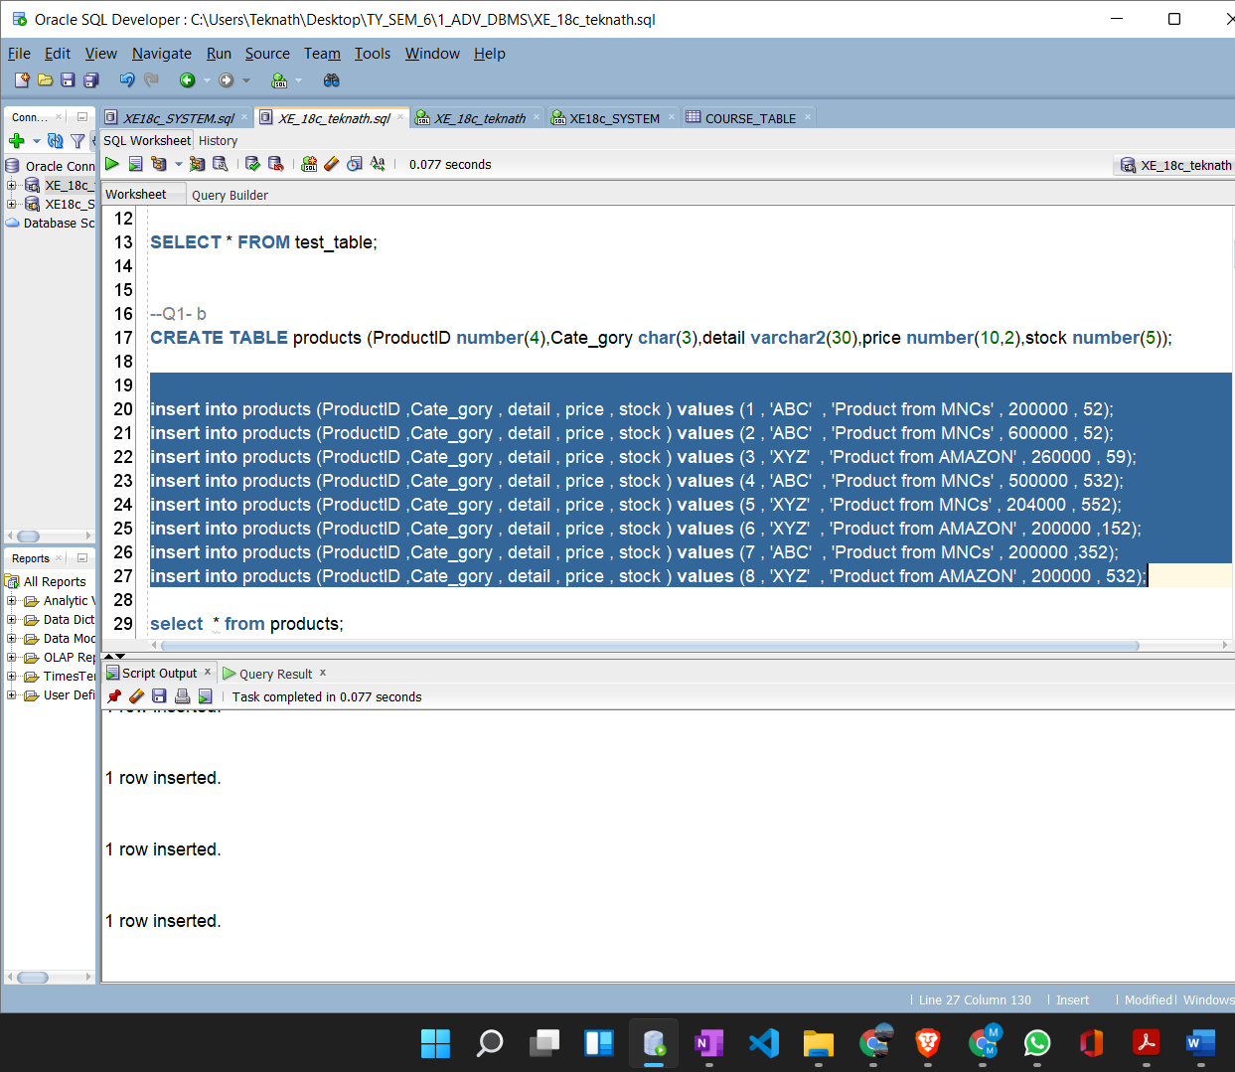

1. **Procedure creation**

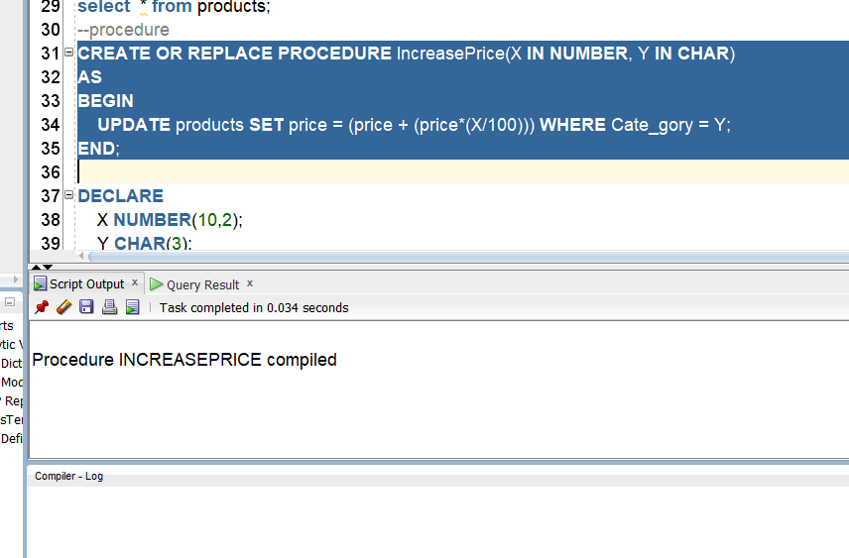

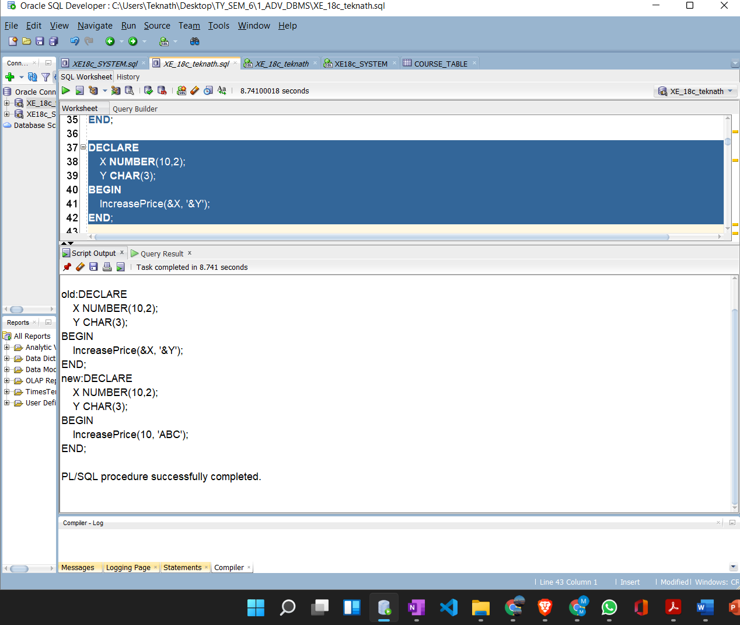

1. **Output**

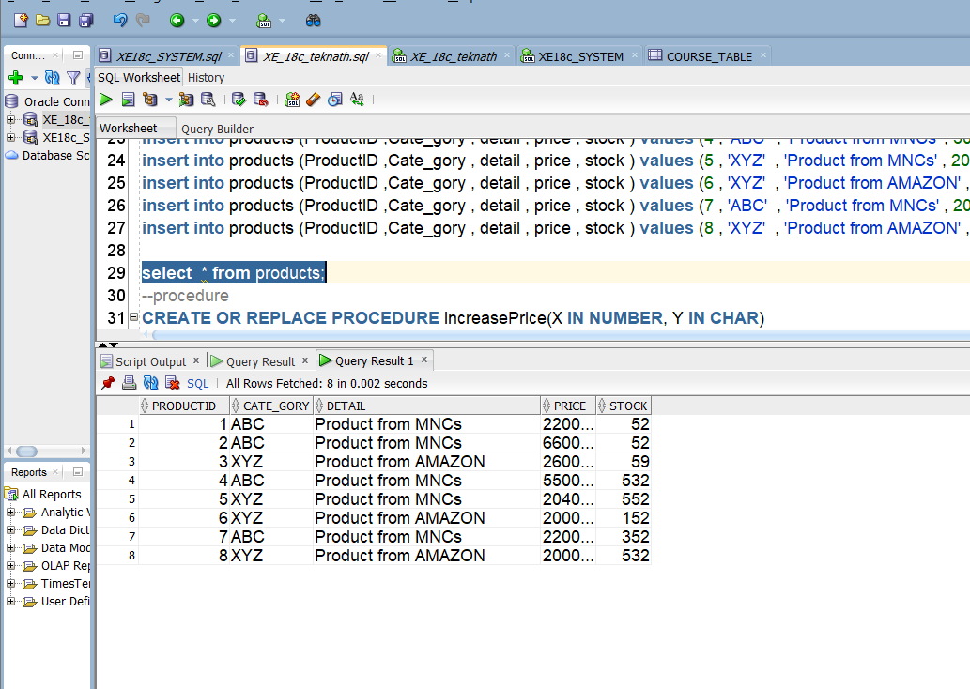

**Question B**

1. **Creating Object**

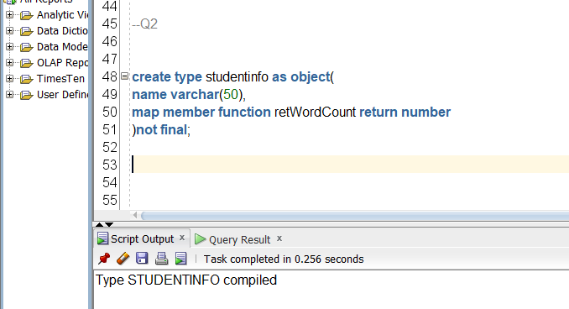

1. **Creating Table**

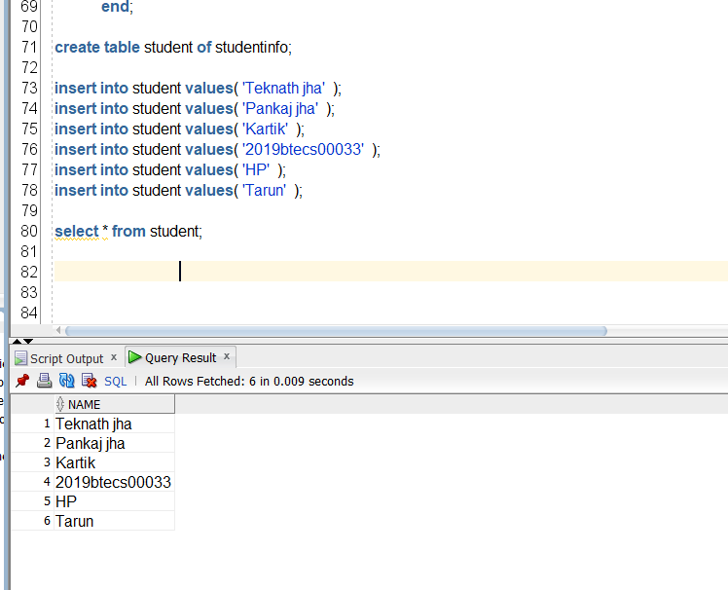

1. **Performing Operations**

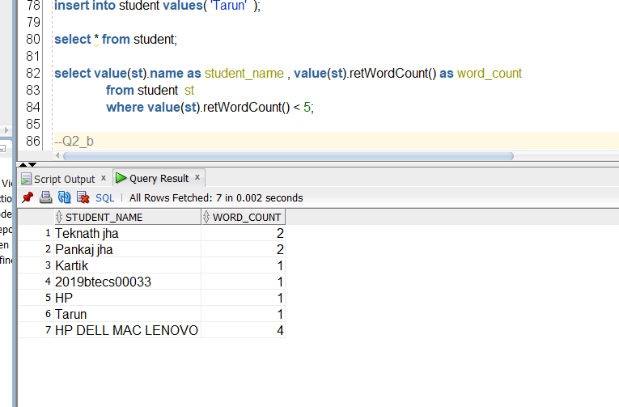

**Question B**

1. **Creating Address Type**

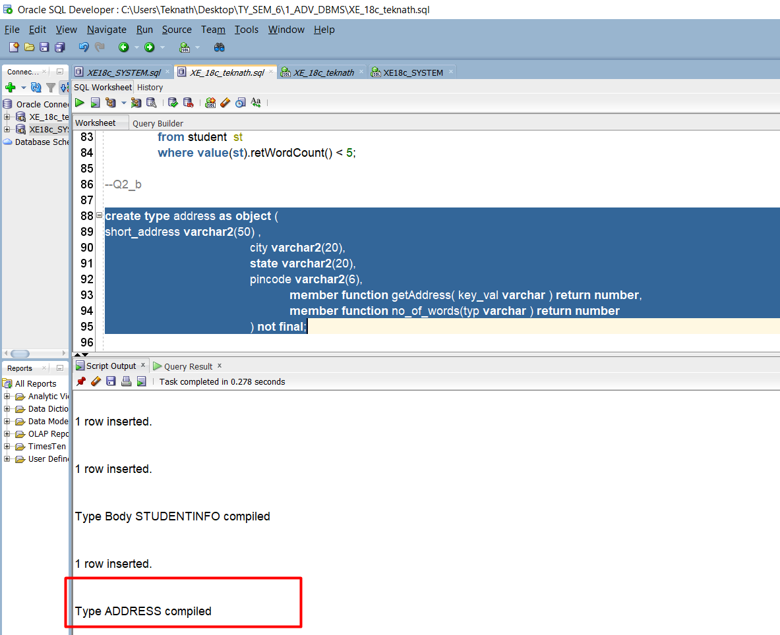

**2.creating table**

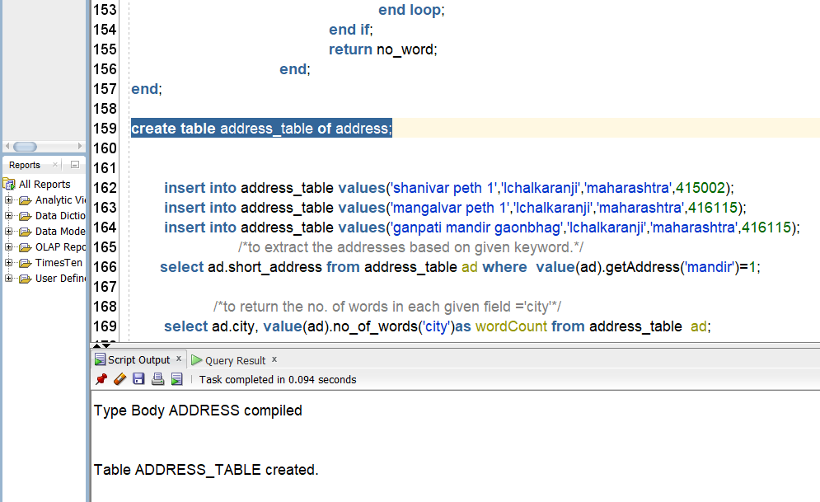

3.Inserting values:



**4.operations:**

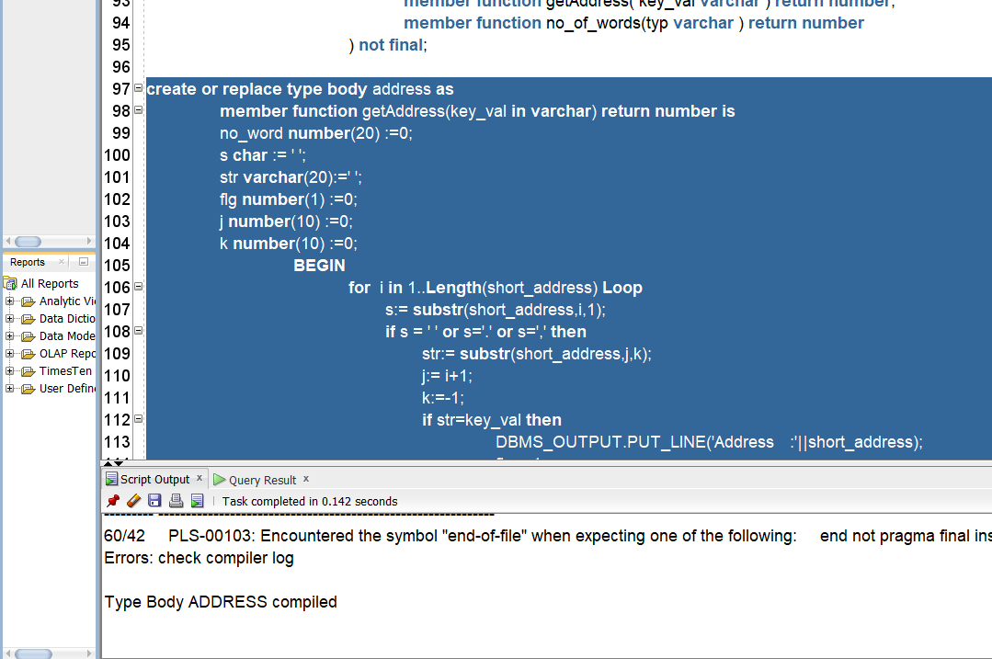

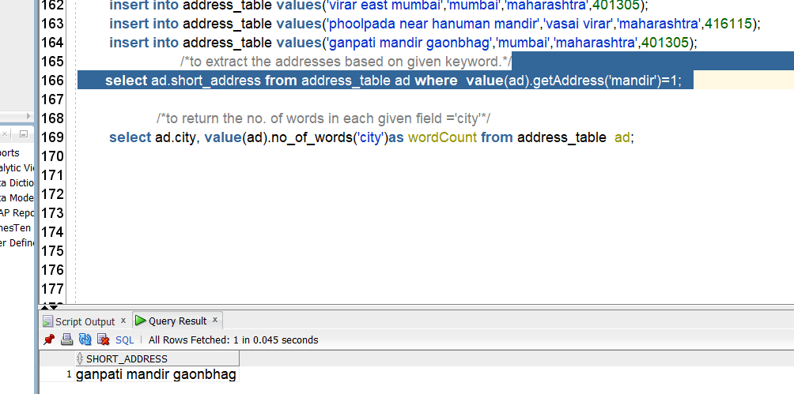

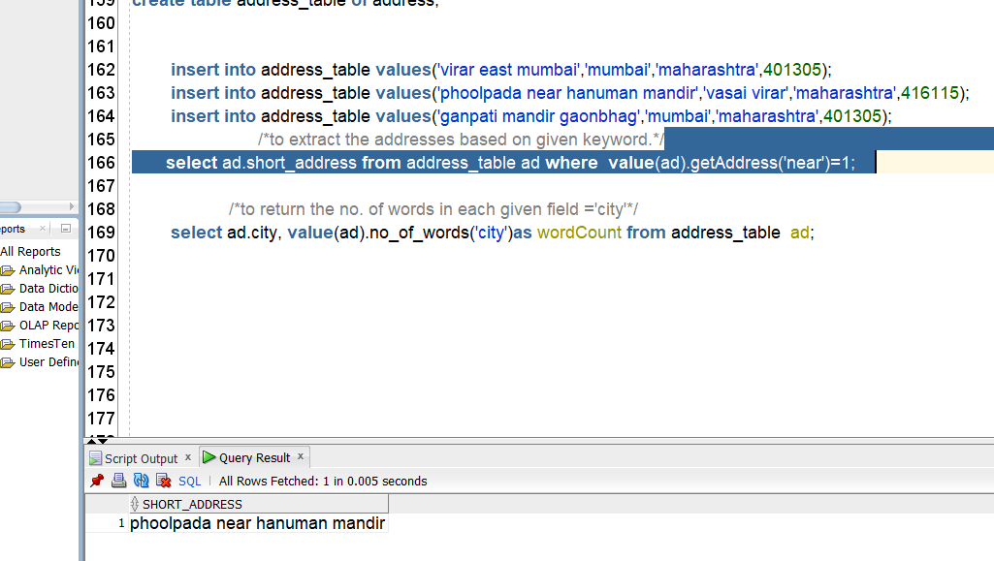

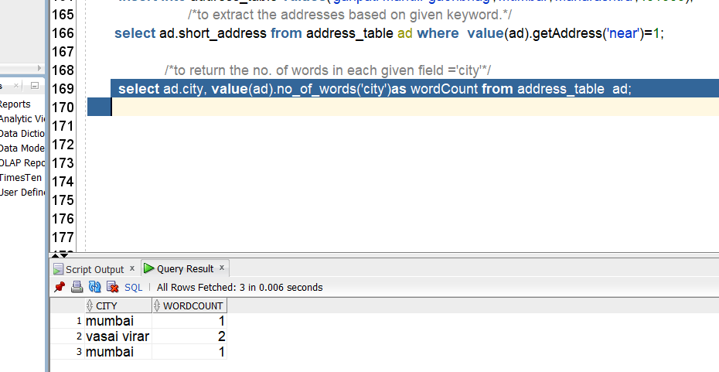

**Question C**

1. **Creating type course and faculty**

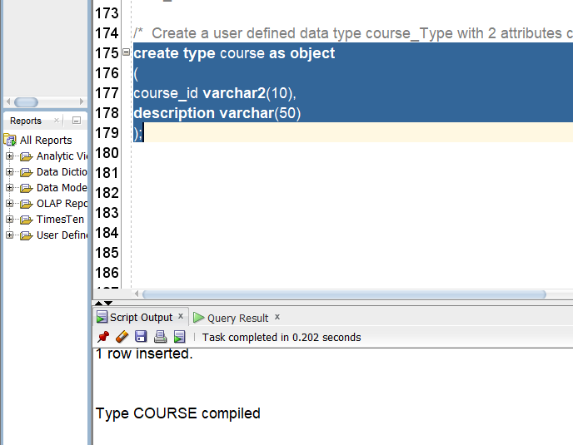

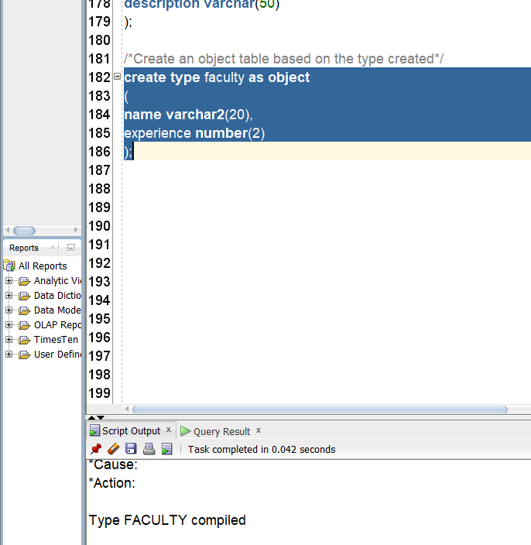

**2.table creation:**

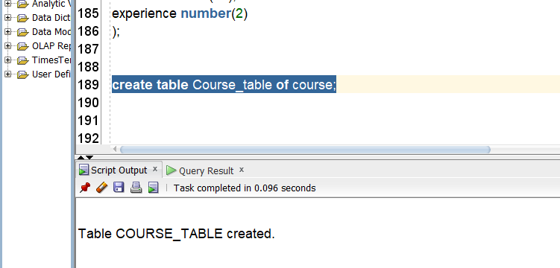

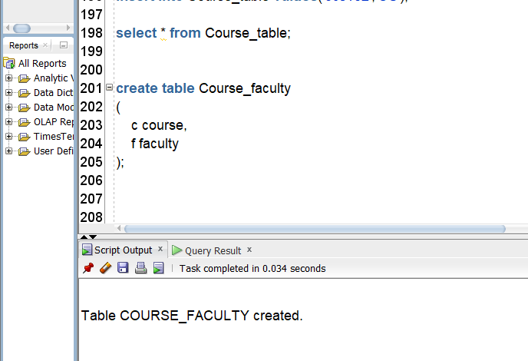

**3.Inserting values:**

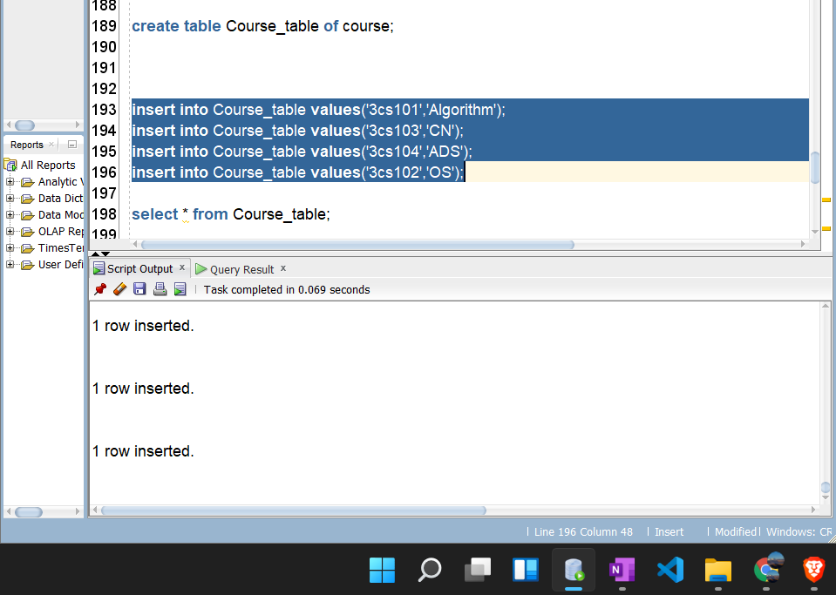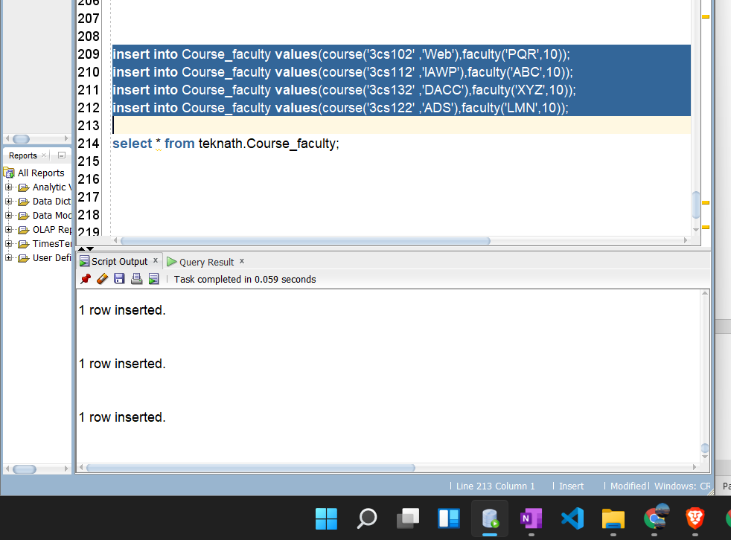

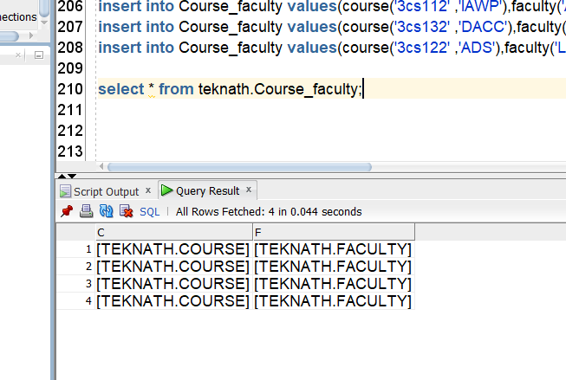

**Conclusion:**

* Studied Object Relational Databases.
* Demonstrated working with different data sets and entering different data