**TY B.Tech. (CSE) – II [ 2021-22 ]**

**Advanced Database System Lab.**

**Assignment No. 3**

**Batch:** T6

**Roll No:** 2019BTECS00033

**Title:**

Design and implement a GUI based CRUD operations .

**Objective**: Use Oracle / MYSQL / Tinker.

**Introduction:**

**Tinker:**

Tinker is a python library use for fast GUI development . Tinker is used to develop web apps, desktop apps, mobile apps, games and much more.

The Tinker library is designed to be a simple, modern, general-purpose, and completely code less do more functionality.

**MySQL:**

**MySQL** is an open-source relational database management system (RDBMS). A relational database organizes data into one or more data tables in which data types may be related to each other; these relations help structure the data. SQL is a language programmers use to create, modify and extract data from the relational database, as well as control user access to the database.

In addition to relational databases and SQL, an RDBMS like MySQL works with an operating system to implement a relational database in a computer's storage system, manages users, allows for network access and facilitates testing database integrity and creation of backups.

**Oracle 18c :**

Interactive grids present end users with a set of data in a searchable, customizable report. From a functional perspective, an interactive grid includes the customization capabilities available in interactive reports plus the ability to rearrange the report interactively using the mouse. In an editable interactive grid, users can also add to, modify, and refresh the data set directly on the page.

**CRUD OPERATIONS :**

**INSERT**

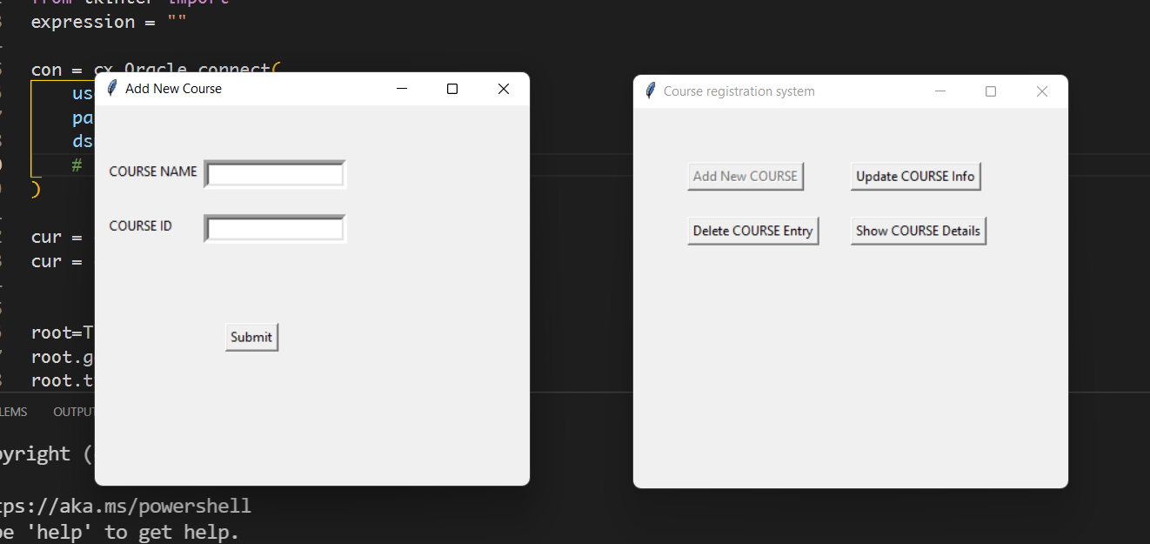

**READ**

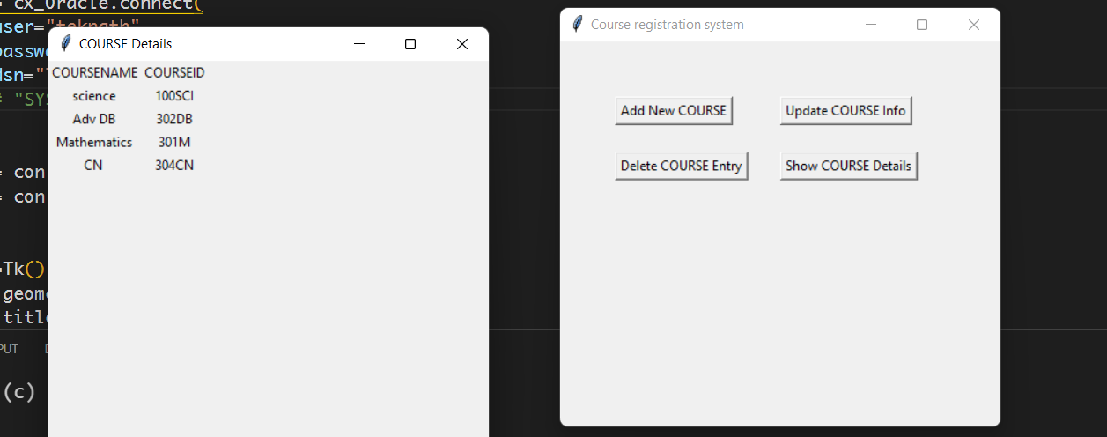

**UPDATE**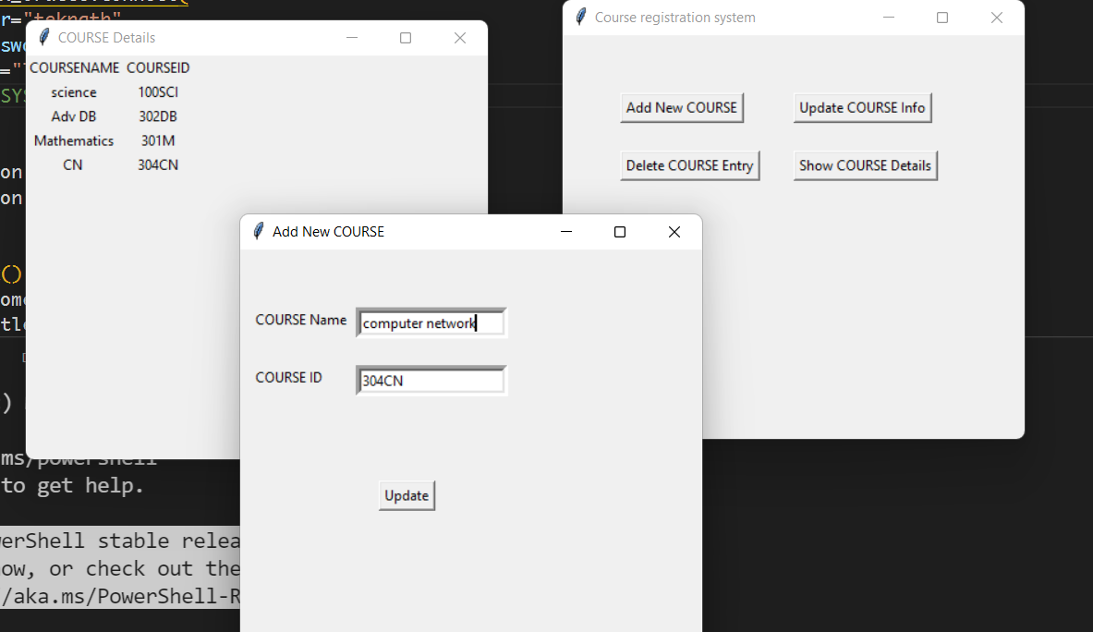

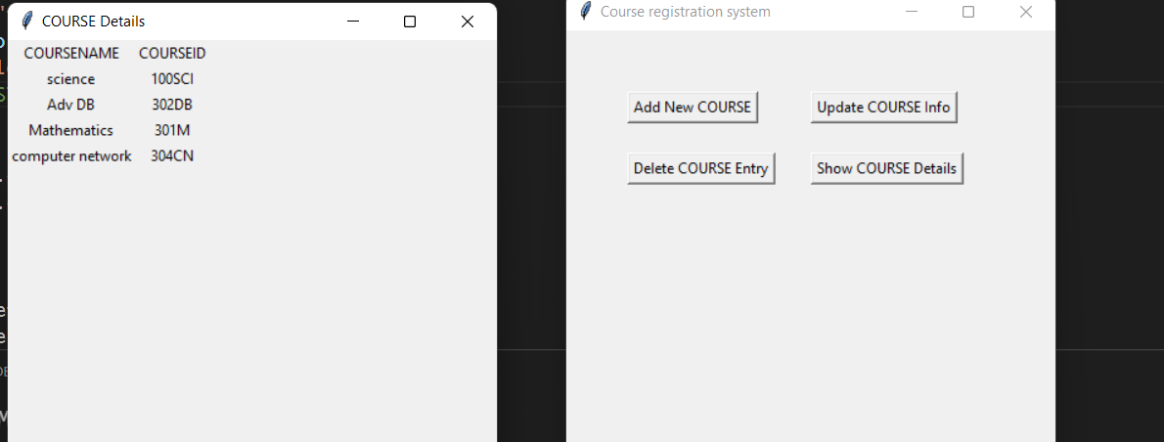

**DELETE**

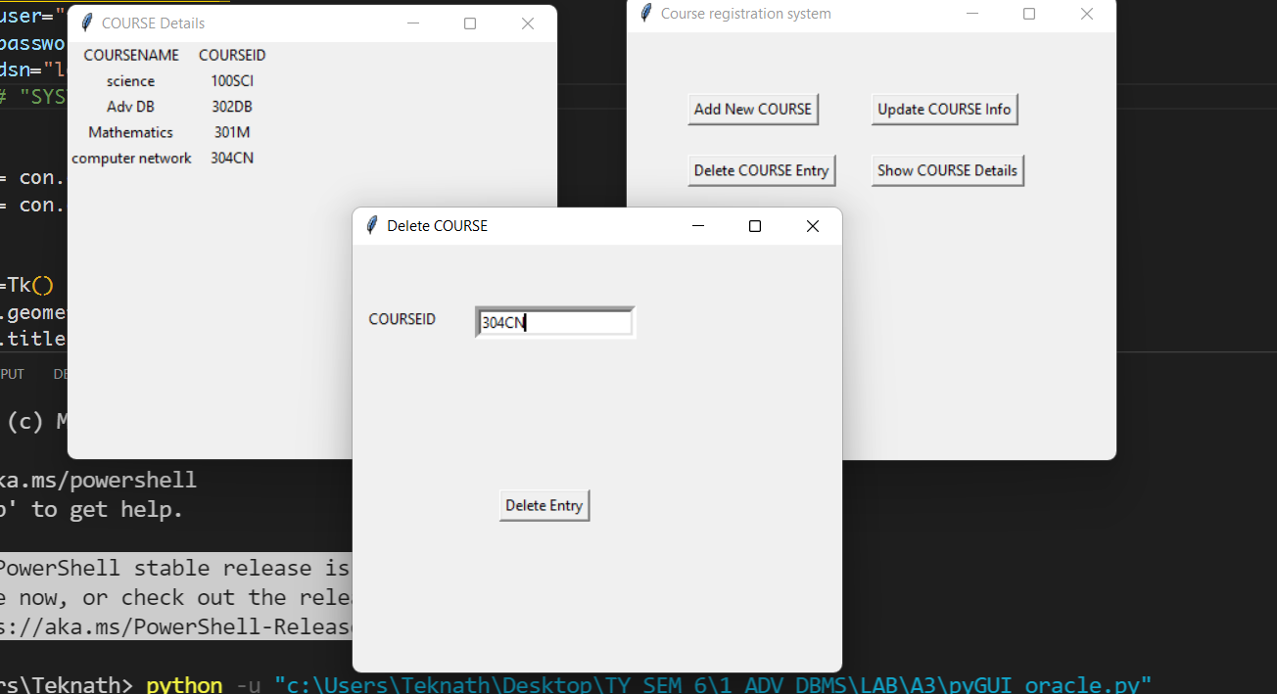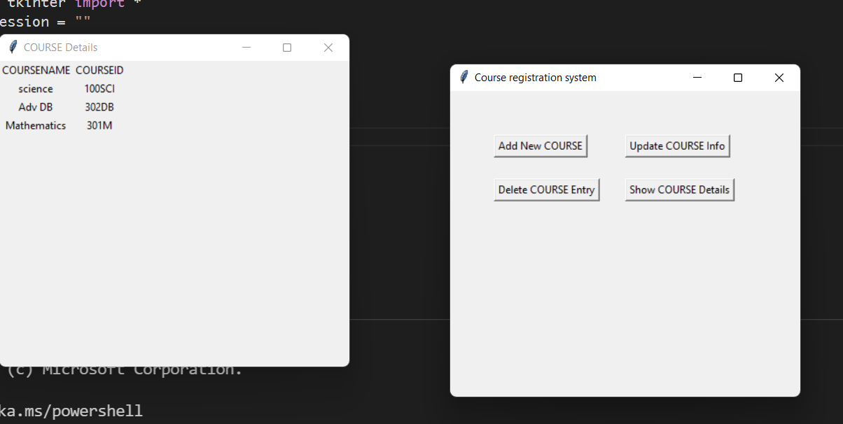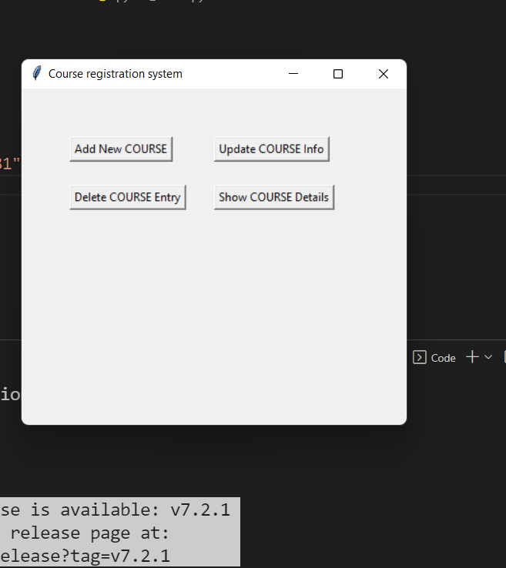

.

**WITH MYSQL :**



**INSIDE DATABASE:**

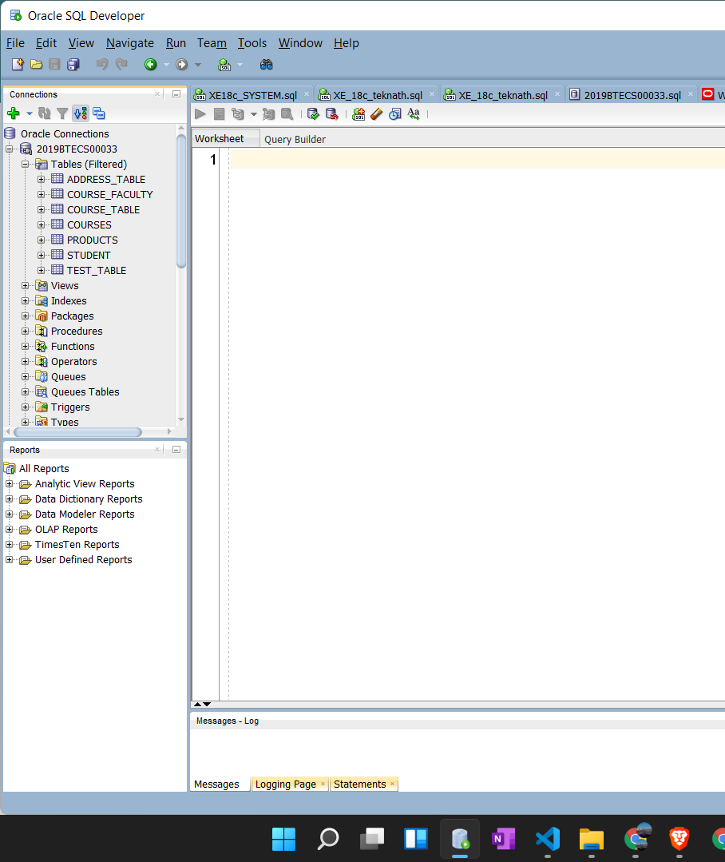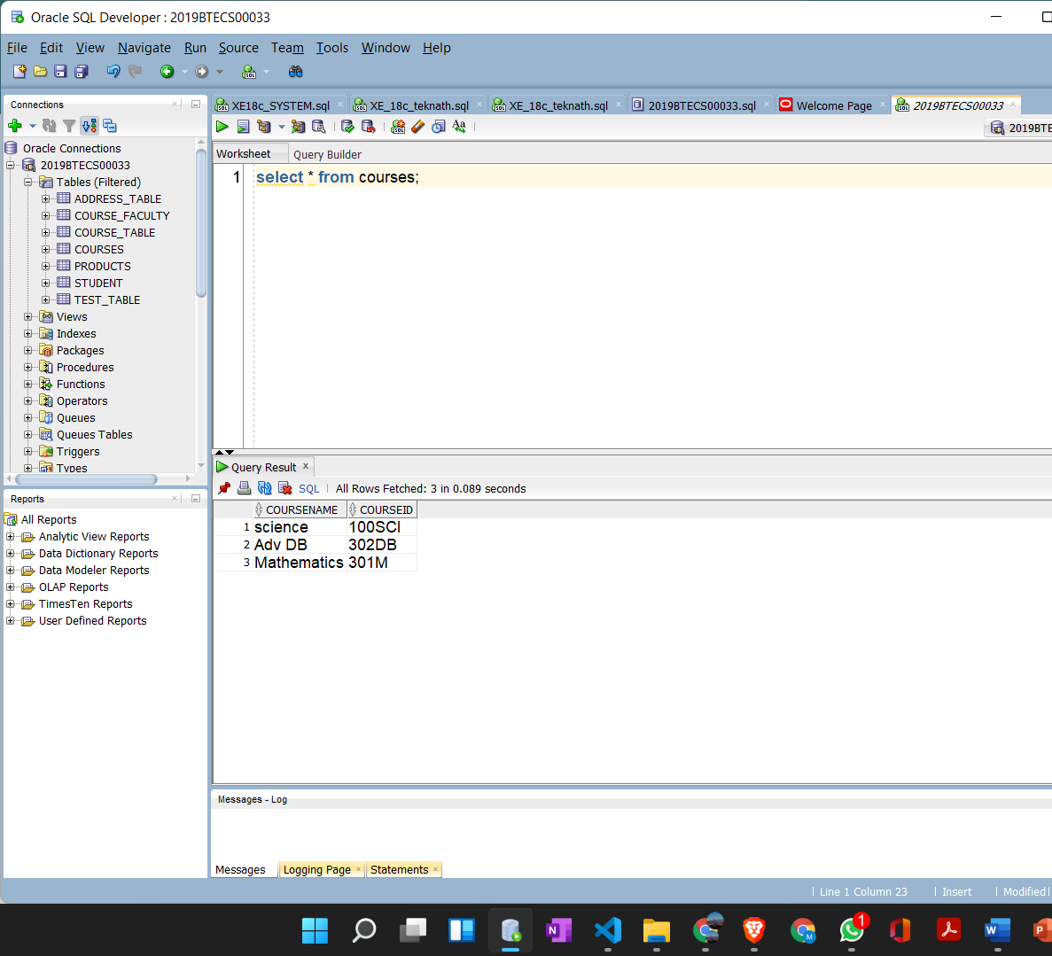

**Conclusion:**

Tinker application was developed for the Study purpose for connection and CRUD with the help of Tinker as a front-end framework and Oracle 18c as backend database.