**TY B.Tech**

**Advanced Database System Lab.**

**Assignment No. 4**

**Batch:** T6

**Roll No:** 2019BTECS00033

**Title:**

Design and implement a web-enabled student MIS (Management Information System).

**Objective**: Use Django/ MySQL / Bootstrap v5.0.

**Introduction:**

**Django:**

Django is a python library which is popular for its entire development .

This is how Django MVT model works .

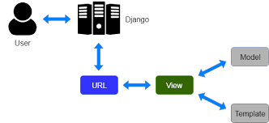

**MySQL:**

**MySQL** : Here Django provides inbuilt db.SQLite for its database .which has admin panel to visualize entire db in more efficient way also we have create a superuser for that .

**Bootstrap v5.0:**

Bootstrap is a free and open-source CSS framework directed at responsive, mobile-first front-end web development. It contains CSS- and (optionally) JavaScript-based design templates for typography, forms, buttons, navigation, and other interface components.

Adding bootstrap to application:

    <link rel="stylesheet" href="https://stackpath.bootstrapcdn.com/bootstrap/4.1.3/css/bootstrap.min.css" integrity="sha384-MCw98/SFnGE8fJT3GXwEOngsV7Zt27NXFoaoApmYm81iuXoPkFOJwJ8ERdknLPMO" crossorigin="anonymous">

Above script is added in <head> </head> of the HTML page.

**Home page:**

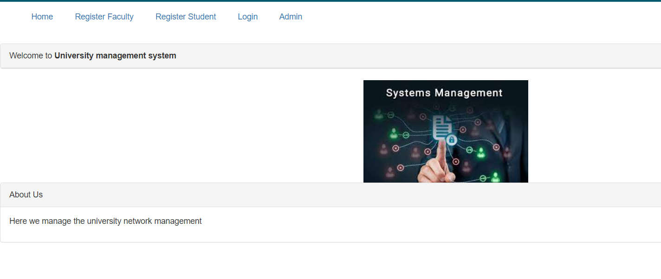

**Entity Boards :**

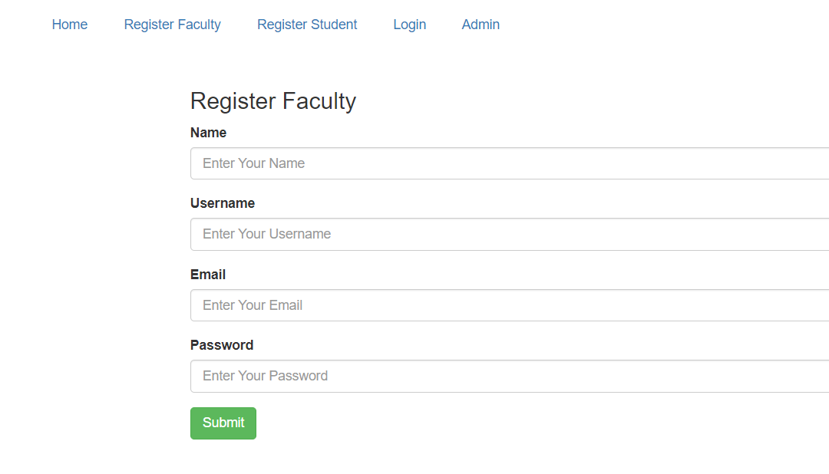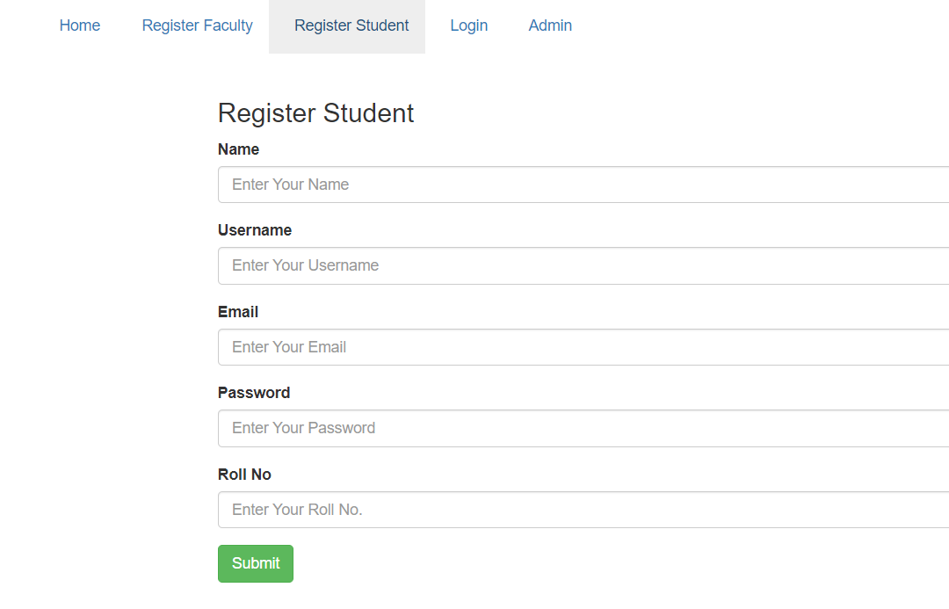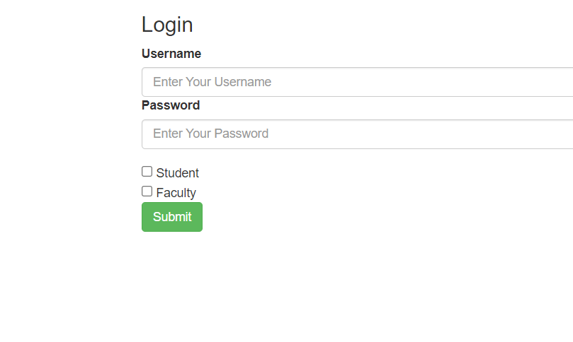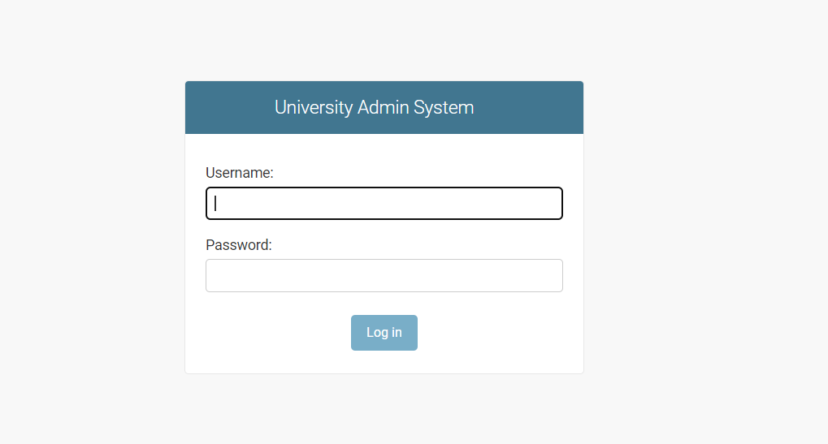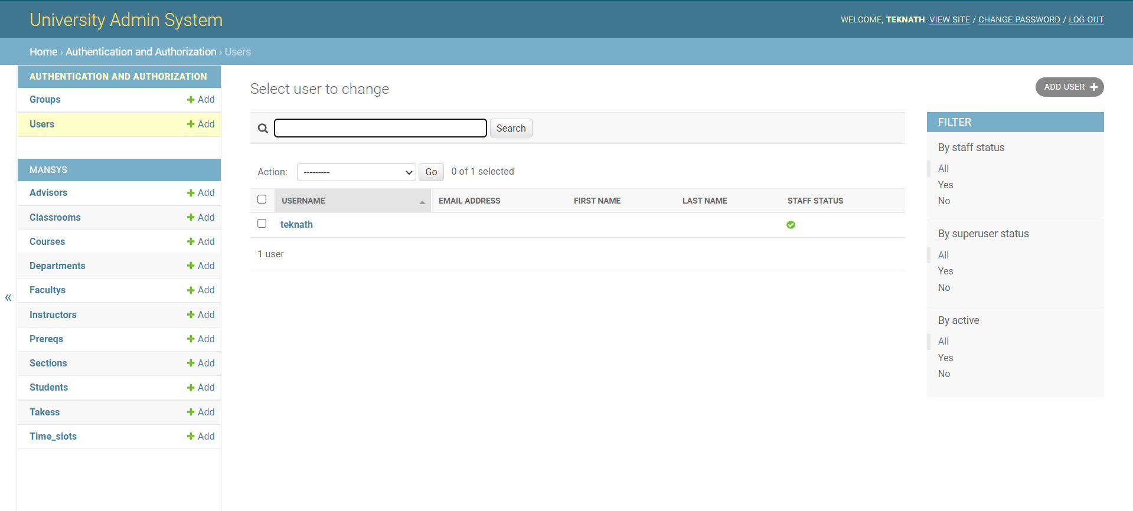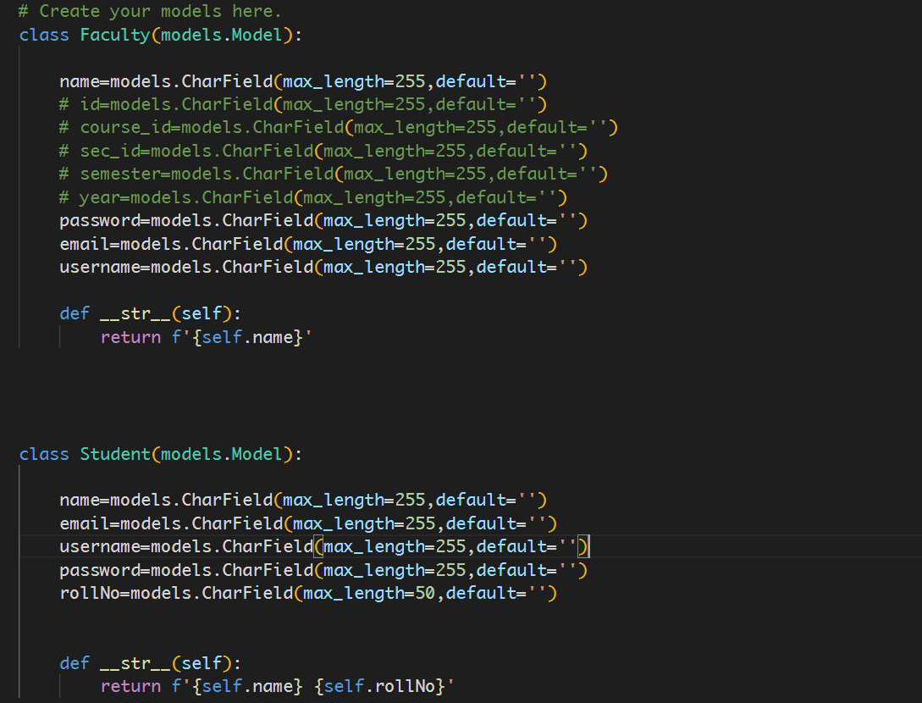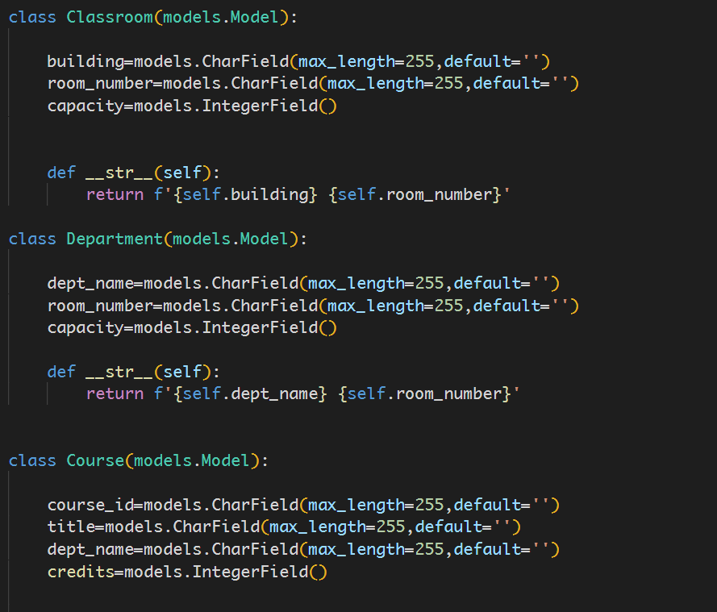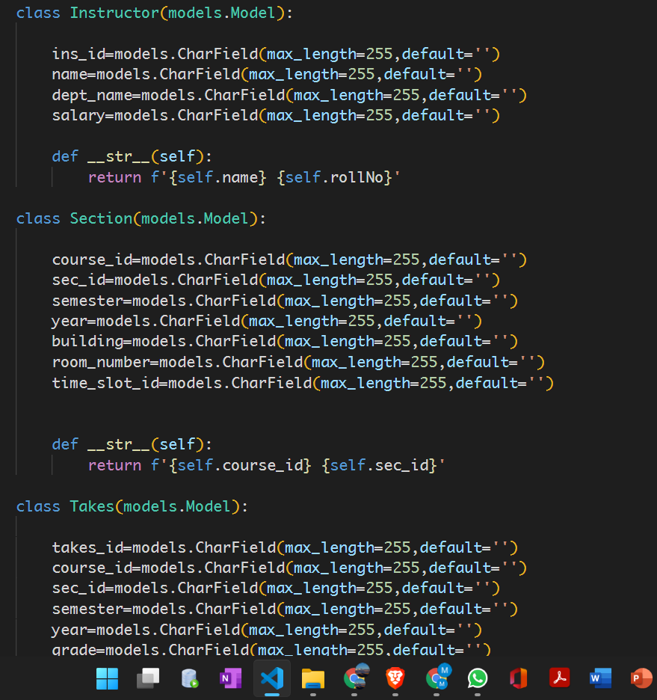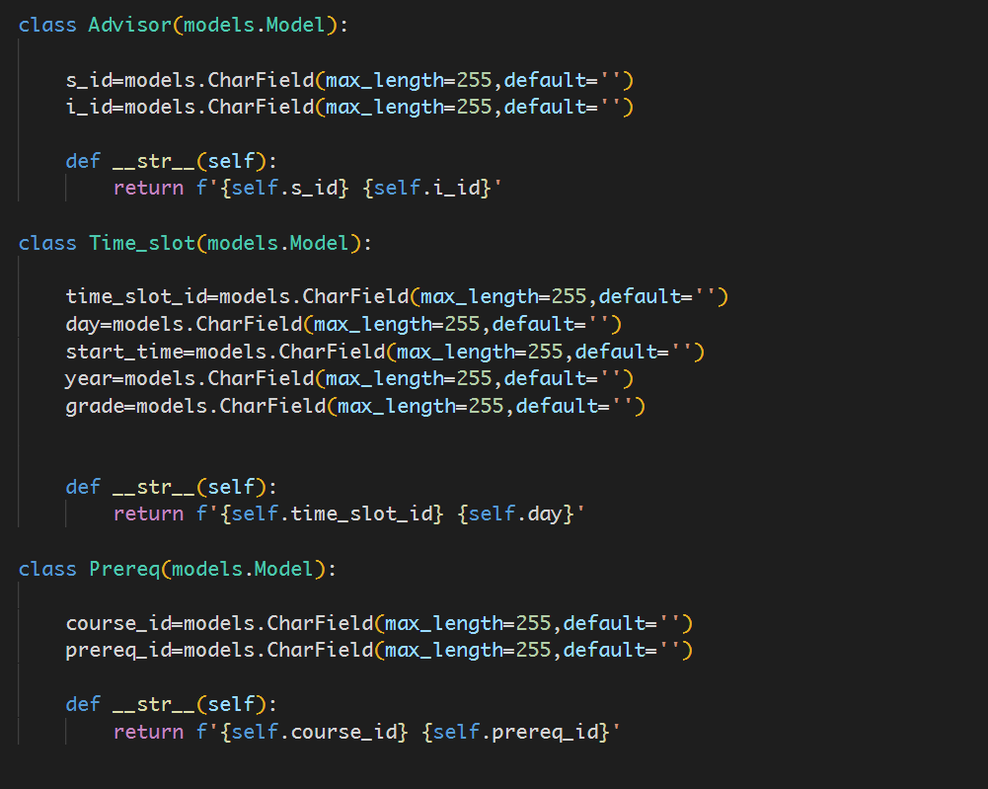

**Conclusion:**

Django application was developed for the Student Information Management System with the help of Bootstrap5 as a front-end framework and SQLITE as backend database.