**Assignment No.5**

**ADS Lab**

**Date: 19/02/2022**

**PRN: 2019BTECS00033**

**Title:**

Design and implement a system for managing online multiple-choice tests. The system should support distributed contribution of questions by teaching assistants, editing of the questions by whoever is in-charge of the course and creation of tests from the available set of questions. It should be able to administer the tests online, either at a fixed time for all students or at any time but with a time limit from start to finish and give students feedback on their scores at the end of the exam.

**Objective:**

Implementation of online MCQ exam portal in Django, MySQL, Bootstrap v5.0 that is look and feel UI template.

**Introduction:**

In this assignment , I’ve developed a website for MCQ pattern of examination . Where teachers can add questions and execute the exam as per the convenient time .

On the other hand student may appear for MCQ test and complete within time period .

**Technology:**

**The Django Framework:**

**SQL**

**Bootstrap**

**(Screenshots)**

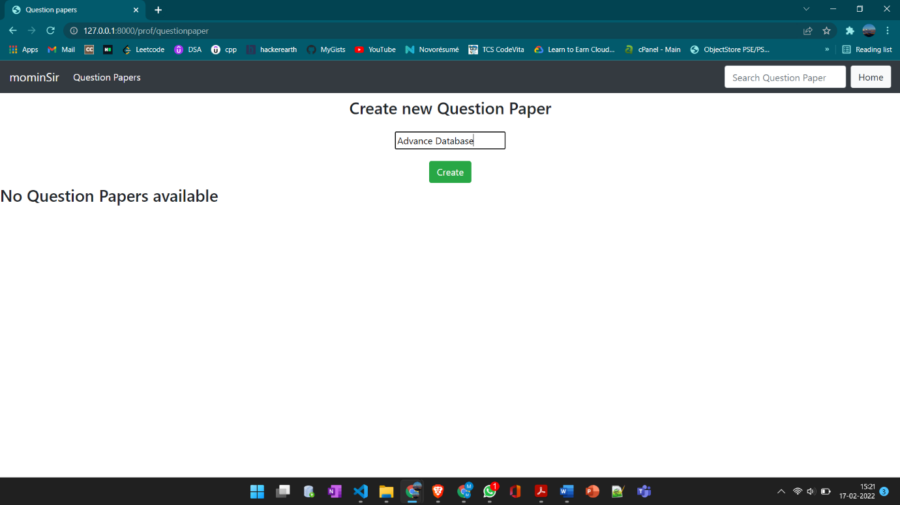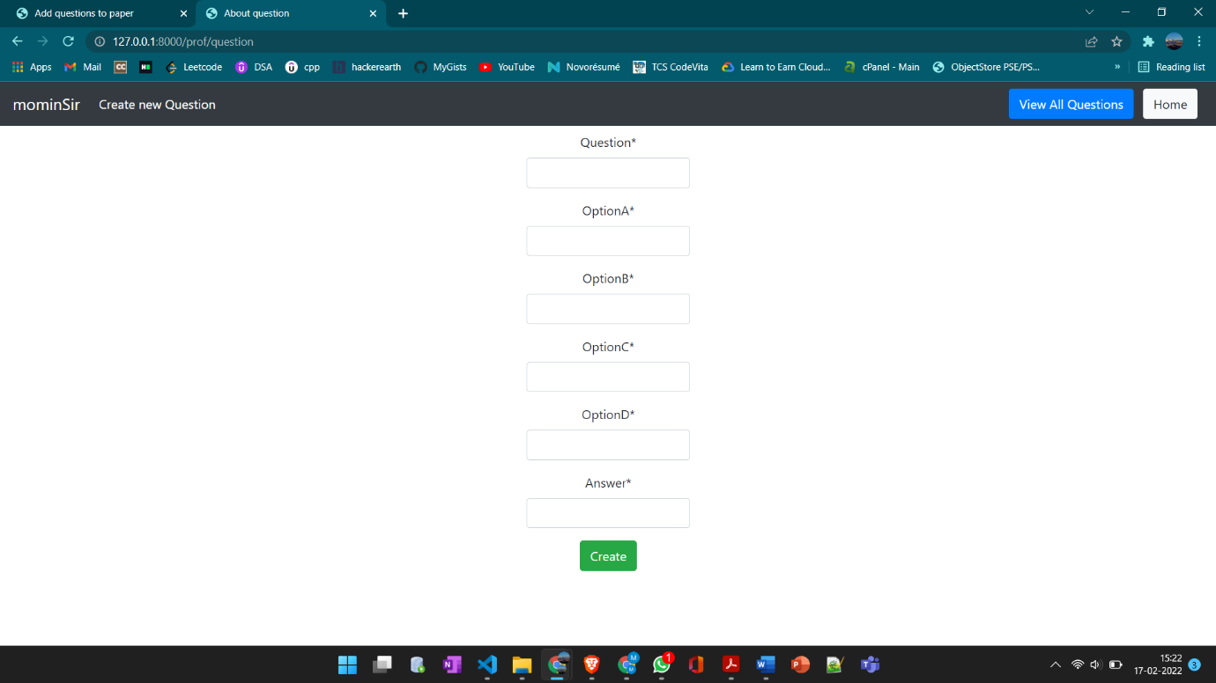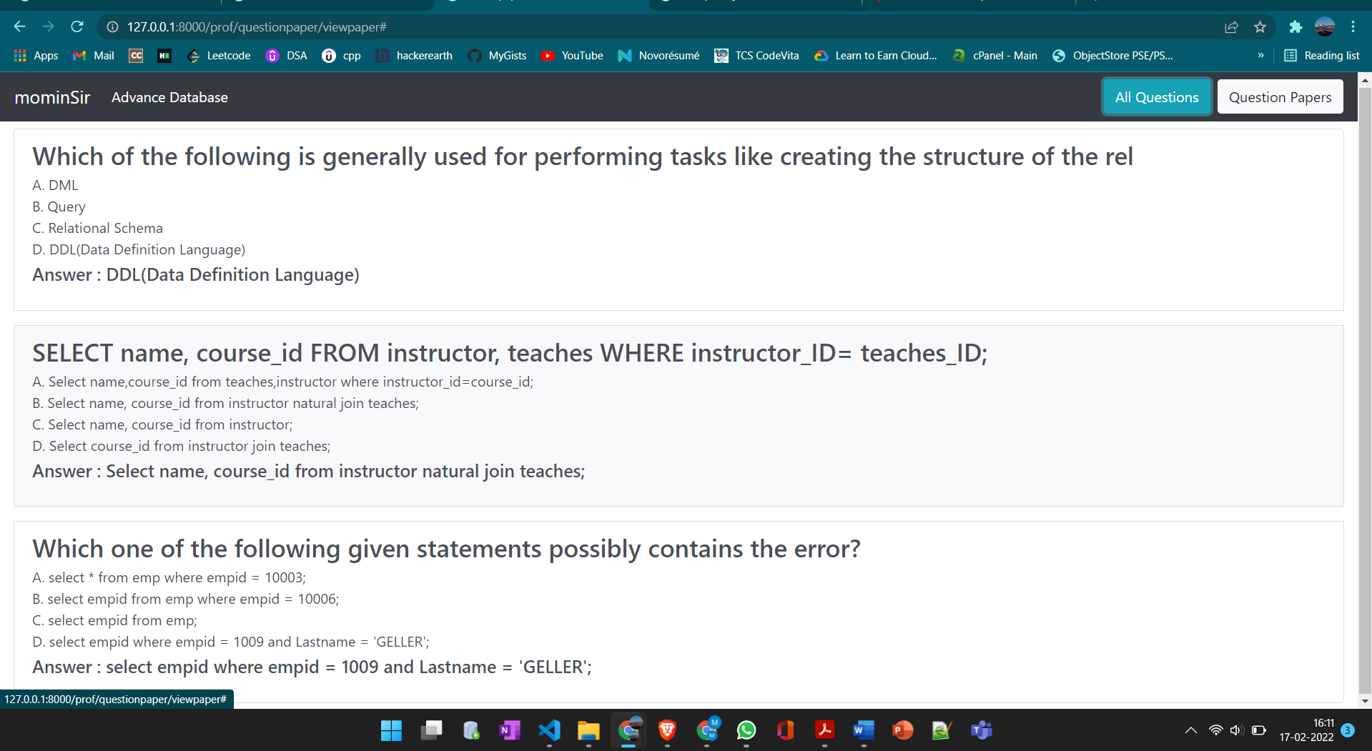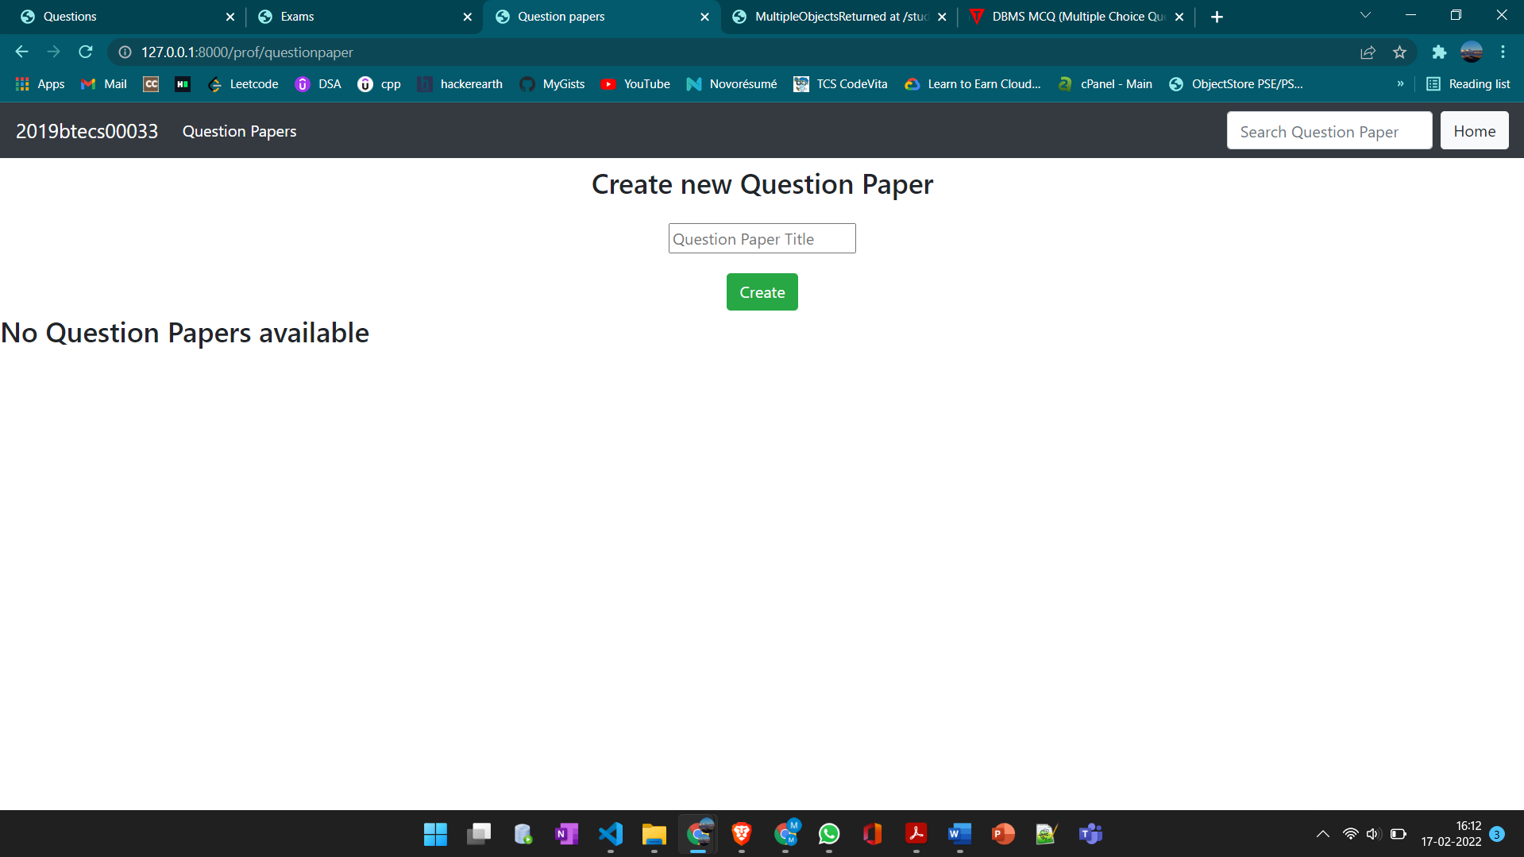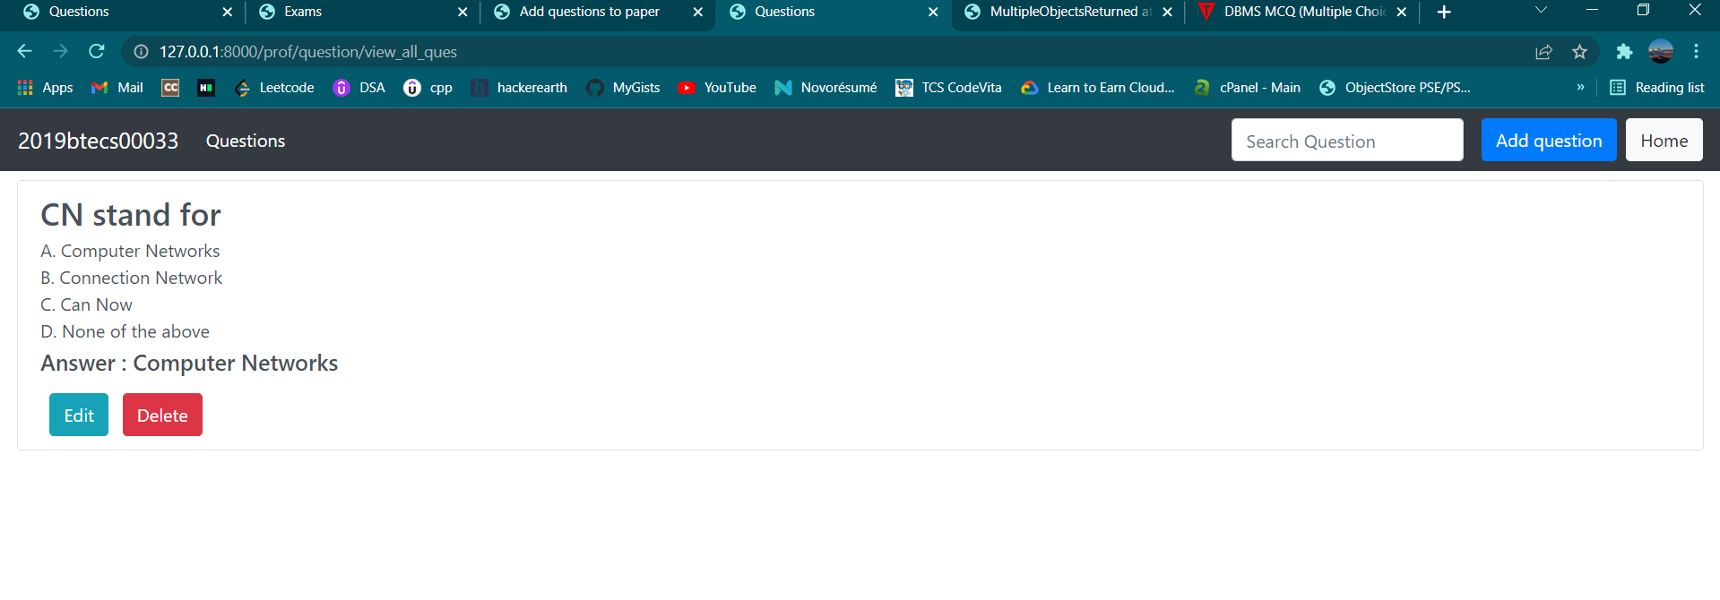

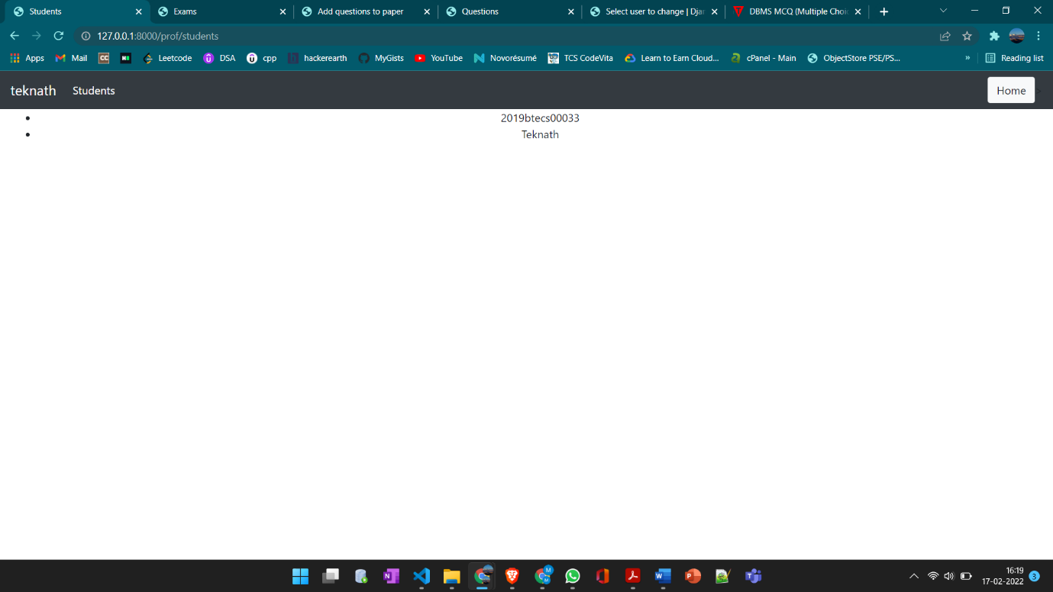

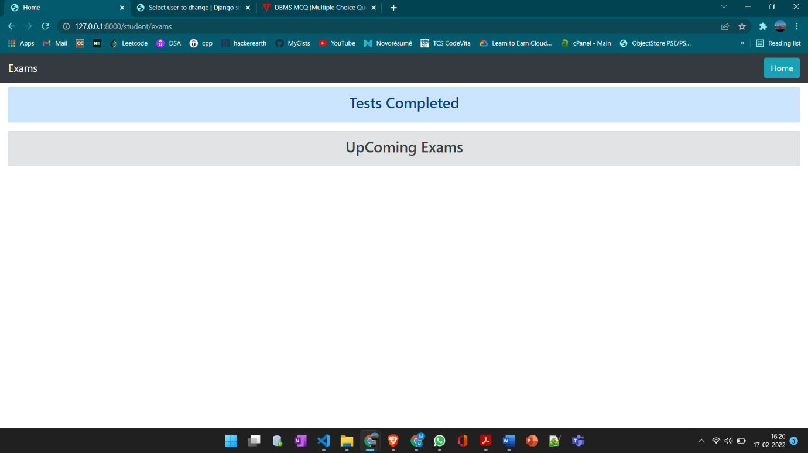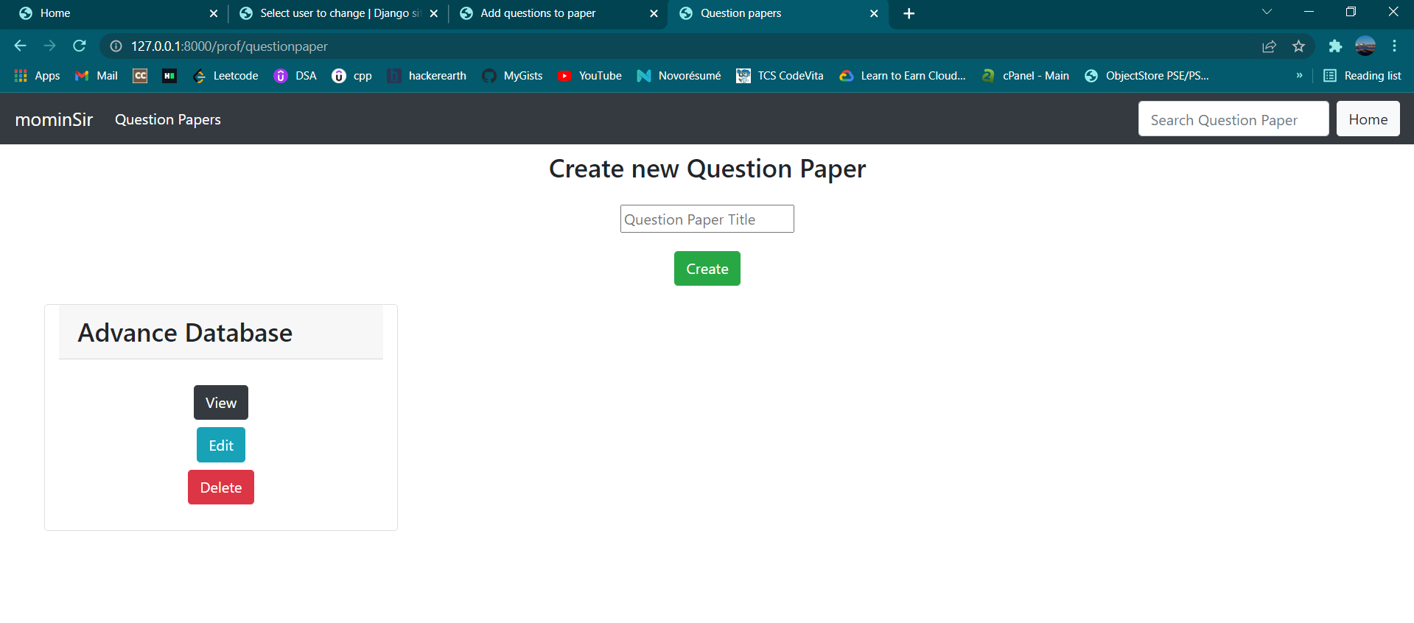

**Student Test UI**

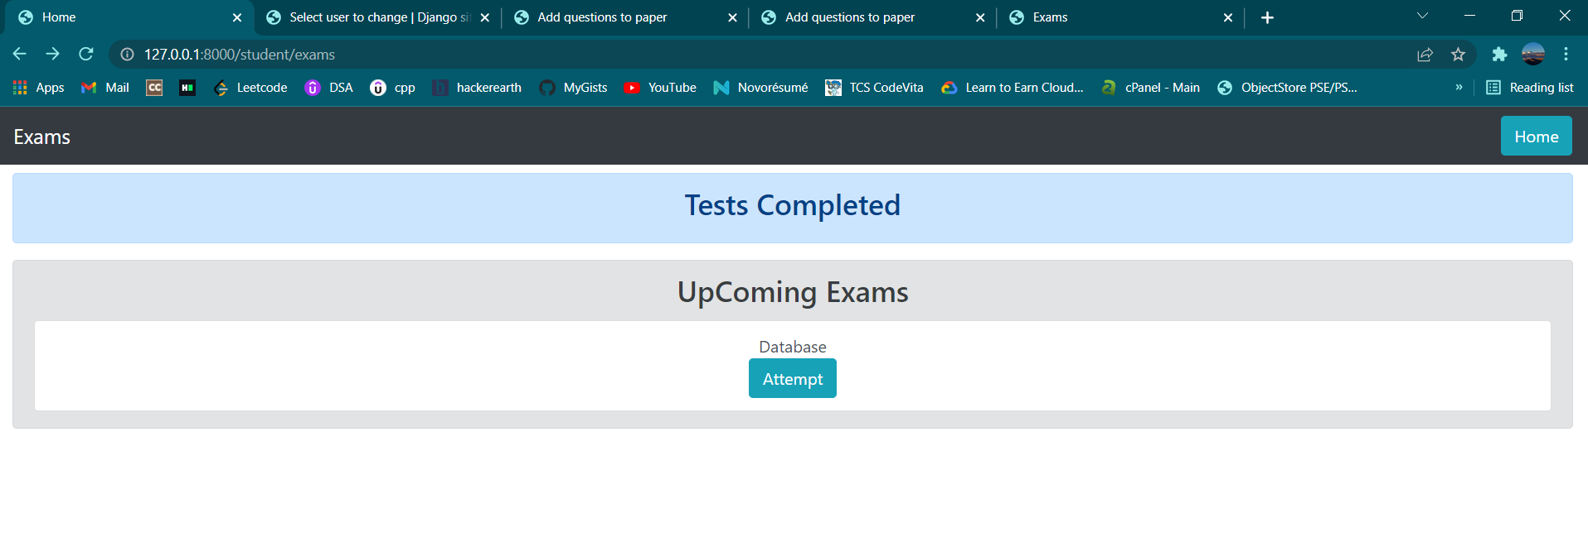

**Student HomePage**

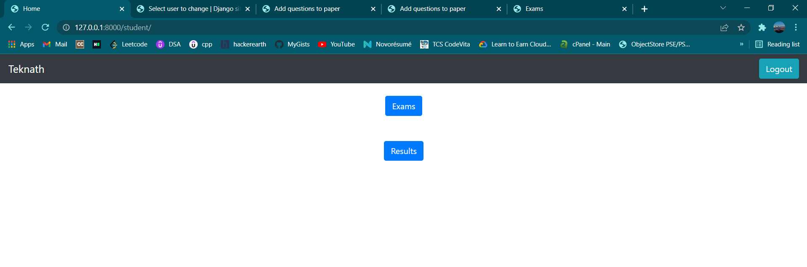

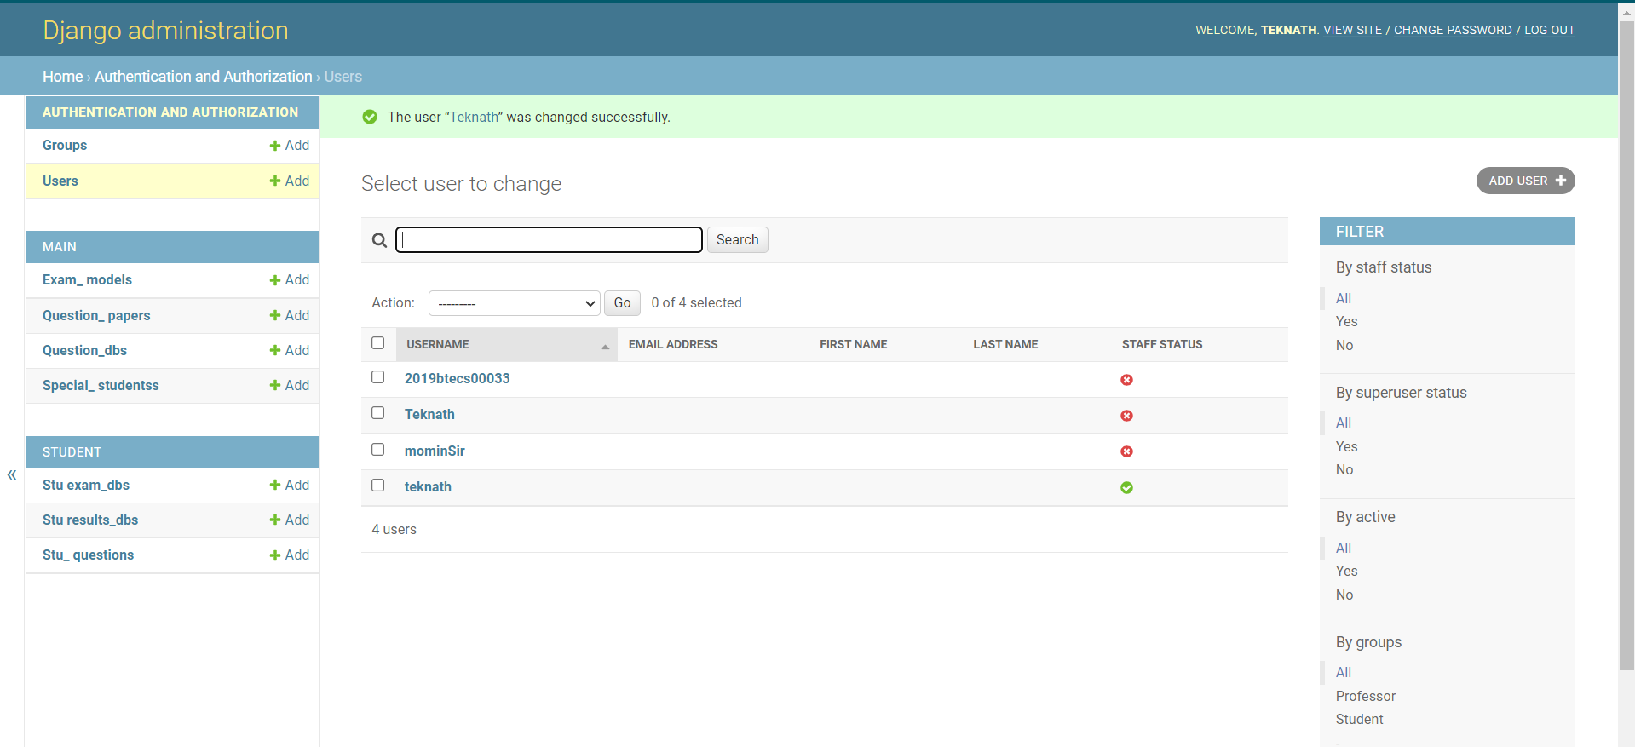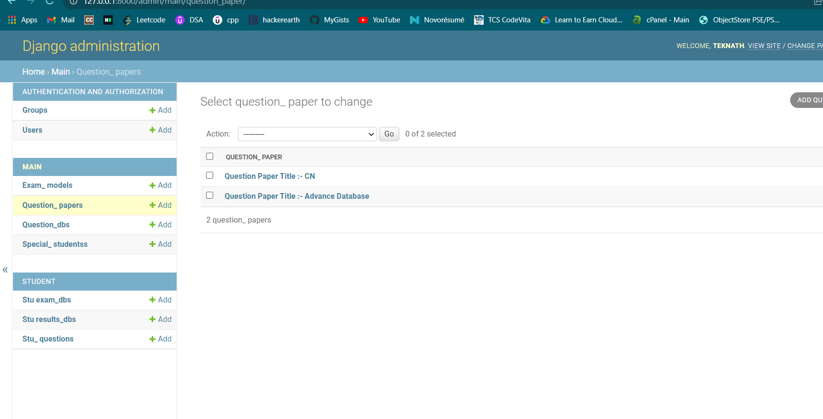

**Conclusion:**

The importance of work in academics cannot be overemphasized. It broadens the horizon of students in their area of studies with focus on the research topic. It provides a user-friendly platform of multiple-choice questions examination. It can be used for academic purpose, professional certifications, staff promotion examination, Post UTME entrance examination, etc. The online examination system is developed using Django with SQLite database .