**TY B.Tech. (CSE) – II [ 2020-21 ]**

**4CS372 : Advanced Database System Lab.**

**Assignment No. 1**

**Title:**

Installation, configuration & testing of Oracle 12c EE / 18c XE.

**Objective:**

· Installation, configuration & testing of Oracle 18c XE and MySQL 8.0 database.

· Create GUI desktop application in Python which will conduct to schema. Allows to choose available tables.

· Demonstrate the CRUD operations on selected table.

**Introduction:**

A **database management system (DBMS)** is software that controls the storage, organization, and retrieval of data.

The relational model is the basis for a **relational database management system (RDBMS)**. An RDBMS moves data into a database, stores the data, and retrieves it so that applications can manipulate it.

In Oracle Database, a database [**schema**](https://docs.oracle.com/en/database/oracle/oracle-database/18/cncpt/glossary.html#GUID-D55ED7A6-3BC4-4A16-981F-92E7E905A64D) is a collection of logical data structures, or schema objects. A database user owns a database schema, which has the same name as the [**user name**](https://docs.oracle.com/en/database/oracle/oracle-database/18/cncpt/glossary.html#GUID-E141F64B-73ED-43DC-B22A-DA0210B8EBEF).

MySQL is released under an open-source license. So you have nothing to pay to use it. MySQL is a very powerful program in its own right. It handles a large subset of the functionality of the most expensive and powerful database packages. MySQL uses a standard form of the well-known SQL data language. MySQL works on many operating systems and with many languages including PHP, PERL, C, C++, JAVA, etc. MySQL works very quickly and works well even with large data sets.

**Procedure:**

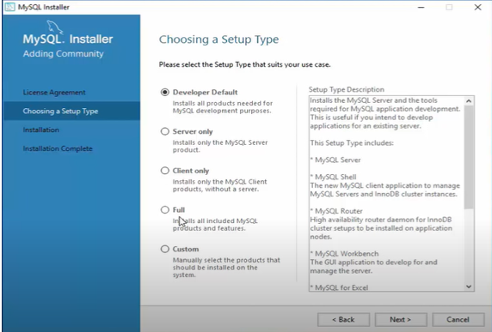

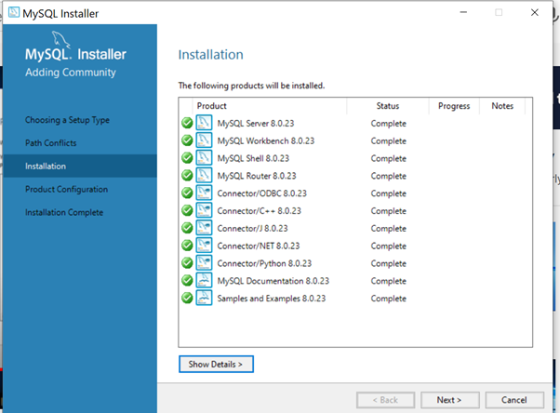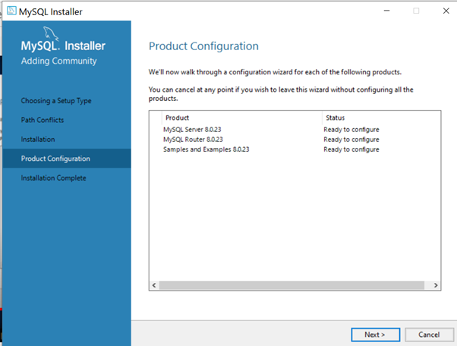

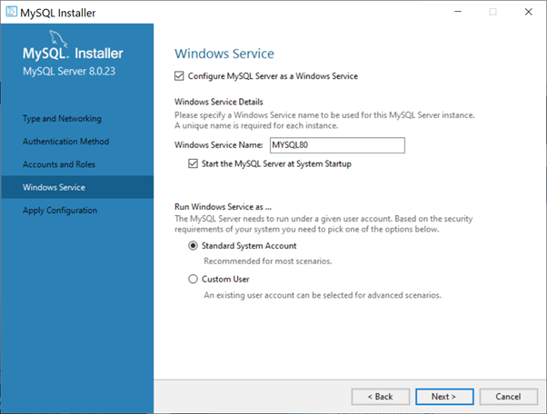

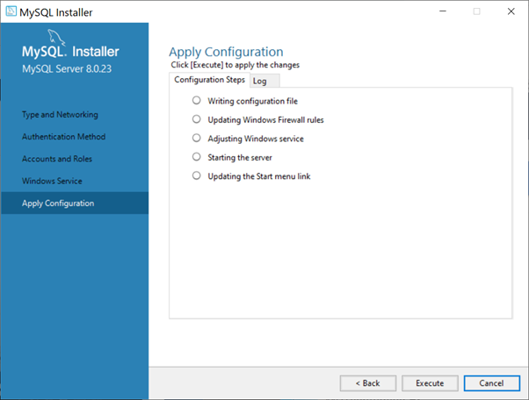

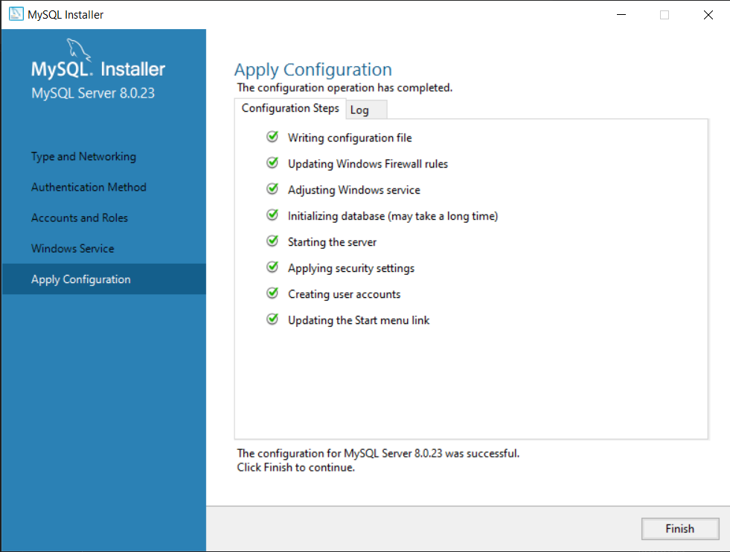

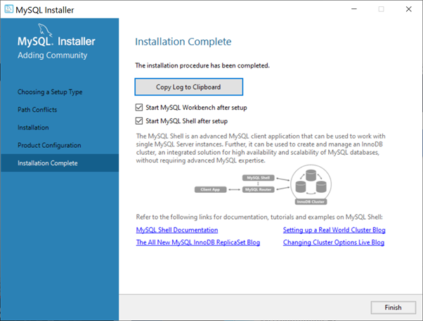

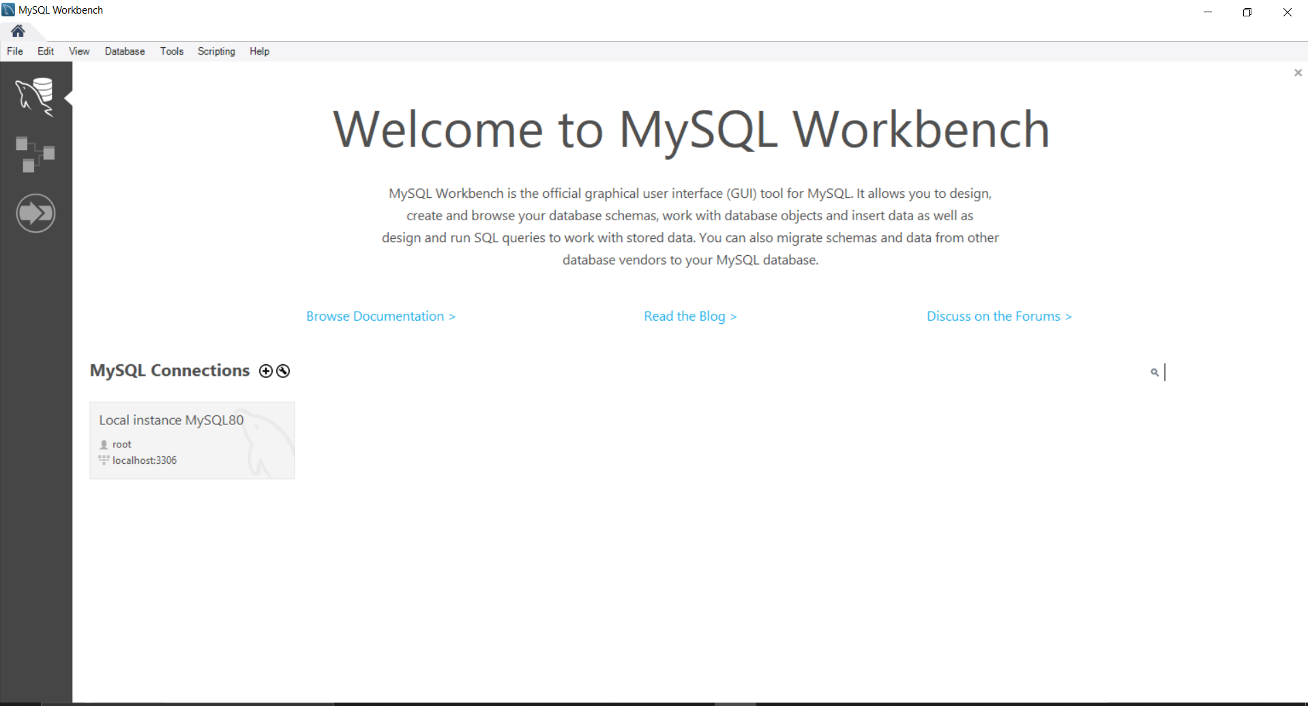

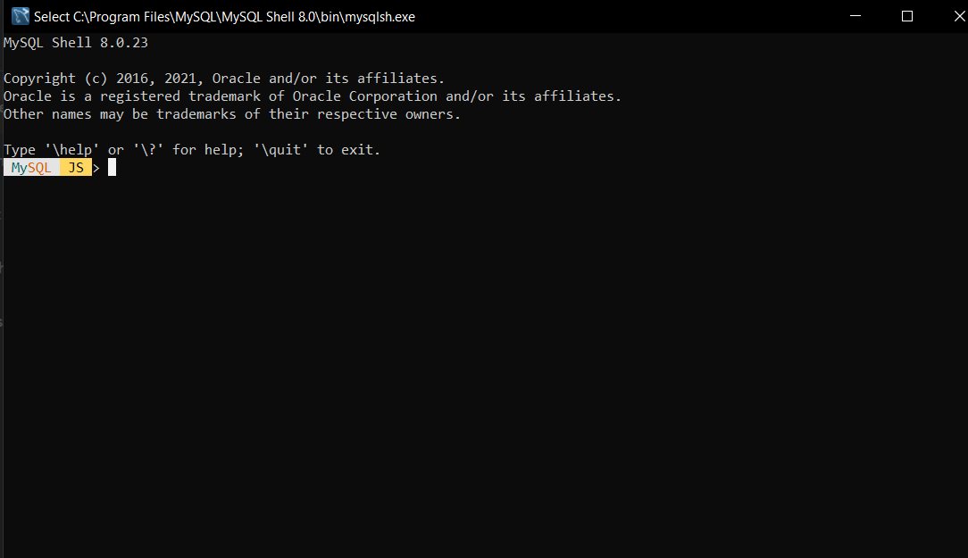

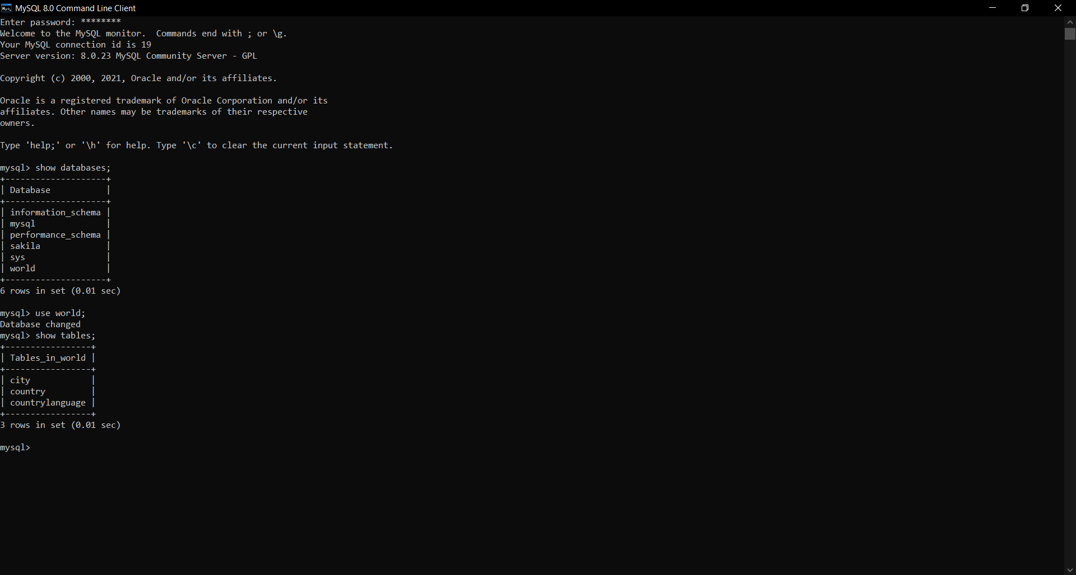

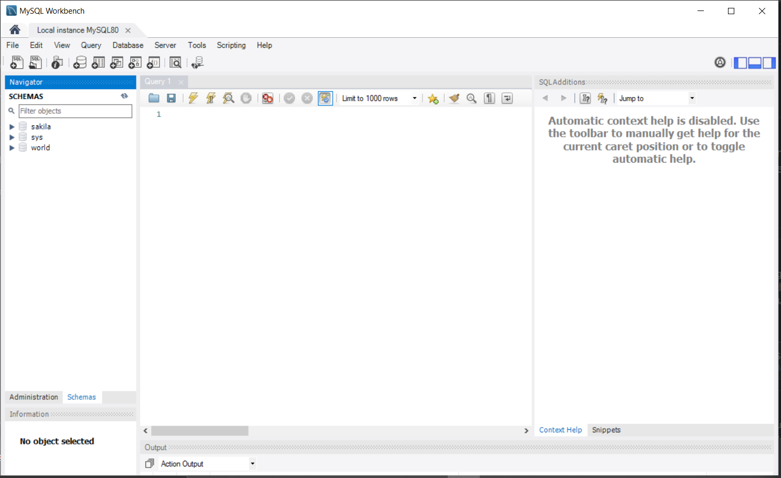

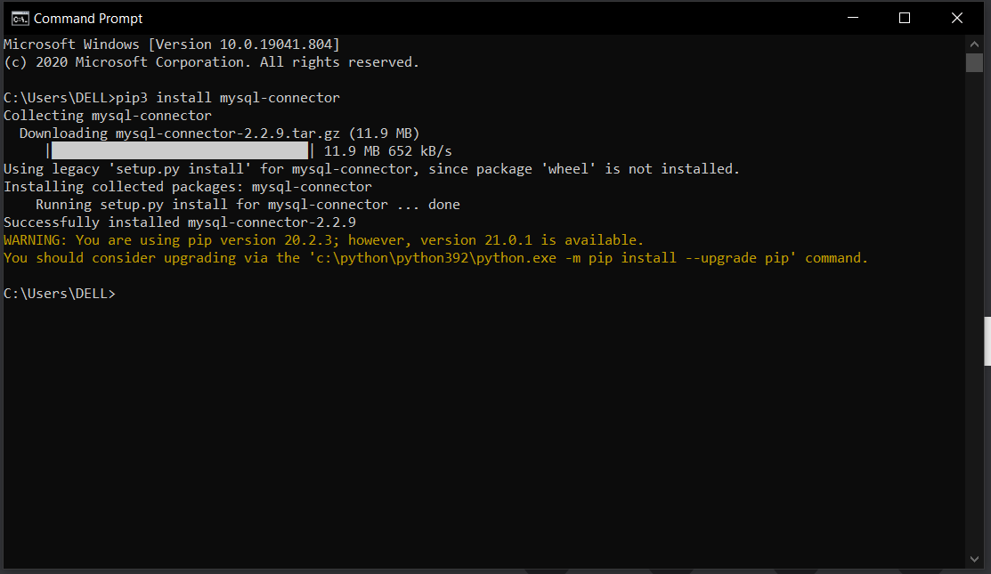

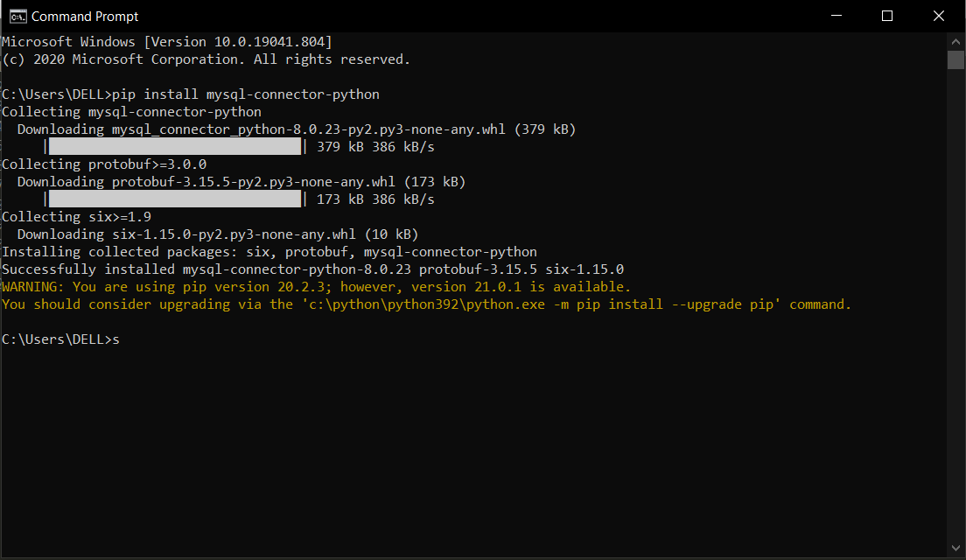

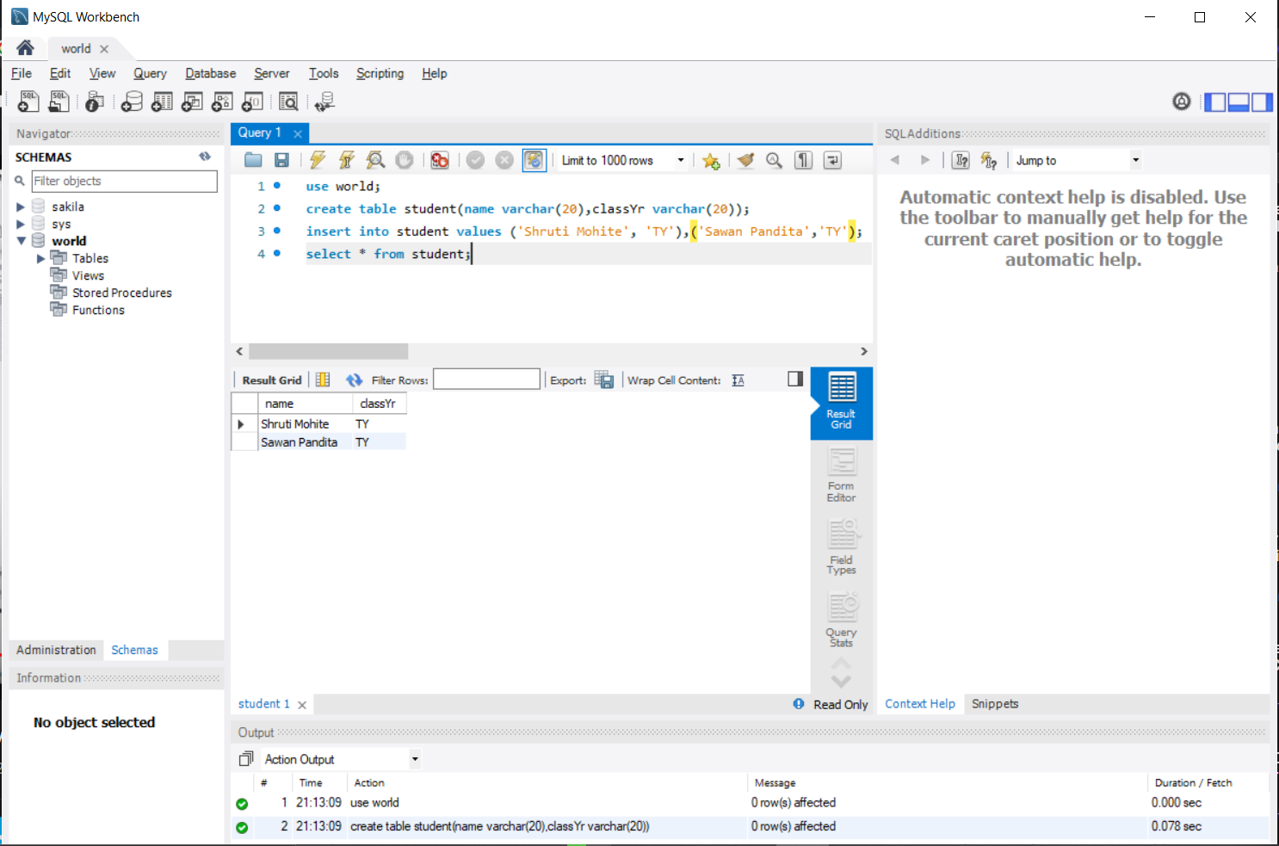

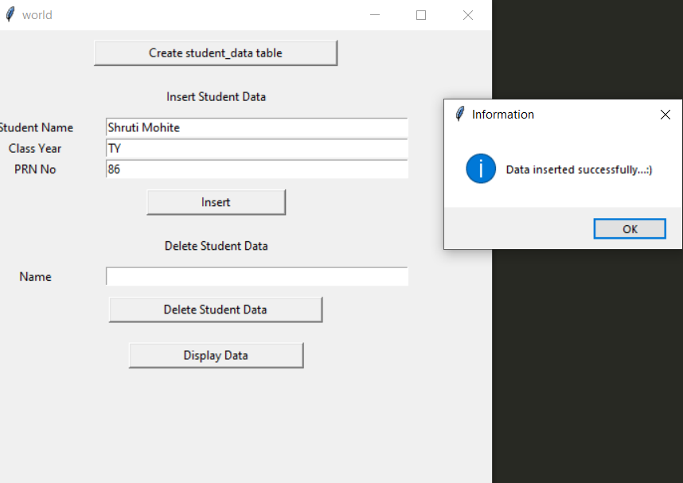

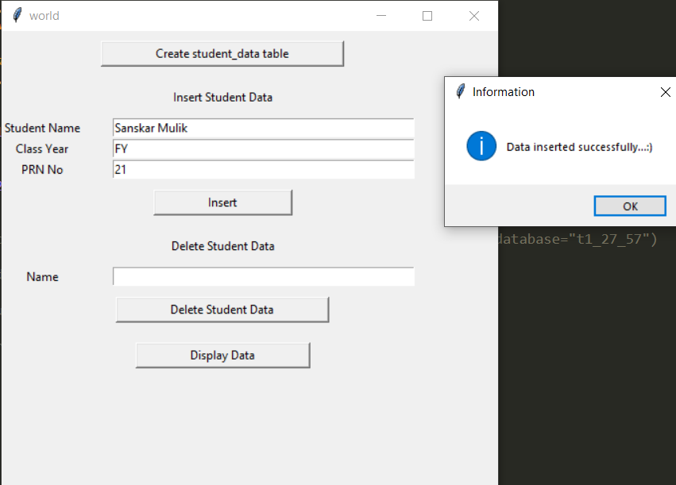

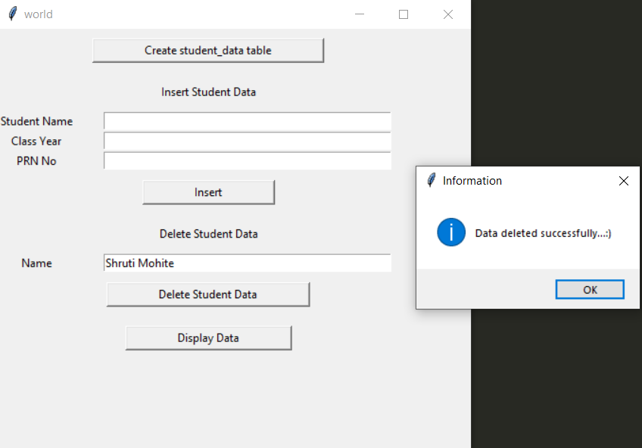

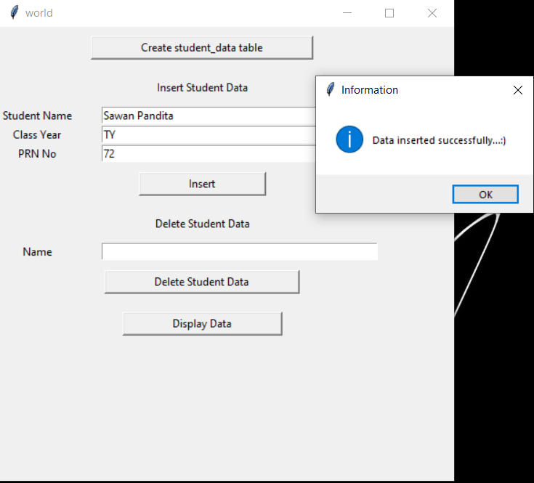

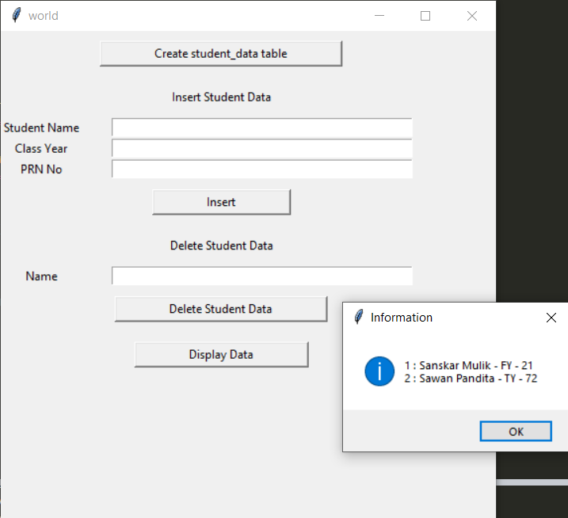

**Conclusion:**

In this assignment, we saw how to use MySQL Connector and Oracle connector /Python to integrate a MySQL database and Oracle database with our Python application. Along the way, we learned some programming best practices that are worth considering when it comes to establishing a connection, creating tables, and inserting and updating records in a database application.

**References:**

1. <https://www.oracle.com/tools/downloads/sqldev-downloads.html>

2. <https://www.oracle.com/in/database/technologies/xe-downloads.html>