**Assignment No. 5**

**Group ID:** 2018BCGRP10

**Batch:** T2

**PRN No:** 2018BTECS00072 & 2018BTECS00086

* **Title: Performance Tuning**
* **Aim:** To do the performance tuning for Assignment No.3 & 4.
* **Introduction:**

When developing an application, it’s important to know how it performs under various workloads. Performance software testing helps determine how responsive and stable an app will be in different scenarios.

Although testing is a key part of app development, many developers underestimate its importance. Skipping the testing phase could mean overlooking issues related to security, functionality, accessibility, and performance. **Performance testing is done to verify server response time and throughput under different load conditions.**

**Apache JMeter:**

A great resource for performance testing is Apache JMeter, an open-source, 100% pure Java application that load-tests functional behavior and measures performance. JMeter simulates a heavy load to test an app’s strength and analyze its overall performance under different load types.

JMeter flexibly tests the dynamic and static resources of an application. Now, you might be wondering what these resources are. Dynamic resources include JSP, Servlets, and AJAX, while static resources are Document Object Model (DOM) elements like JavaScript and HTML.

* **The Importance of Performance Testing:**

Performance testing is a crucial step in determining how your web app will perform under heavy loads. JMeter is a valuable tool for performance testing, as it can discover the maximum number of users that your web app can handle.

JMeter does both load and stress testing; while load testing models expected usage by simulating concurrent users, stress testing determines the maximum load that a web server can handle. The results of these [tests will help you reduce bottlenecks](https://clutch.co/app-developers/resources/questions-startups-should-ask-design-development-when-building-app) and boost performance.

* **Functional Block Diagram:**

The diagram below shows how JMeter models users and simulates a heavy load:

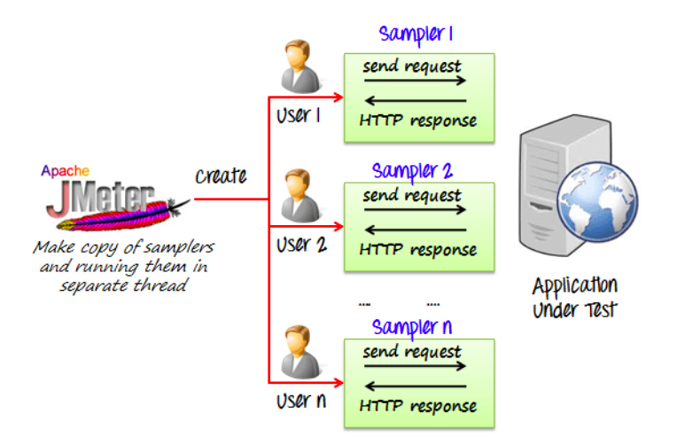

JMeter models users to calculate an app’s expected usage and load-bearing capacity.

* **Creating a Performance Test in JMeter**

1. **We created a performance test named “Test_Plan_Assg5”**

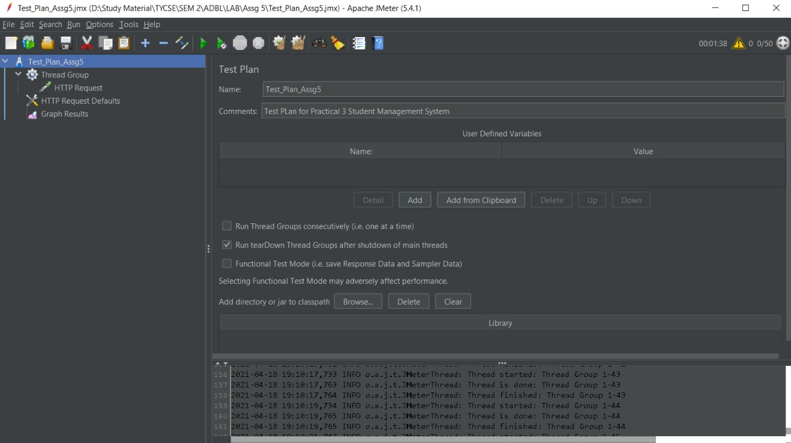

1. **Create a thread group, then add thread properties and add JMeter elements**

Install and launch the JMeter application. Right-click on “Test Plan”, click “Add”, then “Thread(Users)” and finally “Thread Group.”

You have successfully created a thread group.

**HTTP Request Default:**

Attach the HTTP Request Defaults element to your thread.

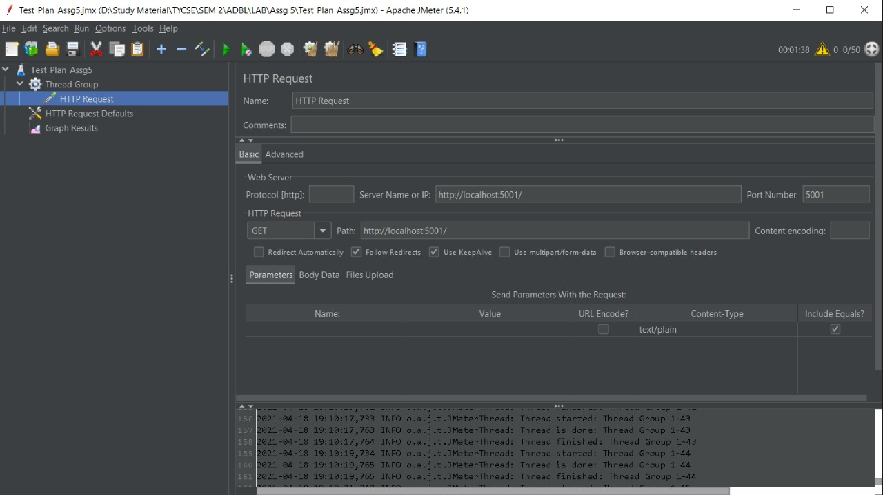

1. **Run the test and analyze the results**

Carefully analyze the graph that you got in real time. Here are the two main factors to consider:

**Throughput:**

The measuring capacity of the server, or how much it can handle. Ideally, this number should be infinite, if not very high.

It’s important to note that throughput depends on other factors, such as internet speed, the Google server’s current load, and CPU power. These factors continuously change, meaning you won’t get the same results every time you run the test.

**Deviation:**

The variation from the average. This number should be zero, or very low.

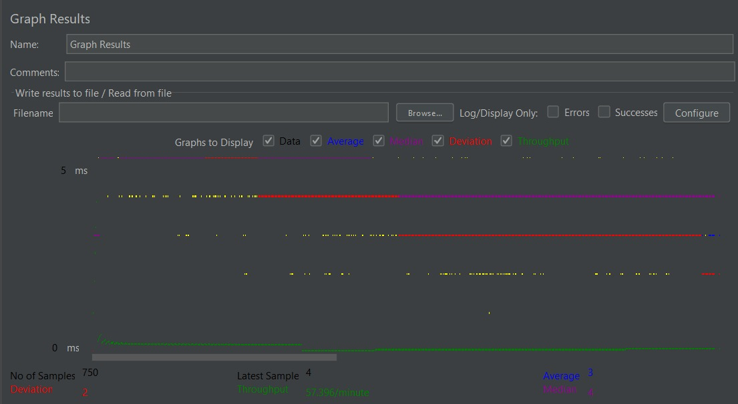

As you can see, this output report comes in five colors, each of which signifies something different:

1. **Black**- the total number of samples sent to the server
2. **Blue**- the average of the total number of samples sent to the server
3. **Red**- the standard deviation in real-time output
4. **Green**- the throughput rate (the number of requests the server handled per minute)
5. **Purple**: the median (a number which divides the samples into two equal halves)

* **Conclusion:**

After analyzing the graph, following are the conclusions:

* The throughput is 955 requests per minute.
* This means that the server handled 955 requests per minute.
* Sometimes, the throughput even got 1,000 requests per minute.

Based on these numbers, we can deduce that site has very good throughput.

* **References:**

<https://clutch.co/web-developers/resources/how-use-jmeter-test-your-web-application>