**ADSL LA2 Submission**

Name : Teknath K jha

PRN : 2019BTECS0033

Batch : T6

Title : To Demonstrate Distributed databases usingcasandra.

Aim : To understand the working of distributed databases.

Implementation :

Database tables preparation for site1 , site2 , site3

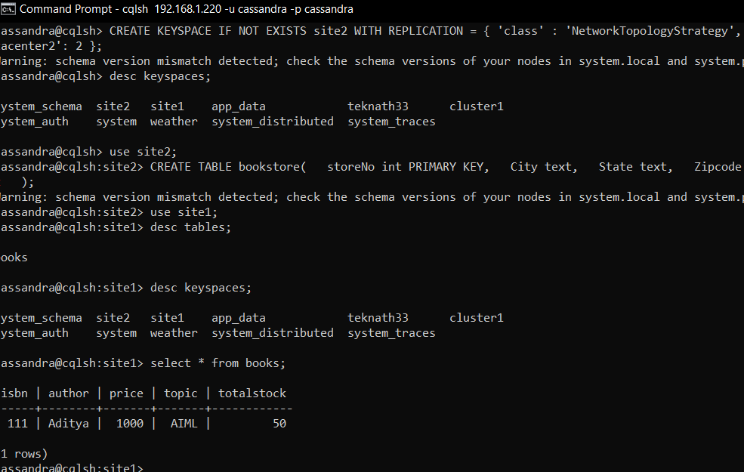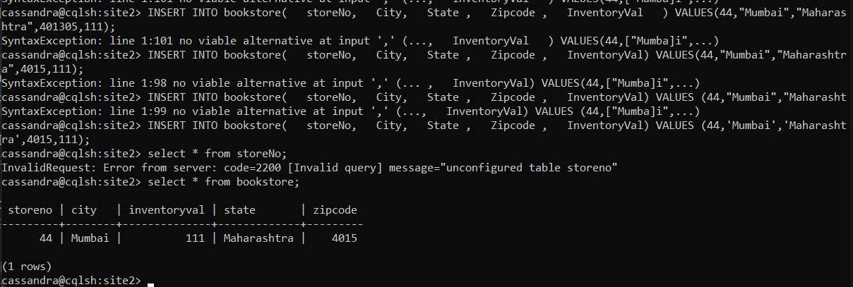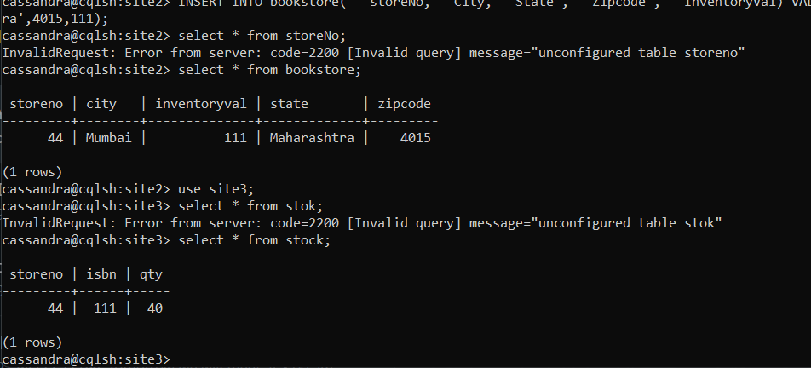

From second Node :

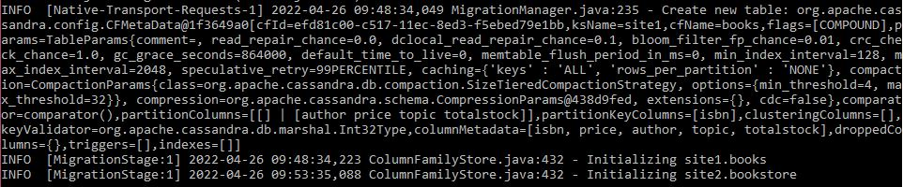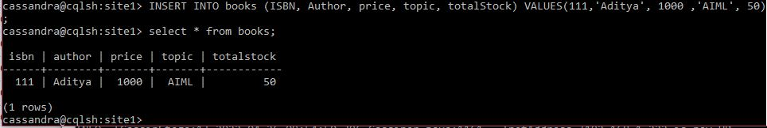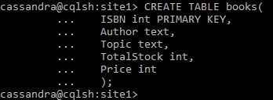

From 3rd Node :

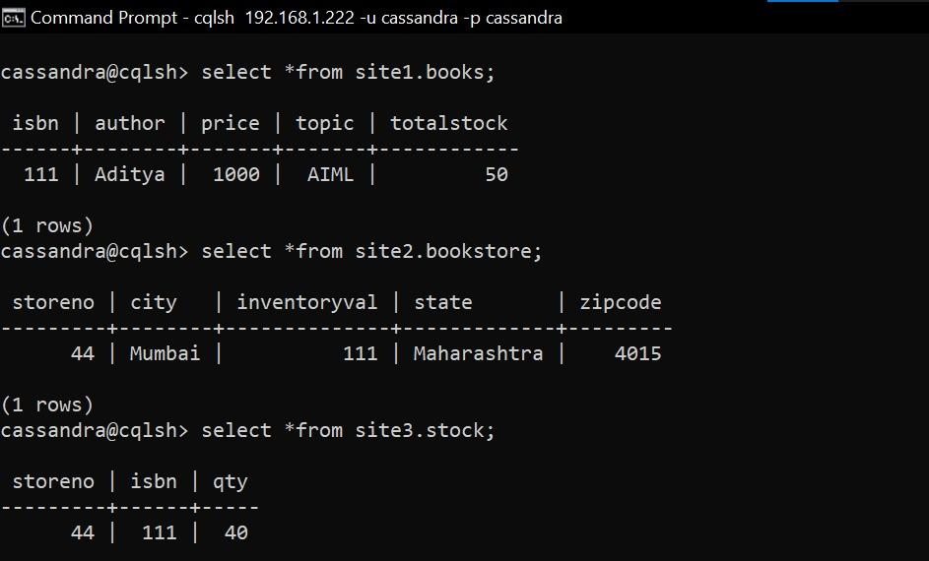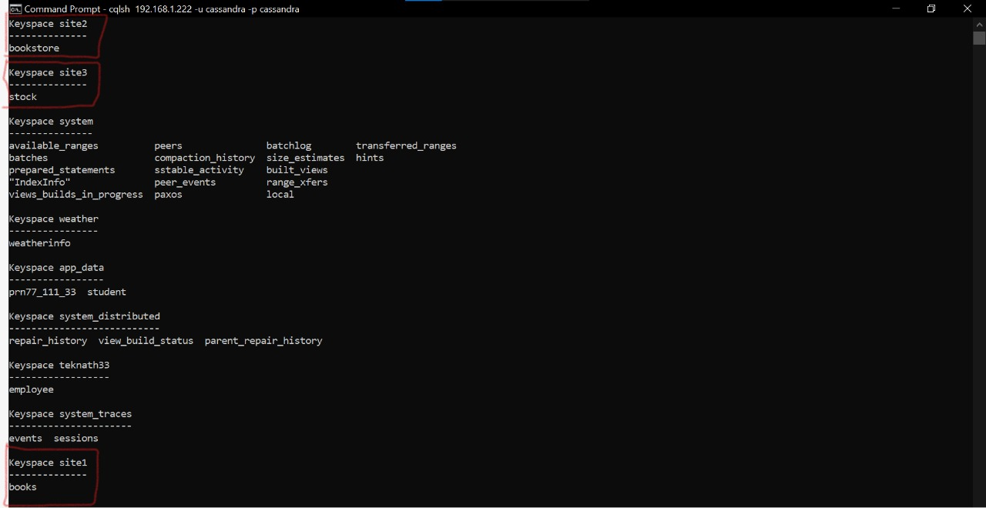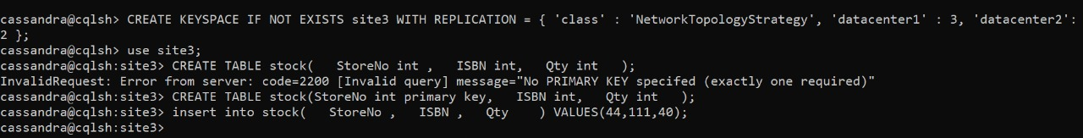

Conclusion : Nodes connections done on the basis of different port and ip configurations .