***Advanced Database System Lab***

**Assignment no. 8**

* **Title:** Distributed Database.
* **Aim:** Implement MySQL distributed database.
* **Procedure:**

**Installation & configuration:**

1. Getting the IPv4 address of both the machines.

Slave IPv4

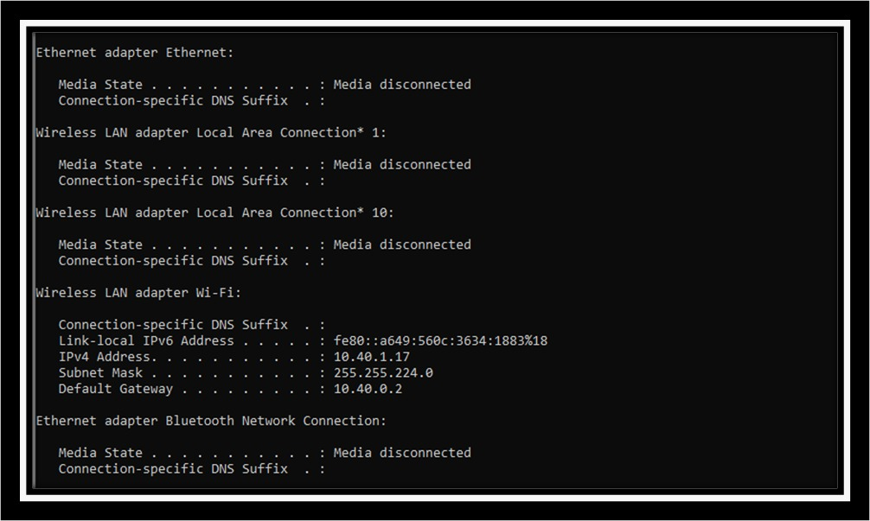

Master ipv4

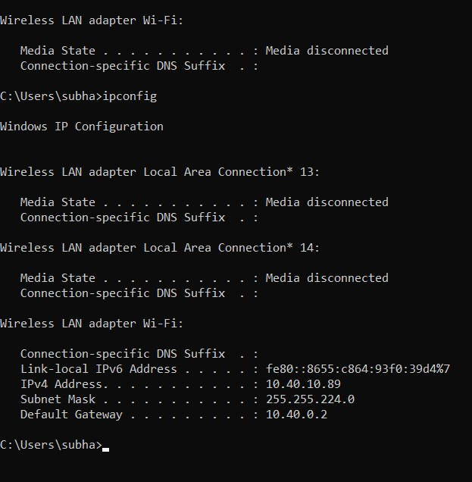

1. Creating the slave node on given IP address on machine having the DB.

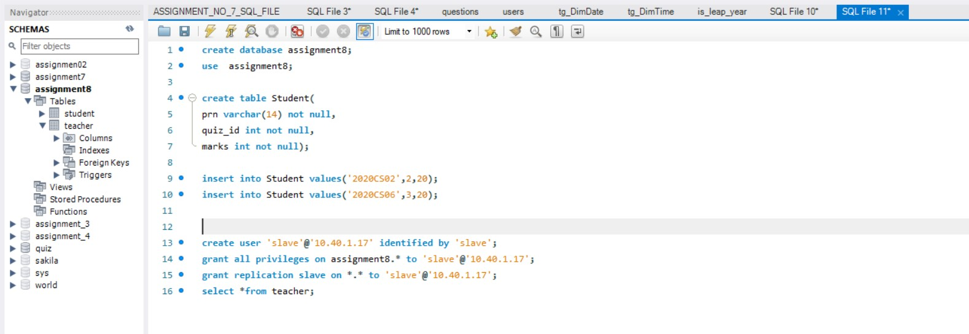

1. Granting all privileges to created user.



1. Granting replication privilege to created user.



This same procedure can be followed with other machines to connect different nodes on a network.

**Using this database for Assignment no. 4:**

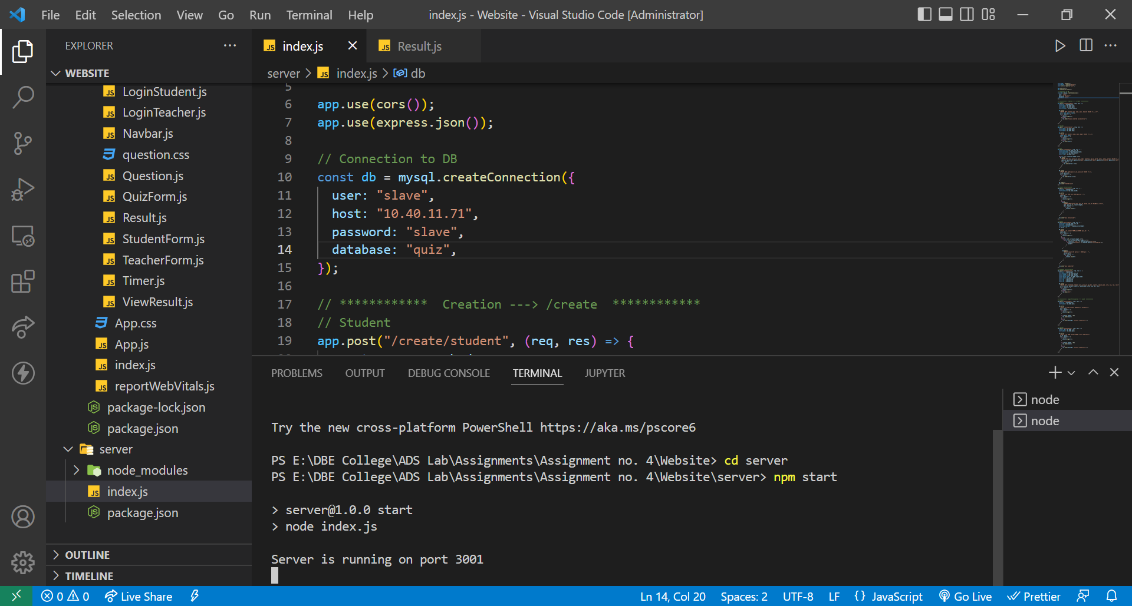

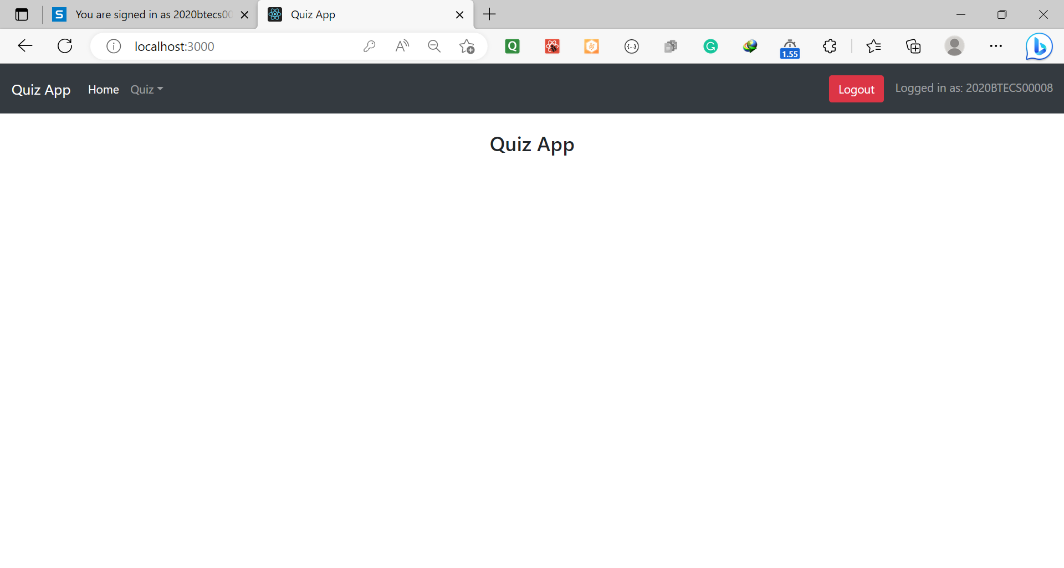

**CRUD operations on DB:**

1. Configuring the remote connection.

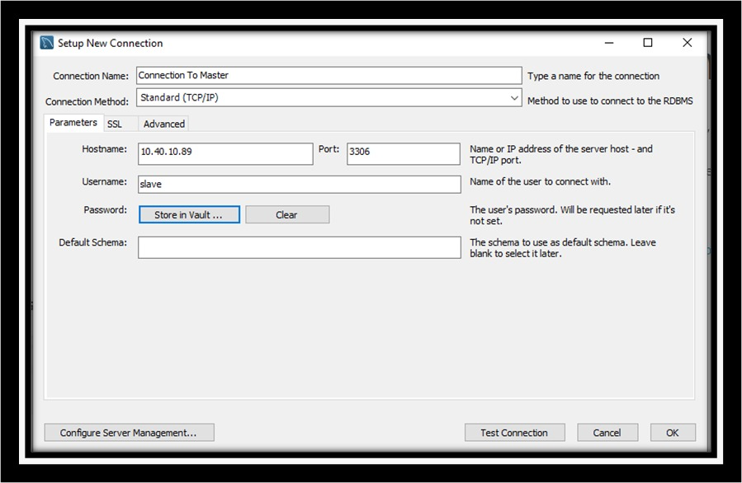

1. Connecting to remote database.

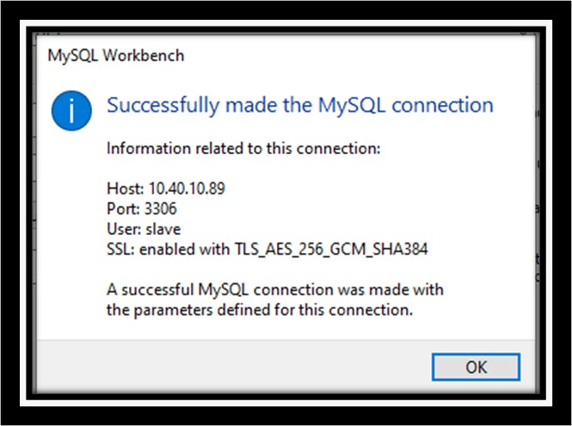

1. Performing the operations:
   1. Creating table from slave node.

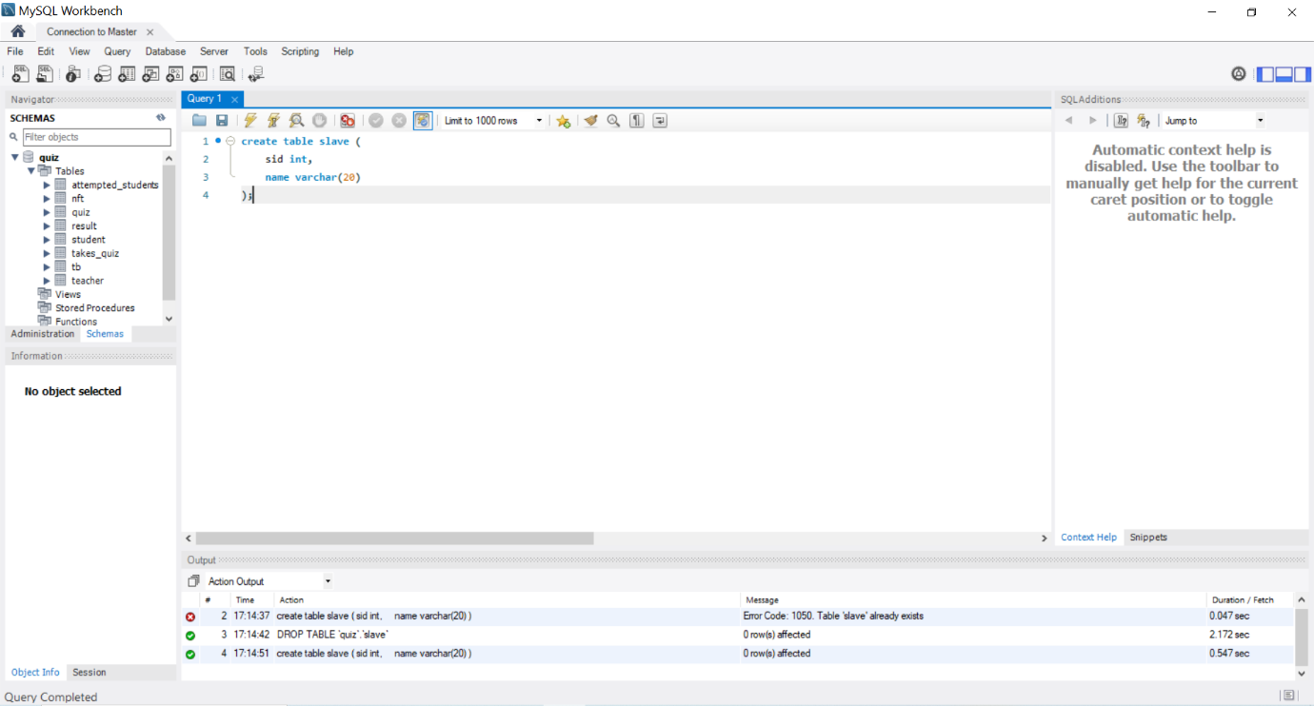

* 1. Viewing the table on master.

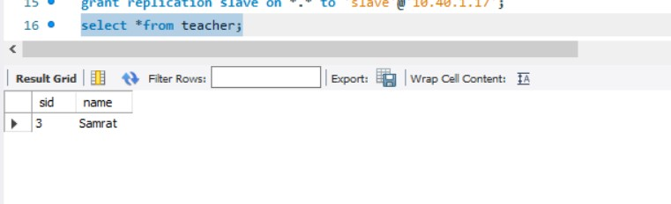

* 1. Inserting the data by master.

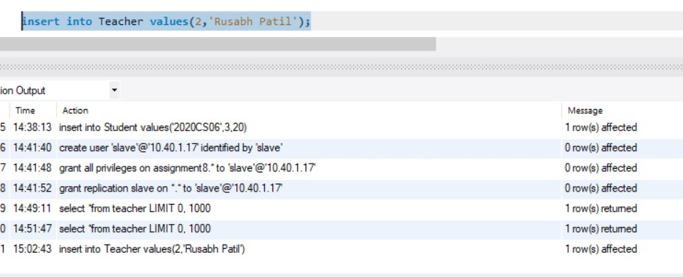

* 1. Viewing & updating the inserted data by slave.

