**Aim:** To implement DDA algorithms for drawing a line segment between two given end points.

**Objective:** Draw the line using (vector) generation algorithms which determine the pixels that should be turned ON are called as digital differential analyzer (DDA).It is one of the techniques for obtaining a rasterized straight line. This algorithm can be used to draw the line in all the quadrants.

**Theory:**

DDA algorithm is an incremental scan conversion method. Here we perform calculations at each step using the results from the preceding step. The characteristic of the DDA algorithm is to take unit steps along one coordinate and compute the corresponding values along the other coordinate. Digital Differential Analyzer (DDA) algorithm is the simple line generation algorithm which is explained step by step here.

**Algorithm:**

**{**

**dx=x2-x1;**

**dy=y2-y1;**

**if(abs(dx) > abs(dy)) {**

**step = dx;**

**} else {**

**step = dy;**

**}**

**Xn = dx/step;**

**Yn = dy/step;**

**for(i=0;i<=step;i++)**

**{**

**putpixel(x1,y1,RED);**

**x1 = x1 + Xn;**

**y1 = y1 + Yn;**

**}**

**}**

**Program:**

**#include<stdio.h>**

**#include<conio.h>**

**#include<graphics.h>**

**#include<math.h>**

**void main()**

**{**

**int gd=DETECT,gm;**

**int i;**

**int xinc,yinc,x1,x2,y1,y2,steps,dx,dy;**

**initgraph(&gd,&gm,"C:\\turboc3\\bgi");**

**printf("Enter values of x1 and x2:");**

**scanf("%d %d",&x1,&x2);**

**printf("Enter values of y1 and y2:");**

**scanf("%d %d",&y1,&y2);**

**dx=x2-x1;**

**dy=y2-y1;**

**if(abs(dx)>abs(dy))**

**steps=abs(dx);**

**else steps=abs(dy);**

**xinc=dx/steps;**

**yinc=dy/steps;**

**for(i=1;i<=steps;i++)**

**{**

**putpixel(x1,x2,RED);**

**x1=x1+xinc;**

**y1=y1+yinc;**

**}**

**getch();**

**closegraph();**

**}**

**Output:**

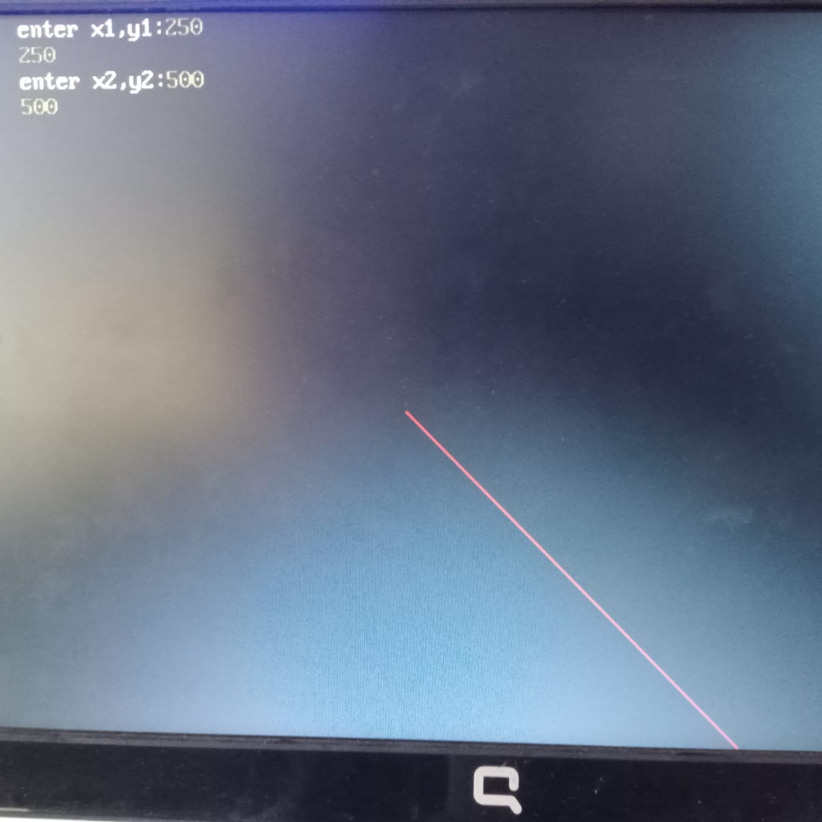

**Conclusion:** Comment on -

1. Pixel :-In computer graphics, the display or screen is composed of a grid of individual picture elements, commonly known as pixels. Each pixel can be independently controlled to display a specific color, creating the overall image.
2. Equation for line:- ((y - y1) = m(x - x1)) or (y = mx + b)
3. Need of line drawing algorithm:-Line drawing algorithms are essential in computer graphics to render lines between specified points. Without a line drawing algorithm, displaying a straight line on a pixel grid would require individually setting each pixel position along the line, which is impractical and inefficient. The DDA algorithm provides a simple and efficient way to approximate lines on the pixel grid.
4. Slow or fast :-The DDA algorithm is relatively fast and suitable for real-time rendering on most systems.