Java
Q1 | Print using member.
Code | class emp  {  static int a = 10;  static int input(int a1)  {  a = 1;  for(int i = 1; i <= a1; i++)  {  a *= i;  }  return a;  }  }  class temp5  {  public static void main(String k[])  {  emp e = new emp();  int a1 = e.input(5);  System.out.println(a1);  }  }
Output | 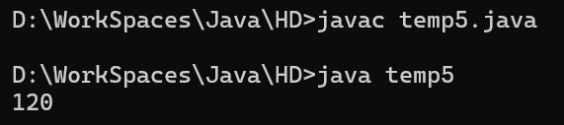
Q2 | Factorial.
Code | class emp  {  static int a = 10;  static int input(int a1)  {  a = a1;  a *= 5;  return a1;  }  }  class temp4  {  public static void main(String k[])  {  emp e = new emp();  int a1 = e.input(10);  System.out.println(a1);  }  }
Output | 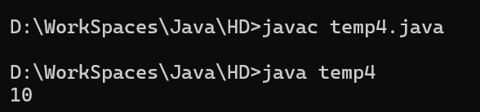
Q3 | Compare
Code: | class Compare  {  public static void main(String args[])  {  String a = new String("Hello");  String b = new String("Hello");  System.out.println(a == b);  System.out.println(a.equals(b));  }  }
Output: | 