🏢 Lumina Reserve: System Design & Complete UML Architecture Manual
End-to-End Visual System Design, Subsystem Engineering & UML Diagram Specification
TECHNICAL DOCUMENT SPECIFICATION
System Name: Lumina Reserve (Enterprise Meeting Room Booking System)
Document Version: 2.0 (Production Release) | Database Engine: MySQL 8.0 InnoDB Relational SQL
Tech Stack: Next.js 16 (React 19), Express.js REST API, Prisma ORM, Green API, Nodemailer

- Executive Overview & System Architecture Foundations

Lumina Reserve is an enterprise-grade corporate meeting room booking and spatial management system engineered to streamline office room scheduling, enforce strict double-booking prevention, automate approval workflows, and maintain immutable audit histories across corporate organizations.
This document serves as the master technical blueprint and visual UML manual for the system. It incorporates the complete 9-diagram UML specification located in the `uml main/` project repository, offering deep architectural explanations, element breakdowns, runtime sequence flows, state machine transition rules, component interactions, and deployment topologies.

📌 CORE ARCHITECTURAL DIRECTIVE
Lumina Reserve operates under a zero-double-booking guarantee enforced at both the database level (MySQL transactions & Prisma query isolation) and the backend API layer. Furthermore, the system incorporates a 15-minute auto-approval threshold engine to prevent scheduling bottlenecks.

1.1 UML Diagram Suite Index

Diagram File | UML Diagram Type | Architectural Focus & Purpose
sys ar.drawio.svg | System Architecture | End-to-end 4-tier structural and subsystem topology
use case main.drawio.svg | Use Case Diagram | Actor roles, permissions, and functional use cases
class main.drawio.svg | Class Diagram | Domain model, database entities, attributes, and relationships
object main.drawio.svg | Object Diagram | Concrete runtime state snapshot during an active booking
sequence main.drawio.svg | Sequence Diagram | Message flow, conflict checking, DB ops, and async notifications
activity main.drawio.svg | Activity Diagram | User workflow, business logic branches, and audit log flow
state machine main.drawio.svg | State Machine Diagram | Lifecycle states and 15-min auto-approval transition rules
component main.drawio.svg | Component Diagram | Modular software components and interface boundaries
deployment main.drawio.svg | Deployment Diagram | Physical nodes, runtime containers, network protocols, and ports

2. System Architecture Diagram
The System Architecture diagram illustrates the high-level structural decomposition of Lumina Reserve across four decoupled functional tiers: Presentation, API & Security Gateway, Business Logic & Data Persistence, and External Integration Services.
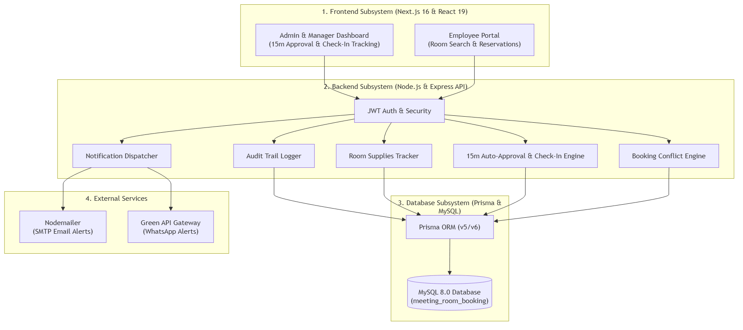
Figure 1: Lumina Reserve 4-Tier High-Level System Architecture Diagram — Visualizing the decoupled architecture from Next.js 16 UI to Node.js REST API, Prisma ORM, MySQL 8.0, and External API Gateways.
2.1 Detailed Tier Breakdown
- Tier 1 — Presentation Subsystem (Next.js 16 & React 19): Serves as the user-facing layer. Provides the Employee Portal for room search, instant booking, and timeline slot selection, as well as the Admin & Manager Dashboard for 15-minute approval queues, member editing, and supply tracking.
- Tier 2 — API Subsystem (Node.js & Express REST API): Manages client request routing, security, and middleware execution. Contains JWT Auth & Security for stateless token verification and bcrypt password hashing.
- Tier 3 — Business Subsystem: Houses core engines including the Booking Conflict Engine (protects overlapping time slots), 15m Auto-Approval & Check-In Engine, Room Supplies Tracker, Audit Trail Logger, and Notification Dispatcher.
- Tier 4 — Persistence Subsystem (Prisma ORM & MySQL 8.0): Relational storage layer built on MySQL 8.0 with InnoDB transaction engine, enforcing foreign key integrity across 12 schema tables.
- Tier 5 — External Services Subsystem: Integrates Green API Gateway for automated WhatsApp notifications and Nodemailer SMTP Gateway for automated HTML confirmation emails with Google Calendar .ics attachments.

2.2 Protocol & Network Topology
Connection Segment | Protocol / Port | Data Payload / Format | Security Mechanism
Client -> Web Portal | HTTPS / Port 443 | HTML5 / React Hydration | TLS 1.3 / SSL
Web Portal -> REST API | HTTPS / Port 5000 | JSON RESTful API | JWT Bearer Header
REST API -> MySQL Server | TCP/IP / Port 3306 | SQL / Prepared Statements | DB Auth & Socket Security
API -> Green API Gateway | HTTPS / REST | JSON (WhatsApp Payload) | API Token / Key
API -> Email Gateway | SMTP / Port 587 | MIME HTML + .ics Calendar | TLS Encryption

3. Use Case Diagram
The Use Case Diagram defines the functional boundary of the Lumina Reserve platform, capturing the interactions between corporate actors and system capabilities.
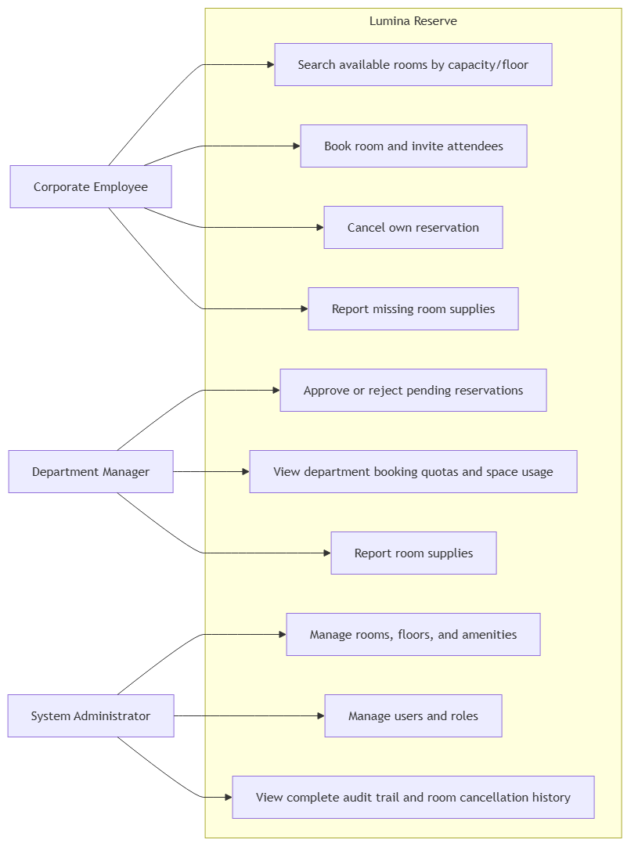
Figure 2: Lumina Reserve Use Case Diagram — Depicting Corporate Employees, Department Managers, and System Administrators interacting with core system capabilities.

3.1 System Actors & Privilege Levels
- Corporate Employee: Standard corporate user. Primary goal is identifying available room slots, reserving meeting spaces, inviting colleagues, managing own bookings, and reporting missing room equipment.
- Department Manager: Department supervisor. Possesses all employee permissions plus access to the Manager Approval Suite, pending request approval/rejection, editing active meeting participants, and tracking room supply restocks.
- System Administrator: System superuser. Full administrative rights including room creation/editing, floor plan uploads, setting maintenance status, user management, and viewing the global system audit trail.
3.2 Use Case Specification & Traceability Matrix
Use Case ID & Title | Primary Actor(s) | Preconditions | Backend API Endpoint
UC-01: Room Search | Employee, Manager, Admin | User is logged in | GET /api/rooms
UC-02: Room Booking | Employee, Manager, Admin | Room available, quota free | POST /api/bookings
UC-03: WhatsApp Share | Employee, Manager, Admin | Active booking created | Client-side Green API trigger
UC-04: Manage Approval Queue | Manager, Admin | Booking in Pending status | PATCH /api/bookings/:id/approve
UC-05: Edit Members | Manager, Admin | Booking in Confirmed state | PUT /api/bookings/:id/attendees
UC-06: Supply Reporting | Employee, Manager, Admin | Room equipment issue noted | POST /api/rooms/:id/supplies
UC-07: Room & Floor Admin | Admin | Admin authentication JWT | POST /api/admin/rooms
UC-08: Audit Log View | Admin | Admin authentication JWT | GET /api/admin/audit-logs

4. Class Diagram
The Class Diagram specifies the object-oriented structure and domain model of Lumina Reserve, detailing entity attributes, primary/foreign keys, and relational cardinality.
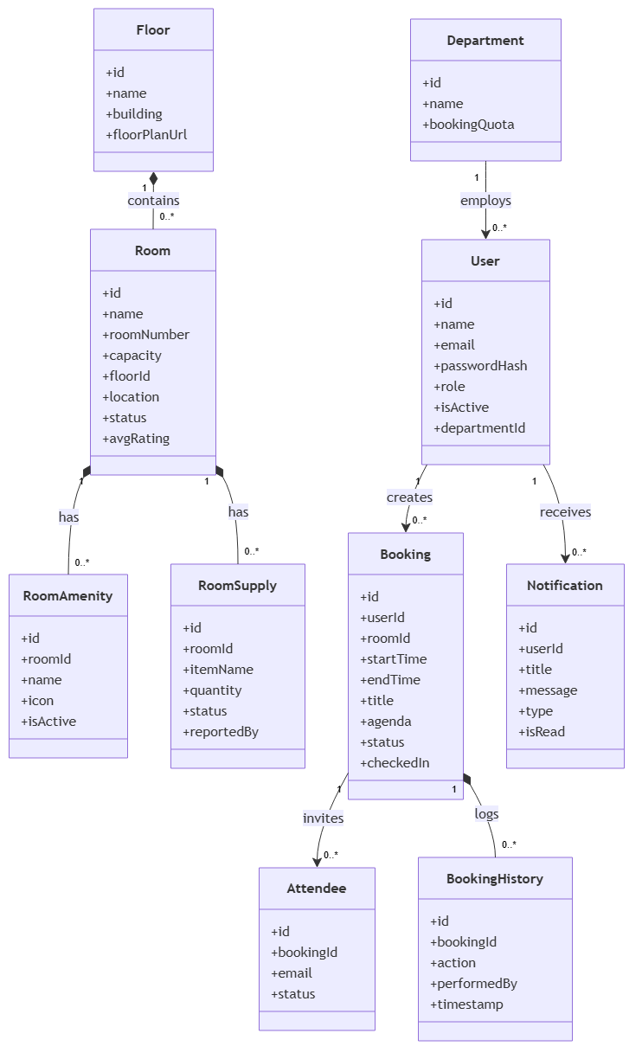
Figure 3: Lumina Reserve Core Class Diagram — Object-oriented representation of domain entities, relationships, attributes, and foreign key connections.

4.1 Core Domain Entities & Attributes
- 1. User Entity: Attributes `id`, `name`, `email`, `passwordHash`, `role`, `departmentId`, `isActive`. Serves as the central user identity for authentication and booking ownership.
- 2. Department Entity: Attributes `id`, `name`, `bookingQuota`. Defines corporate organizational units and sets monthly room booking quotas.
- 3. Floor Entity: Attributes `id`, `building`, `floorPlanUrl`. Represents physical building levels hosting meeting rooms.
- 4. Room Entity: Attributes `id`, `roomNumber`, `capacity`, `floorId`, `location`, `status`, `avgRating`. Represents physical conference rooms.
- 5. Booking Entity: Attributes `id`, `userId`, `roomId`, `startTime`, `endTime`, `title`, `agenda`, `status`, `checkedIn`. Stores reservation contracts.
- 6. Attendee Entity: Attributes `id`, `bookingId`, `name`, `email`, `status`. Tracks invited participants for each meeting.
- 7. BookingHistory Entity: Attributes `id`, `bookingId`, `action`, `performedBy`, `details`, `createdAt`. Immutable audit log records.
4.2 Multiplicity & Relational Cardinality
Source Entity | Target Entity | Cardinality | Relationship Description | Cascade Rule
Department | User | 1 to 0..* | A department employs multiple users | RESTRICT
Floor | Room | 1 to 1..* | A floor contains one or more rooms | RESTRICT
User | Booking | 1 to 0..* | A user organizes zero or more bookings | CASCADE
Room | Booking | 1 to 0..* | A room hosts zero or more bookings | RESTRICT
Booking | Attendee | 1 to 0..* | A booking includes zero or more attendees | CASCADE
Booking | BookingHistory | 1 to 1..* | A booking generates audit trail entries | CASCADE

5. Object Diagram
The Object Diagram models a specific runtime instantiation of the domain objects at a given moment in time, illustrating attribute values and linked instances during an active booking execution.
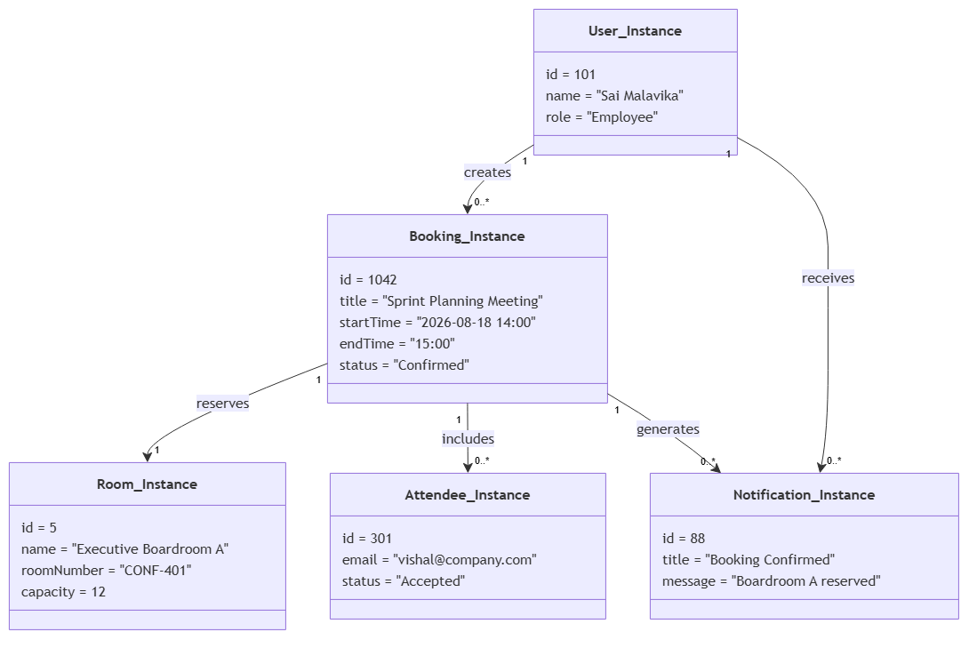
Figure 4: Lumina Reserve Concrete Object Instance Diagram — Snapshot of runtime instances (`User_Instance`, `Room_Instance`, `Booking_Instance`, `Attendee_Instance`, `Notification_Instance`).

5.1 Runtime Object Instance Attributes
Instance Name | Class Type | Attribute State Values | Runtime Role / Meaning
User_Instance | User | id=101, name='Sai Malavika', role='Employee' | Active meeting organizer
Room_Instance | Room | id=5, name='Executive Boardroom A', capacity=12 | Selected high-capacity room
Booking_Instance | Booking | id=1042, title='Sprint Planning', status='Confirmed' | Active reservation state
Attendee_Instance | Attendee | id=301, email='vishal@company.com', status='Accepted' | Confirmed meeting guest
Notification_Instance | Notification | id=88, title='Booking Confirmed' | Dispatched system alert

📌 RUNTIME INSTANTIATION FLOW
During execution, `User_Instance` initiates a `reserves` link with `Room_Instance`, resulting in the instant creation of `Booking_Instance`. The booking object automatically instantiates `Attendee_Instance` and triggers `Notification_Instance` generation.

6. Sequence Diagram
The Sequence Diagram specifies the chronological message sequence and control flow between system participants during the room reservation lifecycle, emphasizing conflict checking and notification dispatching.
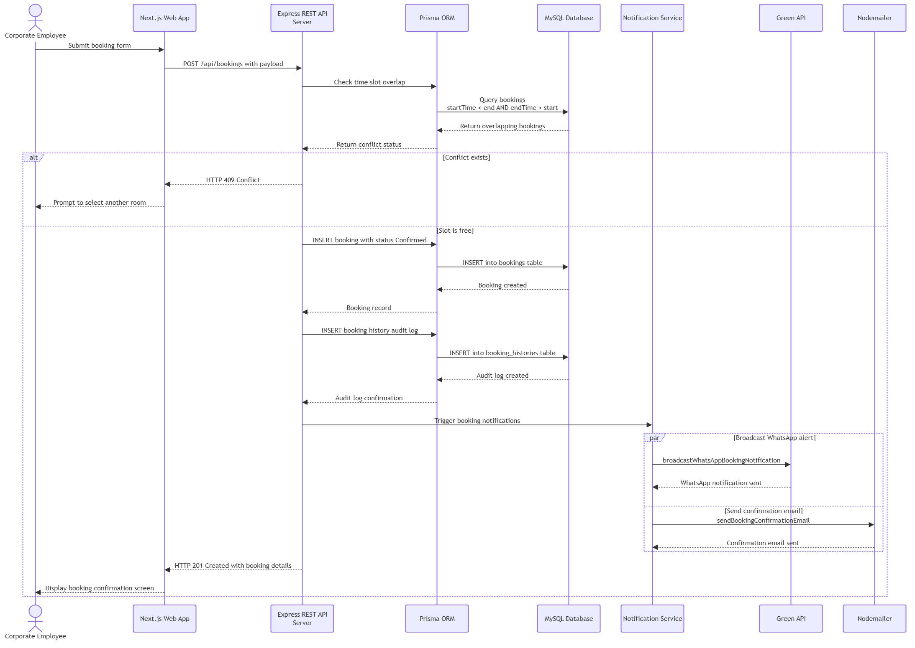
Figure 5: Lumina Reserve Booking Sequence & Conflict Verification Flow — Illustrating interaction across Employee Client, Next.js Web App, Express API Server, Prisma ORM, MySQL DB, and Notification Gateways.

6.1 Detailed Sequence Execution Steps

- Step 1 — 1. User Form Submission: Employee submits booking form with title, room ID, start time, end time, and attendee emails via Next.js Web App.
- Step 2 — 2. HTTP POST Dispatch: Web App sends `POST /api/bookings` JSON payload with Bearer JWT token to Express REST API Server.
- Step 3 — 3. Conflict Query Execution: Express API invokes Prisma ORM to query existing database reservations where `startTime < requestEnd AND endTime > requestStart`.
- Step 4a — 4. Alternative Branch [Conflict Exists]: If overlapping bookings exist, MySQL returns matching records. Express API halts execution and returns HTTP 409 Conflict error to client.
- Step 4b — 5. Alternative Branch [Slot Free]: If no overlap exists, Prisma issues an atomic transaction inserting the new `Booking` record with status `Confirmed` and writes an entry to `booking_histories`.
- Step 5 — 6. Parallel Notification Execution: API triggers async tasks to Green API (dispatching WhatsApp alert) and Nodemailer (sending Gmail confirmation with .ics attachment).

7. Activity Diagram
The Activity Diagram models the operational workflow and decision logic executed by the system during room reservation, search, conflict validation, and audit recording.
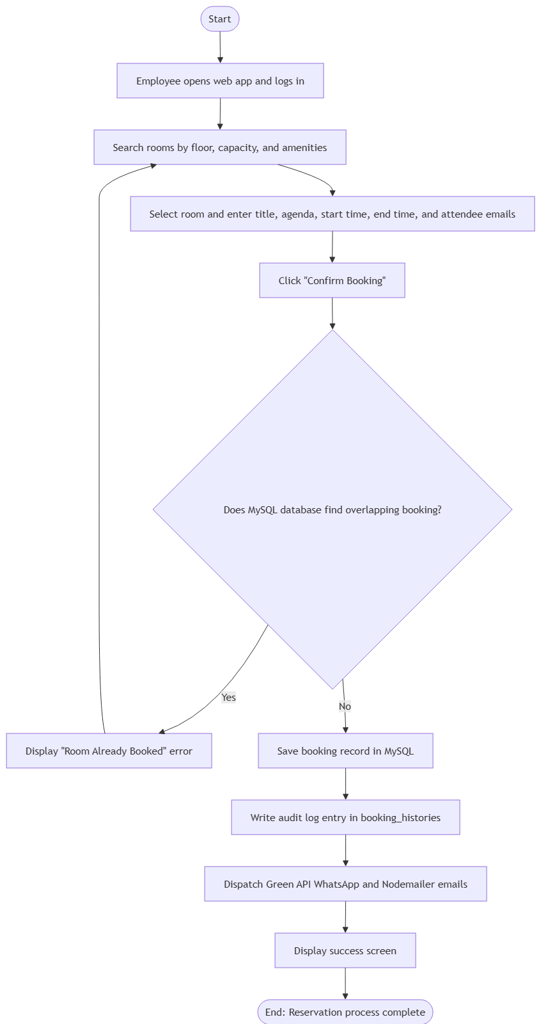
Figure 6: Lumina Reserve End-to-End Reservation Activity Workflow — Step-by-step decision flow from login to room filtering, database overlap checking, audit logging, and notification completion.

7.1 Workflow Control & Decision Nodes

- Start -> Initial Node: Employee opens web application and logs in with corporate credentials.
- Search Phase -> Room Discovery: User searches available rooms by floor, seating capacity, and desired amenities (e.g. Projector, Video Conf).
- Selection Phase -> Slot & Attendee Input: User selects room and enters meeting title, agenda, time window, and attendee email list.
- Validation Node -> Decision Node [Overlapping Booking?]: System queries MySQL database. If Yes -> Display 'Room Already Booked' error screen. If No -> Save booking record in MySQL database.
- Post-Booking Node -> Audit & Notification Phase: Write audit log entry in `booking_histories` and dispatch Green API WhatsApp and Nodemailer emails.
- Final Node -> Activity End: Display success screen to user; reservation workflow complete.

8. State Machine Diagram
The State Machine Diagram details the operational lifecycle states of a `Booking` instance, defining state transitions, guard conditions, and event triggers.
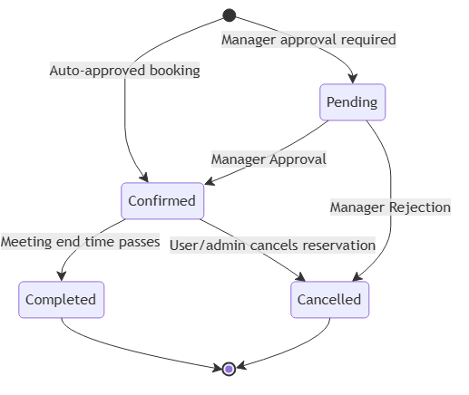

Figure 7: Lumina Reserve Booking Lifecycle State Machine Diagram — State transitions across Pending, Confirmed, Cancelled, and Completed states.

8.1 State Definitions & Transition Matrix

Current State | Trigger Event | Guard Condition | Target State | Action Executed
[Initial State] | User submits booking | Room requires approval | Pending | Create booking record
[Initial State] | User submits booking | Auto-approval enabled | Confirmed | Create booking + send emails
Pending | 15 minutes elapse | No manager response | Confirmed | Auto-approve & dispatch alerts
Pending | Manager approves | Manager logged in | Confirmed | Update status & send confirmation
Pending | Manager rejects | Manager logged in | Cancelled | Update status & notify user
Confirmed | Meeting end time passes | Current time > endTime | Completed | Archive booking state
Confirmed | User/Admin cancels | Before meeting start | Cancelled | Release slot & log audit

9. Component Diagram
The Component Diagram details the software component architecture, interfaces, and modular dependencies that constitute the Lumina Reserve application.
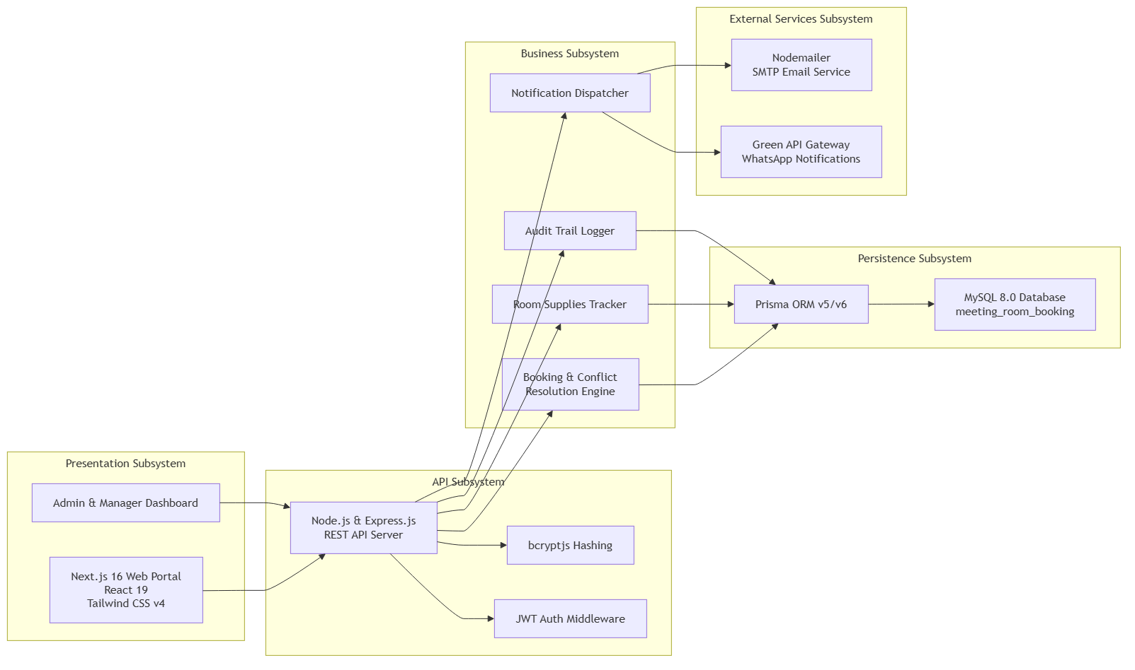
Figure 8: Lumina Reserve Subsystem Component Diagram — Modular decomposition across Next.js React UI, Express API Server, Prisma ORM, MySQL DB, and External Notification Gateways.

9.1 Subsystem Component Details

- 1. Presentation Subsystem Component: Next.js 16 Web Portal, React 19 UI components, Tailwind CSS v4 styling, Admin & Manager Dashboard components.
- 2. API Subsystem Component: Node.js & Express.js REST API Server, JWT Authentication Middleware, bcryptjs hashing module.
- 3. Business Subsystem Component: Booking & Conflict Resolution Engine, Room Supplies Tracker, Audit Trail Logger, Notification Dispatcher.
- 4. Persistence Subsystem Component: Prisma ORM v5/v6 data mapper, MySQL 8.0 relational database (`meeting_room_booking`).
- 5. External Services Component: Green API Gateway (WhatsApp notifications), Nodemailer (SMTP Email service).

10. Deployment Diagram
The Deployment Diagram maps the logical software components to physical hardware infrastructure nodes, execution environments, network protocols, and port allocations.
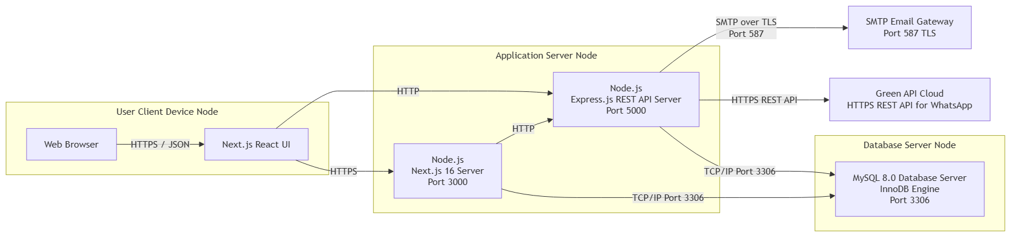
Figure 9: Lumina Reserve Infrastructure Deployment Diagram — Mapping Client Devices, Application Servers, Database Nodes, and Cloud Gateway APIs.

10.1 Physical Node & Protocol Configuration
Hardware / Cloud Node | Runtime Environment | Hosted Software / Services | Port / Protocol
User Client Device | Web Browser (Chrome/Edge/Safari) | Next.js React UI Client | HTTPS / Port 443
Application Server Node | Node.js v22 LTS Runtime | Next.js 16 (Port 3000) & Express API (Port 5000) | HTTP / TCP Port 5000
Database Server Node | Linux Server / MySQL 8.0 | MySQL Database (InnoDB Engine) | TCP/IP Port 3306
Green API Cloud Gateway | External REST SaaS Node | WhatsApp Messaging API | HTTPS REST API
Gmail SMTP Gateway | Google SMTP Servers | Email & Calendar Dispatcher | SMTP TLS / Port 587

