**Motor_Vehicle_SQL_Queries**

* **SQL Based Question**

1. **Total Number of rows in Vehicle data**

* **select Count(*) from vehicle_data;**

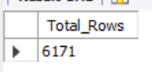

1. **Find the count of null values or 0 values per columns**

* **Select**

**sum (case when year = 0 then 1 else 0 end) null_year,**

**sum (case when state = 0 then 1 else 0 end) null_state,**

**sum (case when auto = 0 then 1 else 0 end) null_auto,**

**sum (case when bus = 0 then 1 else 0 end) null_bus,**

**sum (case when truck = 0 then 1 else 0 end ) null_truck,**

**sum (case when motorcycle = 0 then 1 else 0 end) null_motorcycle**

**from vehicle_data;**

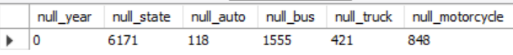

1. **Top 3 States with Highest Motorcycle Registrations(Identifies the states where motorcycles are most popular.)**

* **select state ,sum(motorcycle) as total_motorcycle from vehicle_data**

**group by state**

**order by total_motorcycle desc**

**limit 3;**

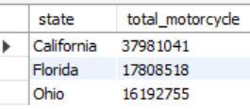

1. **Average Registrations Per Year for Each Vehicle Type**

* **SELECT ROUND(AVG(Auto), 2) AS Avg_auto,**

**Round(Avg(bus),2) as Avg_bus,**

**Round(Avg (truck) ,2) as Avg_truck,**

**Round(Avg (motorcycle) , 2) as Avg_motorcycle**

**FROM vehicle_data;**



1. **Last 5 Year of Percentage of Each Vehicle Type Per Year**

* **SELECT year,**

**Round(SUM(Auto) * 100.0 / SUM(Auto + Bus + Truck + Motorcycle), 2) AS auto_percentage,**

**Round(SUM(Bus) * 100.0 / SUM(Auto + Bus + Truck + Motorcycle),2) AS bus_percentage,**

**Round( SUM(Truck) * 100.0 / SUM(Auto + Bus + Truck + Motorcycle),2) AS truck_percentage,**

**Round (SUM(Motorcycle) * 100.0 / SUM(Auto + Bus + Truck + Motorcycle), 2) AS motorcycle_percentage**

**FROM vehicle_data**

**group by year**

**order by year desc**

**limit 5 ;**

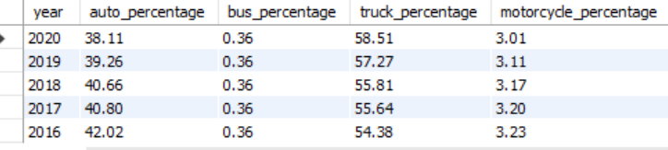

1. **Top 3 State with the Most Consistent Yearly Growth in Registrations**

* **select state,**

**count(*) as Growth_year,**

**(max(year) - min(year) ) +1 as total_year**

**from vehicle_data**

**group by state**

**order by growth_year desc**

**limit 3;**

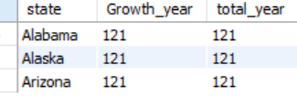

1. **Top 5 States with the Highest Vehicle Registrations in the Latest Year**

* **SELECT state ,**

**sum(auto + bus + truck + Motorcycle) as Total_vehicles**

**from vehicle_data**

**where year = ( select max(year) from vehicle_data)**

**group by state**

**order by Total_vehicles desc**

**limit 5;**

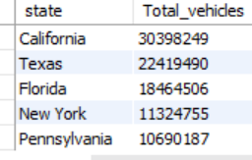

1. **Total Vehicle Registrations Per Year**

* **Select**

**sum(auto + bus + truck + Motorcycle) as Total_vehicles**

**from vehicle_data**

**group by year**

**order by year;**

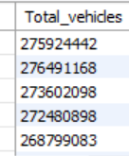

1. **Last 10 year Vehicle Registrations by State & Year (Pivot Format)**

* **select state,**

**sum(case when year = 2020 then auto + bus + truck + Motorcycle end) as "2020" ,**

**sum(case when year = 2019 then auto + bus + truck + Motorcycle end) as '2019' ,**

**sum(case when year = 2018 then auto + bus + truck + Motorcycle end) as '2018' ,**

**sum(case when year = 2017 then auto + bus + truck + Motorcycle end) as '2017' ,**

**sum(case when year = 2016 then auto + bus + truck + Motorcycle end) as '2016' ,**

**sum(case when year = 2015 then auto + bus + truck + Motorcycle end) as '2015' ,**

**sum(case when year = 2014 then auto + bus + truck + Motorcycle end) as '2014' ,**

**sum(case when year = 2013 then auto + bus + truck + Motorcycle end) as '2013' ,**

**sum(case when year = 2012 then auto + bus + truck + Motorcycle end) as '2012' ,**

**sum(case when year = 2011 then auto + bus + truck + Motorcycle end) as '2011' ,**

**sum(case when year = 2010 then auto + bus + truck + Motorcycle end) as '2010'**

**from vehicle_data**

**group by state;**

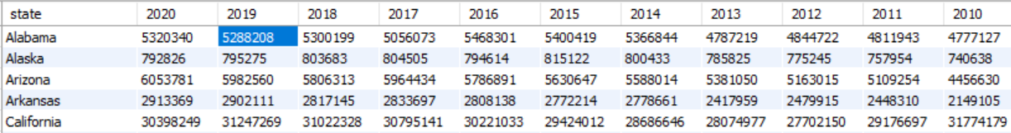

**10.** **Year-over-Year Percentage Growth**

* **select state, year , sum(auto + bus + truck + Motorcycle) as total_vehicle,**

**(sum (auto + bus + truck + Motorcycle)- lag(sum(auto + bus + truck + Motorcycle))over (partition by state order by year)) * 100.0 /**

**lag (sum(auto + bus + truck + Motorcycle))over (partition by state order by year) as YOY_growth_percentage**

**from vehicle_data**

**group by state, year;**

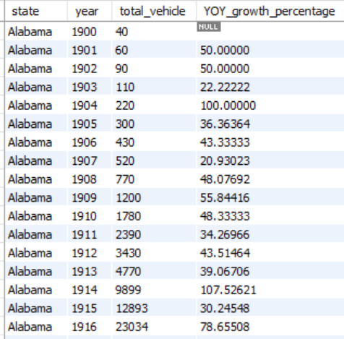

1. **Find Most Commonly Registered Vehicle Type**

* **SELECT year,**

**case**

**when sum(auto) = greatest(sum(auto), sum(truck) , sum(bus),sum(motorcycle)) then 'auto'**

**when sum(bus) = greatest(sum(auto), sum(truck) , sum(bus),sum(motorcycle)) then 'bus'**

**when sum(truck) = greatest(sum(auto), sum(truck) , sum(bus),sum(motorcycle)) then 'truck'**

**else 'Motorcycle’ end as Most_registered_vehicle**

**FROM vehicle_data**

**GROUP BY year;**

