AltLayer
Website | Twitter | Docs | Deck | Binance Research
Last updated January 12, 2024

Analysis by Shabbir Khan

Overview
AltLayer is a RaaS platform offering various types of rollups with optimistic and zk stacks, including new restaked rollups that leverage EigenLayer for enhanced security and other benefits.

Fundraising
- Raising $15M at $180M FDV
- 6 month cliff (% unlock), 30 month vest
- Their last round happened July 1. 2022. They raised $7M at $80M
- In total, AltLayer has raised 22.8MM USD from two rounds of private token sales, where 18.50% of the ALT total token supply has been sold at $0.008/ALT and $0.018/ALT respectively.
- AltLayer's investors include Polychain Capital, Binance Labs, Jump Crypto, Breyer Capital, DAO5, Balaji Srinivasan (former CTO of Coinbase and former GP of a16z), Gavin Wood (Co-Founder of Ethereum and Parity), Sean Neville (Circle Co-Founder and USDC architect) and Ryan Selkis (Founder of Messari), among others.

Team
- Jia Yaoqi: Founder & CEO: Twitter | Linkedin
  - Strong CS background (Phd and Research Fellow at NUS, papers on web security/privacy, network security and distributed system security)
  - CTO & Founder at Ziliqa (sharded blockchain)
  - Director at Parity technologies (Lead to build/advocate the technologies of Parity like Substrate/Polkadot and grow dev community)
- Dr. Amrit Kumar: COO : Twitter | LinkedIn
  - Computer science background (Computer science Phd, Master's in cryptography)
  - Cofounder, President and Chief Science Officer at Zilliga
  - Co-Chief Investment Officer at Zilliqa Capital Chairperson - Worked at Binarii Labs
  - Co-Chief Investment Officer - Rule72

Why now?
Ethereum's rollup-centric roadmap is going to require... many more rollups (duh). Launching a new application specific or generalized rollups needs to be simple and customizable.

The Solution
Altlayer is a is a Rollup as a Service (Raas) provider that offers three core types of rollups:

- Standard Rollups: with their one-click deployment and no-code dashboard, AltLayer supports all major rollup stacks, data availability layers, settlement layers, decentralized sequencer sets and interoperability bridges. Altlayer also allows users to customize the number of sequencers, chain-level parameters such as block gas limit, gas token, contract size, etc... RaaS partners include Optimism, Arbitrum, Polygon, zkSync, EigenLayer, Celestia and Hyperlane.
- Restaked rollups: these comprise 3 AVSs. Each can be created on demand.
  - AVS 1 - Vital: Vital verifies the correctness of the rollup's state and conducts validity proof challenges or generates and verifies ZK proofs.
  - AVS 2 - Mach: With the validation of rollup states, MACH provides fast finality with shared security guarantee for RPC/ bridge/exchanges.
  - AVS 3 - Squad: SQUAD enables decentralization of sequencing by involving community to join rollup as sequencers and stakers
- Ephemeral Rollups: Altlayer also offers ephemeral rollups (AKA Flash Layers) which are disposable rollups with optional fraud proofs tailored to dapps in specific scenarios. For example, if a dApp has a high traffic for the auction of an NFT w/ bidding, the whole process would take place in the ephemeral rollup and after the transaction is completed, the dApp would declare end of life for that rollup.

Competition
Dymension | Dymension is a network of easily deployable and lightning fast modular blockchains called RollApps. This documentation serves as a source for all things Dymension.
Saga | Saga makes launching a dedicated blockchain, or Chainlets, as easy as deploying a smart contract. We accomplish this by offering an integrated stack of all the necessary components needed to launch a chain into a single product experience for Chainlets.
Caldera | Caldera is a rollup deployment platform that allows you to launch high-performance, customizable, application-specific rollups with the Arbitrum Nitro, Optimism Bedrock, zkSync ZK Stack, and Polygon CDK frameworks.
Gelato | Gelato is an all-in-one Ethereum Rollup-as-a-Service (RaaS) platform built without limits.
Conduit | Conduit allows anyone to deploy a rollup through our self-serve Rollups-as-a-Service platform in a matter of minutes, no code required. We provide all-in-one infrastructure that enables our customers, like Zora and Gitcoin, to rapidly deploy on mainnet or testnet and prioritize building great products instead of wrangling security and devops.
Snapchain | Snapchain (https://www.snapchain.dev/) is a zk RaaS (rollup-as-a-service) meant to mitigate the learning curve and maintenance cost for launch a zk rollup (similar to Caldera (https://caldera.xyz/) but focused on zk). With Snapchain, developers can configure, create, and manage their roll-ups. Team is ex-Meta payments, and the solution has effortless integration with AWS-inspired no-code console to deploy roll-ups in seconds. Rollups are EVM compatible.
TrueZK | TrueZK is a Modular blockchain network enabling custom rollup deployments. Deploy Custom Rollups with your preferred Modular components using TrueZK that offers a permissionless platform with ZK Stack, Privacy on Demand, & Account Abstraction to drive mass adoption.
Gateway | Presto is a Platform as a Service that allows you to effortlessly create your own zkEVM rollups with all the necessary infrastructure in just four clicks.

AltLayer has a significantly differentiated product in their restaked and ephemeral rollup offerings. They are not a simple RaaS, but a restaked rollup launchpad with the EigenLayer & restaking premium.

Traction
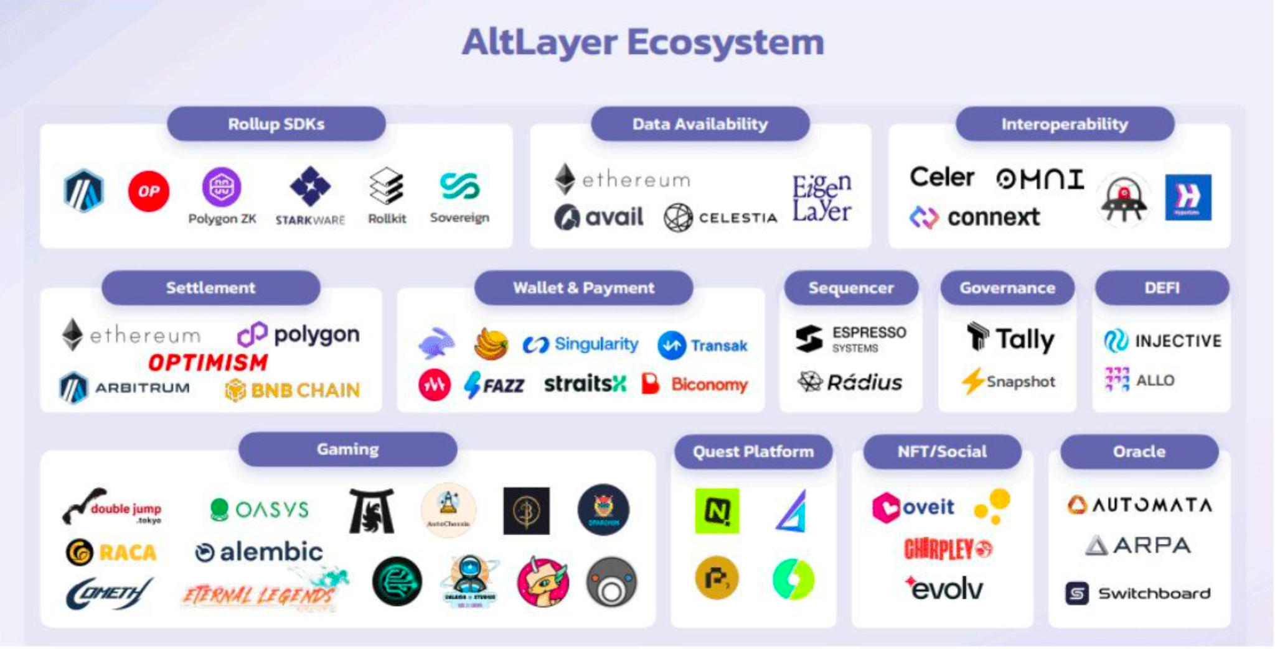

AltLayer has >30 strategic partnerships, >500k rollups deployed (including ephemeral), and >200m transactions.

Risks
- EigenLayer Dependency Risk
- Competition: RaaS is quite competitive. Some well funded competitors might quickly offer Eigen powered rollups
- Valuation: $180 FDV is outside of our typical valuation target. The FDV on launch could fail to reach a meaningful multiple, even with a relatively successful performance.

Verdict: IC Passed

