Fhenix
Website | Medium | Twitter | Tech Docs | Github
Last updated August 11th, 2023

Analysis by Shabbir Khan

Overview
Fthenix is the first blockchain powered by fully homomorphic encryption (FHE) to bring computation over encrypted data to EVM smart contracts. One of the most pressing challenges in the blockchain space is ensuring privacy, and FHE presents a promising solution. By leveraging FHE's ability to process encrypted data, Fhenix can effectively address privacy concerns, creating a safer environment for Web3 applications.
Fully Homomorphic Encryption (FHE) is a technology that enables processing data without decrypting it.
This means companies can offer their services without ever seeing their users' data — and users will never notice a difference in functionality.

Deal Terms
- Stage: Seed
- Type: SAFE
- Token Warrant: Yes, 1:1
- Raise: $4M at $40M valuation
- Investors:
- Multicoin Capital
- Bankless Ventures
- Collider Ventures
- Node Capital
- TaneLabs
- Hashkey
- Metaplanet

Use of Proceeds
The funds raised will be used for scaling the Fhenix team as well as the blockchain into public testnet early next year and support ecosystem application development on it.

Why now?
Demand for web 3 privacy infra: The rising demand for privacy-based infrastructure in the web 3 world has accelerated the development of such technologies with emphasis being placed on ZK technologies. However, ZK comes with its limitations that hinder the development of fuly privacy preserving protocols. FHE removes those limitations and advances the future of privacy in web3.

Why you?
Team
- Guy Zyskind | Founder | Linkedin | Twitter
• Founder of Scrt Labs (Secret Network)
  - Previously Research Assistant at MIT media Lab
  - Taught MAS. S65 during the fal of 2015 at MIT. This was the first class about bitcoin and cryptocurrencies at MIT.
  - Completed PhD in applied cryptography from MIT
  - Completed Masters of Science from MIT

- Guy Itzhaki | CEO | Linkedin | Twitter
• Previously, the director of Homomorphic Encryption and Blockchain Business Development at Intel
• Completed Bachelor of Mathematics from the Hebrew University of Jerusalem

The Problem
- Lack of Encryption in Web3: The lack of encryption on commercially sensitive and personal data in the Web is a threat. To scale the industry, privacy must be an integral part of blockchains, meaning that data encryption and computation capabilities should be key features.
- No privacy gold standard in Web 3: Despite the significant developments ni the privacy space, limitations still exist, hindering the acceleration of truly privacy-preserving protocols.
- ZK isn't enough: zk enables verification, which supports scalability but does not facilitate encrypted computation due to the inability to combine private data from multiple parties. FHE allows for higher levels of data security coupled with unprecedented use cases supported by its 'holistic' encryption features, like private onchain auctions.

The Solution
Fhenix is building the first confidential smart contract platform using fully homomorphic encryption (FHE), powered by Zama's novel FHE primitives. FHE is a novel cryptographic scheme that enables direct computation over encrypted data without ever revealing the underlying data. Fhenix's goal is to advance application development in the blockchain ecosystem by bringing data encryption and encrypted data computation to smart contracts, transactions, and on-chain assets for the first time.
By leveraging the power of FHE, Fhenix redefines how sensitive data is being managed in the blockchain ecosystem, envisioning a future where privacy and decentralization are not at odds, but rather, complementary aspects of a secure digital economy.

Fully Homomorphic Encryption
FHE is considered the holy grail of cryptography, as ti enables direct computation over encrypted data while never revealing the data to the server, or ni the context of blockchains, to validators or sequencers. This means that Fhenix now enables a wide array of versatile use cases:
• Trustless Gaming: Every game that requires players to hide their information from other players, like on-chain casino gaming, where you need to hide information between opponents or the dealer, while still allowing computation on the data.
• Private Voting: Both on-chain and off-chain voting mechanisms can operate with fuly encrypted variables, ensuring confidentiality without sacrificing trustworthiness.
• Privacy-Preserving A:l The ability to compute encrypted data opens the door for on-chain artificial intelligence applications, thereby expanding the range of possible use cases exponentially.
• Confidential Token Transfers: P2P payments, commercial transactions, and other sensitive transfers can be made private, yet auditable.
These are al multi-billion dollar industries growing at a rapid pace, but applicability also extends to areas such as blind auctions, MEV protection, account abstraction, and confidential DAOs.

The Gold Standard: fhEVM
fhEVM is a set of extensions for the Ethereum Virtual Machine (EVM) that allows Solidity developers to seamlessly create FHE smart contracts without any cryptographic expertise. Solidity is the most popular Web3 language to date and comes with an extensive suite of developer tools and libraries, making fhEVM extremely easy to begin working with.
This is important, as blockchains that rely upon entirely novel programming languages have significant costs associated with attracting and training developers to begin using their unique language. In contrast, HEVM taps into the expansive EVM community and enables developers to easily begin deploying new, innovative projects.
Fhenix also has a modular, extension-like design, which means that its ability to compute encrypted data can be integrated across all blockchain layers, enabling the easy development of confidential smart contracts on public blockchains. For example, developers can now build applications around encrypted data, such as decentralised email services or private voting.
This comes in the form of the Fhenix SD,K which developers can now use to add encryption capabilities to their existing products, seamlessly, without any changes to their existing smart contracts.

Target Market
Fhenix targets developers looking to build applications with strong privacy-preserving features.

Competitive Landscape
Fhenix maintains a first mover advantage as its the first FHE-based blockchain. The closest competitor to Fhenix is Sunscreen, which has been around since 2022 and is more of a FHE engine for web 3 developers rather than a full-on blockchain.

Roadmap: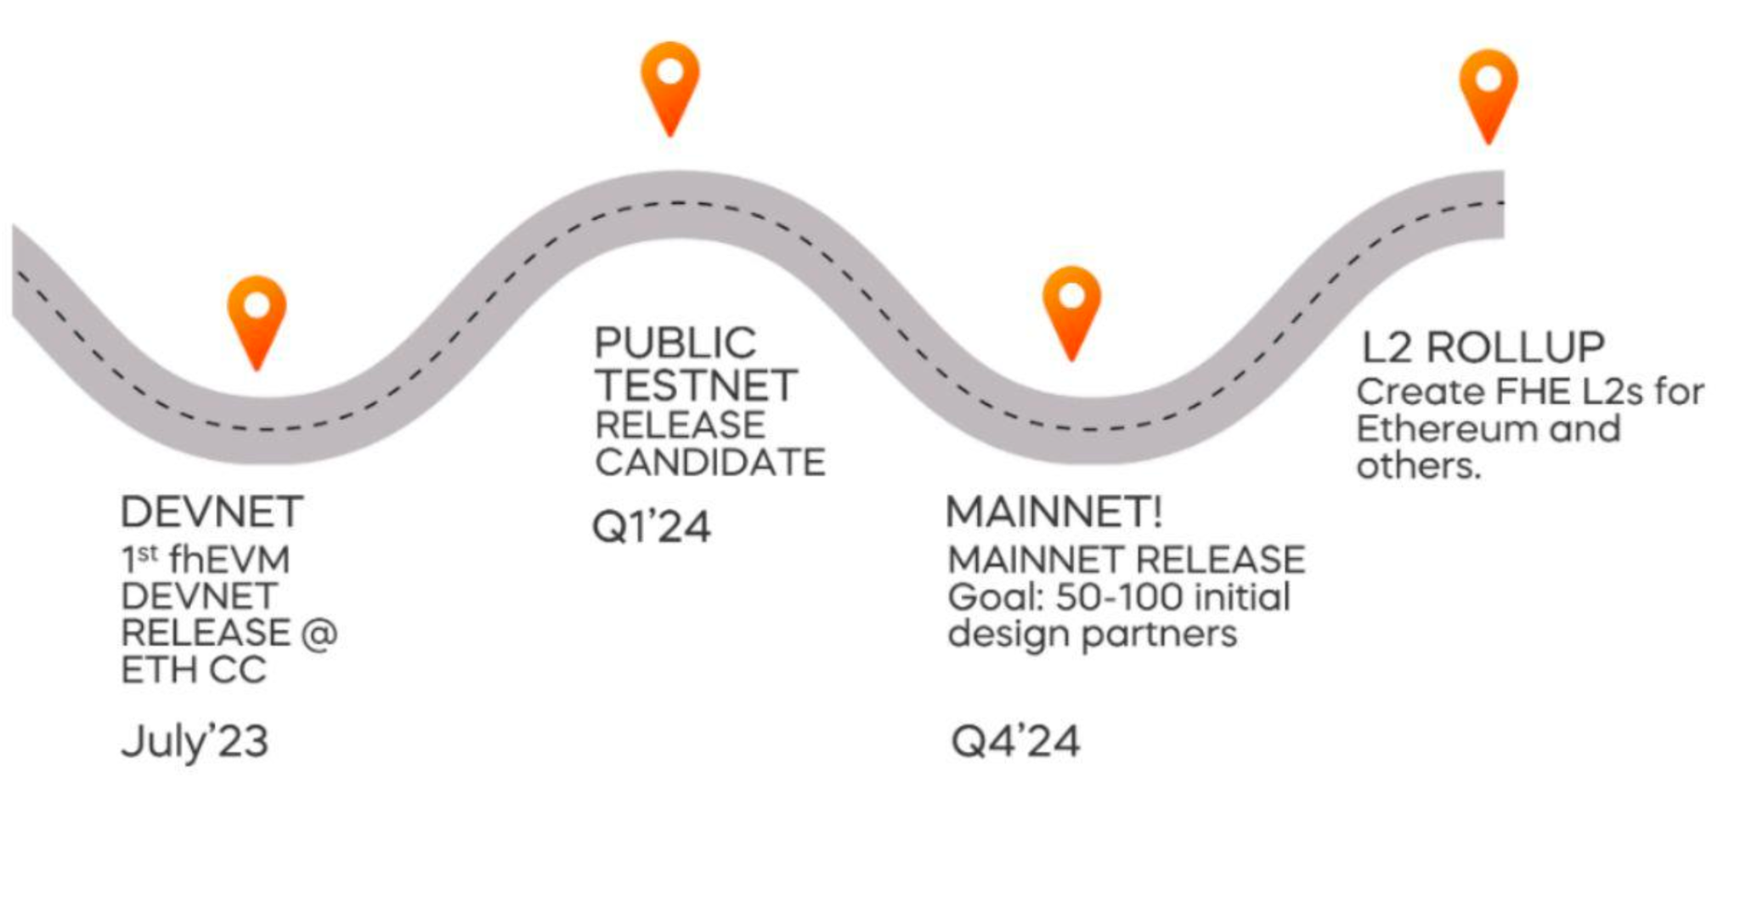

Risks:
- Platform nascency risk: Being the first mover comes with unforeseen risks on both the operational and security side. We trust that the team's deep understanding of this niche and tremendous experience ni building and scaling similar ventures is reassuring to handle any situation that may arise from this risk.
- Possible hardware constraints
- Zama platform risk

Verdict: IC Passed

