Modulus
Website | Medium | Twitter
Last updated August 11th, 2024

Analysis by Shabbir Khan

Overview
Modulus Labs brings verifiable AI inference to the blockchain using zero-knowledge proofs.

Dealterm
- Stage: Seed
- Type: Priced Round
- Token Warrant: Yes, conversion TBA
- Raise & valuation:
  - Priced Round: $5M at a $25M valuation
  - Other token terms to be communicated after allocation and lead docs are finalized

Exit Strategies
There are two primary exit opportunities:
- Native token
- Acquisition

Use of Proceeds
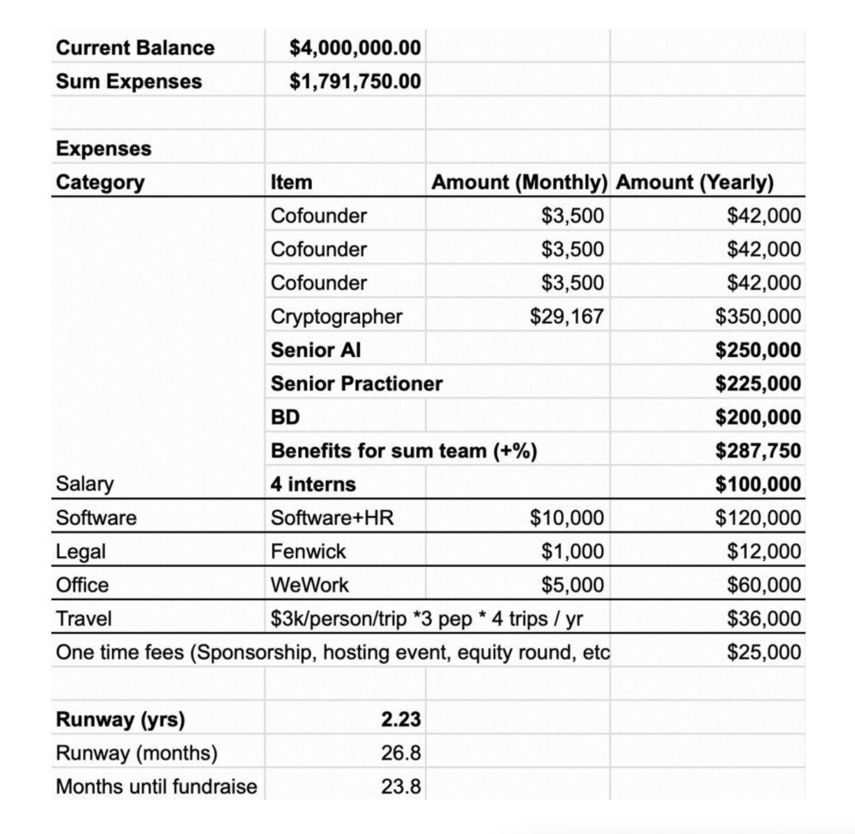

Why Now?
Using zkSNARKs to prove machine learning (ML) model inference is poised to be one of the most significant advancements in smart contracts this decade. This development opens up an excitingly large design space, allowing applications and infrastructure to evolve into more complex and intelligent systems.
In many ways, it is surprising that smart contracts do not currently use embedded ML models given the prominence of ML in most applications outside of web3. This absence of ML was largely due to the high computational cost of running these models on-chain. For example, FastBERT, a compute-optimized language model, uses ~1800 MFLOPS (million floating point operations), which would be infeasible to run directly on the EVM.
With zkSNARKs, it is now possible to run a model off-chain and generate a succinct and verifiable proof showing that the intended model did, in fact, produce a particular result. This proof can be published on-chain and ingested by smart contracts to amplify their intelligence.

Why You?
The Modulus Labs team consists of three talented co-founders: Daniel Shorr, Ryan Cao, and Nick Cosby. All three of them have technical engineering backgrounds. Daniel met Nick in High School and Ryan at Stanford. Modulus Labs has 3 advisors: Zhang Zhenfei (EF), Riad Wahby (CMU), Rand Hindi (Zama). The team built the first fully on-chain deployment of an AI algorithm to mainnet (RockyBot). They then went on to build the first on-chain AI game (leelavstheworld.xyz).
Though the Modulus team has extensive research experience with prestigious research labs and institutions, they emphasize the fact that Modulus Labs is not a PhD research lab. They are a business. This means they are focused on ensuring their technology is justified by customer use-cases.
1. Daniel Shorr (CEO)
- Education:
  - Stanford University MS (2020–2022)
  - Stanford University BS (2017–2021)
- Work / Research Experience:
  - Apple
  - Zipline
  - Planet
  - Boeing
  - Stanford Bird Lab
2. Ryan Cao (CTO)
- Education:
  - Stanford University MS Computer Science (2021–2022)
  - Stanford University BS Computer Science (2017–2021)
- Work / Research Experience:
  - Research Intern – UT Health San Antonio
  - Student Researcher – UTSA College of Engineering
  - Undergraduate Researcher – Brunskill Lab, Stanford
  - SWE Intern – Google
  - Student Researcher – Stanford Vision and Learning Lab (SVL)
  - Student Teacher – Stanford
  - SWE Intern – Citadel
3. Nick Cosby (VP Eng)
- Education:
  - High School – Coding Bootcamp
- Work Experience:
  - Software Engineer – People Tech Group Inc
    - Worked on several projects including Microsoft Azure Backend and AI Sales Forecasting for Prophecy

The Problem
No single entity should be the sole owner of any true AGI. It creates far too much power in the hands of only well-capitalized institutions. Current AI models are made by ingesting an enormous amount of publicly available text and data, but are extremely centralized—only a small number of people right now control and own those models. The heart of these problems lies in the question:
“How do we embed these systems with trustworthiness, privacy, and the ability for people to reap economic benefits?”
Recently, there has been a vocal effort to pause or mitigate the advancement of major AI projects like ChatGPT. It would be better to push for models that are open-source. And in cases where model providers want their weights or data to be private, to secure them with privacy-preserving zero-knowledge proofs that are on-chain and fully auditable.

The Solution
Modulus is building the world's fastest zero-knowledge Al prover. Zero-knowledge proofs usually represent programs as arithmetic circuits. Using these circuits, the prover generates a proof from public and private inputs. The verifier can mathematically compute that the output of this statement is correct without obtaining any information about the private inputs.

To solve Ethereum's scalability problem, teams prove generalized computation off-chain in sophisticated proof systems, and then bundle those proofs for fast verification on-chain. This method achieves a remarkably high level of cryptographic security, allowing for scalability without sacrificing web3's core values. A similar mechanism can be used for trustless intelligence: an Al model's parameters and inputs can be pumped through an efficient zk-proof system, and the proof of that inference can be verified before accepting the result on-chain. This allows Modulus to:

- Take advantage of the undeniable efficiency of centralized computation power (which is practically necessary given the size of modern Al models and the overhead of creating a proof).
- Force the central operator to surrender control of the model, preventing them from tampering with the final result by switching out model weights, architecture, or inputs.

The consequence of this system is the following: accessible use of verified Al inference that is trustless. This allows dApps to access intelligence without compromising trustlessness and decentralization.

In general, incorporating Al models on-chain without compromising Ethereum's decentralization and trustless nature would be a significant advancement for Web3. Here are some possible use cases though there are possibilities here that even the Modulus team can't think of yet:

- Matching: Recommendation and matching algorithms can be brought to Web3.
- NFTs: Wallet owners can be better served based on the NFTs they currently own.
- Al Oracles: A highly accurate Al model can be trained to solve any off-chain validation problem, making a single, centralized oracle trusted by all.
- Support: On-chain Al support can enable new use cases that would have been impossible otherwise.
- Tokenomics: Improving the quality of a model on-chain and being paid in tokens for the improvements, such as running a DAO based on an Al, or distributing Airdropped tokens based on the evaluation of participation by an Al.
- Decentralized Health Care Ensemble: Data scientists can apply their techniques without needing to understand anything about healthcare data or outcomes.
- Model Authenticity: Providing assurance that the purveyor of a particular model is serving the more expensive one instead of the cheaper one.
- Model Integrity: Providing assurance that the same machine learning algorithm is being run on different users' data the same way.
- Attestations: Integrating attestations from external verified parties into a model or any other kind of smart contract running on-chain.
- Decentralized Inference or Training: Performing machine-learning inference or training in a decentralized way, and allowing people to submit data to a public model.
- Proof of Personhood: Checking that someone has been verified, without revealing any information about that person's identity, whether that identity is fully recognizable, or pseudonymous, like a public key.
- ML-parameterized DeFi applications: Updating parameters in real-time using an ML model.
- Automated trading strategies: Providing proof of the financial model inference when deploying into a specific position.
- Fraud monitoring for smart contracts: Detecting possible malicious behavior and enacting a pause.
- Decentralized prompt marketplaces for generative Al: Verifying the outputs of a prompt to ensure to a potential purchaser that the prompt does in fact create the desired images.
- Replacing the private key with privacy-preserving biometric authentication: Abstracting the private key via facial recognition or other unique factors.
- Fair airdrops and contributor rewards: Creating detailed personas of users that determine airdrop allocations or contribution rewards based on multiple factors.
- Filtering for Web3 social media: A social media platform could use an open-source ML model that is agreed upon by the community and publish proofs of the model's inference when electing to filter a post.
- Advertising / Recommendations: Running a model on my tastes locally that feeds into media applications to serve me content.
- New types of on-chain games: Creating cooperative human versus Al games and other innovative takes on on-chain games.

Target Market/Business Model
There are a number of markets Modulus is experimenting with:
- Privacy Protocols
- NFTs
- Gaming
- DeFi
Monetization strategy is still being developed however (as noted in the Traction section), they have already secured paid pilots.

Competition Landscape
Project | Description
Giza | Giza is working on porting pretrained ONNX models into Cairo for verifiable inference. However, these models will be limited to CPU-only computation since Cairo does not support CUDA-based STARK generation.
RISC Zero | RISC Zero's zkVM allows programming languages like C++ and Rust to use zero-knowledge proof (ZKP) technology to verify an application's output without access to its inputs. This verifiability enables decentralization of applications, leading to improved resilience and economic efficiency.
=nil; | nil provides different software solutions that aim to provide trustless data accessibility. Current products include:  Marketplace for zero knowledge/non-interactive proofs  zkLLVM - Compile zero-knowledge proofs from high-level programming languages with no performance overhead  Fast and scalable database management system for blockchains  Cryptography suite in C++17 designed for cryptographers by cryptographers to enable fast and safe prototyping of novel cryptographic primitives
Axiom | Axiom is a ZK coprocessor for Ethereum that allows smart contracts to access on-chain data and perform complex computations on it without the need for trust.
HyperOracle | Hyper Oracle consists of three main components: zkPoS, zkGraph, and zkWASM. zkPoS securely retrieves block headers and data roots from the Ethereum blockchain, while zkWASM runs programmable customized off-chain computations and data mappings defined by zkGraph. In addition to these, Hyper Oracle Meta Apps - zkAutomation and zkIndexing - provide secure automation for smart contracts and indexing/querying of blockchain data defined by zkGraph. Compared to other traditional oracle networks, Hyper Oracle addresses issues of security, decentralization, and performance by proposing a trustless, zk-powered infrastructure solution.
EZKL | ezkl is a library and command-line tool for performing inference for deep learning models and other computational graphs in a zk-snark. It enables the following workflow:
Delphinus Lab | Delphinus Lab provides solutions for trustless computation and an application SDK based on the ZKWasm virtual machine. They offer three primary products:1. ZK-WASM: A web assembly virtual machine that generates a ZKSNARK proof for the emulation.2. ZK-Relayer: Compiles attestation protocol into WASM and runs it in ZK-WASM to create a trustless message3. ZK-WASM-SDK: A development kit that leverages the power of the ZK-WASM virtual machine. It supports generic programming primitives such as File, Database, and ML.
IronMill | The Web3 Computing Layer for zkOps. Very early.
Kosen Labs | Kosen Labs was founded by ex-DeepMind AI researchers with the mission to build decentralised AI. Raised 5mm in 2021, nothing seems to have come of it yet. Almost no public data.

Differentiation from Incumbents
- First to integrate with high value customers
- >10x better costs for high volume
- Scalable / fast improving product
- In-house cryptography + Al talent
- Specialized full-stack focus
- Hardware acceleration friendly
- Academic and community mind-share (verifying deep models)

Moat
Technology: this is a complex solution requiring significant zero-knowledge expertise Stickiness: the Modulus solution will be integrated deep into customers' tech stack

Roadmaр
In the short term, to demonstrate that demand exists and is growing rapidly, Modulus has selected 5 paid pilots / LOIs with diverse projects. Each represents a category-specific insight that is necessary for targeted bets at this stage. In other words, they have moderate to high confidence in each relationship, and each builds a convincing pattern to scale. The rest of the roadmap is contingent on the traction and how it progresses.

Traction
Modulus Labs addresses the problems faced by various groups of users in the crypto space. They are collaborating with several innovative teams to bring on-chain Al to various industries:
- Worldcoin - private identity verification: Worldcoin aims to bring digital currency and privacy-preserving identity verification to everyone on Earth. All data processing must happen locally at the user, in a zk-proven manner to prevent tampering for customer data security. Modulus is the Worldcoin Foundation's first grant recipient. They will help them solve the challenge of zk-proving large models on consumer-grade hardware.
- Polychain Monsters - on-chain art generation: Polychain Monsters approached them with an intriguing value proposition: 2-layer market validation. They are working with this proven team to create the world's first zkGAN NFT project, which upholds the crypto standards of verifiability and trustlessness.
- Al Arena - tamper-resistant on-chain gaming: They are collaborating with this team to bring all Al decisions on-chain. This means truly trustless on-chain tournaments that reward player investment on the scale of millions of decisions a day.
- Upshot - complex risk algorithms on-chain: This implementation will increase user trust and the capital scale that Upshot can carry. We are also working with a team that is building an entire financial suite on top of their best-in-class Al models. This will be the first major integration post-raise and represents an extremely convincing scale case for zkML.

Key Risks
1. Technical Challenge
a. The tech is challenging - it is possible that Modulus is not technically capable of implementing
this solution, though this is mitigated by their 2 previous crypto-ai implementations

2. Adoption
a. Decentralised solutions may fail to exceed of even match the demand for centralized solutions

Verdict: IC Passed

