Puffer
Website | Medium | Twitter
Last updated content June 26, 2023
Analysis by Shabbir Khan

Overview
At first glance, Puffer is a slash-free and permissionless liquid staking protocol (LSP) that facilitates at-home staking via a low bond requirement of 2 ETH. In the future, Puffer is a trusted execution environment (TEE)- enabled ecosystem that provides TEE-enabled services to crypto protocols.

Deal Terms
- Stage: Seed
- Type: SAFT
- Raise & valuation:
  - Priced Round: $5.5M at a $50M valuation
  - 12-month cliff, 36-month vesting. 20% unlock at the end of year 1

Exit Strategies
- Native token

Use of Proceeds
- Expanding the team (TBA Details)
- Code audits
- Potential token listing

Why Now?
Anyone with 32 ETH can activate their own Ethereum validator (providing security and participating in consensus on the Ethereum network), but the high capital requirement favours institutions. As a result, the validator set trends towards centralization. Liquid staking tokens (LSTs) have recently accelerated this, resulting in a validator set composed of just a few entities with unprecedented control over Ethereum blockspace. Regardless of their intention, these entities may be compelled to censor transactions, threatening Ethereum’s value proposition as a credibly neutral platform. All ETH holders and, by extension, all LST holders bear this risk. It is essential to diversify the validator set to safeguard the value and values of Ethereum.
Currently, TEEs, or enclaves, have a relatively poor track record though still have significant promise as a technology. They have been buggy, have been used for unpopular applications such as DRMs (Digital Rights Management software), and have not been commercially successful. They have been vilified in the blockchain space because of the trust assumption on the manufacturer (e.g. Intel with SGX), and even the successful uses of enclaves like the Ledger Nano are now questioned. Though they are currently undervalued, enclaves as a technology are going to be hugely impactful for blockchains. Enclaves are valuable because they provide incremental defence. When used properly, they add strictly more security. This is the case for hardware wallets (key segregation), staking (anti-slashing), rollups (multi-proving), restaking (anti-stealth-restaking), oracles and bridging (attestations), and ME (decentralised building). Importantly, TEE is not a new last line of security. It is a value-add because when the enclave breaks, users can just temporarily fallback to the next best thing that can be done without the enclave.

Team
The Puffer team consists of two talented co-founders: Amir Forouzani and Jason Vranek. Both of them have technical engineering backgrounds. Christina Chen has also joined the team as Puffer's Chief Marketing Officer (CMO).
- Amir Forouzani (CEO)
a. Education
i. University of Southern California - MS Electrical Engineering - 2020
b. Work / Research Experience
i. Lead engineer - NASA Jet Propulsion Lab
ii. USC Engineering - Research Assistant
- Jason Vranek (CTO)
a. Education
i. UC Santa Cruz - Computer Science PhD - Dropped Out 2022
b. Work / Research Experience
i. Associate Software Engineer - Innovation Matrix
ii. Research Engineer - Chainlink
- Christina Chen (CMO)
a. Education:
i. Hult International Business School - MBA - 2015
b. Work Experience
i. CMO - SWFT Blockchain
ii. GP - Wagmi33 Foundation
iii. Head of Marketing & BD - Venture Capital College of America
iv. Regional Director of Marketing & Sales - Slightech Inc
v. Marketing Manager - Al Dahra ACX
vi. Marketing Communications Manager + PR Coordinator - Cargill

The Problem
There are three different liquid staking categories with various problems:
- Centralised:
Centralised and Custodial
  - Regulatory target (censorship)
  - High & opaque fees (~25%)
  - Arbitrary terms
  - Slashing risk
  - Prone to cartelization
  - 27.1% of total ETH staked
- Intermediate (e.g. Lido):
  - Permissioned with highly centralised DAO
  - Regulatory target (censorship)
  - Unwilling to self-limit
  - Slashing risk
  - Prone to cartelization
- Decentralised:
  - Permissionless
  - High barrier of entry (17.6 ETH / 10.4 ETH Atlas upgrade) and bad at scaling
  - Slashing Risk
  - Node Operators can steal MEV rewards
  - 2.4% of total ETH staked

To ensure Ethereum's long-term security, it is essential to build decentralised staking operations that are competitive enough to compete with incumbents. Current bond requirements make decentralised staking out of reach for many people. Additionally, since Proof of Stake (PoS) went live, there have been 220 slashing events. While this number may seem low, slashing poses an existential threat to all Ethereum validators and LSD holders. For example, assume there is a bug in one of the five consensus clients that causes a slashing rule to be broken (for simplicity, assume each consensus client is used by 20% of the validators). The anti-correlation penalty causes the slashing amount to increase as the number of offenders increases, in this case to 20.2 ETH. Unfortunately, 20% of the validators using this consensus client would face a 20.2 ETH slashing penalty. This would wipe out years of staking revenue.
There are also a number of problems with Distributed Validator technology (DVT) that Puffer can address with their pDVT technology. The current problems with DVT are listed below:
- Not mainnet-ready for permissionless pools
  - Not scalable
  - DVT uses expensive PBFT consensus
- In the research phase
a. Free-rider problem, collusion, and coordinated withdrawals are open to questions in permissionless DVT

The Solution
Puffer is a trustless liquid staking protocol, specifically designed to address the threats to decentralisation posed by existing stake pools on Ethereum. Puffer's Secure-Signer technology enables permissionless node operator participation and prevents slashable offences, serving as the foundation to build a secure, scalable, and performant stake pool that helps stakers maximise their rewards. Because of this technology, the node operator's bond is reduced to just 2 ETH.
Puffer's pool offers a LSD called pufETH that is an ERC20 token based off of Compound’s cToken. Any Staker with at least 0.01 ETH can mint new pufETH and begin earning passive staking rewards.
Puffer introduces Puffer DVT (pDVT), an optimised version of DVT that resolves the problems of using DVT in a permissionless setting. Each pDVT group contains node operators, is led by a secure-router, and manages a single validator key on behalf of the Puffer Pool. Each node operator operates like a normal validator, signing block proposals and attestations with their validator key share, then forwards their signatures to the secure-router. The secure-router must aggregate signatures from node operators, provide an additional layer of slash protection via Secure-Signer, and sign Voluntary Exit messages (VEMs) if the node operators go offline or misbehave.

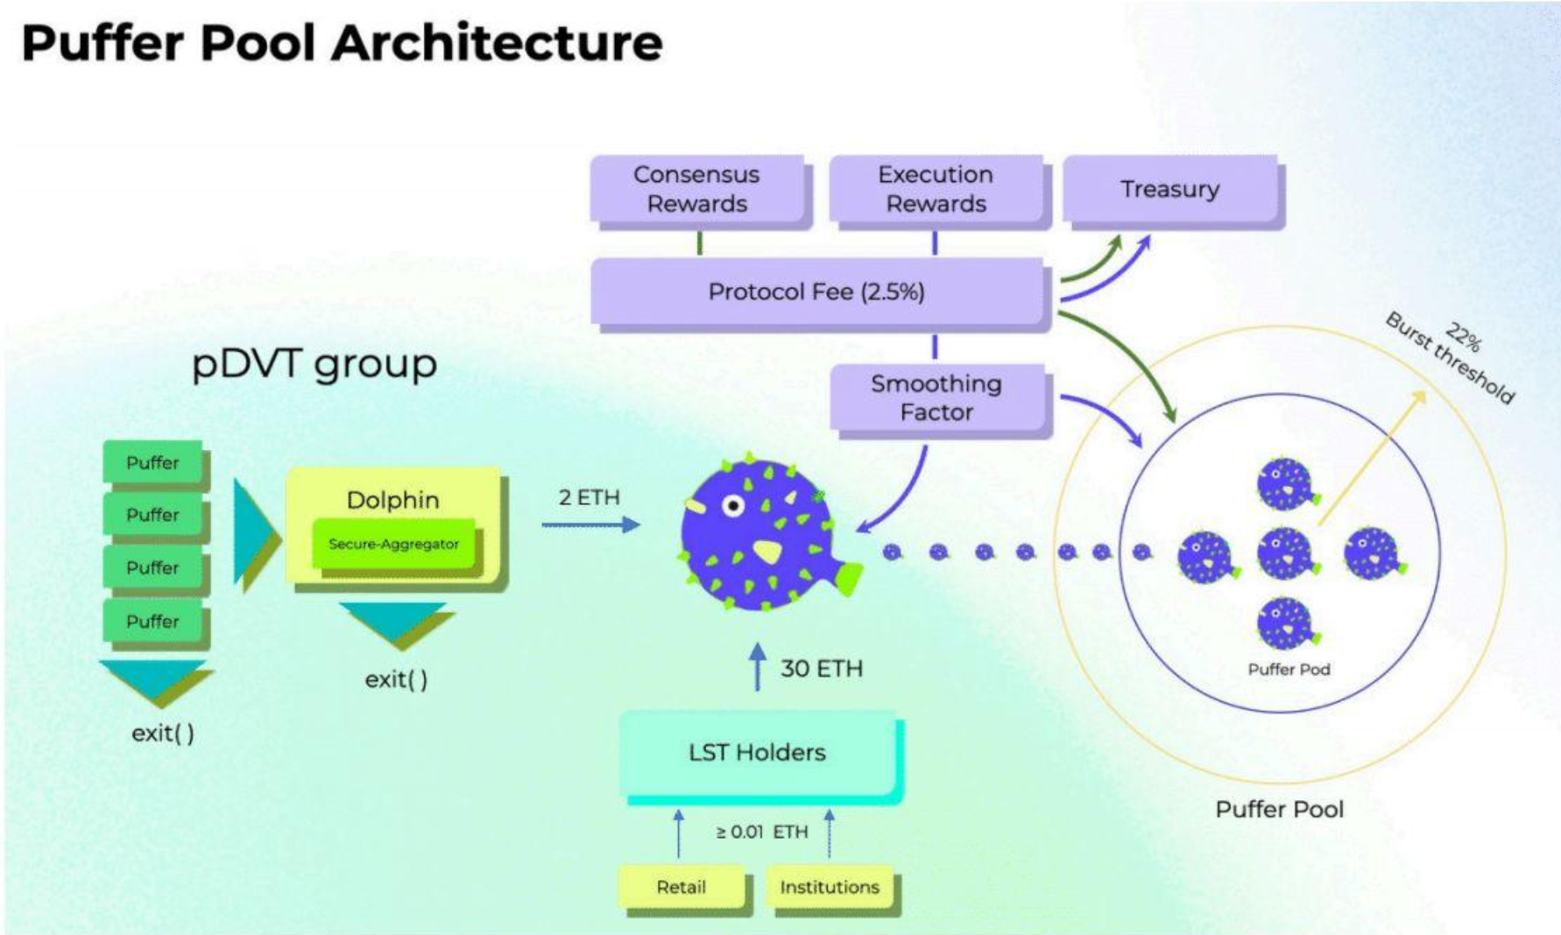

In a broader sense, Puffer operates as a foundation for providing TEE-enabled services to further crypto-protocols. Scroll is talking with Puffer because zkRollups could benefit from TEE. Sreeram from EigenLayer is angel-investing into Puffer because restaking needs the TEE.

Target Market/Business Model
Puffer charges a 2.5% fee on consensus rewards managed by the Puffer DAO to fuel protocol development. There is also a 2.5% execution rewards fee.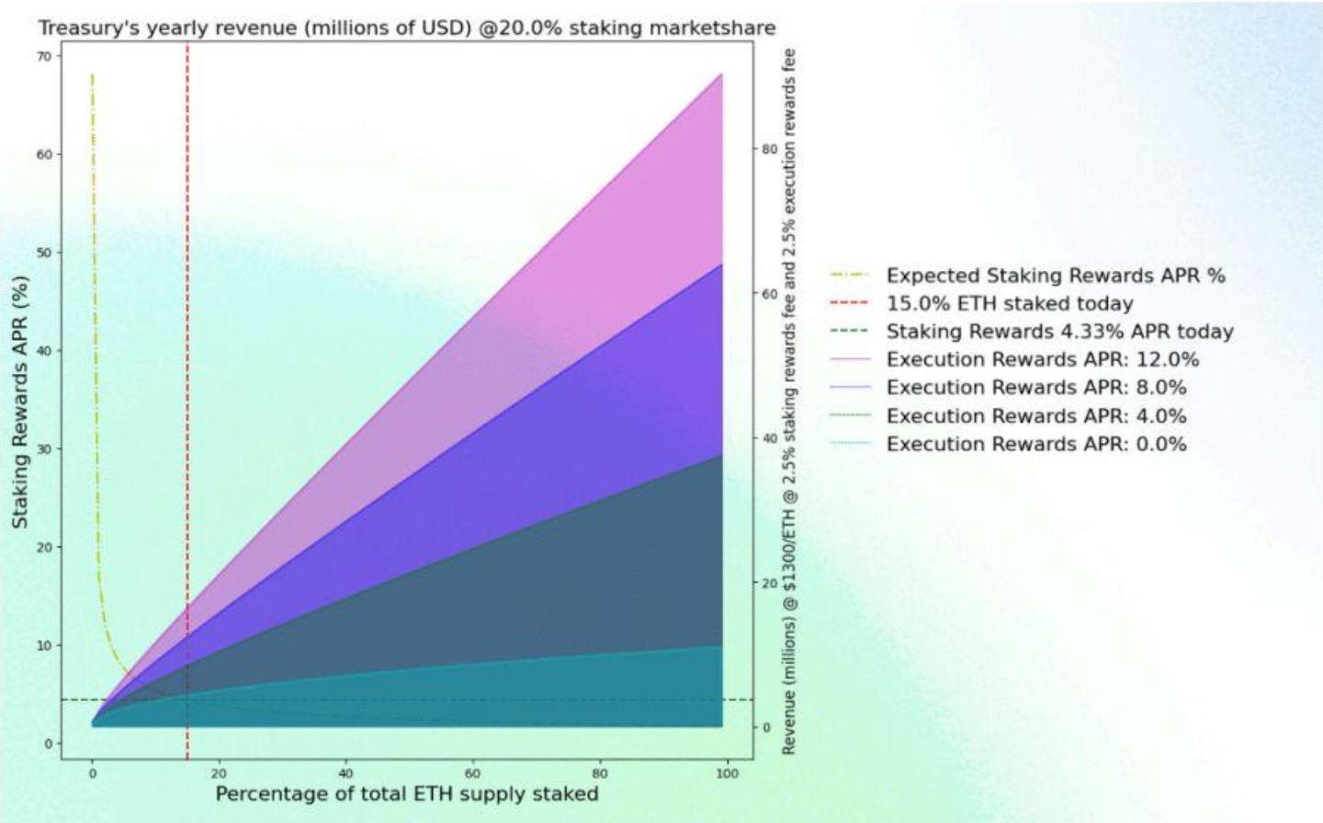

Competitive Landscape

Project | Description
Lido | Liquidity for staked assets. Daily rewards, no lock-ups. Available for Ethereum, Solana, Polygon, Terra, Kusama & Polkadot.
Coinbase Wrapped | Coinbase is allowing customers who stake ETH to receive an ERC20 utility token called Coinbase Wrapped Staked ETH (‚ÄúcbETH‚Äù), which is a liquid representation of their staked ETH.
Rocket Pool | Rocket Pool is the first truly decentralised Ethereum staking pool. Liquid staking, Audited SC, and Minimised Penalty Risk. Unlike solo stakers, who are required to put 32 ETH up for deposit to create a new validator, Rocket Pool nodes only need to deposit 16 ETH per validator. This will be coupled with 16 ETH from the staking pool (which stakers deposited in exchange for rETH) to create a new ETH2 validator.
Frax Ether | Frax Ether is a liquid ETH staking derivative designed to uniquely leverage the Frax Finance ecosystem to maximise staking yield and smoothen the Ethereum staking process for a simplified, secure, and DeFi-native way to earn interest on ETH.
StakeWise | Stake ETH and manage capital flexibly with the principal and yield tokens from StakeWise.
Binance staked ETH | A token created by depositing BETH into the BETH wrapper. Each WBETH represents 1 BETH (1:1 to staked ETH) plus all of its accrued ETH2.0 staking rewards.
Ankr | Liquid, secure, and easy to integrate staking infrastructure.
Swell | Swell is a non-custodial liquid staking protocol.
ether.fi | Decentralised and non-custodial Ethereum staking protocol.
SharedStake | SharedStake is a decentralised ETH staking solution that allows users to stake any amount of Ether and earn additional yield on top of their rewards.
Stafi | StaFi is a decentralised & scalable Cross-Chain Staking Derivatives Protocol that unlocks the liquidity of your staked assets.
Tranchess Ether | Tranchess ETH Fund is a Tranchess fund uniquely designed with ETH staking strategy.
NodeDAO | Experience the ease of staking on Ethereum 2.0 through NodeDAO‚Äôs liquid staking service.
Bifrost Liquid Staking | Bifrost is a substrate developed web3 derivatives protocol that provides decentralised cross-chain liquidity for staked assets. Bifrost‚Äôs mission is to provide standardised cross-chain interest-bearing derivatives for Polkadot relay chains, parachains and heterogeneous chains bridged with Polkadot.
uniETH | uniETH represents the staked ETH in Bedrock plus all future staking rewards. uniETH is non-rebasing, i.e. does not grow in quantity over time.

Differentiation from Incumbents
- Most Secure
a. Puffer’s Secure-Signer prevents slashable offences, protects staked ETH, and provides best-in-class security for a decentralised stake pool.
- Permissionless
a. Anyone can join the pool without going through governance or requiring high capital.
- Higher Yield
a. Execution reward sharing provides higher yield for pufETH holders.
- High Capital Efficiency
a. They reduce bond requirements from 32 ETH to 2 ETH, increasing execution reward opportunities 16x.
- Low Fees
a. Staking rewards fee of 2.5% increases the APR for stakers, attracting more capital.
- Decentralised
a. Low barrier of entry allows the pool to scale quickly and preserves Ethereum’s decentralisation.

Comparison Table (text extracted):
 | NoOp Requirements | Staker Fee | Decentralized | Shares Execution Rewards | Permissionless Nodes | LST Token | Non-Custodial | Open Source
Puffer | 2 ETH | 2.5% | ✓ | ✓ | ✓ | ✓ | ✓ | ✓
Rocket Pool | 17.6 ETH (10.4 w/ Atlas) | 15% | ✓ | X | ✱ | ✓ | ✓ | ✓
Lido | Win DAO Vote | 10% | ✱ | ✱✱ | X | ✓ | ✱ | ✓
Centralised Players | CEX-Operated | ~25% | X | X | X | X | X | X

Moat
- Low bond requirement:
Reducing the bond requirement would increase the slashing risk for other LSPs. Puffer mitigates this risk through their architecture.
- TEE:
SGX is just a specific implementation of a broad, highly technical category that Puffer can optimise for and bring into the Ethereum ecosystem.

Roadmap
- Feb 2022 – Team formation at ETHDenver
- Q1/Q2/Q3 2022 – R&D into system architecture, researching Ethereum staking
- Oct 2022 – Started dev for Ethereum Foundation (EF)
- Nov 2022 – EF grant approved
- Dec 2022 – Present and host workshop at Columbia + EF cryptoeconomics event
- Jan/Feb 2023 – Launch Secure-Signer on testnet
- March 2023 – Launch DAO + pufETH Mainnet
- Shanghai Update and Beyond 2023

Traction
In advance of the full launch, Puffer launched the secure Secure-Signer (May 17th), a remote signing tool for Ethereum PoS validators.
They are also in talks with many teams regarding the broader possibilities of TEEs. These teams include: Scroll, Ion Protocol, EigenLayer, Obol, and more.

Key Risks
- Nice To Have
a. TEE could be seen as a “nice to have” as they provide an additional layer of security, not a new base level of security, as previously discussed.
- Moat
a. Puffer is largely open source. This means that other teams can fork them and eat into their market share.
- Fees – Race To The Bottom
a. As competition in the LST space heats up, there will be increased pressure to reduce fees to maintain competitiveness.

Verdict: IC Passed

