1. Display the date using the “**date**” command.



1. Check who are the users logged in using the “**who**” command.



1. Check the running processes using the “**ps**” command.

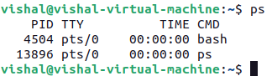

1. List the files with “**ls**” command with and without **-l** option.

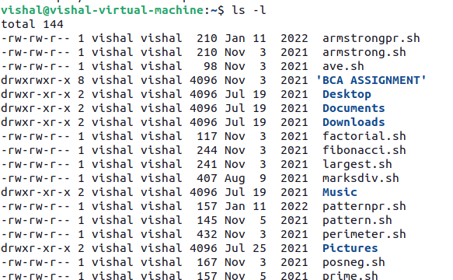

1. Check the *manual of* **ls** command.

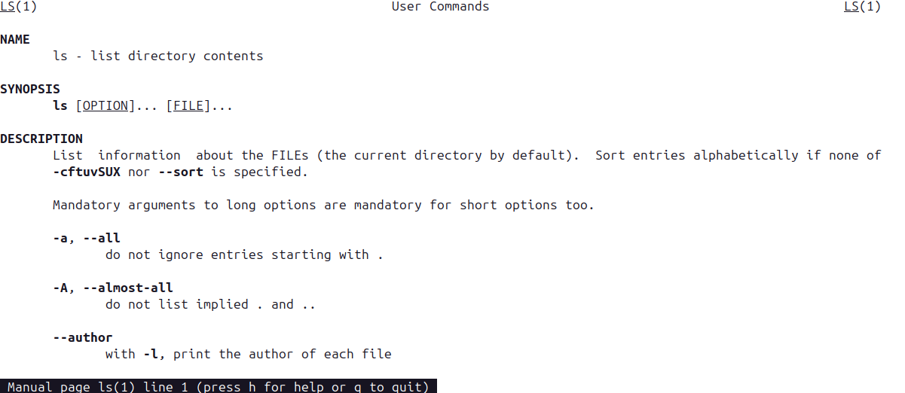

1. Show the commands used to display (i) filenames (ii) processes (iii)users.







1. Check and state the difference between man and whatis command by checking **man cp** & **whatis cp**.

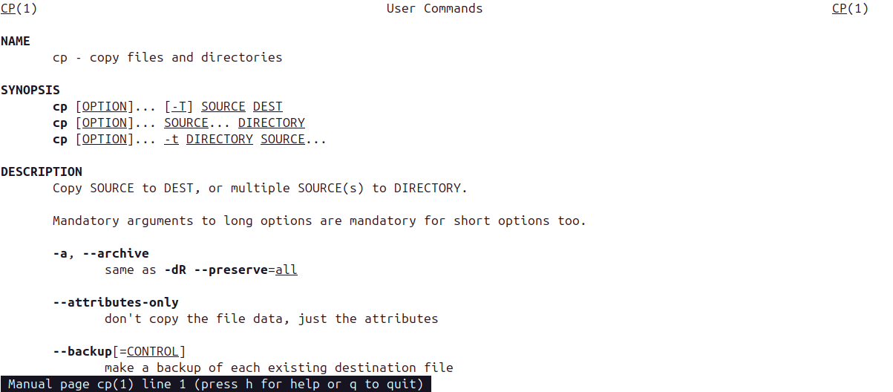



1. What is the primary difference between **printf** and **echo** command. Check and print.

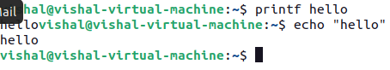

1. In the home directory, create a directory *MCA2022*. Inside the *MCA2022,* create another directory *<FistName_Section_ClassRoll>* and get into the directory [**~ /MCA2022/Ankur_A_00$**].

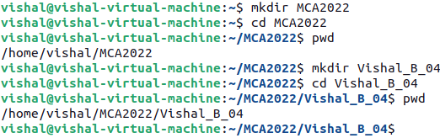

1. Go to the subdirectory and create another subdirectory “**Unix_File_System**” within it.

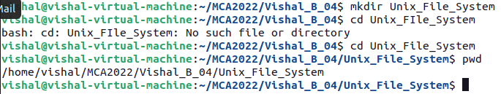

1. Create the subdirectories TestA, TestB, TestC and corresponding sub-subdirectories TestA-1, TestA-2, TestB-1, TestB-2, TestB-3, TestC-1, TestB-2-i in a single command.

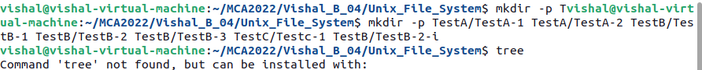

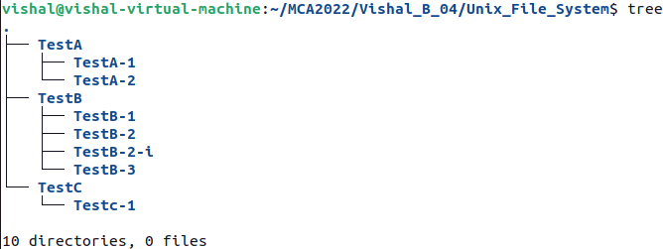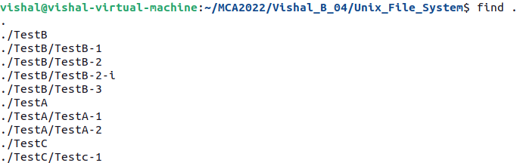

1. Show the absolute path of TestB-2-i.

