1. Create two C files to print “**Hello World!**” in two different ways:
   1. Program containing normal statement terminator → HelloWorld1.c.
   2. Program without any statement terminator → HelloWorld2.c.

a)

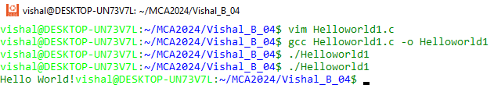

b)

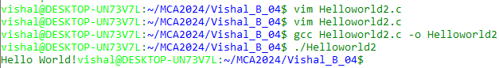

1. Display the contents of the files.

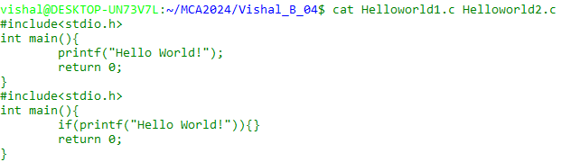

1. Concatenate the two files to a third file.

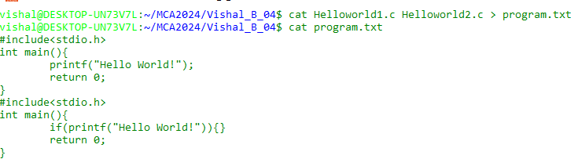

1. Show the above file types.

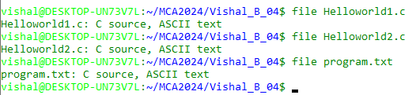

1. Copy all the files to the home directory in an interactive manner.

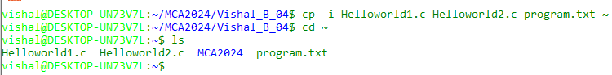

1. Create a copy of the C file in TestA-1.

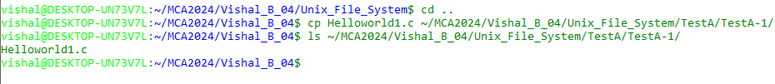

1. Copy the file to the home directory in an interactive manner.



1. Remove the directories TestC & TestC-1.

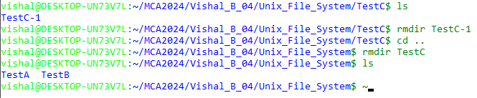

1. Delete the file C file from TestA-1.

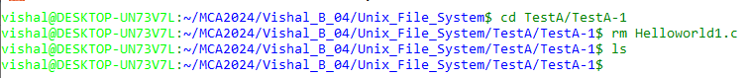

1. Rename the text file in the home directory.

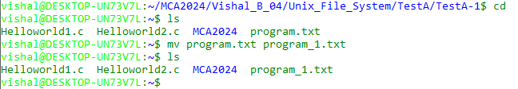

1. Create a C file for a menu driven calculator.

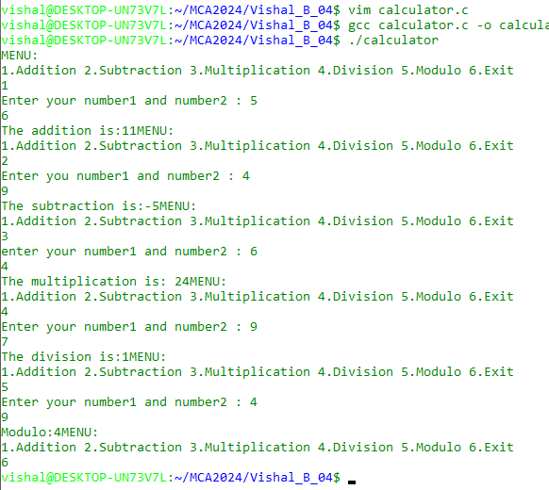

1. Show the C file in the paged manner using **more** and **less** commands.

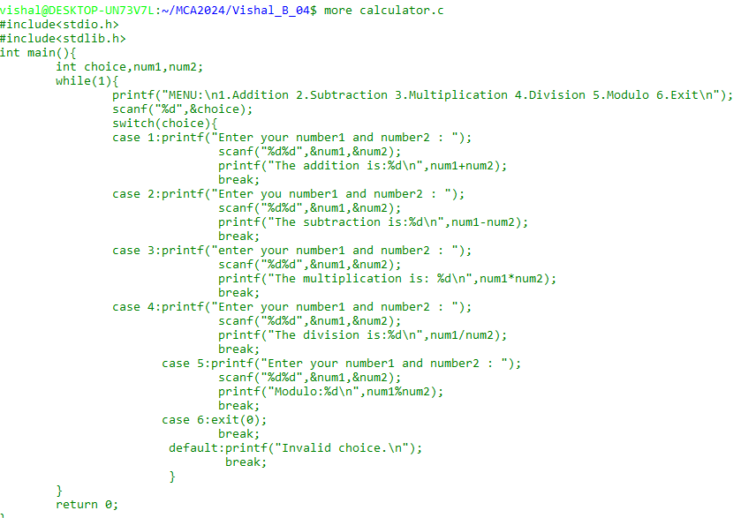

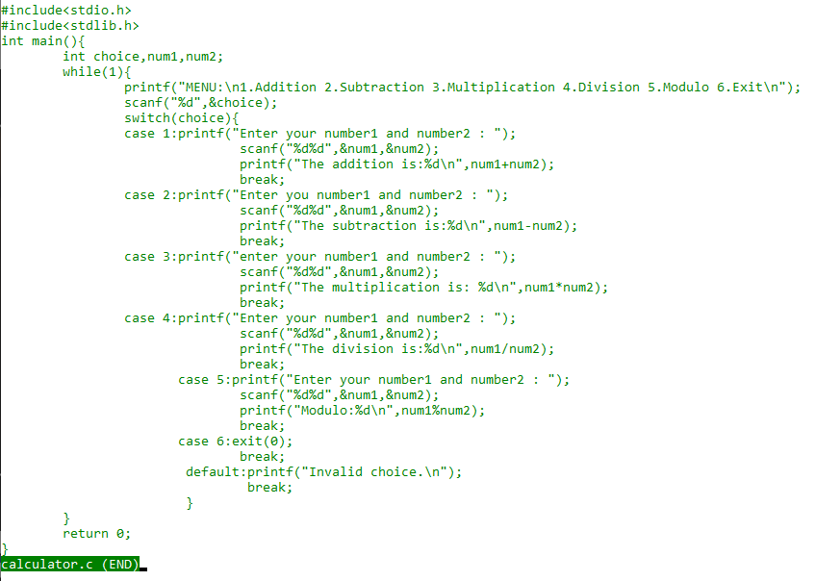

1. Count the number of lines, words and characters separately.



1. Compare the two C files.



1. Find what is common in two C files.

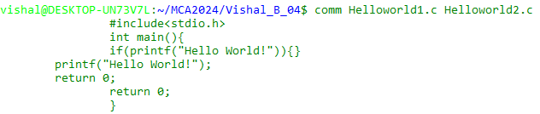

1. Find the difference in two C files.

