Time Series

# Introduction

The aim of this analysis is to predict the unemployment rate in United States of America based on the data released by U.S Department of Labor, which is also known as the Bureau of Labor Statistics (BLS). The Labor Bureau has been collecting the unemployment rate data since 1948 to present, to analyze the effect of employment due to external factors like recessions. This rate represents the percentage of the labor force who are unemployed and this rate is also defined as the U-3 measure of labor under utilization.

A detailed analysis is done using different time series techniques to identify the best model which predicts the future unemployment rate in U.S.

# Scope

In this project, we are going to analyse different trends in the data to identity the suitable model. Also, the orders (p, d, q) if required are identified using the model specification tools. Then, we integrate the GARCH model with the best ordered (p, d, q) model to finalize the best model which fits the data. With this resultant model we are going to predict the forecast of unemployment rate in U.S.

# Method

Here we used R language built in pakages like TSA, fUnitRoots, forecast, tsereies, etc., and model specification tools to identify the models which predict the forecast.

# Data:

The data used here to predict the future unemployment rate is recorded by U.S Bureau of Labor Statistics, this time series data is released every year by the Labor Bureau since 1948 by conducting Current Population Survey (Household Survey) in United States of America. This data has two variables namely Data and Rate (measured in percentage).

Importing the required packages.

## Warning: package 'TSA' was built under R version 4.0.5

##   
## Attaching package: 'TSA'

## The following objects are masked from 'package:stats':  
##   
## acf, arima

## The following object is masked from 'package:utils':  
##   
## tar

## Warning: package 'fUnitRoots' was built under R version 4.0.5

## Loading required package: timeDate

## Warning: package 'timeDate' was built under R version 4.0.5

##   
## Attaching package: 'timeDate'

## The following objects are masked from 'package:TSA':  
##   
## kurtosis, skewness

## Loading required package: timeSeries

## Warning: package 'timeSeries' was built under R version 4.0.5

## Loading required package: fBasics

## Warning: package 'fBasics' was built under R version 4.0.5

## Warning: package 'forecast' was built under R version 4.0.5

## Registered S3 method overwritten by 'quantmod':  
## method from  
## as.zoo.data.frame zoo

## Registered S3 methods overwritten by 'forecast':  
## method from  
## fitted.Arima TSA   
## plot.Arima TSA

## Warning: package 'CombMSC' was built under R version 4.0.5

##   
## Attaching package: 'CombMSC'

## The following object is masked from 'package:stats':  
##   
## BIC

## Warning: package 'lmtest' was built under R version 4.0.5

## Loading required package: zoo

## Warning: package 'zoo' was built under R version 4.0.5

##   
## Attaching package: 'zoo'

## The following object is masked from 'package:timeSeries':  
##   
## time<-

## The following objects are masked from 'package:base':  
##   
## as.Date, as.Date.numeric

## Warning: package 'fGarch' was built under R version 4.0.5

## Warning: package 'rugarch' was built under R version 4.0.5

## Loading required package: parallel

##   
## Attaching package: 'rugarch'

## The following object is masked from 'package:stats':  
##   
## sigma

## Warning: package 'tseries' was built under R version 4.0.5

## Warning: package 'FitAR' was built under R version 4.0.5

## Loading required package: lattice

## Loading required package: leaps

## Warning: package 'leaps' was built under R version 4.0.5

## Loading required package: ltsa

## Warning: package 'ltsa' was built under R version 4.0.3

## Loading required package: bestglm

## Warning: package 'bestglm' was built under R version 4.0.5

##   
## Attaching package: 'FitAR'

## The following object is masked from 'package:forecast':  
##   
## BoxCox

Importing the data from CSV file to dataframe.

DATE variable is changed to DATE format and converted as rownames.

Here, the dataframe is converted to Time Series(ts) object.

Plotting the time series data for better understanding.

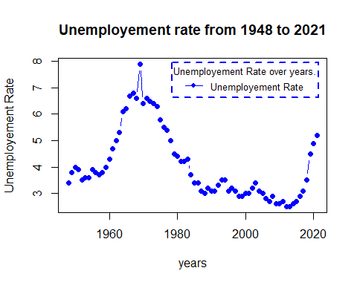

Fig 1: Unemployment rate from 1960 to 2021 - Time series plot.

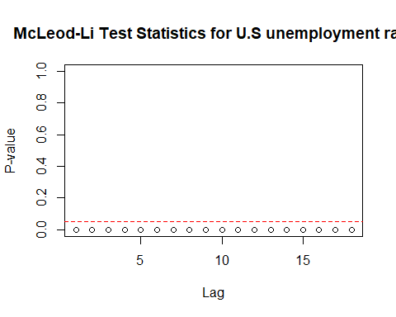 Fig 1: McLeod-Li Test Statistics for U.S unemployment rate.

McLeod-Li test is significant at 5% level of significance for all lags suggesting volatility clustering.

## Descriptive analysis

1. From fig1, we can observe an upward trend in the plot until 1970 and from then we can see downward trend. By this we can say that there is no trend in the plot.
2. This series shows Autoregressive and moving average behaviour.
3. From the plot, we can conclude that there is no seasonality in the series.
4. From the time series plot and McLeod-Li test, we can see change in variance.

## Model Building Strategy:

1. Model Specification
2. Model Fitting
3. Model Diagnostics.

### Model Specification:

Since the series has autoregressive and moving average behaviour, AR/MA model fits the series. Also, we choose AR/MA + GARCH model to fit the series as the series has a change in variance. Let us check whether the data is stationary or not because to fit the AR/MA model, the data should be in stationary.

#### Testing for stationary

Let us analyse ACF and PACF plots.

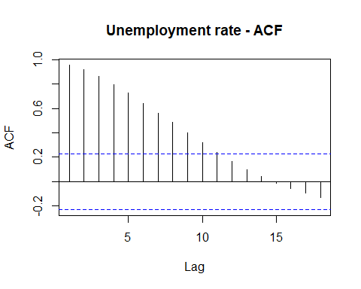 Fig 3: ACF plot for U.S unemployment rate.

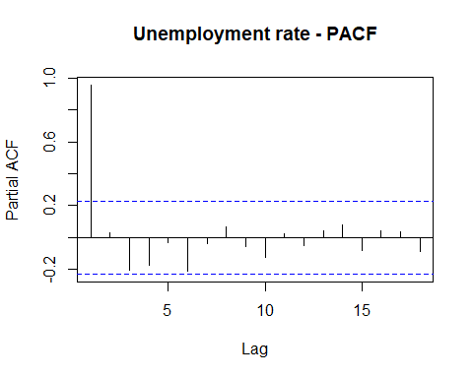

Fig 4: PACF plot for U.S unemployment rate.

In both ACF and PACF, we can observe high peak at the first lag and significant lags are in decomposition pattern in ACF plot.

Running Augmented Dickey-Fuller tests on series data.

##   
## Title:  
## Augmented Dickey-Fuller Test  
##   
## Test Results:  
## PARAMETER:  
## Lag Order: 1  
## STATISTIC:  
## Dickey-Fuller: 0.1193  
## P VALUE:  
## 0.65   
##   
## Description:  
## Sun Jun 13 20:11:46 2021 by user: HP

Hypotheses : H0 : The data is not stationary. HA : The data is stationary.

Interpretations: p - value - 0.65 > 0.05

Since, p - value is greater than 0.05, the test is not statistically significant. Thereby, we fail to reject Null hypothesis i.e., The data is not stationary.

Let’s apply transformation on the data to check whether the change in variance is decreasing or not.

Applying Box_Cox transformation,

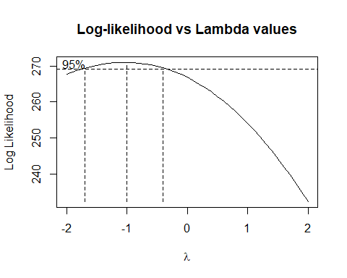

Fig 5: Log-likelihood vs Lambda values

Change in variance is decreased. Now, let us calculate the best lambda.

Running shapiro test to check the normality,

##   
## Shapiro-Wilk normality test  
##   
## data: UNRATE_TS_BC  
## W = 0.96005, p-value = 0.01964

p-value = 0.02 < 0.05

Since, p - value is less than 0.05, the test is statistically significant at 95% confidence intervals. Thereby, Null hypothesis can be rejected i.e., data is normalized.

Running ADF test,

##   
## Title:  
## Augmented Dickey-Fuller Test  
##   
## Test Results:  
## PARAMETER:  
## Lag Order: 1  
## STATISTIC:  
## Dickey-Fuller: 0.1874  
## P VALUE:  
## 0.6716   
##   
## Description:  
## Sun Jun 13 20:11:47 2021 by user: HP

Hypotheses : H0 : The data is not stationary. HA : The data is stationary.

Interpretations: p - value - 0.67 > 0.05

Since, p - value is greater than 0.05, the test is not statistically significant. Thereby, we fail to reject Null hypothesis i.e., The data is not stationary.

Since the data is not stationary, we are differencing the data to order 1 i.e., d=1.

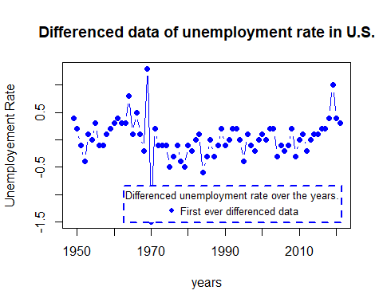

Fig 6: Differenced series of unemployment rate.

Applying ADF test,

## Warning in adfTest(UNRATE_diff): p-value smaller than printed p-value

##   
## Title:  
## Augmented Dickey-Fuller Test  
##   
## Test Results:  
## PARAMETER:  
## Lag Order: 1  
## STATISTIC:  
## Dickey-Fuller: -4.3833  
## P VALUE:  
## 0.01   
##   
## Description:  
## Sun Jun 13 20:11:47 2021 by user: HP

Hypotheses : H0 : The data is not stationary. HA : The data is stationary.

Interpretations:

p - value ~ 0.01 < 0.5

P - value rounded to 0.01 as it is very small (exponential value.)

Since, p - value is less than 0.05, the test is statistically significant at 95% confidence intervals. Thereby, Null hypothesis can be rejected i.e., data is stationary.

## Order Specification

### Using ACF and PACF

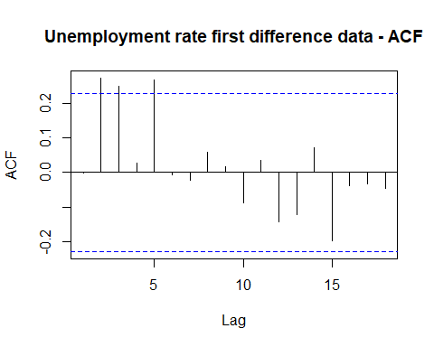 Fig 7: Unemployment rate first difference data - ACF

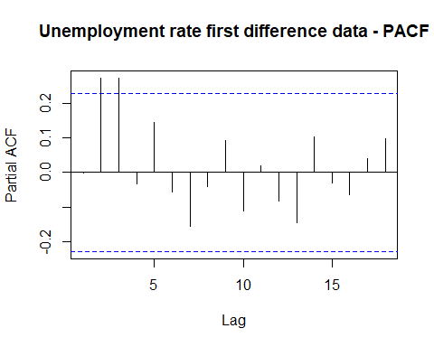

Fig 8: Unemployment rate first difference data - PACF

The possible orders from ACF and PACF are, (0,1), (0,2), (0,3), (1, 0), (1,1), (1,2), (1,3), (2, 0), (2,1), (2,2), (2,3)

## Using EACF

## AR/MA  
## 0 1 2 3 4 5 6 7 8 9  
## 0 o x x o x o o o o o  
## 1 o o o o x o o o o o  
## 2 x x o o x o o o o o  
## 3 o x o o o o o o o o  
## 4 o x o x x o o o o o  
## 5 x x o o x o o o o o  
## 6 x x o o x o o o o o

Possible orders from EACF, (3,2), (3,3), (3,4).

## Using BIC

## Warning in leaps.setup(x, y, wt = wt, nbest = nbest, nvmax = nvmax, force.in =  
## force.in, : 5 linear dependencies found

## Reordering variables and trying again:

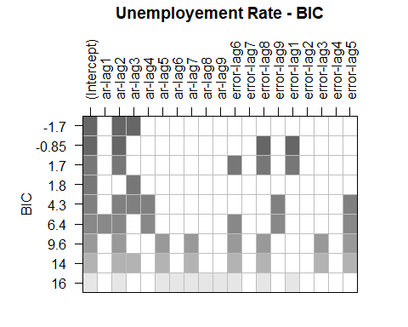

Possible orders from BIC, (3, 0), (2, 1).

Overall possible ARMA orders are,

(0,1), (0,2), (0,3), (1, 0), (1,1), (1,2), (1,3), (2, 0), (2,1), (2,2), (2,3), (3,2), (3,3), (3,4) and (3, 0).

### Model Fitting and Diagnostics

ARIMA(0,0,1)

##   
## z test of coefficients:  
##   
## Estimate Std. Error z value Pr(>|z|)  
## ma1 -0.0012071 0.0942890 -0.0128 0.9898  
## intercept 0.0246484 0.0422593 0.5833 0.5597

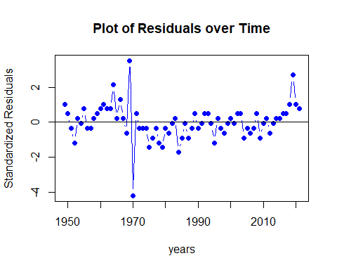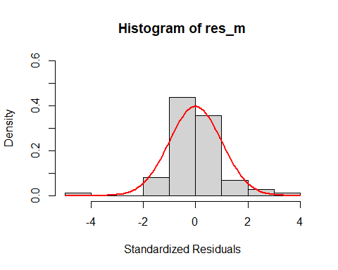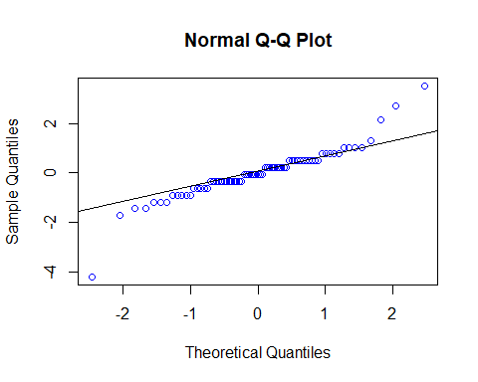

##   
## Shapiro-Wilk normality test  
##   
## data: res_m  
## W = 0.90137, p-value = 3.091e-05

## Warning in (ra^2)/(n - (1:lag.max)): longer object length is not a multiple of  
## shorter object length

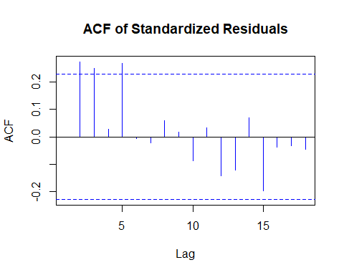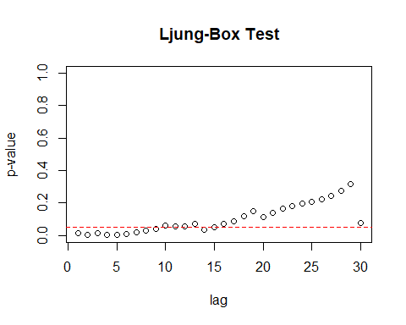 Residual Analysis for ARIMA(0,0,1):

1. p-value is greater than 0.05 for ma1.
2. In Residual plot, the line is passing through 0.
3. From normal distribution curve, qq plot and Shapiro Walk test, we can see some normality in the data.
4. There are significant lags in Autocorrelation plot.
5. From Ljung box test, we can observe few significant lags.

Therefore, it is not a good model for the data.

ARIMA (0,0,2)

##   
## z test of coefficients:  
##   
## Estimate Std. Error z value Pr(>|z|)   
## ma1 -0.079466 0.119146 -0.6670 0.504795   
## ma2 0.284368 0.101772 2.7942 0.005203 **  
## intercept 0.028440 0.048514 0.5862 0.557716   
## ---  
## Signif. codes: 0 '***' 0.001 '**' 0.01 '*' 0.05 '.' 0.1 ' ' 1

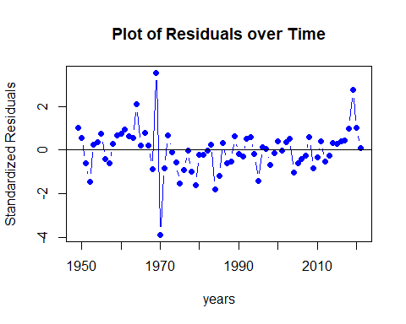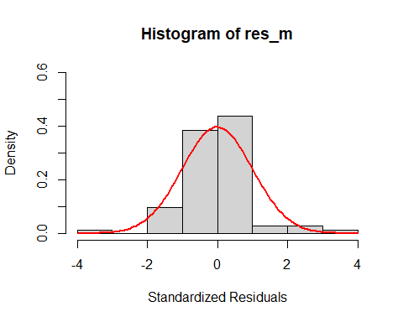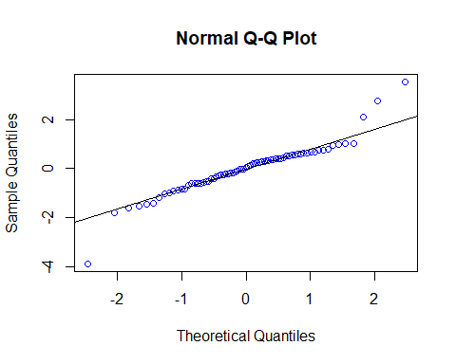

##   
## Shapiro-Wilk normality test  
##   
## data: res_m  
## W = 0.91889, p-value = 0.0001722

## Warning in (ra^2)/(n - (1:lag.max)): longer object length is not a multiple of  
## shorter object length

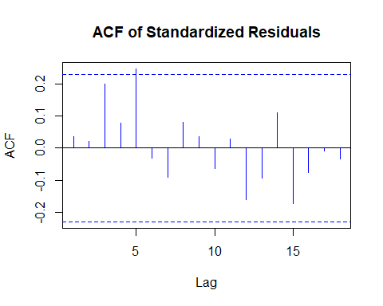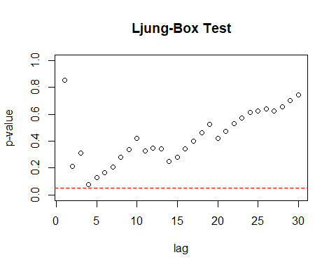

Residual Analysis for ARIMA(0,0,2):

1. p-value is less than 0.05 for ma2. Thereby, it is significant.
2. In Residual plot, the line is passing through 0.
3. From normal distribution curve, qq plot and Shapiro Walk test, we can see some normality in the data.
4. There is only one significant lag in Autocorrelation plot.
5. Ljung box test shows good results as all the dots are above the dotted line.

Therefore, it can be considered as a good model for the data.

ARIMA(0,0,3)

##   
## z test of coefficients:  
##   
## Estimate Std. Error z value Pr(>|z|)   
## ma1 -0.135365 0.131755 -1.0274 0.30423   
## ma2 0.158017 0.108373 1.4581 0.14482   
## ma3 0.341004 0.170296 2.0024 0.04524 *  
## intercept 0.035071 0.053313 0.6578 0.51065   
## ---  
## Signif. codes: 0 '***' 0.001 '**' 0.01 '*' 0.05 '.' 0.1 ' ' 1

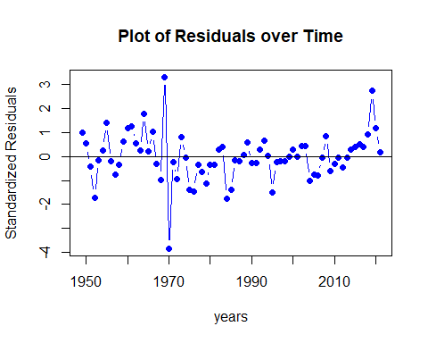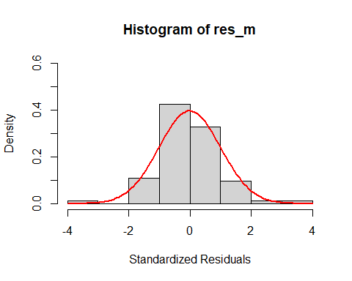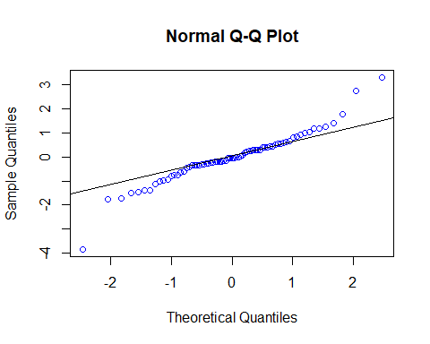

##   
## Shapiro-Wilk normality test  
##   
## data: res_m  
## W = 0.93929, p-value = 0.001601

## Warning in (ra^2)/(n - (1:lag.max)): longer object length is not a multiple of  
## shorter object length

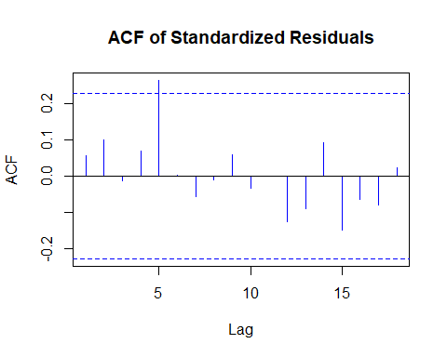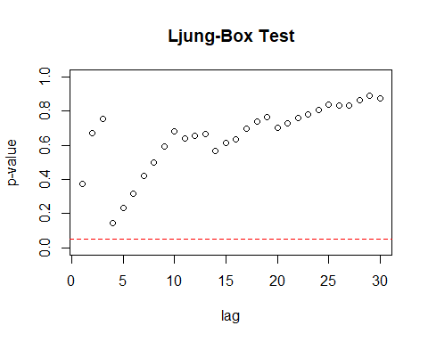 Residual Analysis for ARIMA(0,0,3):

1. p-value is less than 0.05 for ma3. Thereby, it is significant.
2. In Residual plot, the line is passing through 0.
3. From normal distribution curve, qq plot and Shapiro Walk test, we can see some normality in the data.
4. There is only one significant lag in Autocorrelation plot.
5. Ljung box test shows good results as all the dots are above the dotted line.

Overall, it can be considered as a good model but comparatively, ARIMA(0,0,2) performed better as the coefficients of ARIMA(0,0,3) are less significant than the coefficients of ARIMA(0,0,2).

ARIMA (1,0,0)

##   
## z test of coefficients:  
##   
## Estimate Std. Error z value Pr(>|z|)  
## ar1 -0.001878 0.117609 -0.0160 0.9873  
## intercept 0.024634 0.042236 0.5833 0.5597

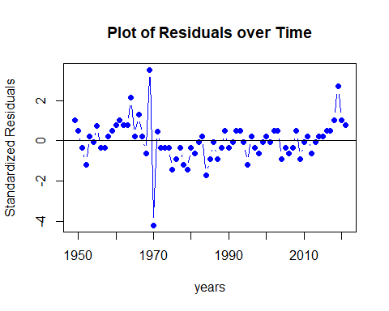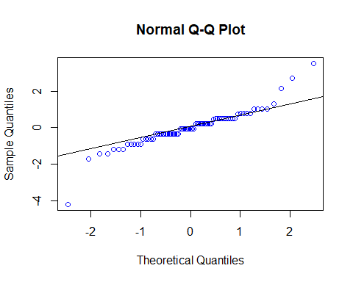

##   
## Shapiro-Wilk normality test  
##   
## data: res_m  
## W = 0.90161, p-value = 3.162e-05

## Warning in (ra^2)/(n - (1:lag.max)): longer object length is not a multiple of  
## shorter object length

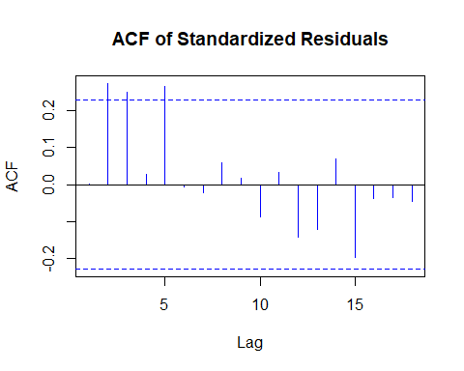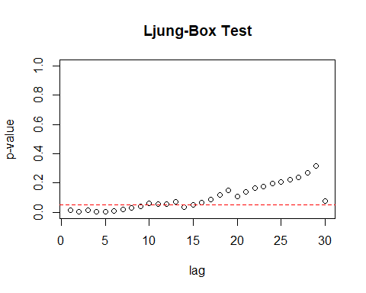

Residual Analysis for ARIMA(1,0,0):

1. p-value is greater than 0.05 for ma1.
2. In Residual plot, the line is passing through 0.
3. From normal distribution curve, qq plot and Shapiro Walk test, we can see some normality in the data.
4. There are significant lags in Autocorrelation plot.
5. From Ljung box test, we can observe few significant lags.

Therefore, it is not a good model for the data.

ARIMA (1,0,1)

##   
## z test of coefficients:  
##   
## Estimate Std. Error z value Pr(>|z|)  
## ar1 -0.436057 0.502016 -0.8686 0.3851  
## ma1 0.382523 0.504920 0.7576 0.4487  
## intercept 0.024364 0.040670 0.5991 0.5491

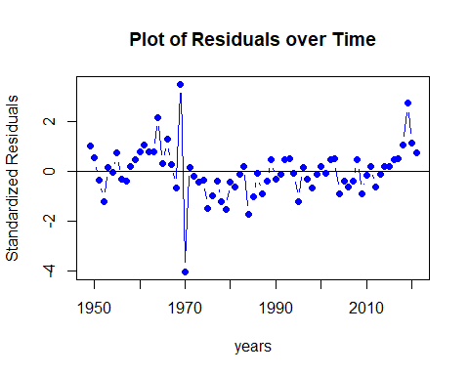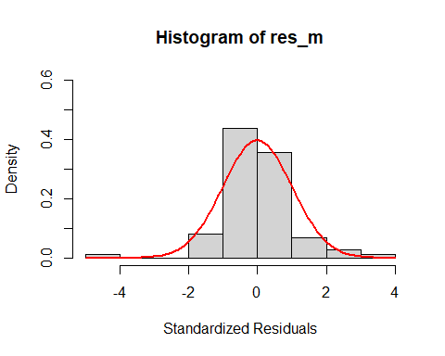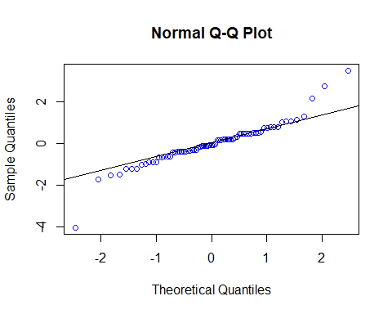

##   
## Shapiro-Wilk normality test  
##   
## data: res_m  
## W = 0.91706, p-value = 0.0001428

## Warning in (ra^2)/(n - (1:lag.max)): longer object length is not a multiple of  
## shorter object length

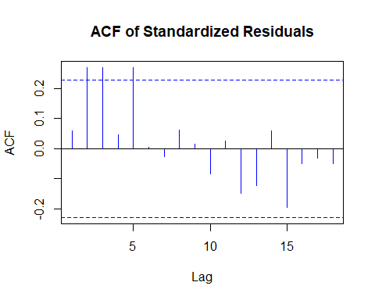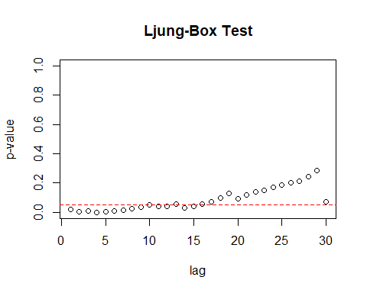

Residual Analysis for ARIMA(1,0,1):

1. p-value is greater than 0.05 for ar1 and ma1.
2. In Residual plot, the line is passing through 0.
3. From normal distribution curve, qq plot and Shapiro Walk test, we can see some normality in the data.
4. There are significant lags in Autocorrelation plot.
5. From Ljung box test, we can observe few significant lags.

Therefore, it is not a good model for the data.

ARIMA (1,0,2)

##   
## z test of coefficients:  
##   
## Estimate Std. Error z value Pr(>|z|)   
## ar1 0.798396 0.129194 6.1798 6.418e-10 ***  
## ma1 -0.946113 0.152809 -6.1915 5.960e-10 ***  
## ma2 0.422548 0.127995 3.3013 0.0009624 ***  
## intercept 0.056250 0.088843 0.6331 0.5266427   
## ---  
## Signif. codes: 0 '***' 0.001 '**' 0.01 '*' 0.05 '.' 0.1 ' ' 1

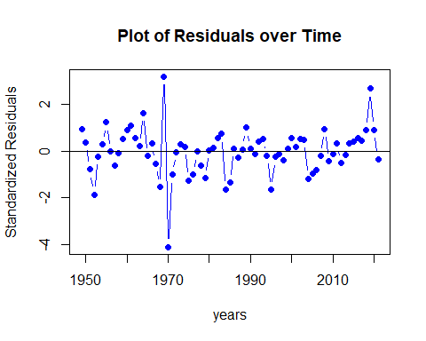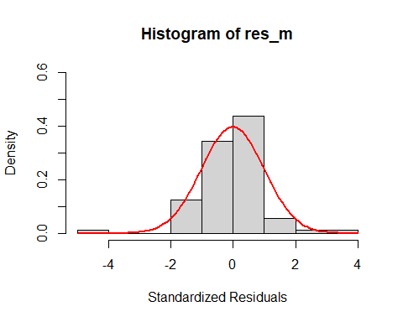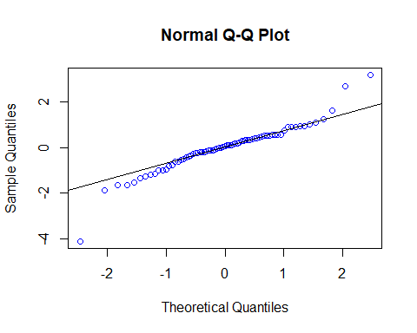

##   
## Shapiro-Wilk normality test  
##   
## data: res_m  
## W = 0.92758, p-value = 0.0004307

## Warning in (ra^2)/(n - (1:lag.max)): longer object length is not a multiple of  
## shorter object length

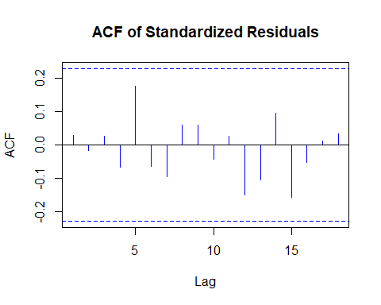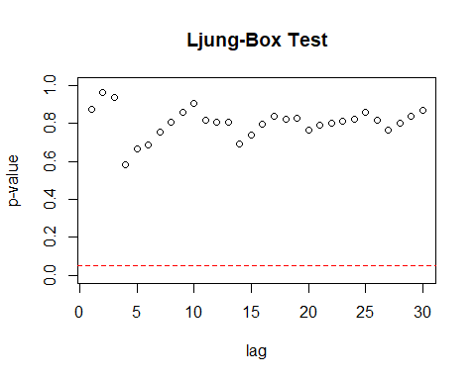

Residual Analysis for ARIMA(1,0,2):

1. p-value is less than 0.05 for ar1, ma1, and ma2. Hence, significant.
2. In Residual plot, the line is passing through 0.
3. From normal distribution curve, qq plot and Shapiro Walk test, we can see some normality in the data.
4. There are no significant lags in Autocorrelation plot.
5. Ljung box test shows good results as all the dots are above the dotted line.

Overall, it can be considered as a best model.

ARIMA (1,0,3)

##   
## z test of coefficients:  
##   
## Estimate Std. Error z value Pr(>|z|)   
## ar1 0.716644 0.273053 2.6246 0.008676 **  
## ma1 -0.846430 0.293113 -2.8877 0.003880 **  
## ma2 0.360540 0.169874 2.1224 0.033804 *   
## ma3 0.096113 0.211756 0.4539 0.649912   
## intercept 0.050341 0.081955 0.6143 0.539046   
## ---  
## Signif. codes: 0 '***' 0.001 '**' 0.01 '*' 0.05 '.' 0.1 ' ' 1

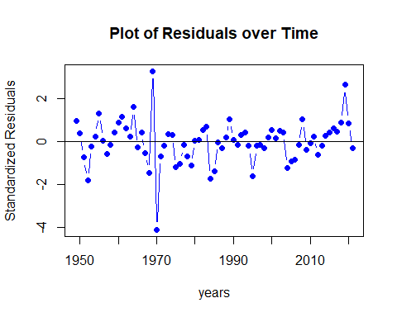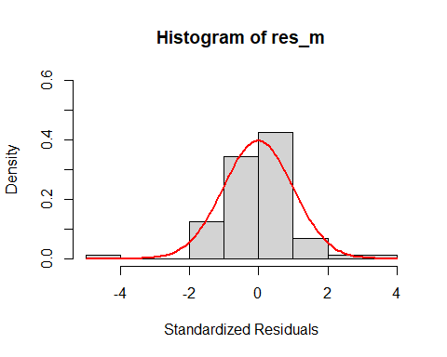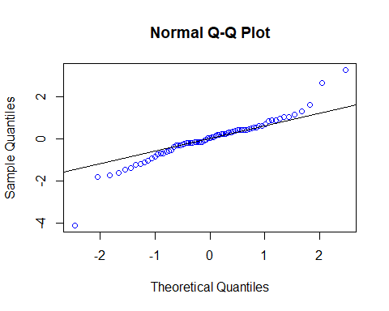

##   
## Shapiro-Wilk normality test  
##   
## data: res_m  
## W = 0.92607, p-value = 0.0003661

## Warning in (ra^2)/(n - (1:lag.max)): longer object length is not a multiple of  
## shorter object length

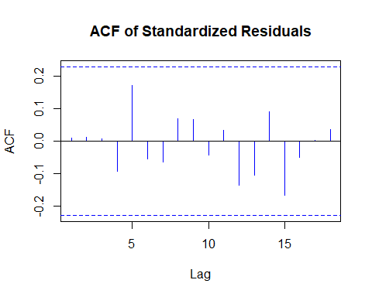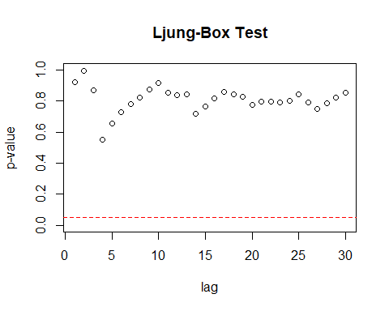

Residual Analysis for ARIMA(1,0,3):

1. p-value is less than 0.05 for ar1, ma1 and ma2. Hence, significant.
2. For ma3 p-value is greater than 0.05. Hence, not significant.
3. In Residual plot, the line is passing through 0.
4. From normal distribution curve, qq plot and Shapiro Walk test, we can see some normality in the data.
5. There are no significant lags in Autocorrelation plot.
6. Ljung box test shows good results as all the dots are above the dotted line.

Therefore, it can be considered as a good model but comparatively, ARIMA(1,0,2) performed better as the coefficients of ARIMA(1,0,3) are less significant than the coefficients of ARIMA(1,0,2).

ARIMA (2,0,0)

##   
## z test of coefficients:  
##   
## Estimate Std. Error z value Pr(>|z|)   
## ar1 0.0039028 0.1123138 0.0347 0.97228   
## ar2 0.2787470 0.1129483 2.4679 0.01359 *  
## intercept 0.0309668 0.0561633 0.5514 0.58138   
## ---  
## Signif. codes: 0 '***' 0.001 '**' 0.01 '*' 0.05 '.' 0.1 ' ' 1

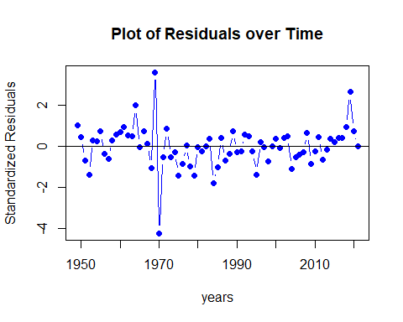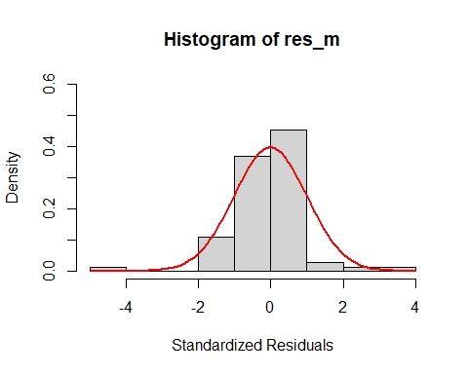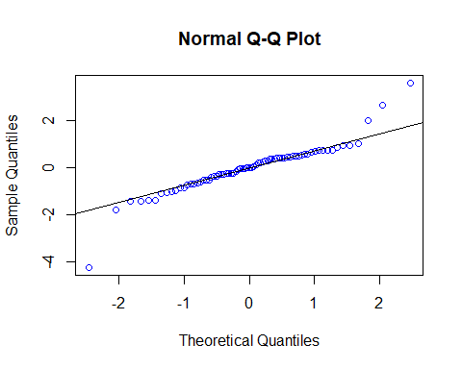

##   
## Shapiro-Wilk normality test  
##   
## data: res_m  
## W = 0.89873, p-value = 2.419e-05

## Warning in (ra^2)/(n - (1:lag.max)): longer object length is not a multiple of  
## shorter object length

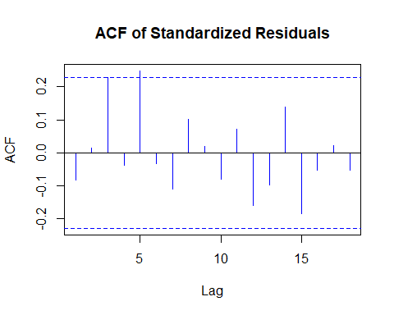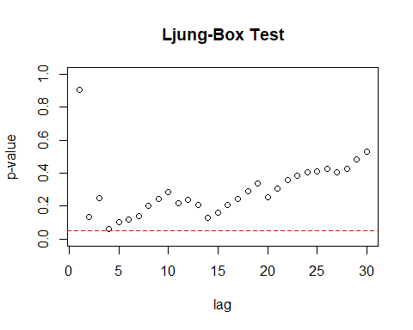

Residual Analysis for ARIMA(2,0,0):

1. p-value is greater than 0.05 for ar1 and less than 0.05 for ar2.
2. In Residual plot, the line is passing through 0.
3. From normal distribution curve, qq plot and Shapiro Walk test, we can see some normality in the data.
4. There is one significant lag in Autocorrelation plot.
5. From Ljung box test, we can observe one dot touching the dotted line.

Therefore, it is not a good model for the data.

ARIMA (2,0,1)

##   
## z test of coefficients:  
##   
## Estimate Std. Error z value Pr(>|z|)   
## ar1 0.474855 0.172715 2.7494 0.0059711 **   
## ar2 0.333597 0.116953 2.8524 0.0043391 **   
## ma1 -0.546236 0.157253 -3.4736 0.0005135 ***  
## intercept 0.055383 0.090437 0.6124 0.5402775   
## ---  
## Signif. codes: 0 '***' 0.001 '**' 0.01 '*' 0.05 '.' 0.1 ' ' 1

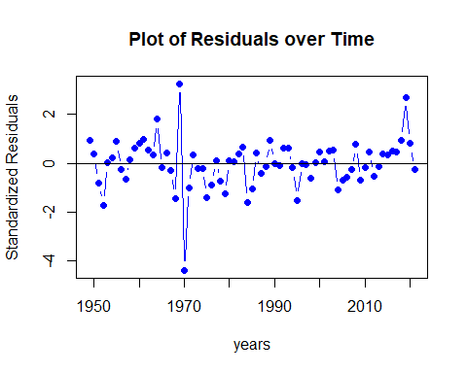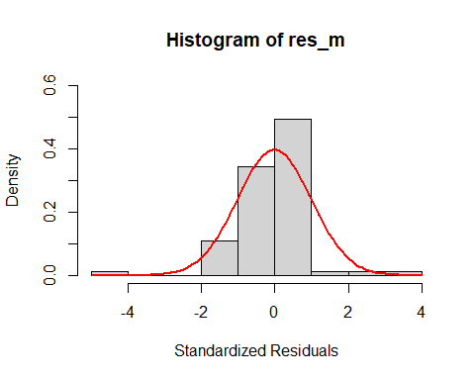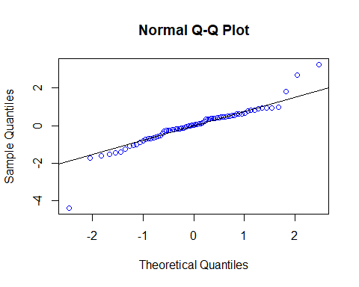

##   
## Shapiro-Wilk normality test  
##   
## data: res_m  
## W = 0.90391, p-value = 3.926e-05

## Warning in (ra^2)/(n - (1:lag.max)): longer object length is not a multiple of  
## shorter object length

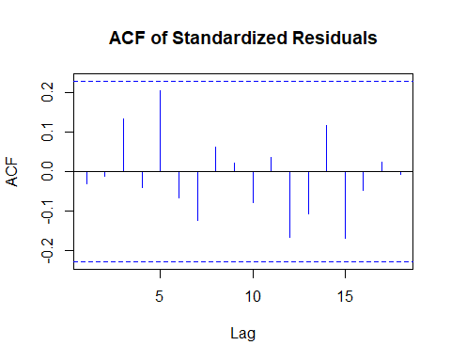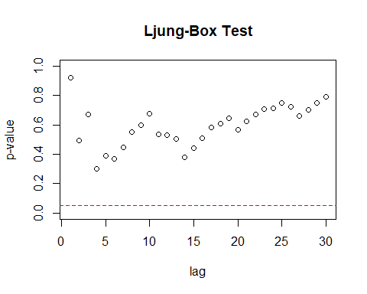 Residual Analysis for ARIMA(2,0,1):

1. p-value is less than 0.05 for ar1, ar2 and ma1. Hence, significant.
2. In Residual plot, the line is passing through 0.
3. From normal distribution curve, qq plot and Shapiro Walk test, we can see some normality in the data.
4. There are no significant lags in Autocorrelation plot.
5. Ljung box test shows good results as all the dots are above the dotted line.

Therefore, it can be considered as a good model but comparatively, ARIMA(1,0,2) performed better.

ARIMA (2,0,2)

##   
## z test of coefficients:  
##   
## Estimate Std. Error z value Pr(>|z|)   
## ar1 0.911148 0.241978 3.7654 0.0001663 ***  
## ar2 -0.143022 0.285848 -0.5003 0.6168336   
## ma1 -1.042590 0.207317 -5.0290 4.932e-07 ***  
## ma2 0.540727 0.270317 2.0003 0.0454627 *   
## intercept 0.050194 0.082589 0.6078 0.5433476   
## ---  
## Signif. codes: 0 '***' 0.001 '**' 0.01 '*' 0.05 '.' 0.1 ' ' 1

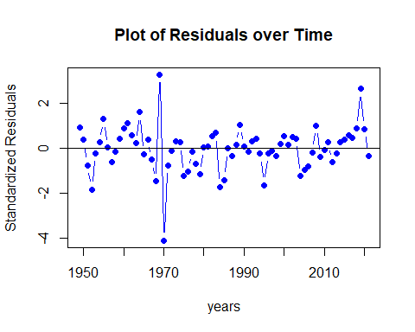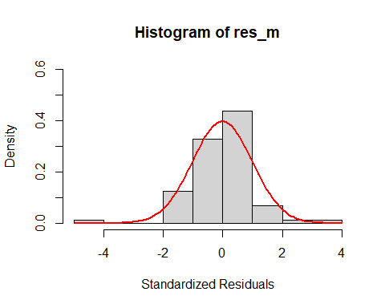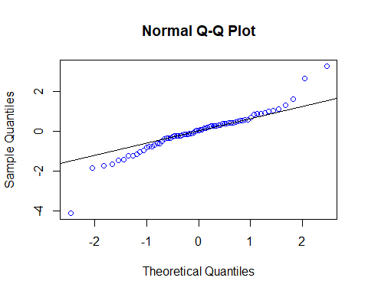

##   
## Shapiro-Wilk normality test  
##   
## data: res_m  
## W = 0.92627, p-value = 0.0003739

## Warning in (ra^2)/(n - (1:lag.max)): longer object length is not a multiple of  
## shorter object length

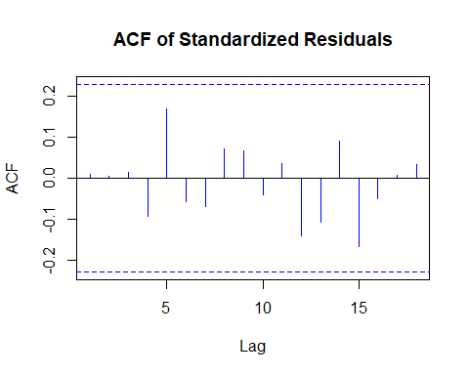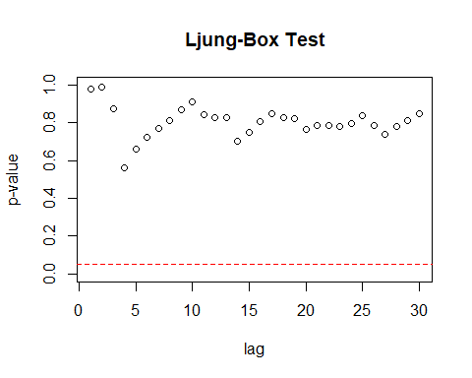 Residual Analysis for ARIMA(2,0,2):

1. p-value is less than 0.05 for ar1, ma1 and ma2. Hence, significant.
2. For ar2 p-value is greater than 0.05. Hence, not significant.
3. In Residual plot, the line is passing through 0.
4. From normal distribution curve, qq plot and Shapiro Walk test, we can see some normality in the data.
5. There are no significant lags in Autocorrelation plot.
6. Ljung box test shows good results as all the dots are above the dotted line.

Therefore, it can be considered as a good model but comparatively, ARIMA(1,0,2) performed better.

ARIMA (2,0,3)

##   
## z test of coefficients:  
##   
## Estimate Std. Error z value Pr(>|z|)   
## ar1 0.035923 0.253459 0.1417 0.887293   
## ar2 0.552169 0.248142 2.2252 0.026067 *   
## ma1 -0.148764 0.249274 -0.5968 0.550647   
## ma2 -0.318535 0.252178 -1.2631 0.206540   
## ma3 0.405351 0.129386 3.1329 0.001731 **  
## intercept 0.054010 0.085088 0.6348 0.525587   
## ---  
## Signif. codes: 0 '***' 0.001 '**' 0.01 '*' 0.05 '.' 0.1 ' ' 1

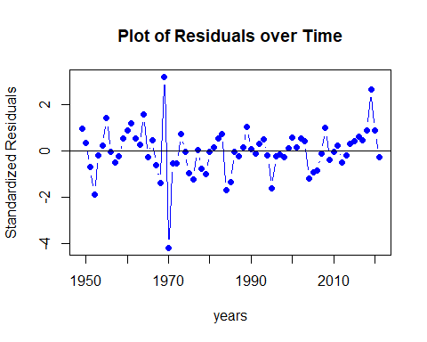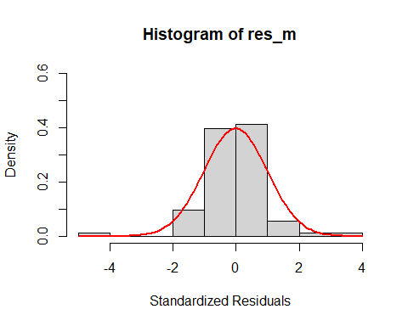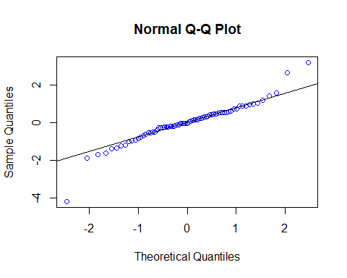

##   
## Shapiro-Wilk normality test  
##   
## data: res_m  
## W = 0.92773, p-value = 0.0004378

## Warning in (ra^2)/(n - (1:lag.max)): longer object length is not a multiple of  
## shorter object length

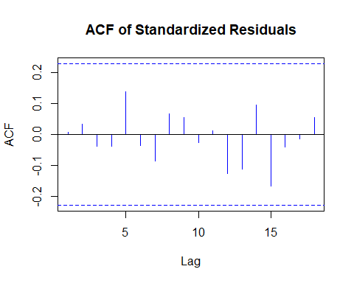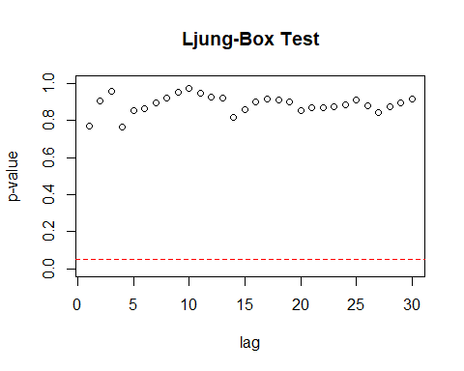 Residual Analysis for ARIMA(2,0,3):

1. p-value is less than 0.05 for ar2, and ma3. Hence, significant.
2. For ar1, ma1, and ma2, p-value is greater than 0.05. Hence, not significant.
3. In Residual plot, the line is passing through 0.
4. From normal distribution curve, qq plot and Shapiro Walk test, we can see some normality in the data.
5. There are no significant lags in Autocorrelation plot.
6. Ljung box test shows good results as all the dots are above the dotted line.

Therefore, it cannot be considered as a good model.

ARIMA (3,0,0)

##   
## z test of coefficients:  
##   
## Estimate Std. Error z value Pr(>|z|)   
## ar1 -0.081572 0.110613 -0.7375 0.460847   
## ar2 0.295658 0.106759 2.7694 0.005616 **  
## ar3 0.323403 0.116612 2.7733 0.005549 **  
## intercept 0.050956 0.081397 0.6260 0.531305   
## ---  
## Signif. codes: 0 '***' 0.001 '**' 0.01 '*' 0.05 '.' 0.1 ' ' 1

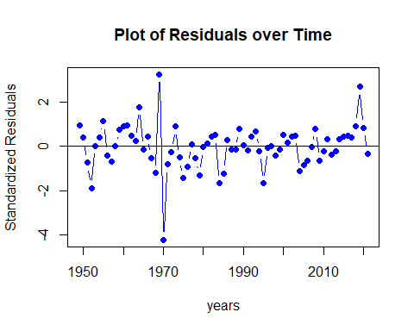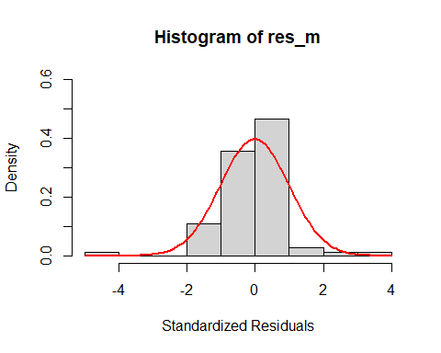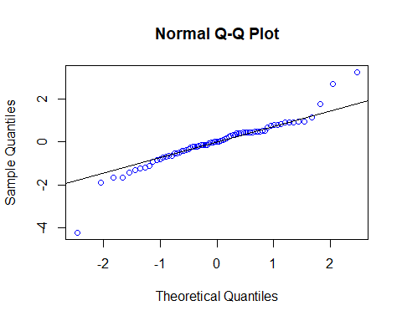

##   
## Shapiro-Wilk normality test  
##   
## data: res_m  
## W = 0.91737, p-value = 0.0001474

## Warning in (ra^2)/(n - (1:lag.max)): longer object length is not a multiple of  
## shorter object length

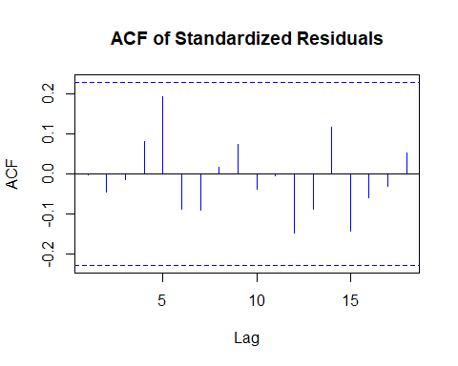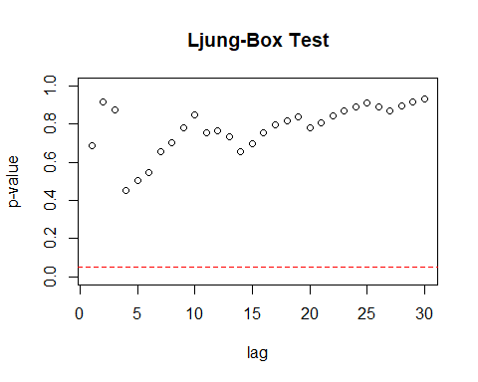 Residual Analysis for ARIMA(3,0,0):

1. p-value is less than 0.05 for ar2, and ar3. Hence, significant.
2. For ar1, p-value is greater than 0.05. Hence, not significant.
3. In Residual plot, the line is passing through 0.
4. From normal distribution curve, qq plot and Shapiro Walk test, we can see some normality in the data.
5. There are no significant lags in Autocorrelation plot.
6. Ljung box test shows good results as all the dots are above the dotted line.

Therefore, it cannot be considered as a good model.

ARIMA (3,0,2)

##   
## z test of coefficients:  
##   
## Estimate Std. Error z value Pr(>|z|)   
## ar1 -0.323554 0.280430 -1.1538 0.2485909   
## ar2 0.528993 0.216385 2.4447 0.0144976 *   
## ar3 0.396153 0.117745 3.3645 0.0007668 ***  
## ma1 0.250286 0.301592 0.8299 0.4066050   
## ma2 -0.282254 0.238282 -1.1845 0.2362011   
## intercept 0.057545 0.090998 0.6324 0.5271440   
## ---  
## Signif. codes: 0 '***' 0.001 '**' 0.01 '*' 0.05 '.' 0.1 ' ' 1

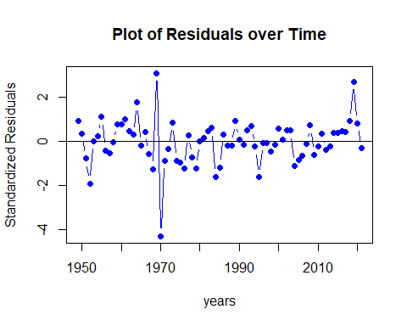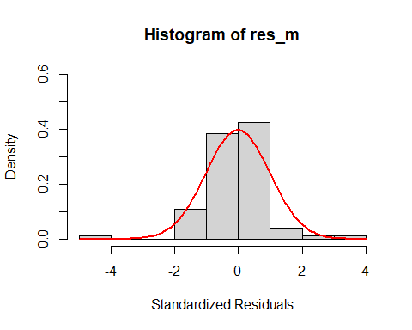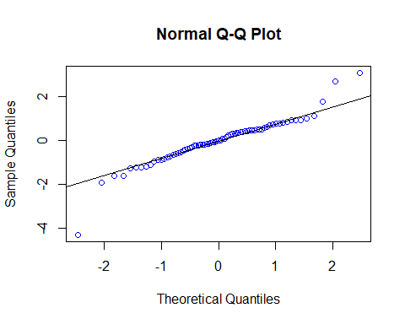

##   
## Shapiro-Wilk normality test  
##   
## data: res_m  
## W = 0.92004, p-value = 0.0001939

## Warning in (ra^2)/(n - (1:lag.max)): longer object length is not a multiple of  
## shorter object length

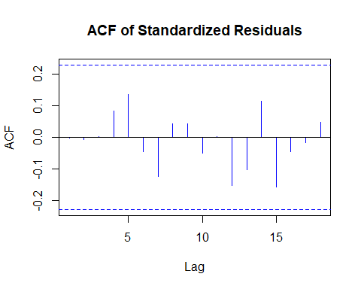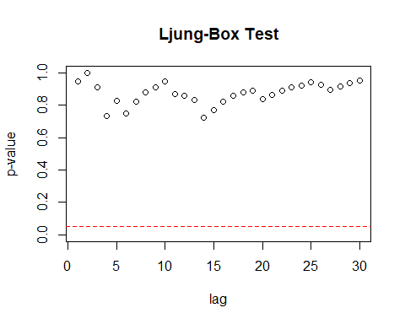

Residual Analysis for ARIMA(3,0,2):

1. p-value is less than 0.05 for ar2, and ar3. Hence, significant.
2. For ar1, ma1 and ma2, p-value is greater than 0.05. Hence, not significant.
3. In Residual plot, the line is passing through 0.
4. From normal distribution curve, qq plot and Shapiro Walk test, we can see some normality in the data.
5. There are no significant lags in Autocorrelation plot.
6. Ljung box test shows good results as all the dots are above the dotted line.

Therefore, it cannot be considered as a good model.

ARIMA (3,0,3)

##   
## z test of coefficients:  
##   
## Estimate Std. Error z value Pr(>|z|)   
## ar1 0.022084 0.328317 0.0673 0.94637   
## ar2 0.553295 0.243475 2.2725 0.02306 *  
## ar3 0.021414 0.315931 0.0678 0.94596   
## ma1 -0.136343 0.316287 -0.4311 0.66641   
## ma2 -0.319450 0.247150 -1.2925 0.19617   
## ma3 0.387554 0.294861 1.3144 0.18872   
## intercept 0.054969 0.087382 0.6291 0.52931   
## ---  
## Signif. codes: 0 '***' 0.001 '**' 0.01 '*' 0.05 '.' 0.1 ' ' 1

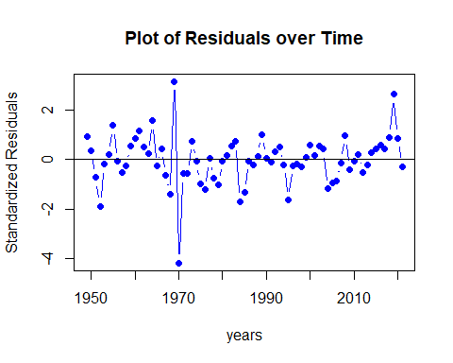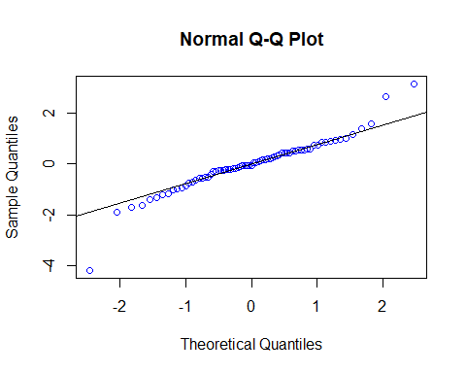

##   
## Shapiro-Wilk normality test  
##   
## data: res_m  
## W = 0.92803, p-value = 0.0004523

## Warning in (ra^2)/(n - (1:lag.max)): longer object length is not a multiple of  
## shorter object length

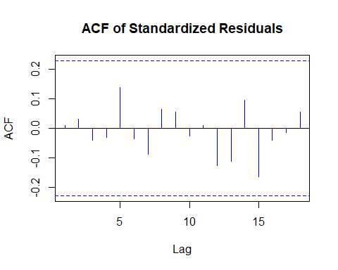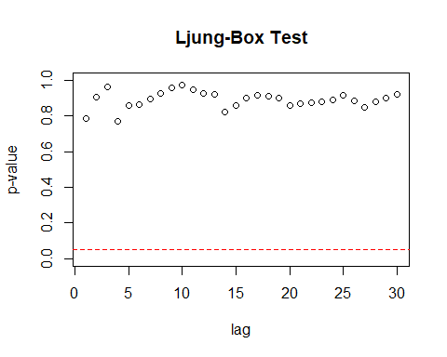

Residual Analysis for ARIMA(3,0,3):

1. p-value is less than 0.05 for ar2. Hence, significant.
2. For ar1, ar3, ma1, ma2 and ma3, p-value is greater than 0.05. Hence, not significant.
3. In Residual plot, the line is passing through 0.
4. From normal distribution curve, qq plot and Shapiro Walk test, we can see some normality in the data.
5. There are no significant lags in Autocorrelation plot.
6. Ljung box test shows good results as all the dots are above the dotted line.

Therefore, it cannot be considered as a good model.

ARIMA (3,0,4)

##   
## z test of coefficients:  
##   
## Estimate Std. Error z value Pr(>|z|)   
## ar1 -1.038563 0.203496 -5.1036 3.332e-07 ***  
## ar2 0.540636 0.250023 2.1623 0.0305915 *   
## ar3 0.696890 0.182612 3.8162 0.0001355 ***  
## ma1 0.943105 0.224047 4.2094 2.561e-05 ***  
## ma2 -0.418491 0.269339 -1.5538 0.1202383   
## ma3 -0.052883 0.261685 -0.2021 0.8398476   
## ma4 0.427136 0.144079 2.9646 0.0030309 **   
## intercept 0.055116 0.087359 0.6309 0.5280958   
## ---  
## Signif. codes: 0 '***' 0.001 '**' 0.01 '*' 0.05 '.' 0.1 ' ' 1

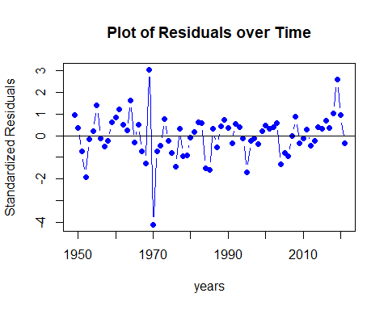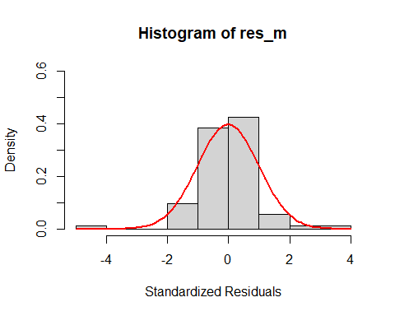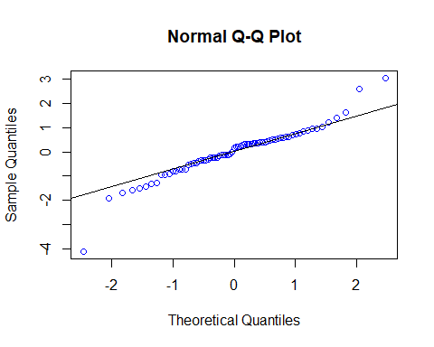

##   
## Shapiro-Wilk normality test  
##   
## data: res_m  
## W = 0.93499, p-value = 0.0009773

## Warning in (ra^2)/(n - (1:lag.max)): longer object length is not a multiple of  
## shorter object length

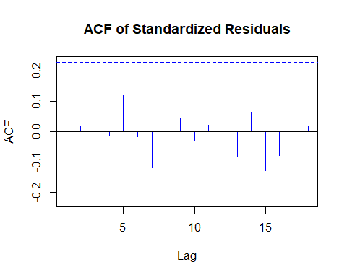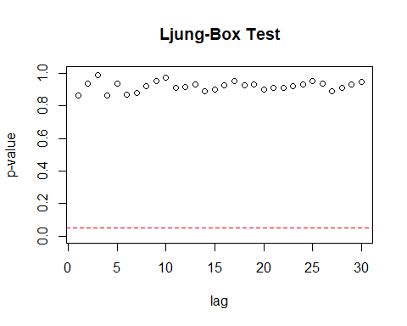

Residual Analysis for ARIMA(3,0,4):

1. p-value is less than 0.05 for ar1, ar2, ar3, ma1 and ma4. Hence, significant.
2. For ma2 and ma3, p-value is greater than 0.05. Hence, not significant.
3. In Residual plot, the line is passing through 0.
4. From normal distribution curve, qq plot and Shapiro Walk test, we can see some normality in the data.
5. There are no significant lags in Autocorrelation plot.
6. Ljung box test shows good results as all the dots are above the dotted line.

Therefore, it cannot be considered as a good model.

## df AIC  
## model_12_ml 5 55.15990  
## model_30_ml 5 55.55828  
## model_13_ml 6 56.87477  
## model_22_ml 6 56.89851  
## model_21_ml 5 57.75292  
## model_23_ml 7 57.96646  
## model_32_ml 7 58.51401  
## model_03_ml 5 58.99181  
## model_33_ml 8 59.96165  
## model_02_ml 4 60.29462  
## model_34_ml 9 60.55548  
## model_20_ml 4 60.76434  
## model_10_ml 3 64.57871  
## model_01_ml 3 64.57880  
## model_11_ml 4 66.32107

Overall, ARIMA(1,0,2) is the best model.

Now over-fitting AR and MA,

Over-fitting models: AR - ARMA(2, 0, 2) MA - ARMA(1, 0, 3)

Over-fitting model - ARIMA (2,0,2)

##   
## z test of coefficients:  
##   
## Estimate Std. Error z value Pr(>|z|)   
## ar1 0.911148 0.241978 3.7654 0.0001663 ***  
## ar2 -0.143022 0.285848 -0.5003 0.6168336   
## ma1 -1.042590 0.207317 -5.0290 4.932e-07 ***  
## ma2 0.540727 0.270317 2.0003 0.0454627 *   
## intercept 0.050194 0.082589 0.6078 0.5433476   
## ---  
## Signif. codes: 0 '***' 0.001 '**' 0.01 '*' 0.05 '.' 0.1 ' ' 1



##   
## Shapiro-Wilk normality test  
##   
## data: res_m  
## W = 0.92627, p-value = 0.0003739

## Warning in (ra^2)/(n - (1:lag.max)): longer object length is not a multiple of  
## shorter object length

 Residual Analysis for ARIMA(2,0,2):

1. p-value is less than 0.05 for ar1, ma1 and ma2. Hence, significant.
2. For ar2 p-value is greater than 0.05. Hence, not significant.
3. In Residual plot, the line is passing through 0.
4. From normal distribution curve, qq plot and Shapiro Walk test, we can see some normality in the data.
5. There are no significant lags in Autocorrelation plot.
6. Ljung box test shows good results as all the dots are above the dotted line.

Therefore, it can be considered as a good model but comparatively, ARIMA(1,0,2) performed better.

Over-fitting - ARIMA (1,0,3)

##   
## z test of coefficients:  
##   
## Estimate Std. Error z value Pr(>|z|)   
## ar1 0.716644 0.273053 2.6246 0.008676 **  
## ma1 -0.846430 0.293113 -2.8877 0.003880 **  
## ma2 0.360540 0.169874 2.1224 0.033804 *   
## ma3 0.096113 0.211756 0.4539 0.649912   
## intercept 0.050341 0.081955 0.6143 0.539046   
## ---  
## Signif. codes: 0 '***' 0.001 '**' 0.01 '*' 0.05 '.' 0.1 ' ' 1



##   
## Shapiro-Wilk normality test  
##   
## data: res_m  
## W = 0.92607, p-value = 0.0003661

## Warning in (ra^2)/(n - (1:lag.max)): longer object length is not a multiple of  
## shorter object length



Residual Analysis for ARIMA(1,0,3):

1. p-value is less than 0.05 for ar1, ma1 and ma2. Hence, significant.
2. For ma3 p-value is greater than 0.05. Hence, not significant.
3. In Residual plot, the line is passing through 0.
4. From normal distribution curve, qq plot and Shapiro Walk test, we can see some normality in the data.
5. There are no significant lags in Autocorrelation plot.
6. Ljung box test shows good results as all the dots are above the dotted line.

Therefore, it can be considered as a good model but comparatively, ARIMA(1,0,2) performed better as the coefficients of ARIMA(1,0,3) are less significant than the coefficients of ARIMA(1,0,2).

ARIMA (1, 0, 2) is best model compared to over-fitting models. Thereby, we are good to use (1, 0, 2) order in ARIMA model.

Absolute residuals to find the order for GARCH model,

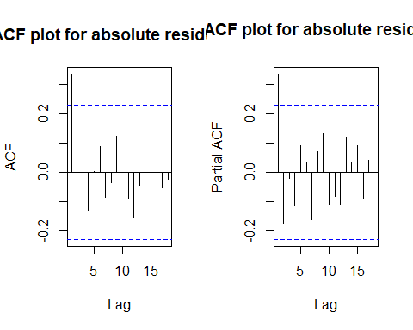

Possible orders from ACF and PACF, (0, 1), (1, 0), and (1, 1)

## AR/MA  
## 0 1 2 3 4 5 6 7 8 9  
## 0 x o o o o o o o o o  
## 1 x o o o o o o o o o  
## 2 o o o o o o o o o o  
## 3 x x x o o o o o o o  
## 4 x x o o o o o o o o  
## 5 x x x o o o o o o o  
## 6 o x x o o o o o o o

Possible orders from EACF are (0, 1), (0, 2), (1, 1), and (1, 2).

## Warning in leaps.setup(x, y, wt = wt, nbest = nbest, nvmax = nvmax, force.in =  
## force.in, : 8 linear dependencies found

## Reordering variables and trying again:

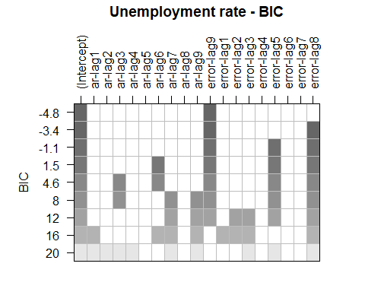

Possible orders from BIC are (0, 9) and (0, 8).

Overall possible ARMA orders are (0, 1), (0, 2), (1, 0), (1, 1), (1, 2), (0, 9) and (0, 8).

GARCH orders for above orders: max(p,q) = 0 and q = 1 ==> max(p,1) = 0 and q = 1 ==> No models can be identified. max(p,q) = 0 and q = 2 ==> max(p,2) = 0 and q = 2 ==> No models can be identified. max(p,q) = 1 and q = 0 ==> max(p,0) = 1 and q = 0 ==> p can only be 1. max(p,q) = 1 and q = 1 ==> max(p,1) = 1 and q = 1 ==> p can only be 1. max(p,q) = 1 and q = 2 ==> max(p,2) = 1 and q = 2 ==> No models can be identified. max(p,q) = 0 and q = 9 ==> max(p,9) = 0 and q = 9 ==> No models can be identified. max(p,q) = 0 and q = 8 ==> max(p,8) = 0 and q = 8 ==> No models can be identified.

GARCH models - GARCH(1, 0), GARCH(1, 1).

Squared residuals to find the order for GARCH model,

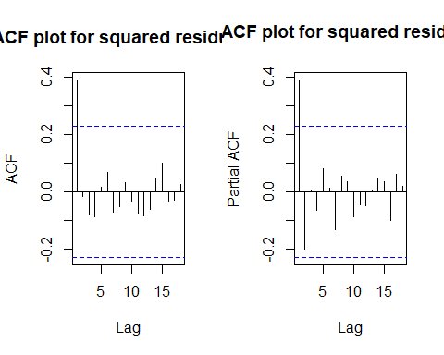

Possible orders from ACF and PACF, (0, 1), (1, 0), and (1, 1)

## AR/MA  
## 0 1 2 3 4 5 6 7 8 9  
## 0 x o o o o o o o o o  
## 1 x o o o o o o o o o  
## 2 o o o o o o o o o o  
## 3 o o x o o o o o o o  
## 4 x x o o o o o o o o  
## 5 o x o o o o o o o o  
## 6 o x o o o o o o o o

Possible orders from EACF are (0, 1), (0, 2), (1, 1), and (1, 2).

## Warning in leaps.setup(x, y, wt = wt, nbest = nbest, nvmax = nvmax, force.in =  
## force.in, : 7 linear dependencies found

## Reordering variables and trying again:

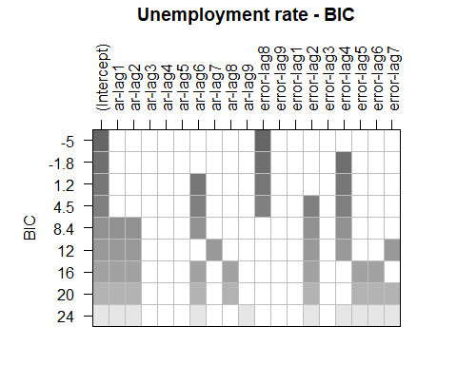

Possible orders from BIC are (0, 8), (0, 4) and (6, 4).

Overall possible ARMA orders are (0, 1), (0, 2), (1, 0), (1, 1), (1, 2), (0, 8), (0, 4) and (6, 4).

GARCH orders for above orders: max(p,q) = 0 and q = 1 ==> max(p,1) = 0 and q = 1 ==> No models can be identified. max(p,q) = 0 and q = 2 ==> max(p,2) = 0 and q = 2 ==> No models can be identified. max(p,q) = 1 and q = 0 ==> max(p,0) = 1 and q = 0 ==> p can only be 1. max(p,q) = 1 and q = 1 ==> max(p,1) = 1 and q = 1 ==> p can only be 1. max(p,q) = 1 and q = 2 ==> max(p,2) = 1 and q = 2 ==> No models can be identified. max(p,q) = 0 and q = 8 ==> max(p,8) = 0 and q = 8 ==> No models can be identified. max(p,q) = 0 and q = 4 ==> max(p,4) = 0 and q = 4 ==> No models can be identified. max(p,q) = 6 and q = 4 ==> max(p,4) = 6 and q = 4 ==> p can only be 6.

GARCH models - GARCH(1, 0), GARCH(1, 1) and GARCH(6, 4).

Oveall GARCH models are, GARCH(1, 0), GARCH(1, 1) and GARCH(6, 4).

Combining GARCH model with ARMA models we get ARMA + GARCH models, i.e., {ARMA(1,2) + GARCH(1,0), ARMA(1,2) + GARCH(1,1), ARMA(1,2) + GARCH(6,4)}

ARMA(1,2) + GARCH(1,0):

## Warning in .sgarchfit(spec = spec, data = data, out.sample = out.sample, :   
## ugarchfit-->waring: using less than 100 data  
## points for estimation

##   
## *---------------------------------*  
## * GARCH Model Fit *  
## *---------------------------------*  
##   
## Conditional Variance Dynamics   
## -----------------------------------  
## GARCH Model : sGARCH(0,1)  
## Mean Model : ARFIMA(1,0,2)  
## Distribution : norm   
##   
## Optimal Parameters  
## ------------------------------------  
## Estimate Std. Error t value Pr(>|t|)  
## ar1 0.82084 0.131580 6.238327 0.000000  
## ma1 -0.93022 0.155780 -5.971397 0.000000  
## ma2 0.39653 0.123439 3.212397 0.001316  
## omega 0.00000 0.000358 0.000003 0.999998  
## beta1 0.99594 0.004370 227.883527 0.000000  
##   
## Robust Standard Errors:  
## Estimate Std. Error t value Pr(>|t|)  
## ar1 0.82084 0.167855 4.890153 0.000001  
## ma1 -0.93022 0.177523 -5.240009 0.000000  
## ma2 0.39653 0.254318 1.559204 0.118948  
## omega 0.00000 0.000394 0.000003 0.999998  
## beta1 0.99594 0.007069 140.881139 0.000000  
##   
## LogLikelihood : -22.3546   
##   
## Information Criteria  
## ------------------------------------  
##   
## Akaike 0.74944  
## Bayes 0.90632  
## Shibata 0.74084  
## Hannan-Quinn 0.81196  
##   
## Weighted Ljung-Box Test on Standardized Residuals  
## ------------------------------------  
## statistic p-value  
## Lag[1] 0.008877 0.9249  
## Lag[2*(p+q)+(p+q)-1][8] 1.936403 1.0000  
## Lag[4*(p+q)+(p+q)-1][14] 3.850541 0.9803  
## d.o.f=3  
## H0 : No serial correlation  
##   
## Weighted Ljung-Box Test on Standardized Squared Residuals  
## ------------------------------------  
## statistic p-value  
## Lag[1] 10.21 0.001399  
## Lag[2*(p+q)+(p+q)-1][2] 10.24 0.001649  
## Lag[4*(p+q)+(p+q)-1][5] 10.75 0.005888  
## d.o.f=1  
##   
## Weighted ARCH LM Tests  
## ------------------------------------  
## Statistic Shape Scale P-Value  
## ARCH Lag[2] 0.06761 0.500 2.000 0.7948  
## ARCH Lag[4] 0.63239 1.397 1.611 0.8251  
## ARCH Lag[6] 0.81633 2.222 1.500 0.9277  
##   
## Nyblom stability test  
## ------------------------------------  
## Joint Statistic: 0.9053  
## Individual Statistics:   
## ar1 0.2321  
## ma1 0.4364  
## ma2 0.1105  
## omega 0.1233  
## beta1 0.1304  
##   
## Asymptotic Critical Values (10% 5% 1%)  
## Joint Statistic: 1.28 1.47 1.88  
## Individual Statistic: 0.35 0.47 0.75  
##   
## Sign Bias Test  
## ------------------------------------  
## t-value prob sig  
## Sign Bias 1.6071 1.127e-01   
## Negative Sign Bias 0.7077 4.815e-01   
## Positive Sign Bias 4.8561 7.346e-06 ***  
## Joint Effect 24.3336 2.128e-05 ***  
##   
##   
## Adjusted Pearson Goodness-of-Fit Test:  
## ------------------------------------  
## group statistic p-value(g-1)  
## 1 20 17.14 0.5806  
## 2 30 29.33 0.4480  
## 3 40 32.75 0.7493  
## 4 50 34.53 0.9415  
##   
##   
## Elapsed time : 0.109571

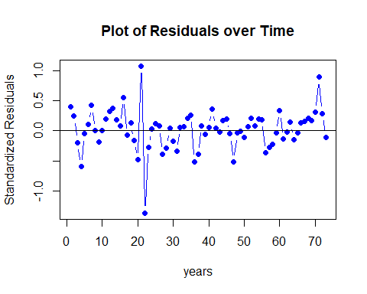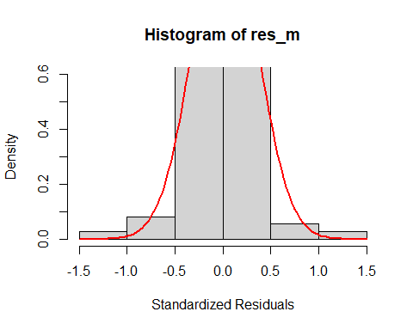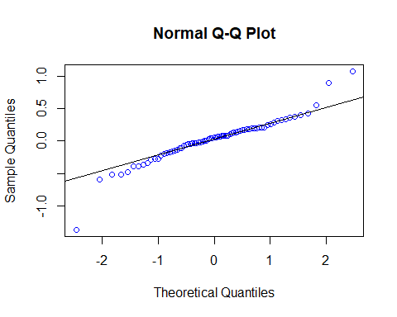

##   
## Shapiro-Wilk normality test  
##   
## data: res_m  
## W = 0.92213, p-value = 0.000241

## Warning in (ra^2)/(n - (1:lag.max)): longer object length is not a multiple of  
## shorter object length

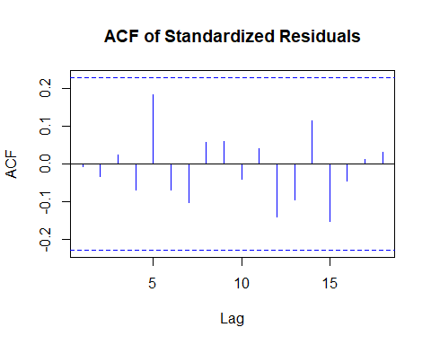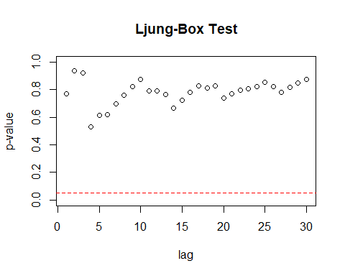

Residual Analysis for ARMA(1,2) + GARCH(1,0):

1. p-value is less than 0.05 for ar1, ma1, ma2, and beta1. Hence, significant.
2. In Residual plot, the line is passing through 0.
3. From normal distribution curve, qq plot and Shapiro Walk test, we can see normality in the data.
4. There are no significant lags in Autocorrelation plot.
5. Ljung box test shows good results as all the dots are above the dotted line.

Overall, it can be considered as a best model.

ARMA(1,2) + GARCH(1,1):

## Warning in .sgarchfit(spec = spec, data = data, out.sample = out.sample, :   
## ugarchfit-->waring: using less than 100 data  
## points for estimation

##   
## *---------------------------------*  
## * GARCH Model Fit *  
## *---------------------------------*  
##   
## Conditional Variance Dynamics   
## -----------------------------------  
## GARCH Model : sGARCH(1,1)  
## Mean Model : ARFIMA(1,0,2)  
## Distribution : norm   
##   
## Optimal Parameters  
## ------------------------------------  
## Estimate Std. Error t value Pr(>|t|)  
## ar1 0.82084 0.132559 6.192249 0.000000  
## ma1 -0.93022 0.157979 -5.888266 0.000000  
## ma2 0.39653 0.131092 3.024848 0.002488  
## omega 0.00000 0.000395 0.000017 0.999986  
## alpha1 0.00000 0.009565 0.000000 1.000000  
## beta1 0.99594 0.008947 111.314582 0.000000  
##   
## Robust Standard Errors:  
## Estimate Std. Error t value Pr(>|t|)  
## ar1 0.82084 0.183733 4.467567 0.000008  
## ma1 -0.93022 0.203951 -4.561001 0.000005  
## ma2 0.39653 0.306328 1.294476 0.195501  
## omega 0.00000 0.000310 0.000022 0.999983  
## alpha1 0.00000 0.012121 0.000000 1.000000  
## beta1 0.99594 0.006366 156.439550 0.000000  
##   
## LogLikelihood : -22.3546   
##   
## Information Criteria  
## ------------------------------------  
##   
## Akaike 0.77684  
## Bayes 0.96510  
## Shibata 0.76465  
## Hannan-Quinn 0.85186  
##   
## Weighted Ljung-Box Test on Standardized Residuals  
## ------------------------------------  
## statistic p-value  
## Lag[1] 0.008877 0.9249  
## Lag[2*(p+q)+(p+q)-1][8] 1.936403 1.0000  
## Lag[4*(p+q)+(p+q)-1][14] 3.850541 0.9803  
## d.o.f=3  
## H0 : No serial correlation  
##   
## Weighted Ljung-Box Test on Standardized Squared Residuals  
## ------------------------------------  
## statistic p-value  
## Lag[1] 10.21 0.001399  
## Lag[2*(p+q)+(p+q)-1][5] 10.75 0.005888  
## Lag[4*(p+q)+(p+q)-1][9] 11.31 0.025944  
## d.o.f=2  
##   
## Weighted ARCH LM Tests  
## ------------------------------------  
## Statistic Shape Scale P-Value  
## ARCH Lag[3] 0.4224 0.500 2.000 0.5157  
## ARCH Lag[5] 0.8240 1.440 1.667 0.7858  
## ARCH Lag[7] 1.1479 2.315 1.543 0.8884  
##   
## Nyblom stability test  
## ------------------------------------  
## Joint Statistic: 3.6216  
## Individual Statistics:   
## ar1 0.2321  
## ma1 0.4364  
## ma2 0.1105  
## omega 0.1233  
## alpha1 0.1514  
## beta1 0.1304  
##   
## Asymptotic Critical Values (10% 5% 1%)  
## Joint Statistic: 1.49 1.68 2.12  
## Individual Statistic: 0.35 0.47 0.75  
##   
## Sign Bias Test  
## ------------------------------------  
## t-value prob sig  
## Sign Bias 1.6071 1.127e-01   
## Negative Sign Bias 0.7077 4.815e-01   
## Positive Sign Bias 4.8561 7.346e-06 ***  
## Joint Effect 24.3336 2.128e-05 ***  
##   
##   
## Adjusted Pearson Goodness-of-Fit Test:  
## ------------------------------------  
## group statistic p-value(g-1)  
## 1 20 17.14 0.5806  
## 2 30 29.33 0.4480  
## 3 40 32.75 0.7493  
## 4 50 34.53 0.9415  
##   
##   
## Elapsed time : 0.07097483



##   
## Shapiro-Wilk normality test  
##   
## data: res_m  
## W = 0.92213, p-value = 0.000241

## Warning in (ra^2)/(n - (1:lag.max)): longer object length is not a multiple of  
## shorter object length



Residual Analysis for ARMA(1,2) + GARCH(1,1):

1. p-value is less than 0.05 for ar1, ma1, ma2 and beta1. Hence, significant.
2. For alpha1, p-value is greater than 0.05. Hence, not significant.
3. In Residual plot, the line is passing through 0.
4. From normal distribution curve, qq plot and Shapiro Walk test, we can see normality in the data.
5. There are no significant lags in Autocorrelation plot.
6. Ljung box test shows good results as all the dots are above the dotted line.

Therefore, it is not considered as a good model since alpha1 is not significant.

ARMA(1,2) + GARCH(6,4):

## Warning in .sgarchfit(spec = spec, data = data, out.sample = out.sample, :   
## ugarchfit-->waring: using less than 100 data  
## points for estimation

##   
## *---------------------------------*  
## * GARCH Model Fit *  
## *---------------------------------*  
##   
## Conditional Variance Dynamics   
## -----------------------------------  
## GARCH Model : sGARCH(4,6)  
## Mean Model : ARFIMA(1,0,2)  
## Distribution : norm   
##   
## Optimal Parameters  
## ------------------------------------  
## Estimate Std. Error t value Pr(>|t|)  
## ar1 0.933069 0.068765 13.568977 0.000000  
## ma1 -0.817909 0.107240 -7.626921 0.000000  
## ma2 0.149800 0.102695 1.458692 0.144650  
## omega 0.039661 0.010318 3.843870 0.000121  
## alpha1 0.678364 0.001311 517.255633 0.000000  
## alpha2 0.000000 0.144540 0.000000 1.000000  
## alpha3 0.000000 0.137700 0.000000 1.000000  
## alpha4 0.000000 0.177355 0.000000 1.000000  
## beta1 0.000000 0.219305 0.000000 1.000000  
## beta2 0.000000 0.195995 0.000000 1.000000  
## beta3 0.000000 0.267271 0.000000 1.000000  
## beta4 0.036393 0.047856 0.760465 0.446976  
## beta5 0.000000 0.072914 0.000002 0.999998  
## beta6 0.000000 0.049406 0.000001 1.000000  
##   
## Robust Standard Errors:  
## Estimate Std. Error t value Pr(>|t|)  
## ar1 0.933069 0.046509 20.062237 0.000000  
## ma1 -0.817909 0.091187 -8.969610 0.000000  
## ma2 0.149800 0.082955 1.805806 0.070949  
## omega 0.039661 0.012412 3.195293 0.001397  
## alpha1 0.678364 0.023591 28.754763 0.000000  
## alpha2 0.000000 0.119428 0.000000 1.000000  
## alpha3 0.000000 0.087163 0.000000 1.000000  
## alpha4 0.000000 0.152673 0.000000 1.000000  
## beta1 0.000000 0.175900 0.000000 1.000000  
## beta2 0.000000 0.125331 0.000000 1.000000  
## beta3 0.000000 0.235662 0.000000 1.000000  
## beta4 0.036393 0.025278 1.439680 0.149958  
## beta5 0.000000 0.049348 0.000003 0.999997  
## beta6 0.000000 0.037837 0.000001 0.999999  
##   
## LogLikelihood : -10.51211   
##   
## Information Criteria  
## ------------------------------------  
##   
## Akaike 0.67156  
## Bayes 1.11083  
## Shibata 0.61266  
## Hannan-Quinn 0.84662  
##   
## Weighted Ljung-Box Test on Standardized Residuals  
## ------------------------------------  
## statistic p-value  
## Lag[1] 0.002159 0.9629  
## Lag[2*(p+q)+(p+q)-1][8] 3.404995 0.9720  
## Lag[4*(p+q)+(p+q)-1][14] 7.003266 0.5596  
## d.o.f=3  
## H0 : No serial correlation  
##   
## Weighted Ljung-Box Test on Standardized Squared Residuals  
## ------------------------------------  
## statistic p-value  
## Lag[1] 0.04532 0.8314  
## Lag[2*(p+q)+(p+q)-1][29] 9.58378 0.9002  
## Lag[4*(p+q)+(p+q)-1][49] 16.10311 0.9541  
## d.o.f=10  
##   
## Weighted ARCH LM Tests  
## ------------------------------------  
## Statistic Shape Scale P-Value  
## ARCH Lag[11] 0.08271 0.500 2.000 0.7737  
## ARCH Lag[13] 0.92992 1.493 1.855 0.7985  
## ARCH Lag[15] 1.66676 2.471 1.754 0.8577  
##   
## Nyblom stability test  
## ------------------------------------  
## Joint Statistic: 7.9713  
## Individual Statistics:   
## ar1 0.20140  
## ma1 0.07810  
## ma2 0.24034  
## omega 0.08484  
## alpha1 0.10355  
## alpha2 0.87760  
## alpha3 0.85646  
## alpha4 0.92669  
## beta1 0.69567  
## beta2 0.84351  
## beta3 0.70532  
## beta4 0.05524  
## beta5 0.11318  
## beta6 0.70596  
##   
## Asymptotic Critical Values (10% 5% 1%)  
## Joint Statistic: 3.08 3.34 3.9  
## Individual Statistic: 0.35 0.47 0.75  
##   
## Sign Bias Test  
## ------------------------------------  
## t-value prob sig  
## Sign Bias 0.1315 0.8958   
## Negative Sign Bias 0.3873 0.6997   
## Positive Sign Bias 0.5094 0.6121   
## Joint Effect 0.5648 0.9045   
##   
##   
## Adjusted Pearson Goodness-of-Fit Test:  
## ------------------------------------  
## group statistic p-value(g-1)  
## 1 20 13.85 0.7924  
## 2 30 21.11 0.8551  
## 3 40 41.52 0.3614  
## 4 50 45.49 0.6161  
##   
##   
## Elapsed time : 0.237272

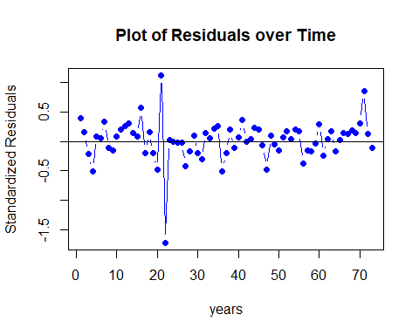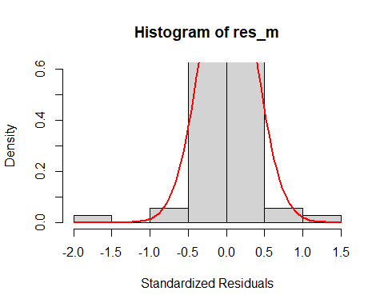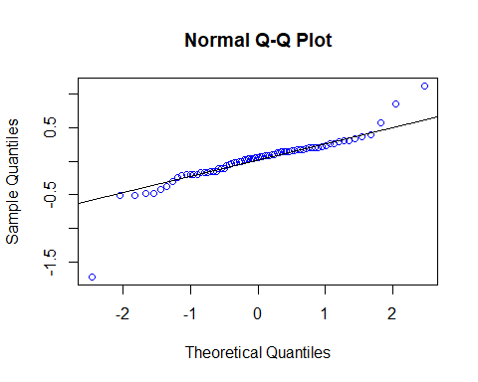

##   
## Shapiro-Wilk normality test  
##   
## data: res_m  
## W = 0.84873, p-value = 3.946e-07

## Warning in (ra^2)/(n - (1:lag.max)): longer object length is not a multiple of  
## shorter object length

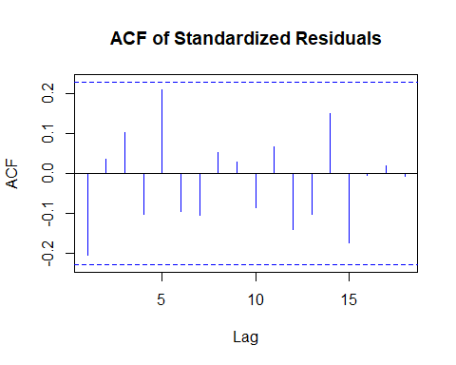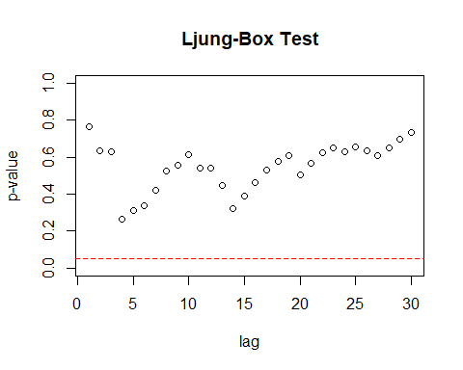

Residual Analysis for ARMA(1,2) + GARCH(6,4):

1. p-value is less than 0.05 for ar1, ma1, and alpha1. Hence, significant.
2. For ma2, alpha2, alpha3, alpha4, beta1, beta2, beta3, beta4, beta5, and beta6, p-value is greater than 0.05. Hence, not significant.
3. In Residual plot, the line is passing through 0.
4. From normal distribution curve, qq plot and Shapiro Walk test, we can see normality in the data.
5. There are no significant lags in Autocorrelation plot.
6. Ljung box test shows good results as all the dots are above the dotted line.

Therefore, it is not considered as a good model since there are lot of insignificant values.

## model AIC BIC  
## 3 model_12_64 0.6715646 1.1108308  
## 1 model_12_10 0.7494412 0.9063220  
## 2 model_12_11 0.7768385 0.9650954

## model AIC BIC  
## 1 model_12_10 0.7494412 0.9063220  
## 2 model_12_11 0.7768385 0.9650954  
## 3 model_12_64 0.6715646 1.1108308

Overall, ARMA(1,2) + GARCH(1,0) model is best compared to others.

Now we are doing Over-fitting on the best model ARMA(1,2) + GARCH(1,0).

Over-fitting models are,

{ARMA(2, 2) + GARCH(1, 0), ARMA(1, 3) + GARCH(1, 0), ARMA(1, 2) + GARCH(2, 0), ARMA(1, 2) + GARCH(1, 1)}

ARMA(2, 2) + GARCH(1, 0):

## Warning in .sgarchfit(spec = spec, data = data, out.sample = out.sample, :   
## ugarchfit-->waring: using less than 100 data  
## points for estimation

##   
## *---------------------------------*  
## * GARCH Model Fit *  
## *---------------------------------*  
##   
## Conditional Variance Dynamics   
## -----------------------------------  
## GARCH Model : sGARCH(0,1)  
## Mean Model : ARFIMA(2,0,2)  
## Distribution : norm   
##   
## Optimal Parameters  
## ------------------------------------  
## Estimate Std. Error t value Pr(>|t|)  
## ar1 0.94283 0.297081 3.173649 0.001505  
## ar2 -0.13705 0.302879 -0.452485 0.650919  
## ma1 -1.01561 0.253721 -4.002853 0.000063  
## ma2 0.48730 0.251722 1.935856 0.052885  
## omega 0.00000 0.000329 0.000002 0.999999  
## beta1 0.99564 0.004362 228.226931 0.000000  
##   
## Robust Standard Errors:  
## Estimate Std. Error t value Pr(>|t|)  
## ar1 0.94283 0.394698 2.388736 0.016906  
## ar2 -0.13705 0.266172 -0.514886 0.606633  
## ma1 -1.01561 0.165077 -6.152324 0.000000  
## ma2 0.48730 0.228218 2.135234 0.032742  
## omega 0.00000 0.000222 0.000002 0.999998  
## beta1 0.99564 0.007291 136.564587 0.000000  
##   
## LogLikelihood : -22.36174   
##   
## Information Criteria  
## ------------------------------------  
##   
## Akaike 0.77703  
## Bayes 0.96529  
## Shibata 0.76484  
## Hannan-Quinn 0.85206  
##   
## Weighted Ljung-Box Test on Standardized Residuals  
## ------------------------------------  
## statistic p-value  
## Lag[1] 0.03938 0.8427  
## Lag[2*(p+q)+(p+q)-1][11] 2.80742 1.0000  
## Lag[4*(p+q)+(p+q)-1][19] 5.96041 0.9723  
## d.o.f=4  
## H0 : No serial correlation  
##   
## Weighted Ljung-Box Test on Standardized Squared Residuals  
## ------------------------------------  
## statistic p-value  
## Lag[1] 9.728 0.001814  
## Lag[2*(p+q)+(p+q)-1][2] 9.807 0.002150  
## Lag[4*(p+q)+(p+q)-1][5] 10.295 0.007733  
## d.o.f=1  
##   
## Weighted ARCH LM Tests  
## ------------------------------------  
## Statistic Shape Scale P-Value  
## ARCH Lag[2] 0.1487 0.500 2.000 0.6998  
## ARCH Lag[4] 0.6577 1.397 1.611 0.8169  
## ARCH Lag[6] 0.8224 2.222 1.500 0.9267  
##   
## Nyblom stability test  
## ------------------------------------  
## Joint Statistic: 1.3369  
## Individual Statistics:   
## ar1 0.2364  
## ar2 0.1031  
## ma1 0.4392  
## ma2 0.1075  
## omega 0.1243  
## beta1 0.1328  
##   
## Asymptotic Critical Values (10% 5% 1%)  
## Joint Statistic: 1.49 1.68 2.12  
## Individual Statistic: 0.35 0.47 0.75  
##   
## Sign Bias Test  
## ------------------------------------  
## t-value prob sig  
## Sign Bias 1.656 1.022e-01   
## Negative Sign Bias 0.525 6.013e-01   
## Positive Sign Bias 4.981 4.595e-06 ***  
## Joint Effect 25.258 1.364e-05 ***  
##   
##   
## Adjusted Pearson Goodness-of-Fit Test:  
## ------------------------------------  
## group statistic p-value(g-1)  
## 1 20 17.68 0.5436  
## 2 30 26.86 0.5791  
## 3 40 32.75 0.7493  
## 4 50 46.86 0.5602  
##   
##   
## Elapsed time : 0.1221571

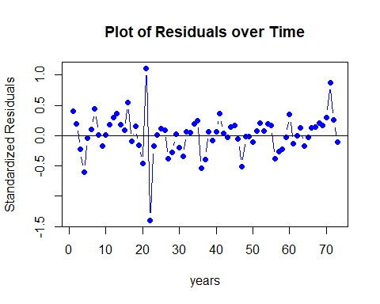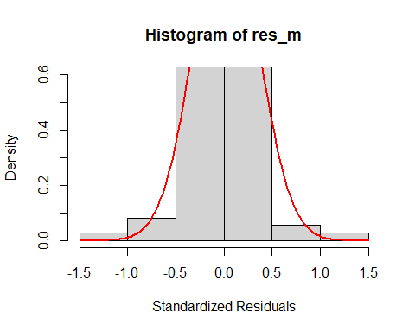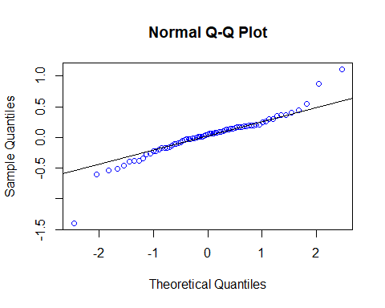

##   
## Shapiro-Wilk normality test  
##   
## data: res_m  
## W = 0.91365, p-value = 0.0001013

## Warning in (ra^2)/(n - (1:lag.max)): longer object length is not a multiple of  
## shorter object length

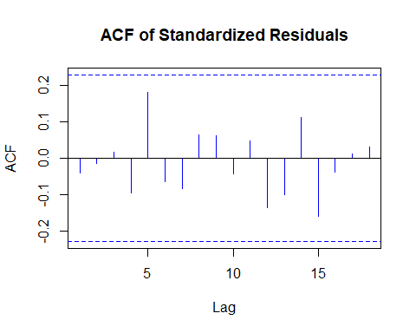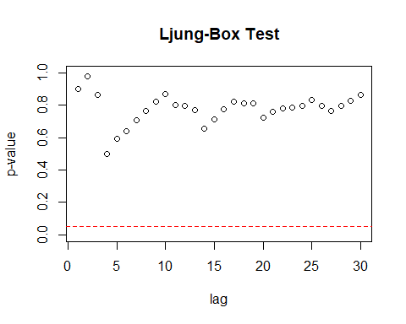

Residual Analysis for ARMA(2,2) + GARCH(1,0):

1. p-value is less than 0.05 for ar1, ma1, and beta1. Hence, significant.
2. For ar2 and ma2, p-value is greater than 0.05. Hence, not significant.
3. In Residual plot, the line is passing through 0.
4. From normal distribution curve, qq plot and Shapiro Walk test, we can see normality in the data.
5. There are no significant lags in Autocorrelation plot.
6. Ljung box test shows good results as all the dots are above the dotted line.

Therefore, it is not considered as a good model.

ARMA(1, 3) + GARCH(1, 0):

## Warning in .sgarchfit(spec = spec, data = data, out.sample = out.sample, :   
## ugarchfit-->waring: using less than 100 data  
## points for estimation

##   
## *---------------------------------*  
## * GARCH Model Fit *  
## *---------------------------------*  
##   
## Conditional Variance Dynamics   
## -----------------------------------  
## GARCH Model : sGARCH(0,1)  
## Mean Model : ARFIMA(1,0,3)  
## Distribution : norm   
##   
## Optimal Parameters  
## ------------------------------------  
## Estimate Std. Error t value Pr(>|t|)  
## ar1 0.761049 0.238477 3.191295 0.001416  
## ma1 -0.850391 0.270238 -3.146824 0.001651  
## ma2 0.341165 0.164435 2.074774 0.038007  
## ma3 0.079606 0.183995 0.432653 0.665267  
## omega 0.000000 0.000351 0.000001 1.000000  
## beta1 0.995597 0.004521 220.203122 0.000000  
##   
## Robust Standard Errors:  
## Estimate Std. Error t value Pr(>|t|)  
## ar1 0.761049 0.278493 2.732742 0.006281  
## ma1 -0.850391 0.305443 -2.784122 0.005367  
## ma2 0.341165 0.272743 1.250864 0.210984  
## ma3 0.079606 0.157622 0.505044 0.613528  
## omega 0.000000 0.000174 0.000001 0.999999  
## beta1 0.995597 0.007949 125.240678 0.000000  
##   
## LogLikelihood : -22.21719   
##   
## Information Criteria  
## ------------------------------------  
##   
## Akaike 0.77307  
## Bayes 0.96133  
## Shibata 0.76088  
## Hannan-Quinn 0.84810  
##   
## Weighted Ljung-Box Test on Standardized Residuals  
## ------------------------------------  
## statistic p-value  
## Lag[1] 0.004487 0.9466  
## Lag[2*(p+q)+(p+q)-1][11] 2.647551 1.0000  
## Lag[4*(p+q)+(p+q)-1][19] 5.691649 0.9812  
## d.o.f=4  
## H0 : No serial correlation  
##   
## Weighted Ljung-Box Test on Standardized Squared Residuals  
## ------------------------------------  
## statistic p-value  
## Lag[1] 9.728 0.001815  
## Lag[2*(p+q)+(p+q)-1][2] 9.810 0.002146  
## Lag[4*(p+q)+(p+q)-1][5] 10.297 0.007723  
## d.o.f=1  
##   
## Weighted ARCH LM Tests  
## ------------------------------------  
## Statistic Shape Scale P-Value  
## ARCH Lag[2] 0.1543 0.500 2.000 0.6944  
## ARCH Lag[4] 0.6615 1.397 1.611 0.8157  
## ARCH Lag[6] 0.8248 2.222 1.500 0.9263  
##   
## Nyblom stability test  
## ------------------------------------  
## Joint Statistic: 1.056  
## Individual Statistics:   
## ar1 0.2708  
## ma1 0.4897  
## ma2 0.1141  
## ma3 0.1073  
## omega 0.1194  
## beta1 0.1271  
##   
## Asymptotic Critical Values (10% 5% 1%)  
## Joint Statistic: 1.49 1.68 2.12  
## Individual Statistic: 0.35 0.47 0.75  
##   
## Sign Bias Test  
## ------------------------------------  
## t-value prob sig  
## Sign Bias 1.6733 9.886e-02 *  
## Negative Sign Bias 0.5953 5.536e-01   
## Positive Sign Bias 4.8814 6.682e-06 ***  
## Joint Effect 24.5262 1.940e-05 ***  
##   
##   
## Adjusted Pearson Goodness-of-Fit Test:  
## ------------------------------------  
## group statistic p-value(g-1)  
## 1 20 17.14 0.5806  
## 2 30 21.11 0.8551  
## 3 40 36.04 0.6056  
## 4 50 44.12 0.6708  
##   
##   
## Elapsed time : 0.199332

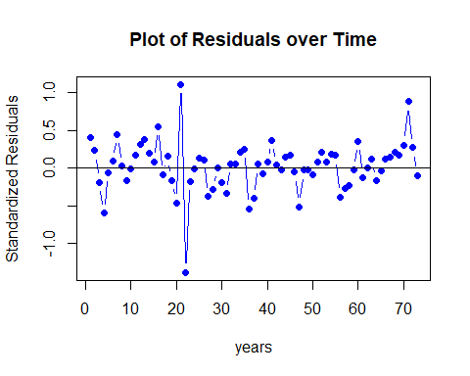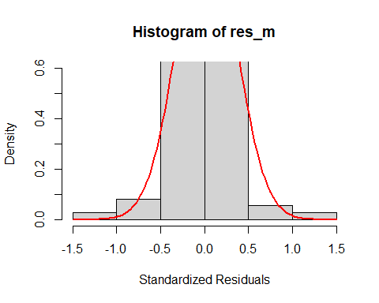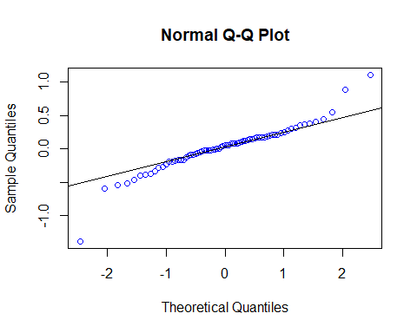

##   
## Shapiro-Wilk normality test  
##   
## data: res_m  
## W = 0.91881, p-value = 0.0001708

## Warning in (ra^2)/(n - (1:lag.max)): longer object length is not a multiple of  
## shorter object length

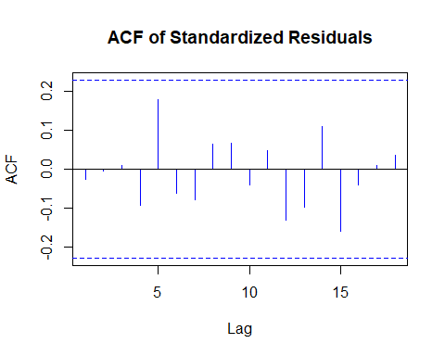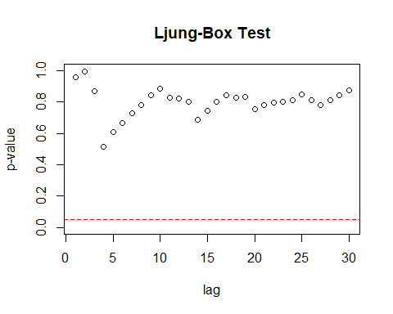

Residual Analysis for ARMA(1, 3) + GARCH(1, 0):

1. p-value is less than 0.05 for ar1, ma1, ma2 and beta1. Hence, significant.
2. For ma3, p-value is greater than 0.05. Hence, not significant.
3. In Residual plot, the line is passing through 0.
4. From normal distribution curve, qq plot and Shapiro Walk test, we can see normality in the data.
5. There are no significant lags in Autocorrelation plot.
6. Ljung box test shows good results as all the dots are above the dotted line.

Therefore, it is not considered as a good model.

ARMA(1, 2) + GARCH(2, 0):

## Warning in .sgarchfit(spec = spec, data = data, out.sample = out.sample, :   
## ugarchfit-->waring: using less than 100 data  
## points for estimation

##   
## *---------------------------------*  
## * GARCH Model Fit *  
## *---------------------------------*  
##   
## Conditional Variance Dynamics   
## -----------------------------------  
## GARCH Model : sGARCH(0,2)  
## Mean Model : ARFIMA(1,0,2)  
## Distribution : norm   
##   
## Optimal Parameters  
## ------------------------------------  
## Estimate Std. Error t value Pr(>|t|)  
## ar1 0.820838 0.131565 6.23905 0.000000  
## ma1 -0.930222 0.155666 -5.97575 0.000000  
## ma2 0.396534 0.123416 3.21297 0.001314  
## omega 0.000000 0.000234 0.00000 1.000000  
## beta1 0.995901 0.017291 57.59595 0.000000  
## beta2 0.000043 0.018326 0.00237 0.998109  
##   
## Robust Standard Errors:  
## Estimate Std. Error t value Pr(>|t|)  
## ar1 0.820838 0.167413 4.903086 0.000001  
## ma1 -0.930222 0.174017 -5.345586 0.000000  
## ma2 0.396534 0.252653 1.569481 0.116536  
## omega 0.000000 0.000032 0.000000 1.000000  
## beta1 0.995901 0.001205 826.262057 0.000000  
## beta2 0.000043 0.006971 0.006231 0.995028  
##   
## LogLikelihood : -22.3546   
##   
## Information Criteria  
## ------------------------------------  
##   
## Akaike 0.77684  
## Bayes 0.96510  
## Shibata 0.76465  
## Hannan-Quinn 0.85186  
##   
## Weighted Ljung-Box Test on Standardized Residuals  
## ------------------------------------  
## statistic p-value  
## Lag[1] 0.008877 0.9249  
## Lag[2*(p+q)+(p+q)-1][8] 1.936403 1.0000  
## Lag[4*(p+q)+(p+q)-1][14] 3.850542 0.9803  
## d.o.f=3  
## H0 : No serial correlation  
##   
## Weighted Ljung-Box Test on Standardized Squared Residuals  
## ------------------------------------  
## statistic p-value  
## Lag[1] 10.21 0.001399  
## Lag[2*(p+q)+(p+q)-1][5] 10.75 0.005888  
## Lag[4*(p+q)+(p+q)-1][9] 11.31 0.025944  
## d.o.f=2  
##   
## Weighted ARCH LM Tests  
## ------------------------------------  
## Statistic Shape Scale P-Value  
## ARCH Lag[3] 0.4224 0.500 2.000 0.5157  
## ARCH Lag[5] 0.8240 1.440 1.667 0.7858  
## ARCH Lag[7] 1.1479 2.315 1.543 0.8884  
##   
## Nyblom stability test  
## ------------------------------------  
## Joint Statistic: 1.3364  
## Individual Statistics:   
## ar1 0.2321  
## ma1 0.4364  
## ma2 0.1105  
## omega 0.1233  
## beta1 0.1304  
## beta2 0.1304  
##   
## Asymptotic Critical Values (10% 5% 1%)  
## Joint Statistic: 1.49 1.68 2.12  
## Individual Statistic: 0.35 0.47 0.75  
##   
## Sign Bias Test  
## ------------------------------------  
## t-value prob sig  
## Sign Bias 1.6071 1.127e-01   
## Negative Sign Bias 0.7077 4.815e-01   
## Positive Sign Bias 4.8561 7.346e-06 ***  
## Joint Effect 24.3336 2.128e-05 ***  
##   
##   
## Adjusted Pearson Goodness-of-Fit Test:  
## ------------------------------------  
## group statistic p-value(g-1)  
## 1 20 17.14 0.5806  
## 2 30 29.33 0.4480  
## 3 40 32.75 0.7493  
## 4 50 34.53 0.9415  
##   
##   
## Elapsed time : 0.09893608



##   
## Shapiro-Wilk normality test  
##   
## data: res_m  
## W = 0.92213, p-value = 0.000241

## Warning in (ra^2)/(n - (1:lag.max)): longer object length is not a multiple of  
## shorter object length



Residual Analysis for ARMA(1, 2) + GARCH(2, 0):

1. p-value is less than 0.05 for ar1, ma1, ma2 and beta1. Hence, significant.
2. For beta2, p-value is greater than 0.05. Hence, not significant.
3. In Residual plot, the line is passing through 0.
4. From normal distribution curve, qq plot and Shapiro Walk test, we can see normality in the data.
5. There are no significant lags in Autocorrelation plot.
6. Ljung box test shows good results as all the dots are above the dotted line.

Therefore, it can be considered as a good model.

ARMA(1,2) + GARCH(1,1):

## Warning in .sgarchfit(spec = spec, data = data, out.sample = out.sample, :   
## ugarchfit-->waring: using less than 100 data  
## points for estimation

##   
## *---------------------------------*  
## * GARCH Model Fit *  
## *---------------------------------*  
##   
## Conditional Variance Dynamics   
## -----------------------------------  
## GARCH Model : sGARCH(1,1)  
## Mean Model : ARFIMA(1,0,2)  
## Distribution : norm   
##   
## Optimal Parameters  
## ------------------------------------  
## Estimate Std. Error t value Pr(>|t|)  
## ar1 0.82084 0.132559 6.192249 0.000000  
## ma1 -0.93022 0.157979 -5.888266 0.000000  
## ma2 0.39653 0.131092 3.024848 0.002488  
## omega 0.00000 0.000395 0.000017 0.999986  
## alpha1 0.00000 0.009565 0.000000 1.000000  
## beta1 0.99594 0.008947 111.314582 0.000000  
##   
## Robust Standard Errors:  
## Estimate Std. Error t value Pr(>|t|)  
## ar1 0.82084 0.183733 4.467567 0.000008  
## ma1 -0.93022 0.203951 -4.561001 0.000005  
## ma2 0.39653 0.306328 1.294476 0.195501  
## omega 0.00000 0.000310 0.000022 0.999983  
## alpha1 0.00000 0.012121 0.000000 1.000000  
## beta1 0.99594 0.006366 156.439550 0.000000  
##   
## LogLikelihood : -22.3546   
##   
## Information Criteria  
## ------------------------------------  
##   
## Akaike 0.77684  
## Bayes 0.96510  
## Shibata 0.76465  
## Hannan-Quinn 0.85186  
##   
## Weighted Ljung-Box Test on Standardized Residuals  
## ------------------------------------  
## statistic p-value  
## Lag[1] 0.008877 0.9249  
## Lag[2*(p+q)+(p+q)-1][8] 1.936403 1.0000  
## Lag[4*(p+q)+(p+q)-1][14] 3.850541 0.9803  
## d.o.f=3  
## H0 : No serial correlation  
##   
## Weighted Ljung-Box Test on Standardized Squared Residuals  
## ------------------------------------  
## statistic p-value  
## Lag[1] 10.21 0.001399  
## Lag[2*(p+q)+(p+q)-1][5] 10.75 0.005888  
## Lag[4*(p+q)+(p+q)-1][9] 11.31 0.025944  
## d.o.f=2  
##   
## Weighted ARCH LM Tests  
## ------------------------------------  
## Statistic Shape Scale P-Value  
## ARCH Lag[3] 0.4224 0.500 2.000 0.5157  
## ARCH Lag[5] 0.8240 1.440 1.667 0.7858  
## ARCH Lag[7] 1.1479 2.315 1.543 0.8884  
##   
## Nyblom stability test  
## ------------------------------------  
## Joint Statistic: 3.6216  
## Individual Statistics:   
## ar1 0.2321  
## ma1 0.4364  
## ma2 0.1105  
## omega 0.1233  
## alpha1 0.1514  
## beta1 0.1304  
##   
## Asymptotic Critical Values (10% 5% 1%)  
## Joint Statistic: 1.49 1.68 2.12  
## Individual Statistic: 0.35 0.47 0.75  
##   
## Sign Bias Test  
## ------------------------------------  
## t-value prob sig  
## Sign Bias 1.6071 1.127e-01   
## Negative Sign Bias 0.7077 4.815e-01   
## Positive Sign Bias 4.8561 7.346e-06 ***  
## Joint Effect 24.3336 2.128e-05 ***  
##   
##   
## Adjusted Pearson Goodness-of-Fit Test:  
## ------------------------------------  
## group statistic p-value(g-1)  
## 1 20 17.14 0.5806  
## 2 30 29.33 0.4480  
## 3 40 32.75 0.7493  
## 4 50 34.53 0.9415  
##   
##   
## Elapsed time : 0.07993007



##   
## Shapiro-Wilk normality test  
##   
## data: res_m  
## W = 0.92213, p-value = 0.000241

## Warning in (ra^2)/(n - (1:lag.max)): longer object length is not a multiple of  
## shorter object length



Residual Analysis for ARMA(1,2) + GARCH(1,1):

1. p-value is less than 0.05 for ar1, ma1, ma2 and beta1. Hence, significant.
2. For alpha1, p-value is greater than 0.05. Hence, not significant.
3. In Residual plot, the line is passing through 0.
4. From normal distribution curve, qq plot and Shapiro Walk test, we can see normality in the data.
5. There are no significant lags in Autocorrelation plot.
6. Ljung box test shows good results as all the dots are above the dotted line.

Therefore, it is not considered as a good model since alpha1 is not significant.

Overall, ARMA(1,2) + GARCH(1,0) is best model. With this we are going to predict the future unemployment rate of U.S for the next 6 years i.e., till 2027.

From the forecast graph, we can observe a decrease in the unemployment rate over the next 6 years.

## Conclusion

The decrease in the unemployment rate indicates that there will be more employment in US in future.