A PROJECT REPORT
ON
Smart Water Monitoring: Machine Learning and CPS for Safe & Sustainable Mining
(JalDrishti – Groundwater Contamination Screening Platform for Jharkhand)
Submitted to

TEXMiN-BIT Sindri CPS CoE
Submitted in Partial Fulfilment of the requirements for
UDAAN UG Fellowship Programme (2025-26)
Submitted By
VISHAL RAJ
(Roll No. 24030480134)
Department of Information Technology
Under the Guidance of
Asst. Prof. MUKESH CHANDRA
Department of Production and Industrial Engineering

CERTIFICATE
This is to certify that the project work entitled “Smart Water Monitoring: Machine Learning and CPS for Safe & Sustainable Mining (JalDrishti)” carried out under the UDAAN UG Fellowship Programme (2025-26) is a genuine, original and completed record of work done by Vishal Raj (Roll No: 24030480134), a student of Bachelor of Technology in the Department of Information Technology at B.I.T. Sindri for the academic session 2024-28.
This project work has been completed under our direct supervision and proper guidance during the fellowship tenure. The results embodied in this final report have not been submitted to any other university or institute for the award of any degree or diploma.
(Signature of Centre in Charge)  Date:  Mr. Rajesh Das  TEXMiN BIT Sindri CPS CoE | (Signature of Supervisor)  Date:  Asst. Prof. Mukesh Chandra  Dept. of Production and Industrial Engineering
(Signature of Project Coordinator)
Date:
Dr. Prakash Kumar
TEXMiN-BIT Sindri CPS CoE

CANDIDATE’S DECLARATION
I hereby declare that the work presented in this final project report entitled “Smart Water Monitoring: Machine Learning and CPS for Safe & Sustainable Mining (JalDrishti)” is original, authentic and completed by me under the proper guidance of my academic mentor, Asst. Prof. Mukesh Chandra (Department of Production and Industrial Engineering, B.I.T. Sindri), and under the institutional supervision of the TEXMiN-BIT Sindri CPS Centre of Excellence team.
This fellowship study was conducted during the tenure of the UDAAN UG Fellowship Programme (2025-26). I have cited and acknowledged all data sources, standards, published methods and software frameworks used in this work. The content of this report, either in full or in part, has not been previously submitted by me or any other individual for an academic degree or fellowship certification elsewhere.
(Signature of Student)  Vishal Raj  Roll No: 24030480134  Department of Information Technology  B.Tech, Session 2024-28  B.I.T. Sindri | Place: Sindri, Jharkhand  Date:

ACKNOWLEDGEMENT
I wish to express my deepest gratitude to my academic mentor, Asst. Prof. Mukesh Chandra, Department of Production and Industrial Engineering, B.I.T. Sindri, for the guidance, supervision and constant encouragement given to me throughout the ten months of this fellowship. The suggestion in April 2026 to look for internationally published ISR operating records, at a time when no Indian ISR data could exist, shaped the final method of this project.
I am grateful to Dr. Prakash Kumar, Project Coordinator, and Mr. Rajesh Das, Centre In-Charge, TEXMiN-BIT Sindri Cyber-Physical Systems Centre of Excellence (CPS CoE), for the institutional platform, the monthly progress reviews and the final review panel in August 2026.
I also thank the faculty members of the Department of Information Technology, B.I.T. Sindri, for their academic support.
This project depends on open data published by others. I thank the Central Ground Water Board and the National Water Informatics Centre for the groundwater quality and water-level records and the NAQUIM aquifer reports; the Geological Survey of India and the National Remote Sensing Centre for the lineament map on Bhuvan; the International Atomic Energy Agency for the UDEPO uranium deposit database; the U.S. Geological Survey for the Texas ISR data releases; the European Space Agency and OpenTopography for the elevation data; the HydroRIVERS team for the river network; the scientists of the Bhabha Atomic Research Centre whose published groundwater surveys gave the local uranium and radium backgrounds; the Uranium Corporation of India Ltd. for its public technical documents; and the Internet Archive for keeping a copy of the uranium belt’s NAQUIM report.
Finally, I sincerely thank the UDAAN UG Fellowship Programme committee for giving me the platform, support and opportunity to carry out this work during the 2025-26 academic session.
Vishal Raj

ABSTRACT
Groundwater is the main source of drinking water in Jharkhand, and the Singhbhum region in the south-east of the state holds India’s main uranium deposits. In-situ recovery (ISR) is a way of mining uranium in which a chemical solution is pumped into the ore underground and pumped back out with the dissolved uranium. If some of this solution escapes, it can pollute the surrounding groundwater, and such leaks are found only later, by manual sampling. No ISR mine operates in Jharkhand. This project is therefore a preparedness study: if ISR solution entered an aquifer in Jharkhand, how far and how fast would it spread, could it reach the shallow drinking-water layer, who should be informed, and what should be monitored?
To answer this, a web-based decision-support system named JalDrishti was developed. Its core is a groundwater contamination model based on standard analytical transport equations (Domenico and Ogata–Banks), adapted for fractured hard rock and fed with real Jharkhand data (CGWB water quality and water levels, aquifer maps, NAQUIM reports, GSI lineaments, IAEA deposit data) and ISR records from Texas, USA. In the uranium belt the rock permeability comes from the belt’s own pumping tests, checked against the mines’ dewatering records, and each run also gives a labelled hypothetical answer for rock permeable enough for ISR. An XGBoost model trained on 18,000 scenarios from the physics model gives fast answers with calibrated 80% uncertainty bands. The system also checks 397 government wells against IS 10500:2012, sends tiered email alerts to residents, ranks all 264 blocks by monitoring gaps, and runs online with five user roles.
The ML model reproduces the physics model with an R² (log scale) of 0.89 to 0.97 and keeps its 80% coverage on real-location tests; for the travel distance of radium it misses its target, which is reported openly. In the measured data, uranium is within its limit at all 342 tested wells, but nitrate exceeds its limit at 22 wells and fluoride at 32, and iron, arsenic and manganese have never been tested. At the hypothetical Jaduguda site the measured rock is too tight for ISR: in 20 years dissolved salts (TDS) spread about 30 m beyond the wellfield and uranium 4 m, against about 535 m for TDS in ISR-grade rock. In both cases the chemical indicators travel ahead of uranium. At a more permeable belt site between the deposits, the salts could reach the shallow drinking-water layer in about 16 years. The 25 most poorly monitored blocks all lie in the uranium belt. Since no real ISR plume exists in Jharkhand, all modelled results are screening estimates, not forecasts.
Keywords: Groundwater contamination; In-situ recovery (ISR) uranium mining; Contaminant transport model; Machine learning; Conformal prediction; Monitoring network; Decision-support system; Jharkhand; IS 10500.

CONTENTS:
Chapter | Title | Page no.
 | Certificate | 2
 | Declaration by Student | 3
 | Acknowledgement | 4
 | Abstract | 5-6
Chapter 1 | Introduction | 8-10
Chapter 2 | Objectives | 11-12
Chapter 3 | Problem Statement | 13-14
Chapter 4 | Methodology / Approach | 15-34
Chapter 5 | Tools & Technologies Used | 35-40
Chapter 6 | Work Carried Out During Fellowship | 41-51
Chapter 7 | Results & Achievements | 52-63
Chapter 8 | Prototype / Software Details | 64-72
Chapter 9 | Challenges Faced | 73-78
Chapter 10 | Financial Utilization | 79-80
Chapter 11 | Conclusion | 81-82
Chapter 12 | Future Scope | 83-85
Chapter 13 | References | 86-92
Annexure | Datasets, Code and Supporting Documents | 93-99
 | Mentor Remark & Recommendation | 100
 | Centre/Institute Approval | 101
 | Submission Checklist | 102

1. INTRODUCTION
Groundwater is the main source of drinking water in Jharkhand. Most villages and many towns depend on hand pumps, dug wells and bore wells. Jharkhand is a hard-rock state. Outside the Damodar valley coalfields and the river plains, groundwater is stored in a thin weathered layer near the surface and in cracks (fractures) in the hard rock below it. The Central Ground Water Board (CGWB) describes this as a three-layer system: a weathered zone about 13 to 30 m deep, a fractured zone that ends somewhere between 90 m and 260 m depending on the district, and solid rock below that [1], [2]. The water table also moves up and down with the seasons. In the CGWB record used in this project, the median depth to water across the state is 7.20 m in May and 3.22 m in August [3].
The Singhbhum Shear Zone, in the East Singhbhum and Saraikela-Kharsawan districts, contains India’s main uranium deposits: Jaduguda, Bhatin, Narwapahar, Turamdih, Banduhurang, Mohuldih and Bagjata [4]. These are mined by the Uranium Corporation of India Ltd. using conventional underground and open-pit methods [5]. The ore is uraninite in metamorphic rock, found together with sulphide minerals such as pyrite and chalcopyrite, in what is a uranium–copper–iron deposit [6], [7]. None of these mines uses in-situ recovery.
In-situ recovery (ISR), also called in-situ leaching, is a different way of mining uranium. Instead of digging out the ore, wells are drilled into the ore body. A chemical solution called the lixiviant is injected through some wells. In the alkaline type of ISR, the lixiviant is local groundwater with added oxygen and carbonate. It dissolves the uranium, and the uranium-rich solution is pumped back to the surface through other wells. The operator pumps out slightly more water than it injects (this extra is called the bleed) so that groundwater flows inward and the solution stays inside the wellfield. ISR supplied 56% of the uranium mined in the world in 2022 [8]. It is used where the ore lies in porous, water-bearing sand or sandstone that is sealed by low-permeability layers above and below [8].
ISR does not only move uranium. The lixiviant also raises sulphate and total dissolved solids (TDS) in the groundwater, releases radium-226, and, depending on the ore, can mobilise arsenic, selenium and molybdenum [9], [10], [11]. If the solution escapes past the ring of monitoring wells around the wellfield, the event is called an excursion. After mining ends, the aquifer must be restored by pumping and cleaning the water, and then watched for many years. In the United States, excursions are detected by regularly sampling the monitoring wells and comparing a set of indicator chemicals (such as chloride, conductivity and alkalinity) with control limits. Uranium itself is not used as an indicator, because it is slowed down by the rock and arrives much later than the other chemicals [12]. In other words, excursions are found by manual sampling, after they have already happened.
This project was carried out under the UDAAN UG Fellowship Programme (2025-26) of the TEXMiN–BIT Sindri CPS Centre of Excellence, with the title “Smart Water Monitoring: Machine Learning and CPS for Safe & Sustainable Mining”. The proposal aimed to use machine learning (ML) and cyber-physical systems (CPS) to assess water-quality damage and aquifer vulnerability in ISR mining areas, to find gaps in the existing monitoring data, and to build a prototype decision-support tool.
One fact shapes the whole project: no ISR uranium mine operates in Jharkhand, and none is planned. Every mining site in this project is therefore hypothetical. Every modelled result means only this: “if ISR-strength solution entered this aquifer at this point, this is how it would behave.” It is never a judgement that mining is feasible, never a plan, and never a permit. The project is a preparedness screening study. It tries to answer, in advance, how far and how fast contamination would spread, whether it could reach the shallow drinking-water layer, which blocks and residents should be informed, and what should be monitored and where.
The system built in this project is called JalDrishti (“a view of water”). It has six main parts:
1. A groundwater contamination model based on standard analytical equations, adapted for Jharkhand’s fractured hard rock and fed with real Jharkhand data and real ISR operating records from Texas, USA.
2. A machine learning model trained on the output of this physics model, which gives fast answers together with calibrated uncertainty bands.
3. An assessment of 397 government wells against the Indian drinking-water standard IS 10500:2012 [13].
4. An alert system that informs residents by email when a limit is crossed or a screening is published.
5. A ranking of all 264 blocks of the state by how poorly they are monitored.
6. A web portal with five user roles, deployed on the internet.
The way of working changed during the ten months of the fellowship. The first five months were spent building the data platform and training ML models on measured and synthetic water-quality data, as the proposal described. In June 2026 it became clear that these models could not show where contamination would travel, because the measured data had no information about spread over distance or time. The prediction part was therefore rebuilt around a physics-based transport model, with ML trained on its output. The last three months turned this into a working product, tested it in several review rounds, and deployed it. In September 2026 the model inputs for the uranium belt were checked against the belt’s own pumping tests, the water pumped out of the uranium mines and published radionuclide surveys. Since then every run gives two answers: one for the rock as it has been measured near the mines, and one, clearly labelled as hypothetical, for rock permeable enough for ISR to work at all. This report describes the work in the following order: objectives, problem statement, methodology, tools, month-wise work, results, prototype details, challenges, expenditure, conclusion and future scope.

2. OBJECTIVES
The primary objective of this project is to design and develop a groundwater contamination screening and decision-support system for Jharkhand that can estimate how contamination from a hypothetical ISR uranium operation would spread, check the existing groundwater quality record, identify monitoring gaps, and inform the people concerned.
The three objectives given in the fellowship proposal were:
- O1: Develop ML-based predictive models to assess water quality degradation and aquifer vulnerability in mining-affected ISR regions.
- O2: Identify key data gaps in hydrogeological systems and recommend improved monitoring strategies.
- O3: Design a prototype tool that integrates prediction, visualization and decision-support features for stakeholders.
Based on these, the specific objectives of the project are as follows:
1. To collect the available groundwater data for Jharkhand (water quality, water levels, aquifer maps, geology, rivers and uranium deposits) and organise it in one spatial database.
2. To build a contamination transport model that estimates how far and how fast chemicals from a hypothetical ISR operation would spread, using real Jharkhand hydrogeology and real ISR records from Texas.
3. To develop machine learning models that give fast predictions of the plume footprint, travel distance, concentration at the monitoring ring and chance of an excursion, each with an uncertainty band.
4. To check whether contamination at ore depth could reach the shallow aquifer from which people drink.
5. To assess the existing measured groundwater quality against IS 10500:2012 and show the results block by block, keeping measured results separate from modelled ones.
6. To identify the gaps in hydrogeological and water-quality monitoring, and recommend where new monitoring is needed most.
7. To design an alert system that informs officials and residents, with a clear explanation and a recommended action for every alert.
8. To develop a prototype web portal with role-based access for administrators, regulators, analysts, field officers and residents.
9. To deploy the system online and test it thoroughly.
10. To state the limits of the system clearly, so that a modelled estimate is never mistaken for a measurement and a missing measurement is never shown as “safe”.

3. PROBLEM STATEMENT
Mining regions in India depend on groundwater for drinking water, and monitoring of that groundwater is mostly manual. Samples are collected at intervals, tested in a laboratory and compared with limits. As the fellowship proposal pointed out, this approach reacts to problems after they happen instead of predicting them.
For ISR uranium mining, this problem is sharper. ISR has never been carried out in India, so there is no Indian data on how an ISR leak would behave. If ISR were ever considered for the Singhbhum uranium belt, officials would have no tool to judge where contamination could go, how long it would take to reach drinking-water wells, which villages would be affected, or where monitoring wells should be placed. The existing international experience comes from sandstone aquifers in the USA [12], [9], while Jharkhand’s uranium lies in fractured hard rock, where water and chemicals move very differently.
The existing monitoring data also has serious limits. The 2023 CGWB water-quality record for Jharkhand has only one sample per well, taken in one year, with no repeat samples [14]. The 2024 table adds a second year of general chemistry, but again has no uranium or metals for Jharkhand [15]. No well depth is recorded. Iron and arsenic were never tested at any of the 397 wells, and manganese has no column at all. In the three Singhbhum districts, which make up the uranium belt, 55 wells were sampled but never tested for uranium. With data like this, a purely data-driven ML model cannot forecast water-quality trends or show how a plume would spread, because nothing in the data ever spread. Most published groundwater ML studies need long records from many stations [16], [17]. Standard vulnerability indices such as DRASTIC need soil, recharge and other layers that are not available at a useful scale for the state [18], and they answer a different question: they describe pollution from the surface, not from an injection deep underground.
Finally, even when a limit is crossed, the information often does not reach the people who drink the water. A result that sits in a database table, visible only to someone who logs in and searches for it, does not protect anyone.
Problem statement: There is no tool for Jharkhand that can (a) estimate the spread of contamination from a hypothetical ISR operation in fractured hard rock using real local data, with honest uncertainty; (b) show what the existing groundwater quality record says, and what it does not say; (c) identify the places where monitoring is weakest; and (d) inform the officials and residents concerned through a working alert system. This project aims to build such a tool, and to be clear about which of these questions the available data can and cannot answer.

4. METHODOLOGY / APPROACH
The development of JalDrishti was carried out through a structured method: requirement analysis, data collection and preparation, building a physics-based contamination model, training a machine learning model on that physics model, building the assessment, alert and monitoring-gap modules, and finally building, testing and deploying the web portal.
One principle guided the order of the work. The physics model is the authority, and the machine learning model is trained on its output. The ML model therefore never claims to “predict reality” better than the physics it learned from. It is used to give fast answers with uncertainty bands, and to warn when something has changed. Measured laboratory results are always kept separate from modelled results, and a place with no data is never shown as safe.

4.1 Requirement Analysis
The first stage was to understand the problem and the users. Groundwater monitoring guidance, aquifer vulnerability methods and ISR contamination pathways were studied [19], [11], along with the US regulatory rules for ISR excursion monitoring [12]. The users were identified as five groups: an administrator who manages the system and publishes screenings, a regulator who reviews field submissions, analysts who run the model, field officers who submit field observations, and residents who want to know about their own area.
Based on this analysis, the following requirements were identified:
- Use real Jharkhand data (water quality, water levels, aquifers, geology, deposits) wherever it exists.
- Estimate how far and how fast contamination would spread from any point in the state, not only at one site.
- Give an uncertainty band with every modelled number, and say clearly when a result is outside the range the model was trained on.
- Assess the measured water quality against IS 10500:2012 and show which substances were never tested.
- Send alerts to the people concerned, with a clear reason and a recommended action.
- Rank the blocks of the state by how poorly they are monitored.
- Provide role-based access, so that residents never see exact coordinates of hypothetical mine sites or model internals.
- Keep every action traceable through an audit log.
- Run on low-cost hosting and be easy to maintain.

4.2 System Architecture
The system is organised in five layers. Data flows from the data layer through the physics model and the ML model to the decision layer, and then through the web portal to the users.
Data Layer (CGWB chemistry, levels and boreholes, aquifers, NAQUIM, lineaments, deposits, rivers, DEM, BARC surveys, UCIL mine records, Texas ISR records)
↓
Data Preparation (parsing, block assignment, flow field, fracture field, local backgrounds)
↓
Physics Transport Engine (measured-rock answer and ISR-feasibility hypothetical: plume footprint, travel distance, ring concentration, excursion test)
↓
ML Surrogate (XGBoost P10 / P50 / P90 with conformal bands)
↓
Decision Layer (IS 10500 assessment, alerts, monitoring-gap ranking)
↓
API and Web Portal (FastAPI, five roles, security)
↓
Action (publish screening, alert, email, acknowledgement)

The deployed system has the following structure. The browser loads the portal from a Cloudflare Worker, which also forwards API calls to the backend. The backend runs on Render and contains the physics engine and the trained ML model in the same process. The database is PostgreSQL with PostGIS, hosted on Neon. Alert emails are sent through an SMTP relay (Brevo).
User’s Browser
↓
Cloudflare Worker (portal + API forwarding)
↓
Render Web Service (FastAPI + physics engine + ML model + scheduler)
↓
Neon PostgreSQL / PostGIS (with row-level security)
↓
Brevo SMTP relay (alert emails)

4.3 Data Collection and Preparation
All the data used is open data from government and international sources. The full list is given in Section 5.7 and Annexure A. The main preparation steps were:
Water quality (2023)
The CGWB water-quality table for Jharkhand (397 wells, 24 districts) [14] was loaded into the database. Blank values written as “-” were treated as missing, not as zero. TDS was calculated from electrical conductivity where it was missing, using TDS = 0.64 × EC, a standard factor for mixed groundwater [20]. Each well was placed in its block using a point-in-polygon test, with the nearest block used for wells on a boundary. Each file was loaded only once, checked by its SHA-256 checksum.
Water quality (2024) and natural variability
The CGWB national water-quality table for 2024 [15] was extracted from its PDF pages: 288 Jharkhand samples (138 pre-monsoon and 150 post-monsoon) in all 24 districts. The extractor refuses any page whose header does not have the expected 36 columns, and the serial numbers run without a gap, so no row was lost. The table has no uranium, arsenic, iron, manganese or other metals for Jharkhand, so the 2023 table stays the only source of measured uranium.
What the 2024 table does give is the first measurement of how much clean groundwater changes by itself. 127 stations were sampled in both 2024 seasons, and most of the rows lie within 500 m of a 2023 well, so TDS, sulphate and chloride now have up to three samples per site. The natural 95th-percentile change between seasons is 2.5 times for TDS, 4.4 times for chloride and 5.7 times for sulphate. If the excursion rule (Section 4.5, Step 7) used a control limit of 1.2 times the baseline on these shallow wells, 33% of clean station pairs would raise a false alarm (20% at 1.5 times, 12% at 2 times and 3.5% at 3 times). The control limit used by the engine was not changed, because the monitoring ring samples the deeper ore-zone aquifer, where seasonal swings are expected to be smaller; this remains an open decision. Nitrate is above 45 mg/L in 116 of the 288 samples, against 22 of 393 in 2023. The table cannot show whether this is a real rise, a different set of wells or a change in reporting, so it is recorded but not yet used for alerts.
Water levels and the groundwater flow field
The CGWB water-level record (9,583 readings at 398 stations, 2013 to 2021) [3] was used to find the direction and slope of groundwater flow. Each reading was turned into a water-table height: the ground height from the elevation model [21] minus the depth to water. Readings were grouped into the four CGWB seasons (Dec–Feb, Mar–May, Jun–Aug, Sep–Nov) and averaged. On a 5 km grid over the state, a sloping plane was fitted through the nearby stations (within 25 km, at least five stations) for each cell. The slope of this plane gives the hydraulic gradient, and its downhill direction gives the flow direction. Of the 3,247 grid cells inside the state, 2,416 were fitted from stations. The other 831 cells had too few stations, so their flow direction was taken from a smoothed version of the ground surface and they were marked as lower confidence. The change of the gradient between seasons was also stored, because it is used later to widen the uncertainty.
How well the flow direction is known was also measured on the same grid. The standard error of each fitted plane, turned into an angle, has a median of 17° over the station cells; at Jaduguda it is 22° (one standard deviation). This is used to fan the plume on the map (Section 4.5, Step 7).
A longer record was then extracted from CGWB’s national depth-to-water tables [22]: 26,009 readings at about 700 wells from 1994 to January 2026. Station by station it agrees with the 2013–2021 file: 298 of 300 shared stations match within 0.1 m. The long-term flow direction fitted from this record agrees with the direction used by the engine to a median of 3.3° (90th percentile 17°), and lies inside the served uncertainty in 90% of cells. The flow field was therefore kept as it is, because the longer record confirms it. The long record is not yet loaded into the backend database, so the portal’s water-level screens still show the 2013–2021 stations.
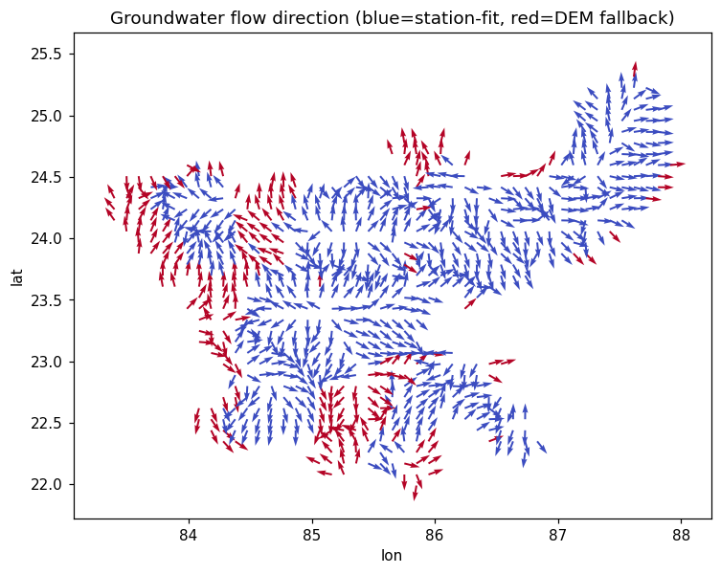
Figure 4.1: The groundwater flow field used by the model: arrows point down-gradient on a 5 km grid; blue cells are fitted from CGWB stations and red cells use the terrain fallback. Data: CGWB levels [3] and GLO-30 DEM [21].
Fracture directions from lineaments
In hard rock, water moves mostly along fractures, so the direction of the fractures matters. The Geological Survey of India and NRSC lineament map for Jharkhand [23] was downloaded (1,889 features), and 1,826 structural lineaments (joints, fractures, dykes, shear zones, faults and fold axes) were used. For each 5 km cell, the average fracture direction and how well the fractures are aligned were calculated using standard directional statistics for undirected lines [24]. Well-aligned fractures make a narrow plume; scattered fractures make a wider one.
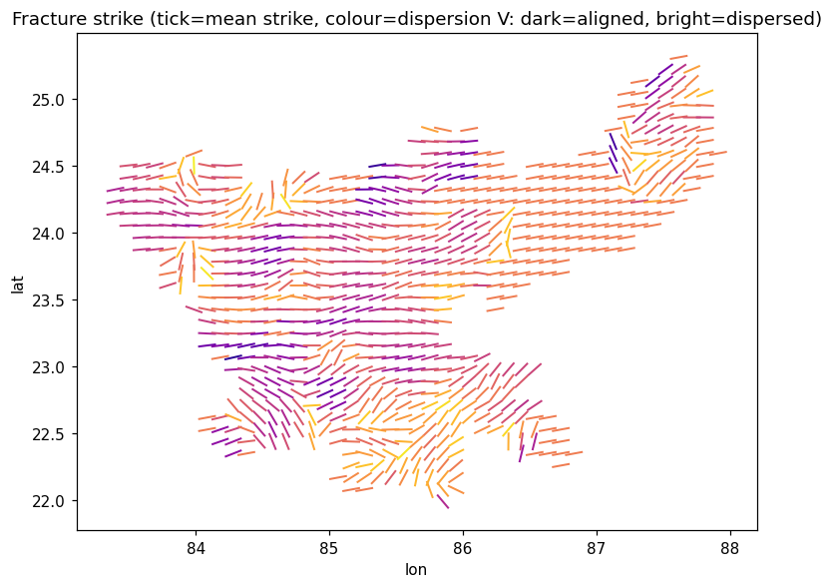
Figure 4.2: The fracture-direction field: each tick shows the average fracture direction in a 5 km cell; the colour shows how scattered the fractures are. Data: GSI–NRSC lineaments [23].
Aquifer layers from NAQUIM reports
Twenty-two CGWB aquifer-mapping (NAQUIM) reports were downloaded [1]. A keyword search collected 410 text snippets about layer depths, and a table of 24 districts was built from them by hand: the base of the weathered layer (13–22 m), the depth range of water-bearing fractures (down to 90–258 m), and whether the deeper aquifer is confined. East Singhbhum came from the CGWB district booklet [2], and three districts with no report used estimates from neighbouring districts.
The NAQUIM report that covers the uranium belt itself (East Singhbhum, Saraikela-Kharsawan and parts of West Singhbhum) had been removed from the CGWB website. A copy was recovered from the Internet Archive [25]. Its tables give CGWB’s exploratory boreholes in the belt, and these were transcribed from the page images into a table of 48 holes (43 with a position), together with their water-bearing zones. Blank cells were left blank, and every disagreement between sources was written into the row. Three findings from this report are used later. First, its pumping tests give the permeability of the belt’s own rock (Section 4.4). Second, the Kudada well near Turamdih is recorded as auto-flowing: its deep fractures at 105–139 m pushed water up to the surface. Third, Kudada’s deep water is low in the excursion indicators (EC 721 µS/cm, chloride 7 mg/L and sulphate 5 mg/L), so a lixiviant would stand out clearly there. The layer depths used for East Singhbhum (weathered base 20 m, fractures to 258 m) lie inside what the report records.
Uranium and radium backgrounds near the mines
The CGWB well nearest to each of the seven deposits was never tested for uranium, and CGWB does not measure radium. Published surveys by the Bhabha Atomic Research Centre (BARC) around the mines were therefore collected into one table of 16 rows from 7 studies. A location takes a blend of these surveys, weighted by inverse distance squared, together with a regional value that counts as one survey at 5 km. Near a mine the survey dominates; far from all mines the regional value takes over. The same function is used to build the training data and to serve a run.
Table 4.1: Uranium and radium backgrounds used near the mines
Area | Radium-226 (mBq/L) | Uranium (µg/L)
Jaduguda | 23, regional average [5] | 1.1, median [26]
Narwapahar | 13.7, mean [27] | 0.87, mean [27]
Turamdih, Banduhurang, Mohuldih | 19.8, geometric mean [28] | 0.99, geometric mean [28]
Bagjata | 12.4, geometric mean [29] | 3.22, geometric mean [29]
Regional value | 10, geometric mean of 108 wells [30] | 0.775, median of 342 CGWB wells [14]

Where two surveys disagree, both are kept. For the Turamdih area, a smaller survey gives a radium geometric mean of 9.1 mBq/L [29] against 19.8 from the larger one; the larger survey is used and the smaller one is recorded. Near Jaduguda, potable wells range from below 3.5 to 208 mBq/L [31]. All these backgrounds are one to three orders of magnitude below the drinking-water limits, so their effect on the results is small. What matters is that each value is now measured where it is used.
UCIL mine records
Public documents of the Uranium Corporation of India Ltd. (UCIL) were used for two things. The first is the depth of the ore at each deposit. Each deposit has a documented depth range and one default depth (the seed) inside it, which the portal fills in and prints with its range.
Table 4.2: Ore depth at the seven deposits
Deposit | Documented ore depth | Seed | Source
Jaduguda | 0–900 m | 180 m | [32], [33]
Bhatin | 0–135 m | 90 m | [33]
Narwapahar | 100–380 m | 150 m | [34]
Turamdih | 50–200 m | 140 m | [35]
Banduhurang | 0–164 m | 60 m | [33]
Bagjata | 0–270 m | 160 m | [36]
Mohuldih | 0–250 m | 150 m | secondary source; no UCIL document gives a depth

The second is the water pumped out of the mines. UCIL’s 2017 pre-feasibility reports give 2,700 m³/day from Narwapahar, developed to 380 m [34], and at least 3,170 m³/day from Turamdih, worked to 260 m [37]. A dewatered mine behaves like a very large pumping test, so these figures are used to check the rock permeability (Section 7.4).
Texas ISR records
Because no ISR data exists for India, the USGS records of groundwater quality at ISR mines in Texas were used [9], [38]. From the end-of-mining samples at 7 mines, the source strength was taken: uranium 9,027 to 41,595 ppb, and sulphate and TDS in proportion. From samples taken after restoration at the same mines, the fraction left after cleaning was found: 6.0% for uranium, 13.8% for sulphate, 33.7% for TDS and 53.1% for chloride. The median restoration period across 13 production areas was 5.0 years. The Texas data was used only for the chemistry of the source and for restoration behaviour. All the hydrogeology (rock type, flow, fractures, layers, background chemistry) comes from Jharkhand.
Other data
District and block boundaries, the 24 CGWB aquifer polygons, the outlines of seven uranium deposits and a regional belt envelope, uranium ore grades from the IAEA UDEPO database [4], and perennial rivers from HydroRIVERS [39] were also loaded.

4.4 Hydrogeological Framework
Each of the 12 rock types in the aquifer map was classed as fractured (schist, gneiss, granite, quartzite, charnockite, Basement Gneissic Complex, basalt, intrusive rocks) or porous (limestone, sandstone, laterite, alluvium). This choice decides which equations are used for a location.
Hydraulic conductivity (K) tells how easily water moves through rock. It was taken from the aquifer polygon. Where a value was missing, a typical value for that rock type from the literature was used [40]. Since CGWB values describe the shallow aquifer, but ISR ore lies deeper, K was reduced with depth using a law fitted for each district from the NAQUIM fracture depths. In East Singhbhum this law leaves about 15% of the reference K at an ore depth of 180 m.
In the Singhbhum shear zone, where the deposits lie, K is taken from pumping tests in the belt’s own rock. The largest transmissivity (T) measured in the host rock near the deposits is 19 m²/day, at the Kudada exploratory well in metasediments about 3 km north-east of Turamdih, tested as an open hole from 15.6 to 145.4 m [25]. This measured maximum is used as the baseline, with a cap of 20 m²/day. The thickness is the tested interval, 130 m. The reference K is then solved so that the engine’s own depth law, integrated over the tested interval, gives back the measured T. This gives K = 0.228 m/day at the 45 m reference depth and 0.034 m/day at Jaduguda’s ore depth of 180 m. Dividing T by the thickness directly would apply the depth decay twice. Other tests were looked at but not used: granite wells in the belt districts read 2 to 39 m²/day; a test at AMD Jamshedpur in the same metasediments read 101 m²/day, but its position is not published; and the values of 207 to 570 m²/day in the same CGWB table come from Tertiary sediments 51 to 58 km east of Jaduguda, outside the belt. The baseline was also checked against the water pumped out of UCIL’s mines (Section 7.4). The shear-zone value applies fully at the deposits and fades into the aquifer-map value with distance from them. Values were blended smoothly across aquifer boundaries so that the results do not jump suddenly between two nearby points.
Ore zones. A uranium source can exist only where uranium ore exists. Each location is classed as deposit (inside a deposit outline or within 500 m of it), belt (inside the Singhbhum envelope, with a reduced source) or none (no uranium plume is drawn). Sulphate and TDS are not limited this way, because the lixiviant carries them wherever it is injected.
Sorption and retardation. Some chemicals stick to rock and move slower than the water. This is measured by the distribution coefficient Kd [41]. In porous rock, the retardation factor is:
R = 1 + (ρb × Kd) / n
where ρb is the bulk density of the rock and n is the porosity. The chemical then moves at v / R, where v is the water velocity. Uranium has a low Kd under alkaline conditions, while radium has a very high Kd and hardly moves at all. The upper end of the radium Kd range, 2,285 L/kg, is the largest value measured in soils around the Turamdih mine [42]. The most likely value is kept at 13.2 L/kg, much lower, because the local measurements are for organic-rich soil and not for fractured rock at ore depth.
Background chemistry. Each location takes its natural background from the nearest CGWB well. Uranium and radium are blended from the BARC surveys described in Section 4.3. Away from the mines, uranium falls back to the nearest CGWB well, or to the statewide median of 0.775 µg/L where that well was not tested for uranium; radium falls back to the regional survey value of 10 mBq/L.

4.5 Contaminant Transport Model
The transport engine calculates the concentration of a chemical around a hypothetical ISR wellfield on a map grid, for a chosen time after injection begins. One run, including the second answer described in Step 9, takes about 0.3 seconds when run locally. The main steps are explained below in simple terms.
Step 1: Groundwater velocity
The water velocity comes from Darcy’s law:
v = (K × i) / φ
where K is the hydraulic conductivity, i is the hydraulic gradient from the flow field, and φ is the porosity through which water actually flows. In fractured rock φ is less than 1%, which is why water can move quickly through fractures even when K is small.
Step 2: Containment by the bleed
While the mine is operating, the extra water pumped out (the bleed) pulls groundwater back towards the wellfield. Using capture-zone theory [43], the fraction of flow that is captured is:
η = min (1, Qnet / (q × b × W))
where Qnet is the net extraction, q = K × i is the regional water flux, b is the aquifer thickness and W is the wellfield width. If η = 1, the wellfield holds everything in. Pump downtime reduces η.
Step 3: Three phases of the plume
The front of the plume moves differently in three phases: during operation it moves slowly because of containment; during restoration it is held in place; and after closure it drifts freely with the groundwater.
Step 4: Slowing down in fractured rock
In fractured rock, chemicals move in the fractures but also soak into the solid rock between them (the matrix), which slows the plume. This is described by a dual-porosity model [44]. Late in time, the plume moves slower than the water by a factor:
R_eff = 1 + β × R_m, β = (n_total − φ_mobile) / φ_mobile
Here β is the ratio of water stored in the rock matrix to water in the fractures, and R_m is the sorption in the matrix. β is calculated from the porosities of each location. At Jaduguda, β = 3.0, which gives R_eff ≈ 271 for uranium, but only 4 for TDS, which does not sorb. This is why uranium stays close to the mine while the other chemicals travel much further.
Step 5: The shape of the plume
The concentration map is calculated with the standard Domenico solution [45], using the full Ogata–Banks form along the flow direction [46]. It describes how a chemical released from a source of width W spreads along and across the flow direction. The amount of spreading (dispersivity) grows with the distance travelled, following the Xu and Eckstein formula [47], and the sideways spreading is set from the fracture alignment in each cell [48]. For fractured rock, a second solution for flow along a single fracture with diffusion into the rock (Tang, Frind and Sudicky [49]) is also calculated, and the larger of the two is used, so that fast early arrival is not missed.
Step 6: The leach zone, restoration and attenuation
The wellfield area itself is contaminated by design, so it is drawn as a circular “leach zone”. After mining, restoration lowers the source concentration step by step, calibrated so that a 5-year restoration reaches the measured Texas end result. After restoration, the source does not fall below the measured Texas level, because some contamination comes back after cleaning (rebound) [50]. The source also never falls below the natural background chemistry of the site. Down-gradient of the mine, dissolved uranium meets reducing rock and turns into a solid form, so a first-order decay factor exp(−k × age) is applied to uranium only [51]. The rate k is between 0.05 and 0.70 per year, based on a field test at a Wyoming ISR site [52], and it is set higher inside the sulphide-rich ore zone.
Step 7: Outputs and the excursion test
For every run, the engine reports:
- Footprint area (hectares) where the concentration is above the drinking-water limit (only the part caused by the mine is counted, not the natural background).
- Maximum travel distance of the plume beyond the wellfield, measured along the flow centreline.
- Concentration at the monitoring ring, placed 100 m beyond the wellfield edge.
- Excursion test, following the US rule [12]: an excursion is declared when at least two of the three indicators (chloride, TDS and sulphate) are above their control limits at the ring. Uranium is not used as an indicator.
- Map rasters. The concentration field is returned as a map image in which each pixel is the analytical value at that pixel’s own centre, not an interpolation. A second image, the chance over limit, shows for each pixel the share of the Monte Carlo draws (Step 8) in which the drinking-water limit is exceeded there. Without any change of direction, this image gives exactly the excursion probability at the monitoring ring. On the map, each draw is also turned through 15 flow directions spread by the measured direction uncertainty (Section 4.3), which fans the image sideways.
Drawn continuously, the plume is a straight-sided band about as wide as the wellfield. This is what a wide source gives in steady regional flow when sideways spreading is small, and field tracer tests show that sideways spreading is small: at Cape Cod the transverse dispersivity was measured in centimetres against about a metre along the flow [53]. A fracture network model, which would give a more irregular plume, was not built. Within 10 km of Jaduguda the lineament map holds only three structural fractures, and no fracture spacing or aperture has been published for the mines, so such a network would be almost entirely assumed.
Step 8: Monte Carlo uncertainty
Many input values are not known exactly. For each scenario, 48 random versions (draws) are run with different values of K, Kd, β, fracture opening, gradient (widened by the measured seasonal change), dispersivity, bleed and attenuation rate. The 10th, 50th and 90th percentiles (P10, P50, P90) of the results give a range. The share of draws in which the ring concentration crosses the limit gives the excursion probability. The draws vary K by a factor of 0.37 to 2.46 around its served value, which at Jaduguda is 0.013 to 0.084 m/day. The Monte Carlo therefore describes uncertainty within the rock as measured, not the possibility that the rock is of a different kind.
Step 9: Two answers for every run
In-situ leaching works only in rock that lets the solution flow through the ore. The IAEA gives a rule of thumb: a permeability of the order of 1 m/day or more is advantageous, and ISR usually becomes unfeasible at about 0.1 m/day and less [54]. An earlier IAEA manual places clayey schists and solid rocks at 0 to 0.1 m/day [55], and UCIL’s own note on in-situ leaching lists good host-rock permeability as a condition [56]. The measured K at ore depth in the Singhbhum deposits is well below the working level:
Table 4.3: Measured ore-zone K at the default ore depth of each deposit
Deposit | Ore-zone K (m/day)
Jaduguda (180 m) | 0.034
Narwapahar (150 m) | 0.052
Turamdih (140 m) | 0.060
Mohuldih (150 m) | 0.032
Bagjata (160 m) | 0.045
Bhatin (90 m) | 0.12
Banduhurang (60 m) | 0.18

Five of the seven deposits are below the 0.1 m/day floor, the two shallow ones lie between the floor and the working level, and none reaches 1 m/day. Every run therefore returns two answers:
1. The measured-rock answer (baseline). This uses the measured K described in Section 4.4. It gives every number on the screen, the vertical screening, the excursion panel and every alert.
2. The ISR-feasibility hypothetical. This is the same run with only the ore-zone K raised to 1 m/day, the IAEA’s advantageous level. It answers the question “how far would it spread if this rock were permeable enough for ISR to work at all?”. It is labelled “Not a prediction”, it carries its own Monte Carlo band, and it is never read by the alert system; a backend test checks this. The rock above the ore keeps its measured K, because the IAEA criterion is about the ore horizon, so the vertical arrival times are the same in both answers.
The two answers are shown side by side and are not merged into one band. Merging them would need a probability that the rock at the site is of ISR grade. No data gives such a probability, and the measured K says that it is not, so a merged band would only show the weight that was chosen for it.
The engine was checked against an exact numerical solution on 240 test cases. This check found that an earlier simplified version under-estimated concentrations by 17–42%, and the full formula was restored (Section 7.4).

4.6 Vertical (Shallow Aquifer) Screening
The plan-view model above describes the ore layer. People, however, drink from the shallow layer. A separate screening estimates whether contamination at ore depth could reach the shallow aquifer through three routes:
1. Dispersion upward from the ore layer.
2. Leakage upward through the fractured rock, driven by the upward head difference.
3. Old wells (boreholes) acting as short-cuts, with a small base probability of 5%.
On the leakage route, what moves is the dissolved chemical, not just the water. The chemical front climbs on the same matrix-storage clock as the horizontal front [44], with β taken from the porosities of the rock it passes through. So a sorbing chemical such as uranium climbs far more slowly than the water, while TDS and chloride are held back only a little. The old-well route is not slowed in this way, because an open borehole has no rock matrix. The K of the column is the harmonic mean of the depth law between the top of the ore and the base of the shallow aquifer, which is the correct average for flow across layers [40]. The ratio of vertical to horizontal K is 0.12, the geometric mean of five pumping-test interpretations in the Maheshwaram granite near Hyderabad [57]; the measured range of 0.034 to 0.61 is evaluated on every run and shown beside the result. This is not a Singhbhum measurement, and it may understate vertical flow in the folded schists of the belt.
The salts carried by the lixiviant (chloride, TDS and sulphate) are screened on the same column. The result names the first arrival: the earliest constituent whose source concentration is above its drinking-water limit. The aquifer alerts (Section 4.9) use this first arrival, so a uranium screening also reports that the salts would arrive much earlier.
The three routes are combined into one screening index between 0 and 1, which is shown as high, moderate, low or contained, together with the main route and an estimated breakthrough time. The upward push of water changes with the monsoon, so the breakthrough time is calculated for both the dry-season and the wet-season case, and for the yearly average of the upward push. The upward head difference itself is still an assumption (a gradient of 0.005). Close pairs of deep and shallow wells in the belt show natural vertical gradients of 0.03 to 0.23, pointing up at some sites and down at others [1], [25], so the assumption can be neither confirmed nor ruled out.
A full 3-D transport model was not built. The chemistry wells have no recorded depth, and there is no deep water-level data in the belt. A 3-D model built on this data would look precise but would not be backed by measurements. The system therefore stays “2.5-D” and says so. To help users see the answers in place, the portal draws a 3-D site block (Section 8.5): the ground from the GLO-30 elevation model [21], the aquifer layers at the district’s NAQUIM depths, the water table, the nearest CGWB boreholes, the plume on the ore horizon, and the vertical fronts climbing year by year. The block is a picture of the 2-D and 1-D answers above; it adds no physics of its own.

4.7 Machine Learning Surrogate Model
Why a surrogate
The proposal planned ML models trained on measured groundwater data. The first pipelines (March–May 2026) did this. However, an audit in June 2026 found that these models were not learning contamination spread at all. The measured records have no distance from any mine and no time since injection, so those fields had been filled with a constant value, and the model was really predicting the natural background uranium. The spread with distance existed only in the synthetic data the project had generated itself (Section 9.3). The ML approach was therefore changed: the physics engine produces the labels, and the ML model learns to copy the engine quickly and give calibrated uncertainty bands. Such a model is called a surrogate.
Training data
The training set was produced by the physics engine: 900 scenarios placed on real Jharkhand aquifer polygons, each evaluated at 5 times (2, 5, 8, 12 and 20 years) for 4 chemicals (uranium, sulphate, TDS and radium-226), giving 18,000 rows. Each scenario used 48 Monte Carlo draws to produce its P10, P50 and P90 values. Of the scenarios, 60% took their gradient and fracture values from the real Jharkhand fields at their location, and 40% from wider operating ranges. Half of the scenarios apply the engine’s depth law for K at a randomly chosen ore depth, so that the training data also covers the tight rock of the deposits: in fractured rock it reaches K values from 0.0021 to 9.8 m/day. Radium backgrounds are drawn over their served range of 10 to 23 mBq/L. The data can be regenerated exactly from a fixed random seed.
Features
Each row has 40 features, grouped as: rock type; K, gradient, porosity and velocity; Kd and retardation; dispersivity; dimensionless groups (such as pore volumes injected); operating settings (injection rate, bleed, containment, operating years, wellfield width); source and background concentration; restoration and attenuation; the plume front position calculated by the engine; and the chemical type. No map coordinates are used as features. This stops the model from inventing patterns tied to location instead of to physics.
Model and training
For each of three targets (footprint area, travel distance and ring concentration), three XGBoost models [58] were trained for the 10th, 50th and 90th percentiles, using the quantile (pinball) loss [59]. A fourth model predicts the excursion probability. This gives ten models in total. The settings were fixed: 450 trees, depth 5, learning rate 0.05. Physical rules were built into the models using monotone constraints. For example, a higher K can only increase the spread, and a higher bleed can only reduce it. Each of these rules was checked against the engine’s own results.
Calibrated uncertainty (conformal prediction)
Raw quantile models often give bands that are too narrow. Conformal prediction [60], [61] was used to fix this. On a separate calibration set, the model’s errors are measured, and the bands are widened just enough that at least 80% of new cases fall inside them. The widening is done separately for each rock type and chemical (a “Mondrian” scheme), so that one chemical’s errors do not affect another. The 80% target is checked at the scenario level, which is stricter than checking individual rows.
Validation
- GroupKFold (5 folds) by scenario: all rows from one scenario stay in the same fold, so the model is never tested on a scenario it has already seen.
- Leave-aquifer-out: whole aquifer polygons (23 groups) are held out to test the model on geology it has never seen.
- Baselines: a mean predictor, a ridge regression and a single-split tree are tested on the same folds for comparison.
- Field-location test: a separate batch of 120 scenarios, all placed on real flow and fracture values, must also reach 80% coverage.
SHAP values [62] were used to see which features the model relies on. In the live system, every request compares the ML answer with the engine’s answer, and a drift warning is raised if they start to disagree.

4.8 Water Quality Assessment
The measured water quality is assessed against IS 10500:2012 [13], which gives an acceptable limit and a permissible limit (used when no other source is available) for each substance. For uranium, the limit of 30 µg/L is used [63].
Every map and page for residents uses one shared rule to give each block a health band, based on the highest measured value of uranium, nitrate and fluoride in its wells:
- High concern: any of them is above its permissible (or “no relaxation”) limit.
- Moderate concern: any of them is above its acceptable limit.
- Low concern: all tested values are within limits.
- Not tested (grey, never green): wells exist but none was tested for these substances.
- No data: the block has no sampled well.
Hardness, calcium, magnesium and TDS are not used for the health band, because they exceed their limits in about two-thirds of the state’s wells due to natural hard-rock chemistry, not pollution. They are still shown on the water-quality page. Every band also shows which substance decided it, and which health-related substances (such as arsenic and iron) were never tested. A water quality index (WQI) [64] is shown only as a secondary figure, together with the substance that dominates it.
Two further checks were added. A charge-balance check compares the positive and negative ions in each sample, which is a standard way of checking a laboratory analysis [20]. Trend tests use the Theil–Sen slope [65], [66] and the Mann–Kendall test [67] on the water-level records and on the older 2000–2021 chemistry record [68]. These methods suit short and uneven records. A station with too few readings is reported as “not enough record”, never as “stable”.

4.9 Alert Generation and Delivery
The alert system has five kinds of alert:
1. Measured exceedance: a laboratory value in a block’s well is above an IS 10500 limit.
2. Published screening: a hypothetical screening was published and its central (P50) footprint touches the block.
3. Possible reach: the block is inside the wider P90 spread but outside the central footprint.
4. Aquifer pathway: the block shares the shallow aquifer that a modelled vertical route would reach, within a distance groundwater could actually travel.
5. Breakthrough due: the modelled breakthrough time of a published site has passed since its injection start date.
Both vertical alerts (4 and 5) use the first arrival from the vertical screening (Section 4.6). All modelled alerts are raised from the measured-rock answer only; the ISR-feasibility hypothetical never raises an alert.
Each alert has a tier, based on the IS 10500 limits:
Table 4.4: Alert tiers
Tier | When it is used
Notice | A published modelled screening touches the block.
Warning | A measured value is above the acceptable limit but within the permissible limit; or a modelled possible reach, aquifer pathway or breakthrough-due alert.
Alert | A measured value is above the permissible or “no relaxation” limit; or a modelled screening with excursion probability of 0.5 or more.
Critical | A measured value is at least twice the limit, or two or more health substances exceed their limits at the same well (a project-defined rule). A modelled result can never be critical.

Every alert carries seven fields: the basis (measured or modelled), the driver (substance, value, limit and times-limit), where it is (block, district, well), the tier, the confidence (for example, the laboratory date or the model band), the next action (for example, “re-sample; boiling does not remove nitrate”), and one plain sentence saying what happened.
Residents choose their home block when they register and are subscribed to it. A scheduler runs once every 24 hours. It scans the measured data and sends each new alert by email to every subscriber of that block. Every delivery is recorded (sent, failed or skipped), so the same email is never sent twice, and failed deliveries are retried.

4.10 Monitoring Gap Analysis and Sensitivity
Every block is given a monitoring-priority score from 0 to 100. The score shows how poorly the block is observed, not how risky the model thinks it is. The weights are shown on screen, so that anyone can see and question them.
Table 4.5: Monitoring priority weights
Factor | Weight (points)
Block has never been sampled | 30
Wells sampled but never tested for uranium | 30
Low number of wells per 100 km² | 20
Far from the nearest uranium-tested well (up to 25 km) | 15
Close to a registered hypothetical site | 5

The ranking is based on observation on purpose. The model is least reliable where there is no data, so ranking by predicted risk would send field teams to places the model is already confident about. Along with the ranking, a gap table (block × substance × tested or not) and suggested new well sites are provided.
A global sensitivity analysis was also carried out to find which inputs control the model results. Thirteen inputs were varied at three reference sites, and Sobol indices were calculated [69], [70]. All the constants that could not be backed by a local measurement, or that are a modelling choice rather than a measurement (20 in total), were listed in an assumption register, which is shown inside the portal together with what measurement would be needed to replace each one.

4.11 Testing and Validation
Testing was carried out at every level:
- Engine tests (463): physical rules (for example, more bleed never increases the spread), the exact-solution check, restoration behaviour, the extracted CGWB records, the local backgrounds, the vertical pathway and fixes found in review rounds.
- Backend tests (533): run against a real PostGIS database; they cover role access for all 143 endpoints, database security, alert tiers, email delivery and retry, the water-quality module, and a check that no alert ever reads the ISR-feasibility hypothetical.
- Review rounds: from July 2026, the system went through several numbered review rounds. Each finding was either fixed and pinned with a test, or shown to be wrong with evidence.
- Browser testing: every screen was checked for every role by hand.
- Deployment checks: the deployed system was checked for speed, security settings and correct operation.

4.12 Methodology Summary
The method combined real local data, standard groundwater physics and machine learning in a way where each part does what it is good at. The physics engine gives answers that can be explained and checked against exact solutions. In the uranium belt it uses the permeability measured in the belt’s own rock, and it shows beside it, clearly labelled, what would happen if the rock were permeable enough for ISR. The ML surrogate gives fast answers with honest uncertainty bands. The assessment, alert and ranking modules turn these results into information that officials and residents can act on. The result is a screening tool that can be used anywhere in Jharkhand, while being clear about which of its numbers are measured, which are modelled, and which could not be checked because no data exists.

5. TOOLS & TECHNOLOGIES USED
The development of JalDrishti involved programming languages, a web backend framework, a spatial database, scientific and machine learning libraries, a web frontend framework, cloud hosting services, and open datasets from several agencies. Together these made it possible to build a system that runs a groundwater model, trains and serves ML models, stores spatial data securely, and presents the results through a web portal. All the software used is open source or has a free tier, and no hardware was purchased.

5.1 Programming Languages
Table 5.1: Programming languages
Language | Purpose
Python 3.12 | Physics engine, data preparation, machine learning, backend API and tests
TypeScript 5.7 | Web portal (frontend) with type checking
SQL (PostgreSQL / PostGIS) | Spatial queries, database migrations and row-level security policies
HTML and CSS | Page layout and styling of the portal, including light and dark themes

Python
Python was used for most of the project. The physics engine, the synthetic data generator, the ML training pipeline and the backend server are all written in Python, because it has strong scientific libraries (NumPy, SciPy, pandas) and good support for web APIs (FastAPI).
TypeScript
TypeScript was used for the portal. Its type checking catches mistakes when the shape of the data sent by the backend changes, which happened often during development.

5.2 Backend Technologies
Table 5.2: Backend technologies
Technology | Purpose
FastAPI 0.115 | Asynchronous REST API framework with automatic API documentation [71]
Uvicorn | ASGI server that runs the FastAPI application
SQLAlchemy 2.0 + asyncpg | Database access from Python (asynchronous)
GeoAlchemy2 | Spatial (geometry) columns in SQLAlchemy models
Alembic 1.14 | Database schema migrations (26 migrations in total)
Pydantic 2 | Request and response validation, settings management
python-jose | JSON Web Tokens (JWT) for login sessions
passlib + argon2 | Secure password hashing
slowapi | Rate limiting of API requests (for example, on login)
loguru | Application logging
smtplib (Python standard library) | Sending alert emails through an SMTP relay

FastAPI
FastAPI was chosen because it is fast, supports asynchronous code, and creates interactive API documentation automatically. The backend was first started in Node.js in November 2025 and moved to FastAPI in December 2025. Using Python for both the backend and the ML code kept the whole system in one language.
Authentication and security
Users log in with JWT tokens. Passwords are hashed with argon2. The user’s role is read again from the database on every request instead of being trusted from the token. Rate limiting protects the login endpoint from repeated password guessing.

5.3 Database
Table 5.3: Database technologies
Technology | Purpose
PostgreSQL 16 | Main relational database
PostGIS | Spatial data types and queries (points, polygons, “which block contains this well”) [72]
Row-Level Security (RLS) | Database-level rules that decide which rows each role can read or change
Neon | Managed cloud hosting for the PostgreSQL database

PostGIS was essential because almost everything in the project is spatial: wells, blocks, districts, aquifers, deposit outlines and plume footprints. For example, an alert is raised for a block when the plume footprint polygon intersects the block polygon, which is a single PostGIS query. Row-level security gives a second line of protection: even if an API check were missed, the database itself refuses to show a resident a hypothetical site coordinate or a draft screening.

5.4 Machine Learning and Scientific Libraries
Table 5.4: Machine learning and scientific libraries
Library | Purpose
NumPy 1.26 | Numerical arrays and the physics calculations
SciPy 1.13 | Special functions (erf, erfc), statistics and integration
pandas 2.2 | Reading and cleaning tabular data (CSV, Excel)
GeoPandas 1.0 / Shapely 2.0 | Reading map data (GeoJSON, shapefiles) and geometry operations
XGBoost 3.3 | Gradient-boosted tree models for the quantile surrogate [58]
scikit-learn 1.5 | Cross-validation, baseline models and metrics
SHAP | Explaining which features the ML model relies on [62]
joblib | Saving and loading trained models
Matplotlib | Charts for flow field, fracture field, SHAP and sensitivity results
openpyxl | Reading the Texas ISR Excel data and the IAEA UDEPO sheet
pdfplumber, pypdfium2 | Reading the CGWB national PDF tables (water quality 2024, water levels 1994–2026): pypdfium2 finds the Jharkhand pages, pdfplumber reads the table cells and word positions

XGBoost
XGBoost was chosen over the Random Forest and SVM models named in the proposal for three reasons: it supports quantile (percentile) training directly, it allows monotone constraints so that physical rules can be built into the model, and it trains quickly (all ten models train in about 200 seconds). Random Forest and logistic regression were used in the earlier pipelines of March to May 2026 (Chapter 6).

5.5 Frontend Technologies
Table 5.5: Frontend technologies
Technology | Purpose
React 18 | Component-based user interface [73]
Vite 6 | Fast development server and production build tool
Leaflet 1.9 | Interactive maps: districts, blocks, wells, plumes and alerts [74]
TanStack Query 5 | Fetching and caching data from the API
React Router 6 | Page navigation for the 22 screens
three.js 0.186 | The 3-D site block: terrain, aquifer layers, boreholes, plume and vertical fronts; loaded only when opened [75]
html2pdf.js | Downloading the ISR site report as a PDF
OpenStreetMap and Esri tiles | Background maps (street and satellite views)

The portal has a public front page and a role-based application behind the login. It supports a light and a dark theme. Every colour is defined in one place, so that both themes stay consistent.

5.6 Deployment and Hosting
Table 5.6: Deployment and hosting services
Service | Purpose
Neon | Managed PostgreSQL + PostGIS database in the cloud
Render | Hosting of the FastAPI backend, the physics engine and the trained models
Cloudflare Workers | Hosting of the portal and forwarding of API calls to the backend
Brevo (SMTP relay) | Sending alert emails to residents
GitHub | Source code hosting and version control (191 commits)

The deployed system is available at jaldrishti.letsmailvishal111.workers.dev (portal) and jaldrishti-api.onrender.com (API). The online deployment runs the build described in this report: the engine with the measured-rock baseline and the ISR-feasibility hypothetical, surrogate version 6, and a database migrated to 0026 (alert tiers). It was redeployed in September 2026 after the build had been tested locally.

5.7 Data Sources
Table 5.7: Datasets used in the project
Dataset | Source | Used for
Groundwater quality 2023 (397 wells, 24 districts) | CGWB [14] | IS 10500 assessment, health bands, measured alerts, background chemistry
Groundwater quality 2000–2021 (1,632 analyses, 366 stations) | CGWB via NWDP [68] | Station baselines and chemistry trends
Groundwater quality 2024 (288 samples, 24 districts) | CGWB national table [15] | Natural variability of TDS, sulphate and chloride
Groundwater levels 2013–2021 (9,583 readings, 398 stations) | CGWB / India-WRIS [3] | Flow field, seasonal change, level trends in the portal
Groundwater levels 1994 – January 2026 (26,009 readings, about 700 wells) | CGWB national tables [22] | Check of the flow direction, 32-year level trends
Aquifer polygons (24) | CGWB | Rock type, K, porosity, thickness
NAQUIM reports (22) | CGWB [1] | Aquifer layer depths per district
NAQUIM Phase-III report for the uranium belt; 48 exploratory boreholes | CGWB, recovered from the Internet Archive [25] | Shear-zone permeability, boreholes in the 3-D block
Lineaments (1,889 features) | GSI and NRSC, Bhuvan [23] | Fracture directions
Uranium deposits (7 outlines + belt) and grades | Project-digitised outlines; IAEA UDEPO [4] | Ore zones and source strength
Elevation model (GLO-30, 30 m) | ESA Copernicus via OpenTopography [21] | Water-table height, flow direction, terrain of the 3-D block
Perennial rivers (4,577 reaches) | HydroRIVERS [39] | Distance to rivers
District and block boundaries | Government of India | Block-level results and alerts
Texas ISR water quality and operations | USGS [9], [38] | Source strength, restoration results and duration
Jaduguda mine-water and radium studies | BARC [76], [5] | Radium source term
Groundwater uranium and radium surveys near the mines (16 rows, 7 studies) | BARC and others [26], [27], [28], [29], [30] | Local uranium and radium backgrounds
Mine documents (pre-feasibility reports, technical notes) | UCIL [34], [37], [33] | Ore-depth ranges, mine discharge check

5.8 Development and Testing Tools
Table 5.8: Development and testing tools
Tool | Purpose
Git and GitHub | Version control, pull requests and code history
Visual Studio Code | Code editor
pytest, pytest-asyncio, httpx | Automated tests for the engine (463) and the backend (533)
Swagger UI (FastAPI) | Testing API endpoints in the browser
Docker | Local database and service setup in the early months
Browser developer tools | Checking the portal screens, network calls and console errors

5.9 Technology Integration
All the tools above work together as one system. The overall technology workflow can be shown as:
Open Datasets (CGWB, GSI–NRSC, IAEA, USGS, Copernicus, BARC, UCIL)
↓
Python Data Preparation (pandas, GeoPandas, NumPy)
↓
Physics Engine (NumPy, SciPy)
↓
ML Surrogate (XGBoost, scikit-learn, SHAP)
↓
FastAPI Backend + PostgreSQL / PostGIS
↓
React + Leaflet + three.js Portal
↓
Residents and Officials (web portal and email alerts)

The selected tools gave a low-cost, flexible and maintainable platform for building a groundwater contamination screening system that can be used anywhere in Jharkhand.

6. WORK CARRIED OUT DURING FELLOWSHIP
The fellowship work was carried out over ten months, from November 2025 to August 2026, followed by a short finishing phase in September 2026. The work began with literature study and building the software platform, moved through three rounds of machine learning on measured and synthetic data, and then changed direction in June 2026 to a physics-based model with an ML surrogate. The last months were spent on review rounds, building the full portal, the alert system and deployment. The activities of each month are summarised below, based on the monthly progress reports (MPRs) and the project’s code history.

6.1 November 2025: Literature Study and Project Setup
The fellowship began with a study of groundwater monitoring network design [19], aquifer vulnerability methods and the ways in which ISR uranium mining can contaminate groundwater [11]. This helped in understanding what a useful monitoring tool should do and what data it would need.
On the development side, the overall system architecture was designed as separate services (frontend, backend API, ML service, database and cache). A local development environment was set up with Node.js, PostgreSQL, Redis, a Python environment and Docker. The project code was started on GitHub, and a first admin panel was built in React and TypeScript with JWT-based login and three roles.
Activities Performed
- Study of monitoring network design and aquifer vulnerability frameworks
- Study of ISR contamination pathways
- Design of the overall system architecture
- Setting up the development environment (Node.js, PostgreSQL, Redis, Python, Docker)
- Development of the first admin panel with JWT login

6.2 December 2025: Move to FastAPI and Spatial Database
In December the backend was moved from Node.js to FastAPI (Python), organised into API, service and repository layers. A full database schema with spatial (PostGIS) columns was designed, with SQLAlchemy models and Alembic migrations. REST APIs were built for users, districts, blocks and aquifers, with input checking using Pydantic and role-based access. A simulation workflow was set up with a placeholder output, to be replaced by a real model later. The required groundwater parameters (porosity, depth to water, hydraulic conductivity and transmissivity) were identified from CGWB and aquifer datasets, and data collection plans were discussed with the mentor.
Activities Performed
- Migration of the backend from Node.js to FastAPI
- Design of the PostgreSQL + PostGIS database schema (13 tables)
- REST APIs for users, districts, blocks and aquifers
- Role-based access control and JWT authentication
- Study of PostGIS and of how physics and ML could be combined for plume modelling

6.3 January 2026: First Real CGWB Data
In January, published CGWB datasets on groundwater levels and quality were studied, and the Dhanbad groundwater-level data was loaded into the database. The aquifer model was extended with fields such as transmissivity, hydraulic conductivity, fractures encountered and yield range, to match the CGWB data structure. An ISR points API (create, read, update, delete) was built with coordinates stored in PostGIS. A data ingestion API was built for district boundary GeoJSON files and CGWB aquifer Excel files. The React frontend was connected to the backend, and a Leaflet map was added to show districts and aquifers.
Activities Performed
- Study and mapping of CGWB dataset columns to the database
- Loading of Dhanbad groundwater-level data
- ISR points API with spatial coordinates
- Data ingestion API for GeoJSON and Excel files
- Map view of districts and aquifers using Leaflet

6.4 February 2026: Complete Data Layer
February was spent building a complete and reliable data layer. A new migration added tables for monitoring wells, water samples and data sources, with columns that record where each value came from. Five data ingestion pipelines were written for GeoJSON, JSON and CSV files. They handle range values such as “26 - 176” and “2-3%”, fill missing values from the literature [40], and use SHA-256 checksums so that the same file is never loaded twice. A seeding script loaded all five Jharkhand datasets in one go and produced a data-quality report. Eleven new REST endpoints were added. The final counts were 25 districts, 275 blocks, 24 aquifer polygons, 397 monitoring wells and 397 water samples. The data-quality report gave the first data-gap finding: iron and arsenic were missing from every sample.
Activities Performed
- Database migration for wells, samples and data provenance
- Five ingestion pipelines with range parsing and duplicate protection
- One-step seeding script with a data-quality report
- Eleven new REST endpoints
- First data-gap finding: iron and arsenic never tested
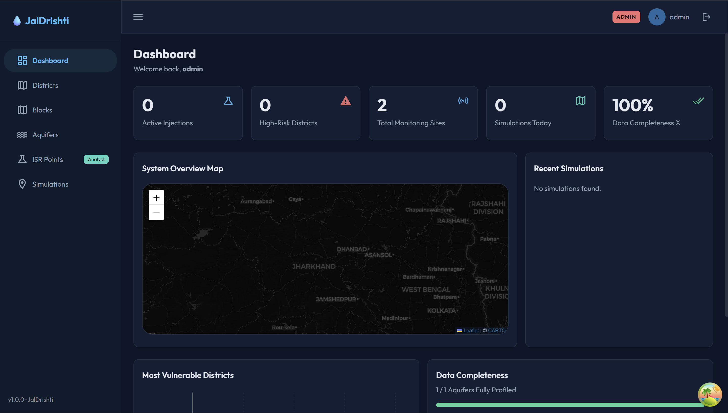
Figure 6.1: The admin dashboard of the early platform (February 2026).
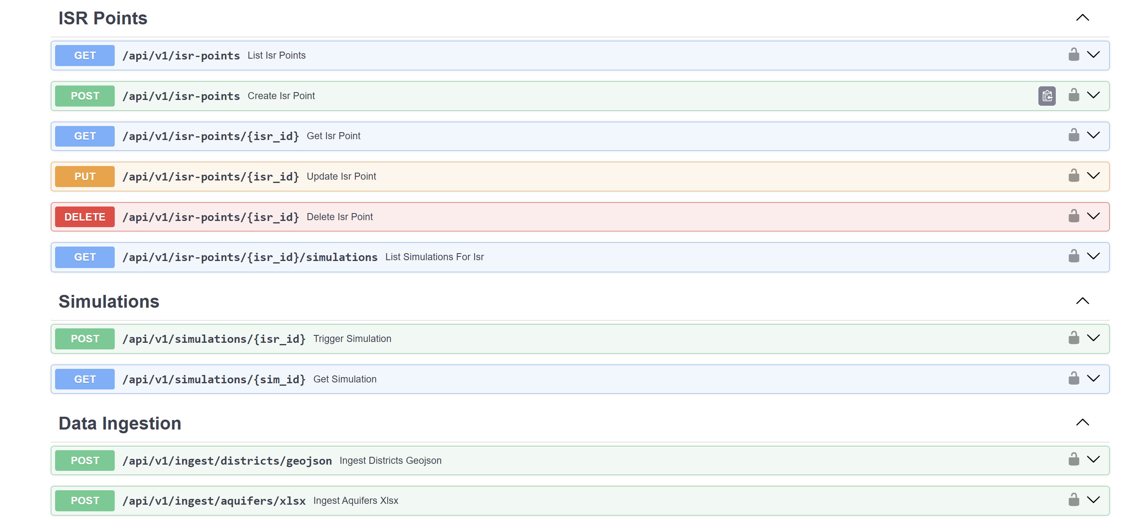
Figure 6.2: Automatically generated API documentation (Swagger UI) for the ISR points, simulation and data ingestion endpoints (February 2026).

6.5 March 2026: First Machine Learning Pipeline
In March the first machine learning pipeline was built. A 16-feature schema was designed, covering aquifer properties, distance to the nearest ISR point, time and a simple vulnerability value, and the features were extracted with a single PostGIS query. The real data had very few unsafe samples, so a synthetic data generator was written using a Gaussian copula (with NumPy and SciPy) to add more unsafe and marginal samples. A TDS regression model (Random Forest and Ridge) and a contamination classifier (Random Forest and Logistic Regression) were trained with 5-fold cross-validation, and SHAP was used to explain them. A prediction service in the backend loaded the trained models and returned a risk score for each simulation.
Activities Performed
- 16-feature schema with PostGIS feature extraction
- Gaussian-copula synthetic data generator
- TDS regressor and contamination classifier with cross-validation
- SHAP explanation of both models
- Prediction service connected to the simulation API
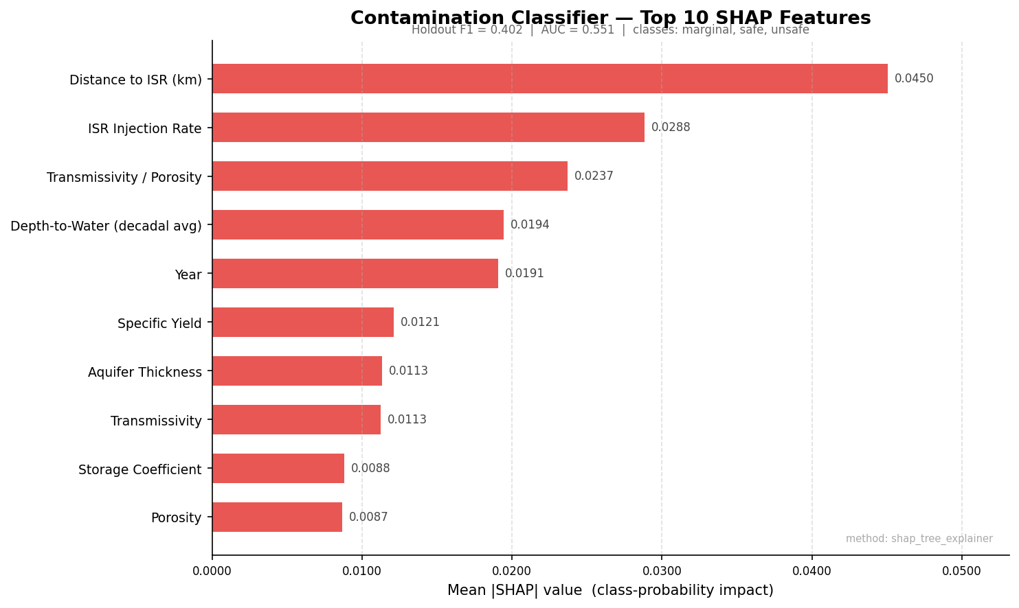
Figure 6.3: SHAP feature importance of the March 2026 contamination classifier. This pipeline was later replaced (Section 6.8).

6.6 April 2026: International ISR Data
Since ISR is not carried out in India, the mentor advised looking for internationally published ISR data. USGS, EPA and CGWB datasets were compared, and the USGS Texas ISR dataset [9] was chosen because it covers three stages of mining: before mining, at the end of mining and after restoration. The Excel file was cleaned, handling values such as “<.001” (below detection limit) and “1044±5”, which gave 186 usable rows. A synthetic dataset of 5,186 rows was generated with contamination falling with distance from the ISR site and seasonal effects. A Random Forest classifier trained on this data reached 91.1% test accuracy and 0.90 macro-F1.
Activities Performed
- Survey of global ISR groundwater datasets
- Selection and cleaning of the USGS Texas ISR dataset (186 usable rows)
- Synthetic dataset of 5,186 rows with physical rules
- Random Forest risk classifier (91.1% accuracy)
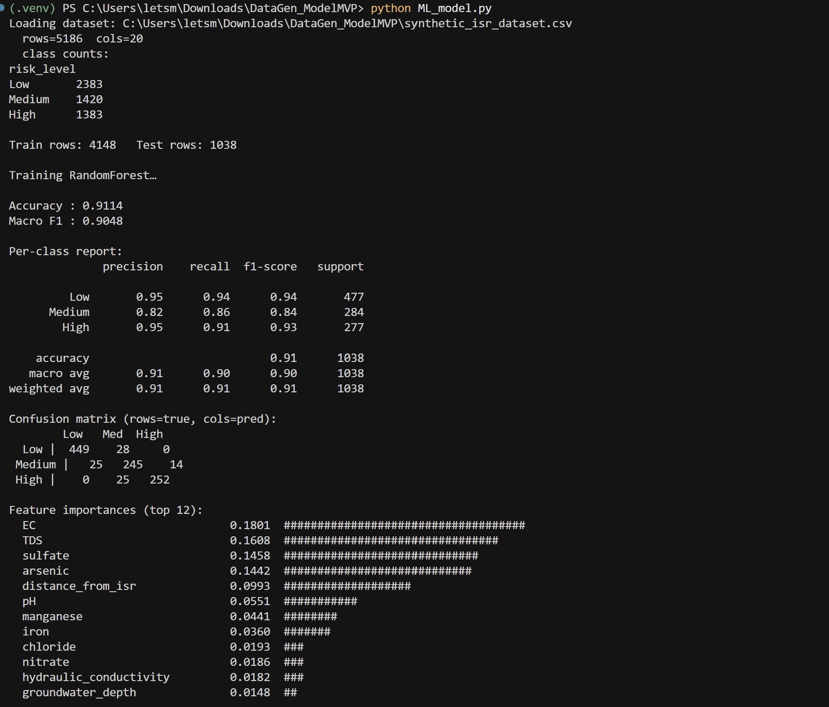
Figure 6.4: Training output of the April 2026 Random Forest risk model.

6.7 May 2026: Uranium as the Prediction Target
In the earlier work, uranium values were being dropped, and the model only predicted a general risk label. In May a single unified pipeline was built with uranium as the real target. It combined 342 real Jharkhand rows, 131 real Texas rows and 3,000 synthetic rows, and trained five models: regressors for uranium, TDS, sulphate and pH, and a safe/marginal/unsafe classifier. Every row was tagged as real, transferred (Texas) or synthetic. The uranium model reported an R² of 0.69 (log scale) on real rows. The backend was also simplified: unused parts such as Celery and Redis were removed, and the database setup was reduced to two commands.
Activities Performed
- Unified ML pipeline with uranium as the target
- Five trained models with real/synthetic tagging of every row
- Simplification of the backend
- Two-command, repeat-safe database setup

6.8 June 2026: Audit and Rebuild with a Physics Engine
June was the turning point of the project. When the May pipeline was checked in detail, it was found that the real data rows had no distance from any mine and no time since injection. These fields had been filled with one median value. Distance made up about 70% of the model’s decisions, so the R² of 0.69 was really measuring how well the model predicted natural background uranium, not contamination spread. The relationship between uranium and distance existed only in the synthetic data. It was decided to replace the pipeline instead of patching it.
A 2-D contaminant transport engine was built on the Domenico solution [45], with scale-dependent dispersion [47], matrix diffusion for fractured rock [49], dual-porosity slowing [44] and containment by the bleed. It modelled the full mine life (operation, restoration and after closure) and uranium re-trapping by reducing rock [52]. Nine hundred scenarios placed on real Jharkhand aquifer polygons were evaluated with this engine to create 13,500 training rows, and ten XGBoost models with monotone constraints and conformal uncertainty bands were trained on them. The engine was then grounded in real Jharkhand data: the groundwater flow field from CGWB levels, fracture directions from GSI lineaments, NAQUIM layers, uranium deposit grades, shear-zone transmissivity and rivers. An interactive dashboard showed the plume on the map. A test sweep of about 1,100 cases at nine locations found and fixed four defects.
Activities Performed
- Audit of the earlier ML approach and decision to rebuild
- Development of the physics-based transport engine
- Generation of 13,500 physics-labelled training rows
- Training of ten XGBoost surrogate models with calibrated bands
- Grounding in real Jharkhand flow, fracture, layer and deposit data
- Interactive dashboard and a 1,100-case quality sweep
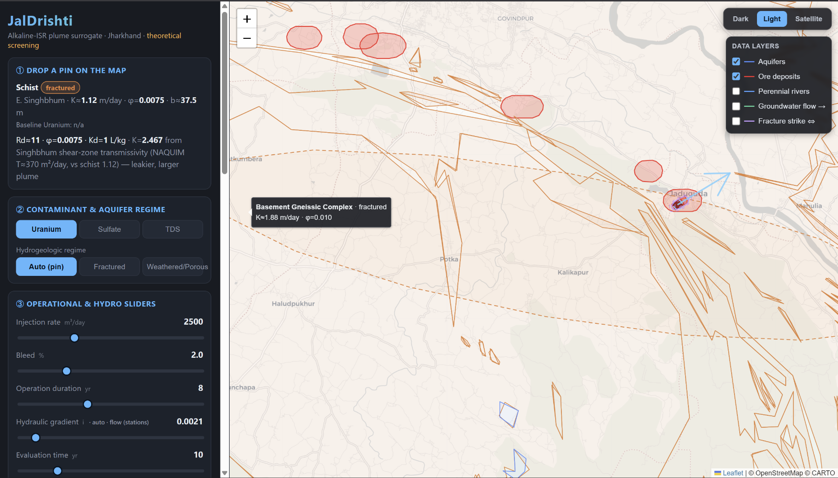
Figure 6.5: The June 2026 engine dashboard: a hypothetical ISR site on the Jharkhand map with its modelled plume, the operating settings on the left and the map layers on the right.

6.9 July 2026: Review Rounds and Backend Rebuild
In July the engine was improved and reviewed. Rock permeability was made to fall with depth, calibrated for each district from the NAQUIM reports. The uranium re-trapping rate was set by ore-zone mineralogy. Values were smoothed across aquifer boundaries. Radium-226 was added as a fourth chemical, which raised the training set to 18,000 rows. The engine went through three review rounds; each finding was either fixed and pinned with a test, or disproved with evidence. An exact-solution check showed that one suspected error was not real, but found a different one: a missing term in the transport formula, which was restored. The surrogate was retrained four times, and the travel-distance R² rose from 0.72 to 0.90. A chloride indicator was added for the excursion test.
The backend was also rebuilt on the real engine. The old placeholder simulation (random flow direction and a fixed area) was deleted. A security hole was found and closed: the signup route accepted a role chosen by the user. The three roles were replaced by five roles (admin, regulator, analyst, field officer and resident), enforced both by the API and by database row-level security, with an audit log. A field-observation workflow was added (submit, review, sync into the data). It was also found that the district and block boundaries had been stored with latitude and longitude swapped since February, and this was fixed. A new React and TypeScript portal replaced the old frontend.
Activities Performed
- Depth-dependent permeability, mineralogy-based attenuation and boundary smoothing
- Radium-226 added (18,000 training rows)
- Three review rounds and an exact-solution check
- Placeholder simulation removed; backend wired to the real engine
- Five roles with row-level security and an audit log
- Field-observation workflow; swapped coordinates fixed
- New role-based React portal

6.10 August 2026: Complete Product and Deployment
In August the portal was completed: the Console (click anywhere in Jharkhand, run the engine and see the plume), one-step publication of a screening, the resident’s “My Area” and alerts pages, a site report with PDF export, site comparison, saved scenarios, the dataset manager, the monitoring-network plan and a public front page with light and dark themes.
All the determinands in the 397-well CGWB record were assessed against IS 10500:2012. Nitrate was found above its limit at 22 wells and fluoride at 32, while uranium was within its limit everywhere it was tested. Nine years of water levels were analysed with the Theil–Sen and Mann–Kendall methods, and the observation-based monitoring ranking was built. Three security controls were found that had been configured but were not working: the rate limiter, the alert write under row-level security, and the exceedance scan. Each was fixed and pinned with a test that measures it. Alerts were connected to email delivery with a delivery log and a daily scheduler, and residents now choose their home block at registration. The system was deployed on Neon, Render and Cloudflare, with a restricted database role so that row-level security works in production. The final presentation was given to the TEXMiN–BIT Sindri review panel.
Activities Performed
- Completion of the 22-screen portal
- IS 10500 assessment of the measured record
- Water-level trend analysis and monitoring-gap ranking
- Fixing of three inactive security controls
- Email alert delivery with a daily scheduler
- Deployment on Neon, Render and Cloudflare Workers
- Final presentation to the review panel

6.11 September 2026: Final Improvements and Report
After the fellowship period, a final round of improvements was made before freezing the project. The dual-porosity ratio β was changed from a fixed literature value of 10 to a value calculated from the porosities at each location, and the surrogate was retrained. Alert tiers (notice, warning, alert and critical) with a seven-field explanation were added. Map timelines, a hydrochemical quality check, a global sensitivity analysis and the CGWB 2000–2021 chemistry record were added. A floor was added so that the restored source can never read cleaner than the natural background, and the model was retrained again (version 5). Email delivery was configured on the deployed system, and a defect where failed emails were never retried was found and fixed. A demo record left in the deposit data from testing was removed, and the references were checked.
The last week of September was spent checking the model inputs for the uranium belt against data from the belt itself. A review of why the plume “barely moves” found that the vertical screening moved a parcel of water, not the dissolved chemical: every chemical reached the shallow aquifer at Jaduguda in the same 17.5 years, and the matrix storage that holds uranium back sideways had no effect upward. The vertical path was rebuilt to carry the solute on the same matrix-storage clock, with a harmonic-mean K for the column and a measured vertical-to-horizontal ratio of 0.12 in place of the chosen 0.03 (Section 4.6). The plume map was changed from flat contour fills to a continuous raster, and a chance-over-limit map was added, fanned by the flow-direction uncertainty, which was measured for the first time.
Three new CGWB records were extracted from PDF files: the 2024 water-quality table, which gave the first measure of natural variability; water levels from 1994 to January 2026, which confirmed the flow direction; and the exploratory boreholes of the belt from the NAQUIM Phase-III report, which was recovered from the Internet Archive after CGWB removed it (Section 4.3). The boreholes, together with the terrain and the model output, were used to build the 3-D site block in the portal.
The boreholes also showed a problem with the shear-zone permeability. The transmissivity used until then, 370 m²/day, had been described as coming from where the mines are, but the three wells behind it (Kalapathar, Baharagora and Manusmuria) are in Tertiary sediments 51 to 58 km east of Jaduguda, outside the belt. The belt’s own host rock near the deposits tests at 2 to 101 m²/day, and UCIL’s mine records rule the old value out, because it would force Turamdih to pump about 17.5 times the water it reports. The value was corrected to the measured maximum, 19 m²/day at Kudada, and every run was given two answers: the measured rock as the baseline and the ISR-feasibility hypothetical beside it (Sections 4.4 and 4.5). In the same pass, uranium and radium backgrounds were taken from BARC surveys near each mine, the upper end of the radium Kd was taken from Turamdih soils, the ore-depth defaults were checked against UCIL documents (Bhatin moved from 150 m to 90 m and Mohuldih from 250 m to 150 m), and the portal’s “No uranium ore here” banner, which had never appeared, was fixed. The surrogate was retrained as version 6, with half the training scenarios on the tight rock of the deposits; its radium ring-concentration R² went from 0.235 to 0.746, for the reason given in Section 7.3.
Activities Performed
- β calculated from local porosities; surrogate retrained
- Alert tiers with seven-field explanations
- Timelines, hydrochemical QA, sensitivity analysis and 2000–2021 chemistry record
- Background floor on the source and retrain (version 5)
- Email delivery configured on the live system; retry defect fixed
- Data clean-up and project freeze
- Vertical pathway rebuilt to carry the dissolved chemical; measured Kv/Kh
- Continuous plume raster, chance-over-limit map and measured direction uncertainty
- CGWB 2024 water quality, water levels 1994–2026 and belt boreholes extracted
- 3-D site block in the portal
- Shear-zone permeability corrected to the measured Kudada value; two answers per run
- Local uranium and radium backgrounds, radium Kd and ore depths from local sources
- Surrogate version 6 and sensitivity analysis re-run

6.12 Final Integrated System
The final outcome of the fellowship is a working, deployed system consisting of:
- A physics-based groundwater contamination engine covering the whole of Jharkhand, which gives a measured-rock answer and a labelled ISR-feasibility hypothetical for every run
- A trained ML surrogate with calibrated 80% uncertainty bands (version 6)
- An IS 10500 assessment of the measured groundwater record
- An alert system with four tiers and email delivery
- An observation-based monitoring-gap ranking of all 264 blocks
- A five-role web portal with 22 screens, protected by row-level security, including plume maps with a chance-over-limit view and a 3-D site block
- 463 engine tests and 533 backend tests
The completed system shows that a groundwater contamination screening tool for hard-rock India can be built from open data, standard physics and machine learning, and deployed at low cost, while being honest about what the data can and cannot support.

7. RESULTS & ACHIEVEMENTS
JalDrishti was successfully developed, tested and deployed during the fellowship. The project met its three main objectives: a physics-based prediction model with a calibrated ML surrogate (O1), a data-gap analysis with monitoring recommendations (O2), and a working decision-support prototype (O3). The results fall into three kinds, and they are kept separate throughout this chapter:
- Measured results: laboratory values and water-level readings compared with published limits. Nothing is modelled.
- Modelled results: outputs of the engine or the surrogate for a hypothetical ISR operation. These are “what if” estimates, never forecasts of real contamination.
- Validation results: checks of the surrogate against the engine, or of the engine against an exact solution.

7.1 Measured Groundwater Quality (IS 10500:2012)
The 2023 CGWB record of 397 wells [14] was checked against IS 10500:2012 [13]. The main findings for the health-related substances are shown below.
Table 7.1: Health-related results in the 2023 CGWB record (397 wells)
Substance | Wells tested | Maximum | Limit | Wells above limit
Uranium | 342 | 28.5 ppb | 30 ppb | 0
Nitrate | 393 | 121 mg/L | 45 mg/L (no relaxation) | 22
Fluoride | 397 | 1.91 mg/L | 1.0 / 1.5 mg/L | 32 above acceptable, 11 above permissible
Chloride | 397 | 430 mg/L | 250 / 1,000 mg/L | 9 above acceptable, 0 above permissible
Sulphate | 393 | 234 mg/L | 200 / 400 mg/L | 2 above acceptable, 0 above permissible
Iron | 0 | – | 1.0 mg/L | never tested
Arsenic | 0 | – | 10 / 50 ppb | never tested

Uranium is within its 30 ppb limit at every one of the 342 wells where it was tested (maximum 28.5 ppb at Sukurhutu, Ranchi). The health problems in Jharkhand’s groundwater today are nitrate and fluoride. Nitrate reaches 121 mg/L at Biru (Simdega), 2.7 times the limit, and 99 mg/L at Lowadih (Ranchi). Fluoride reaches 1.91 mg/L at Baresad (Latehar). In total, 32 wells have a health exceedance, and 14 of 24 districts have at least one such well. Hardness, calcium and magnesium are above their acceptable limits at a third to two-thirds of wells, but this is natural hard-rock chemistry and is reported separately.
The record also shows important gaps. Iron and arsenic were tested at none of the 397 wells, and manganese has no column. In the three Singhbhum districts (the uranium belt), 55 wells were sampled but never tested for uranium: 28 in East Singhbhum, 11 in Saraikela-Kharsawan and 16 in West Singhbhum. A published study near two Singhbhum deposits found iron up to 5.3 mg/L and manganese up to 1.3 mg/L, above the drinking-water limits [77], so these untested metals are a real concern in the belt.
A hydrochemical check showed that all 393 complete analyses in the 2023 file balance within ±3.2%. This is better than any normal laboratory batch, and it is explained by sodium having been calculated from the other ions. So the file’s charge balance cannot be used as proof of laboratory quality. In the older 2000–2021 record, the check is meaningful: 127 of 753 analyses were flagged as suspect.
Key achievements include:
- The full measured record was assessed against IS 10500 for the first time in the system.
- Nitrate and fluoride were identified as the real health issues, with 32 wells and 14 districts affected.
- “Not tested” was made a separate grey class, so that missing data is never shown as safe.
- The public map shows each district by its worst measured health substance.
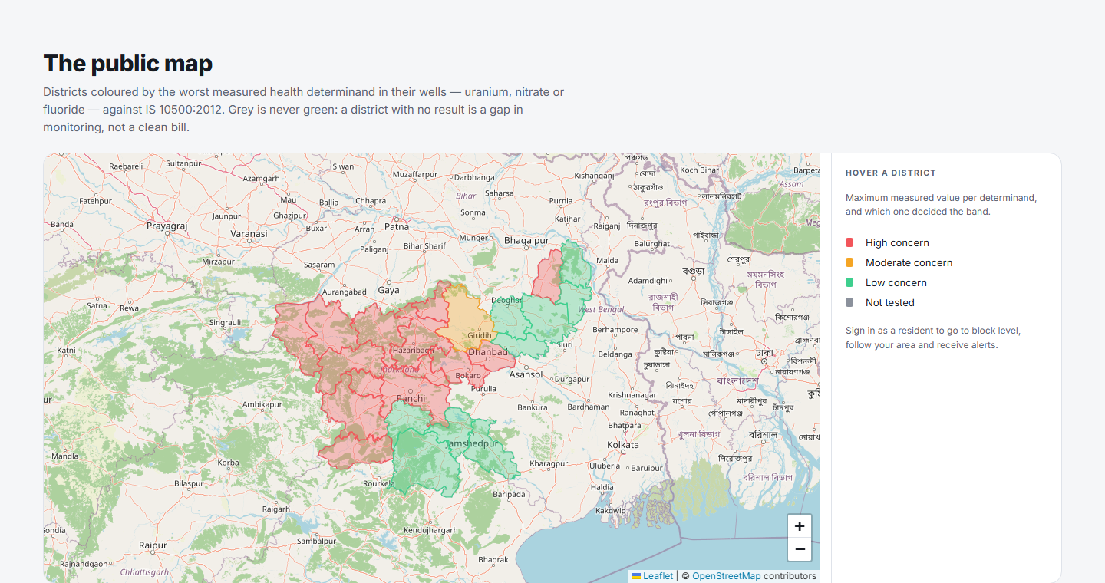
Figure 7.1: The public map: districts coloured by the worst measured health substance (uranium, nitrate or fluoride) against IS 10500:2012; 14 of 24 districts are High concern. Basemap © OpenStreetMap contributors (Open Database Licence).

7.2 Groundwater Level Trends
The water-level records held in the portal (2013 to 2021) were tested with the Theil–Sen slope and the Mann–Kendall test. Of 415 stations in the database, 331 had enough data for a trend test and 84 did not (fewer than 8 readings or less than 3 years).
Table 7.2: Groundwater level trends, 2013–2021
Result | Number of stations
Declining (water table falling) | 5
Recovering (water table rising) | 20
Stable (no significant trend) | 306
Not enough record to test | 84

The fastest decline was 0.785 m per year at Chapodia (Dumka). The median seasonal swing of the water table is 2.38 m. There is no statewide groundwater-level crisis in this record, and stations with short records are reported as such, never as stable. In the 2000–2021 chemistry record, electrical conductivity is rising at 13 wells and falling at 6.
The longer CGWB record, from 1994 to January 2026 [22], was tested in the same way, using only wells with at least 15 years of readings spread over at least 20 years.
Table 7.3: Water-table trends, 1994 – January 2026 (a positive trend means the water table gets deeper each year)
Group | Wells | Median trend (m/yr) | Significant deepening | Significant rising
Statewide, pre-monsoon | 177 | +0.011 | 29 | 20
Statewide, post-monsoon | 173 | +0.008 | 23 | 18
Uranium-belt districts, pre-monsoon | 24 | +0.003 | 5 | 5
Uranium-belt districts, post-monsoon | 23 | −0.025 | 1 | 6

Over 32 years the network shows no net fall of the water table. The steepest decline is one West Singhbhum well at 0.31 m per year. This supports the use of the 2013–2021 water tables in the vertical screening. It is a statement about the monitoring network, not a guarantee for any single well, and it covers only the shallow unconfined aquifer, not the fractured rock below.

7.3 Machine Learning Model Performance
The final surrogate (version 6) was tested with 5-fold cross-validation grouped by scenario, on 18,000 rows from 900 scenarios.
Table 7.4: Surrogate model performance (P50 model, cross-validation)
Target | R² (log scale) | Scenario coverage (target ≥ 0.80) | Ridge baseline R² (log) | Average error (MAE)
Footprint area | 0.892 | 0.869 | 0.561 | 6.18 ha
Travel distance | 0.930 | 0.865 | 0.721 | 48.0 m
Ring concentration | 0.968 | 0.857 | 0.761 | mixed units
Excursion probability | 0.913 (R²) | – | – | 0.033

The surrogate is better than all the baseline models on every target. When whole aquifer polygons were held out (leave-aquifer-out), the R² values were 0.891, 0.925 and 0.966, almost the same, which shows that the model works on geology it has not seen. On a separate test batch of 120 scenarios placed on real Jharkhand flow and fracture values, the 80% bands covered 0.900, 0.921 and 0.902 of scenarios for the three targets, so all three passed.
Table 7.5: R² (log scale) of the P50 model for each chemical (target ≥ 0.60)
Target | Uranium | Sulphate | TDS | Radium-226
Footprint area | 0.957 | 0.797 | 0.814 | 0.890
Travel distance | 0.945 | 0.907 | 0.898 | 0.412 (below target)
Ring concentration | 0.909 | 0.909 | 0.972 | 0.746

For radium, the travel distance is below the project’s own target of 0.60. This is because radium hardly moves: most of its travel-distance values are exactly zero, and a regression model cannot learn such data well. The result is reported openly instead of lowering the target. The radium ring concentration passes (0.746), but this should be read with care. In almost all cases the radium value at the ring equals the scenario’s own background, and the background is a feature that varies between scenarios (10 to 23 mBq/L), so the model learns “ring equals background” from that feature. This helps the tool serve the right number, but it says nothing new about how radium moves. The radium uncertainty bands still cover at least 90% of cases in cross-validation and at least 95% in the real-location test, and the physics engine always gives the main radium value, so users are not misled.
SHAP analysis showed that the model relies on the right physical quantities. The plume front position calculated by the engine is the strongest feature for travel distance and excursion probability. The source concentration, the dispersivity and the wellfield width are the strongest for the footprint area, because most of the footprint is the leach zone itself. No map coordinate can appear, because none is a feature.
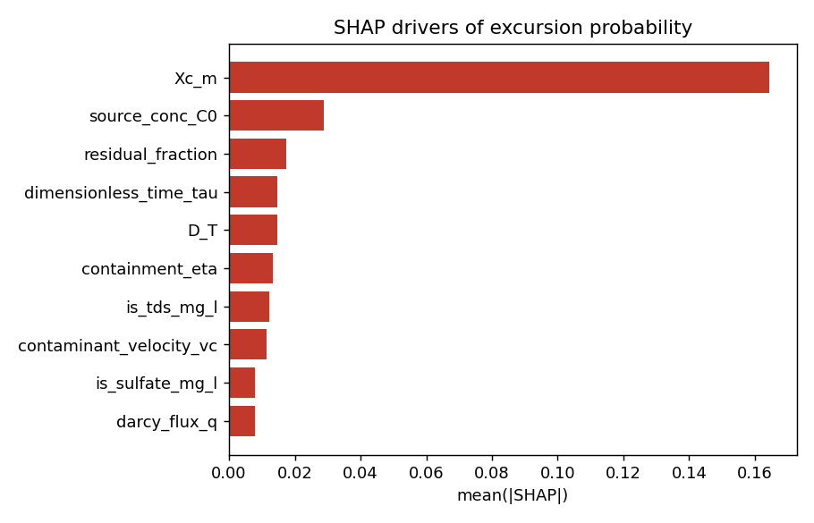
Figure 7.2: SHAP feature importance for the excursion-probability model (version 6): the plume front position calculated by the engine (Xc_m) dominates.
Key achievements include:
- Surrogate R² (log) of 0.89 to 0.97, better than all baselines.
- 80% coverage achieved on real-location test scenarios for all three targets (0.90 to 0.92).
- Training data that covers the tight rock of the deposits, down to K = 0.0021 m/day.
- Physical rules built into the model and checked against the engine.
- The radium travel-distance weakness reported openly, with the engine used as the authority.

7.4 Validation of the Transport Engine
In the second review round, a reviewer suggested that the Domenico approximation could cause errors of up to 80% [78]. To test this, the engine was compared with an exact numerical solution on 240 parameter sets drawn from the training data. The result disproved the concern but found a different problem.
Table 7.6: Error of the engine along the plume centreline compared with the exact solution
Position along the plume | Domenico approximation only | Version then in use (missing term)
Half-way to the front | 0.00% | −16.9% (typical)
At the front | 0.00% | −22.4% (typical)
Beyond the front | −0.10% to 0.00% | −24.3% (typical)

The Domenico approximation itself caused no error in this project’s range of parameters. However, the version then in use had dropped the second term of the Ogata–Banks formula [46], which made every concentration 17% to 42% too low. This was the opposite of the safe (conservative) side the tool aims for. The full term was restored and the surrogate was retrained on the exact formula. The end-to-end audit of the final version passes 43 of 44 checks; the only failure is the radium target described above.
Checking the shear-zone permeability against the mines
The permeability used at the deposits (Section 4.4) was also checked against the water that UCIL pumps out of its mines. A mine that is kept dry by pumping behaves like a pumping test over several square kilometres. The Thiem equation was applied to the reported discharges [34], [37], over every plausible radius of influence and drawdown. All the results are upper bounds, because the pumped water also includes water from backfill, drilling and rain.
Table 7.7: Bulk transmissivity allowed by the mine discharge
Check | Turamdih | Narwapahar
Reported discharge | at least 3,170 m³/day, worked to 260 m | 2,700 m³/day, developed to 380 m
Largest bulk T the discharge allows | 9.1 m²/day | 5.3 m²/day
The engine’s K column, integrated over the drained depth | 24.6 m²/day (2.7 times the bound) | 26.0 m²/day (4.9 times the bound)

At Turamdih, in the most generous geometry, the measured baseline of 19 m²/day would force about 0.9 times the reported discharge, while the AMD Jamshedpur value of 101 m²/day would force about 4.8 times. The engine therefore sits on the cautious side of the mine data: it lets water, and so contamination, move somewhat faster than the mines suggest.

7.5 Case Study: Hypothetical ISR Site at Jaduguda
The engine was run for a hypothetical ISR operation inside the Jaduguda deposit (86.347 E, 22.652 N), with the ore at 180 m (the seed depth), 8 years of operation, an injection rate of 2,500 m³/day, 2% bleed, a 300 m wide wellfield, no restoration and a monitoring ring 100 m from the wellfield. The location resolves to fractured schist in the shear zone, with a gradient of 0.00205, K of 0.034 m/day at ore depth and β of 3.0. The effective retardation is about 271 for uranium, 17.3 for sulphate, 4.0 for TDS and 3,525 for radium.
Table 7.8: Modelled results at the Jaduguda deposit after 20 years: measured-rock answer with ML band, and the ISR-feasibility hypothetical
Chemical | Source | Natural level | Area (ha) | Reach (m) | Chance at ring | ML reach, P10–P90 (m) | ISR-grade reach (m), chance at ring
Uranium | 15,180 ppb | 1.08 ppb | 9.37 | 3.9 | 0.00 | 0.1 – 13.4 | 38.4, 0.06
Sulphate | 1,624.5 mg/L | 227 mg/L | 9.47 | 10.6 | 0.00 | 0.2 – 36.5 | 156.0, 0.56
TDS | 3,655.5 mg/L | 1,778.6 mg/L | 10.09 | 30.4 | 0.00 | 1.7 – 198.7 | 534.6, 1.00
Radium-226 | 1,706 mBq/L | 22.1 mBq/L | 9.37 | 0.0 | 0.00 | 0.0 – 0.3 | 1.1, 0.00

The chance at the ring is the excursion probability. In the measured rock the plume barely leaves the wellfield in 20 years. TDS reaches about 30 m beyond the wellfield edge, sulphate 11 m and uranium 4 m, and most of the 9 to 10 ha footprint is the leach zone itself. No indicator reaches its control limit at the 100 m ring, so no excursion is declared. The order of spread (uranium far behind sulphate, which is behind TDS) comes from how strongly each chemical is held back by the rock. This is the same reason the US rules do not use uranium as an excursion indicator [12], and the engine reproduces it without being told. At a location with no uranium ore (Ranchi), no uranium plume is drawn, while sulphate and TDS still spread, because the lixiviant carries them wherever it is injected.
The sulphate and TDS runs report that their background lies outside the range the surrogate was trained on, so their ML bands are shown with a warning. Jaduguda’s TDS background (1,779 mg/L) comes from a single CGWB well about 8 km away.
If the ore at Jaduguda were permeable enough for ISR (ore-zone K of 1 m/day), the same operation would send TDS about 535 m, over the limit at the ring in every draw, sulphate about 156 m (probability 0.56) and uranium about 38 m (0.06). This is the hypothetical answer, not a prediction.
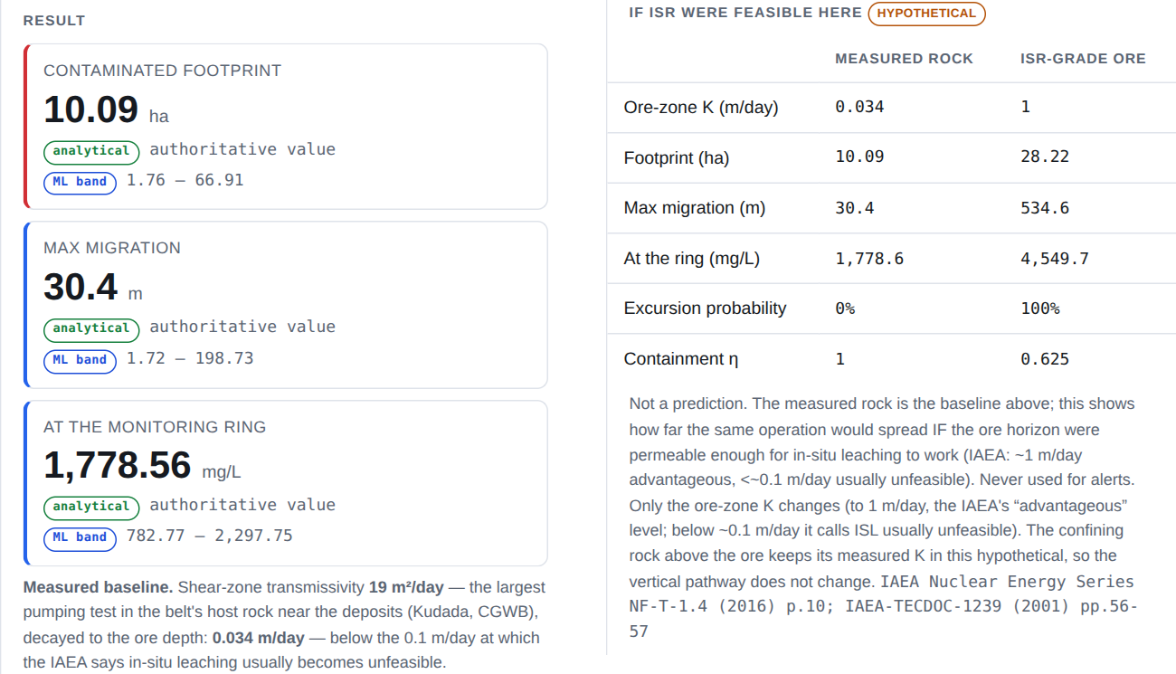
Figure 7.3: The console result for TDS at the Jaduguda deposit, 20 years (local build, September 2026): the engine values with their ML bands and the measured-baseline note (left), and the ISR-feasibility comparison, labelled hypothetical (right).
The two answers describe different rock, and their ranges do not overlap. The table below uses the same 48 Monte Carlo draws for both; Turamdih is run at the centre of the deposit at its seed depth of 140 m. The P50 of the draws is not exactly the engine’s single central value used in the other tables (for example 381 m against 389 m for Turamdih TDS in ISR-grade rock), because the draws also vary the other inputs.
Table 7.9: Travel distance at 20 years (P10 – P50 – P90) in the measured rock and in ISR-grade rock
Site and chemical | Measured rock | Chance at ring | ISR-grade rock | Chance at ring
Jaduguda, TDS | 18 – 31 – 59 m | 0 | 215 – 555 – 1,395 m | 1.0
Turamdih, TDS | 10 – 20 – 47 m | 0 | 144 – 381 – 1,094 m | 0.92
Jaduguda, uranium | 2 – 3 – 7 m | 0 | 15 – 35 – 71 m | 0.06

The other deposits behave in the same way. With the default operation at the centre of each deposit and its seed depth, the measured-rock excursion probability is 0 at every deposit.
Table 7.10: Reach at two other deposits after 20 years
Site | Chemical | Measured-rock reach | ISR-grade reach (excursion probability)
Turamdih | TDS | 20 m | 389 m (0.92)
Turamdih | Sulphate | 11 m | 128 m (0.44)
Turamdih | Uranium | 5 m | 36 m (0.06)
Bagjata | TDS | 8 m | 98 m (0.50)
Bagjata | Uranium | 2 m | 14 m (0)

Shallow aquifer screening. At the Jaduguda deposit, the top of the ore is at 170 m and the base of the shallow layer at 20 m, a separation of 150 m. Water itself would climb this distance in about 38 years on the yearly-average basis, but the dissolved chemicals are slower. The first constituent to arrive is TDS, after about 140 years (index 0.148, low); sulphate would take about 600 years and uranium about 9,400 years. The old-well route dominates the combined index, which is 0.052 (low). These arrival times are the same in both answers, because the hypothetical changes only the ore zone. TDS arrives first after about 48 years at Turamdih and about 109 years at Bagjata. This is a screening of whether a pathway exists, not a prediction of concentration in drinking water.
The registered site. For the hypothetical site registered on the deployed system (86.36 E, 22.65 N, 0.35 km outside the Jaduguda deposit outline, injection 1,500 m³/day, ore at 150 m), the engine was run over 50 years with no restoration. Because the site lies just outside the outline, it is classed as belt and its uranium source is reduced.
Table 7.11: Lifecycle of the registered Jaduguda site (no restoration; engine values)
Year | Phase | Footprint (ha) | Uranium reach (m) | Excursion declared
4 | operation | 7.83 | 0.3 | no
8 | closure | 8.59 | 0.4 | no
12 | after closure | 8.70 | 3.2 | no
20 | after closure | 8.70 | 5.4 | no
30 | after closure | 8.81 | 6.8 | no
50 | after closure | 8.81 | 8.6 | no (only chloride over its control limit)

Uranium never reaches the 100 m ring in 50 years. In this tight rock the salts do not trip the 2-of-3 rule either: by year 50 only chloride is over its control limit. The vertical index stays low (0.053 to 0.059), and TDS is the first to reach the shallow aquifer, after about 58.5 years. With a 6-year restoration sweep, the 20-year uranium reach is 0 m.
Early warning by the indicators. The early-warning role of the indicators is clearer at a belt site 2 km from Narwapahar (86.29 E, 22.69 N; same operation), where the shear-zone value fades towards the schist aquifer value and K at ore depth is 0.196 m/day. There, chloride crosses its control limit at the ring in year 17 and TDS in year 19, so an excursion is declared in year 19. At that time uranium is still at its background of 0.90 µg/L at the ring and has moved only about 11 m. The chemical indicators give the warning long before uranium, exactly as intended. At this more permeable site the salts would also reach the shallow aquifer much sooner: TDS first, after about 16 years, with a high screening index (0.65).

7.6 Monitoring Gap Results
The gap analysis of all 264 blocks found:
- 53 blocks with no monitoring well
- 83 blocks with no water-level station
- 55 wells never tested for uranium
- 397 of 397 wells with only a single sample (2023)
Table 7.12: Top 10 blocks by monitoring priority (out of 264)
Rank | Block | District | Score | Wells | Distance to nearest uranium-tested well (km)
1 | Ghatshila | East Singhbhum | 65.2 | 1 | 77.7
2 | Manoharpur | West Singhbhum | 65.0 | 0 | 46.1
3 | Tonto | West Singhbhum | 65.0 | 0 | 68.2
4 | Goilkera | West Singhbhum | 65.0 | 0 | 45.5
5 | Manjhari | West Singhbhum | 65.0 | 0 | 74.4
6 | Dumaria | East Singhbhum | 65.0 | 0 | 86.0
7 | Anandpur | West Singhbhum | 65.0 | 0 | 28.8
8 | Kumardungi | West Singhbhum | 65.0 | 0 | 90.2
9 | Majhgaon | West Singhbhum | 65.0 | 0 | 103.4
10 | Boram | East Singhbhum | 65.0 | 0 | 46.5

The most important finding is the location of these blocks: all top 25 blocks lie in East Singhbhum, West Singhbhum, Saraikela-Kharsawan or neighbouring Khunti, which is the uranium belt itself. Sixteen of the 25 have no well at all, and the other nine have wells that were sampled but never tested for uranium. The cheapest improvement is to test those existing samples for uranium.

7.7 Sensitivity Analysis Results
The Sobol sensitivity analysis showed which of the thirteen inputs control the results at the three reference sites (20 years, 8 years of operation and 3 years of restoration). The leading inputs by total-order index are:
Table 7.13: Leading inputs by total-order Sobol index
Site and chemical | Output | Leading inputs (total-order index)
Jaduguda, uranium | travel distance | matrix transfer rate ω 0.48, β 0.22, Kd 0.14
Jaduguda, sulphate | travel distance | β 0.35, Kd 0.24, K 0.17
Belt point, uranium | travel distance | β 0.39, ω 0.24, K 0.15
Belt point, sulphate | ring concentration | K 0.68, β 0.60, Kd 0.44

The footprint area depends mostly on the two leach-zone growth constants, which are project assumptions. At Ranchi, where there is no ore, the uranium outputs do not change at all, because the uranium source is suppressed there. The fracture opening and the matrix diffusion coefficient have almost no effect at 20 years.
This is an important result for future work. With K set by the tight rock measured in the belt, the travel distance is carried less by K itself and more by the fracture–matrix exchange terms: the matrix transfer rate ω and the storage ratio β. Neither has been measured anywhere in the Singhbhum shear zone; ω is a literature value and β comes from typical porosities. A tracer test in the belt would reduce this uncertainty more than any other measurement.
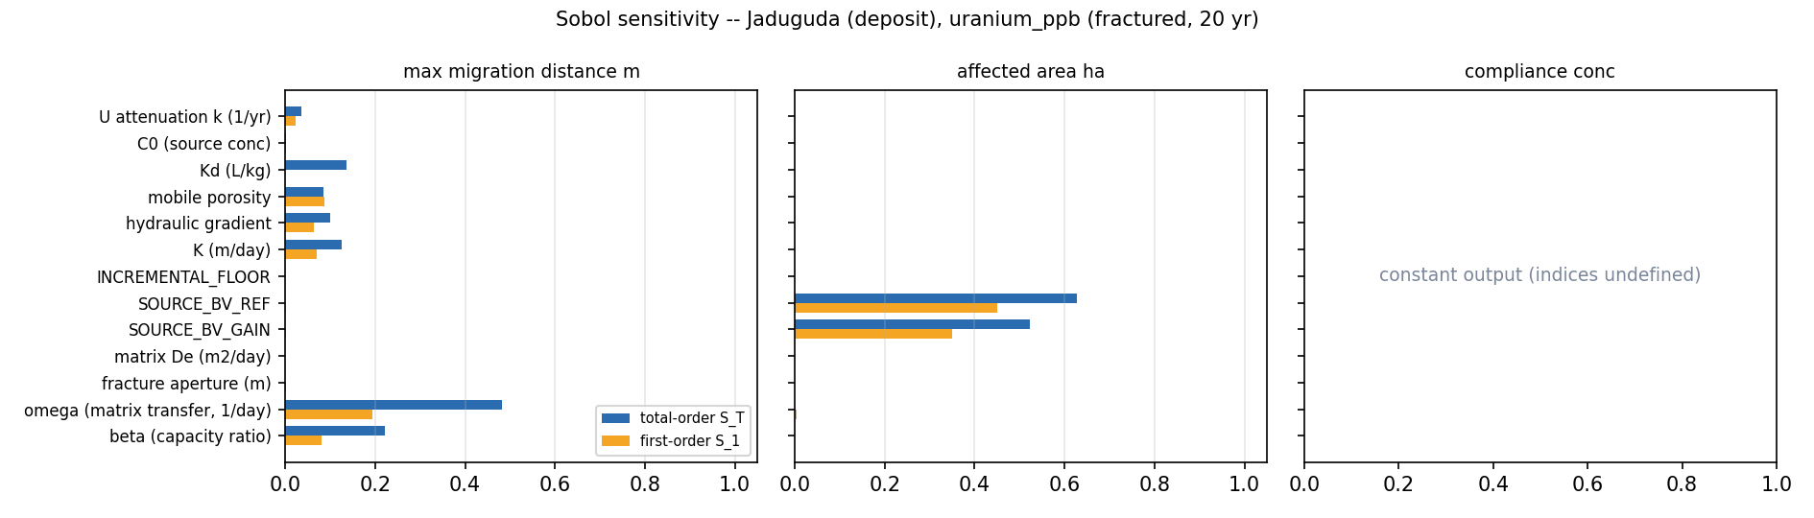
Figure 7.4: Sobol total-order and first-order sensitivity indices for uranium at the Jaduguda deposit location, for travel distance, footprint area and ring concentration (the ring concentration stays at background, so its indices are undefined).

7.8 Alert System Results
On the local database, the measured-exceedance scan raised 53 alerts from the 2023 record:
- 3 critical: Biru (Simdega, nitrate 121 mg/L, 2.7 times the limit), Lowadih (Ranchi, nitrate 99 mg/L) and Gidhaur (Chatra, above both the nitrate and fluoride limits)
- 29 alert: other wells above a permissible or “no relaxation” limit
- 21 warning: fluoride between 1.0 and 1.5 mg/L
Before these fixes, the same scan had matched zero rows every time, because it only checked uranium above 30 ppb, which never happens in this record. On the deployed system (21 September 2026), 55 alerts had been raised, 4 residents were following 7 blocks, and email delivery through the Brevo relay was working.

7.9 Software and Deployment Results
Table 7.14: Final software figures
Item | Value
Engine automated tests | 463 (all passing)
Backend automated tests (real PostGIS database) | 533 (all passing)
End-to-end audit | 43 of 44 checks pass (the radium travel-distance target fails)
API endpoints | 143, across 23 routers
Portal screens | 22
Database migrations | 26
User roles | 5 (admin, regulator, analyst, field officer, resident)
Code commits | 191
One engine run with 48 Monte Carlo draws, both answers | about 0.3 s locally
One engine run on the free cloud tier | about 4 s (timed before the September 2026 redeployment)
Surrogate training time | about 200 seconds
Full data bake (900 scenarios) | about 1.5 to 2 hours

The online deployment runs the build described in this report, including surrogate version 6 and migration 0026 (Section 5.6).
Key achievements include:
- A working, deployed system available online.
- All 143 endpoints covered by a generated role-access matrix and tests.
- Database row-level security verified on the live connection.
- A complete alert loop, from measured data to email delivery.
- A monitoring recommendation that points to the uranium belt as the weakest-monitored region.
- Model inputs in the uranium belt taken from the belt’s own measurements and checked against the mines.

8. PROTOTYPE / SOFTWARE DETAILS
The developed prototype, JalDrishti, is a web-based groundwater contamination screening and monitoring system for Jharkhand. It combines a physics-based contamination engine, a trained ML surrogate, a spatial database, an alert system and a role-based web portal. The prototype was built so that officials can study “what if” ISR scenarios anywhere in the state, see what the measured groundwater record says, find where monitoring is weakest, and inform residents, all from one place.

8.1 Prototype Overview
The prototype consists of the following major subsystems:
- Physics-based contamination engine (plume, restoration, excursion test, shallow-aquifer screening), with a measured-rock answer and an ISR-feasibility hypothetical
- ML surrogate with calibrated uncertainty bands
- Spatial database (PostgreSQL + PostGIS) with row-level security
- Backend API (FastAPI) with 143 endpoints
- Water-quality assessment, monitoring-gap and trend modules
- Alert module with tiers, explanations and email delivery
- Web portal with 22 screens for five user roles, including a 3-D site block

8.2 Overall System Architecture
The main path of a request through the system is:
User selects a location or site in the portal
↓
API checks login and role
↓
Location details resolved (rock type, K, gradient, fractures, layers, ore zone, background)
↓
Physics engine runs (plume map, metrics, excursion test, vertical screening)
↓
ML surrogate adds P10–P90 bands and checks for extrapolation
↓
Result saved and shown on the map
↓
Screening published
↓
Alerts raised for affected blocks and emailed to residents

The physics engine is loaded inside the backend process, not as a separate service. This keeps the system simple and fast. A single adapter file is the only point where the backend calls the engine, and it only passes allowed inputs, so that measured chemistry is never fed into a model that was not calibrated for it. Every saved run records the exact model version that produced it.

8.3 User Roles and Access
Table 8.1: User roles in JalDrishti
Role | What the role can do
Admin (one account only) | Everything: publishes screenings, manages accounts, datasets, data sync, model operations, alert scans and email delivery, and reads the audit log. The single admin account is created by a setup script, never from the portal.
Regulator | Reviews and decides field-officer submissions; can run the model and view reports and data screens; cannot publish or change datasets.
Analyst | Runs the console, saves runs, compares sites, proposes screenings for publication, and uses the water-quality, groundwater, data-gap and network-plan screens.
Field Officer (Data Submitter) | Submits field observations (water sample, water level or ore occurrence) and can withdraw them; reads other screens.
Resident (Citizen) | Sees the front page, “My Area”, a citizen map, their alerts, published screenings and the methods page. Never sees exact site coordinates or model internals.

Residents are not shown exact coordinates of hypothetical sites. A precise point next to a named village could easily be misread as a real mining plan. Residents see the affected blocks, the modelled spread and whether the shallow aquifer might be reached.

8.4 Portal Screens
The portal has a public front page and a role-based application behind the login. Its 22 screens are:
Table 8.2: Portal screens
Group | Screens
Public | Front page, public map, public view of published screenings
Account | Login, overview (home), methods
Modelling | Console, site report, compare sites, saved scenarios
Publishing | Publications (propose, decide, withdraw)
Data | Water quality, groundwater trends, data & gaps, network plan, field data
Residents | My Area, citizen map, alerts
Administration | Datasets, ingest, audit log, administration panel


Figure 8.1: The deployed front page. The four figures on the right (districts assessed, wells checked, districts with a health exceedance and published screenings) are read live from the database.

8.5 Console and Site Report
Console
The console is the main working screen for analysts. The user clicks anywhere in Jharkhand, or chooses a registered hypothetical site. The system shows the local rock type, K, flow direction and ore zone, and the user sets the operating values: injection rate, bleed, wellfield width, years of operation, years of restoration and time since start. The engine then draws the plume on the map, shows the footprint, travel distance, ring concentration and excursion probability with their ML bands, and shows the 2-of-3 excursion panel and the shallow-aquifer screening. Below the result, a note states the measured permeability used and whether it is below the IAEA floor for in-situ leaching, and a table compares the measured-rock answer with the ISR-feasibility hypothetical, which is always labelled as hypothetical (Figure 7.3). The plume layer can be shown as a continuous concentration field, as the chance of exceeding the limit, or as contours. A timeline slider replays the plume over the years.
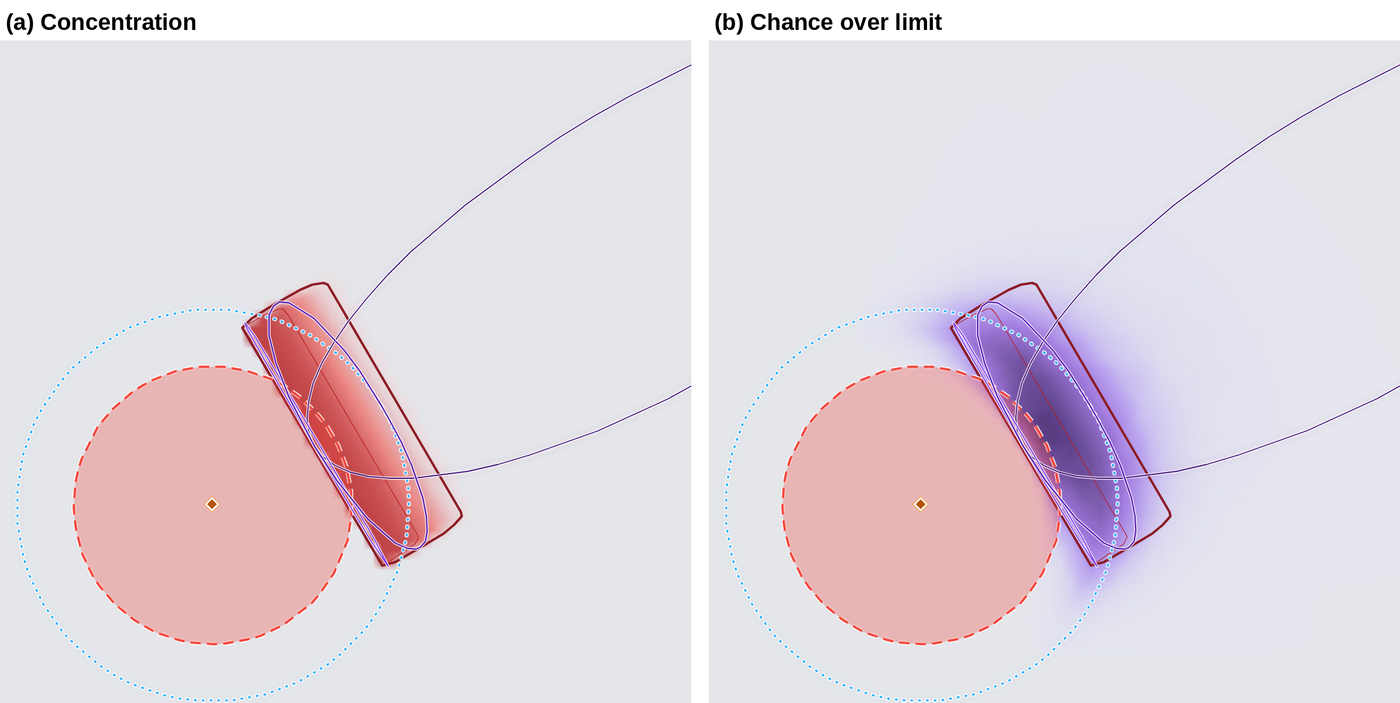
Figure 8.2: The plume at the belt site near Narwapahar (TDS, 20 years; local build, September 2026, drawn without the background map tiles): (a) the concentration field and (b) the chance over the limit, fanned by the measured flow-direction uncertainty. The pink disc is the leach zone, the dotted circle is the monitoring ring and the thin outline is the ML P90 envelope.
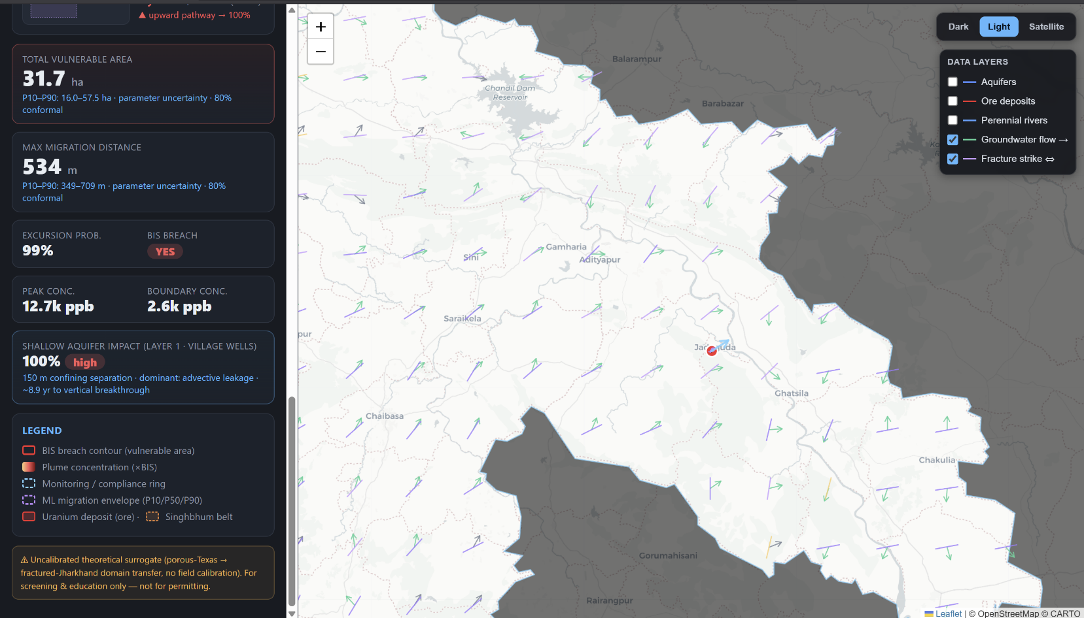
Figure 8.3: The engine view with a modelled plume on the map (June 2026 build). The coloured contours show concentration levels around the hypothetical wellfield; the left panel holds the operating settings.
3-D site block
From a run’s result, the user can open a 3-D view of the site, built with three.js [75] and loaded only when it is opened. It shows a block of ground 3 or 6 km wide: the terrain from the GLO-30 elevation model, the weathered and fractured layers at the district’s NAQUIM depths, the water table, the nearest CGWB exploratory boreholes, the run’s plume laid on the ore horizon, and one ring for each constituent climbing from the ore towards the drinking-water layer. The rings use the same clock as the printed arrival times, so the animation cannot disagree with them. A corner is cut away so that the ore horizon can be seen, and the vertical exaggeration (×3 by default) is always printed. Most blocks contain no borehole; near Jaduguda the nearest ones are 8 to 9 km away, so the view lists them with their distance and direction instead of drawing them at the site. The block is a picture of the model’s 2-D and 1-D answers, not a 3-D transport model.
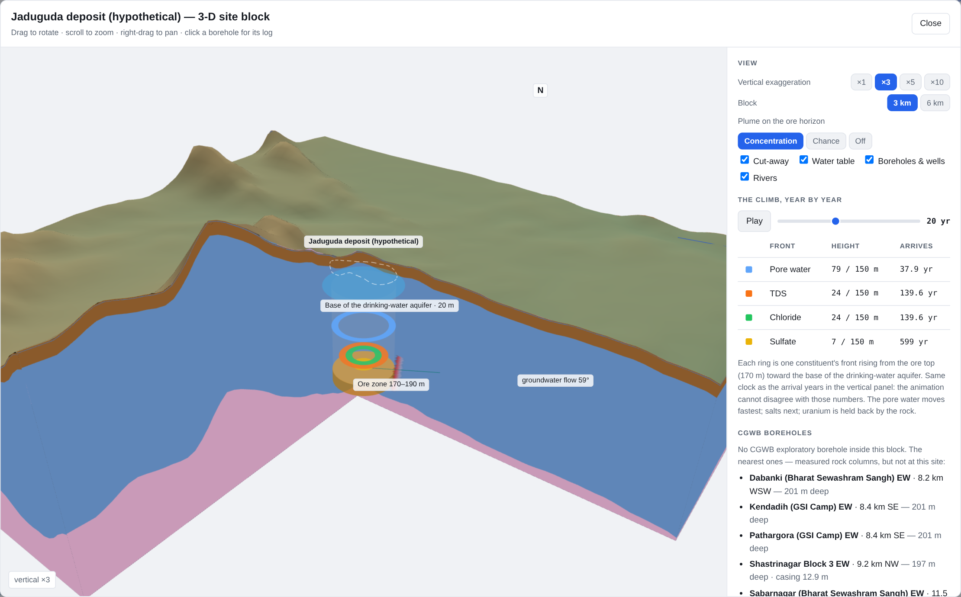
Figure 8.4: The 3-D site block for the Jaduguda deposit site (local build, September 2026): terrain, aquifer layers, the ore zone at 170–190 m and the vertical fronts at 20 years, with the arrival table and the nearest CGWB boreholes on the right.
ISR site report
For every published screening, a site report can be downloaded as a PDF. It states clearly at the top that no ISR mine operates in Jharkhand and that the document describes a modelled scenario. It gives a plain-language summary (for example: “uranium contamination would cover 9.4 hectares, with the furthest edge about 4 m from the wellfield”), the shallow-aquifer result, and a note that the physics engine is the authority and the ML model only adds uncertainty bands. For a uranium screening, the shallow-aquifer result also names what the injected solution carries that would arrive first, because the salts reach the shallow aquifer centuries before uranium.
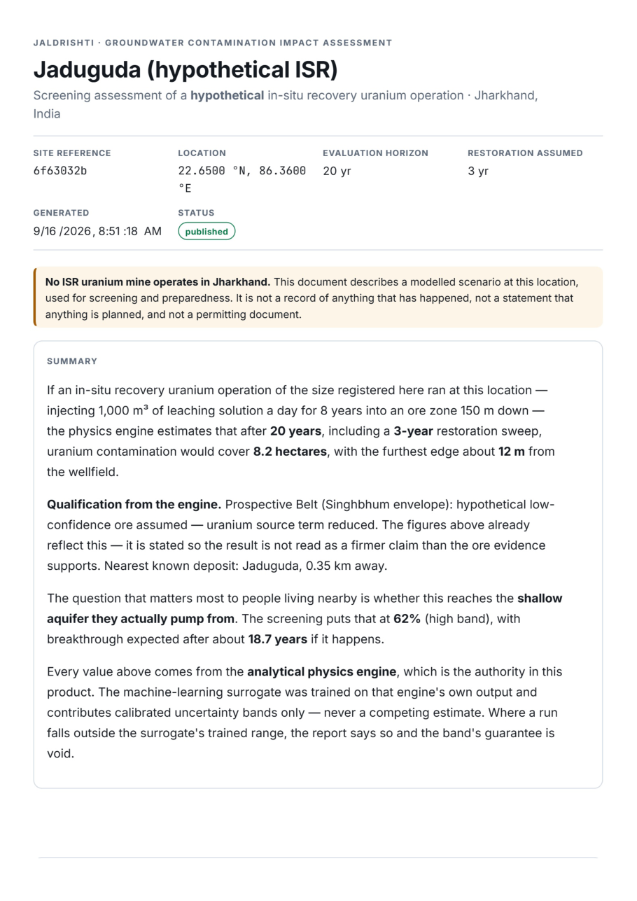
Figure 8.5: The ISR site report for the published Jaduguda screening, as a resident or officer downloads it (August 2026).

8.6 Backend and API Design
The backend is a FastAPI application with 23 routers and 143 endpoints under /api/v1. The main groups are:
Table 8.3: Main API groups
Router group | Purpose
auth, users | Login, session refresh, account management
districts, monitoring wells, water samples | Reference data
isr_points | Register, edit and delete hypothetical sites
ml | Location details, prediction, assumption register, drift check, map layers
preview, simulations, lifecycle, scenarios | Quick previews, saved runs, restoration sweeps, lifecycles, comparison, timelines
advisories | Propose, decide and withdraw screenings
citizen, public_risk | My Area, alerts, block search and the public pages
water_quality, groundwater, data_gaps | IS 10500 assessment, QA, trends, gap ranking, suggested sites
field_observations | Submit, withdraw, review queue and decisions
datasets, dataset_sync, ingest, model_ops, audit | Dataset manager with restore points, data sync, file ingest, model operations, audit log

There is no separate task queue. Simulations run as background tasks inside the FastAPI process, and the one scheduled job (the daily alert scan and email delivery) runs inside the application. A table of which role can call which endpoint is generated automatically from the running application, and a test fails if it changes without being updated.

8.7 Database Design
The database is PostgreSQL 16 with PostGIS. Its main tables are users and organisations; districts, blocks and aquifers; monitoring wells, water samples and monitoring stations; data sources and dataset versions; ISR points (hypothetical sites); scenarios and simulation runs (with plume geometry and timeline frames); advisories (published screenings); alerts, alert deliveries and block subscriptions; field observations; and the audit log. The schema was built through 26 Alembic migrations.
Every table that holds sensitive data is protected by row-level security (RLS). For example, residents can never read the coordinates of a hypothetical site, residents can only read published screenings (not drafts), and the audit log has no update or delete permission for any role, so it can only grow. The API connects with a restricted database role that cannot bypass these rules; only database migrations use the owner account.

8.8 Security Features
- Login: JWT tokens with a sliding session; passwords hashed with argon2.
- Role check on every request: the role is read from the database each time, not trusted from the token.
- Three layers of access control: API checks, database row-level security, and a restricted database role.
- Single admin: exactly one admin account is allowed by a database rule.
- Rate limiting: repeated logins are blocked (tested: 10 logins accepted, then refused).
- Audit log: every important action is recorded and cannot be edited or deleted.
- Safe production settings: the server refuses to start in production with a placeholder secret, an empty database address, an open CORS setting, or row-level security switched off.
- Build guard: the portal build fails if any password or secret is found in the code bundle.

8.9 Alert and Notification Module
When a screening is published, or when the daily scan finds a measured exceedance, the alert module creates alerts for the affected blocks (Section 4.9). Each alert has a tier (notice, warning, alert or critical) and seven fields explaining what happened, why, where, how sure the system is and what to do next. Residents who follow a block see the alert in their portal inbox and also receive it by email. Each email is recorded as sent, failed or skipped. The same email is never sent twice, and failed ones are retried. If no email server is configured, the system does not fail; it shows the number of unsent alerts on the administration screen.

8.10 Deployment Details
The prototype is deployed on three cloud services:
Table 8.4: Deployment setup
Part | Where it runs
Portal (static build) | Cloudflare Workers, which also forwards /api calls to the backend, so the site works from one address
Backend API, physics engine, ML models, scheduler | Render web service (free tier; the service sleeps when idle and takes about 53 seconds to wake)
Database | Neon PostgreSQL 16 + PostGIS, with separate owner and application roles
Email | Brevo SMTP relay (port 2525)

Secret values such as database passwords, the JWT secret and the SMTP key are kept in the hosting settings, never in the code. The online services run the build described in this report (Section 5.6).

8.11 Prototype Features
The final prototype provides the following capabilities:
- Contamination screening at any location in Jharkhand
- Four chemicals: uranium, sulphate, TDS and radium-226, plus chloride as an excursion indicator
- Plume maps with P10–P90 uncertainty bands, a chance-over-limit view and timelines
- Two answers for every run: the measured rock and a labelled ISR-feasibility hypothetical
- A 3-D site block showing the ground, the layers, boreholes, the plume and the vertical fronts
- Restoration and lifecycle analysis
- Shallow-aquifer (vertical) screening that follows the dissolved chemicals
- IS 10500 assessment of 397 wells with “not tested” shown in grey
- Water-level and chemistry trends
- Monitoring-gap ranking and suggested well sites
- Tiered alerts with email delivery
- Field-observation workflow with review
- PDF site reports
- Five roles with database-level security and an audit log
- Light and dark themes
- Low-cost deployment on free cloud tiers

8.12 Final Prototype Description
The completed prototype brings together real Jharkhand groundwater data, a physics-based contamination model, a calibrated ML surrogate and a secure web portal into one decision-support system. An analyst can test a hypothetical ISR scenario anywhere in the state in a few seconds and see how each chemical would spread, with its uncertainty. The system shows where the measured water is already a health concern, points to the blocks where monitoring is weakest, and informs residents through tiered, explained alerts. At every step it separates measured results from modelled ones, and it never shows missing data as safe.

9. CHALLENGES FACED
The development of JalDrishti involved groundwater science, data engineering, machine learning, web development, database security and cloud deployment. Throughout the fellowship, several technical, data-related and practical challenges were faced. Some of them changed the direction of the project. These challenges gave valuable learning and improved the final system.

9.1 No ISR Data from India
ISR uranium mining is not carried out in India, so there is no Indian record of how an ISR operation affects groundwater. The project needed real values for the source concentration, the effect of restoration and typical operating settings, but none could be found locally.
Mitigation Measures
- Searched global sources and selected the USGS Texas ISR records [9], [38], following the mentor’s advice.
- Used the Texas data only for the chemistry of the source and for restoration results, never for rock or flow properties.
- Took all hydrogeology (rock type, flow, fractures, layers and background chemistry) from Jharkhand data.
- Stated clearly in the system and the reports that every site is hypothetical.

9.2 Limited Groundwater Monitoring Data
The measured groundwater quality record has only one sample per well, from one year (2023). Well depths are not recorded. Iron, arsenic and manganese were never tested, and 55 wells in the uranium belt were never tested for uranium. With such data, trends cannot be calculated and a plume cannot be learned from measurements.
Mitigation Measures
- Used the measured data for what it can support: assessment against IS 10500 and background chemistry.
- Added the older 2000–2021 CGWB record [68] for trends in general chemistry.
- Created a separate “not tested” class so that missing data is never shown as safe.
- Turned the gaps themselves into a result: the monitoring-gap ranking and recommendations.

9.3 Early ML Models Learned the Wrong Thing
The ML pipelines of March to May 2026 appeared to perform well (R² of 0.69 on real rows). A detailed check in June showed that the real rows had no distance from any mine and no time since injection, because those values had been filled with one median value. The model was really predicting natural background uranium, not contamination spread. The distance relationship existed only in the project’s own synthetic data. This meant that several months of ML work could not meet the project’s objective.
Mitigation Measures
- Accepted the finding and decided to rebuild instead of patching the old pipeline.
- Moved the physics into a transport engine based on published groundwater equations.
- Trained the ML model on the engine’s output, so that it learns physics, not artefacts of the data.
- Added strict validation (grouped folds, leave-aquifer-out and baselines) so that such a mistake would be caught.

9.4 Modelling Fractured Hard Rock
Most ISR and contaminant models are made for sandstone. Jharkhand’s uranium lies in fractured metamorphic rock, where water moves through cracks and chemicals soak into the rock between them. Important parameters such as the matrix storage ratio (β), fracture opening and matrix diffusion have never been measured in the Singhbhum shear zone.
Mitigation Measures
- Added dual-porosity slowing and matrix diffusion from the published fractured-rock literature [44], [49].
- Reduced permeability with depth using district-wise NAQUIM evidence.
- Calculated β from the local porosities instead of using a fixed literature value.
- Listed all unmeasured constants and modelling choices (20 in total) in an assumption register and ran a sensitivity analysis to show which ones matter.

9.5 Errors Found in the Transport Model
Several errors were found in the engine during the review rounds. The most serious ones were: the travel distance was being measured to the corner of a calculation box instead of along the plume (422.8 m instead of 35.9 m at Jaduguda); the plume in fractured rock moved at the same speed for all chemicals; a term of the Ogata–Banks formula was missing, which made concentrations 17% to 42% too low; restoration was credited before it had actually happened; and the vertical screening moved a parcel of water instead of the dissolved chemical, so every chemical reached the shallow aquifer at the same time and the matrix storage that holds uranium back sideways had no effect upward.
Mitigation Measures
- Carried out three review rounds, each with a written list of findings.
- Built an exact numerical reference solution and compared the engine with it on 240 cases.
- Fixed every confirmed error and pinned it with an automated test.
- Retrained the ML model after each fix that changed the training data.

9.6 A Borrowed Permeability Value
The permeability of the shear zone at the mines decides how far every plume in the belt can travel. For most of the project a transmissivity of 370 m²/day was used there, described as coming from where the mines are. When the belt’s own NAQUIM report was recovered in September 2026, its pumping-test table showed that the three wells behind that value (Kalapathar, Baharagora and Manusmuria, 207 to 570 m²/day) are in Tertiary sediments 51 to 58 km east of Jaduguda, outside the belt. The belt’s host rock near the deposits tests at only 2 to 101 m²/day. The mines gave a second, independent check: at Turamdih a transmissivity of 370 m²/day would force the mine to pump about 17.5 times the water that UCIL reports. The number had passed every review because it looked reasonable and its source had never been traced back to the well.
Mitigation Measures
- Traced the value to the individual wells in the CGWB table and read their rock type.
- Replaced it with the largest value measured in the belt’s own rock near the deposits (Kudada, 19 m²/day), converted to K with the engine’s own depth law.
- Checked the result against UCIL’s mine discharges, which bound the bulk value at single digits of m²/day.
- Added the ISR-feasibility hypothetical as a separate, labelled answer, so that the question “what if the rock were more permeable?” is still answered without mixing it into the measured baseline.
- Re-pointed the engine tests that had used the old value to a fixture that keeps it, so that they still test what they were written for.

9.7 Poor ML Accuracy for Radium
Radium hardly moves in the rock, so most of its training values are exactly zero or equal to the background. The ML model could not learn this well, and the radium travel-distance result stays below the project’s own accuracy target of 0.60.
Mitigation Measures
- Reported the result openly instead of lowering the target.
- Kept the physics engine as the authority for all radium values.
- Checked that the radium uncertainty bands still cover at least 90% of cases.
- Listed a two-stage model (first “does it move?”, then “how far?”) as future work.

9.8 Data Quality Problems in Source Files
Several problems were found in the data files. The district and block boundaries had been stored with latitude and longitude swapped for months. Aquifer values were stored as text ranges such as “26 - 176” or “2-3%”. The Texas file had units rows, footnotes and one data-entry error (a pH of 795). The 2023 chemistry file balanced perfectly because sodium had been calculated from the other ions. A test record added during field-observation testing was later found in the deposit data.
Mitigation Measures
- Fixed the swapped coordinates with a database migration and corrected the loader.
- Wrote parsers for range values, detection limits (“<.001”) and uncertainty notation (“1044±5”).
- Added row-count checks so that parsers cannot silently drift.
- Added a hydrochemical quality check and reported its limits honestly.
- Removed the test record through the dataset manager and checked the live database.

9.9 Silent Database Security Failures
The database uses row-level security, which depends on a setting that lasts only until the end of a database transaction. Code that saved data and then continued writing lost this setting and became “anonymous”, so the database quietly returned nothing instead of an error. Because of this, publishing a screening never raised any alerts, and one run endpoint never worked. The automated tests could not catch this, because the test database did not have the security policies.
Mitigation Measures
- Found the problem by counting rows in the live database instead of trusting the logs.
- Changed the code to write all values in the first insert.
- Added the missing update permission needed for alert updates.
- Added source-level tests and clear comments explaining the rule.

9.10 Security Controls That Did Nothing
Some security controls looked correct but were not working. The rate limit was set in the configuration, but the component that enforces it had never been installed, so it limited nothing. The measured-exceedance scan checked only uranium above 30 ppb, which never happens, so it matched zero wells. Earlier, the signup page accepted a role chosen by the user, and admin login details were found built into the portal code.
Mitigation Measures
- Installed the rate-limit middleware and added a test that makes 30 quick logins and checks that they are refused.
- Changed the scan to check all health substances and tiers.
- Closed the signup hole and moved to five roles with database enforcement.
- Added a build guard that fails if any secret reaches the portal code.

9.11 Email Alert Delivery on Free Hosting
Setting up email delivery on the deployed system took several attempts. The hosting service silently blocked the usual email port (587), so connections timed out. The email relay needed a special login name, not the account email address. The relay’s IP allow-list rejected the hosting server, whose address changes. Also, a failed email was marked as failed forever and never retried.
Mitigation Measures
- Switched to port 2525, which the host allows.
- Used the relay’s own SMTP login and key.
- Removed the IP restriction, since the host has no fixed address.
- Changed the delivery code so that failed emails are retried, and added a test for it.

9.12 Limits of Free Cloud Hosting
The backend runs on a free hosting tier. The service sleeps when idle and takes about 53 seconds to wake. A single engine run takes about 4 seconds there, compared with about 0.3 seconds locally. One long request (a lifecycle with 48 evaluations) was cut off by the hosting gateway.
Mitigation Measures
- Split long requests into smaller ones (one chemical per request).
- Fixed the chart sections that did not render on the slow free tier, after walking every screen on the deployed system.
- Kept the design simple (engine inside the backend, no extra services) to fit the free tier.

9.13 Learning a New Subject
The project needed knowledge of hydrogeology, groundwater chemistry, contaminant transport and mining regulation, none of which is part of the Information Technology course.
Mitigation Measures
- Self-study of textbooks, government reports and research papers from the first month.
- Used published equations and standards instead of inventing new ones.
- Wrote down every assumption and its source in the code and documents.
- Discussed the direction of the work with the mentor.

9.14 Lessons Learned
The challenges of this fellowship gave practical experience in data engineering, scientific modelling, machine learning, database security and deployment. The most important lessons were:
- A good accuracy score does not prove that a model has learned the right thing; the data behind it must be checked.
- A control that looks correct in the code may still do nothing; it must be measured.
- Missing data should be shown as missing, never as safe.
- Every assumption should be written down with its source, so that it can be checked and replaced later.
- A value that looks reasonable should still be traced back to the well or sample it came from.
The experience gained will be useful for future work on environmental monitoring systems and data-driven tools for the mining sector.

10. EXPENDITURE / FINANCIAL UTILIZATION
JalDrishti is a software project, so no hardware components were purchased. The fellowship funds were used for research tools and subscriptions, books and e-books on hydrogeology and contaminant modelling, and cloud hosting for deployment. The amounts below are taken from the “Utilization of Fellowship / Grant” section of each monthly progress report (MPR). Each MPR records ₹10,000 as the fellowship amount received.

10.1 Month-wise Expenditure
Table 10.1: Month-wise utilization of the fellowship grant (as recorded in the MPRs)
Sl. No. | Month | Purpose of utilization | Amount (₹)
1 | Nov 2025 | Not applicable (no expenditure) | –
2 | Dec 2025 | Not applicable (no expenditure) | –
3 | Jan 2026 | Advanced research tools for understanding hydrogeology and plume modelling | 1,600.00
4 | Feb 2026 | Claude Pro subscription for research and system design | 2,196.00
5 | Mar 2026 | Not applicable (no expenditure) | –
6 | Apr 2026 | Not applicable (no expenditure) | –
7 | May 2026 | Claude Pro subscription, and books and e-books (₹2,226 + ₹5,120) | 7,346.00
8 | Jun 2026 | Claude Pro subscription | 2,273.00
9 | Jul 2026 | Claude Pro subscription (research and system design) | __________
10 | Aug 2026 | Cloud hosting and deployment (Neon, Render, Cloudflare); Claude Pro subscription | __________
 |  | Total recorded (Nov 2025 – Jun 2026) | 13,415.00
 |  | Total including July and August 2026 | __________

10.2 Expenditure Summary
Most of the expenditure was on research resources: books and e-books for learning hydrogeology and contaminant transport, a research tool subscription, and an AI research and system-design subscription used from February onwards. Because the project is entirely software-based, no electronic components or fabrication materials were needed. The backend was hosted on free cloud tiers wherever possible, and the August MPR records spending on cloud hosting and deployment.
The amounts for July and August 2026 were not filled in the MPRs and are to be completed from the corresponding bills. All expenditure was made only for project-related purposes, and the purchase bills and invoices are attached as supporting documents in Annexure F.

11. CONCLUSION
The aim of this fellowship project was to build a system that can screen how groundwater contamination from a hypothetical ISR uranium operation would behave in Jharkhand, check what the existing groundwater record says, find where monitoring is weakest, and inform the people concerned. The project achieved this through JalDrishti, a web-based decision-support system that is deployed and working.
The most important step of the project was a change of method. The first five months followed the proposal and trained machine learning models on measured and synthetic water-quality data. In June 2026 a careful check showed that these models were not learning how contamination spreads, because the measured data had no information about distance or time. The prediction core was rebuilt as a physics-based contaminant transport engine, using the Domenico and Ogata–Banks solutions adapted for fractured hard rock, with dual-porosity slowing, matrix diffusion, a leach zone, restoration based on Texas ISR records, uranium attenuation and the NUREG-1569 2-of-3 excursion test. The engine uses real Jharkhand data: aquifer maps, a groundwater flow field from 398 CGWB stations (confirmed by a 32-year record), a fracture field from GSI lineaments, NAQUIM layers, uranium deposit grades and ore depths, and, in the uranium belt, the permeability measured in the belt’s own rock, checked against the water pumped out of the mines, with local uranium and radium backgrounds from BARC surveys. Every run gives two answers: one for the rock as measured, and one, labelled hypothetical, for rock permeable enough for ISR. An XGBoost surrogate trained on 18,000 engine scenarios gives fast answers with calibrated 80% uncertainty bands.
The main results are:
- The ML surrogate (version 6) reproduces the physics engine with an R² (log scale) of 0.89 to 0.97, performs better than all baseline models, and keeps its 80% coverage on real-location test cases. The radium travel-distance result does not meet the target and is reported openly.
- The engine matches an exact numerical solution after a missing formula term was found and restored, and its permeability in the belt lies on the cautious side of the mines’ own discharge records.
- In the measured record, uranium is within its limit at every tested well, while nitrate (22 wells) and fluoride (32 wells) are the real health concerns, in 14 of 24 districts. Iron, arsenic and manganese have never been tested.
- At the hypothetical Jaduguda site, in the rock as measured, uranium spreads about 4 m beyond the wellfield in 20 years, sulphate 11 m and TDS 30 m, and no excursion is declared. If the rock were permeable enough for ISR, TDS would spread about 535 m. At a more permeable belt site near Narwapahar, chloride and TDS declare an excursion in year 19 while uranium is still at background at the ring, so the chemical indicators, not uranium, give the first warning.
- The shallow-aquifer screening at Jaduguda gives a low index (0.05); the first constituent to reach the shallow aquifer is TDS, after about 140 years, while uranium would take thousands of years. At the more permeable belt site near Narwapahar the result is different: TDS would reach the shallow aquifer in about 16 years, with a high index (0.65). Between the deposits, where the model falls back towards the more permeable aquifer-map value, the shallow drinking-water layer is therefore the most exposed.
- The 25 most poorly monitored blocks all lie in the uranium belt.
- The alert system raises 53 tiered alerts from the measured data and delivers them to residents by email.
- The system is supported by 463 engine tests and 533 backend tests and runs online with five secure user roles.
The project also has clear limits. No real ISR plume exists in Jharkhand, so the model cannot be validated against a measured plume, and its uncertainty bands cover only the uncertainty of the input values, not errors in the model itself. With the permeability now taken from the belt’s own rock, the inputs that control the plume extent most are the fracture–matrix exchange terms, the transfer rate ω and the storage ratio β, and neither has been measured anywhere in the shear zone. No pumping test has been made at a deposit itself. Trend forecasting of health-related water quality was not possible, because no repeated measurements exist. The system works on the manual monitoring network; it is a decision-support tool ready for sensors, not a live sensor network.
In conclusion, JalDrishti shows that a useful and honest groundwater contamination screening tool can be built for hard-rock India from open data, standard groundwater physics and machine learning, and deployed at low cost. Its main strength is not only the model but the discipline around it: every modelled number comes with its uncertainty and its source, measured and modelled results are kept apart, missing data is never shown as safe, and the places where more monitoring is needed are clearly identified.

12. FUTURE SCOPE
JalDrishti provides a base for more advanced groundwater monitoring and screening in the mining sector. The current prototype works well within the limits of the available data. Several improvements can make it more accurate and more useful.

12.1 Field Measurements in the Uranium Belt
The sensitivity analysis showed that, in the tight rock measured in the belt, the plume extent depends mostly on the fracture–matrix exchange terms (the transfer rate ω and the storage ratio β), which have never been measured in the Singhbhum shear zone. The permeability itself comes from a test 3 km from Turamdih, not from a deposit.
Possible work includes:
- A tracer test in the belt to measure ω and β; this is the single most valuable missing measurement.
- A pumping test at a deposit itself, to replace the nearest measured value.
- A packer test in the shear zone to measure fracture opening and matrix diffusion.
- Rock porosity for the Singhbhum schists: a published study measured it on 16 rocks from the shear zone, but its full text could not be obtained, so the model still uses literature values.
- Deep piezometers under the belt to measure the upward head difference that controls the shallow-aquifer screening.
- Updating the model inputs and retraining the surrogate with the new values.

12.2 Better Monitoring Data
Many of the gaps found in this project can be closed with low-cost changes to the sampling programme.
Recommended steps include:
- Testing the 55 existing Singhbhum samples for uranium.
- Adding iron, manganese and arsenic to the statewide testing panel.
- Repeating sampling at the same wells every year, so that trends and rate-of-change alerts become possible.
- Recording well depth and screen depth with every sample.
- Loading the 1994–2026 water-level record into the portal, and checking the 2024 nitrate values against CGWB’s own report before they are used for alerts.
- Adding wells in the 53 blocks with no well and level stations in the 83 blocks with none, starting from the priority ranking.

12.3 Integration of Real-Time Sensors
The data layer of JalDrishti is ready to accept new data. If water-quality or water-level sensors are installed in the belt, the system can become a true cyber-physical system [79].
Possible applications include:
- Automatic intake of sensor readings through a data interface
- Live alerts when a sensor value crosses a limit
- Comparison of sensor trends with the modelled plume

12.4 Water Quality Trend Forecasting
When repeated measurements of nitrate, fluoride and other health substances become available, the existing trend module can be extended to forecast water quality and to raise alerts when values rise quickly.

12.5 Improved Radium Model
A two-stage ML model can be built for radium: the first stage decides whether radium moves at all, and the second estimates how far. This is expected to fix the low accuracy of the current radium surrogate.

12.6 Cross-Check with a Numerical Groundwater Model
A detailed numerical model (such as MODFLOW with MT3D, or a discrete fracture network model) can be built for one site to measure how far the analytical engine differs from a more complete model.

12.7 More Ways to Reach Residents
Many residents in rural Jharkhand may not use email. Future versions can add:
- SMS alerts
- Alerts in Hindi and other regional languages
- A mobile-friendly app for field officers and residents
- Paid hosting, so that the scheduler never sleeps

12.8 Other Mining Contexts
The chemical list in the engine is modular. The system can be extended to other mining problems, such as acid drainage from coal mines (sulphate, iron and manganese), after the model is checked for those conditions.
Future Vision
The long-term vision of this project is a groundwater safety platform for the mining regions of Jharkhand that combines field measurements, sensors, physics-based models and machine learning. Such a platform can help regulators plan monitoring before any new mining begins, give residents timely and clear information about the water they drink, and support safe and sustainable mining in the state.

13. REFERENCES
[1] Central Ground Water Board, Aquifer Maps and Ground Water Management Plan (NAQUIM) reports for Jharkhand districts and blocks, State Unit Office Ranchi, 2016–2022 (22 reports). Downloaded July 2026.
[2] Central Ground Water Board, Ground Water Information Booklet: East Singhbhum District, Jharkhand State, S. Toppo, State Unit Office Ranchi, Sept. 2013.
[3] Central Ground Water Board, Ministry of Jal Shakti, “CGWB – Changes in Depth to Water Level,” India-WRIS (https://indiawris.gov.in), as redistributed by the India Data Portal; Jharkhand rows 2013–2021. Accessed Jan.–Feb. 2026.
[4] International Atomic Energy Agency, World Distribution of Uranium Deposits (UDEPO), INFCIS online database (now UThDEPO), India export. Accessed July 2026.
[5] R. M. Tripathi, S. K. Sahoo, V. N. Jha, A. H. Khan, and V. D. Puranik, “Assessment of environmental radioactivity at uranium mining, processing and tailings management facility at Jaduguda, India,” Applied Radiation and Isotopes, vol. 66, no. 11, pp. 1666–1670, 2008.
[6] D. C. Pal and D. Rhede, “Geochemistry and chemical dating of uraninite in the Jaduguda uranium deposit, Singhbhum Shear Zone, India,” Economic Geology, vol. 108, no. 6, pp. 1499–1515, 2013, doi: 10.2113/econgeo.108.6.1499.
[7] D. C. Pal, T. Sarkar, B. Mishra, and A. K. Sarangi, “Chemical and sulphur isotope compositions of pyrite in the Jaduguda U (–Cu–Fe) deposit, Singhbhum shear zone, eastern India: Implications for sulphide mineralization,” Journal of Earth System Science, vol. 120, no. 3, pp. 475–488, 2011, doi: 10.1007/s12040-011-0080-7.
[8] World Nuclear Association, “In Situ Leach Mining of Uranium,” Information Library, updated 20 Jan. 2026. [Online]. Available: https://world-nuclear.org/information-library/nuclear-fuel-cycle/mining-of-uranium/in-situ-leach-mining-of-uranium
[9] S. M. Hall and T. B. Hennesy, “Historic groundwater quality of in situ recovery (ISR) uranium mines, Texas,” U.S. Geological Survey data release, doi: 10.5066/F74T6GC4. Accessed Apr. 2026.
[10] S. M. Hall, Groundwater Restoration at Uranium In-Situ Recovery Mines, South Texas Coastal Plain, U.S. Geological Survey Open-File Report 2009-1143, 2009.
[11] J. A. Saunders, B. E. Pivetz, N. Voorhies, and R. T. Wilkin, “Potential aquifer vulnerability in regions down-gradient from uranium in situ recovery (ISR) sites,” Journal of Environmental Management, vol. 183, pp. 67–83, 2016, doi: 10.1016/j.jenvman.2016.08.049.
[12] U.S. Nuclear Regulatory Commission, Standard Review Plan for In Situ Leach Uranium Extraction License Applications, NUREG-1569, Final Report, June 2003.
[13] Bureau of Indian Standards, IS 10500:2012 — Drinking Water — Specification (Second Revision), New Delhi, 2012, with amendments.
[14] Central Ground Water Board, Annual Ground Water Quality Report 2024, Ministry of Jal Shakti, Dec. 2024 (2023 sampling); Jharkhand state table (397 locations).
[15] Central Ground Water Board, Ministry of Jal Shakti, national groundwater-quality data table for 2024 (pre-monsoon and post-monsoon samples, all states; PDF, 163 pp.); Jharkhand rows on pp. 19–20 (pre-monsoon) and pp. 101–103 (post-monsoon). Accessed Sept. 2026.
[16] S. Sahoo and M. K. Jha, “Groundwater-level prediction using multiple linear regression and artificial neural network techniques: a comparative assessment,” Hydrogeology Journal, vol. 21, no. 8, pp. 1865–1887, 2013.
[17] T. Rajaee, H. Ebrahimi, and V. Nourani, “A review of the artificial intelligence methods in groundwater level modeling,” Journal of Hydrology, vol. 572, pp. 336–351, 2019.
[18] L. Aller, T. Bennett, J. H. Lehr, R. J. Petty, and G. Hackett, DRASTIC: A Standardized System for Evaluating Ground Water Pollution Potential Using Hydrogeologic Settings, EPA/600/2-87/035, U.S. EPA, 1987.
[19] Minnesota Department of Agriculture, Monitoring & Assessment Unit, Groundwater Monitoring Network Design (Revised), St. Paul, MN, USA, July 2011.
[20] J. D. Hem, Study and Interpretation of the Chemical Characteristics of Natural Water, 3rd ed., U.S. Geological Survey Water-Supply Paper 2254, 1985.
[21] European Space Agency, Copernicus Global Digital Elevation Model (GLO-30), distributed by OpenTopography, doi: 10.5069/G9028PQB. Downloaded July 2026.
[22] Central Ground Water Board, depth-to-water-level tables of the national monitoring network (dug wells), January, pre-monsoon, August and November campaigns, 1994 – January 2026, Ministry of Jal Shakti; Jharkhand rows.
[23] Geological Survey of India and National Remote Sensing Centre (ISRO), National Geomorphology and Lineament Mapping on 1:50,000 scale, Jharkhand layer JH_LN50K_0506, Bhuvan WMS; method in NRSC Technical Report NRSC-RSAA-ERG-G&GD-SEP'12-TR-445, Sept. 2012. Harvested July 2026.
[24] K. V. Mardia and P. E. Jupp, Directional Statistics. Chichester, U.K.: Wiley, 2000.
[25] Central Ground Water Board, Aquifer Mapping and Management of Ground Water Resources: East Singhbhum, Saraikela-Kharsawan and Parts of West-Singhbhum Districts, Jharkhand (NAQUIM Phase-III, draft report), State Unit Office, Ranchi; copy held by the Internet Archive, captured 25 July 2022.
[26] V. N. Jha, R. Kumar, N. K. Sethy, S. K. Sahoo, P. M. Ravi, and R. M. Tripathi, “Comparison of natural distribution pattern of uranium in groundwater in the vicinity of tailings management facilities at Jaduguda and Turamdih in Singhbhum region, Jharkhand,” Radiation Protection and Environment, vol. 37, no. 3–4, pp. 143–149, 2014, doi: 10.4103/0972-0464.154867.
[27] B. K. Rana, R. M. Tripathi, S. K. Sahoo, N. K. Sethy, V. S. Sribastav, A. K. Shukla, and V. D. Puranik, “Assessment of natural uranium and 226Ra concentration in ground water around the uranium mine at Narwapahar, Jharkhand, India and its radiological significance,” Journal of Radioanalytical and Nuclear Chemistry, vol. 285, no. 3, pp. 711–717, 2010, doi: 10.1007/s10967-010-0608-3.
[28] R. Kumar, V. N. Jha, S. K. Sahoo, S. Jha, S. Kumar, P. M. Ravi, and R. M. Tripathi, “Distribution of naturally occurring radionuclides uranium and 226Ra in groundwater adjoining uranium complex of Turamdih, Jharkhand, India,” Current Science, vol. 108, no. 12, pp. 2266–2272, 2015.
[29] S. Giri, G. Singh, and V. N. Jha, “Evaluation of radionuclides in groundwater around proposed uranium mining sites in Bagjata and Banduhurang, Jharkhand (India),” Radioprotection, vol. 46, no. 1, pp. 39–57, 2011, doi: 10.1051/radiopro/2010056.
[30] S. Molla, R. Kumar, P. Singhal, V. S. Srivastava, and S. K. Jha, “Physicochemical and spatial distribution patterns of radon and its parent radionuclides in the uranium-mineralized Singhbhum Region, India,” Journal of Radioanalytical and Nuclear Chemistry, vol. 334, pp. 1021–1032, 2025, doi: 10.1007/s10967-024-09888-7.
[31] R. M. Tripathi, V. N. Jha, S. K. Sahoo, N. K. Sethy, A. K. Shukla, V. D. Puranik, and H. S. Kushwaha, “Study of the distribution of 226Ra in ground water near the uranium industry of Jharkhand, India,” Radiation Protection Dosimetry, vol. 148, no. 2, pp. 211–218, 2012, doi: 10.1093/rpd/ncr014.
[32] A. K. Sarangi and A. S. Singh, “Vein type uranium mineralisation in Jaduguda uranium deposit, Singhbhum, India,” Uranium Corporation of India Ltd., extended abstract (ucil.gov.in).
[33] R. Gupta, A. K. Sarangi, and A. Bhattacharya, “Uranium mining in Jharkhand – state-of-art new ventures,” in Proc. National Seminar on Role of Mining Industry in Economic and Industrial Development of Jharkhand – Problems and Prospects (JHMIN-04), Dhanbad, 28 Feb. 2004.
[34] Uranium Corporation of India Ltd., Pre-Feasibility Report for Proposed Expansion of Narwapahar Mine for 0.6 million TPA, 2017. Available: environmentclearance.nic.in.
[35] A. K. Sarangi, D. R. Dash, and P. P. Sharma, “Some observations on uranium mineralisation at Turamdih,” Uranium Corporation of India Ltd., Jaduguda, technical note (ucil.gov.in).
[36] A. K. Sarangi, S. C. Bhowmik, and V. N. Jha, “Radiological impact assessment in Bagjata uranium deposit: A case study,” Uranium Corporation of India Ltd., technical note (ucil.gov.in).
[37] Uranium Corporation of India Ltd., Pre-Feasibility Report for Turamdih Mines Augmentation (0.45 to 0.75 million TPA), 2017. Available: environmentclearance.nic.in.
[38] U.S. Geological Survey, “Data compiled on historical water use, spatial land disturbance, aquifer disturbance and uranium produced by in situ recovery of uranium from sandstone-hosted uranium deposits in the South Texas Coastal Plain, USA,” data release, 2022, doi: 10.5066/P9U7QKC1. Accessed Apr. 2026.
[39] B. Lehner and G. Grill, “Global river hydrography and network routing: baseline data and new approaches to study the world’s large river systems,” Hydrological Processes, vol. 27, no. 15, pp. 2171–2186, 2013, doi: 10.1002/hyp.9740.
[40] R. A. Freeze and J. A. Cherry, Groundwater. Englewood Cliffs, NJ, USA: Prentice-Hall, 1979.
[41] U.S. Environmental Protection Agency, Understanding Variation in Partition Coefficient, K_d, Values, Vols. I–III, EPA 402-R-99-004A/B (1999) and EPA 402-R-04-002C (2004).
[42] S. Maity, S. K. Sahu, and G. G. Pandit, “Estimation of distribution coefficient of radium around a uranium mining site,” Radioprotection, vol. 50, no. 2, pp. 129–134, 2015, doi: 10.1051/radiopro/2014040.
[43] I. Javandel and C.-F. Tsang, “Capture-zone type curves: A tool for aquifer cleanup,” Ground Water, vol. 24, no. 5, pp. 616–625, 1986.
[44] M. N. Goltz and P. V. Roberts, “Three-dimensional solutions for solute transport in an infinite medium with mobile and immobile zones,” Water Resources Research, vol. 22, no. 7, pp. 1139–1148, 1986.
[45] P. A. Domenico, “An analytical model for multidimensional transport of a decaying contaminant species,” Journal of Hydrology, vol. 91, no. 1–2, pp. 49–58, 1987.
[46] A. Ogata and R. B. Banks, “A solution of the differential equation of longitudinal dispersion in porous media,” U.S. Geological Survey Professional Paper 411-A, 1961.
[47] M. Xu and Y. Eckstein, “Use of weighted least-squares method in evaluation of the relationship between dispersivity and field scale,” Ground Water, vol. 33, no. 6, pp. 905–908, 1995.
[48] L. W. Gelhar, C. Welty, and K. R. Rehfeldt, “A critical review of data on field-scale dispersion in aquifers,” Water Resources Research, vol. 28, no. 7, pp. 1955–1974, 1992.
[49] D. H. Tang, E. O. Frind, and E. A. Sudicky, “Contaminant transport in fractured porous media: Analytical solution for a single fracture,” Water Resources Research, vol. 17, no. 3, pp. 555–564, 1981.
[50] T. J. Gallegos et al., “Persistent U(IV) and U(VI) following in-situ recovery (ISR) mining of a sandstone uranium deposit, Wyoming, USA,” Applied Geochemistry, vol. 63, pp. 222–234, 2015.
[51] C. J. Newell, H. S. Rifai, J. T. Wilson, J. A. Connor, J. A. Aziz, and M. P. Suarez, Calculation and Use of First-Order Rate Constants for Monitored Natural Attenuation Studies, EPA/540/S-02/500, U.S. EPA, 2002.
[52] P. W. Reimus, M. A. Dangelmayr, J. T. Clay, and K. R. Chamberlain, “Uranium natural attenuation downgradient of an in situ recovery mine inferred from a cross-hole field test,” Environmental Science & Technology, vol. 53, no. 13, pp. 7483–7493, 2019.
[53] S. P. Garabedian, D. R. LeBlanc, L. W. Gelhar, and M. A. Celia, “Large-scale natural gradient tracer test in sand and gravel, Cape Cod, Massachusetts: 2. Analysis of spatial moments for a nonreactive tracer,” Water Resources Research, vol. 27, no. 5, pp. 911–924, 1991, doi: 10.1029/91WR00242.
[54] International Atomic Energy Agency, In Situ Leach Uranium Mining: An Overview of Operations, IAEA Nuclear Energy Series No. NF-T-1.4. Vienna, Austria: IAEA, 2016, ISBN 978-92-0-102716-0.
[55] International Atomic Energy Agency, Manual of Acid In Situ Leach Uranium Mining Technology, IAEA-TECDOC-1239. Vienna, Austria: IAEA, Aug. 2001.
[56] A. K. Sarangi and K. K. Beri, “Uranium mining by in-situ leaching,” in Proc. Int. Conf. Technology Management for Mining, Processing and Environment, IIT Kharagpur, 1–3 Dec. 2000.
[57] J. C. Maréchal, R. Wyns, P. Lachassagne, and K. Subrahmanyam, “Vertical anisotropy of hydraulic conductivity in the fissured layer of hard-rock aquifers due to the geological patterns of weathering profiles,” Journal of the Geological Society of India, vol. 63, no. 5, pp. 545–550, 2004, doi: 10.17491/jgsi/2004/630510.
[58] T. Chen and C. Guestrin, “XGBoost: A scalable tree boosting system,” in Proc. 22nd ACM SIGKDD Int. Conf. Knowledge Discovery and Data Mining, 2016, pp. 785–794.
[59] R. Koenker and G. Bassett, “Regression quantiles,” Econometrica, vol. 46, no. 1, pp. 33–50, 1978.
[60] Y. Romano, E. Patterson, and E. J. Candès, “Conformalized quantile regression,” in Advances in Neural Information Processing Systems 32 (NeurIPS 2019), 2019.
[61] V. Vovk, A. Gammerman, and G. Shafer, Algorithmic Learning in a Random World. New York, NY, USA: Springer, 2005.
[62] S. M. Lundberg and S.-I. Lee, “A unified approach to interpreting model predictions,” in Advances in Neural Information Processing Systems 30 (NeurIPS 2017), 2017.
[63] World Health Organization, Guidelines for Drinking-water Quality, 4th ed. incorporating the 1st addendum. Geneva, Switzerland: WHO, 2017.
[64] R. M. Brown, N. I. McClelland, R. A. Deininger, and R. G. Tozer, “A water quality index — do we dare?,” Water & Sewage Works, vol. 117, no. 10, pp. 339–343, 1970.
[65] H. Theil, “A rank-invariant method of linear and polynomial regression analysis, I, II, III,” Proc. Koninklijke Nederlandse Akademie van Wetenschappen, Series A, vol. 53, pp. 386–392, 521–525, 1397–1412, 1950.
[66] P. K. Sen, “Estimates of the regression coefficient based on Kendall’s tau,” Journal of the American Statistical Association, vol. 63, no. 324, pp. 1379–1389, 1968.
[67] H. B. Mann, “Nonparametric tests against trend,” Econometrica, vol. 13, no. 3, pp. 245–259, 1945.
[68] Central Ground Water Board via National Water Informatics Centre, “Ground Water Quality Chemical Parameters CGWB Jharkhand (1961–2025) Manual” and “… Physical Parameters …,” National Water Data Portal, https://nwdp.nwic.gov.in. Downloaded 20 Sept. 2026.
[69] I. M. Sobol’, “Sensitivity estimates for nonlinear mathematical models,” Mathematical Modelling and Computational Experiments, vol. 1, no. 4, pp. 407–414, 1993.
[70] A. Saltelli, P. Annoni, I. Azzini, F. Campolongo, M. Ratto, and S. Tarantola, “Variance based sensitivity analysis of model output. Design and estimator for the total sensitivity index,” Computer Physics Communications, vol. 181, no. 2, pp. 259–270, 2010.
[71] S. Ramírez, FastAPI Documentation, 2025. [Online]. Available: https://fastapi.tiangolo.com
[72] PostGIS Project Steering Committee, PostGIS Documentation, 2025. [Online]. Available: https://postgis.net/documentation/
[73] Meta Platforms, React Documentation, 2025. [Online]. Available: https://react.dev
[74] V. Agafonkin et al., Leaflet Documentation, 2025. [Online]. Available: https://leafletjs.com
[75] three.js authors, three.js Documentation, 2026. [Online]. Available: https://threejs.org/docs/
[76] N. K. Sethy et al., “Dissolved uranium, 226Ra in the mine water effluent: A case study in Jaduguda,” Radiation Protection and Environment, vol. 36, no. 1, pp. 32–37, 2013.
[77] S. Giri, M. K. Mahato, G. Singh, and V. N. Jha, “Risk assessment due to intake of heavy metals through the ingestion of groundwater around two proposed uranium mining areas in Jharkhand, India,” Environmental Monitoring and Assessment, vol. 184, no. 3, pp. 1351–1358, 2012.
[78] M. R. West, B. H. Kueper, and M. J. Ungs, “On the use and error of approximation in the Domenico (1987) solution,” Ground Water, vol. 45, no. 2, pp. 126–135, 2007.
[79] E. A. Lee, “Cyber physical systems: Design challenges,” in Proc. 11th IEEE Int. Symp. Object and Component-Oriented Real-Time Distributed Computing (ISORC), 2008, pp. 363–369.

14. ANNEXURES
The following annexures give supporting information, technical details, code excerpts, screenshots and records related to the development of JalDrishti.

Annexure A: Datasets Used
Table 14.1: Datasets used in JalDrishti, with size and use
Dataset | Provider | Size / extent | File in the project
Groundwater quality, 2023 | CGWB | 397 wells, 24 districts, 17 substances, one sample per well | waterQuality_jharkhand.csv
Groundwater quality, 2000–2021 | CGWB via NWDP | 1,632 analyses at 366 stations | cgwb_gwq_chemical_jharkhand_2000_2021.csv (+ physical file)
Groundwater quality, 2024 | CGWB national table | 288 samples (138 pre-monsoon, 150 post-monsoon), 24 districts; no uranium or metals | cgwb_gwq_2024_jharkhand.csv
Groundwater levels, 2013–2021 | CGWB / India-WRIS | 9,583 readings at 398 stations | cgwb_waterlevel_jharkhand.csv
Groundwater levels, 1994 – January 2026 | CGWB national tables | 26,009 readings at about 700 wells | cgwb_waterlevel_jharkhand_1994_2026.csv
Aquifer polygons | CGWB | 24 polygons, 12 rock types | Aquifers_Jharkhand.geojson
District and block boundaries | Government of India | 24 districts, 264 blocks used (275 loaded) | District_ and Sub_District_Boundary_JH.geojson
NAQUIM aquifer layer table | CGWB NAQUIM reports and booklet | 24 districts | naquim_vertical.csv
Exploratory boreholes of the uranium belt | CGWB NAQUIM Phase-III report and East Singhbhum booklet | 48 holes (43 with a position) and their water-bearing zones | cgwb_exploratory_wells_singhbhum.csv (+ zones file)
Lineaments | GSI and NRSC (Bhuvan) | 1,889 features (1,826 structural used) | jharkhand_lineaments.geojson
Perennial rivers | HydroRIVERS | 4,577 river reaches | jharkhand_rivers.geojson
Uranium deposits | Project-digitised outlines; IAEA UDEPO grades | 7 deposits + belt envelope | jharkhand_uranium_deposits.csv, udepo_uranium_deposits.xlsx
Elevation model | ESA Copernicus GLO-30 via OpenTopography | Whole state, 30 m; a clipped copy of the belt for the 3-D block | jharkhand_glo30_dem.tif, belt_terrain.npz
Uranium and radium backgrounds near the mines | BARC and other published surveys | 16 rows from 7 studies | singhbhum_groundwater_radionuclide_baselines.csv
UCIL mine documents | UCIL | 3 pre-feasibility reports (2017) and 6 technical notes | ucil_reference/ (with README)
Texas ISR water quality | USGS | Baseline 86, end-of-mining 9, post-restoration 86 rows | TX_ISR_Final.xlsx
Texas ISR operations | USGS | 13 restoration records and operating tables | Restoration.csv and related files
Training set (generated) | This project | 900 scenarios × 5 times × 4 chemicals = 18,000 rows | regenerated from a fixed seed

Annexure B: Database Tables and Migrations
The main database tables are:
- users, orgs: accounts (with home block and email opt-in) and organisations
- districts, blocks, aquifers: administrative and aquifer geometry
- monitoring_wells, water_samples, monitoring_stations: measured data, with the source of every row
- data_sources, dataset_versions: checksums and versions of loaded files
- isr_points: hypothetical sites with operating settings and injection start date
- scenarios, simulation_runs: saved scenarios and runs, with plume geometry, timeline frames, vertical screening and the model version used
- advisories: screenings with their status (draft, published, withdrawn)
- alerts, alert_deliveries, block_subscriptions: alerts with tier and explanation, the email delivery log, and residents’ followed blocks
- field_observations: submissions from field officers and their review
- audit_log: record of every important action (cannot be edited or deleted)
The schema was built through 26 Alembic migrations, from 0001_initial to 0026_alert_tiers_and_explanation. Important steps included: 0004 (wells and samples), 0007 (organisations, provenance and audit log), 0009 (row-level security), 0011 (fix of swapped district coordinates), 0012 (simulation runs), 0017 (advisories), 0018 (resident alerts), 0022 (single admin and restored regulator role), 0025 (home block and email delivery log) and 0026 (alert tiers and explanations).

Annexure C: Source Code Excerpts
The following excerpts are taken from the project’s source code. Long comments have been shortened; the code lines are unchanged.
C.1 Plume shape: Ogata–Banks and Domenico factors (ml_pipeline/physics/transport.py)
def _ogata_banks_second_term(X, Xc, aL):
"""Second Ogata-Banks (1961) term (comment shortened)."""
expo = X / aL
safe = (expo < 700.0) & (X > 0.0)
arg2 = (X + Xc) / (2.0 * np.sqrt(aL * Xc))
return np.where(safe, 0.5 * np.exp(np.where(safe, expo, 0.0)) * erfc(arg2), 0.0)

def _long_factor(X: np.ndarray, Xc: float, aL: float) -> np.ndarray:
Xc = max(Xc, 1e-3)
aL = max(aL, 1e-3)
return np.clip(0.5 * erfc((X - Xc) / (2.0 * np.sqrt(aL * Xc)))
+ _ogata_banks_second_term(X, Xc, aL), 0.0, 1.0)

def _tran_factor(X: np.ndarray, Y: np.ndarray, aT: float, W: float) -> np.ndarray:
aT = max(aT, 1e-4)
Xpos = np.where(X > 0.1, X, 0.1)
tw = 2.0 * np.sqrt(aT * Xpos)
return 0.5 * (erf((Y + W / 2.0) / tw) - erf((Y - W / 2.0) / tw))
C.2 Dual-porosity slowing: the retarded clock (ml_pipeline/physics/transport.py)
def apparent_retardation(t_days: float, beta: float, omega: float) -> float:
"""R_app(t) = 1 + beta*(1 - e^(-a t)), a = omega*(1+beta)/beta.
[Goltz & Roberts 1986] (comment shortened)"""
if beta <= 0.0 or omega <= 0.0:
return 1.0
a = omega * (1.0 + beta) / beta
return 1.0 + beta * (1.0 - math.exp(-a * max(t_days, 0.0)))

def retarded_clock(t_days: float, beta: float, omega: float) -> float:
"""Closed-form I(t) = int_0^t dt'/R_app(t') [days] (comment shortened)."""
t = max(t_days, 0.0)
if beta <= 0.0 or omega <= 0.0:
return t
a = omega * (1.0 + beta) / beta
I = t / (1.0 + beta) + math.log1p(-beta * math.expm1(-a * t)) / (a * (1.0 + beta))
if not math.isfinite(I) or I < 0.0: # unreachable by construction
raise ValueError(f"retarded_clock non-finite: t={t}, beta={beta}, omega={omega}")
return I
C.3 The 2-of-3 excursion test (ml_pipeline/dashboard/isr_excursion.py)
indicators, n_over = [], 0
for sp in P.ISR_EXCURSION_INDICATORS:
try:
r = _ring_concentration(payload, sp, ring)
except Exception as e: # never break the main answer
indicators.append({"species": sp, "status": f"unavailable: {e}"})
continue
ucl = P.isr_upper_control_limit(r["baseline"], r["lixiviant_C0"], inc)
over = bool(r["ring_conc"] >= ucl) if ucl == ucl and ucl != float("inf") else False
n_over += int(over)
# ... (output fields omitted)
indicators.append(r)

n_available = sum(1 for i in indicators if "status" not in i)
declared = n_over >= P.ISR_EXCURSION_MIN_INDICATORS

Annexure D: Sample Alert Record and Assumption Register
D.1 One alert of each type, shown as the seven-field record
Both records below were produced by the current build on a local copy of the database in September 2026. The modelled record comes from publishing a uranium screening of the demonstration site near Jaduguda (1,000 m³/day in the demonstration data, 10-year horizon).
Table 14.2: Sample alerts (measured and modelled)
Field | Measured alert: Biru, Simdega | Modelled alert: Jaduguda screening, Musabani block
Basis | observed | modelled
Driver | nitrate 121 mg/L; limit 45 mg/L (no relaxation); 2.7 times the limit | uranium; the central (P50) footprint covers about 8.0 ha of the block
Where | Simdega block, Simdega district; well “Biru” | Musabani block, East Singhbhum district
Tier | critical (at least 2 times the limit; project-defined rule) | notice (a modelled alert can never be critical)
Confidence | laboratory result, single sample (2023); charge balance within 0.1% | model; ML band for reach 0.0–9.7 m and for footprint 6.8–11.6 ha; inside the trained range
Next action | re-sample for nitrate; do not use for infant feeding, and boiling concentrates nitrate rather than removing it; use another supply until confirmed; arsenic and iron were not analysed | no government monitoring well lies inside the modelled reach, which is a monitoring gap; ask the block water office when wells here were last tested for uranium, nitrate and fluoride
What happened | a government monitoring well (Biru) in Simdega block was sampled in 2023 and nitrate came back above the IS 10500 limit | a regulator published a modelled screening of a hypothetical ISR operation whose central footprint covers about 8.0 ha of Musabani block; no such mine exists

D.2 Assumption register (constants with no local measurement, and modelling choices)
Table 14.3: The 20 entries of the assumption register
Constant | Value used | What would replace it with a measurement
Leach-zone growth gain | 0.40 | Field data on how far lixiviant spreads beyond the well pattern
Leach-zone growth scale | 2.0 bulk volumes | Same as above
Attribution floor | 10% of the limit | A regulator’s rule on how much of a poor baseline a mine is responsible for
Control-limit increase | 20% over baseline | Repeated baseline samples at each ore-zone monitoring well (the shallow wells’ natural swing is now measured, Section 4.3)
Matrix storage ratio β (range) | 0.3 to 20; central value from porosities, band a factor of 4 either side | A tracer test in the Singhbhum shear zone
Matrix exchange rate ω | 0.001 per day | Same as above
Fracture opening | 0.1 to 0.5 mm | A packer test in the shear zone
Matrix diffusion coefficient | 5 × 10⁻⁶ m²/day | No defensible range exists yet
Vertical to horizontal permeability ratio | 0.12 fractured (measured range 0.034–0.61, Maheshwaram granite); 0.008 porous | A packer or pumping test with an observation well in the shear zone below 70 m
Upward hydraulic gradient | 0.005 | Deep piezometers in the belt
Old-well failure probability | 0.05 | Failure statistics of ISR wells
Pump downtime and drift ranges | operating ranges | Records of real excursions and downtime
Shear-zone transmissivity (choice of the measured maximum) | 19 m²/day (Kudada), capped at 20 | A pumping test at a deposit
ISR-feasibility K (hypothetical answer only) | 1 m/day | A modelling choice (the IAEA “advantageous” level); used only for the labelled hypothetical
Background blend distance | 5 km | A denser well-by-well radionuclide survey
Ore-depth seed at each deposit | 60 to 180 m (Section 4.3) | A site-specific target depth
Total porosity and grain density | schist 0.03 and 2,750 kg/m³ (literature values) | Porosity measured on Singhbhum rocks
K at the base of the fractured zone | 5% of the reference K | Deep packer tests in Singhbhum
Uranium source at belt sites between deposits | 0.30 of the deposit source | Drill-hole grades for the belt between the mined deposits
Sideways-to-lengthwise dispersivity where no fracture data exists | 0.02 fractured, 0.10 porous | A tracer test in the belt

Annexure E: Software Screenshots
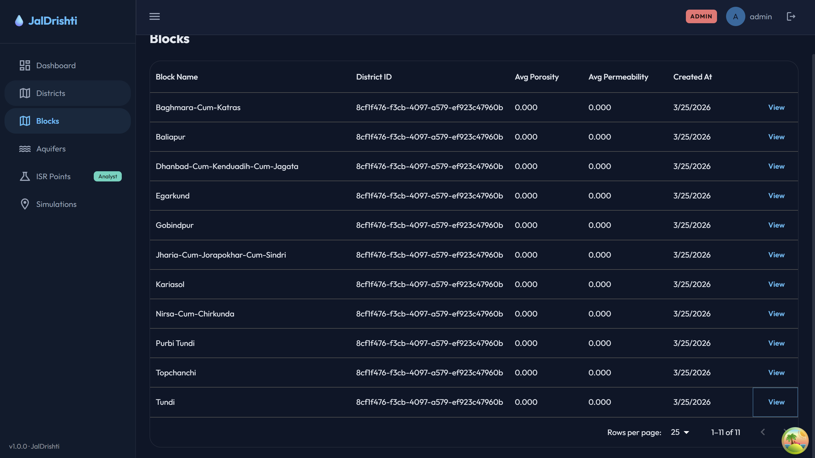
Figure 14.1: Blocks page of the early platform (February 2026), listing Dhanbad blocks with aquifer properties.
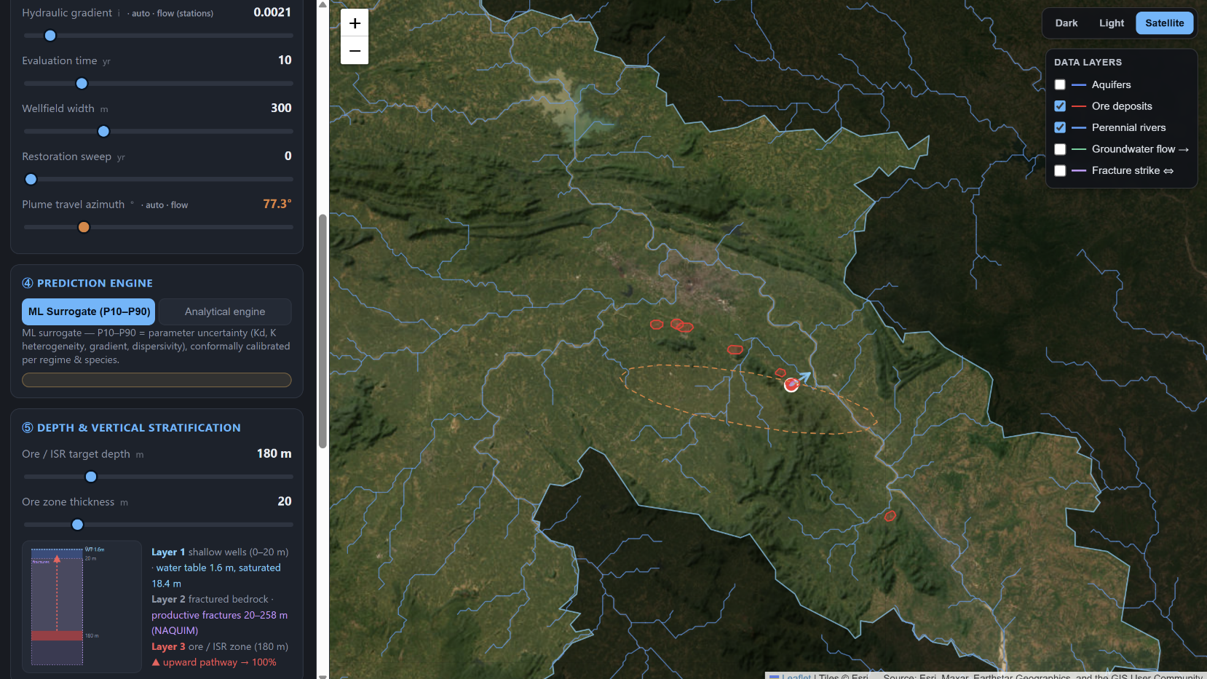
Figure 14.2: The June 2026 engine view on satellite imagery, with the hypothetical site and its plume.
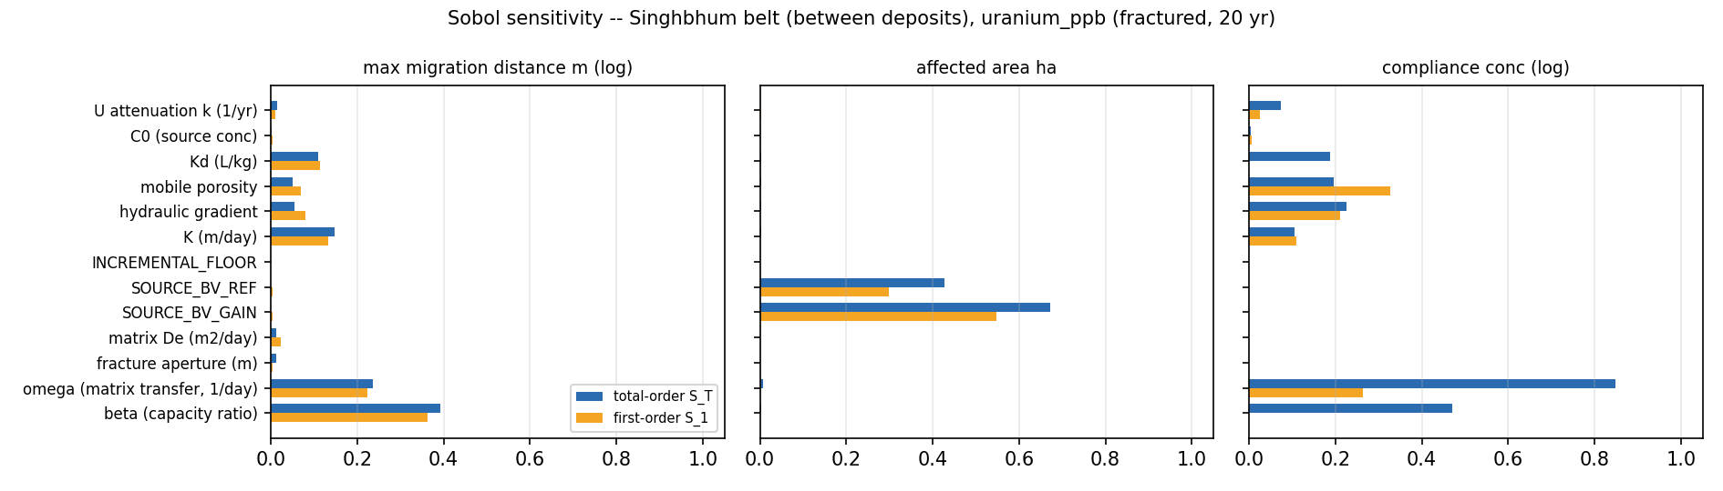
Figure 14.3: Sobol sensitivity indices for uranium at the belt location, where β is the most important input for travel distance.
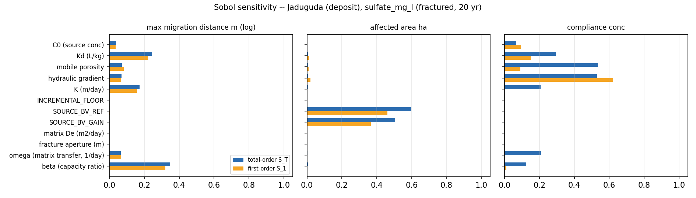
Figure 14.4: Sobol sensitivity indices for sulphate at the Jaduguda deposit location.

Annexure F: Financial Documents
The purchase bills, subscription invoices and payment receipts for the expenditure listed in Chapter 10 are attached after this page.
Table 14.4: List of attached financial documents
Sl. No. | Document | Month | Amount (₹)
1 | Invoice: research tools (hydrogeology and plume modelling) | January 2026 | 1,600.00
2 | Invoice: Claude Pro subscription | February 2026 | 2,196.00
3 | Invoices and bills: Claude Pro subscription, and books and e-books | May 2026 | 7,346.00 (2,226 + 5,120)
4 | Invoice: Claude Pro subscription | June 2026 | 2,273.00
5 | Invoice: Claude Pro subscription | July 2026 | __________
6 | Invoices: cloud hosting (Neon, Render, Cloudflare) and Claude Pro subscription | August 2026 | __________

MENTOR’S REMARKS & RECOMMENDATION
The student has completed the project titled “Smart Water Monitoring: Machine Learning and CPS for Safe & Sustainable Mining (JalDrishti)” under the UDAAN UG Fellowship Programme. The work was carried out sincerely and the project objectives were achieved. The student showed good technical understanding, problem-solving ability and commitment throughout the fellowship period.
Remarks: ____________________________________________________
_________________________________________________________________
Recommendation: ☐ Satisfactory ☐ Needs Improvement ☐ Excellent
Signature of Mentor: ____________________________
Asst. Prof. Mukesh Chandra
Date: _______________________

CERTIFICATE OF APPROVAL
The foregoing project report entitled “Smart Water Monitoring: Machine Learning and CPS for Safe & Sustainable Mining (JalDrishti)” is hereby approved as a creditable piece of work carried out under the UDAAN Fellowship Program. The project has been completed and presented in a satisfactory manner and is considered worthy of acceptance as fulfilment of the requirements of the fellowship.
It is understood that by this approval, the undersigned do not necessarily endorse every conclusion drawn or opinion expressed therein, but approve the report for the purpose for which it is submitted.
Asst. Prof. Mukesh Chandra  Mentor  Department of Production and Industrial Engineering  BIT Sindri, Dhanbad  Date: ____________________ | Dr. Prakash Kumar  Project Coordinator,  TEXMiN-BIT Sindri CPS CoE  BIT Sindri, Dhanbad  Date: ____________________

SUBMISSION CHECKLIST
The following documents and materials have been submitted along with the fellowship report:
Sl. No. | Item Submitted | Status (✓/✗)
1 | Final prototype (deployed software system) | ☐
 | Web portal (public site and role-based portal) | ☐
 | Backend API with database | ☐
 | Contamination model and trained ML model files | ☐
 | Source code repository (GitHub) | ☐
 | Datasets used, with their sources | ☐
2 | Purchase Bills / Invoices | ☐
3 | Monthly reports | ☐
 | November MPR | ☐
 | December MPR | ☐
 | January MPR | ☐
 | February MPR | ☐
 | March MPR | ☐
 | April MPR | ☐
 | May MPR | ☐
 | June MPR | ☐
 | July MPR | ☐
 | August MPR | ☐
4 | Final presentation slides | ☐

