Use Case: End-user (The Consumer)

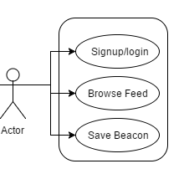

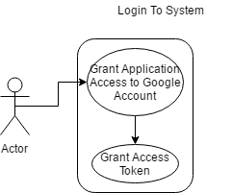

|  |  |
| --- | --- |
| Use Case Number | 1 |
| Rank | High |
| Use Case | Sign-up/Login to Application |
| Actors | End-user, System |
| Purpose | To have a user account for the application |
| Description | A user must sign-up by using their Google Account. The Google oAuth system will provide an access token to the application which will then allow our system to confirm their identity, and provide us with a unique identifier for our system. |
| Exceptions | If the user denies access then the system will disallow the user inside the application. |
| Type | Primary |

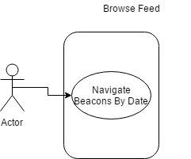

|  |  |
| --- | --- |
| Use Case Number | 2 |
| Rank | High |
| Use Case | Browse Feed |
| Actors | End-user |
| Purpose | To allow the user to scroll through the beacons they have passed. |
| Description | Allows the user to see the beacons they have passed and the data associated with it in a clean, readable way. |
| Exceptions | An Empty feed if no beacons are passed. |
| Type | Primary |

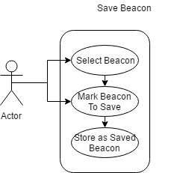

|  |  |
| --- | --- |
| Use Case Number | 3 |
| Rank | Medium |
| Use Case | Save/Favourite Beacon Data |
| Actors | End-user |
| Purpose | To allow the user to save their favourite beacons |
| Description | Allows the user to save the beacon and the information associated with it in order to come back to it quickly. |
| Exceptions | N/A |
| Type | Secondary |

Use Case: End-user (Business Owner)

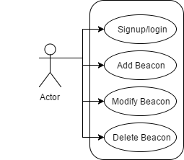



|  |  |
| --- | --- |
| Use Case Number | 1 |
| Rank | High |
| Use Case | Signup/Login |
| Actors | End-user, System |
| Purpose | Register For the System to provide beacon data as well confirm their registration with the system. |
| Description | A user must sign-up by using their Google Account. The Google oAuth system will provide an access token to the application which will then allow our system to confirm their identity, and provide us with a unique identifier for our system. The Access token will also be used for login. |
| Type | Primary |

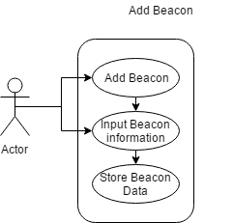

|  |  |
| --- | --- |
| Use Case Number | 2 |
| Rank | High |
| Use Case | Business Owner adds new Beacon Data |
| Actors | End-user |
| Purpose | Allows the Business Owners to insert new data into their beacons. |
| Description | Allows the Business Owners to create or beacon data in order to broadcast their sales and deals to the consumers. |
| Type | Primary |

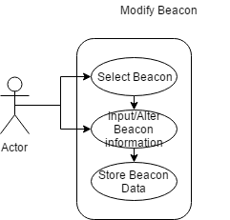

|  |  |
| --- | --- |
| Use Case Number | 3 |
| Rank | High |
| Use Case | Business Owner modifies Beacon Data |
| Actors | End-user |
| Purpose | Allows the Business Owners to modify the data of their beacons. |
| Description | Allows the Business Owners to modify the beacon data to broadcast. |
| Type | Primary |

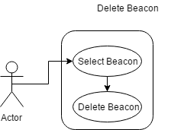

|  |  |
| --- | --- |
| Use Case Number | 4 |
| Rank | High |
| Use Case | Business Owner deletes Beacon Data |
| Actors | End-user |
| Purpose | Allows the Business Owners to delete one of their beacons. |
| Description | Allows the Business Owners to delete the entry for one or all of their beacons. |
| Type | Primary |

