@mxstbr's Karabiner Elements configuration
If you like TypeScript and want your Karabiner configuration maintainable & type-safe, you probably want to use the custom configuration DSL / generator I created in rules.ts and utils.ts!

“This repo is incredible - thanks so much for putting it together! I always avoided Karabiner mostly because of its complicated configuration. Your project makes it so much easier to work with and so much more powerful. I'm geeking out on how much faster I'm going to be now.”

— @jhanstra (source)

Watch the video about this repo:



Watch my interview with Raycast for a deeper dive into how I connect this with Raycast as my personal productivity system:

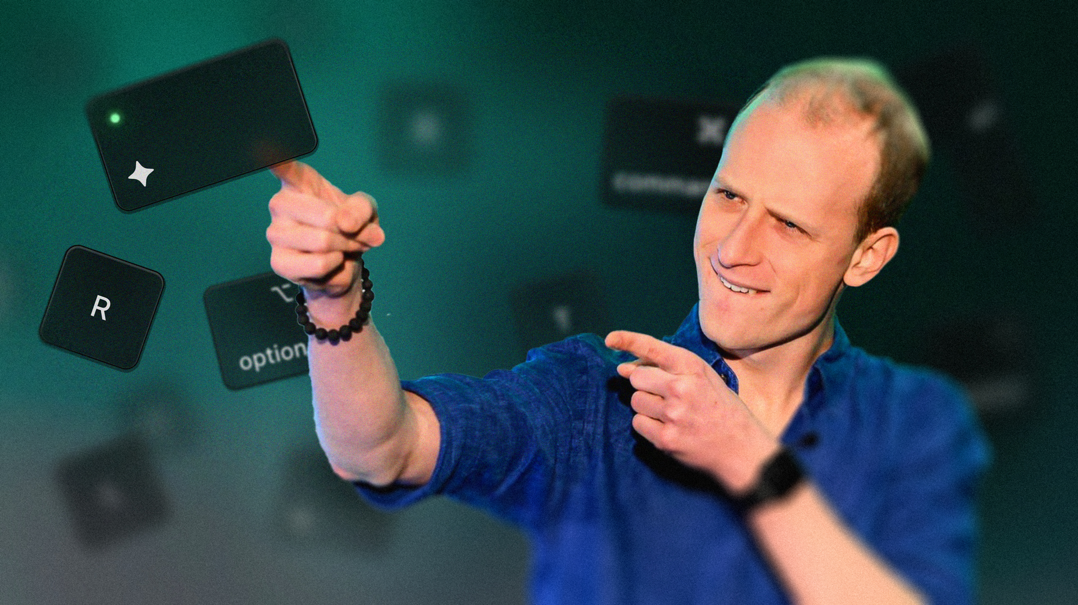

You probably don't want to use my exact configuration, as it's optimized for my personal style & usage. Best way to go about using this if you want to? Probably delete all the sublayers in rules.ts and add your own based on your own needs!

Installation
- Install & start Karabiner Elements
- Clone this repository
- Delete the default ~/.config/karabiner folder
- Create a symlink with ln -s ~/github/mxstbr/karabiner ~/.config (where ~/github/mxstbr/karabiner is your local path to where you cloned the repository)
- Restart karabiner_console_user_server with launchctl kickstart -k gui/`id -u`/org.pqrs.karabiner.karabiner_console_user_server

Development
yarn install

to install the dependencies. (one-time only)

yarn run build

builds the karabiner.json from the rules.ts.

yarn run watch

watches the TypeScript files and rebuilds whenever they change.

License
Copyright (c) 2022 Maximilian Stoiber, licensed under the MIT license.

