**Name:**

**Vishal Salvi (2019230069)**

**Shivam Pawar (2019230068)**

**Batch: C**

**Experiment No. 5**

**Aim:** To perform the following and find the effort and cost of the project.

1. Draw wireframes for 5 agile stories and identify the EI, EO, EQ, ILF, EIF.   
 2. Calculate unadjusted function point UFP.

3. Calculate value adjustment factor, VAF.

4. Calculate Adjusted function point, AFP.

5. Calculate effort in man/days.   
6. Calculate cost of project in Rs

**Theory:**

FPA provides standardized method to functionally size the software work product. This work product is the output of software new development and improvement projects for subsequent releases. It is the software which is relocated to the production application at project implementation. It measures functionality from the users point of view i.e. on the basis of what the user requests and receives in return.

Function Point Analysis (FPA) is a method or set of rules of Functional Size Measurement. It assesses the functionality delivered to its users, based on the user’s external view of the functional requirements. It measures the logical view of an application not the physically implemented view or the internal technical view

**Objectives of FPA:**

The objective of FPA is to measure functionality that the user requests and receives.   
The objective of FPA is to measure software development and maintenance independently of technology used for implementation.  
   
It should be simple enough to minimize the overhead of the measurement process.

It should be a consistent measure among various projects and organizations.

**Types of FPA:**

**1. Transactional Functional Type –**    
 **(i) External Input (EI):** EI processes data or control information that comes from outside the

application’s boundary. The EI is an elementary process.   
 **(ii) External Output (EO):** EO is an elementary process that generates data or control

information sent outside the application’s boundary.   
 **(iii) External Inquiries (EQ):** EQ is an elementary process made up of an input-output

combination that results in data retrieval.  
   
**2. Data Functional Type –**    
 **(i) Internal Logical File (ILF):** A user identifiable group of logically related data or control

information maintained within the boundary of the application.

**(ii) External Interface File (EIF):** A group of user recognizable logically related data allusion to

the software but maintained within the boundary of another software.

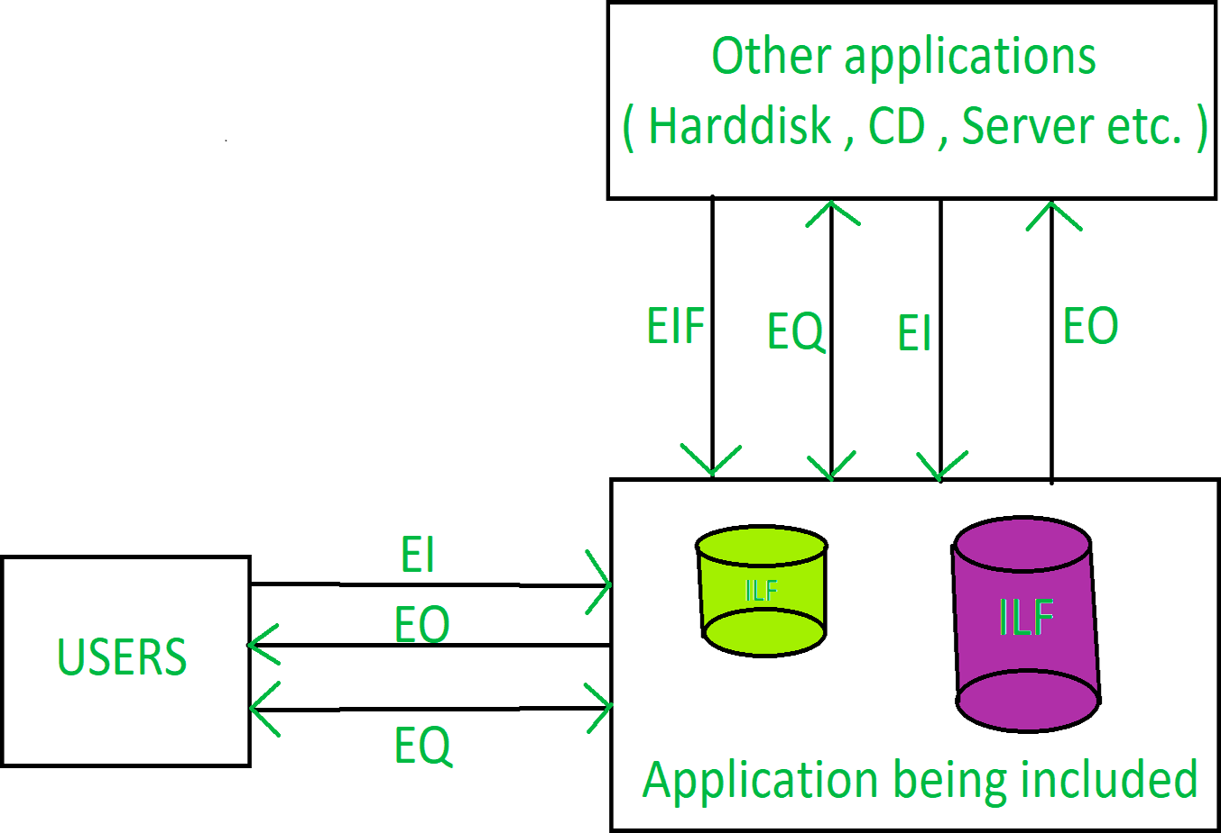

**Benefits of FPA:**

FPA is a tool to determine the size of a purchased application package by counting all the functions

included in the package.

It is a tool to help users discover the benefit of an application package to their organization by

counting functions that specifically match their requirements.

It is a tool to measure the units of a software product to support quality and productivity analysis.  
   
 It is a vehicle to estimate cost and resources required for software development and maintenance.

It is a normalization factor for software comparison.

Steps to Count the Function Points

Below are the steps used in counting the function points of a system.

**1. Type of count:** The very first step of this process is to determine the type of function count. There are 3 types of function point (FP) count.

**Development Project FP Count:** This measures the functions that are directly involved in the

development of the final system. This would include all the phases of the project from

requirements gathering to the first installation.  
   
  **Enhancement Project FP Count:** This measures the functions involved in the modifications

brought in the system. That is the changes made to the system after production.  
   
  **Application FP count:** This measures the functions involved in the final deliverable excluding the

effort of already existing functions that may have existed.

**2. Scope and Boundary of the Count:** In the second step, the scope and boundary of the functions are identified. Boundary indicates the border between the application being measured and the external applications. Scope can be decided with the help of data screens, reports, and files.

**3. Unadjusted Function Point Count:** This is the main step of this process where all the function points produced from the above FPA components **(External Inputs, External Output, Internal Logic files, External Logic files, Inquiries)** are added together and labeled as unadjusted function point count.

**4. Value Adjustment Factor:** In this step the value adjustment factor is determined. VAF contains 14 General system characteristics(GSC) of the system or application that defines the types of application characteristics and is rated on a scale of 0 to 5. The sum of all the 14 GSC rates are calculated to give out a mathematical value and is labeled as Total Degree Influence(TDI). TDI is used in the calculation of VAF and its value may vary from 0 to 35.

**Below are the 14 GSCs listed and the mathematical formula for calculating the VAF.**

Data communications

Distributed data processing

Performance

Heavily used configuration

Transaction rate

On-Line data entry

End-user efficiency  
  
On-Line update

Complex processing

Reusability

Installation ease  
   
Operational ease

Facilitate change

Multiple sites  
 

Once the unadjusted function point and value adjustment factor is calculated, the Adjusted Functional point count is found out using the two values. This is done with the help of the following  
formula.

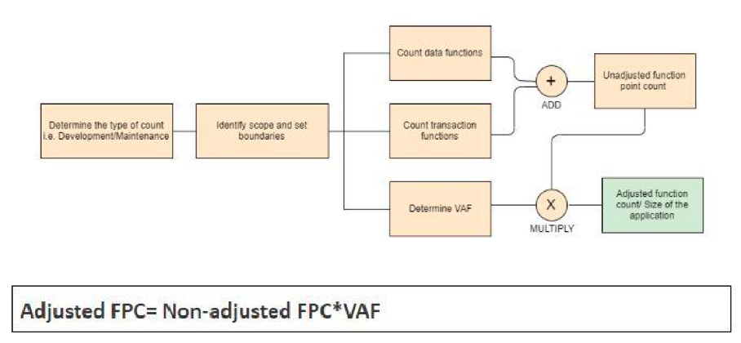

The Adjusted FPC is then multiplied with a numeric value, which is the effort based on the technology. Some of the examples are below.

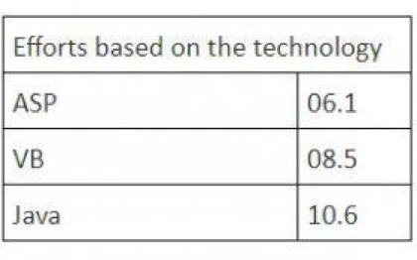

If the technology selected for a particular requirement is Java, then the formula to calculate the final hours are as follows:

FPC = (Non-adjusted FPC*VAF) * 10.6

This will give the total hours of effort required to achieve the requirement under analysis.

**Step 1 - Calculate Unadjusted Function Point for Project**

**Database Tables and their columns:**

USER :

user id (PK)

username

first name

last name

email id

password

address

bank_details

payment_details

PRODUCT :

product_id (PK)

product_name

product_details

category_id (FK)

review_text (FK)

Review :

Review_id (PK)

User_id (FK)

date

time

review_text

CATEGORY :

category_id (PK)

category_name

**Data Functions Table:**

|  |  |  |  |  |  |
| --- | --- | --- | --- | --- | --- |
| **Data Functions/Tables** | **Type** | **DET** | **RET** | **FTR** | **Weightage** |
| **User** | **ILF** | **8** | **3** | **N.A** | **Low** |
| **Category** | **ILF** | **2** | **1** | **N.A** | **Low** |
| **Product** | **ILF** | **9** | **1** | **N.A** | **Low** |
| **Review** | **ILF** | **6** | **1** | **N.A** | **Low** |

**Transactions Functions Tables:**

**User Story 1:**

1. **As a non-registered user, I want to view the product details.**



|  |  |  |  |  |  |
| --- | --- | --- | --- | --- | --- |
| **Transaction Functions/Screen** | **Type** | **DET** | **RET** | **FTR** | **Weightage** |
| **View Product** | **EI** | **6** | **NA** | **2** | **Low** |

**User Story 2:**

1. **As a customer user, I want to filter products so that I can find the items based on different categories.**



|  |  |  |  |  |  |
| --- | --- | --- | --- | --- | --- |
| **Transaction Functions/Screen** | **Type** | **DET** | **RET** | **FTR** | **Weightage** |
| **Filter Product** | **EO** | **5** | **NA** | **3** | **Low** |
| **Delete Product** | **EI** | **2** | **NA** | **1** | **Low** |

**User Story 3:**

1. **As a registered user, I want to buy a product from the website.**



|  |  |  |  |  |  |
| --- | --- | --- | --- | --- | --- |
| **Transaction Functions/Screen** | **Type** | **DET** | **RET** | **FTR** | **Weightage** |
| **Buy Product** | **EQ** | **3** | **NA** | **2** | **Low** |

**User Story 4:**

1. **As a registered user, I want to add money to my AmazonPay account so that I can pay directly from it rather than using a bank account.**



|  |  |  |  |  |  |
| --- | --- | --- | --- | --- | --- |
| **Transaction Functions/Screen** | **Type** | **DET** | **RET** | **FTR** | **Weightage** |
| **Add Money** | **EI** | **9** | **NA** | **2** | **Average** |

**User Story 5:**

1. **As a customer, I want to add my location/address of delivery through map by pinning the location.**

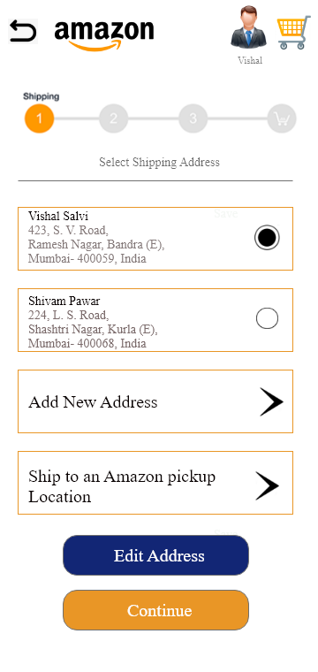

|  |  |  |  |  |  |
| --- | --- | --- | --- | --- | --- |
| **Transaction Functions/Screen** | **Type** | **DET** | **RET** | **FTR** | **Weightage** |
| **Add Address** | **EO** | **3** | **NA** | **2** | **Low** |

**Step 2 - Calculate Value Adjustment Factor**

0 – Not present or no influence 1 – Incidental influence

2 – Moderate influence

3 – Average influence

4 – Significant influence

5 – Strong influence throughout

|  |  |  |  |
| --- | --- | --- | --- |
| **Characteristic** | **Degree of Influence** | **Characteristic** | **Degree of Influence** |
| Data Communications | 5 | On-line update | 5 |
| Distributed Data Processing | 4 | Complex processing | 4 |
| Performance | 4 | Reusability | 5 |
| Heavily used Configuration | 2 | Installation ease | 5 |
| Transaction Rate | 3 | Operational ease | 4 |
| Online Data Entry | 5 | Multiple sites | 3 |
| End-user Efficiency | 5 | Facilitate change | 4 |

**Total Degree of Influence (TDI) = 58**

**VAF = (TDI × 0.01) + 0.65 = 1.23**

**Step 3 - Calculate Adjusted Function Point for Project**

|  |  |  |  |  |
| --- | --- | --- | --- | --- |
| **Type of Component** | **Complexity of Components** | | | |
| **Low** | **Average** | **High** | **Total** |
| **External Inputs** | **1 x 3 = 3** | **2 x 4 = 8** | **0 x 6 = 0** | **11** |
| **External Outputs** | **2 x 3 = 6** | **0 x 5 = 0** | **0 x 7 = 0** | **6** |
| **External Inquiries** | **1 x 4 = 4** | **0 x 4 = 0** | **0 x 6 = 0** | **4** |
| **Internal Logic Files** | **4 x 7 = 28** | **0 x 10 = 0** | **0 x 15 = 0** | **28** |
|  | **Total number of Unadjusted Function Points** | | | **49** |
| **Multiplied Value Adjustment Factor** | | | **1.23** |
| **Total Adjusted Function Points** | | | **60.37** |

**AFP = UFP × VAF = AFP = 60.27**

**Step 4 - Calculate effort in man/days**

**Effort:**

0.9 FP = 1 Man-Day worth of effort [ASSUMPTION]

Total FP = 60.27

**Total Effort** = (60.27)/0.9 = 66.960 Man-Days = **70 Man-Days (approx)**

**Step 5 - Calculate Cost of Project**

Cost per day = Rs.2500 [ASSUMPTION]

Total Effort in man days = 70

**Total cost of project** = Rs(70*2500) = **Rs 1,75,000.**

**CONCLUSION:**

In this experiment, we have learnt how to estimate the function point of a project and hence calculate the effort in man/days and cost of project. The function point technique provides an objective, comparative measure that assists in the evaluation, planning, management and control of software production.