**Name:** Vishal Shashikant Salvi.

**UID:** 2019230069

**Class:** SE Comps

**Batch:** C

**Experiment No:1**

**Aim:**

Create a resume page with following sections

• Abstract

• Skills & Area of Expertise

• Education

• Professional Snapshot

• Internship

• Certification & Achievements

• Interests

**Theory:**

**Syntax:**

**Heading & paragraph**

<!DOCTYPE html>

<html>

<head>

<title>Page Title</title>

</head>

<body style=”background-color:yellow”>

<h1>This is a Heading</h1>

<h2>This is a Heading</h2>

<p>This is a paragraph.</p>

</body>

</html>

**Ordered List**

<!DOCTYPE html>

<html>

<head>

<title>An ordered HTML list</title>

</head>

<body >

<h2>An ordered HTML list</h2>

<ol>

<li>Coffee</li>

<li>Tea</li>

<li>Milk</li>

</ol>

</body>

</html>

**Ordered List with lower case letters**

<ol type="a">

<li>Coffee</li>

<li>Tea</li>

<li>Milk</li>

</ol>

**Un Ordered List**

<!DOCTYPE html>

<html>

<head>

<title>An unordered HTML list</title>

</head>

<body >

<h2>Unordered List with Square Bullets</h2>

<ul style="list-style-type:square;">

<li>Coffee</li>

<li>Tea</li>

<li>Milk</li>

</ul>

</body>

</html>

**How to write comments in HTML?**

<!-- This is a comment -->

**Links**

<!DOCTYPE html>

<html>

<head>

<title>An unordered HTML list</title>

</head>

<body >

<h2>Unordered List with Square Bullets</h2>

<ul style="list-style-type:square;">

<li><a href =”http://www.google.com”>Go to google</a></li>

</ul>

</body>

</html>

**HTML FORMS**

<!DOCTYPE html>

<html>

<head>

<title>Text Input Control</title>

</head>

<body>

<form >

First name: <input type = "text" name = "first_name" />

<br>

Last name: <input type = "text" name = "last_name" />

</form>

</body>

</html>

**There are different types of form controls that you can use to collect data using HTML form −**

**• Text Input Controls**

The <input> tag specifies an input field where the user can enter data.

<input> elements are used within a <form> element to declare input controls that allow users to input data.

An input field can vary in many ways, depending on the type attribute.

<form action="/action_page.php">  
 Firstname: <input type="text" name="fname"><br>  
 Lastname: <input type="text" name="lname"><br>  
  <input type="submit" value="Submit">  
</form>

**• Checkboxes Controls**

The <input type="checkbox"> defines a checkbox.

The checkbox is shown as a square box that is ticked (checked) when activated.

Checkboxes are used to let a user select one or more options of a limited number of choices.

<input type="checkbox" name="vehicle1" value="Bike"> I have a bike<br>  
<input type="checkbox" name="vehicle2" value="Car"> I have a car<br>  
<input type="checkbox" name="vehicle3" value="Boat" checked> I have a boat<br>

**• Radio Box Controls**

The <input type="radio"> defines a radio button.

Radio buttons are normally presented in radio groups (a collection of radio buttons describing a set of related options). Only one radio button in a group can be selected at the same time.

**Note:** The radio group must have share the same name (the value of the name attribute) to be treated as a group. Once the radio group is created, selecting any radio button in that group automatically deselects any other selected radio button in the same group. You can have as many radio groups on a page as you want, as long as each group has its own name.

**Note:** The value attribute defines the unique value associated with each radio button. The value is not shown to the user, but is the value that is sent to the server on "submit" to identify which radio button that was selecte

<input type="radio" name="gender" value="male"> Male<br>  
<input type="radio" name="gender" value="female"> Female<br>  
<input type="radio" name="gender" value="other"> Other

**• Select Box Controls**

The <select> element is used to create a drop-down list.

The [<option>](https://www.w3schools.com/tags/tag_option.asp) tags inside the <select> element define the available options in the list

<select>  
  <option value="volvo">Volvo</option>  
  <option value="saab">Saab</option>  
  <option value="mercedes">Mercedes</option>  
  <option value="audi">Audi</option>  
</select>

**• File Select boxes**

The <input type="file"> defines a file-select field and a "Browse" button for file uploads.

To define a file-select field that allows multiple files to be selected, add the "multiple" attribute.

<!DOCTYPE html>

<html>

<body>

<h1>Show a file-select field:</h1>

<h3>Show a file-select field which allows only one file to be chosen:</h3>

<form action="/action_page.php">

Select a file: <input type="file" name="myFile"><br><br>

<input type="submit">

</form>

<h3>Show a file-select field which allows multiple files:</h3>

<form action="/action_page.php">

Select files: <input type="file" name="myFile" multiple><br><br>

<input type="submit">

</form>

</body>

</html>

**• Hidden Controls**

The <input type="hidden"> defines a hidden input field.

A hidden field let web developers include data that cannot be seen or modified by users when a form is submitted.

A hidden field often stores what database record that needs to be updated when the form is submitted.

**Note:** While the value is not displayed to the user in the page's content, it is visible (and can be edited) using any browser's developer tools or "View Source" functionality. Do not use hidden inputs as a form of security!

 <input type="hidden" id="custId" name="custId" value="3487">

**• Clickable Buttons**

The <button> tag defines a clickable button.

Inside a <button> element you can put content, like text or images. This is the difference between this element and buttons created with the <input> element.

**Tip:** Always specify the type attribute for a <button> element. Different browsers use different default types for the <button> element.

<button type="button">Click Me!</button>

**• Submit and Reset Button**

<form action="/action_page.php" method="get">  
 Firstname: <input type="text" name="fname"><br>  
 Lastname: <input type="text" name="lname"><br>  
  <button type="submit" value="Submit">Submit</button>  
  <button type="reset" value="Reset">Reset</button>  
</form>

**Input:**

**Abstract.html**

<!DOCTYPE html>

<html>

<body bgcolor="#E6E6FA">

<h1>Welcome</h1>

<p>Resume</p>

<p>Name: Vishal Shashikant Salvi.</p>

<p>College: Sardar Patel Institute of Technology.</p>

<p>Branch: Computer Engineering</p>

</body>

</html>

**Skills.html**

<!DOCTYPE html>

<html>

<body bgcolor="#E6E6FA">

<h1>Welcome</h1>

<p>Resume</p>

<p>Languages Known:

<ul>

<li> C</li>

<li> C++</li>

<li> JAVA</li>

<li>HTML</li>

<li>Visual Basic</li>

<li>R</li>

</ul>

<p>Database Known:

<ul>

<li> SQL</li>

<li> NO SQL (Mongodb)</li>

</ul>

</html>

**Education.html**

<!DOCTYPE html>

<html>

<body bgcolor="#E6E6FA">

<h1>Welcome</h1>

<p>Resume<p>

<style>

table, th, td {

border: 1px solid black;

border-collapse: collapse;

}

th, td {

padding: 5px;

text-align: left;

}

</style>

</head>

<body>

<h2>Education Details </h2>

<table style="width:100%">

<caption>Data About Education</caption>

<tr>

<th>Std</th>

<th>School/College</th>

</tr>

<tr>

<td>SSC</td>

<td>D.J.Highschool</td>

</tr>

<tr>

<td>Diploma</td>

<td>Government polytechnic , Mumbai</td>

</tr>

<tr>

<td>B.Tech</td>

<td>Sardar Patel Institute of Technology</td>

</tr>

</table>

</body>

</html>

**Professional.html**

<!DOCTYPE html>

<html>

<body bgcolor="#E6E6FA">

<h1>Welcome</h1>

<p>Resume</p>

<h2>Professional Snapshot</h2>

<ol>

<li> <a href="file:///C:/Users/Vishal/Desktop/vishal/wt/Gesture.html">A Comparative Study on gesture control voice command over android device</a></li>

<li> <a href="http://www.ijmer.com/papers/Vol9_issue1/E0901013337.pdf">IJMER Reserch Paper</a></li>

<li> <a href="file:///C:/Users/Vishal/Desktop/vishal/wt/onekey.html">One key</a></li>

<li> <a href="file:///C:/Users/Vishal/Desktop/vishal/wt/calculator.html">Calculator</a></li>

</ol>

</body>

</html>

**Certification.html**

<!DOCTYPE html>

<html>

<body bgcolor="#E6E6FA">

<h1>Welcome</h1>

<p>Resume</p>

<h2>Certification</h2>

<ol>

<li>Published paper on IJMER</li>

<li>Internship</li>

<li>Elementry</li>

<li>Intermediate</li>

</ol>

</body>

</html>

**Interest.html**

<!DOCTYPE html>

<html>

<body bgcolor="#E6E6FA">

<h1>Welcome</h1>

<p>Resume</p>

<p>Interested in:

<ul>

<li> Software Development</li>

<li> Software Testing</li>

<li> Database Management</li>

<li>Data Analysis</li>

</ul>

<p>Other:

<ul>

<li> Reading</li>

<li> Sports</li>

<li> Painting</li>

<li> Scketching</li>

</ul>

</html>

**Internship.html**

<!DOCTYPE html>

<html>

<body bgcolor="#E6E6FA">

<h1>Welcome</h1>

<p>Resume</p>

<h2>Internship Completed</h2>

<ol>

<li>Linwire Technology</li>

<li>Suven consultace and pvt limeted</li>

<li>SAP</li>

</ol>

</body>

</html>

**Form.html**

<!DOCTYPE html>

<html>

<body bgcolor="#E6E6FA">

<h1>Welcome</h1>

<h2>Feedback Form</h2>

<form>

First name:<br>

<input type="text" name="firstname"><br>

Last name:<br>

<input type="text" name="lastname"><br>

<input type="hidden" id="custId" name="custId" value="3487">

Email id: <br>

<input type="email" name="email"><br><br>

Gender:<br>

<input type="radio" name="gender" value="male" checked> Male<br>

<input type="radio" name="gender" value="female"> Female<br>

<input type="radio" name="gender" value="other"> Other<br><br>

State :<br>

<select >

<option>Maharashta</option>

<option>Gujrat</option>

<option>Madhyapradesh</option>

<option>Delhi</option>

</select>

<br><br>

Comments:<br>

<textarea class="form-control" type="textarea" name="comments" id="comments" placeholder="Your Comments" maxlength="6000" rows="7"></textarea>

<br><br> <form action="myform.cgi">

<input type="file" name="fileupload" value="fileupload" id="fileupload">

<label for="fileupload"> Select a file to upload</label>

<input type="hidden" id="ipaddr" name="ipaddr" value="<?php echo $_SERVER['REMOTE_ADDR']; ?>">

<input type="hidden" id="referer" name="referer" value="<?php echo $_SERVER['HTTP_REFERER']; ?>"> <br>

</form>

<br> <br><input type="checkbox" name="true" value="true"> All given information is correct.<br>

<center><input type="submit" value="Submit"></center>

</form>

</body>

</html>

**Footer.html**

<!DOCTYPE html>

<html>

<head>

<title>HTML footer Tag</title>

<style>

a {

font-size:16px;

text-decoration:none;

}

p {

font-size:16px;

}

</style>

</head>

<body>

<footer>

<p><center>Vishal Shashikant Salvi.<center></p>

<p><center>Contact:vishalsalvi1710@gmail.com, Some rights reserved<center></p>

</footer>

</body>

</html>

**Frame1.html**

<!DOCTYPE html>

<html>

<body bgcolor="#E6E6FA">

<p>Name: Vishal Shashikant Salvi.</p>

<p>College: Sardar Patel Institute of Technology.</p>

<p>Branch: Computer Engineering</p>

</body>

</html>

**Frame2.html**

<!DOCTYPE html>

<html>

<body bgcolor="#E6E6FA">

<p>Name: Vishal Shashikant Salvi.</p>

<p>Email ID: vishalsalvi1710@gmail.com</p>

<p>Contact:8424885314</p>

<p></p>

</body>

</html>

**Img.html**

<!DOCTYPE html>

<html>

<body>

<img src = "dp.jpg" alt = "Test Image" width = "145" height = "135" />

</body>

</html>

**Vishal.html**

<!DOCTYPE html>

<html>

<body bgcolor="cyan">

<p>About Me</p>

<ul>

<li> <a href="file:///C:/Users/Vishal/Desktop/vishal/wt/abstract.html" target ="iframe">Abstract</a> </li><br>

<li><a href="file:///C:/Users/Vishal/Desktop/vishal/wt/skils.html" target ="iframe">Skills & Area of Expertise</a> </li> <br>

<li><a href="file:///C:/Users/Vishal/Desktop/vishal/wt/Education.html" target ="iframe">Education</a> </li><br>

<li><a href="file:///C:/Users/Vishal/Desktop/vishal/wt/professional.html" target ="iframe">Professional Snapshot</a> </li><br>

<li><a href="file:///C:/Users/Vishal/Desktop/vishal/wt/Certification.html" target ="iframe">Certification & Achievements</a> </li><br>

<li><a href="file:///C:/Users/Vishal/Desktop/vishal/wt/Interest.html" target ="iframe">Interests</a> </li><br>

<li><a href="file:///C:/Users/Vishal/Desktop/vishal/wt/Internship.html" target ="iframe">Internship</a> </li><br>

<li><a href="file:///C:/Users/Vishal/Desktop/vishal/wt/form.html" target ="iframe">Feedback Form</a> </li><br>

</ul>

</body>

</html>

**Gesture.html**

<!DOCTYPE html>

<html>

<body bgcolor="#E6E6FA">

<h1>Welcome</h1>

<p>Resume</p>

<p>About Gesture control voice command over android device.</p>

<p>ABSTRACT: “Speech” and “gestures” are the expressions, which are mostly used in communication between human beings. In human communication, the use of speech and gestures is completely coordinated. Gesture Vocalize is a large-scale multi-microcontroller-based systembeing designed to facilitate the communication among the dumb, deaf and blind communities and their communication with the normal people. This system can dynamically reconfigure to work as a “smart device”. This system composed of monitoring the gesture by hand glove via flex sensor and Bluetooth application connected with microcontroller.This system is beneficial for dumb people and their hands will speak having worn the gesture vocalize data glove.</p>

</body>

</html>

**Output:**

**Front page**

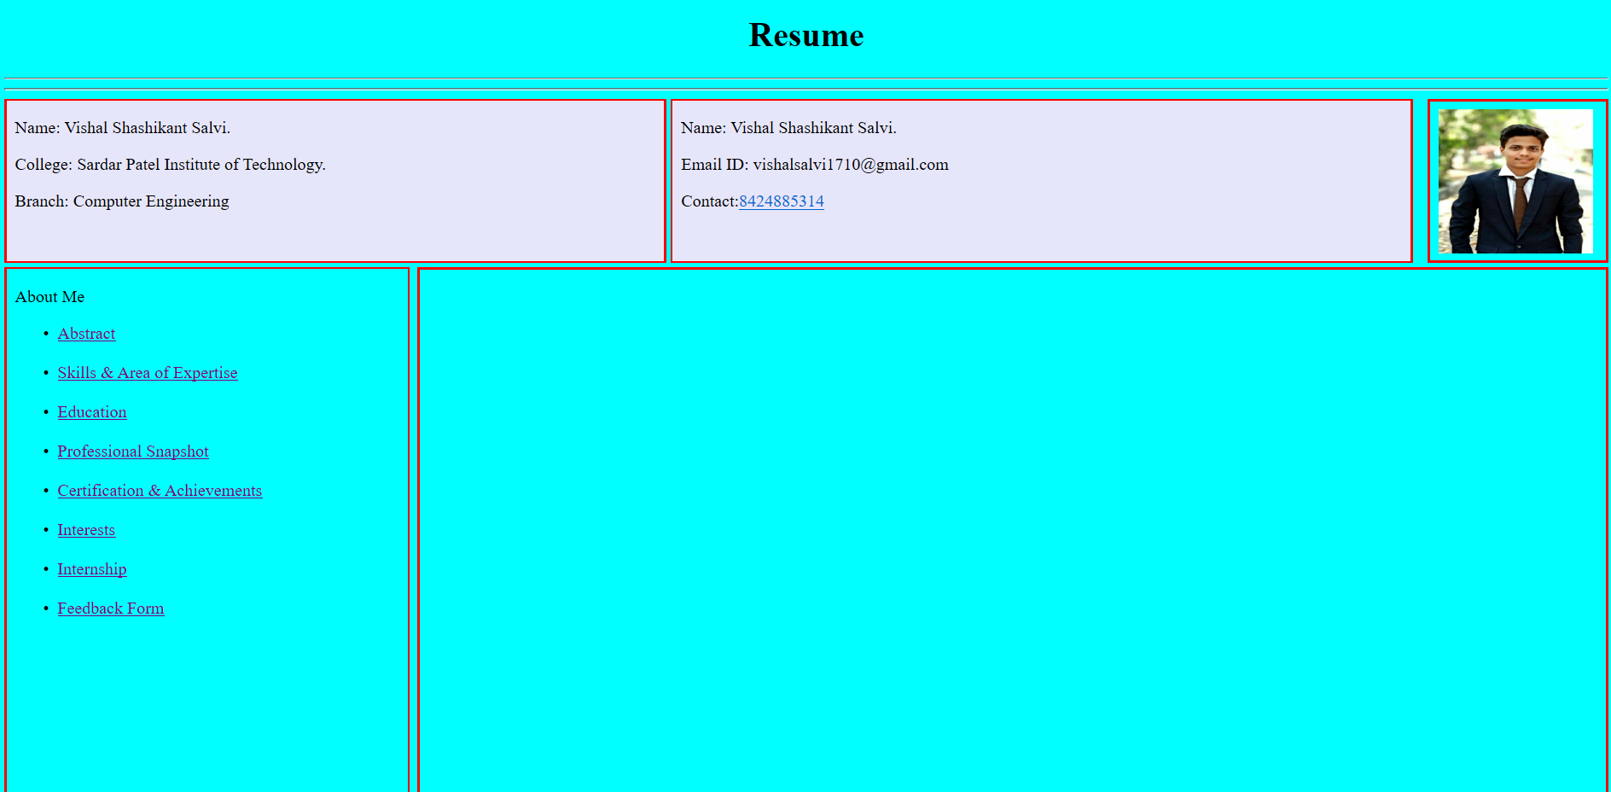

**Hyperlink**

**Abstract**

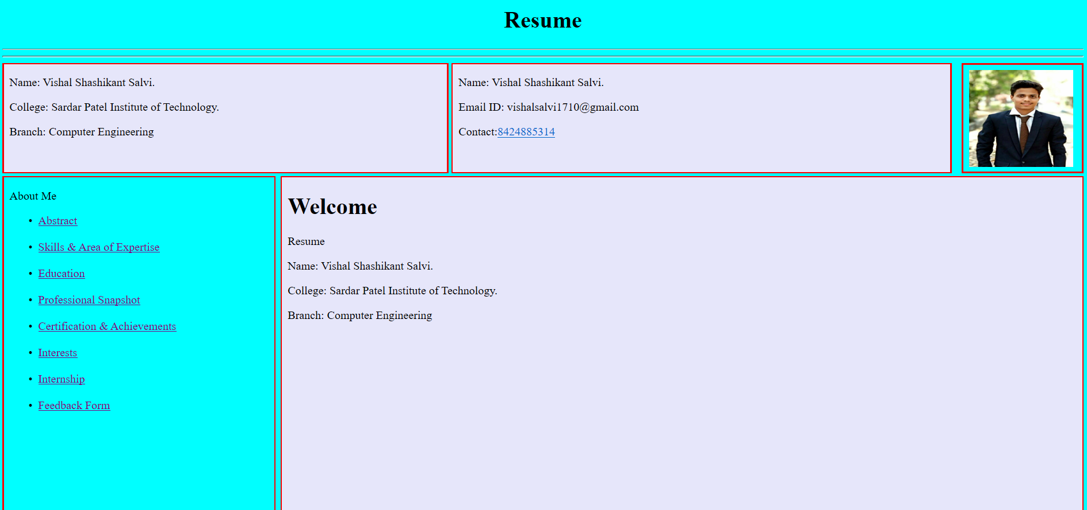

**Skills & Area of Expertise**

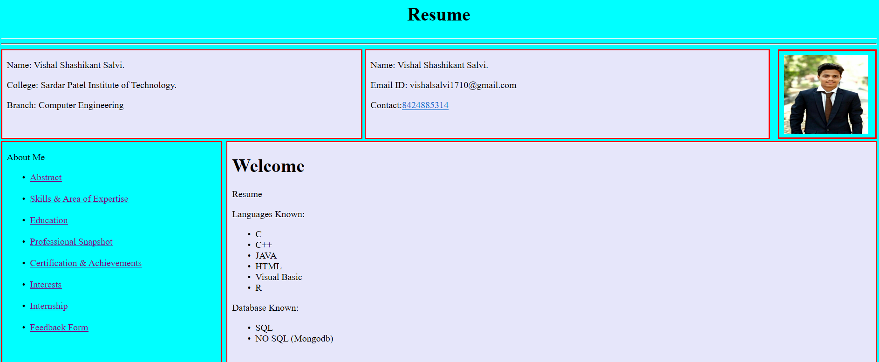

**Education**

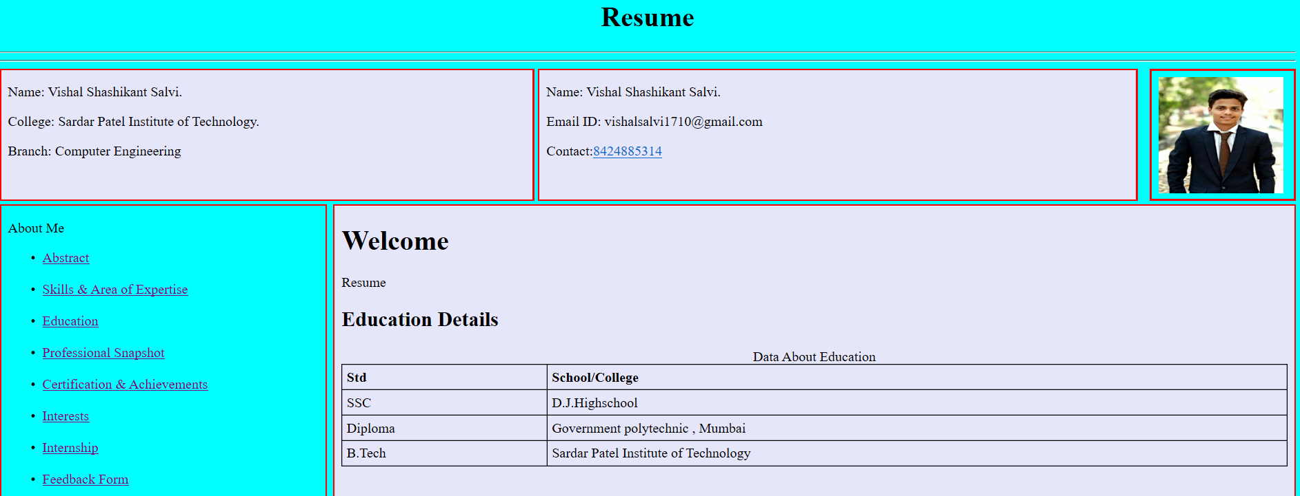

**Professional Snapshot**

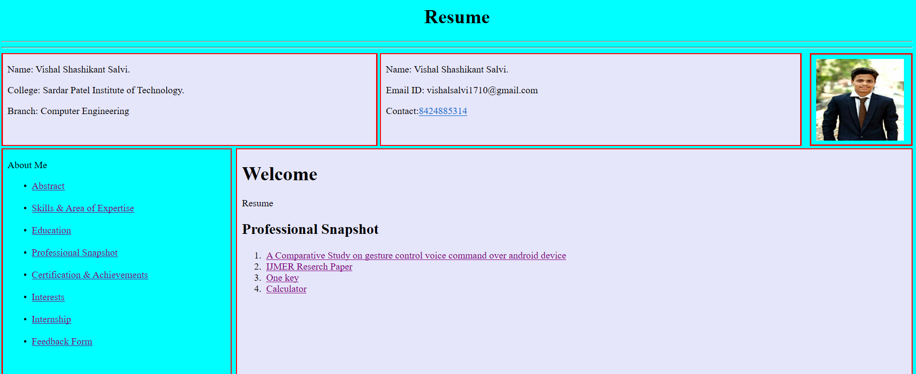

**IJMER Reserch Paper**

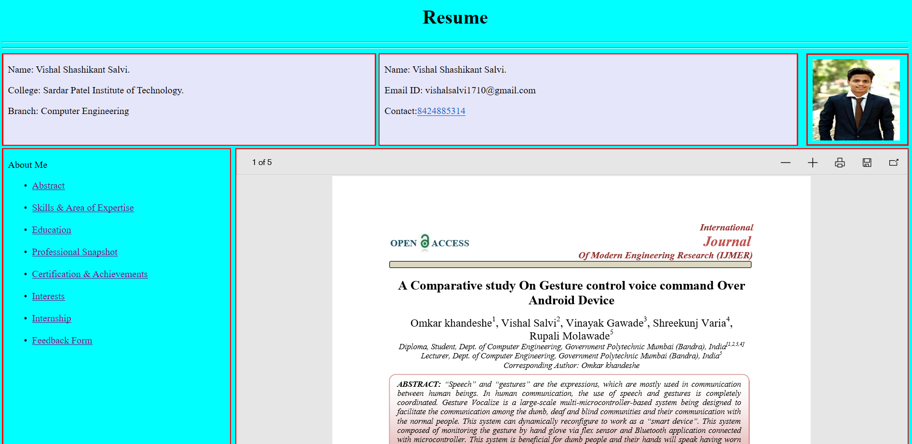

**Certification & Achievements**

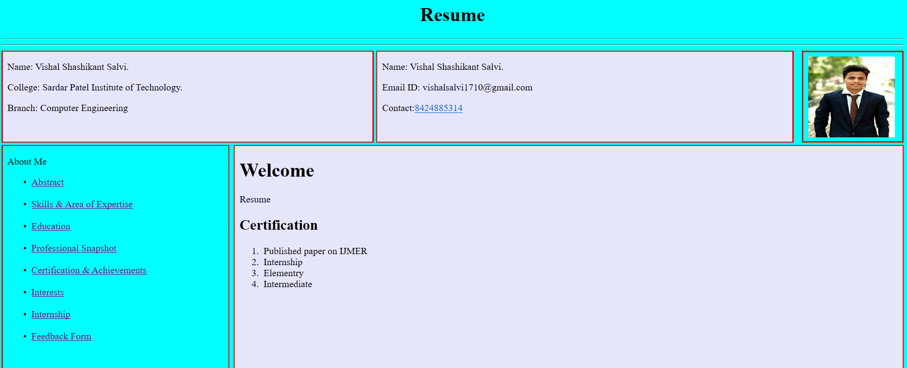

**Interest**

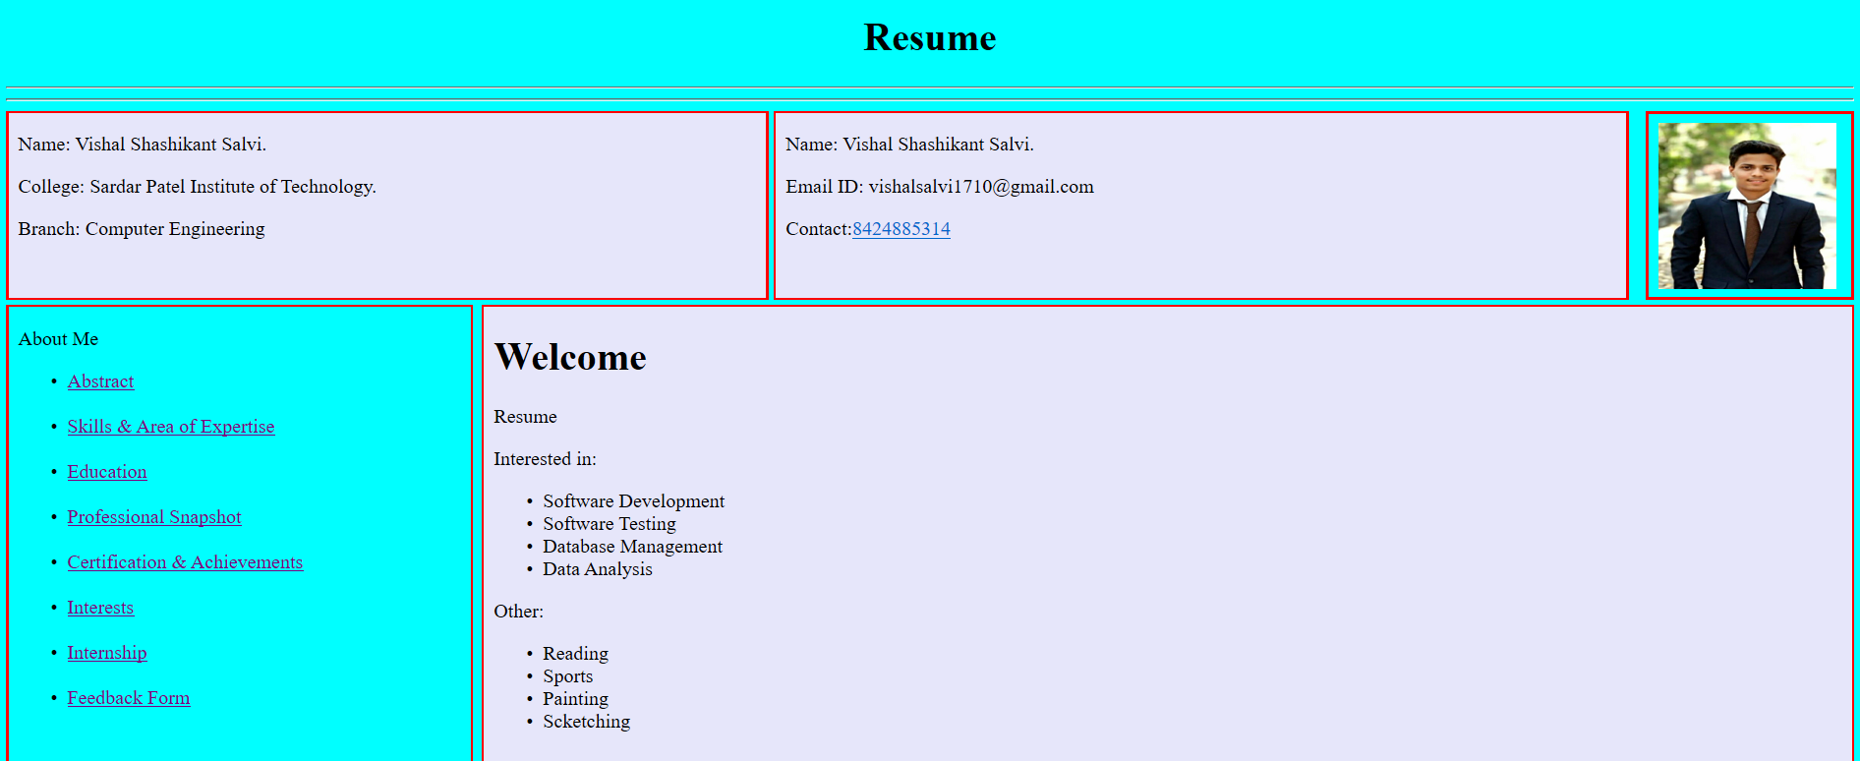

**Internship**

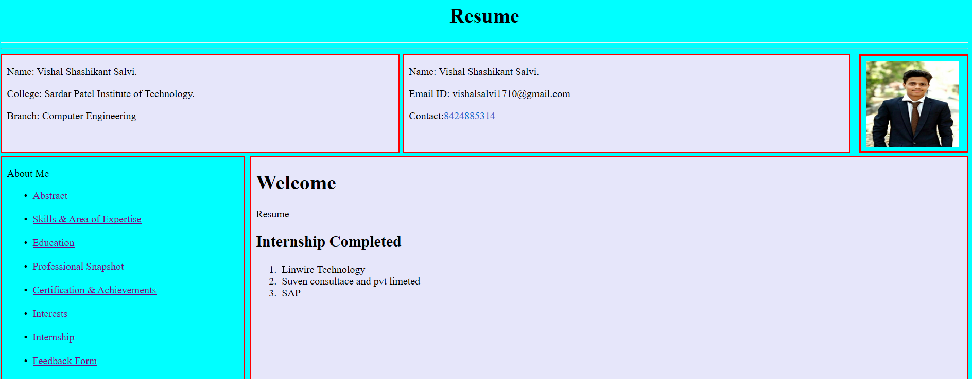

**Feedback Form**

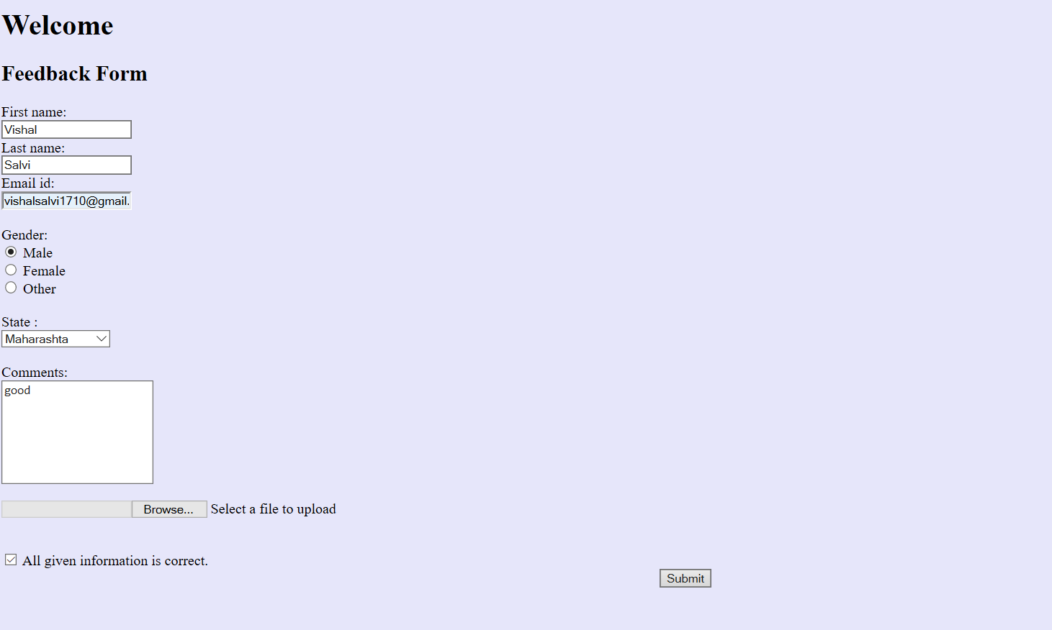

**Select File**

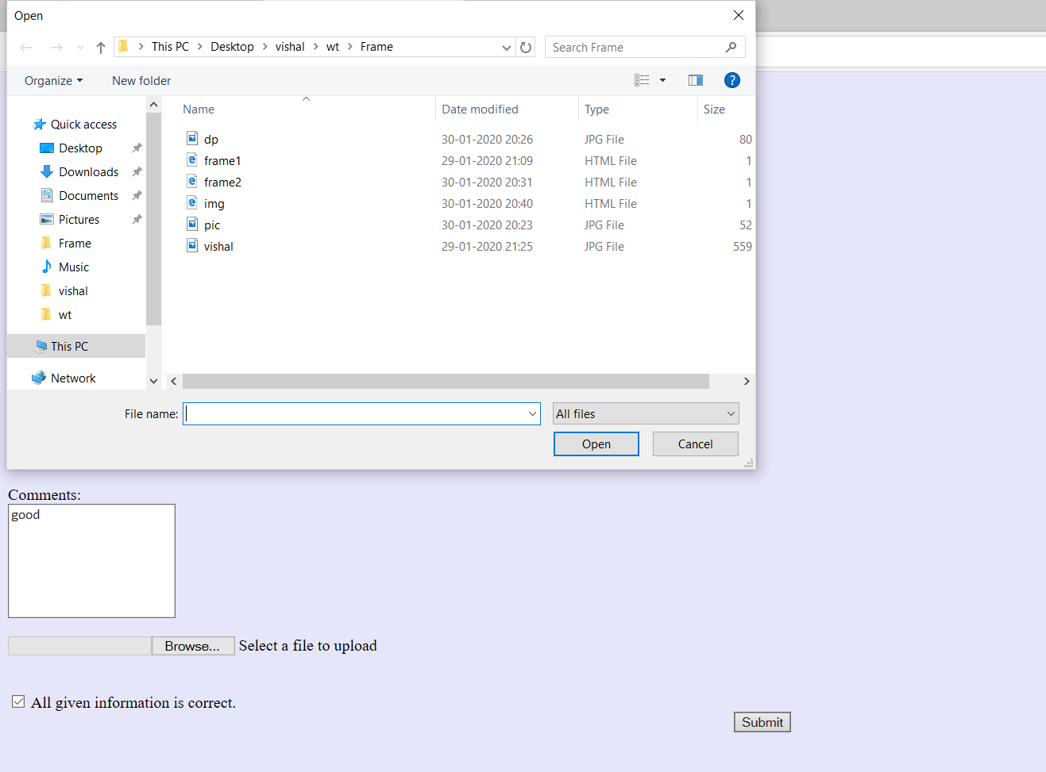

**Footer**



**Conclusion:**

Thus , from this experiment we learn more about what is html, HTML tags, different types of form controls in HTML and create Resume page in html by using different sections.