This is a sample pdf for Testing Tabvision

Lorem Ipsum

|  |  |  |  |
| --- | --- | --- | --- |
| S.No. | Food Name | Food Type | IsDelicious |
| 1 | Apple | Satvik | Yes |
| 2 | Onion | Rajsik | No |
| 3 | Chicken | Tamsik | Yes |

The above table describes about the different types of food with their types according to Hindu culture. It is a pure table form in pdf.

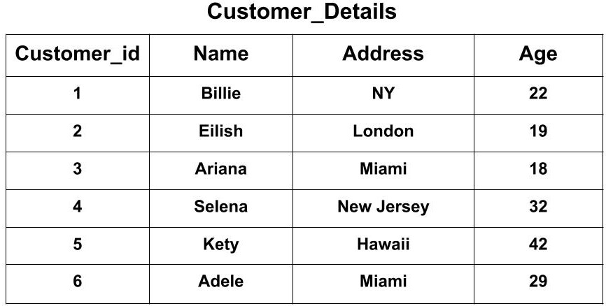

The above table is a table image and data needs to extracted from it. It contains detail regarding customers.

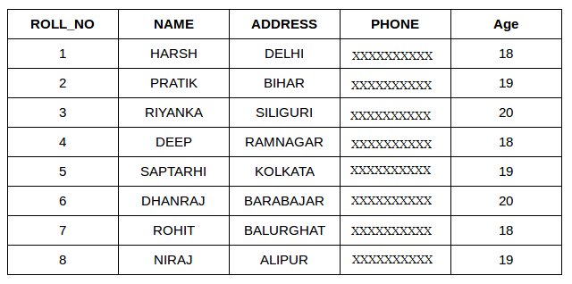

Another table image in the document. It contains information regarding some people.

Next table contains information regarding Students with their name and some information regarding capstone project:

|  |  |  |
| --- | --- | --- |
| Roll Number | Student Name | CPG No |
| 102003265 | Vishal Sehgal | CPG210 |
| 102016073 | Sajeev Yadav | CPG210 |
| 102016072 | Prakhar Dhama | CPG210 |
| 102003249 | Shivam Garg | CPG211 |

The only purpose to generate this pdf is to check the accuracy of the Tabvision’s Logo as well as Table QA bot.