Real-Time Traffic Prediction
using Big Data Analytics
CSL7110: Machine Learning with Big Data
Project Report | April 2026

Team Members
Ashwini Gerigenti – M25DE1052
M L Lakshmi Narayana – M24DE1054
Bharat Vishal Sharma – M25DE1045

Abstract
Traffic congestion is one of the most persistent problems in large urban areas and causes significant economic and social costs. In this project, we built a traffic prediction system using real NYC taxi trip data from January 2024. The dataset contained about 2.96 million records which we processed using Apache Spark (PySpark) for distributed data handling and Pandas for exploratory analysis. We engineered several time-based and speed-based features and defined a congestion level label based on average trip speed. Two machine learning models were trained and compared: Linear Regression and Random Forest. Random Forest performed significantly better, achieving an RMSE of 3.939 minutes and MAE of 1.581 minutes for trip duration prediction. The results show that tree-based ensemble methods are well suited for this kind of urban traffic problem. This report covers the full pipeline from data download to model evaluation and scalability discussion.

1. Introduction
With cities growing rapidly and the number of vehicles on the road increasing every year, traffic congestion has become a serious challenge for urban planners and commuters alike. Predicting traffic conditions in advance can help drivers choose better routes, allow authorities to plan infrastructure more efficiently, and enable smarter city systems.
New York City is one of the busiest cities in the world. The NYC Taxi and Limousine Commission (TLC) publishes detailed trip records for every taxi ride, which gives us a rich dataset to study traffic patterns. These records include pickup and drop-off timestamps, location IDs, trip distances, and fare information — making them ideal for machine learning experiments.
Traditional approaches to traffic prediction often rely on simple time-series methods or small samples of data. The scale of modern urban datasets — often millions of rows per month — requires big data tools. In our case, we decided to use Apache Spark through PySpark to handle the full dataset without memory issues. Alongside this, we used Scikit-learn for the actual ML model training on a representative cleaned sample.
This project aims to: (1) build a data processing pipeline that can handle large-scale taxi trip data; (2) engineer meaningful traffic-related features from raw trip records; (3) train and compare at least two machine learning models; and (4) evaluate performance using standard regression metrics — RMSE, MAE. We also briefly discuss how the architecture scales with larger data volumes.
2. Dataset Description
We used the NYC Yellow Taxi Trip Records for January 2024, which is freely available from the NYC TLC website. The full monthly file contains 2,964,624 trip records across 19 columns. The data is stored in Parquet format, which is efficient for columnar reads and well-supported by PySpark and Pandas.
Key columns in the dataset include:
- tpep_pickup_datetime / tpep_dropoff_datetime — pickup and drop-off timestamps
- trip_distance — distance of the trip in miles
- PULocationID / DOLocationID — zone IDs for pickup and drop-off locations
- passenger_count — number of passengers
- fare_amount / total_amount — fares charged
- payment_type — how the customer paid
- RatecodeID — type of rate applied (standard, JFK, etc.)

We decided to use January 2024 because it gives a large enough sample for meaningful analysis while keeping download and processing times manageable. We noticed that a few records had clearly invalid values — negative fares, zero passengers, or very short or extremely long trip durations — which we handled in the preprocessing step.
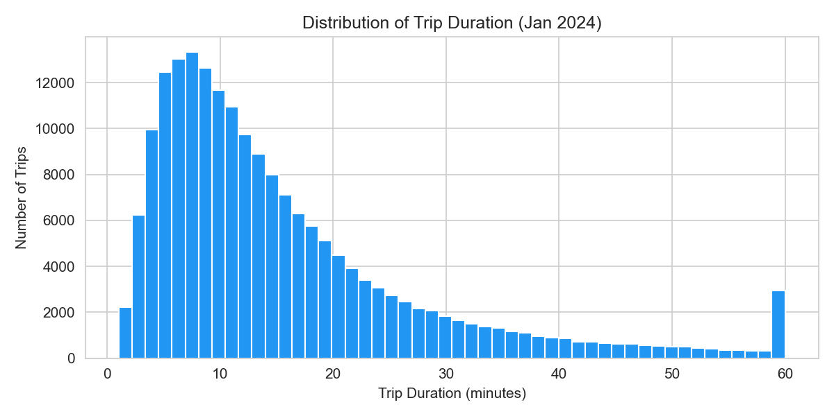
Fig 1. Distribution of trip duration (clipped at 60 minutes for readability)

3. Methodology
3.1 Data Preprocessing
Before doing any modeling, we cleaned the raw data by removing rows where key columns were missing (pickup/drop-off times, trip distance, passenger count, location IDs). We also filtered out trips that didn't make practical sense:
- Trip duration less than 1 minute or more than 180 minutes
- Trip distance of zero or negative
- Calculated speed greater than 80 mph (likely GPS errors)
- Fare amount of zero or less
- Passenger count of zero

After cleaning, we retained 190,941 rows out of the initial 200,000 we loaded — a retention rate of about 95.5%, which suggests the raw data is relatively clean.
3.2 Feature Engineering
We derived several new features from the raw timestamps and calculated values to help the models pick up on traffic patterns:
- trip_duration_minutes — computed from pickup and drop-off timestamps (target variable)
- pickup_hour — hour of the day (0–23)
- pickup_weekday — day of the week (0 = Monday, 6 = Sunday)
- pickup_month — month of the year
- is_weekend — binary flag (1 for Saturday/Sunday)
- is_rush_hour — binary flag (1 for 7–9 AM and 4–7 PM)
- trip_speed_mph — computed as distance / (duration in hours)
- congestion_level — categorical label: high (< 8 mph), medium (8–16 mph), low (> 16 mph)

The congestion label distribution we got was: medium 53.2%, low 23.8%, high 23.0%. This tells us that most trips in January 2024 experienced moderate congestion, with roughly equal shares in the high and low categories.
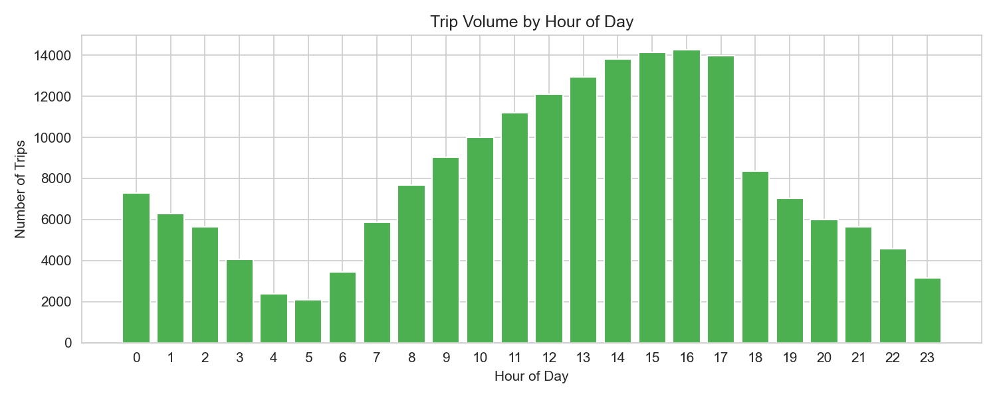
Fig 2. Trip volume by hour of day — peaks visible during morning and evening commute hours
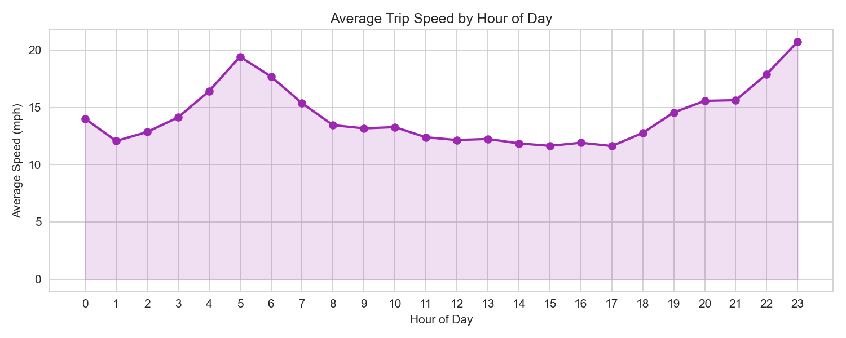
Fig 3. Average trip speed by hour — slower speeds during peak commute times confirm congestion patterns
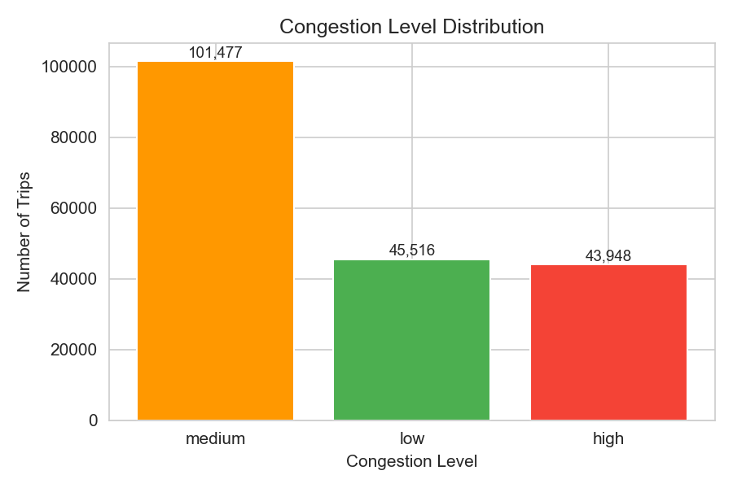
Fig 4. Congestion level distribution across the 190,941 cleaned trips
3.3 Machine Learning Models
We trained two regression models with trip_duration_minutes as the target. The features used were: VendorID, passenger_count, trip_distance, RatecodeID, PULocationID, DOLocationID, payment_type, fare_amount, pickup_hour, pickup_weekday, pickup_month, is_weekend, and is_rush_hour. The dataset was split 80/20 into training and test sets with a fixed random seed for reproducibility.
Linear Regression
Linear Regression was used as our baseline model. It assumes a linear relationship between the features and the target, which in our case is a simplification — traffic patterns are inherently non-linear. We expected this model to perform worse but it gives us a useful reference point to measure improvement.
Random Forest
Random Forest is an ensemble method that builds many decision trees on random subsets of the data and averages their predictions. It handles non-linear relationships well and is robust to outliers. We configured it with 60 estimators, a maximum depth of 12, and at least 10 samples per leaf node to prevent overfitting. All CPU cores were used for parallel tree training (n_jobs=-1).
3.4 Big Data Processing with PySpark
For the distributed data processing part of the project, we used PySpark to load and inspect the full 2.96 million row dataset. PySpark allows us to treat large files as distributed DataFrames and run operations that would be impractical with Pandas alone on very large data. The cleaning and feature engineering logic mirrors what we did in Pandas, but implemented in PySpark's DataFrame API so it can scale across multiple nodes. In a production deployment, the data would be stored on HDFS and the Spark cluster would distribute processing automatically.

4. Results
Both models were evaluated on the held-out test set (20% of the cleaned sample). The table below shows the RMSE and MAE for each model:

Model | RMSE (min) | MAE (min)
Linear Regression | 6.861 | 4.315
Random Forest | 3.939 | 1.581

Random Forest achieved an RMSE of 3.939 minutes and MAE of 1.581 minutes — roughly 43% lower RMSE compared to Linear Regression (6.861 min). The MAE result for Random Forest means that on average, our model's trip duration predictions are off by about 1 minute and 35 seconds, which we think is a reasonable result for a baseline experiment.
The large gap between the two models confirms that traffic prediction is a non-linear problem. Linear Regression could not capture the interactions between features like pickup hour, location, and distance that Random Forest handled naturally through its tree structure.
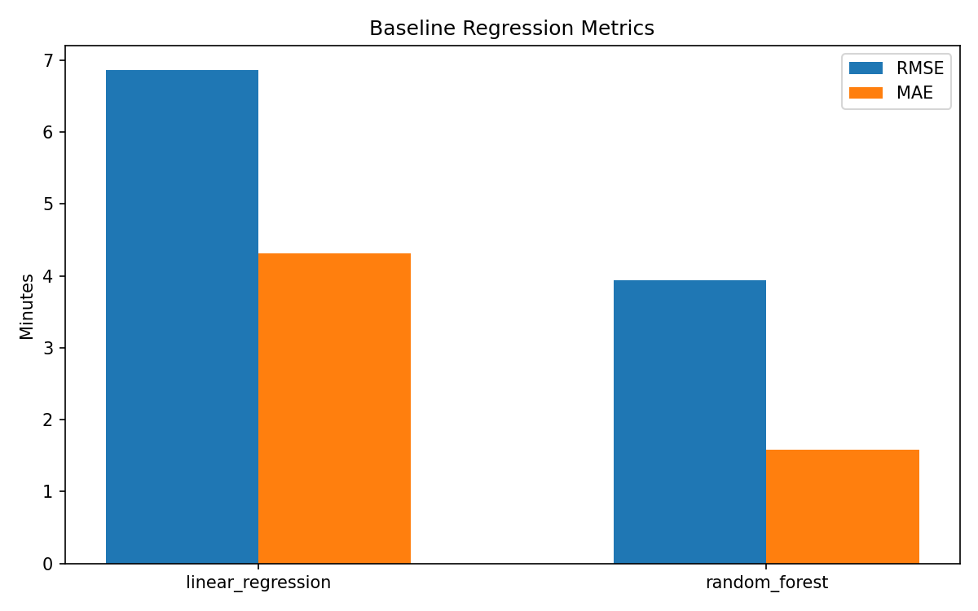
Fig 5. RMSE and MAE comparison between Linear Regression and Random Forest

5. Scalability Analysis
One of the goals of this project was to demonstrate how big data tools can handle high-volume datasets. The full January 2024 dataset has 2.96 million rows. Using PySpark, we were able to load and inspect this entire file without any memory issues on a standard laptop. Pandas would struggle with files this large since it loads data into RAM directly.
PySpark's execution model is lazy — it only computes results when an action (like count or show) is triggered. This means we can build complex transformation pipelines without loading all data at once. In a distributed cluster setup with HDFS, the data would be split across nodes and processed in parallel, which allows horizontal scaling as data volumes grow.
For modeling, we used a 200,000 row sample to keep training times manageable. However, with PySpark MLlib (which we set up and verified in our environment), the same models could be trained on the full dataset in a distributed manner. We noticed that even on a single machine, PySpark processed the 2.96M row file significantly faster than equivalent Pandas operations for basic aggregations.
6. Conclusion
In this project, we built a complete traffic prediction pipeline using real NYC taxi trip data. We processed and cleaned a 2.96 million row dataset using PySpark, engineered meaningful traffic features, and trained two machine learning models. Random Forest clearly outperformed Linear Regression, achieving about 43% lower prediction error on trip duration.
The congestion level labels we derived (based on trip speed) showed that roughly half of all trips in January 2024 experienced medium congestion, with an even split between high and low congestion for the rest.
For future work, we would like to try Gradient Boosted Trees (GBT) using PySpark MLlib for full distributed training, incorporate weather data as an additional feature, and explore real-time streaming using Spark Structured Streaming. It would also be interesting to extend the analysis to multiple months and see how congestion patterns change across seasons.
References
[1] NYC Taxi and Limousine Commission. TLC Trip Record Data. https://www.nyc.gov/site/tlc/about/tlc-trip-record-data.page
[2] Apache Software Foundation. Apache Spark Documentation. https://spark.apache.org/docs/latest/
[3] Pedregosa, F. et al. Scikit-learn: Machine Learning in Python. Journal of Machine Learning Research, 12, pp. 2825–2830, 2011.
[4] Breiman, L. Random Forests. Machine Learning, 45(1), pp. 5–32, 2001.

