**My First Step - First Ride**

I was always fascinated about Travel, places, traverse enchanted land and meeting new peoples. After a long wait I got a chance to make a start for it.

We (me and my friends) were planning to go on bike ride and desperately looking for a place nearby and close to nature and most important near to Mumbai (within 150km). First point to choose nearby place because we were not having much experience of riding and this will be our first ride. So we did not want to have any casualty or problem on our first bike ride. After a bit of research over internet and hearing positive feedback about the place from various friends and colleagues, we settled on Matheran and date is December 19, 2015.

[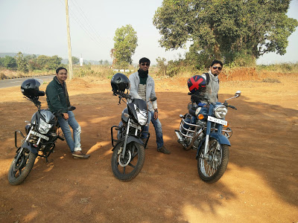](https://2.bp.blogspot.com/-dssKUP3jpKs/WyjJw2O-F8I/AAAAAAAAU58/1vp3d3g4zi02jsehyDHagGPHTCMtiozNACPcBGAYYCw/s1600/IMG_20151219_100908.jpg)

Since the ride was 105 KM one way and route is very much easy, so we were not much worried about reaching destination. As I said it was our first ride, so everyone was so excited and charged up and unexpectedly everyone was on time. We started our journey from Borivali around 6.30AM. First one hour was nice, cool and fast. Crossed Thane via Ghodbunder and reached Mumbra. Post Mumbra the state highway passes through a locality. Roads are bad with huge bumpy speed breakers and with huge potholes. There were lots of huge trucks passing through. We rode for one and half an hour on bad patch and were greeted with shiny road with a new layer of tar. Roads were empty, wide and little or no vehicles. That blank stretch of road was tempting and we gained good speed. We took first halt almost after 2 hours of ride, near Badlapur. We were tired of bumpy ride, so nice tea and breakfast was felt like heavenous.

[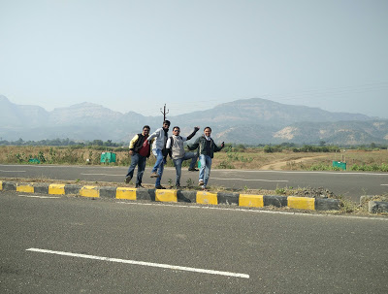](https://3.bp.blogspot.com/-m-ZJlZv8UUM/WzDqEvJFI9I/AAAAAAAAVFs/hM1lo_6UChYNKesJfK3c7tLrJdZqGg9RgCKgBGAs/s1600/IMG_20151219_103218.jpg)

We started our journey after 30 minutes or so, now roads were unknown to everyone, so we were heading little bit cautiously. Somewhere near some village we got a good spot for photo session. When you go on a bike ride, photo session is mandatory to capture a scenic beauty. This part of Raigad district gives you a good eye soothing landscape. It makes you feel like you just sat there and look at those scenic beauties. Soon we reached the base village of the hill station and started riding up the winding roads. It took roughly 15-20 minutes to reach the top but those hairpin bends and elevation took us around 45 minutes to reach top. You have to drive only in 1st gear on those turns, so much so that the tourism dept. has placed sign boards of 1st Gear on the road side.

[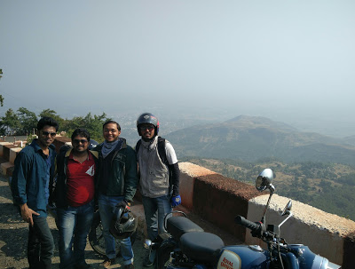](https://3.bp.blogspot.com/-zXn6NWX8CeA/WyjKoLh8XKI/AAAAAAAAU6E/CJO3noka-SQLTKYdJ1U2dDaL-r2oANLQwCKgBGAs/s1600/IMG_20151219_105812.jpg)

Parking area is outside main attraction point, near tourism dept/ticket counter and private vehicles are not allowed to enter the hill station (There is no safe parking place, so parking is at your own risk). You can use Hand Rickshaw or horses for mobility on the hill station. Horses are costly, they can charge you Rs.250-400 from the main gate to market, and this would be around 10 minutes saddle bump. We were on budget trip so we decided to walk till main market. It took around 25 minutes to reach market and finally we reach around 12:30 PM. I would suggest everyone to wear good trekking shoe and mostly not to wear white shoes. In Matheran you will get red soil which will make your white shiny shoe into red muddy and dirty.

After having good walk, we decided that we should have lunch first and then move forward to other activity. As Matheran is famous place, there are varieties of good restaurants’ available in main market. Food we had was good but bit costly. After lunch we started our journey. Instead of roaming around market we headed for interesting points.

|  |  |
| --- | --- |
| * Charlotte Lake | * One Tree Hill Point |
| * Sunset Point | * Louisa Point |
| * Hart Point | * Panorama Point |
| * Rambagh Point | * Monkey Point |

|  |
| --- |
|  |

[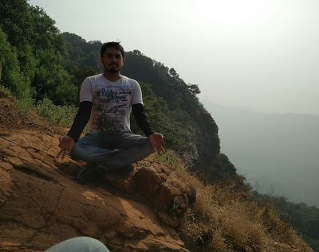](https://4.bp.blogspot.com/-WB9M9kcCO_8/WyjKz0NI56I/AAAAAAAAU6I/ED-vvX4TTgMM79o4AwPzUP8lvbp3OKC3wCKgBGAs/s1600/IMG_20151219_145742.jpg)

[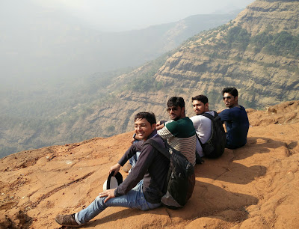](https://4.bp.blogspot.com/-IfIsZdx5CNQ/WyjKz2uLRUI/AAAAAAAAU6I/YXE87nkGZm8SJUeu2OH-_qwU_B9fo9FegCKgBGAs/s1600/IMG_20151219_144909.jpg)

[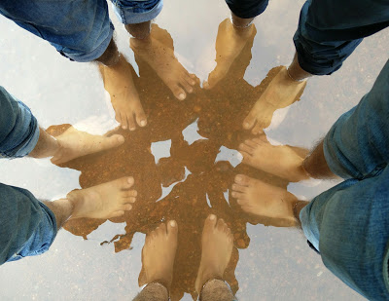](https://4.bp.blogspot.com/-BSHithI50ak/WyjLWuKOEbI/AAAAAAAAU6U/xFS8fkq1KiAUE-iPF2_H4pDC4cM8JDUUACKgBGAs/s1600/IMG_20151219_160246.jpg)

 After roaming around 2-3 hrs and clicking hundreds of photo, we were bit tired. We had snacks near to Charlotte Lake; food was good but too costly. We covered some famous points and returned to main market. In the main market we saw Bungee Jumping Trampoline or Rocket launcher but we were not sure what it is so we tried that too. It was so much fun, one should try. After that we started return journey around 6:00PM. We wanted and also completed difficult part of journey in day light.

Return journey is always quick but it was very tiring. We took so many breaks in return journey; these high beam lights and big line of trucks were forcing us to do so. We stopped at same place where we stopped in the morning. We wanted to have to burji (Masala scrambled egg) pav, so we asked uncle to make an egg burji. Usually it takes around 10 minutes max but uncle took around 45 minutes. But it was worth waiting for. It was so delicious and mouth melting. We reached home around 10:30 PM and ended the tour with a soul-satisfying bath.

Hope you liked it! Do leave a comment, it means a lot to me.