**\*\* Stack \*\***

# Java Stack

1. The **stack** is a linear data structure that is used to store the collection of Objects.
2. It is based on **Last-In-First-Out** (LIFO).
3. [Java collection](https://www.javatpoint.com/collections-in-java) framework provides many interfaces and classes to store the collection of objects.
4. One of them is the **Stack class** that provides different operations such as push, pop, search, etc.
5. It also implements interfaces **List, Collection, Inerrable, Clone able, Serializable.**
6. Real world example of stack is
   1. Undo
   2. Reverse String/Number
   3. Balance parenthesis problem.
7. It implements list Interface.
8. It is child class of vector.
9. It follows LIFP (**Last-In-First-Out**).
10. It incremental factor is as :

New Capacity = current capacity * 2.

1. To reverse the word : we need the last inserted character first We can get it with Stack because it words on LIFO.
2. Undo Operation : is also based on Stack.
3. Backtracking : we go one step back, in the also we used the stack ,

Also back option in brower.

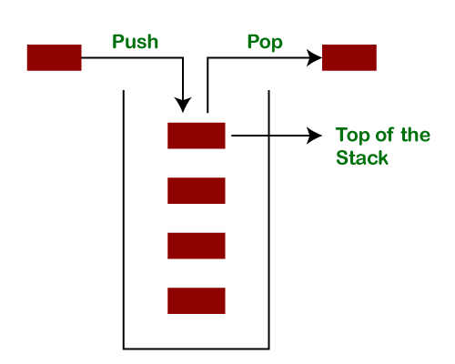

Let's push 20, 13, 89, 90, 11, 45, 18, respectively into the stack.

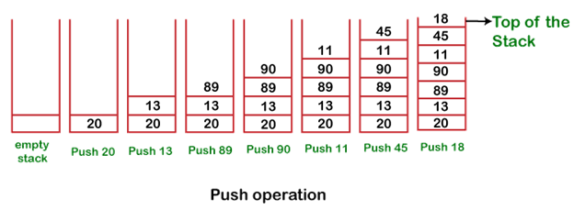

Let's remove (pop) 18, 45, and 11 from the stack.

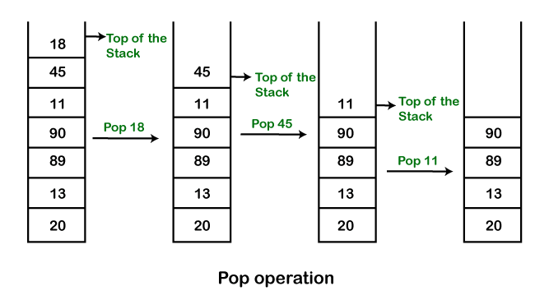

**Empty Stack:** If the stack has no element is known as an **empty stack**. When the stack is empty the value of the top variable is -1

**import** java**.**util**.*;**

class Q01_Stack_push

**{**

    public static void main**(**String args**[])**

**{**

        Stack st **=** **new** Stack**();**

        st**.**push**(**10**);**        st**.**push**(**20**);**        st**.**push**(**30**);**

        st**.**push**(**40**);**        st**.**push**(**50**);**

        System**.**out**.**println**(** st **);**

**}**

**}**

[10, 20, 30, 40, 50]

**import** java**.**util**.*;**

class Q02_Stack_push

**{**

    public static void main**(**String args**[])**

**{**

        Stack st **=** **new** Stack**();**

        System**.**out**.**println**(** st**.**size**()** **);**

        System**.**out**.**println**(** st**.**capacity**()** **);**

**for(**int i **=** 1**;** i  **<=** 10**;** i**++)**

            st**.**push**(**10**\***i**);**

        System**.**out**.**println**(** st**.**size**()** **);**

        System**.**out**.**println**(** st**.**capacity**()** **);**

        st**.**push**(**500**);**

        System**.**out**.**println**(** st**.**size**()** **);**

        System**.**out**.**println**(** st**.**capacity**()** **);**

**}**

**}**

0

10

10

10

11

20

1. Default Capacity of Stack is 10.

2. Increase Capacity for this fromula :

   new Capa. = Curr. * 2;

**import** java**.**util**.*;**

class Q03_Stack_Constructor

**{**

    public static void main**(**String args**[])**

**{**

        Stack st **=** **new** Stack**(**20**);**

**for(**int i **=** 1**;** i  **<=** 10**;** i**++)**

            st**.**push**(**10**\***i**);**

        System**.**out**.**println**(** st**.**size**()** **);**

        System**.**out**.**println**(** st**.**capacity**()** **);**

**}**

**}**

error: constructor Stack in class Stack<E> cannot be applied to given types;

                Stack st = new Stack(20);

                           ^

**import** java**.**util**.*;**

class Q04_Stack_peek

**{**

    public static void main**(**String args**[])**

**{**

        Stack st **=** **new** Stack**();**

        st**.**push**(**10**);**        st**.**push**(**20**);**        st**.**push**(**30**);**

        st**.**push**(**40**);**        st**.**push**(**50**);**

        System**.**out**.**println**(** st **);**

        System**.**out**.**println**(** st**.**peek**()** **);**

        System**.**out**.**println**(** st**.**peek**()** **);**

        System**.**out**.**println**(** st **);**

**}**

**}**

[10, 20, 30, 40, 50]

50

50

[10, 20, 30, 40, 50]

**import** java**.**util**.*;**

class Q05_Stack_pop

**{**

    public static void main**(**String args**[])**

**{**

        Stack st **=** **new** Stack**();**

        st**.**push**(**10**);**        st**.**push**(**20**);**        st**.**push**(**30**);**

        st**.**push**(**40**);**        st**.**push**(**50**);**

        System**.**out**.**println**(** st **);**

        System**.**out**.**println**(** st**.**pop**()** **);**

        System**.**out**.**println**(** st**.**pop**()** **);**

        System**.**out**.**println**(** st **);**

**}**

**}**

[10, 20, 30, 40, 50]

50

40

[10, 20, 30]

**import** java**.**util**.*;**

class Q06_Stack_pop

**{**

    public static void main**(**String args**[])**

**{**

        Stack st **=** **new** Stack**();**

        System**.**out**.**println**(** st**.**pop**()** **);**

        //System.out.println( st.peek() );

        System**.**out**.**println**(** st **);**

**}**

**}**

Exception in thread "main" java.util.EmptyStackException

**import** java**.**util**.*;**

class Q07_Stack_empty

**{**

    public static void main**(**String args**[])**

**{**

        Stack st **=** **new** Stack**();**

        System**.**out**.**println**(** st**.**empty**()** **);**

        st**.**push**(**10**);**        st**.**push**(**20**);**

        st**.**push**(**30**);**        st**.**push**(**40**);**

        st**.**push**(**50**);**        st**.**push**(**60**);**

        System**.**out**.**println**(** st**.**empty**()** **);**

**}**

**}**

true

false

**import** java**.**util**.*;**

class Q08_Stack_Search

**{**

    public static void main**(**String args**[])**

**{**

        Stack st **=** **new** Stack**();**

        st**.**push**(**10**);**        st**.**push**(**20**);**        st**.**push**(**30**);**

        st**.**push**(**40**);**        st**.**push**(**50**);**

        System**.**out**.**println**(** st**.**search**(**20**)** **);**

        System**.**out**.**println**(** st**.**search**(**200**)** **);**

        System**.**out**.**println**(** st**.**search**(**50**)** **);**

        System**.**out**.**println**(** st**.**search**(**10**)** **);**

**}**

**}**

4

-1

1

5

.search() method doesn't return int of founded element it return the number

by which it will be poped.