**Assignment No: 3**

**Title / Objective**: Embedded C Program for Memory Block Transfer

Problem Statement: Write an Embedded C program to transfer elements from one location to another for following: i) Internal to internal memory transfer ii) Internal to external memory transfer

**INPUT:**

INTERNAL TO INTERNAL

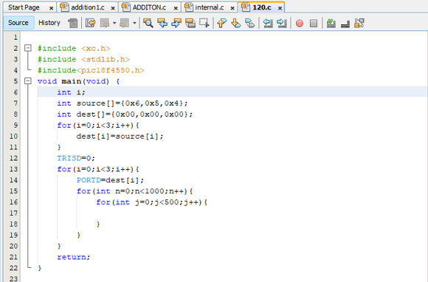

INTERNAL TO EXTERNAL

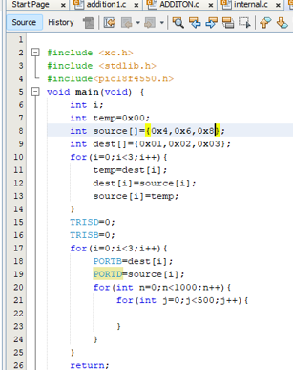

**OUTPUT:**

INTERNAL TO INTERNAL:

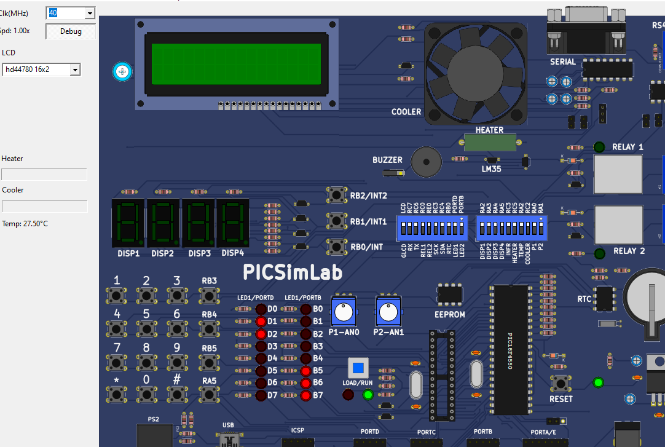

INTERNAL TO EXTERNAL: 