Name: Vishal Sule

Roll No:-234

PRN:-0120190064

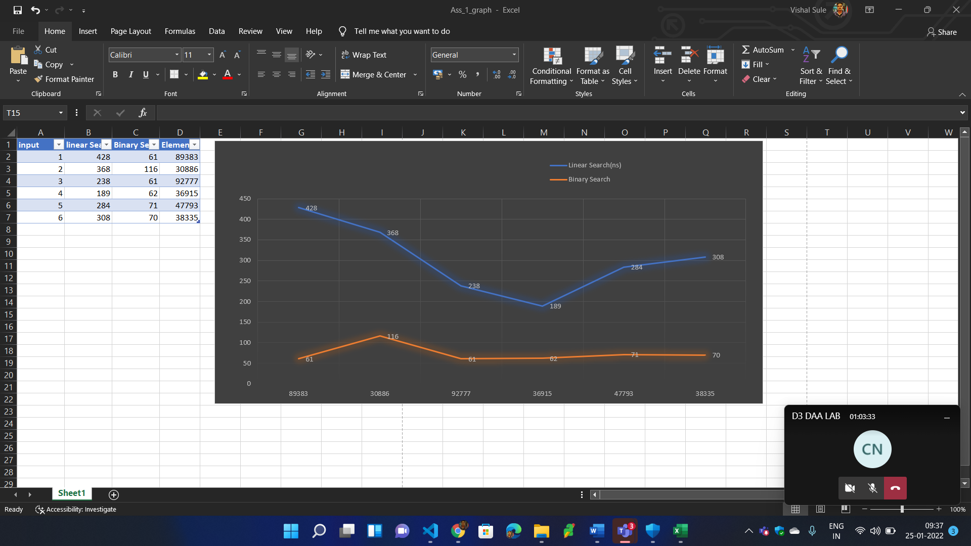

Code:

#include<iostream>

#include <bits/stdc++.h>

#include <algorithm>

#include <chrono>

//#include<vector>

using namespace std;

using namespace std::chrono;

int linearSearch(int a[], int n, int val){

for(int i=0; i<n ; i++){

if(a[i]==val){

return i;

}

}

return -1;

}

int binarySearch(int a[], int val, int start, int end){

while( start <= end){

int mid = start + ((end - start)/2);

if(a[mid]==val){

return mid;

}

if(a[mid] < val){

start = mid+1;

}

else{

end = mid-1;

}

}

return -1;

}

int main(){

int n,val;

cout<<"\nEnter no. of elements(n) : ";

cin>>n;

int a[n];

for(int i=0; i<n ; i++){

a[i] = rand()%100000;

}

sort(a, a + n);

cout<<"\n Sorted Array Elements : ";

for(int j=0; j<n ; j++){

cout<<" "<<a[j];

}

int s=1;

while(s!=0){

cout<<"\nEnter the value for search :";

cin>>val;

//

cout<<"\n------<< Linear Search >>------"<<endl;

auto start = high_resolution_clock::now();

int index = linearSearch(a,n,val);

auto stop = high_resolution_clock::now();

auto duration = duration_cast<nanoseconds>(stop - start);

cout << "\nTime taken by function: "<< duration.count() << " nanoseconds";

if(index==-1){

cout<<"\nValue not found";

}else{

cout<<"\nNumber "<<val<<" is present at position "<<index+1;

}

//

cout<<"\n\n------<< Binary Search >>------"<<endl;

start = high_resolution_clock::now();

int index1 = binarySearch(a , val, 0, n-1);

stop = high_resolution_clock::now();

duration = duration_cast<nanoseconds>(stop - start);

cout << "\nTime taken by function: "<< duration.count() << " nanoseconds";

if(index1==-1){

cout<<"\nValue not found";

}else{

cout<<"\nNumber "<<val<<" is present at position "<<index+1;

}

//

cout<<"\nTo search again press 1 / to exit press 0 : ";

cin>>s;

if(s==0){

break;

}

}

return 0;

}

//Output:

