**Steps need to follow to Understand MongoDB**

Step1:

Go to this location and open cmd

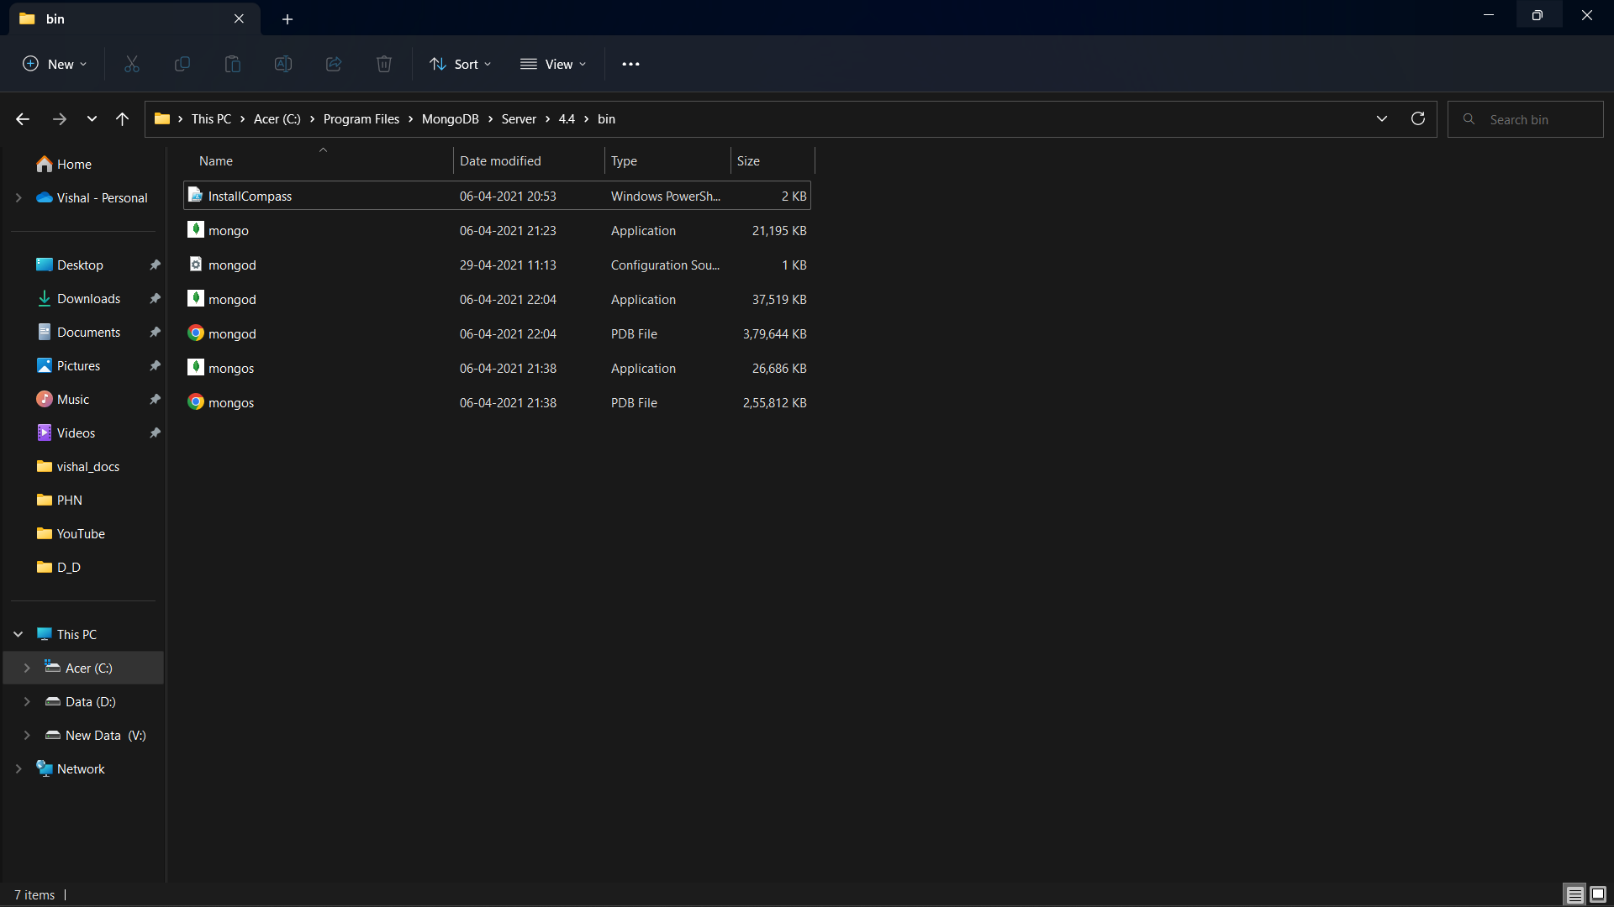

Step 2:

Enter the command “mongod”

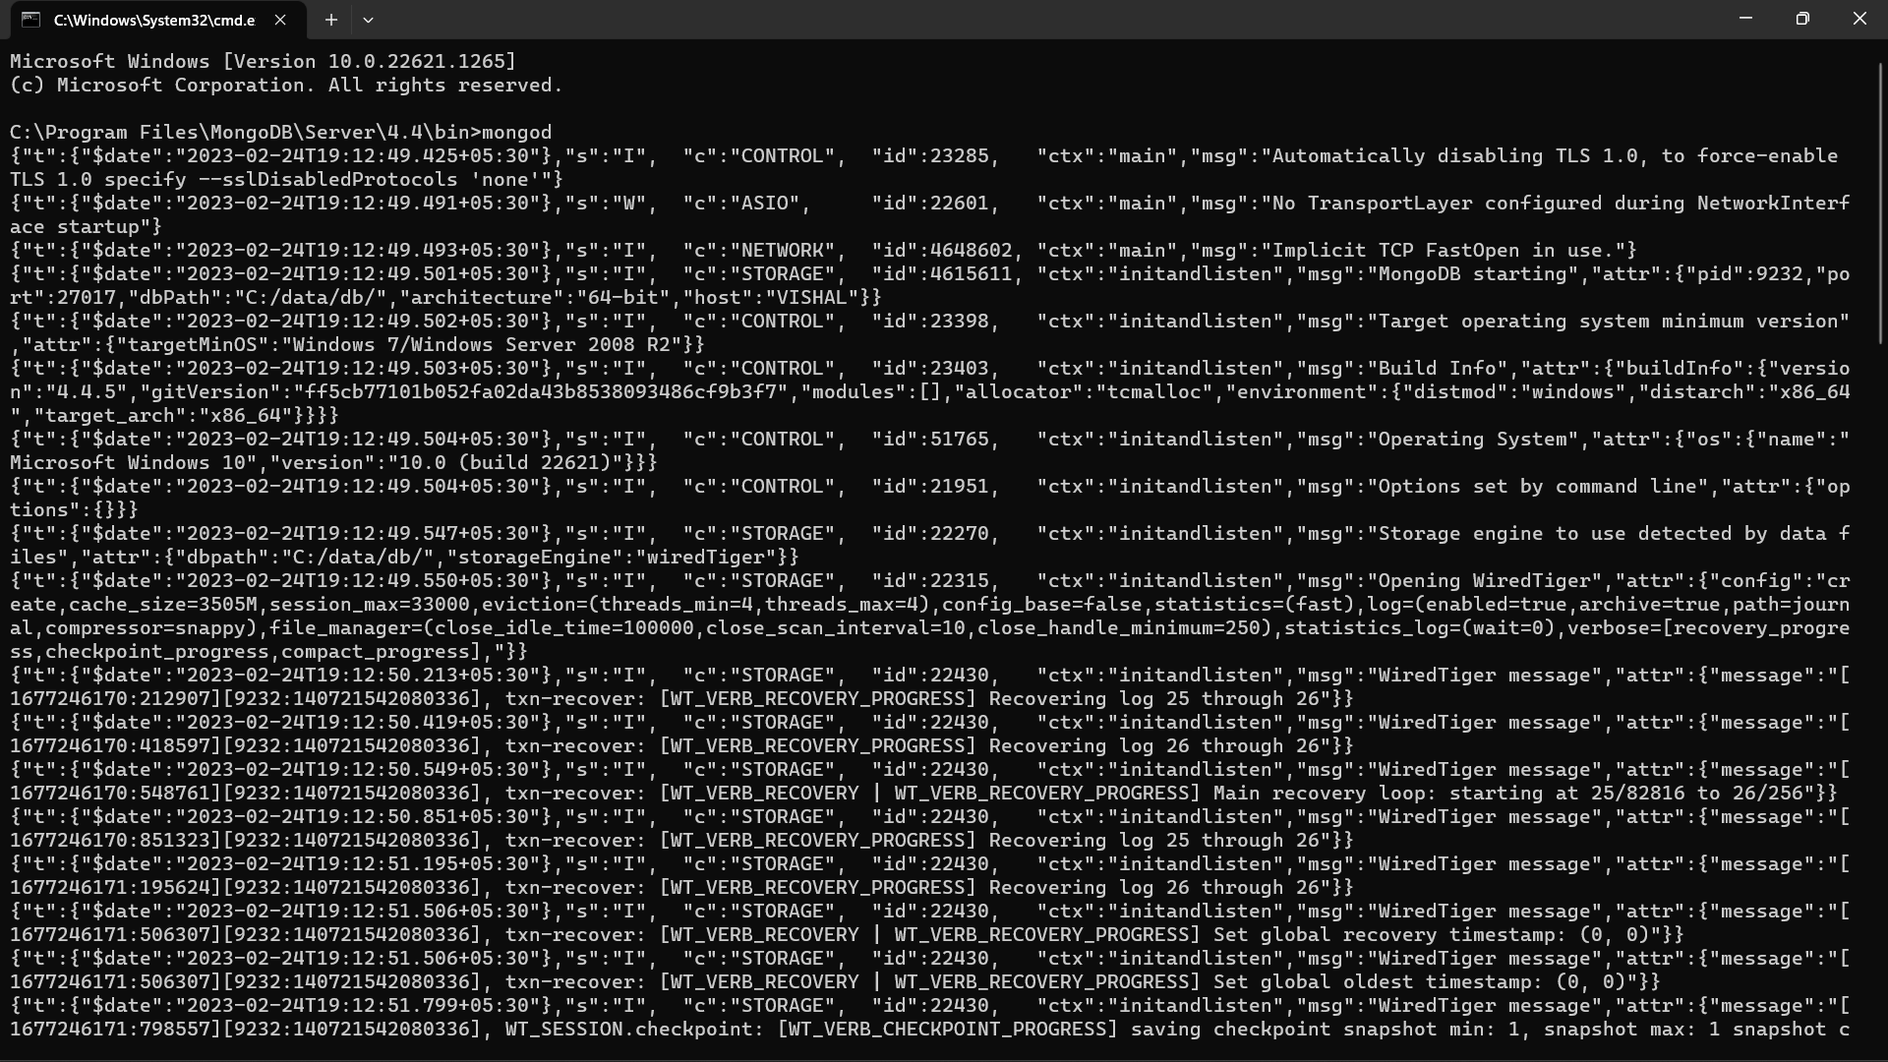

Step 3: Use the Same File Location



Step 4:

Open a new cmd with this file location. 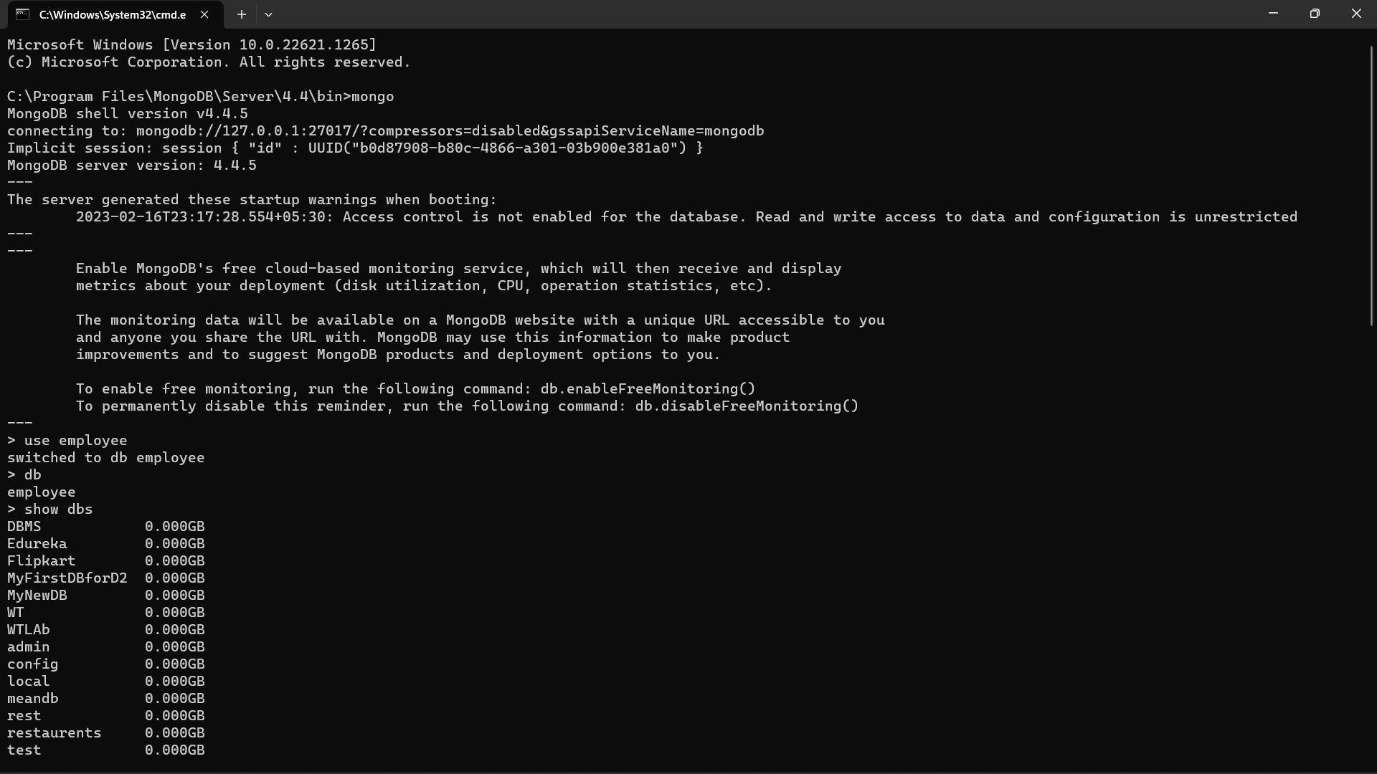

Step 5:

To create a new database just type “use DatabaseName”



Step 6:To check databases

Just type ”show dbs”



Step7:

To insert data in the database

Just type this command.

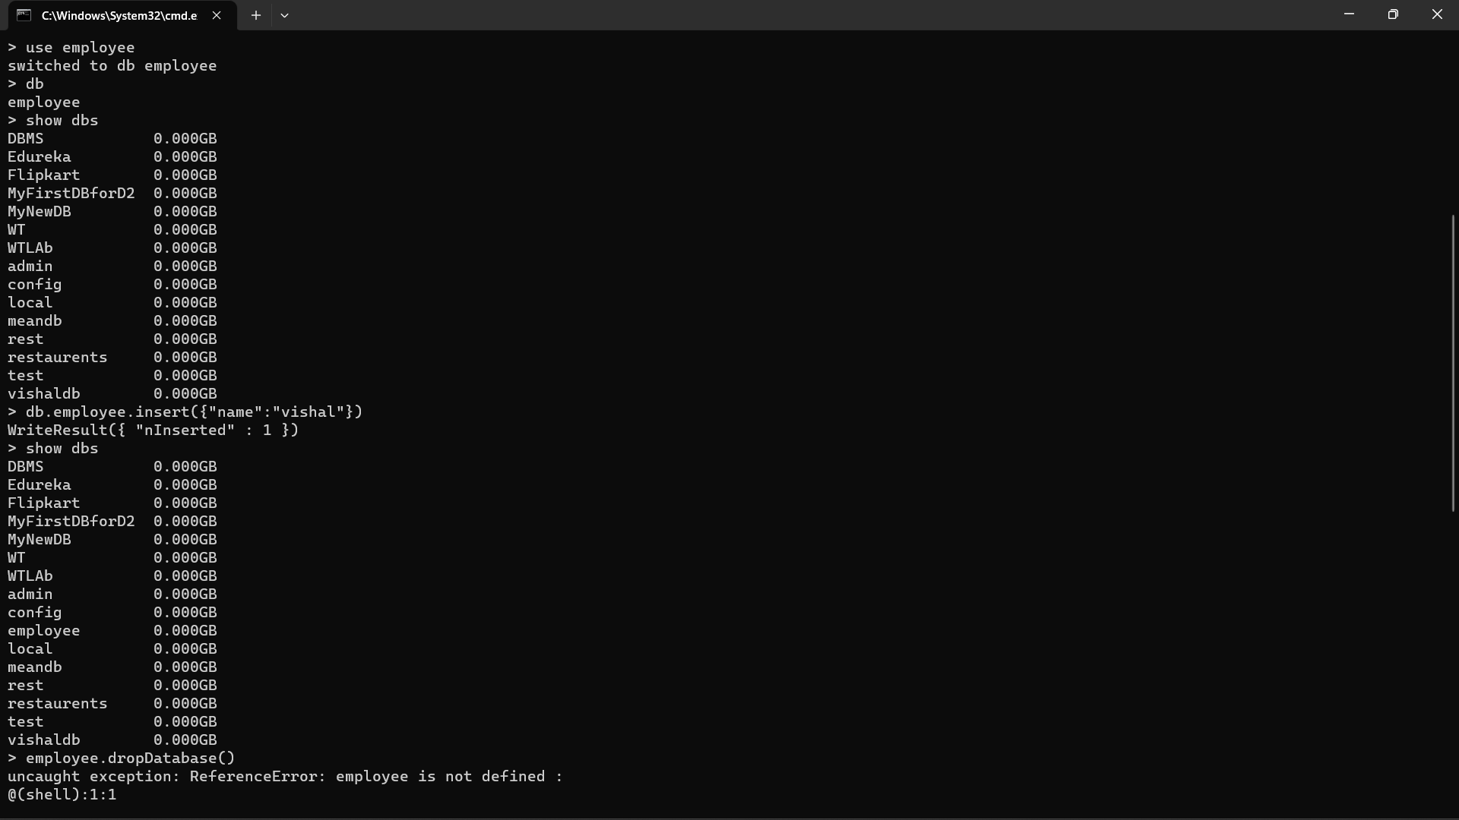

Step 8: To Drop the Database

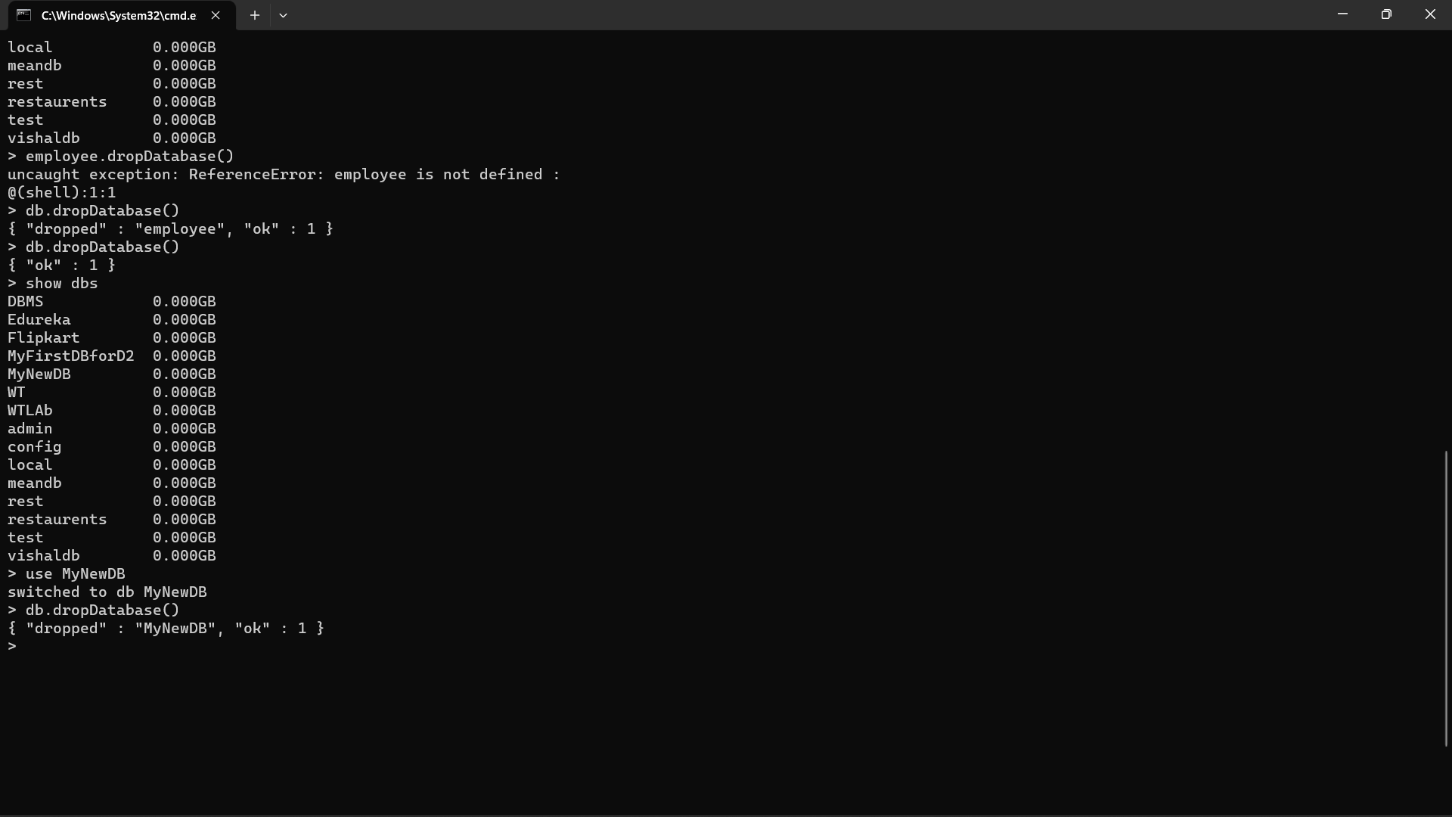

Step 9:To Create new Collection

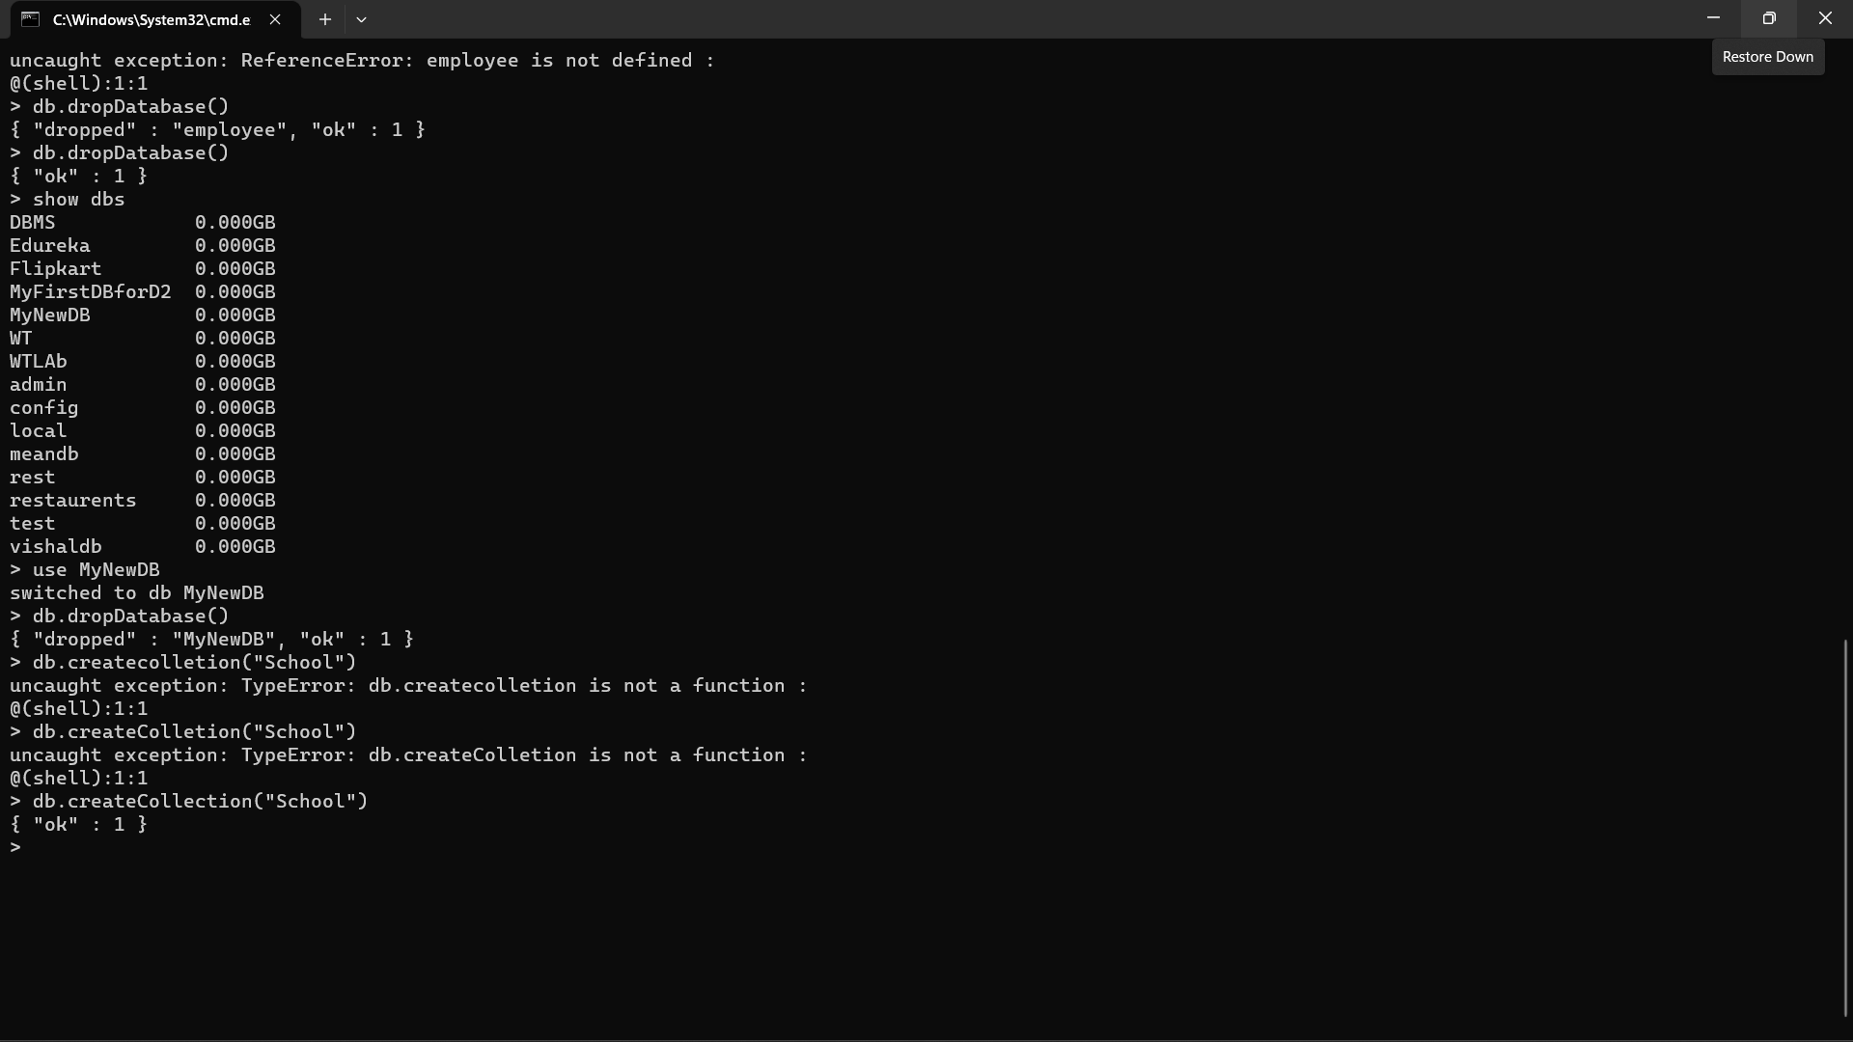

Step 10:

To see collections

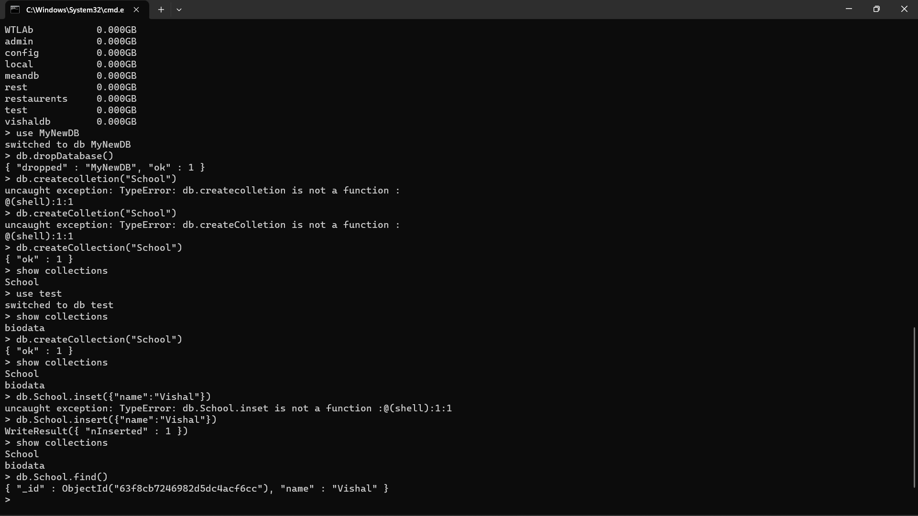

Step11:

Insert Data into collection

Command: “db.collectionName.insert({“name”:”Vishal”})



Step 12:

To see if Data is present in the collection

Command: “db.collectionName.find()”



Step 13:

To Insert multiple data at the same time just follow this command

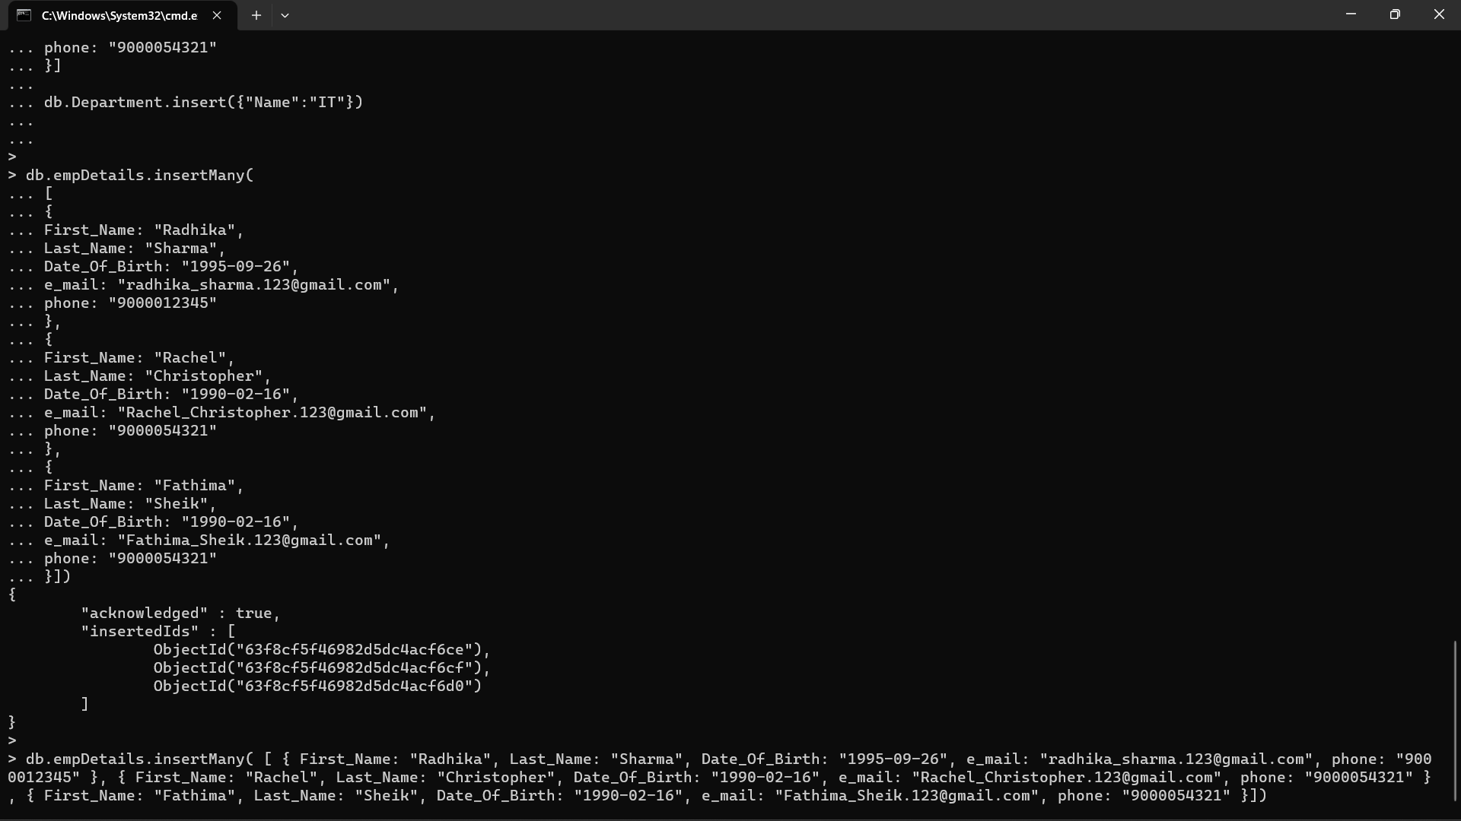

Output of success

