Steps need to follow to Understand MongoDB

Step1:
Go to this location and open cmd
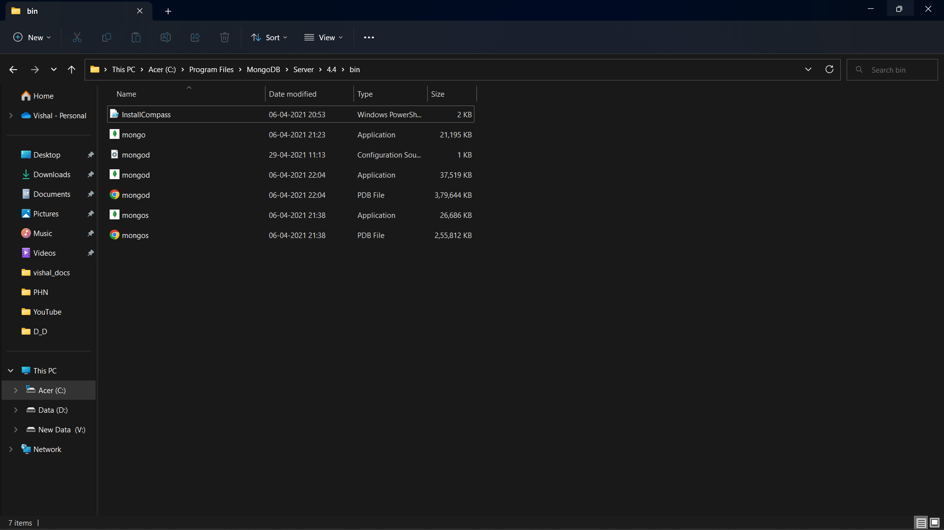
Step 2:
Enter the command “mongod”
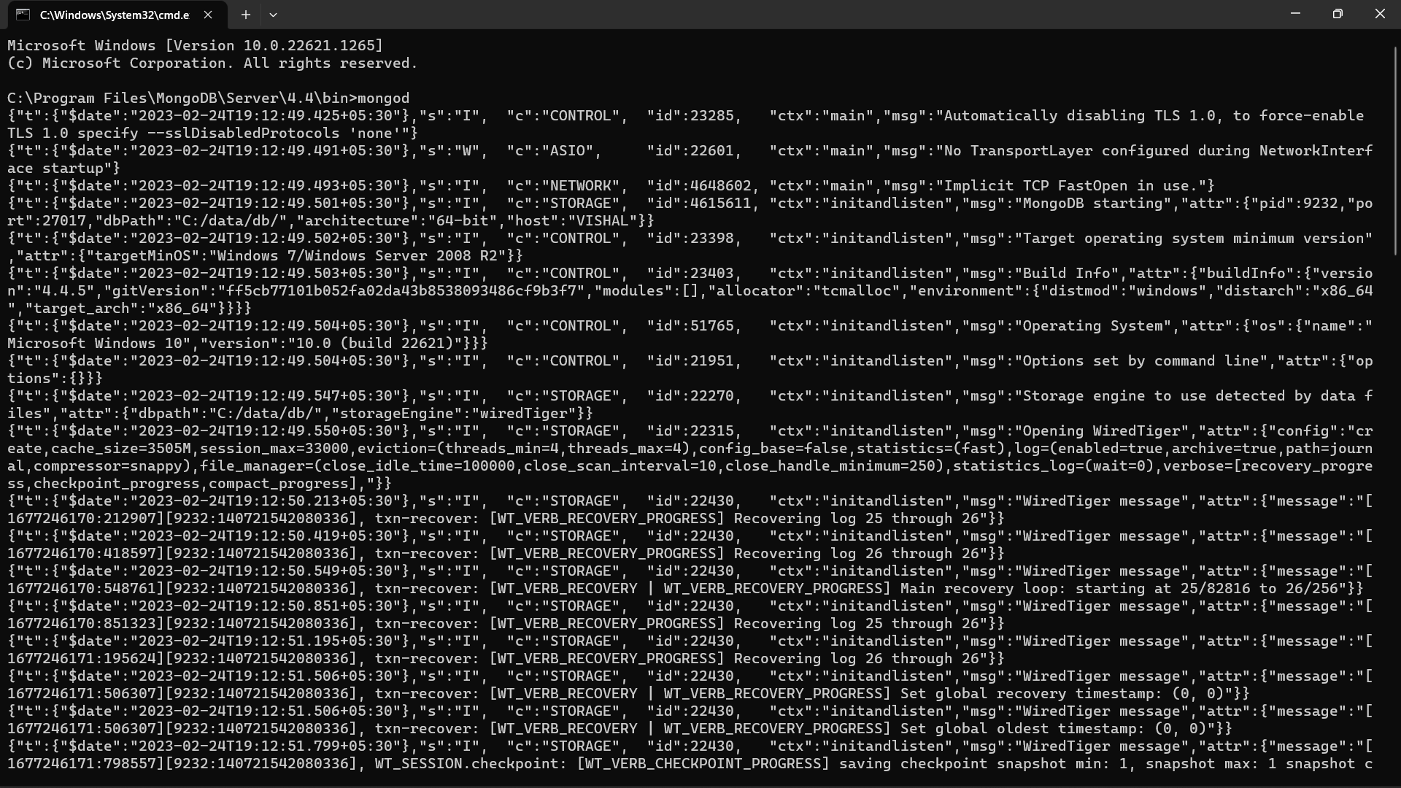

Step 3: Use the Same File Location

Step 4:
Open a new cmd with this file location. 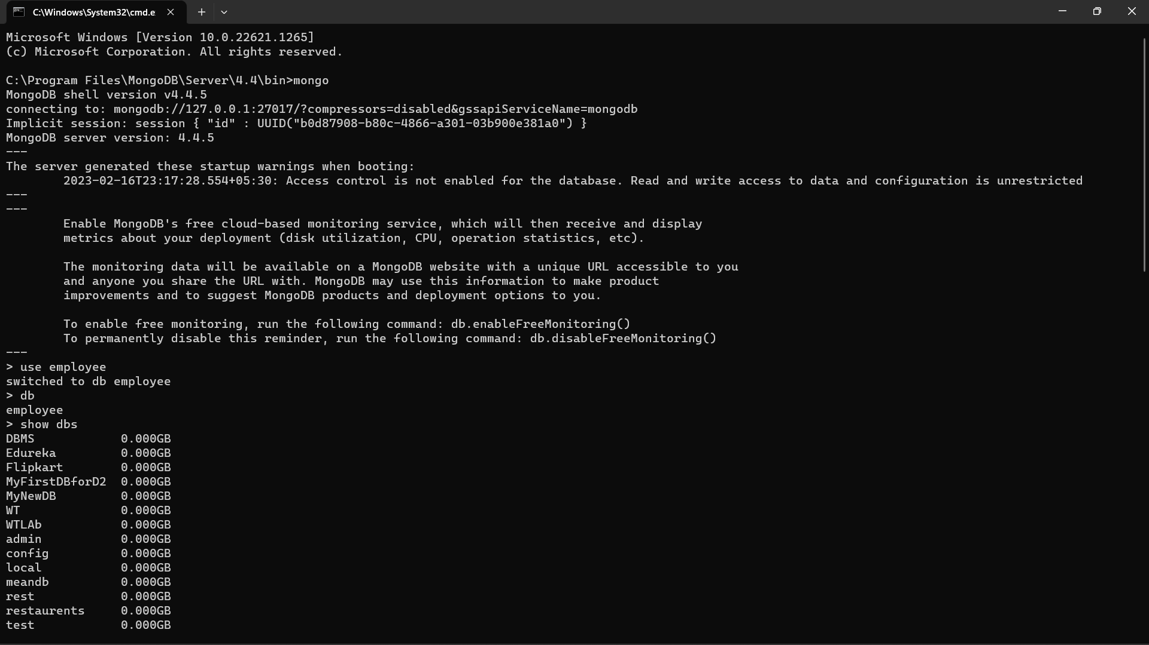
Step 5:
To create a new database just type “use DatabaseName”

Step 6:To check databases
Just type ”show dbs”


Step7:
To insert data in the database
Just type this command.
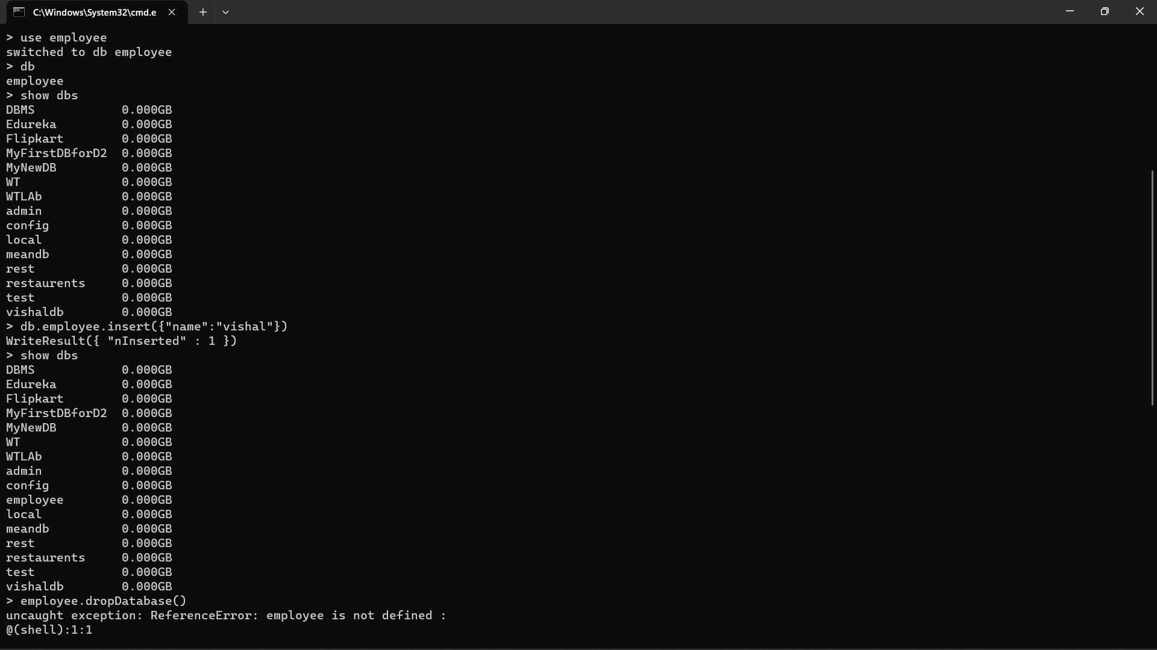

Step 8: To Drop the Database

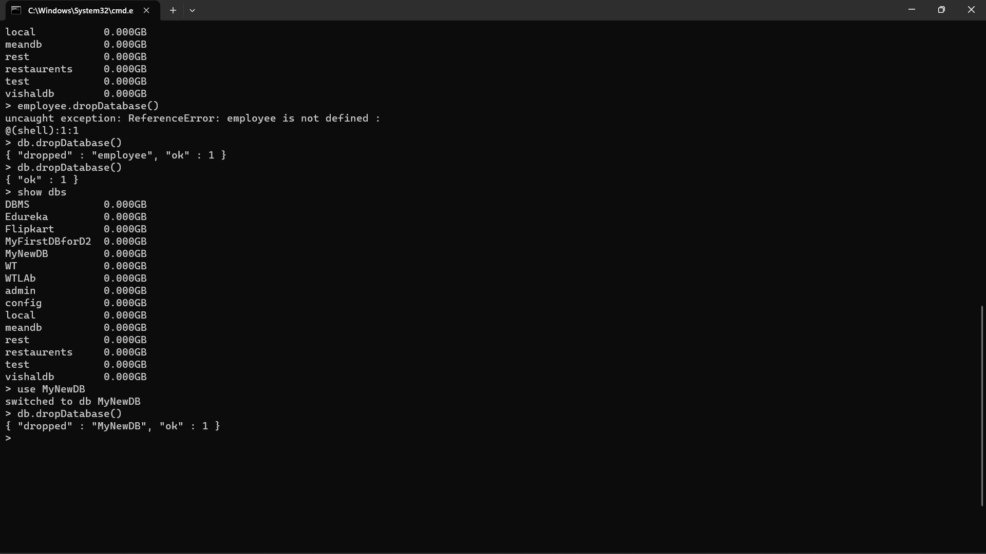

Step 9:To Create new Collection
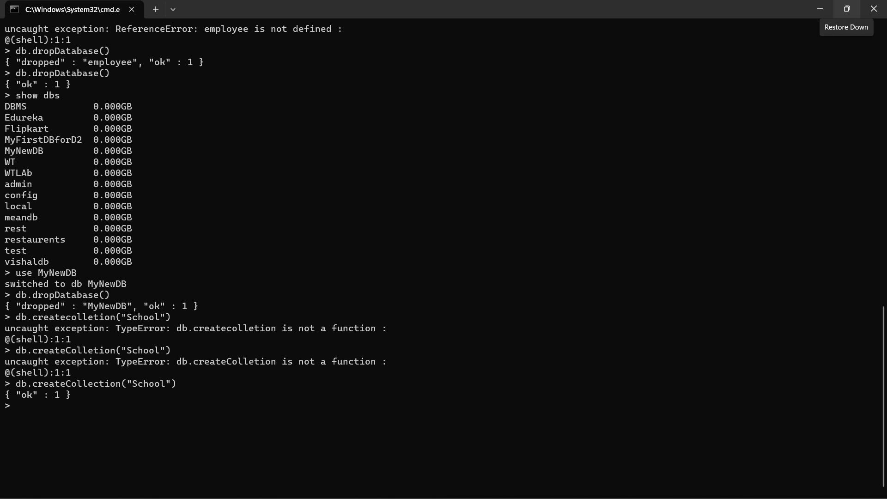

Step 10:
To see collections
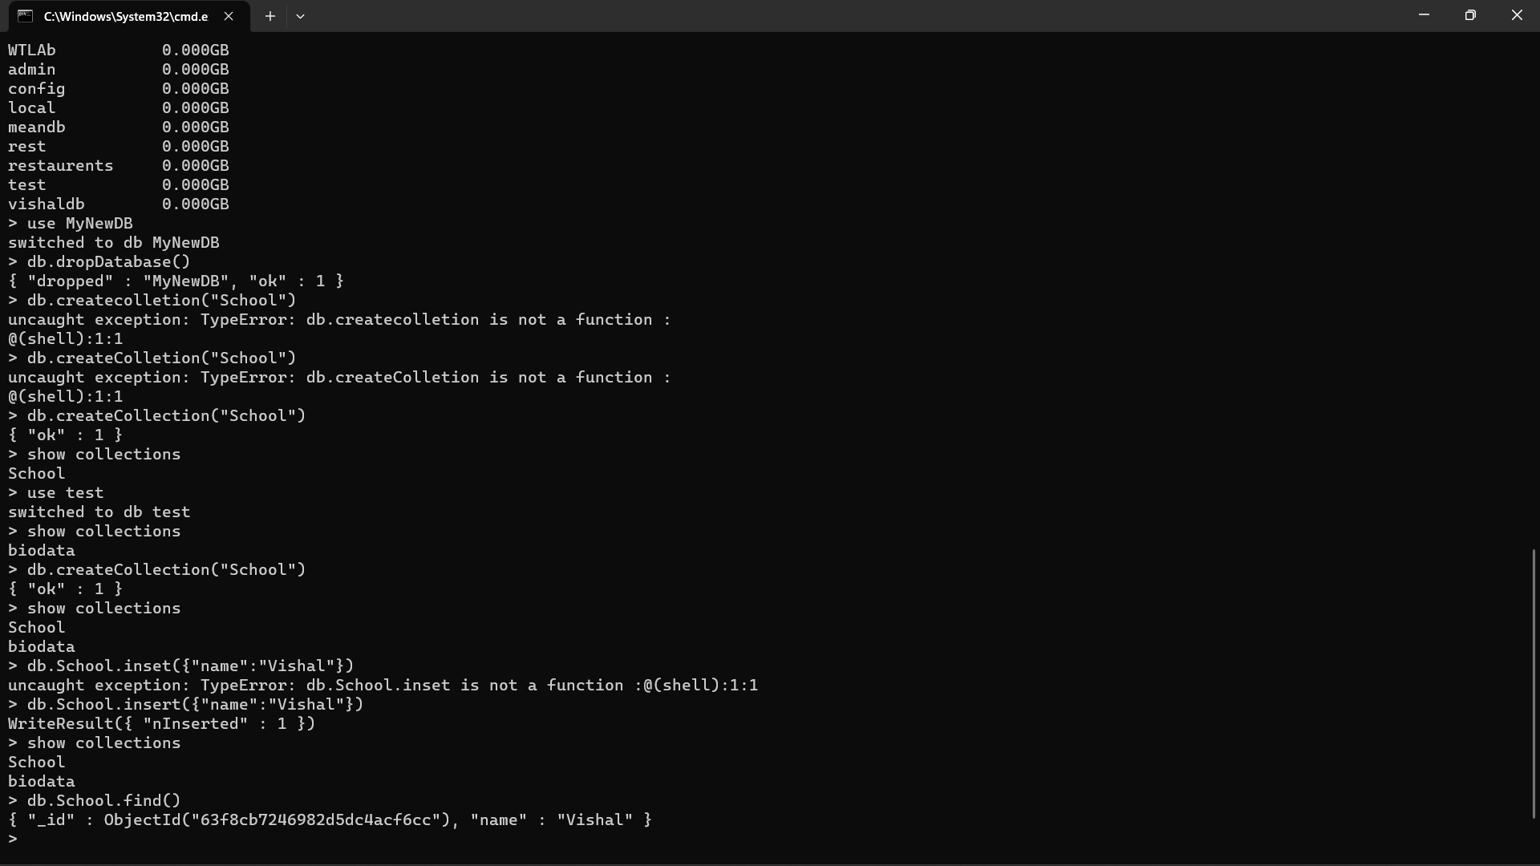
Step11:
Insert Data into collection
Command: “db.collectionName.insert({“name”:”Vishal”})

Step 12:
To see if Data is present in the collection
Command: “db.collectionName.find()”

Step 13:
To Insert multiple data at the same time just follow this command
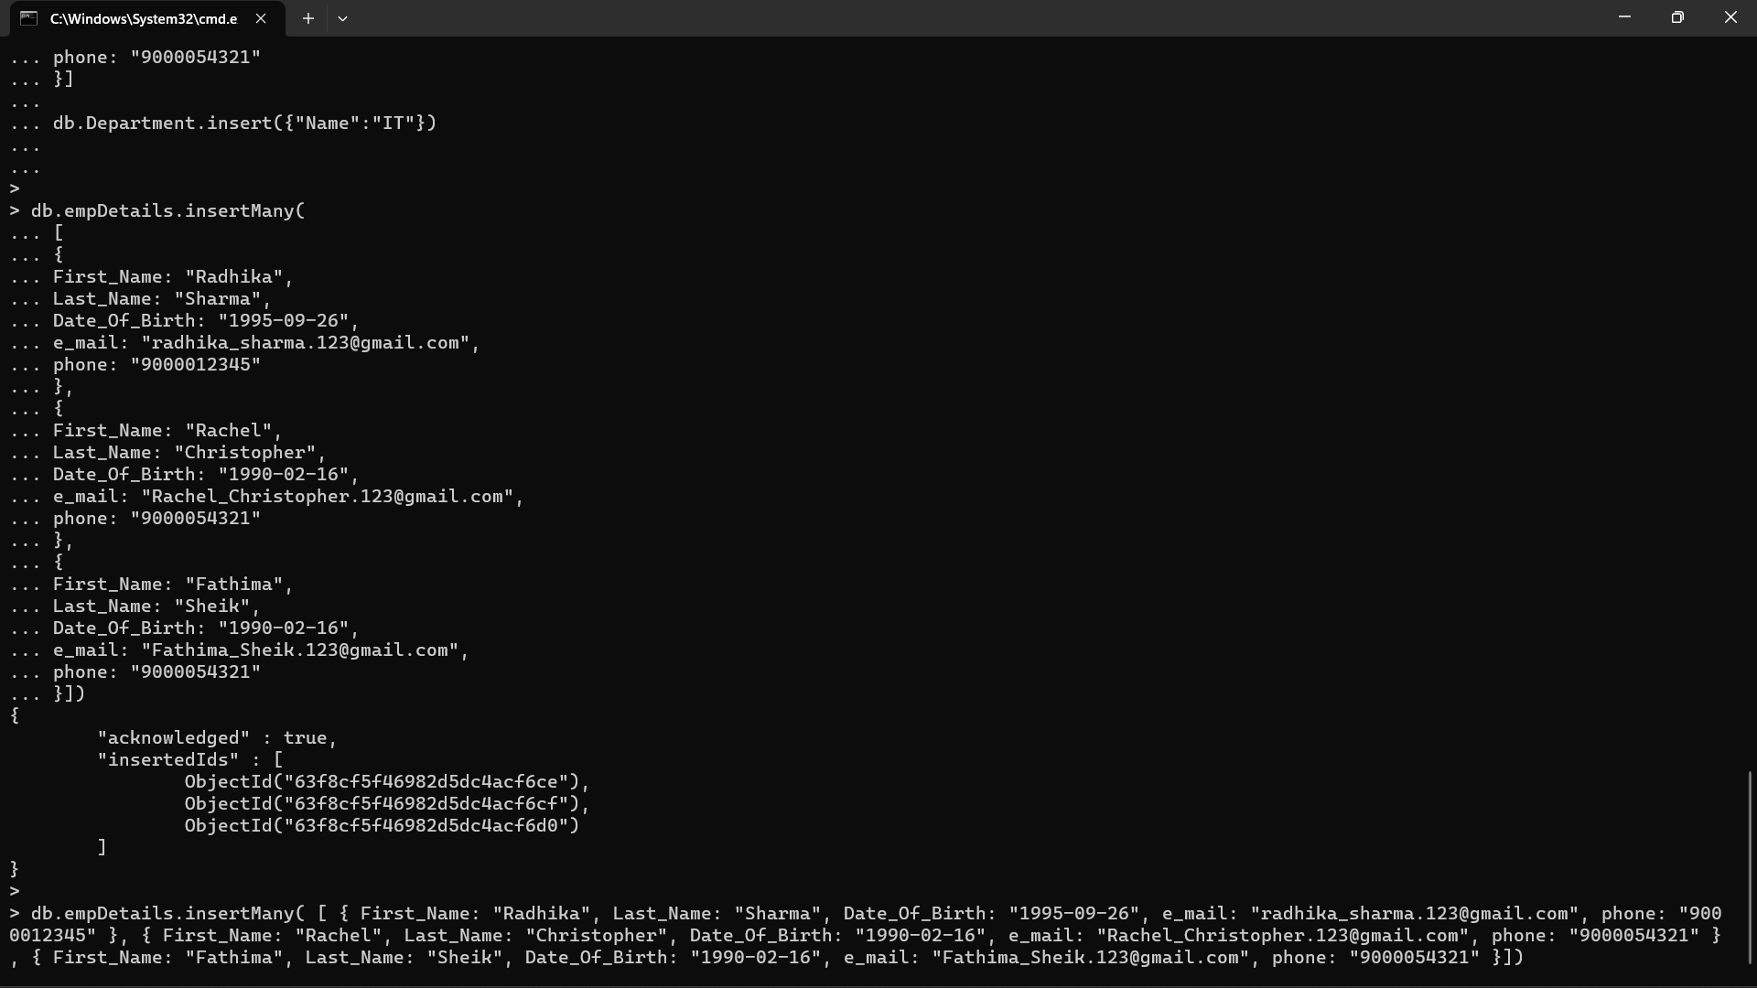
Output of success


