**PROJECT-NAME: FLIPKART**

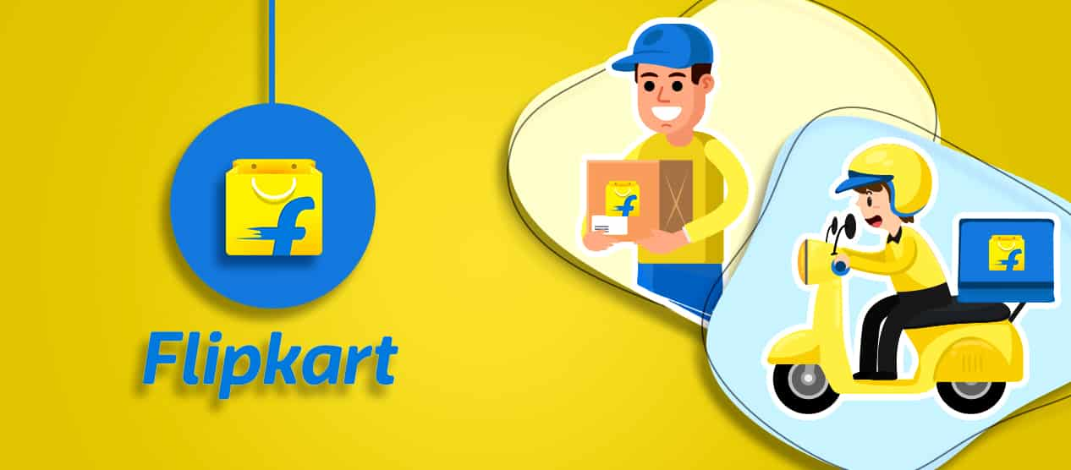

**\*OVERVIEW:** Flipkart is an Indian [e-commerce](https://en.wikipedia.org/wiki/E-commerce) company. The company initially focused on online book sales before expanding into other product categories such as [consumer electronics](https://en.wikipedia.org/wiki/Consumer_electronics), fashion, home essentials, groceries, and lifestyle products.

**HOME PAGE:**

# LOGO

# ICONS - (WISHLIST, ADD TO CART)

# SEARCH BAR

# PRODUCTS - (IMAGES)

# DEALS - (IMAGES)

# USER ACCOUNT BUTTON

# TOP OFFERS

# FOOTER – ( CONTACT US , HELPLINES , BRIEF DESCRIPTION

ABOUT THE COMPANY)

1. **CREATE ACCOUNT:**

# MOBILE NUMBER

# OTP

# NEW PASSWORD

**3. MAIN PAGE:**

# FILTERS - ( BRANDS , COLOR , DISCOUNT RANGE , PRICE

COUNTRY OF ORIGIN, MATERIAL, FEATURES,

FIT, OCCASION, PATTERN, RATING, SIZE,

TYPE, SORT BY: )

# IMAGES OF THE CHOSEN PRODUCT WITH DETAILS LIKE -

( BRAND, PRODUCT NAME, PRICE, DISCOUNT% ( IF

ANY ) )

# ON CLICKING THE IMAGE - (MULTIPLE IMAGES OF THE

THE PRODUCT WILL APPEAR FROM DIFFERENT ANGLES,

ZOOM IN, ZOOM OUT

# PRODUCT DESCRIPTION - BRAND, PRODUCT NAME,

PRICE, DISCOUNT% (IF ANY),

DELIVERY OPTIONS, PRODUCT

DETAILS, SPECIFICATIONS, RATINGS,

CUSTOMER REVIEWS

WITH IMAGES (IF ANY )

# LOWER HALF OF THE PAGE - RELATED PRODUCTS

1. **PAYMENT PAGE:**

# ADDRESS SELECTION

# PAYMENT METHOD - (PHONEPE , GOOGLE PAY , BHIM UPI ,

COD , CREDIT/DEBIT CARD , NET

- BANKING , EMI , PAYTM)