PROJECT REPORT
GreenHarvest
Smart Agriculture & Knowledge Platform

PROJECT PROFILE A full-stack MERN web application that combines crop knowledge, agricultural products, community content, contact workflows, user publishing, administration and analytics in one responsive interface.

Implementation basis: submitted Green-Harvest source tree • JavaScript / JSX • MongoDB + Mongoose • Express.js • React 18 + Vite • Tailwind CSS • Framer Motion
Prepared as an academic project report / technical reference. Names, enrollment details and institutional fields can be completed on the printed copy.
Academic Year 2026–27

CHAPTER 00
Project at a Glance
A compact view of the implementation before the detailed chapters begin.
Area | Implementation evidence | Count / detail
Backend structure | Models, controllers, route modules | 10 models • 12 controllers • 12 route files
API surface | Express route declarations in submitted source | 56 route declarations
Frontend | Pages + reusable UI | 15 pages • 12 common • 10 home • 11 admin components
State architecture | React contexts | Theme + Auth + App context providers
Motion / interaction | Animation helpers + Framer Motion + Lenis | 3 animation modules + motion-based UI
Security layers | Helmet, CORS, rate limiting, sanitation, validation, JWT, bcryptjs | Multiple defensive controls
Media / email | Multer uploads + Nodemailer templates | Single & multiple image upload; welcome email

SOURCE-OF-TRUTH NOTE Implementation claims in this report are based on the submitted source tree, not on assumptions from the project name. The earlier documentation draft inside the ZIP was treated as secondary reference and corrected where it differed from the actual routes/components.

Illustrative business claims displayed inside the prototype (for example, “25+ years” and “5,000+ partner farms”) are application copy. They were not independently verified and should be presented as demo content unless backed by project evidence.

CHAPTER 00
Certificate
Academic certification page — fill in institutional details before submission.
This is to certify that the project titled “GreenHarvest — Smart Agriculture & Knowledge Platform” is an academic software project developed as part of the prescribed curriculum. The project demonstrates the analysis, design, implementation and documentation of a full-stack web application using modern JavaScript technologies.
The submitted work includes a React/Vite frontend, an Express/Node.js REST backend, MongoDB persistence through Mongoose, authentication and role-based authorization, content management, file upload support, responsive UI, animation and analytics features.
This report documents the implementation as inspected from the supplied project archive and is intended to accompany the demonstrable software artifact.
Student Name | ____________________________________________
Enrollment / Roll No. | ____________________________________________
Guide / Faculty | ____________________________________________
Institute / Department | ____________________________________________

CHAPTER 00
Declaration
Student declaration page.
I hereby declare that the project report titled “GreenHarvest — Smart Agriculture & Knowledge Platform” is prepared for academic evaluation and represents the software artifact supplied for review. The technical descriptions are derived from the submitted project files and the referenced external documentation noted in the bibliography.
Where external standards, framework guidance or research context is discussed, the source is identified in the references. Project-specific observations, limitations and improvement recommendations are presented as engineering analysis rather than as claims of production deployment.
IMPORTANT CONFIDENTIALITY REMINDER Do not copy credentials, private keys, database URIs, email passwords or other secrets from environment files into the academic report. The report intentionally documents configuration keys and patterns rather than secret values.

Place: __________________________ Date: __________________________
Signature of Student: ________________________________________________

CHAPTER 00
Acknowledgement
A professional academic acknowledgement suitable for a software project report.
I express my sincere gratitude to the faculty guide and department for providing the opportunity to design and document the GreenHarvest project. The project helped consolidate practical understanding of frontend engineering, REST API design, database modeling, authentication, responsive UI development and software documentation.
I also acknowledge the open documentation and developer communities surrounding React, Express.js, MongoDB, Vite, Tailwind CSS, Framer Motion and OWASP. Their public guidance informed several implementation and best-practice discussions in this report.
Finally, I appreciate the review process itself: reading the complete source tree, checking the relationship between frontend routes and backend endpoints, examining data models and middleware, and identifying both implemented functionality and areas that should remain classified as future work.
REPORT PHILOSOPHY A useful project report should be honest about what is implemented, explicit about what is proposed, and clear about what still requires testing or production hardening. This document follows that principle.

CHAPTER 00
Abstract
Project summary and research context.
GreenHarvest is a modern agriculture-focused web platform built as a monorepo containing a Node.js/Express REST API and a React/Vite single-page frontend. The application is designed around a central digital hub where users can discover crop information, browse agricultural products, read and write blogs, explore a gallery, submit inquiries and manage personal content. Administrative users receive a dedicated dashboard for managing platform resources and viewing analytics.
The system uses MongoDB with Mongoose schemas for users, products, crops, blogs, contacts, FAQs, services, testimonials and analytics. Authentication is implemented using bcryptjs password hashing and JSON Web Tokens, while Express middleware provides security headers, CORS controls, request limits, sanitation, validation, logging and centralized error handling.
From a UI perspective, the implementation emphasizes visual clarity and brand consistency: Tailwind CSS drives responsive utility styling, a custom nature-inspired palette establishes identity, Framer Motion provides transitions, and Lenis is integrated for smoother scrolling. Context providers keep authentication, theme and application notification state accessible without excessive prop drilling.
RESEARCH CONTEXT [R1] FAO describes digital agriculture services as a way to make agricultural information and advisories more accessible to rural communities. GreenHarvest follows the same broad digital-information principle, translated into a portfolio + marketplace + community web experience.

Keywords: smart agriculture, MERN, React, REST API, MongoDB, JWT, responsive UI, content management, analytics, sustainable agriculture

CHAPTER 00
Executive Summary
What the project delivers, how it is structured, and what remains beyond the prototype.
Dimension | Current implementation | Assessment
User experience | Responsive pages, animated transitions, dark mode, reusable cards/buttons, mobile navigation | Strong visual foundation
Content management | CRUD for crops, products, blogs, FAQs, services, testimonials, inquiries, users | Broad admin coverage
Community features | Authenticated blog writing and personal product management | Useful extensibility point
Commerce | Product browsing + “Add to Cart” UI label | Cart/order/payment backend not present
Analytics | Page-view tracking and 30-day dashboard aggregation | Functional baseline; unique visitor metric needs completion
Security | JWT, bcryptjs, validation, Helmet, CORS, rate limiting, mongo-sanitize | Good layered baseline; token storage should be hardened
Deployment | Vite build configuration and Node/Express start command | Deployment-ready architecture; operational secrets/storage need environment hardening

The project is best characterized as a feature-rich academic prototype with a strong frontend experience and a modular backend foundation. The highest-value next step is not adding more screens; it is completing the operational contract around commerce, tests, observability, and hardened authentication/session storage.

CONTENTS
Table of Contents
Chapter map with final rendered page numbers.
Section | Title | Page
Chapter 01 | Introduction & Research Context | 11
Chapter 02 | Problem Definition, Existing System & Literature Review | 14
Chapter 03 | Objectives, Scope & Requirements | 17
Chapter 04 | Feasibility Study & Project Planning | 20
Chapter 05 | System Architecture & Design | 23
Chapter 06 | Technology Stack & Environment | 26
Chapter 07 | UI/UX Design System | 29
Chapter 08 | Functional Modules & User Journeys | 32
Chapter 09 | Backend Implementation | 35
Chapter 10 | Database Design & Data Integrity | 38
Chapter 11 | REST API Design & Endpoint Matrix | 41
Chapter 12 | Frontend Implementation | 44
Chapter 13 | Authentication, Authorization & Security | 47
Chapter 14 | Analytics, Performance & Accessibility | 50
Chapter 15 | Testing, Validation & Quality Assurance | 53
Chapter 16 | Deployment, Configuration & Operations | 56
Chapter 17 | Results, Limitations & Future Enhancements | 59
Chapter 18 | Conclusion | 62

NAVIGATION NOTE The report uses consistent chapter openers, numbered figures, source-file labels and code panels so that a reviewer can move from requirements to implementation evidence quickly.

LISTS
List of Figures & Tables
Visual index for the report.

Figures
• 1. System Architecture
• 2. Authentication & Authorization Flow
• 3. Request Lifecycle
• 4. MongoDB Collection Map
• 5. Frontend Provider & Routing Hierarchy
• 6. Deployment Topology
• 7. GreenHarvest Visual Language
• 8. UI Screenshot Area — Home / Hero
• 9. UI Screenshot Area — Products
• 10. UI Screenshot Area — Admin Dashboard
• 11. UI Screenshot Area — Authentication
• 12. UI Screenshot Area — Content Publishing

Tables
• 1. Project metrics
• 2. Technology stack
• 3. Requirements
• 4. Route and page matrix
• 5. Data model summary
• 6. Security controls
• 7. Test cases
• 8. Deployment checklist
Figure numbering is editorial and does not imply that the source archive itself contained those diagrams. Architecture figures were reconstructed from the implementation to improve the report.

CHAPTER 01
Introduction & Research Context
Why a digital agriculture platform is a useful system pattern.
GreenHarvest is positioned as a digital agriculture platform that brings together information, products, community content and administrative operations. Rather than treating the website as a static brochure, the implementation models the application as a small information ecosystem: public users consume content; authenticated users contribute content and listings; administrators curate the platform; analytics provide operational feedback.
The source tree shows a deliberate separation between frontend presentation and backend service responsibilities. The React app owns routing, interaction state and visual behavior, while the Express API owns data access, authentication, validation and resource management. MongoDB provides flexible document storage appropriate for varied content such as crop descriptions, blogs and FAQ entries.
External research strengthens the rationale. FAO describes cloud-based digital services that disseminate food and agriculture information to rural communities and support digital inclusion [R1]. GreenHarvest is not the same system, but it uses a related principle: make agricultural knowledge and services easier to discover through a single web interface.
RESEARCH-TO-DESIGN LINK The project’s crop knowledge, product catalogue and educational blog are the clearest features where the digital-agriculture research context becomes visible in the implemented product.

CHAPTER 01
Introduction & Research Context
Project identity, audience and information architecture.
The visual language follows the same message as the product name: greens communicate growth and sustainability, earth tones provide grounding, orange signals harvest energy, and cream backgrounds keep content airy. Headings are intended to feel editorial while interface text remains utilitarian and readable. The CSS implements glass cards, gradients, blur effects and motion-safe fallbacks.
Target personas are implicit in the features rather than in separate role tables. General visitors can browse; registered users gain profile, publishing and personal product features; administrators gain resource management and analytics. This creates a simple ladder of access while keeping the public site approachable.
The information architecture is also intentionally discoverable: Home surfaces major content, Products supports browsing, Blog supports knowledge, Gallery adds visual storytelling, FAQ reduces support friction, Contact creates a service channel, while Profile/My Products/Write Blog provide authenticated utilities.
Persona | Primary goals | Key surfaces
Visitor | Understand the platform; discover products and knowledge | Home, About, Products, Blog, Gallery, FAQ, Contact
Registered user | Publish, manage profile and personal listings | Profile, Write Blog, My Products
Administrator | Curate content and monitor the platform | Admin Dashboard + 9 management areas + Analytics

CHAPTER 01
Introduction & Research Context
Project boundary: implemented capability vs. future product vision.
The archive contains an earlier technical documentation draft. This report treats the actual source tree as authoritative and corrects several draft assumptions. For example, there is no Gallery Mongoose model or GalleryController in the submitted backend; Gallery is implemented as a frontend data array with lightbox behavior. Likewise, the product UI contains an “Add to Cart” button, but there is no cart/order/payment model or route in the backend inventory.
Another useful boundary is the analytics model. The schema includes uniqueVisitors, but the page-tracking controller increments only views. The result is a valid page-view counter with a field reserved for future uniqueness analysis, not a completed unique-visitor measurement system.
These distinctions matter in academic reporting: a screen or field can demonstrate design intent without proving that the corresponding business process is fully implemented.
ENGINEERING HONESTY The report intentionally separates “implemented,” “partially implemented,” and “proposed” capabilities so the submission remains defensible during viva or code review.

CHAPTER 02
Problem Definition, Existing System & Literature Review
From fragmented agricultural information to a unified web platform.
A common problem addressed by GreenHarvest is fragmentation. Crop knowledge may live in one place, product details in another, community stories in social channels, and support questions in email. A single web platform can reduce context switching by connecting these journeys through common navigation and shared design patterns.
The legacy or “existing” system discussed in an academic report should not be invented. For GreenHarvest, the reasonable baseline is a fragmented, mostly static experience in which content updates are manual, user contribution is limited, and administrators lack a unified content console. The proposed system improves this by introducing CRUD resources and role-aware workflows.
FAO’s Digital Services Portfolio describes a cloud platform intended to make useful agriculture data and advisories accessible as digital services [R1]. That research direction supports GreenHarvest’s decision to make the website more than a static marketing page.
Problem | Traditional effect | GreenHarvest response
Information fragmentation | Users repeat searches across sources | Centralized crop, product and knowledge pages
Slow content updates | Manual editing / redeployment | Admin CRUD interfaces
Limited user participation | No structured contribution channel | User blogs + personal product listings
Weak feedback loop | Support queries remain in inboxes | Contact model + read/unread admin view
Low visibility into usage | No consolidated traffic view | Analytics tracking and 30-day aggregation

CHAPTER 02
Problem Definition, Existing System & Literature Review
Literature and technology rationale.
MongoDB’s document model stores records as BSON documents and allows arrays and nested documents where appropriate [R2]. For this project, the flexible document approach fits content-oriented entities whose fields differ naturally: a crop needs soil and water fields; a testimonial needs rating and role; a blog needs tags and publishing state.
Express describes an application as a sequence of middleware calls participating in the request-response cycle [R3]. GreenHarvest mirrors this philosophy: Helmet, compression, CORS, parsers, cookie parsing, sanitation, logging and rate limiting run before route handling, and a centralized error handler closes the chain.
React’s Context API is explicitly designed for making shared values available deep in the component tree [R4]. The project uses three contexts for theme, authentication and application-level notifications/loading, which is a compact solution for a medium-sized academic frontend.
SOURCE SYNTHESIS The selected architecture is not arbitrary: the design choices align with the documented strengths of document databases, middleware-based APIs and context-driven React state sharing.

CHAPTER 02
Problem Definition, Existing System & Literature Review
Research gap and design opportunity.
The gap is not “technology access” alone; it is workflow integration. A product catalogue without content education may not help a first-time visitor. A blog without admin review can become noisy. An admin dashboard without analytics cannot prioritize effort. GreenHarvest’s structure therefore connects discovery, contribution and governance rather than building each feature in isolation.
For future research, the platform could be evaluated with real users using task completion, search success, reading time, conversion from content to product discovery, accessibility conformance and perceived trust. The current archive does not contain such empirical study data, so this report avoids inventing performance or adoption claims.
In an academic setting, this creates a valuable research framing: the project demonstrates how a modern web stack can express agricultural information architecture, while user research and field deployment remain open areas for subsequent work.
• Evaluate real farmer journeys rather than only developer expectations.
• Measure accessibility on low-bandwidth and mobile conditions.
• Study how educational content influences product discovery or service contact.
• Add domain experts to validate crop facts, sustainability claims and recommendations.

CHAPTER 03
Objectives, Scope & Requirements
What the project is designed to achieve.
The primary objective is to build a cohesive agriculture-focused web platform with a modern interface, reusable components and a maintainable REST backend. Secondary objectives include secure authentication, content administration, user contribution, image upload, analytics and deployment-friendly configuration.
Functional scope covers public information, authentication, resource browsing, community contribution and admin management. Non-functional scope covers responsive behavior, visual consistency, security middleware, input validation, error handling, logging in development and performance-conscious frontend bundling.
Out-of-scope capabilities are deliberately identified: no completed checkout, payment gateway, persistent shopping cart, order lifecycle, recommendation engine, multi-factor authentication, real unique-visitor measurement, automated test suite or fully automated CI/CD pipeline appears in the submitted source tree.
Type | Requirement examples | Evidence
Functional | Register/login; manage crops/products/blogs/FAQs/services/testimonials/users | Auth routes + CRUD route modules
Functional | Upload images; submit contact inquiries; view analytics | Upload/contact/analytics modules
Non-functional | Responsive UI; dark mode; reusable components | Tailwind + ThemeContext + common components
Security | JWT protection; admin authorization; input validation | auth middleware + express-validator
Performance | Lazy routes; optimized build configuration | React.lazy + Vite build chunks

CHAPTER 03
Objectives, Scope & Requirements
User stories and acceptance criteria.
Requirements become clearer when written as user stories. The following acceptance points reflect the current implementation rather than idealized future functionality.
Actor | User story | Acceptance signal
Visitor | I can browse products by category. | Products page filters by category.
Visitor | I can read blog posts and open an individual post. | Blog list + /blog/:slug route.
User | I can create an account and sign in. | Register/login endpoints + AuthContext.
User | I can create/update/delete my own products. | /api/my-products protected CRUD.
User | I can write a blog for review. | WriteBlog posts through user blog route.
Admin | I can manage platform resources. | Admin routes protected by admin middleware.
Admin | I can inspect recent page views. | Analytics dashboard aggregates 30 days.

ACCEPTANCE PRINCIPLE A requirement is considered “implemented” when a corresponding route, controller, component or workflow exists in the supplied project—not merely because a button or field appears in the UI.

CHAPTER 03
Objectives, Scope & Requirements
Functional decomposition and role boundaries.
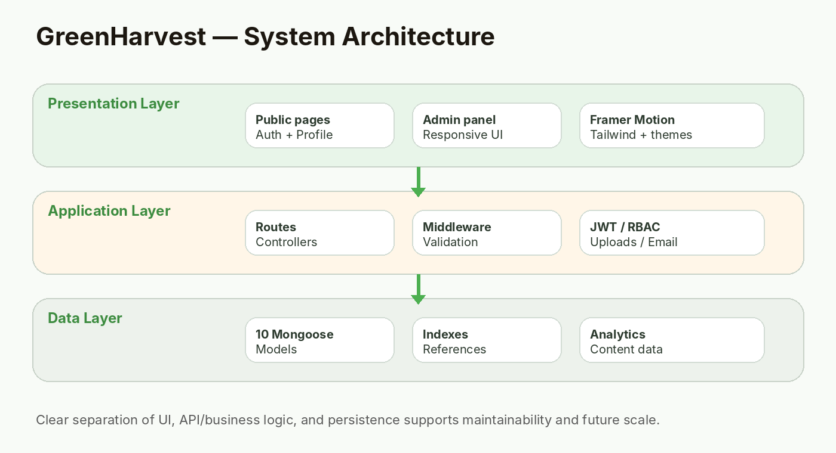
Figure 1. Reconstructed system architecture from the submitted source tree.
SCOPE BOUNDARY The admin panel has ten navigable areas in the current React router: dashboard, crops, products, blogs, users, inquiries, FAQs, services, testimonials and analytics.

CHAPTER 04
Feasibility Study & Project Planning
Technical feasibility.
Technical feasibility is strong for an academic or small-team application because every major layer uses mainstream JavaScript technologies. React and Express provide mature component/routing patterns; MongoDB and Mongoose simplify document persistence; Vite provides an efficient frontend development/build workflow; Tailwind accelerates responsive styling.
Operational feasibility is also reasonable because the project uses environment variables for secrets and a simple two-process development setup: one Node/Express process and one Vite dev server. The root package file includes convenience scripts for starting both sides together.
Economic feasibility is primarily favorable when cloud services are used at entry-level scale. However, the report should not claim that a specific deployment provider was used unless deployment evidence is included. Cost remains an implementation planning topic rather than a verified project outcome.
Feasibility dimension | Finding | Risk
Technical | Modern, widely supported stack | Low
Operational | Simple developer workflow | Low–Medium
Economic | Can run with common/free development tooling | Depends on hosting/storage
Schedule | Modular architecture reduces change impact | Medium if features expand
Security | Good baseline, but token storage/secret fallback need hardening | Medium

CHAPTER 04
Feasibility Study & Project Planning
Project plan and milestone model.
A disciplined build sequence helps avoid UI-first projects that lack backend contracts. The GreenHarvest architecture suggests the following implementation order.
Milestone | Work package | Output
1 | Requirements + information architecture | Feature list, roles, route map
2 | Backend foundation | Express server, DB connection, middleware
3 | Domain models + APIs | Mongoose schemas, controllers, routes
4 | Frontend shell | Router, contexts, theme, shared UI
5 | Feature modules | Products, blogs, profile, admin CRUD
6 | Hardening | Validation, error handling, upload constraints
7 | Verification | Manual tests, build review, security checklist
8 | Release | Production configuration, durable storage, monitoring

PLANNING INSIGHT The source tree already follows this dependency shape closely. The major remaining work is in the final hardening and verification stages rather than architectural restructuring.

CHAPTER 04
Feasibility Study & Project Planning
Risk register.
Risk | Impact | Mitigation
Secrets committed to env or source | High | Use secret manager; scrub reports; rotate keys
localStorage JWT exposure | High | Prefer HttpOnly Secure SameSite cookies with CSRF strategy [R7]
Uploads on local disk | Medium | Use object storage + durable URLs
No automated tests visible | Medium | Add API and component test suites
Cart UI without checkout backend | Medium | Implement order/cart models before marketing commerce as complete
Static gallery content | Low | Create Gallery model/API if admin control is needed
Fallback JWT secret | High | Fail fast in production when JWT secret is missing

SECURITY NOTE [R7] OWASP recommends against storing authentication tokens in localStorage/sessionStorage because JavaScript accessible storage can expose tokens during an XSS incident. The current code uses localStorage for the bearer token while also setting a cookie, so session storage should be redesigned before production release.

CHAPTER 05
System Architecture & Design
Layered architecture.
Figure 1. Client–API–database separation with cross-cutting middleware.

CHAPTER 05
System Architecture & Design
Request lifecycle and separation of concerns.
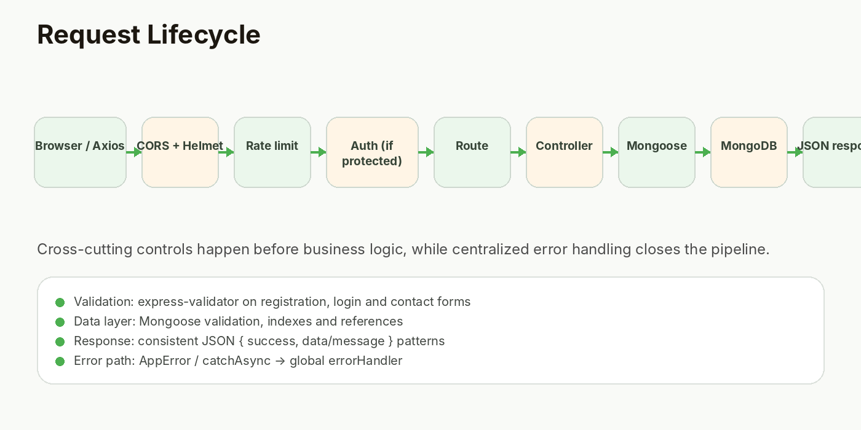
Figure 3. Request lifecycle reconstructed from server.js, route modules and middleware.

CHAPTER 05
System Architecture & Design
Authentication flow as a first-class architecture concern.
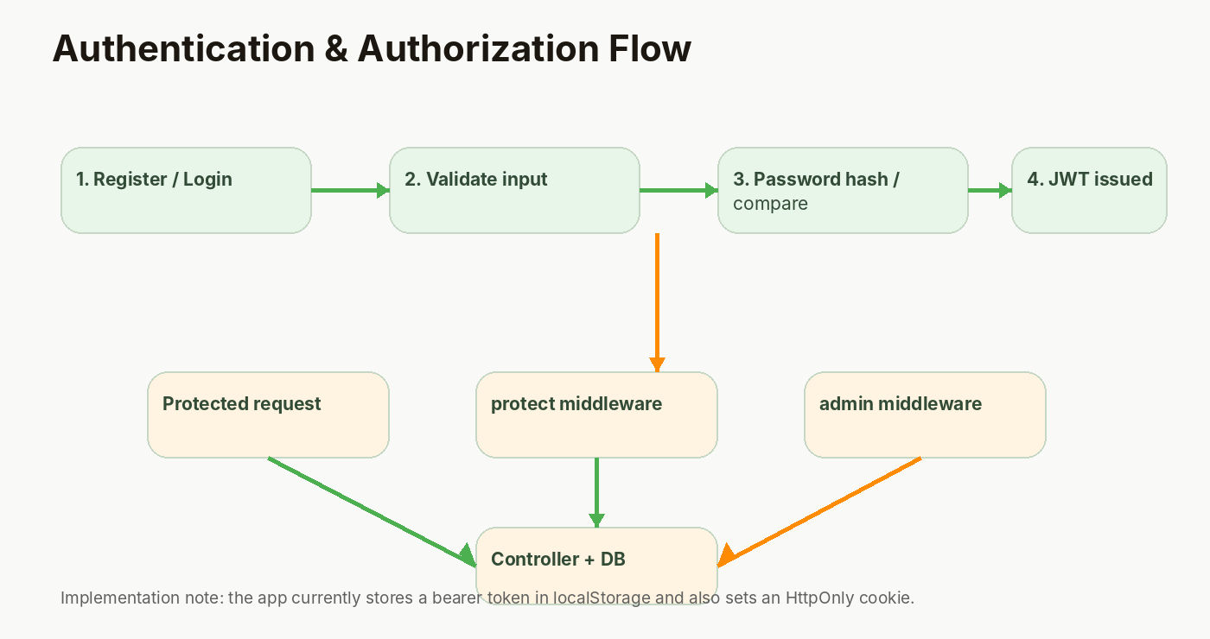
Figure 2. Authentication and authorization flow.

CHAPTER 06
Technology Stack & Environment
Why each technology appears in the project.
Technology | Project role | Why it fits
MongoDB + Mongoose | Document persistence | Flexible content models and validation/index support [R2]
Express.js | REST API and middleware | Simple routing/middleware composition [R3]
Node.js | Backend runtime | JavaScript across the stack
React 18 | UI composition | Reusable components and hooks
Vite 5 | Dev/build tool | Fast dev server + modern build workflow [R5]
Tailwind CSS 3 | Styling system | Responsive utilities + dark mode variants [R6]
Framer Motion | UI motion | Declarative enter/exit/interaction animation
Lenis | Smooth scrolling | Improves the brand experience on long pages
Axios | Selected API client | Interceptor-based token handling
React Router DOM | Client routing | Route composition + dynamic paths
Multer | Image upload middleware | Disk storage + file filtering
Nodemailer | Email delivery | Welcome/contact mail templates

REFERENCE ALIGNMENT Vite describes a fast development server plus an optimized production build command [R5]; Tailwind documents responsive utility variants and dark-mode variants [R6]. GreenHarvest uses both capabilities directly in its frontend build.

CHAPTER 06
Technology Stack & Environment
Environment and configuration model.
The root package provides orchestration scripts, while backend and frontend have independent package manifests. The backend expects a MongoDB URI and JWT configuration through environment variables; email variables are also read by the email utility. The frontend uses a Vite proxy for /api and /uploads during development.
Configuration is centralized in backend/config/config.js, reducing scattered process.env access. The project also includes .env.example, which is good documentation practice. Sensitive values should never be copied into an academic report or committed repository state.
Node version expectations should be checked against the actual developer/hosting environment before deployment. The backend engine metadata accepts Node >=14, while the submitted frontend dependencies are from a modern React/Vite generation.
Configuration key | Used by | Purpose
MONGO_URI | config/db.js | MongoDB connection string
JWT_SECRET | config + User/auth | JWT signing/verification secret
JWT_EXPIRES_IN | User model | Token lifetime
FRONTEND_URL | config/server/email | CORS/email links
EMAIL_HOST / PORT / USER / PASS | email utility | SMTP delivery
PORT | server.js | Express listen port
NODE_ENV | server.js/config | Development vs production behavior

CHAPTER 06
Technology Stack & Environment
Environment setup sequence.
• Install Node.js and npm compatible with the project dependencies.
• Create or populate environment variables from .env.example without copying secrets into source control.
• Install root, backend and frontend dependencies using the provided install:all workflow.
• Start the development pair with npm run dev, or run backend/frontend independently when debugging.
• Open the Vite frontend at the configured local port and verify API proxying to Express.
• For production, build the frontend and start the backend with a real secret and durable storage configuration.
VERIFICATION CHECKLIST Environment setup is a reproducible software step: a report should show the commands, expected ports and configuration keys, but not expose actual credentials.

CHAPTER 07
UI/UX Design System
Visual language reconstructed from Tailwind configuration and CSS.
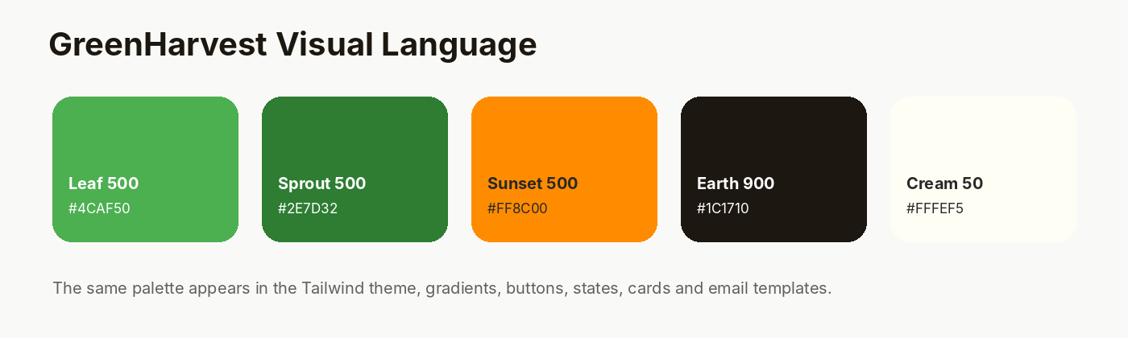
Figure 7. GreenHarvest palette: leaf, sprout, sunset, earth and cream families.

CHAPTER 07
UI/UX Design System
Responsive layout, dark mode and accessibility-aware motion.
The interface uses responsive utility variants and a custom “darkMode: class” configuration. Tailwind documents this variant model for selectively applying dark theme styles [R6]. The ThemeContext persists the theme choice in localStorage and toggles the root dark class, allowing the same component tree to restyle without duplicated page implementations.
Motion is treated as enhancement rather than the only way to communicate state. Framer Motion animates page entry, cards and transitions, while the global CSS includes a prefers-reduced-motion media rule that sharply reduces animation duration for users who request lower motion.
The common component set—Button, GlassCard, Navbar, Footer, Loader, Cursor, ScrollToTop, SectionTitle, ImageUpload and ThemeToggle—helps maintain spacing, interaction and visual patterns across pages.
Design token / pattern | Observed implementation | Benefit
Color | Leaf + sprout greens, sunset orange, earth darks | Brand recognition
Cards | Glass effect + radius + borders | Consistent grouping
Buttons | Primary / secondary / gradient / ghost variants | Predictable actions
Typography | Serif headings + sans body | Editorial + utility balance
Motion | Framer Motion + CSS keyframes | Perceived responsiveness
Responsiveness | Tailwind sm/md/lg/xl utilities | Cross-device layout
Reduced motion | prefers-reduced-motion CSS | Accessibility baseline

CHAPTER 07
UI/UX Design System
Screenshot documentation plan.
The final report can be strengthened further by pasting final browser captures into the reserved frames below. The frames are sized for common 16:9 desktop screenshots and can also accept mobile crops.
SCREENSHOT AREA
Home / Hero section
Capture the initial navigation, headline, CTA buttons and animated hero background.

SCREENSHOT AREA
Products listing / category filter
Capture the product cards and active category state.

CHAPTER 08
Functional Modules & User Journeys
Public website modules.
Module | Key behavior | Data source
Home | Hero, services, statistics, crops, products, testimonials, blog, newsletter/sustainability | Mostly frontend composition + public APIs
About | Mission/vision/values, timeline, team copy | Static content
Products | Category filtering and product cards | GET /api/products
Blog | List, search/filter behavior and post detail | GET /api/blogs + slug endpoint
Gallery | Category filter + lightbox | Static frontend array
FAQ | Accordion interactions + category | GET /api/faq with static fallback
Contact | Form submission + map section | POST /api/contact

UX PRINCIPLE Public pages are designed to build trust before asking for authentication; authenticated actions are moved behind Profile, My Products and Write Blog.

CHAPTER 08
Functional Modules & User Journeys
Authenticated user journey.
The authenticated path begins at register/login. AuthContext stores the active user and token state, then exposes login, register, logout, profile update and password update functions. The Navbar changes to display Write Blog, My Products and a user/profile action when a user is present.
My Products provides CRUD for a user’s own listings. The backend userProducts route is wrapped with protect middleware, which means the resource identity comes from the authenticated session rather than from an arbitrary public user identifier. Write Blog similarly exposes user-scoped create, update and delete routes and leaves publishing review to administrators.
The overall journey is therefore contribution-oriented: discover -> sign in -> contribute -> manage -> receive feedback/review. This is appropriate for a community platform, although commerce fulfillment is still outside the current scope.
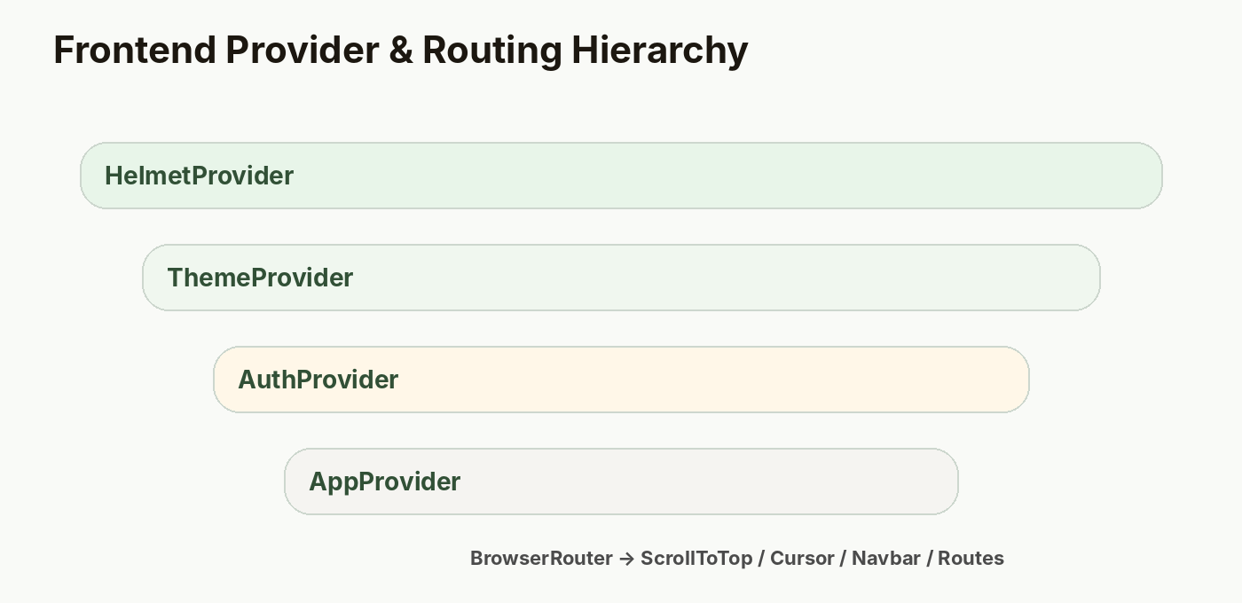
Figure 5. Frontend provider hierarchy that supplies theme, authentication and application state.

CHAPTER 08
Functional Modules & User Journeys
Admin journey and content governance.
The /admin/* tree is guarded twice at the application level: the Admin page checks that a user exists and has an admin role, and individual backend write endpoints use protect + admin middleware. The Sidebar exposes ten operational areas, creating a predictable workspace for platform management.
Admin CRUD screens follow a repeated pattern: fetch resource list, open a form for create/edit, submit to POST/PUT, delete where allowed, then refresh the data set. This repetition supports consistency and simplifies maintenance, although a future shared data-grid/form abstraction could reduce duplication.
Analytics is intentionally read-only in the admin UI: the backend aggregates recent page views by page and by day. This turns page tracking into a management signal rather than a decorative chart.
SCREENSHOT AREA
Admin Dashboard / management shell
Capture the sidebar, dashboard stat cards and quick actions with a demo admin account.

CHAPTER 09
Backend Implementation
Server bootstrap and middleware order.
backend/server.js
01 const express = require('express');
02 const mongoose = require('mongoose');
03 const dotenv = require('dotenv');
04 const cors = require('cors');
05 const helmet = require('helmet');
06 const morgan = require('morgan');
07 const cookieParser = require('cookie-parser');
08 const compression = require('compression');
09 const rateLimit = require('express-rate-limit');
10 const mongoSanitize = require('express-mongo-sanitize');
11 const errorHandler = require('./middleware/errorHandler');
12 const connectDB = require('./config/db');
13
14 dotenv.config();
15 connectDB();
16
17 const app = express();
18
19 app.use(helmet({ crossOriginResourcePolicy: { policy: 'cross-origin' } }));
20 app.use(compression());
21 app.use(cors({ origin: process.env.FRONTEND_URL || 'http://localhost:5173', credentials: true }));
22 app.use(express.json({ limit: '10mb' }));
23 app.use(express.urlencoded({ extended: true }));
24 app.use(cookieParser());
25 app.use(mongoSanitize());
Source: backend/server.js. The order is important: security, compression, CORS, parsers, cookie access, sanitation, logging and rate limiting occur before route dispatch and centralized error handling.
IMPLEMENTATION NOTE The project applies a 100-request / 15-minute limiter to /api. This is a useful baseline for an academic project but should be tuned using production traffic and trusted proxy configuration.

CHAPTER 09
Backend Implementation
Model patterns: validation, references and lifecycle hooks.
backend/models/User.js
01 const mongoose = require('mongoose');
02 const bcrypt = require('bcryptjs');
03 const jwt = require('jsonwebtoken');
04
05 const userSchema = new mongoose.Schema({
06 name: { type: String, required: [true, 'Name is required'], trim: true, maxlength: 50 },
07 email: { type: String, required: [true, 'Email is required'], unique: true, lowercase: true, match: [/^\S+@\S+\.\S+$/, 'Invalid email'] },
08 password: { type: String, required: [true, 'Password is required'], minlength: 6, select: false },
09 role: { type: String, enum: ['user', 'admin'], default: 'user' },
10 avatar: { type: String, default: '' },
11 phone: { type: String, default: '' },
12 address: { type: String, default: '' },
13 resetPasswordToken: String,
14 resetPasswordExpire: Date,
15 }, { timestamps: true });
16
17 userSchema.pre('save', async function (next) {
18 if (!this.isModified('password')) return next();
19 this.password = await bcrypt.hash(this.password, 12);
20 next();
21 });
22
23 userSchema.methods.comparePassword = async function (candidate) {
24 return bcrypt.compare(candidate, this.password);
25 };
26
27 userSchema.methods.generateToken = function () {
28 return jwt.sign({ id: this._id, role: this.role }, process.env.JWT_SECRET, { expiresIn: process.env.JWT_EXPIRES_IN });
29 };
30
31 module.exports = mongoose.model('User', userSchema);
Source: backend/models/User.js. Passwords are excluded by default and hashed before save; comparePassword performs secure comparison; generateToken embeds user identity and role.

CHAPTER 09
Backend Implementation
Route/controller/middleware composition.
backend/routes/blogs.js
01 const router = require('express').Router();
02 const { protect, admin } = require('../middleware/auth');
03 const ctrl = require('../controllers/blogController');
04
05 router.get('/', ctrl.getAll);
06 router.get('/slug/:slug', ctrl.getOne);
07 router.get('/my', protect, ctrl.getMyBlogs);
08 router.get('/:id', ctrl.getById);
09 router.post('/', protect, admin, ctrl.create);
10 router.post('/user', protect, ctrl.createUserBlog);
11 router.put('/:id', protect, admin, ctrl.update);
12 router.put('/user/:id', protect, ctrl.updateMyBlog);
13 router.delete('/:id', protect, admin, ctrl.remove);
14 router.delete('/user/:id', protect, ctrl.deleteMyBlog);
15
16 module.exports = router;
Source: backend/routes/blogs.js. Public reads coexist with protected user/admin writes, illustrating Express route composition and role boundaries.

CHAPTER 10
Database Design & Data Integrity
Collection map and relationship strategy.
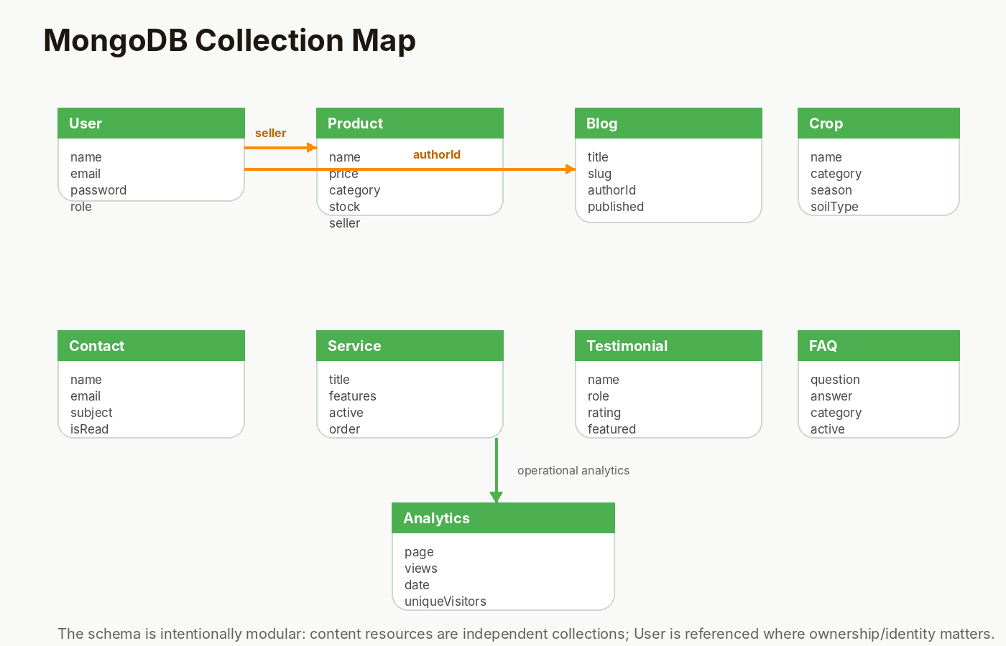
Figure 4. Reconstructed MongoDB collection map from the submitted models.

CHAPTER 10
Database Design & Data Integrity
Core schema details.
Collection | Important fields | Integrity / relationship notes
User | name, email, password, role, avatar, phone, address | email unique; password select:false; role enum
Product | name, price, category, stock, unit, ratings, seller | category enum; non-negative price/stock; seller references User
Crop | name, category, season, soilType, waterRequirement | category enum; featured/order/status fields
Blog | title, slug, content, excerpt, authorId, published | slug unique; pre-save slug generation; authorId ref User
Contact | name, email, subject, message, isRead | read/unread workflow
Analytics | page, views, date, uniqueVisitors | compound index page + date; tracking upsert

INTEGRITY OBSERVATION Mongoose validation protects types and enum values before persistence [R2]. The Blog model also demonstrates a lifecycle hook that derives a URL-friendly slug and checks for collisions.

CHAPTER 10
Database Design & Data Integrity
Indexing, validation and future data growth.
MongoDB indexing should follow actual query patterns. The project includes an explicit Analytics index on page + date, matching the dashboard aggregation and daily tracking pattern. Other resources are comparatively small and rely on standard _id/unique indexes and controller-level pagination/query options.
Future growth would benefit from dedicated indexes on frequently filtered fields such as published, category, active/status and seller. Index selection should be validated using query plans and real traffic rather than added indiscriminately.
The platform also uses references in selected places instead of embedding identity-rich data. This keeps user ownership separate from content and allows user management to remain centralized.
• Keep validation rules in schemas close to data definitions.
• Use compound indexes when queries repeatedly combine the same fields.
• Avoid exposing private or credential fields in normal response payloads.
• Add data retention policies for analytics and uploaded media before production.

CHAPTER 11
REST API Design & Endpoint Matrix
Resource-oriented route structure.
Resource | Methods in submitted route file | Access model
auth | 6 | Public register/login/logout; protected profile/password/me
blogs | 10 | Public reads; protected user/admin writes
products | 5 | Public reads; admin writes
crops | 5 | Public reads; admin writes
services | 5 | Public reads; admin writes
testimonials | 5 | Public reads; admin writes
faq | 5 | Public reads; admin writes
contact | 4 | Public submit; admin list/read/delete
users | 3 | Admin only
analytics | 2 | Public page tracking; admin dashboard
upload | 2 | Authenticated uploads
my-products | 4 | Authenticated user-owned CRUD

The static route inventory yields 56 router method declarations across the 12 route modules (excluding routes/index.js, which mounts those modules). This count is an implementation metric, not a claim of distinct business operations because some methods may vary only by action or path.

CHAPTER 11
REST API Design & Endpoint Matrix
Response and error conventions.
The backend generally returns a JSON object containing a success flag plus either a resource collection/object, count information or a message. This consistency helps frontend components avoid special-case parsing.
Validation errors from express-validator are mapped into a success:false response with an errors array. Mongoose validation errors, duplicate key errors, CastError and MulterError are normalized by the global error handler into understandable HTTP responses. This centralization avoids repeating status selection inside every controller.
The asyncHandler utility further reduces repetitive try/catch code by forwarding rejected promises to the global error middleware. Express documents middleware as part of the request-response cycle, which matches this organization [R3].
Failure class | Status | Handling
Validation / malformed input | 400 | express-validator or Mongoose validation
Duplicate key | 400 | errorHandler maps code 11000
Bad ObjectId cast | 400 | errorHandler maps CastError
Unauthenticated | 401 | protect middleware
Forbidden admin action | 403 | admin middleware
Not found | 404 | controllers throw AppError
Unexpected error | 500 | global errorHandler

CHAPTER 11
REST API Design & Endpoint Matrix
File upload API.
backend/utils/upload.js
01 const multer = require('multer');
02 const path = require('path');
03
04 const storage = multer.diskStorage({
05 destination: (req, file, cb) => cb(null, 'uploads/'),
06 filename: (req, file, cb) => cb(null, `${Date.now()}-${Math.round(Math.random() * 1E9)}${path.extname(file.originalname)}`),
07 });
08
09 const fileFilter = (req, file, cb) => {
10 const allowed = /jpeg|jpg|png|gif|webp|svg/;
11 if (allowed.test(path.extname(file.originalname).toLowerCase()) && allowed.test(file.mimetype)) {
12 cb(null, true);
13 } else {
14 cb(new Error('Only image files allowed'), false);
15 }
16 };
17
18 const upload = multer({ storage, fileFilter, limits: { fileSize: 5 * 1024 * 1024 } });
Source: backend/utils/upload.js. The filter allows JPEG/JPG/PNG/GIF/WebP/SVG and enforces a 5 MB size limit. Production deployments should replace local disk storage with durable object storage.
OPERATIONAL RECOMMENDATION A local uploads/ directory is convenient for development but fragile in horizontally scaled production. Store media outside the application container and persist the final asset URL.

CHAPTER 12
Frontend Implementation
Application shell, lazy routes and shared chrome.
frontend/src/App.jsx
01 import { lazy, Suspense, useState, useEffect } from 'react';
02 import { BrowserRouter, Routes, Route, useLocation } from 'react-router-dom';
03 import { AnimatePresence } from 'framer-motion';
04 import { HelmetProvider } from 'react-helmet-async';
05
06 import { ThemeProvider } from './context/ThemeContext';
07 import { AuthProvider } from './context/AuthContext';
08 import { AppProvider } from './context/AppContext';
09
10 import Navbar from './components/common/Navbar';
11 import Footer from './components/common/Footer';
12 import Cursor from './components/common/Cursor';
13 import ScrollToTop from './components/common/ScrollToTop';
14 import Loader from './components/common/Loader';
15 import useSmoothScroll from './hooks/useSmoothScroll';
16
17 const Home = lazy(() => import('./pages/Home'));
18 const About = lazy(() => import('./pages/About'));
19 const Blog = lazy(() => import('./pages/Blog'));
20 const BlogPost = lazy(() => import('./pages/BlogPost'));
21 const Gallery = lazy(() => import('./pages/Gallery'));
22 const Contact = lazy(() => import('./pages/Contact'));
23 const Products = lazy(() => import('./pages/Products'));
24 const FAQ = lazy(() => import('./pages/FAQ'));
25 const Login = lazy(() => import('./pages/Login'));
26 const Register = lazy(() => import('./pages/Register'));
27 const NotFound = lazy(() => import('./pages/NotFound'));
28 const Profile = lazy(() => import('./pages/Profile'));
29 const MyProducts = lazy(() => import('./pages/MyProducts'));
30 const WriteBlog = lazy(() => import('./pages/WriteBlog'));
31 const Admin = lazy(() => import('./pages/Admin'));
32
33 function PageLoader() {
34 return (
35 <div className="min-h-screen flex items-center justify-center">
36 <div className="flex flex-col items-center gap-3">
37 <div className="w-10 h-10 border-2 border-leaf-500 border-t-transparent rounded-full animate-spin" />
38 <p className="text-sm text-gray-500">Loading...</p>
39 </div>
40 </div>
41 );
42 }
Source: frontend/src/App.jsx. Route modules are lazy-loaded and rendered under a Suspense fallback. React documents lazy + Suspense as a standard way to defer component code until it is rendered [R4].

CHAPTER 12
Frontend Implementation
API client and session behavior.
frontend/src/utils/api.js
01 import axios from 'axios';
02
03 const api = axios.create({
04 baseURL: '/api',
05 headers: { 'Content-Type': 'application/json' },
06 withCredentials: true,
07 });
08
09 api.interceptors.request.use((config) => {
10 const token = localStorage.getItem('token');
11 if (token) config.headers.Authorization = `Bearer ${token}`;
12 return config;
13 });
14
15 api.interceptors.response.use(
16 (response) => response,
17 (error) => {
18 if (error.response?.status === 401) {
19 localStorage.removeItem('token');
20 if (window.location.pathname !== '/login') {
21 window.location.href = '/login';
22 }
23 }
24 return Promise.reject(error);
25 }
26 );
27
28 export default api;
Source: frontend/src/utils/api.js. The Axios interceptor reads a localStorage token and attaches it as a Bearer Authorization header; a 401 response clears the token and redirects to /login.
SECURITY BOUNDARY The server simultaneously sets an HttpOnly cookie in authController. The client, however, relies on localStorage for the bearer header. A production redesign should choose a consistent, hardened session strategy.

CHAPTER 12
Frontend Implementation
Shared context and theme state.
frontend/src/context/AuthContext.jsx
01 import { createContext, useContext, useState, useEffect, useCallback } from 'react';
02 import api from '../utils/api';
03
04 const AuthContext = createContext();
05
06 export function AuthProvider({ children }) {
07 const [user, setUser] = useState(null);
08 const [loading, setLoading] = useState(true);
09
10 useEffect(() => {
11 const token = localStorage.getItem('token');
12 if (token) {
13 api.get('/auth/me').then(({ data }) => {
14 if (data.success) setUser(data.user);
15 }).catch(() => localStorage.removeItem('token'))
16 .finally(() => setLoading(false));
17 } else {
18 setLoading(false);
19 }
20 }, []);
21
22 const login = useCallback(async (email, password) => {
23 const { data } = await api.post('/auth/login', { email, password });
24 if (data.success) {
25 localStorage.setItem('token', data.token);
26 setUser(data.user);
27 }
28 return data;
29 }, []);
30
31 const register = useCallback(async (name, email, password, confirmPassword) => {
32 const { data } = await api.post('/auth/register', { name, email, password, confirmPassword });
33 if (data.success) {
34 localStorage.setItem('token', data.token);
35 setUser(data.user);
36 }
37 return data;
38 }, []);
39
40 const logout = useCallback(async () => {
41 try { await api.get('/auth/logout'); } catch {}
42 localStorage.removeItem('token');
43 setUser(null);
44 }, []);
45
46 const updateProfile = useCallback(async (profileData) => {
47 const { data } = await api.put('/auth/profile', profileData);
48 if (data.success) setUser(data.user);
Source: frontend/src/context/AuthContext.jsx. The provider owns user/session state and exposes small, stable operations to pages. React useContext is designed to read shared values from the closest provider [R4].

CHAPTER 13
Authentication, Authorization & Security
JWT and password protection.
Figure 2. Authentication flow and admin boundary.

CHAPTER 13
Authentication, Authorization & Security
Security controls in the backend.
Control | Implementation | Purpose
Helmet | app.use(helmet(...)) | Security-related HTTP headers
CORS | Configured origin + credentials | Restrict cross-origin access
Rate limiting | 100 requests / 15 min on /api | Reduce abusive request volume
Mongo sanitize | express-mongo-sanitize | Reduce NoSQL operator injection patterns
Input validation | express-validator | Validate registration/login/contact payloads
Password hashing | bcryptjs with cost 12 | Avoid plaintext password storage
JWT verification | jsonwebtoken in protect | Authenticate protected API calls
Role check | admin middleware | Separate privileged operations
Upload filtering | Multer fileFilter + size limit | Restrict uploaded media
Central error handler | errorHandler.js | Consistent error responses

CHAPTER 13
Authentication, Authorization & Security
Security review and hardening roadmap.
The strongest implemented security features are layered rather than isolated: request controls, schema validation, password hashing, JWT verification and role checks reinforce one another. This follows a defense-in-depth approach even though the project is not yet a production security system.
The main hardening concern is token storage. OWASP’s current session guidance states that localStorage/sessionStorage should not be used for authentication tokens because JavaScript can access them [R7]. The current application uses localStorage for API authorization while also sending an HttpOnly cookie, so the safer next architecture is to make the HttpOnly cookie the primary session mechanism and add a deliberate CSRF protection strategy for state-changing requests.
Other hardening items include rotating any fallback secret, enforcing production-only HTTPS, validating issuer/audience/algorithm choices for JWTs, durable media storage, structured audit logs, stronger password reset flows, and dependency scanning.
IMPORTANT PRODUCTION GAP backend/config/config.js provides a fallback JWT secret. For production, a missing secret should cause startup failure rather than silently using a default value.

CHAPTER 14
Analytics, Performance & Accessibility
Analytics model and dashboard aggregation.
backend/controllers/analyticsController.js
01 const Analytics = require('../models/Analytics');
02 const catchAsync = require('../utils/catchAsync');
03
04 exports.getDashboard = catchAsync(async (req, res) => {
05 const thirtyDaysAgo = new Date(Date.now() - 30 * 24 * 60 * 60 * 1000);
06
07 const pageViews = await Analytics.aggregate([
08 { $match: { date: { $gte: thirtyDaysAgo } } },
09 { $group: { _id: '$page', totalViews: { $sum: '$views' } } },
10 { $sort: { totalViews: -1 } },
11 ]);
12
13 const dailyViews = await Analytics.aggregate([
14 { $match: { date: { $gte: thirtyDaysAgo } } },
15 { $group: { _id: { $dateToString: { format: '%Y-%m-%d', date: '$date' } }, views: { $sum: '$views' } } },
16 { $sort: { _id: 1 } },
17 ]);
18
19 const totalViews = pageViews.reduce((acc, p) => acc + p.totalViews, 0);
20
21 res.json({ success: true, dashboard: { pageViews, dailyViews, totalViews } });
22 });
23
24 exports.trackPage = catchAsync(async (req, res) => {
25 const { page } = req.body;
26 if (!page || typeof page !== 'string') return res.status(400).json({ success: false, message: 'Page is required' });
27 const today = new Date();
28 today.setHours(0, 0, 0, 0);
29
30 await Analytics.findOneAndUpdate(
31 { page, date: today },
32 { $inc: { views: 1 } },
33 { upsert: true }
34 );
35
36 res.json({ success: true });
37 });
Source: backend/controllers/analyticsController.js. The dashboard groups page views by page and by day for the most recent 30 days.

CHAPTER 14
Analytics, Performance & Accessibility
Performance patterns.
Frontend performance is supported by route-level lazy loading, Vite’s production build pipeline, manual vendor/animation chunks in vite.config.js, and the use of lightweight shared components. Images are loaded from remote URLs in many pages, which keeps the source repository small but makes page performance dependent on third-party delivery.
On the server, compression reduces response payload size, rate limiting bounds excessive request volume, and simple indexed analytics queries avoid scanning the full collection for daily page metrics. The current code does not show a full caching layer, background job queue or CDN-aware media strategy.
Vite’s documentation notes that production output is optimized for static hosting and that build-time bundling is still appropriate for efficient production delivery [R5]. GreenHarvest’s build configuration is therefore aligned with the expected frontend deployment model.
Performance lever | Observed choice | Next step
Code splitting | React.lazy pages | Measure bundle sizes; split heavy admin areas further
Bundling | Vite + manual chunks | Run real build profiling
Images | Remote Unsplash / URLs | Optimize sizes; use responsive sources/CDN
CSS | Tailwind utilities + small custom layer | Keep unused utilities trimmed by content scanning
API | Compression + simple query limits | Add pagination/caching where traffic warrants
Analytics | Indexed daily/page aggregation | Add retention + unique visitor design

CHAPTER 14
Analytics, Performance & Accessibility
Accessibility and motion review.
Accessibility is visible in several implementation details: form labels exist, images often include alt text, semantic buttons and links are used, focus states are styled through utility classes, and reduced-motion preferences are respected in global CSS. These are good baselines, though a full WCAG audit is still required before claiming conformance.
Interactive components should be tested with keyboard navigation, screen readers and reduced-motion settings. Particular attention is appropriate for the custom cursor, animated mobile menu, lightbox, form error states and dynamic admin tables.
Analytics should also be interpreted as an operational feature rather than a vanity metric. The current controller tracks page-level views but does not yet identify unique visitors reliably. A production design should document consent, retention, privacy and aggregation rules before collecting more detailed behavioral data.
ACCESSIBILITY PRINCIPLE Do not depend on animation, color or hover alone to communicate state. Every important action and status should remain understandable through text, focus, semantics and keyboard interaction.

CHAPTER 15
Testing, Validation & Quality Assurance
Verification strategy for an academic submission.
The submitted archive does not show a dedicated automated test suite. Therefore this report uses a verification plan rather than claiming test execution results that are not evidenced. A good evaluation combines static inspection, API checks, UI workflow tests, security checks and build validation.
For the backend, the minimum automated layer should exercise authentication, role checks, validation failures, CRUD success paths, not-found conditions, file upload rejection and analytics aggregation. For the frontend, component tests can cover context behavior, protected navigation, category filters, form validation and API error states.
End-to-end tests should then cover the main journeys: visitor browsing -> registration -> login -> user product creation -> blog submission -> admin review/management -> logout.
Test layer | Examples | Expected evidence
Static | Source tree audit, lint/type checks if configured | Clean analysis report
Unit | Model helpers, utilities, controllers | Assertions per function/module
API | Register/login, CRUD, role restrictions | HTTP status + payload assertions
Component | Navbar, theme, forms, admin lists | DOM/interaction assertions
E2E | User/admin workflows | Screens + trace/video on failure
Security | JWT tamper, invalid roles, upload limits | Rejected requests
Build | Vite production build + startup | Successful artifact generation

CHAPTER 15
Testing, Validation & Quality Assurance
Manual test cases.
ID | Scenario | Expected result
TC-01 | Register with missing email | 400 validation response
TC-02 | Login with wrong password | 401 Invalid credentials
TC-03 | Open admin route while logged out | Redirect to /login
TC-04 | Standard user calls admin endpoint | 403 Admin access required
TC-05 | Create product with negative stock | Validation failure
TC-06 | Upload non-image file | Upload rejected
TC-07 | Submit valid contact form | Inquiry created
TC-08 | Track page view | Views increment for current date
TC-09 | Delete another user’s personal product | Request denied by ownership query
TC-10 | Switch theme | Theme persists after refresh

CHAPTER 15
Testing, Validation & Quality Assurance
Defect-oriented review of the supplied code.
A source review identifies several areas worth turning into explicit test cases. Authentication has dual token mechanisms; the API client redirects on 401; the Admin component separately guards UI access; and several admin screens fetch and mutate resources using raw fetch rather than the centralized Axios client.
The product model supports seller references, yet the public product browsing flow is not a complete transaction model. The Gallery page is static. The User model contains resetPasswordToken/resetPasswordExpire fields, but the route inventory does not contain password-reset endpoints. These are not “bugs” by themselves; they are capability boundaries that should be reflected in testing and documentation.
Automated regression becomes especially important if the project grows because route duplication, repeated CRUD forms and multiple API access patterns can otherwise drift over time.
QA CONCLUSION The project has a solid manual-test surface but should not be described as fully tested until automated tests and a repeatable build/test pipeline are added.

CHAPTER 16
Deployment, Configuration & Operations
Deployment topology and responsibilities.
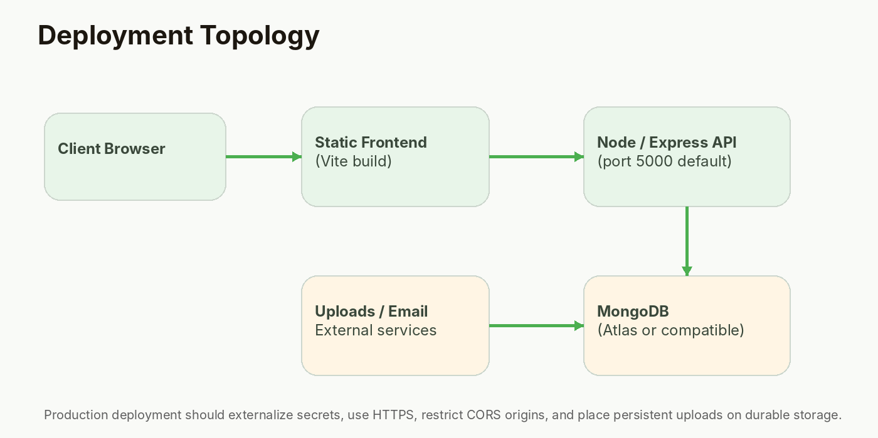
Figure 6. Deployment topology recommended for the existing architecture.

CHAPTER 16
Deployment, Configuration & Operations
Frontend build and backend run flow.
The root package provides “build” and “start” commands that map naturally to a split deployment: build the React application into static assets, then run the Express service for APIs and uploaded assets. The Vite config also defines manual chunks for React dependencies and Framer Motion.
Production deployment should keep the API and static frontend independently deployable even if they share one repository. The FRONTEND_URL variable should be set to the real production origin, CORS should be restricted to that origin, and database credentials should be supplied through the hosting environment rather than committed files.
Persistent media is the operational concern most likely to break a stateless web deployment because the current Multer configuration writes to local disk. Durable object storage is recommended before scaling across multiple instances.
Stage | Action | Evidence
Development | npm run dev | Vite + Express running together
Build | npm run build | frontend/dist generated
API start | npm start | Node/Express listens on PORT
Database | MONGO_URI configured | MongoDB connection log
Media | uploads/ or object storage | Accessible image URLs
HTTPS | TLS at hosting / reverse proxy | Secure browser/API traffic
Monitoring | Logs + health checks | Actionable runtime visibility

CHAPTER 16
Deployment, Configuration & Operations
Operations checklist.
• Rotate any secrets that may have entered local development archives before publication.
• Replace fallback JWT secrets with required production configuration.
• Choose one session strategy; prefer secure HttpOnly cookies and add CSRF protection where needed [R7].
• Move uploads to durable storage and validate file type/content independently where possible.
• Configure backups and retention for MongoDB and analytics data.
• Add application error monitoring and structured logs.
• Set CORS, NODE_ENV, FRONTEND_URL and email variables explicitly for production.
• Document rollback steps and a minimal health endpoint before release.
OPERATIONAL READINESS Deployment is more than a build command. Data persistence, secrets, observability, browser security and rollback procedures should be treated as first-class project deliverables.

CHAPTER 17
Results, Limitations & Future Enhancements
Observed strengths of the current artifact.
The strongest result is architectural breadth without a single monolithic component style. The frontend is split into pages, contexts, reusable components, home sections, admin components, hooks, animations and utilities. The backend follows models/controllers/routes/middleware/utilities, which provides clear navigation for future maintainers.
The UI also communicates a coherent brand. The use of a shared palette, repeated glass-card treatment, responsive grids and motion variants makes the project feel like one product rather than a set of unrelated demo screens.
Functionally, the admin panel covers an unusually broad set of content resources for an academic project: crops, products, blogs, users, inquiries, FAQs, services, testimonials and analytics.
Strength | Why it matters | Evidence
Modular structure | Lower change coupling | Separate folders and route/controller/model boundaries
Strong UI identity | Better perceived quality | Palette + motion + reusable components
Broad admin CRUD | Demonstrates backend depth | Multiple resource managers
Security baseline | Better starting point | Helmet/CORS/JWT/bcrypt/validation/rate limit
Content contribution | Shows user-role thinking | Write Blog + My Products

CHAPTER 17
Results, Limitations & Future Enhancements
Limitations identified by source inspection.
Area | Current limit | Recommended next release
Commerce | UI hint only; no cart/order/payment backend | Cart + order + payment state model
Auth storage | localStorage bearer token used by client | HttpOnly cookie-first session
Password reset | Fields exist but no reset route | Reset request/token/expiry flow
Analytics | views tracked; uniqueVisitors unused | Privacy-aware unique metrics
Gallery | Static frontend array | Gallery model + admin management if needed
Uploads | Local disk | Object storage / CDN
Testing | No visible automated suite | Jest/Vitest + Supertest + Playwright/Cypress
Deployment | No evidence of a completed hosted pipeline | CI/CD + health checks + monitoring

CHAPTER 17
Results, Limitations & Future Enhancements
Recommended roadmap.
• Phase A — hardening: secure cookie session, secret validation, dependency audit, upload storage, automated tests.
• Phase B — commerce: cart, orders, seller ownership, inventory transactions, payment integration and transactional emails.
• Phase C — agronomy intelligence: crop calendars, recommendation rules, weather integrations, soil data and explainable advisory content.
• Phase D — community: moderation queues, comments, reactions, reporting and expert verification.
• Phase E — scale: search indexing, caching, background jobs, observability, localization and multi-tenant architecture.
• Phase F — research: usability study with farmers, accessibility evaluation, low-bandwidth performance study and measurable task outcomes.
RESEARCH OPPORTUNITY The most valuable future enhancement is evidence-driven personalization: use actual farmer/user needs to decide which features create measurable agricultural value instead of adding technology for its own sake.

CHAPTER 18
Conclusion
Final evaluation of the project.
GreenHarvest demonstrates how a modern JavaScript stack can be used to create an agriculture-focused digital platform that is visually distinctive, modular and extensible. The project successfully connects a React frontend, Express API, MongoDB data model, authentication layer, content management workflows and analytics into a coherent application structure.
The submitted source is particularly strong as a learning artifact because it shows both breadth and engineering patterns: REST routes, schema validation, middleware composition, shared React context, lazy-loaded pages, responsive utility styling and animation. The report also identifies the difference between a polished prototype and a production service, which is important for credible academic evaluation.
In conclusion, the project meets the core objective of demonstrating a full-stack agriculture platform while leaving a clear roadmap for production hardening, commerce, stronger analytics, research validation and operational maturity.
FINAL STATEMENT GreenHarvest is a strong foundation for further development. Its next stage should prioritize correctness, security, testing and real-user validation before increasing feature breadth.

APPENDIX A
APPENDIX A — Selected Code Snippets
Implementation evidence for viva and technical review.
backend/middleware/auth.js
01 const jwt = require('jsonwebtoken');
02 const User = require('../models/User');
03 const AppError = require('../utils/AppError');
04
05 exports.protect = async (req, res, next) => {
06 try {
07 let token;
08 if (req.headers.authorization?.startsWith('Bearer')) {
09 token = req.headers.authorization.split(' ')[1];
10 } else if (req.cookies?.token) {
11 token = req.cookies.token;
12 }
13 if (!token) return next(new AppError('Not authorized', 401));
14
15 const decoded = jwt.verify(token, process.env.JWT_SECRET);
16 req.user = await User.findById(decoded.id);
17 if (!req.user) return next(new AppError('User not found', 401));
18 next();
19 } catch (err) {
20 next(new AppError('Not authorized', 401));
21 }
22 };
23
24 exports.admin = (req, res, next) => {
25 if (req.user?.role !== 'admin') return next(new AppError('Admin access required', 403));
26 next();
27 };
Source: backend/middleware/auth.js. This compact middleware demonstrates token extraction, JWT verification, user lookup and the admin role gate.

APPENDIX A
APPENDIX A — Selected Code Snippets
Theme persistence and UI mode switching.
frontend/src/context/ThemeContext.jsx
01 import { createContext, useContext, useState, useEffect, useCallback } from 'react';
02
03 const ThemeContext = createContext();
04
05 export function ThemeProvider({ children }) {
06 const [theme, setTheme] = useState(() => {
07 if (typeof window !== 'undefined') {
08 const saved = localStorage.getItem('theme');
09 if (saved) return saved;
10 return window.matchMedia('(prefers-color-scheme: dark)').matches ? 'dark' : 'light';
11 }
12 return 'light';
13 });
14
15 useEffect(() => {
16 const root = document.documentElement;
17 if (theme === 'dark') {
18 root.classList.add('dark');
19 } else {
20 root.classList.remove('dark');
21 }
22 localStorage.setItem('theme', theme);
23 }, [theme]);
24
25 const toggleTheme = useCallback(() => {
26 setTheme(prev => prev === 'light' ? 'dark' : 'light');
27 }, []);
28
29 return (
30 <ThemeContext.Provider value={{ theme, toggleTheme }}>
31 {children}
32 </ThemeContext.Provider>
33 );
34 }
35
36 export const useTheme = () => useContext(ThemeContext);
Source: frontend/src/context/ThemeContext.jsx. The context stores the selected mode in localStorage and toggles the root HTML class.

APPENDIX A
APPENDIX A — Selected Code Snippets
Hero motion and product identity.
frontend/src/components/home/Hero.jsx
01 import { motion } from 'framer-motion';
02 import Button from '../common/Button';
03 import FloatingElements from '../common/FloatingElements';
04
05 const wordReveal = {
06 hidden: { opacity: 0, y: 50 },
07 visible: (i) => ({
08 opacity: 1, y: 0,
09 transition: { delay: i * 0.12, duration: 0.7, ease: [0.25, 0.46, 0.45, 0.94] },
10 }),
11 };
12
13 export default function Hero() {
14 const titleWords = "Cultivating Tomorrow's Harvest Today".split(' ');
15
16 return (
17 <section className="relative min-h-screen flex items-center justify-center overflow-hidden -mt-16 md:-mt-20">
18 <div className="absolute inset-0">
19 <div className="absolute inset-0 bg-gradient-to-br from-earth-900 via-earth-800 to-sprout-900 z-10" />
20 <div className="absolute inset-0 opacity-30 z-0">
21 <div className="absolute top-20 left-10 w-72 h-72 bg-leaf-500/20 rounded-full blur-3xl animate-float" />
22 <div className="absolute bottom-20 right-10 w-96 h-96 bg-sunset-500/10 rounded-full blur-3xl animate-float" style={{ animationDelay: '2s' }} />
23 <div className="absolute top-1/2 left-1/2 -translate-x-1/2 -translate-y-1/2 w-[500px] h-[500px] bg-sprout-500/10 rounded-full blur-3xl animate-pulse-slow" />
24 </div>
25 </div>
26
27 <div className="relative z-20 max-w-7xl mx-auto px-4 sm:px-6 lg:px-8 text-center">
28 <FloatingElements />
29
30 <motion.div
31 initial={{ opacity: 0, scale: 0.8 }}
32 animate={{ opacity: 1, scale: 1 }}
33 transition={{ duration: 0.8, delay: 0.2 }}
34 className="inline-flex items-center gap-2 px-4 py-2 rounded-full glass text-sm text-white/80 mb-8"
35 >
36 <span className="w-2 h-2 rounded-full bg-leaf-400 animate-pulse" />
37 Pioneering Sustainable Agriculture Since 1998
38 </motion.div>
39
40 <h1 className="font-serif text-5xl md:text-6xl lg:text-8xl font-bold text-white mb-6 max-w-5xl mx-auto leading-tight">
41 {titleWords.map((word, i) => (
42 <motion.span key={i}
43 custom={i}
44 variants={wordReveal}
45 initial="hidden"
46 animate="visible"
47 className="inline-block mr-[0.25em]"
48 >
Source: frontend/src/components/home/Hero.jsx. The hero demonstrates the project’s visual identity, motion timing, calls-to-action and floating decorative layer.

APPENDIX A
APPENDIX A — Selected Code Snippets
Data models and business rules.
backend/models/Product.js
01 const mongoose = require('mongoose');
02
03 const productSchema = new mongoose.Schema({
04 name: { type: String, required: [true, 'Product name required'], trim: true },
05 price: { type: Number, required: [true, 'Price required'], min: 0 },
06 category: { type: String, required: true, enum: ['seeds', 'fertilizers', 'equipment', 'pesticides', 'organic', 'other'] },
07 description: { type: String, required: true },
08 images: [{ type: String }],
09 stock: { type: Number, required: true, min: 0, default: 0 },
10 unit: { type: String, default: 'kg' },
11 ratings: { type: Number, default: 0, min: 0, max: 5 },
12 numReviews: { type: Number, default: 0 },
13 featured: { type: Boolean, default: false },
14 status: { type: String, enum: ['active', 'inactive', 'pending'], default: 'active' },
15 seller: { type: mongoose.Schema.Types.ObjectId, ref: 'User', default: null },
16 }, { timestamps: true });
17
18 module.exports = mongoose.model('Product', productSchema);
Source: backend/models/Product.js. The product schema expresses price/stock constraints, category/status enums, ratings and a seller reference.
backend/models/Crop.js
01 const mongoose = require('mongoose');
02
03 const cropSchema = new mongoose.Schema({
04 name: { type: String, required: [true, 'Crop name required'], trim: true },
05 category: { type: String, required: true, enum: ['cereals', 'vegetables', 'fruits', 'pulses', 'oilseeds', 'cash-crops'] },
06 description: { type: String, required: true },
07 image: { type: String, required: true },
08 season: { type: String, required: true },
09 growingPeriod: { type: String, default: '' },
10 soilType: { type: String, default: '' },
11 waterRequirement: { type: String, default: '' },
12 status: { type: String, enum: ['active', 'inactive'], default: 'active' },
13 featured: { type: Boolean, default: false },
14 order: { type: Number, default: 0 },
15 }, { timestamps: true });
16
17 module.exports = mongoose.model('Crop', cropSchema);
Source: backend/models/Crop.js. The crop schema supports category classification, cultivation metadata, status, featured flag and display ordering.

APPENDIX B
APPENDIX B — API Matrix
Concise endpoint reference for the submitted implementation.
Endpoint | Access | Purpose
POST /api/auth/register | Public | Register new user
POST /api/auth/login | Public | Authenticate user
GET /api/auth/me | Protected | Current user
GET /api/auth/logout | Public | Clear cookie response
PUT /api/auth/password | Protected | Change password
PUT /api/auth/profile | Protected | Update profile
GET /api/crops | Public | List crops
GET /api/crops/:id | Public | Crop detail
POST /api/crops | Admin | Create crop
PUT /api/crops/:id | Admin | Update crop
DELETE /api/crops/:id | Admin | Delete crop
GET /api/products | Public | List products
GET /api/products/:id | Public | Product detail
POST /api/products | Admin | Create product
PUT /api/products/:id | Admin | Update product
DELETE /api/products/:id | Admin | Delete product
GET /api/blogs | Public | List blogs
GET /api/blogs/slug/:slug | Public | Blog by slug
GET /api/blogs/:id | Public | Blog by id
GET /api/blogs/my | Protected | My blogs
POST /api/blogs | Admin | Create admin blog
POST /api/blogs/user | Protected | Create user blog
PUT /api/blogs/:id | Admin | Update admin blog
PUT /api/blogs/user/:id | Protected | Update own blog
DELETE /api/blogs/:id | Admin | Delete admin blog
DELETE /api/blogs/user/:id | Protected | Delete own blog
POST /api/contact | Public | Submit inquiry
GET /api/contact | Admin | List inquiries
PUT /api/contact/:id/read | Admin | Mark inquiry read
DELETE /api/contact/:id | Admin | Delete inquiry
GET/POST/PUT/DELETE /api/services | Mixed | Service CRUD
GET/POST/PUT/DELETE /api/testimonials | Mixed | Testimonial CRUD
GET/POST/PUT/DELETE /api/faq | Mixed | FAQ CRUD
GET/PUT/DELETE /api/users | Admin | User administration
POST /api/upload | Protected | Single image upload
POST /api/upload/multiple | Protected | Multiple image upload
GET/POST/PUT/DELETE /api/my-products | Protected | User-owned products
GET /api/analytics/dashboard | Admin | 30-day dashboard aggregation
POST /api/analytics/track | Public | Increment daily page views

APPENDIX B
APPENDIX B — API Matrix
Endpoint access map and role boundary.
Role | Can read public resources | Can contribute | Can administer
Visitor | Yes | No | No
User | Yes | Yes — own blogs/products | No
Admin | Yes | Yes | Yes

AUTHORIZATION RULE The UI can hide controls, but real protection belongs at the API boundary. GreenHarvest enforces admin writes with protect + admin middleware and user-owned resources with authenticated identity checks.

REFERENCES
REFERENCES & RESEARCH SOURCES
External guidance used for context and best-practice discussion.
[R1] Food and Agriculture Organization (FAO). “FAO Digital Services Portfolio.”
https://www.fao.org/digital-services/en/
Digital agriculture services and information access.
[R2] MongoDB Documentation. “Documents” and “Data Modeling.”
https://www.mongodb.com/docs/v8.0/core/document/
Document model, BSON and schema/data modeling context.
[R3] Express.js Documentation. “Using Middleware” and “Routing.”
https://expressjs.com/en/guide/using-middleware/
Middleware and request lifecycle model.
[R4] React Documentation. “useContext,” “lazy,” and “Suspense.”
https://react.dev/reference/react/useContext
Shared state and lazy loading patterns.
[R5] Vite Documentation. “Why Vite,” “Getting Started,” and “Building for Production.”
https://vite.dev/guide/
Development server and production build rationale.
[R6] Tailwind CSS Documentation. “Responsive Design” and “Dark Mode.”
https://tailwindcss.com/docs/responsive-design
Responsive utility variants and dark-mode approach.
[R7] OWASP Cheat Sheet Series. “JSON Web Token Cheat Sheet” and “Session Management Cheat Sheet.”
https://cheatsheetseries.owasp.org/cheatsheets/JSON_Web_Token_Cheat_Sheet.html
JWT handling and browser token storage guidance.
CITATION NOTE Framework documentation and research references were consulted in October 2026. Project-specific implementation statements are grounded in the supplied Green-Harvest source archive.

END OF REPORT • GreenHarvest Project Report • Version 1.0

