**Documentation**

**On**

**LOGIN AND REGISTRATION**





**11/05/2018**

**THAPALIYA Bishal**

**Contents**

**1.** **Objective** 3

**2.** **Reason behind choosing this task** 3

**3.** **Technologies used** 3

**4.** **Installations** 3

**5.** **Source code** 3

**5.1** **Imports:** 3

**5.2** **Constructor:** 3

**5.3** **Method(s)/Function(s):** 4

**5.3.1** **componentWillMount():** 4

**5.3.2** **togglePasswordModal():** 4

**5.3.3** **toggleSignUpModal():** 4

**5.3.4** **Render():** 4

**6.** **Sample Output:** 5

# **Objective**

The aim of this task is to create a simple login page using React JS where user can get in to the system by entering username and password if it is already registered else the user must register as a new member.

# **Reason behind choosing this task**

Since I am beginner in ReactJS, I was excited to start with a small project where I could be able to show my potentialities toward achieving the goal within the given time boundary. Even though a login and registration is one of the simplest parts of any project, I took it as a good practice to start ReactJS which was completely new to me. By the end of this task, it made me comfortable and boosted up a bit of my confidence level which will definitely underpin my strength if I get a chance to work in React in my nearly future.

# **Technologies used**

React JS : a modern JavaScript framework.

CSS : cascading style sheet to beautify the web page.

# **Installations**

* npm install -g create-react-app (to provide the global access to create-react-app)
* create-react-app twitterexercise (to create “twitterexercise” as a react application)
* npm install react-modal --save (to install and access react modal which is useful to show a dialog)

# **Source code**

## **Imports:**

import React, { Component } from 'react'; - to import and access react components.

import './index.css' - to import and access our css file.

import Modal from 'react-modal'; - to import and access modal window.

## **Constructor:**

constructor(){

super()

this.state = {

signUp: false,

forgotPassword: false

}

}

* In this section the states for sign up and forgotten password modals has been defined.

## **Method(s)/Function(s):**

### **componentWillMount():**

This method is used to handle our Modal element which is called before the initial render.

### **togglePasswordModal():**

This function is used to set the state for forgotPassword section.

### **toggleSignUpModal():**

This function is used to set the state of new user registration modal dialog.

### **Render():**

Here in render-return section, we implement the whole elements of jsx which will render and return the output as we expect.

Example:

render() {

return (

<div className="input_container" >

<input className="input" type="text" name="email" placeholder="Enter Username" required/>

<span className="input_border"></span>

</div>

);

}

# **Sample Output:**

**Output 1:**

This is the first screen when we run our application.

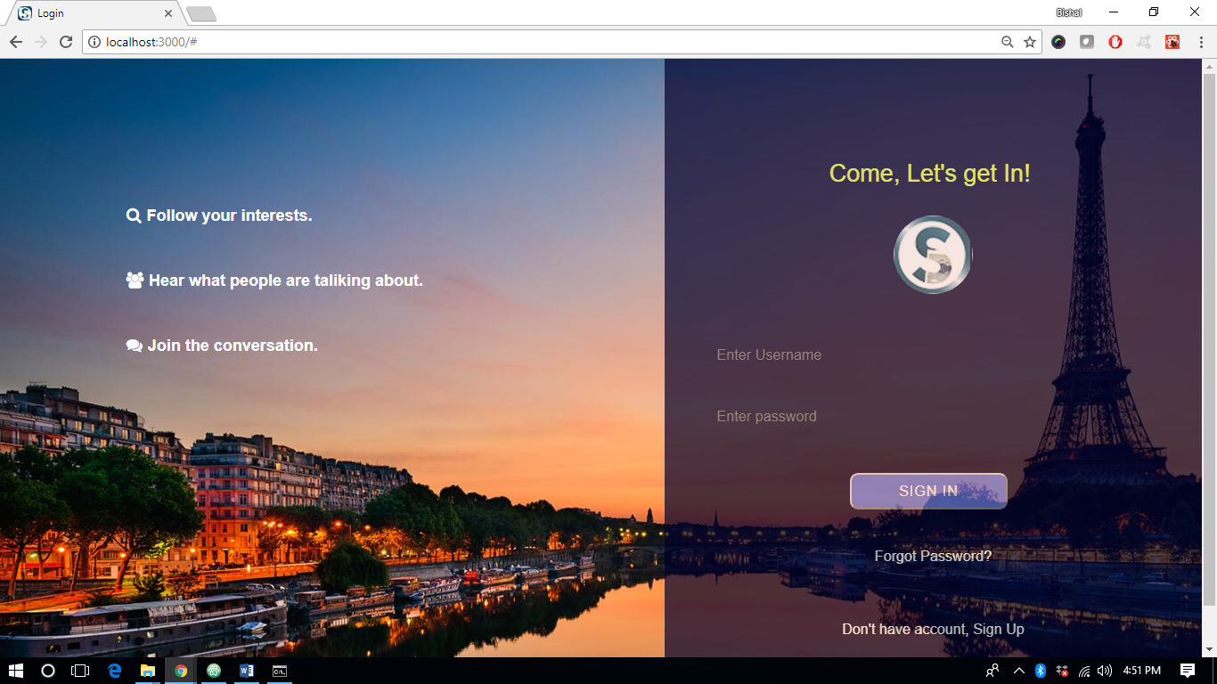

**Output 2 :**

Here user can retrieve their password in their email inbox if in case they forget password.

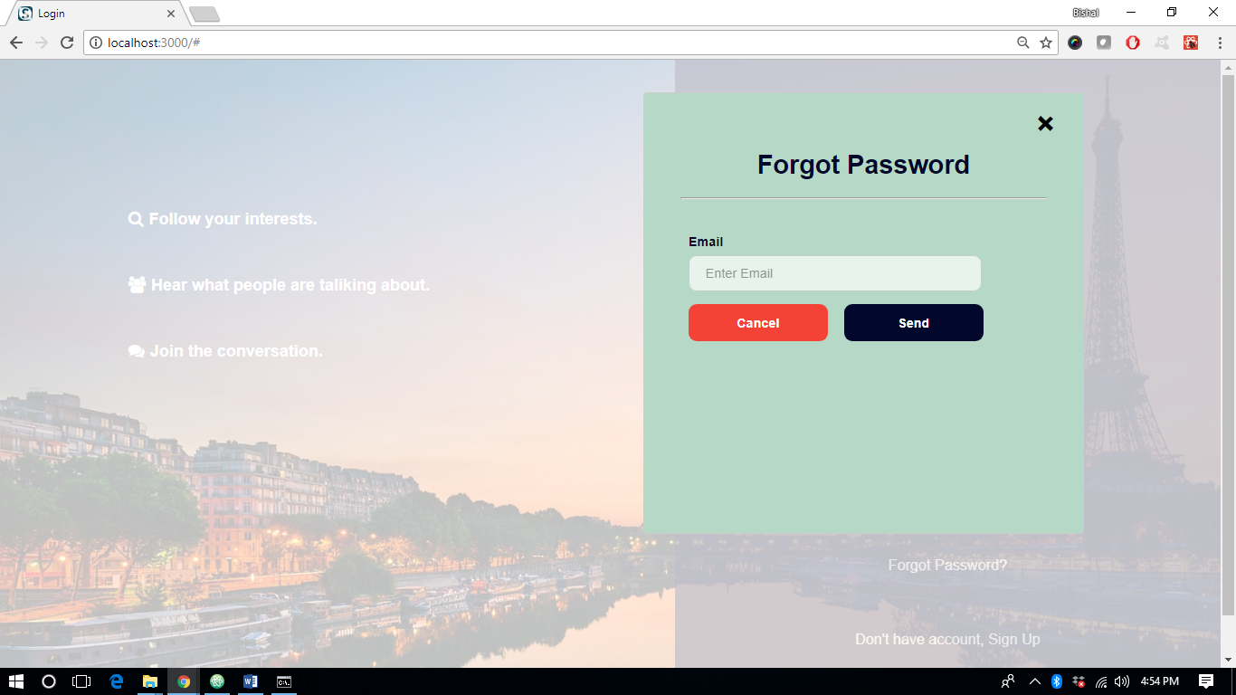

**Output 3 :**

User can create a new login credential by clicking on Sign up option on the main page.

