**RESEARCH & DEVELOPMENT PROJECT REPORT**

**A VISION-BASED**

**GEOSPATIAL INFORMATION SYSTEM (GPS-FREE)**



**SUBMITTED BY**

**ADHIKARI Jyoti**

**THAPALIYA Bishal**

**DEPARTMENT OF SCIENCE & TECHNOLOGY – INFORMATION SYSTEMS**

**ÉCOLE SUPÉRIEURE D'INGÉNIEURS EN GÉNIE ÉLECTRIQUE (ESIGELEC)**

**MAY, 2016**

**ACKNOWLEDGE**

The completion of any inter-disciplinary project depends upon cooperation, co-ordination and combined efforts of several sources of knowledge. We are pleased to acknowledge Prof. Dr. Karim Hammoudi for his even willingness to give us valuable advice and direction; whenever we approached him with a problem, and his invaluable guidance during the course of this project work.

Last but not least, we would like to appreciate the guidance, ideas, tips and comments given by our friends to achieve our project goal.

**ADHIKARI Jyoti**

**THAPALIYA Bishal**

**Table of Contents**

**INTRODUCTION** 1

**OVERVIEW** 1

**BACKGROUND AND MOTIVATION** 1

**OBJECTIVE** 1

**TECHNOLOGY USED** 2

**USER INTERFACE** 2

**SPECIFICATION** 2

**EXAMPLE** 3

**LESSONS LEARNED** 5

**REFERENCES** 5

# **INTRODUCTION**

## **OVERVIEW**

This report discusses the result of the work done in development of "A vision Based Geospatial Information System (GPS Free)" on C++ platform. It is a part of the Research and Development (R&D) project going in Information Systems Department (Masters), ESIGELEC and aims at the development of an application framework for providing a common platform for facilitating the use of methodological approach developed by R&D team and integration of various tools developed during the execution of the project.

The Vision Based Geospatial Information System is a computer application system that is developed to identify the tentative geo-location of an image. It helps user to find the GPS coordinates (longitude & latitude) by matching maximum key points of a reference image with an image in the dataset. This application shows us the matching key points, longitude, and latitude of each and every images that are being compared with the reference image. On the basis of matching maximum number of key points, it stores the maximum key points matched image to the output folder.

## **BACKGROUND AND MOTIVATION**

Research and Development (R&D) projects can be found in large variety of applications today like image processing, networking and wireless communication, gesture controlling, facial expression detection, and many more. The R&D project aims at the development of a design methodology for image processing application. This project deals with the development of such a tool which will help to extract the geo-location of a particular image by detecting features and comparing it with the set of images in the data set.

## **OBJECTIVE**

The main objective of this project was to develop a computer application that is useful to find the geographic location of a picture that is taken by a non-GPS devices such as; camera, webcam and mobile phone by comparing and matching properties with the photos that are stored in the dataset.

## **TECHNOLOGY USED**

For the development of this project, we used following technologies;

* Eclipse IDE,
* OpenCV library,
* C++ as programming language,
* Speeded-Up Robust Features (SURF) algorithm.

## **USER INTERFACE**

The tool is very user friendly and intuitive and uses a GUI interface implemented in C++ to communicate with the user. User can see the reference (source) image on the right hand side and the matching sequence of images on the left hand side. The sequence images shows the longitude and latitude of the image, and value of matching key points.

## **SPECIFICATION**

As we don't have a completely deployed application, we work with the source code at this stage. First of all, we will place our reference image with a suitable name in ***"src"*** folder underneath the program source code folder. Then after, we need to same image file name as reference image in image read source code. Now, we have to run our application to get the tentative geo-location of our reference image.

## **EXAMPLE**

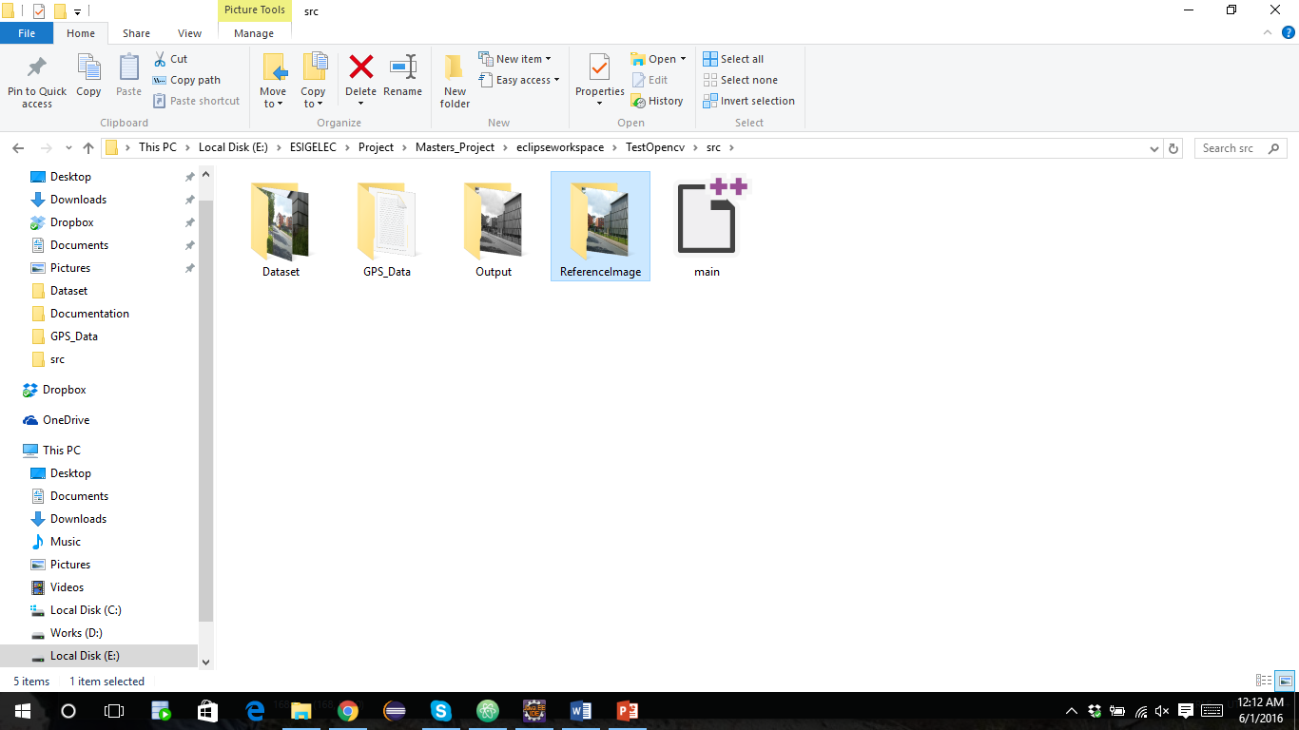

For instance: assume an above image is container of our source code and we have our reference image **"b5.jpeg"** in **"ReferenceImage"** folder. Now we have to extract its GPS latitude and longitude by detecting features from the set of images in **"Dataset"** folder.

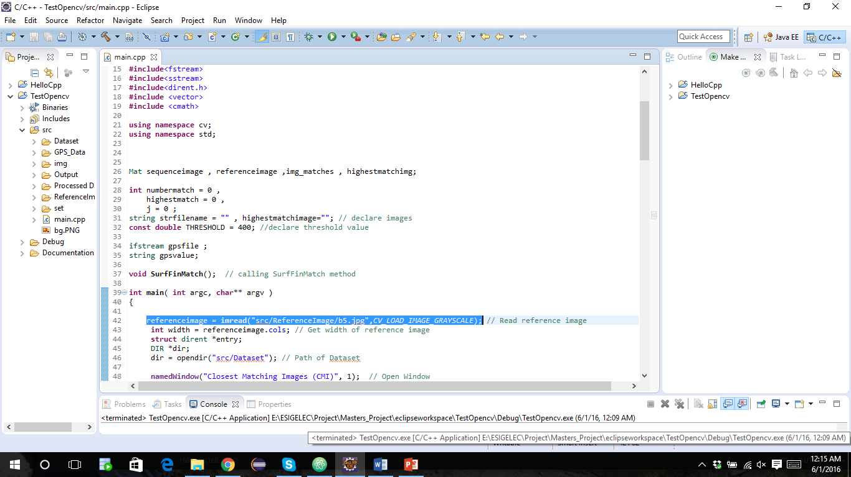

Then we passed the same image file ***"b5.jpg"*** as ***referenceimage*** in source code.



After that, click on **Run** button.

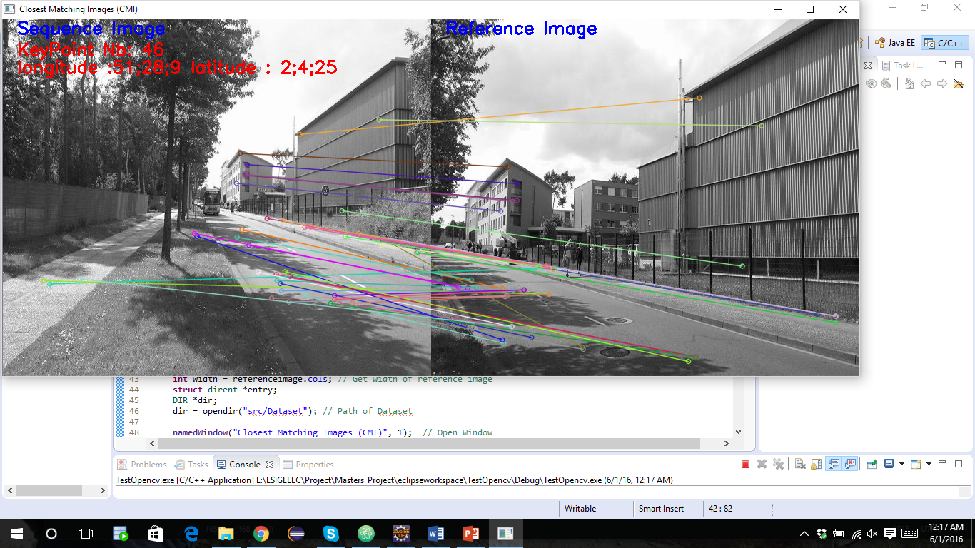

An output of matching key point image.

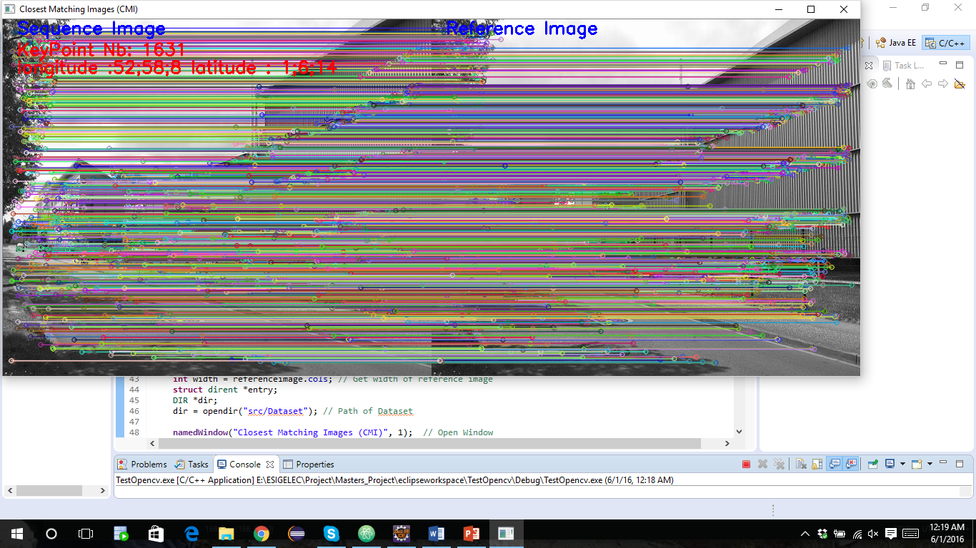

An output of maximum key points matching image.

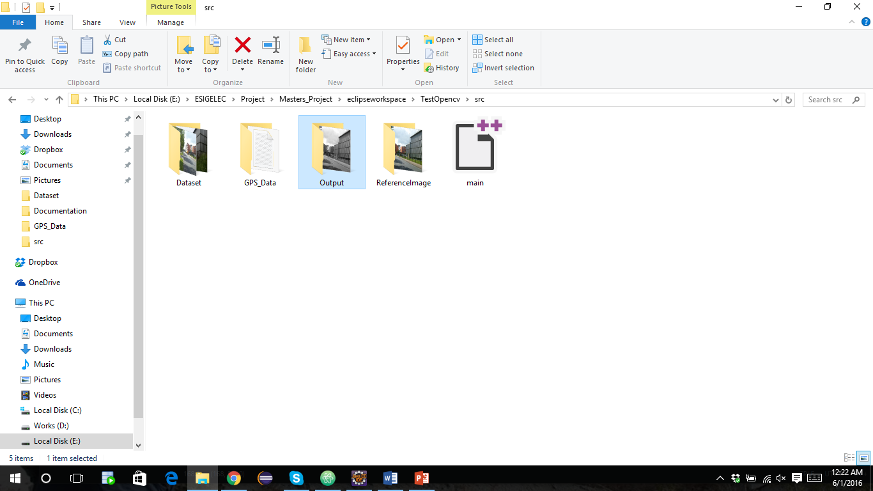

An image with maximum matching key points will be saved as result in **Output** folder that gives longitude and latitude of an image.

## **LESSONS LEARNED**

When things go wrong, as they always will; excuses will not work. Find an alternative action or right suggestions instead. Allocating blame only causes conflict and aggression, searching for solutions will bring the team together. Together with leadership skills will definitely help you towards achieving your goal.

## **REFERENCES**

<http://opencv.org/documentation.html>

<http://docs.opencv.org/2.4.8/modules/refman.html>