Billing Software — Requirements Specification
VERSION 1.0 — LOCKED
Frozen baseline for Version-1 project. Functional changes require Requirements v2 revision (see docs/REQUIREMENTS_V1_LOCK.md).
Mandatory MVP baseline from stakeholder Billing Application – Functional & Calculation Logic Document (Section 1 & CORE-* requirements). Extended themes (§3+) add marketplace catalog, advanced IAM, and suite capabilities beyond MVP.
Document generated for implementation planning.

1. References & inspiration
- The following public product positioning pages informed this superset (feature names are generalized; implement per jurisdiction):
- Zoho — Cloud software suite for businesses: https://www.zoho.com/ (CRM, Books, unified apps).
- Vyapar — GST billing, inventory & accounting for Indian SMEs: https://vyaparapp.in/
- MyBillBook — SMB GST billing segment (trial funnel): https://freetrial.mybillbook.in/
- Stakeholder Billing Application – Functional & Calculation Logic Document (PDF): authoritative MVP scope restated in §1.1–1.6; copy in repo: docs/Billing_Application_Functional_Reference.pdf

1.1 Mandatory baseline — stakeholder billing document
The following is restated from the project document Billing Application – Functional & Calculation Logic Document. This scope is mandatory for MVP: implementation MUST satisfy Section 1.1–1.6 and requirement IDs CORE-01 through CORE-15 in Section 4. Other sections of this specification are additive extensions unless explicitly adopted.

1.2 Application overview & assumptions
Application name: Billing Application.
Purpose: create, manage, and track customer invoices; calculate taxes and totals; record payments; generate billing reports.
- Target users (baseline personas):
- Admin
- Billing Staff
- Accountant (read-only / reports)
- Assumptions:
- Single currency (design MAY allow future extension).
- Percentage-based tax (GST/VAT).
- Line-item–based invoices.
- Decimal precision: 2 places; rounding mode round half up.

1.3 Baseline user roles & permissions
Role | Permissions
Admin | Full access, configuration, reports
Billing Staff | Create/edit invoices, customers
Accountant | View invoices, reports only

1.4 Page-wise functional flow & calculation logic

1.4.1 Login page
Purpose: authenticate users.
Fields: Username; Password.
Logic: validate credentials. No billing calculation on this page.

1.4.2 Dashboard page
Purpose: billing summary.
Metric | Logic
Total Invoices (Today) | Count of invoices created today
Total Sales | Sum of Invoice Grand Total
Total Tax | Sum of Invoice Tax Amount
Pending Payments | Sum of unpaid invoice balances

1.4.3 Customer management
Purpose: create and manage customers.
Fields: Customer Name; Address; Phone; Email; GST type; GST; State (with state code); Credit Balance; opening balance (payable & receivable); four configurable Additional Fields labels (values printed on invoice).
No tax/total calculations on this page beyond storing balances for reference.

1.4.4 Product / service management
Purpose: define billable items.
Fields: Product Name; HSN code; category; Sale Price; Purchase Price; Wholesale Price & Qty; Tax Rate (%); Unit of Measure.
Reporting expectation: profit indicator from Sale Price, Purchase Price, and Tax as defined in the stakeholder document (sale price − purchase price − tax relates to profit %).
No invoice calculations here; master data used on invoice lines.

1.4.5 Invoice creation (core billing)
Invoice header: Invoice Number (auto-generated); Invoice Date; Customer; Due Date.
Each line item: Product; Quantity; Unit Price (from product, editable); Discount (%) optional; Tax Rate (%) from product; Round off (nearest value of 1 per stakeholder doc); Line Total (calculated).
- Line item calculation logic (mandatory order):
- Step 1 — GrossAmount = Quantity × UnitPrice
- Step 2 — DiscountAmount = GrossAmount × (Discount% / 100)
- Step 3 — TaxableAmount = GrossAmount − DiscountAmount
- Step 4 — TaxAmount = TaxableAmount × (TaxRate% / 100)
- Step 5 — LineTotal = TaxableAmount + TaxAmount
- Invoice summary fields:
Field | Calculation
Subtotal | Σ TaxableAmount
Total Discount | Σ DiscountAmount
Total Tax | Σ TaxAmount
Shipping / Other Charges | Manual input
Grand Total | Subtotal + TotalTax + OtherCharges (rounded to 2 decimals)

1.4.6 Invoice view / print
Display invoice details, lines, subtotal, tax breakdown, Grand Total, Paid Amount, Balance Due. BalanceDue = GrandTotal − PaidAmount.

1.4.7 Payment recording
Fields: Invoice Number; Payment Date; Payment Mode (Cash, Card, Bank); Paid Amount.
Partial payments supported: RemainingBalance = PreviousBalance − PaidAmount.
Condition | Invoice status
PaidAmount = 0 | Unpaid
PaidAmount < GrandTotal | Partially Paid
PaidAmount = GrandTotal | Paid

1.4.8 Credit note / refund
Purpose: returns or billing corrections.
RefundAmount ≤ Original Invoice Amount.
AdjustedBalance = OriginalBalance − RefundAmount.

1.4.9 Core reports (dashboard subset)
Sales Report: TotalSales = Σ Invoice.GrandTotal over date range.
Tax Report: TotalTaxCollected = Σ Invoice.TotalTax.
Outstanding Payments Report: OutstandingAmount = Σ BalanceDue where BalanceDue > 0.

1.5 Document modules (sale, purchase, cash)
Sale: Sale invoice; Estimate / quotation; Payment-in entry; Sale order; Delivery challan; Sale return / Credit note (see 1.4.8).
Purchase: Purchase; Payment-out entry; Purchase order; Purchase return / Debit note.
Cash & Bank: Bank account with formal entries derived from sale invoices and payment-in; opening balance as capital investment; digital amount tracking; Cash in Hand (physical cash); Cheque handling.

1.6 Reports enumeration & non-functional requirements (PDF)
Reports SHALL be available for data fetch across required fields for: Sale; Purchase; All-fields report; Payment-in; Payment-out; Delivery challan; Credit note; Debit note; Sale order; Purchase order.
- Non-functional requirements from stakeholder document:
- Decimal precision: 2 digits (consistent with §1.2).
- Secure authentication.
- Role-based access (baseline roles in §1.3).
- PDF invoice generation.
- Audit trail for edits.
- Informative future enhancements (out of mandatory MVP unless promoted): multi-currency; recurring invoices; subscription billing; automatic tax rules; API integration; job-role–based price management extensions.

2. Figures — DFD & conceptual diagrams
Structured analysis uses Data Flow Diagrams (DFD) to show boundaries, processes, and data stores. Lifecycle diagrams explain document sequencing.
- Context diagram (Level 0): external entities vs the billing suite.
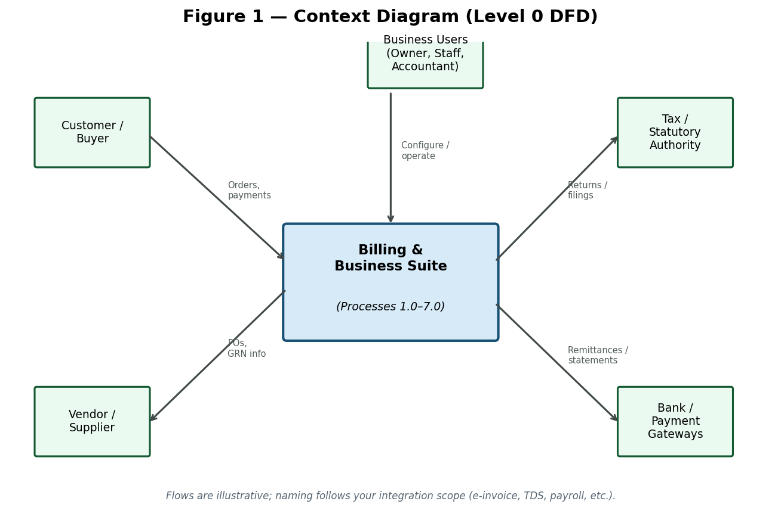

- Level 1 DFD: core processes and logical data stores.
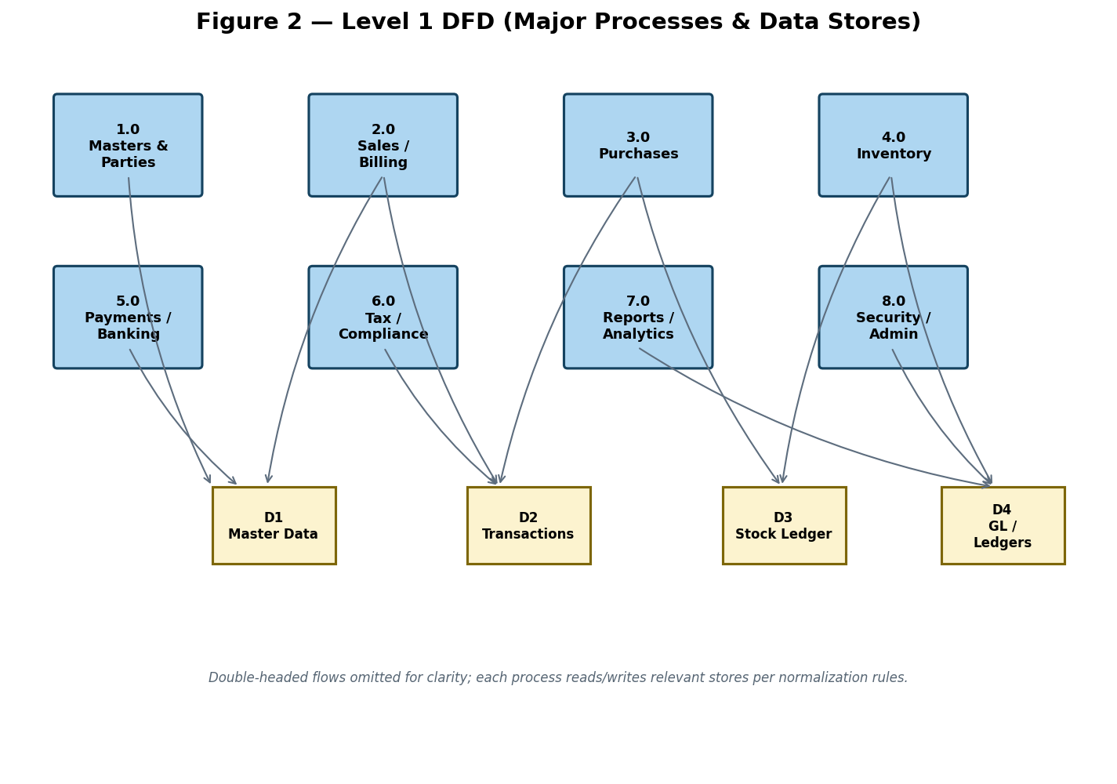

- Billing lifecycle: quotation through payment and returns.
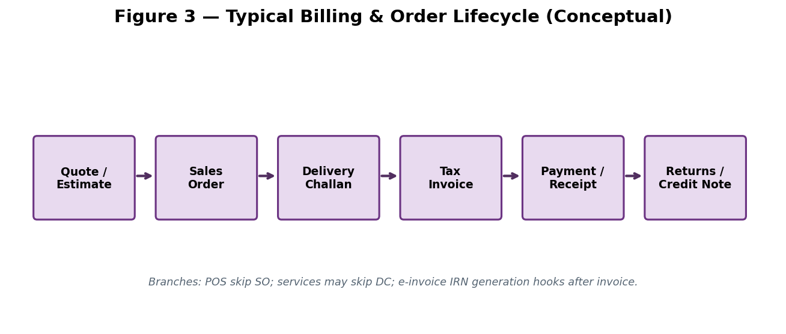

- Capability domain map (market superset).
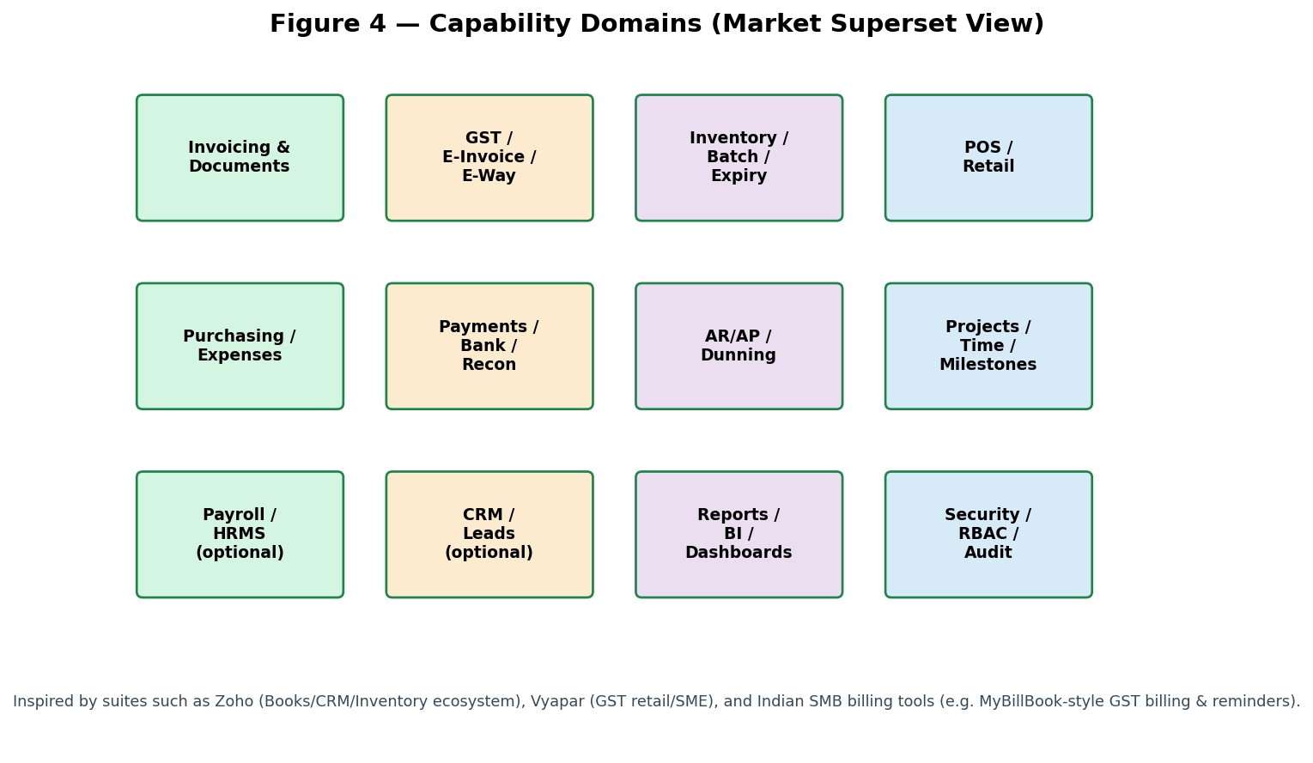

- Product catalog taxonomy (marketplace-style categories, types, variants).
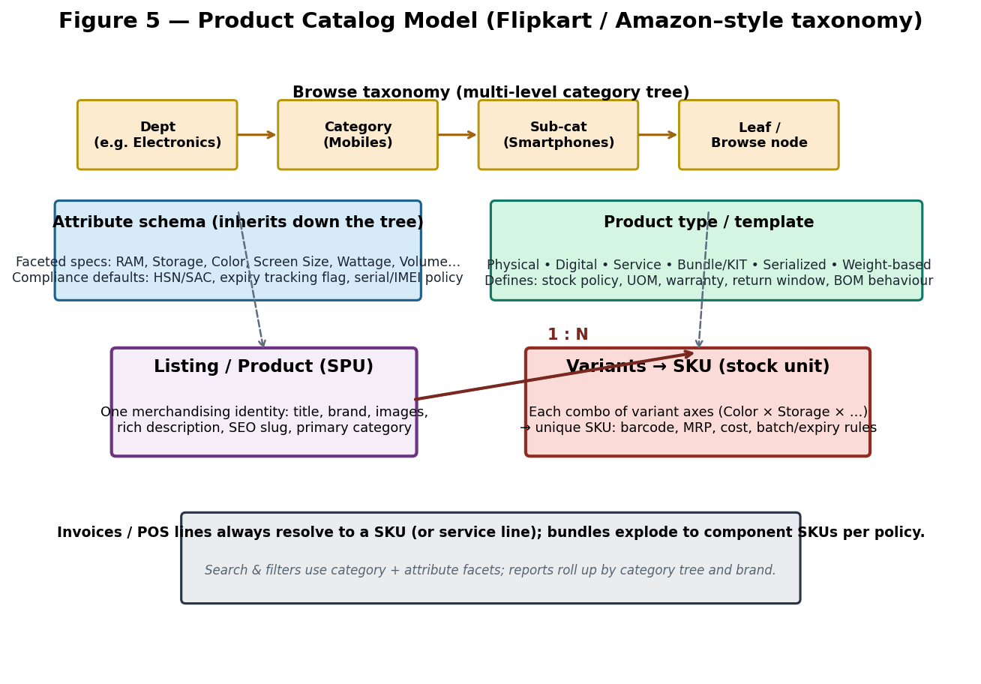

- Identity & access: JWT + refresh, RBAC + ABAC, IAM admin & delegation.
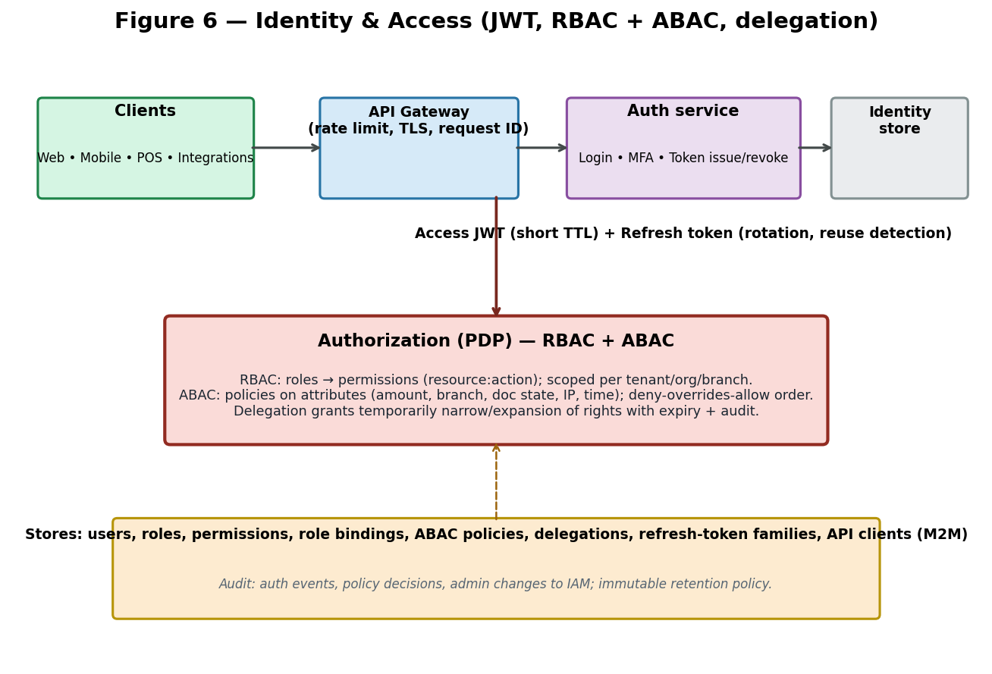

3. Superset feature catalog (extended themes)
Themes below extend the MVP defined in §1. They span Zoho-style breadth, Vyapar/MyBillBook-class GST retail, marketplace catalog, and enterprise IAM. Prioritize after CORE-* delivery unless a theme is explicitly pulled into MVP.
Theme | Superset scope notes
Core documents | Invoice, quote/estimate, proforma, delivery challan, credit/debit note, receipt, purchase bill/GRN, PO, work orders.
Tax & compliance | GST/VAT slabs, HSN/SAC, TDS/TCS, e-invoice IRN/QR, e-way generation/cancel hooks, statutory registers.
Inventory | SKU, variants, batch/MRP/expiry, serial nos., multi-UOM, barcode/scanning, adjust/transfer, reorder alerts.
Parties & pricing | Customer/vendor masters, credit limits & stops, price lists, discounts, schemes, ship-to/bill-to.
Payments & banking | Cash/bank/UPI/card/cheque/wallet, split tenders, allocations, FX gains/losses if multi-currency.
AR/AP & collections | Outstanding, aging, dunning cadence, payment links, bulk reminders (SMS/WhatsApp/email).
Retail / POS | Quick billing, park/hold, returns/exchange, cashier shifts, thermal/A4, offline-capable.
Purchasing & expenses | Vendor bills, landed cost, GRNI, expense claims GST/non-GST, approvals.
Reporting & BI | Financial statements, registers, MIS dashboards, cohort/item profitability, scheduled exports.
Platform | Multi-org/fiscal years/branches/warehouses, IAM (JWT/RBAC/ABAC), field-level audit, backups encryption.
Digital extensions | Online storefront/catalog orders, PG settlements import, OCR for expense snaps.
CRM / projects (optional) | Leads/deals pipeline; quotes tied to opportunities; time & milestone billing.
Subscriptions & recurring | Recurring invoices, usage tiers, proration, dunning for SaaS/service.
Integrations | Email SMTP, SMS gateways, accounting bridges, payment gateways, e-commerce carts.
HR/Payroll (optional) | Salary payouts, statutory deductions summaries feeding GL.
Catalog & taxonomy (marketplace-class) | Multi-level categories; product types (physical/digital/service/bundle); attribute schemas & facets; listing (SPU) vs SKU variants; brand; compatibility with search/filter UX like large marketplaces.
Identity & access (IAM) | JWT access + refresh rotation; RBAC (roles/permissions); ABAC policies; MFA/SSO optional; role admin UI; temporary delegation; API keys (M2M); session/device revoke; auth audit.

3.1 Product types & categories (Flipkart / Amazon–style handling)
Large marketplaces separate what customers browse (department → category → attributes/facets) from what warehouses stock (SKU = variant combination). Billing software should mirror that model so one catalogue supports electronics, apparel, grocery, pharmacy, digital goods, and services without hard-coding item shapes per industry.
- Core concepts (see Figure 5):
- Category tree — unlimited depth; optional multiple category placement per listing with one primary path for breadcrumbs.
- Product type / template — defines behaviour: stocked vs non-stocked, serialised, batch/expiry, weight/count pricing, digital fulfilment (license key/file), service (duration/milestone), bundle/KIT (static or configurable BOM).
- Attribute schema — per category or product type; drives specs on PDP, POS picker facets, and compliance (e.g. medicine schedule, wattage, storage GB). Inherited attributes override at lower levels.
- Listing (SPU) vs SKU — one merchandising product with images/long description; many SKUs for variant axes (e.g. Colour × Storage). Each SKU carries pricing, barcodes, dimensions, and inventory dimensions.
- Bundles — priced assembly exploding to component SKUs at sale or at shipment (configurable); optional gift-box vs multipack semantics.
- Operational hooks — category-level defaults for tax (HSN/SAC), low-stock alerts, return policy, and e-way threshold hints; still overridable per SKU.

3.2 Identity & access — JWT, RBAC, ABAC, delegation
Authentication proves who the principal is; authorization decides what they may do on each request. Enterprise billing needs strong IAM: short-lived access tokens, controlled refresh, fine-grained roles, and attribute-based rules for row-level and workflow-sensitive actions (see Figure 6).
- JWT access token — signed (asymmetric preferred); carries stable subject (user/service id), tenant/org id, session id, optional role hints for UX only; authorization MUST re-evaluate permissions server-side (never trust claims alone for sensitive actions).
- Refresh token — opaque or signed with rotation on each use; detect reuse to revoke token family; bind to device fingerprint optionally.
- RBAC — permissions grouped into roles; users receive roles scoped by org/branch/warehouse; optional role hierarchy inheritance.
- ABAC — policies combining resource/user/environment attributes (e.g. invoice.branch_id == user.branch_id; amount < approval_limit; state == draft); explicit deny wins over allow.
- Delegation — time-bound grant for subset of permissions or scoped objects (e.g. "approve bills up to ₹X until Friday"); full audit.
- Administration — CRUD roles/permissions (with migration-safe ids), user-role assignment effective dating, break-glass / support impersonation with mandatory dual-control audit.

4. Detailed functional requirements
Requirements CORE-01 through CORE-15 are mandatory and trace to §1 (stakeholder billing document). Requirements FR-* are extensions; adopt per phase.
CORE-01 — Billing application purpose & numeric assumptions
- Implement invoice lifecycle: create/manage/track invoices, tax/total calculation, payments, reports.
- Single currency MVP; architecture MAY allow later multi-currency without breaking stored amounts.
- Line-item invoices only; percentage GST/VAT per line from product master.
- All monetary storage and display use 2 decimal places with round-half-up unless superseded by locale pack.
CORE-02 — Baseline roles & access control
- Admin: full access, configuration, reports.
- Billing Staff: create/edit invoices and customers.
- Accountant: view invoices and reports only (no destructive edits).
- Map to IAM implementation (FR-IAM-*) without weakening these boundaries.
CORE-03 — Login
- Username + password authentication; credential validation before access to billing screens.
- No billing math executed on login route.
CORE-04 — Dashboard metrics
- Total Invoices (Today): count invoices whose creation date is today.
- Total Sales: sum Invoice Grand Total over dashboard scope (default all-time or as configured).
- Total Tax: sum Invoice tax amount field.
- Pending Payments: sum unpaid invoice balances (Σ BalanceDue for unpaid + partial).
CORE-05 — Customer master
- Capture Name, Address, Phone, Email, GST type, GST identifier, State + state code.
- Credit Balance; opening balances payable and receivable.
- Four configurable additional field labels whose values print on invoice layout.
CORE-06 — Product / service master
- Fields: Name, HSN, category, Sale Price, Purchase Price, Wholesale Price & Qty, Tax Rate (%), UOM.
- Support profitability insight per stakeholder formula linking sale, purchase, and tax.
- Values feed invoice lines; no invoice totals computed on product screen.
CORE-07 — Invoice header & lines
- Auto invoice number; Invoice Date; Customer reference; Due Date.
- Lines: product, quantity, unit price editable from default, optional line discount %, tax rate from product, round-off per line per stakeholder rule (nearest value of 1 — implement consistently with currency).
- Enforce calculation pipeline exactly: GrossAmount = Qty×Price; DiscountAmount; TaxableAmount; TaxAmount; LineTotal.
CORE-08 — Invoice summary totals
- Subtotal = Σ TaxableAmount; Total Discount = Σ DiscountAmount; Total Tax = Σ TaxAmount.
- Shipping/Other Charges manual entry.
- GrandTotal = Subtotal + TotalTax + OtherCharges; round final to 2 decimals.
CORE-09 — Invoice display & balance due
- Invoice view/print shows lines, subtotal, tax breakdown, Grand Total, Paid Amount, Balance Due.
- BalanceDue = GrandTotal − PaidAmount.
CORE-10 — Payments against invoices
- Record Payment Date, Mode (Cash, Card, Bank), Paid Amount against Invoice Number.
- Partial payments: update RunningBalance = PreviousBalance − PaidAmount.
- Statuses: Unpaid (paid=0), Partially Paid (0<paid<grand), Paid (paid=grand).
CORE-11 — Credit note / refund
- RefundAmount must not exceed original invoice amount context.
- AdjustedBalance = OriginalBalance − RefundAmount after posting.
CORE-12 — Reports — sales, tax, outstanding
- Sales report: Σ GrandTotal by date range.
- Tax report: Σ TotalTax collected.
- Outstanding: Σ BalanceDue where BalanceDue > 0.
CORE-13 — Sale module documents
- Support flows/documents: Sale invoice, Estimate/quotation, Payment-in, Sale order, Delivery challan, Sale return/Credit note.
CORE-14 — Purchase module documents
- Support: Purchase bill/entry, Payment-out, Purchase order, Purchase return/Debit note.
CORE-15 — Cash & bank plus reporting breadth & PDF NFR
- Bank ledger with formal entries integrating sale invoices and payment-in; opening balance / capital investment; digital amounts.
- Cash in Hand tracking for physical cash; Cheque instrument lifecycle minimal support.
- Reports SHALL expose required fields for: Sale, Purchase, All-fields, Payment-in/out, Delivery challan, Credit note, Debit note, Sale order, Purchase order.
- Generate invoice PDF output; secure authentication; RBAC per CORE-02; immutable audit trail for edits.
FR-DOC-01 — Document authoring & templates
- Configurable numbering series per branch/document type with gaps/audit.
- Multiple print themes (A4/A5, thermal 2"/3"); logo, footer, terms.
- Convert estimate→SO→DC→invoice without re-keying; preserve linkage IDs.
- Digital share: PDF, email, WhatsApp deep-link placeholders.
FR-TAX-02 — Tax engine
- Line-level tax breakdown (CGST/SGST/IGST or VAT/sales tax per region).
- Place-of-supply rules for interstate/intrastate.
- E-invoice payload generation & IRN storage when jurisdiction mandates.
- Credit/debit note referencing original invoice for compliance.
FR-INV-03 — Inventory coupling
- Real-time stock reservation or deduction policy per document stage.
- Negative stock policy configurable per SKU/category.
- Batch/expiry picking logic for FEFO/FIFO hints.
- Physical stocktake workflow with variance posting.
FR-PAY-04 — Payments & settlement
- Split tenders on POS; partial invoice settlements.
- Vendor payments with TDS tracking placeholders.
- Cheque lifecycle (issued/received/cleared/bounced).
- UPI QR on invoice template + reconciliation reference capture.
FR-BANK-05 — Banking reconciliation
- Import CSV/OFX; suggest matches by amount/date/reference.
- Manual match UI with audit.
- Roll-forward unreconciled items.
FR-REP-06 — Reporting
- Trial balance, day book, cash/bank books.
- GST summary mimicking GSTR-1/3B data cuts (labels per country pack).
- Dashboard KPIs: sales, gross margin, stock aging, outstanding.
- Scheduled email reports optional.
FR-SEC-07 — Security & governance (platform)
- Immutable audit log for masters, financial docs, and IAM configuration changes.
- Tenant/company-level data isolation; encryption at rest for secrets and backup blobs.
- Backup/restore: local + cloud destination support; key rotation procedures documented.
- Secrets not logged; centralized config for token signing keys with rollover.
FR-IAM-17 — Authentication & JWT lifecycle
- Issue access JWT with configurable TTL (recommended ≤ 15 minutes API / aligned to risk); include jti for revocation tracking.
- Issue refresh token with longer TTL; rotate refresh on each refresh call; on reused refresh detect compromise and revoke family.
- Support revoke: single session, all sessions for user, org-wide emergency revoke.
- Password-based login with strong hashing (e.g. Argon2id/bcrypt), lockout/backoff, optional breached-password check.
- Optional MFA: TOTP and/or WebAuthn/FIDO2; step-up MFA for high-risk actions (void invoice, payout).
- Enterprise SSO: OIDC and/or SAML 2.0 inbound; map IdP groups to application roles (configurable).
- Machine-to-machine: scoped API keys or client-credentials OAuth with rotate/revoke and least-privilege scopes.
- Document binding for mobile/desktop (PKCE for public clients where applicable).
FR-IAM-18 — RBAC, ABAC & enforcement
- Permission model: fine-grained resource:action (e.g. invoice:create, invoice:approve, stock:adjust, report:export).
- Roles aggregate permissions; users hold multiple roles; effective permission = union minus explicit denies.
- Scopes: org/tenant, branch, warehouse — enforced so APIs cannot access cross-scope IDs without policy.
- ABAC policy engine: JSON/Rego-style or equivalent; attributes from user profile, resource, environment (time, IP allowlist).
- Row-level rules: e.g. cashier sees only own shifts; branch manager sees branch ledger only.
- Separation of duties: mutually exclusive role pairs configurable (e.g. creator vs approver on payments).
- Central PDP invocation on each protected endpoint; cache decisions with short TTL invalidating on IAM changes.
- Deny-by-default when policy evaluation fails closed; structured denial reasons for support audit.
FR-IAM-19 — Role & permission administration; delegation
- Admin UI: create/edit/disable roles; clone role; version permission sets with deprecation warnings.
- Bulk assign roles to users; effective-from / effective-to dates; preview effective permissions.
- Permission catalog grouped by module; export matrix role × permission for compliance reviews.
- Delegation wizard: delegator selects delegatee, permission subset or role slice, scope (branch/doc type), start/end datetime; notifications and automatic expiry.
- Delegation cannot exceed delegator's effective rights; circular delegation prevented.
- Break-glass impersonation: super-admin only, ticket/reference required, time-bound, full audit trail visible to tenant.
- Service accounts for integrations with scoped roles; rotate credentials without user passwords.
- Rate limiting & anomaly signals per principal (failed auth, privilege probing).
FR-SYNC-08 — Connectivity
- Offline-first mobile/desktop sync model where required.
- REST/webhooks for orders/payments with idempotency keys.
- Webhook retries & DLQ monitoring.
FR-MAS-09 — Master data management
- Items linked to category tree, brands, and attribute schemas; alternate units; MRP tracking.
- Party KYC fields: GSTIN/PAN, MSME flag, default payment terms.
- Warehouse/bin hierarchy; transfer templates.
- Import/export CSV for bulk onboarding.
FR-POS-10 — Point of sale
- Keyboard shortcuts & barcode-first item entry.
- Shift open/close with cash denomination summary.
- Returns with reference to historical bill.
- Weighing scale integration hook (optional hardware profile).
FR-EWAY-11 — Logistics compliance
- E-way payload assembly from invoice/DC including transporter ID & vehicle.
- Part-B updates & cancellation lifecycle.
- Distance/pin validation per API provider rules.
FR-MCUR-12 — Multi-currency & overseas (Zoho Books–class)
- Transaction currency vs base currency with daily FX rate table.
- Realized/unrealized gain/loss postings optional module.
- Export packing list / commercial invoice templates.
FR-REC-13 — Recurring revenue
- Subscription schedules generating invoices on cron.
- Pause/resume; proration policies.
- Retry failed charges with customer notification templates.
FR-COLL-14 — Collections automation
- Configurable reminder templates per aging bucket.
- Bulk send with rate limiting per channel.
- Payment receipt auto-match via references/UPI RRNs.
FR-DASH-15 — Executive dashboards
- Configurable widgets: sales vs target, top SKUs, stock-outs.
- Role-specific landing layouts.
- Drill-down to voucher level.
FR-CAT-16 — Marketplace-class catalog, categories & product types
- Maintain navigational category tree (N-level); drag-drop reorder; deactivate without deleting historic transactions.
- Support multiple categories per listing with a single primary category for breadcrumb and SEO slug rules.
- Product types/templates: Physical (stocked), Digital (download/license, no stock or licence pool), Service (non-stock, timesheet/milestone optional), Bundle/KIT (BOM), Serialized, Perishable (batch/expiry mandatory).
- Variant builder: define variant axes (e.g. Color, Size); validate Cartesian SKUs; optional open 'misc' variant for clearance.
- Attribute schema inheritance from category/product type; facet types (enum, number, boolean, text); required vs optional; visibility on POS/web/catalog API.
- SKU-level overrides for tax (HSN/SAC), MRP, dimensions, reorder/min-max, serial tracking, shelf life.
- Brand and manufacturer as first-class masters; optional model/part numbers for electronics/spares compatibility lists.
- Tags/keywords distinct from browse categories for merchandising campaigns.
- Listing readiness workflow (draft → QC → published) optional for multi-operator catalogs.
- Invoice/POS lines always reference SKU or non-stock service line; bundles explode per defined policy with audit trail.
- Import/export: bulk category assignment, attribute columns per product type, variant matrix spreadsheet template.
- API: resolve slug/category facet filters to SKU IDs for cart/checkout integrations (marketplace-style).

5. Non-functional requirements
- NFR-PERF: P95 invoice save < 300 ms LAN; POS scan-to-bill under 2 s median.
- NFR-REL: RPO ≤ 15 minutes with automated backups; RTO target defined per deployment.
- NFR-ACC: Monetary calculations decimal-safe; rounding policy documented per currency.
- NFR-LEG: Localization packs for tax/document wording; timezone-aware timestamps.
- NFR-A11Y: WCAG-oriented targets for web UI where applicable.
- NFR-AUTH: JWT validation ≤ 5 ms median locally; clock skew ≤ 120 s; signing keys rotated ≤ 90 days.
- NFR-IAM: Authorization PDP adds ≤ 20 ms P95 per request at gateway when cached policies warm.
- NFR-TOK: Refresh tokens stored hashed server-side; never emit refresh token in URL query strings.

6. Data dictionary (logical)
Maps to Figure 2 stores: D1 masters (parties, items, tax schemas, warehouses); D2 transactional headers/lines/payments; D3 quantity ledger & costing layers; D4 GL postings derived from sub-ledgers. Physical schema is implementation-specific.
Catalog extensions in D1: category_nodes (tree), product_types, attribute_definitions, products_listings (SPU), product_variants (SKU), listing_category_map, bundle_components. Transactions in D2 reference variant_id / SKU.
IAM extensions (logical): users, credentials/credential_history, sessions_refresh_tokens (family id), roles, permissions, role_permission, user_role (scopes: org_id, branch_id), abac_policies, delegations, api_clients / service_accounts, auth_audit_events, iam_admin_audit. PDP reads these stores per request.
MVP extensions aligned with stakeholder PDF (§1): customers (including GST fields, opening balances, four invoice-print labels); products/services (HSN, category, prices, wholesale qty, tax %); invoices_header/lines with calculated taxable/tax/grand totals; payments_allocation; credit_notes; sale_orders; delivery_challans; purchase_documents; payment_in/out; bank_accounts; cash_ledger; cheque_register; audit_log_entries.

7. Traceability note
Phase 0 (MVP): implement CORE-01..CORE-15 exactly as §1; satisfy stakeholder Billing Application functional PDF. Phase 1+: layered FR-* items (documents, tax depth, inventory, POS, IAM hardening, marketplace catalog). Map CORE-* to acceptance tests derived from §1.4 calculation tables.

