Billing Software — Requirements Specification
Superset functional baseline derived from Zoho Cloud Suite, Vyapar, MyBillBook-class products, and common SMB/enterprise billing practice.
Document version 1.0 • Generated for internal planning

1. References & inspiration
- The following public product positioning pages informed this superset (feature names are generalized; implement per jurisdiction):
- Zoho — Cloud software suite for businesses: https://www.zoho.com/ (CRM, Books, unified apps).
- Vyapar — GST billing, inventory & accounting for Indian SMEs: https://vyaparapp.in/
- MyBillBook — SMB GST billing segment (trial funnel): https://freetrial.mybillbook.in/

2. Figures — DFD & conceptual diagrams
Structured analysis uses Data Flow Diagrams (DFD) to show boundaries, processes, and data stores. Lifecycle diagrams explain document sequencing.
- Context diagram (Level 0): external entities vs the billing suite.
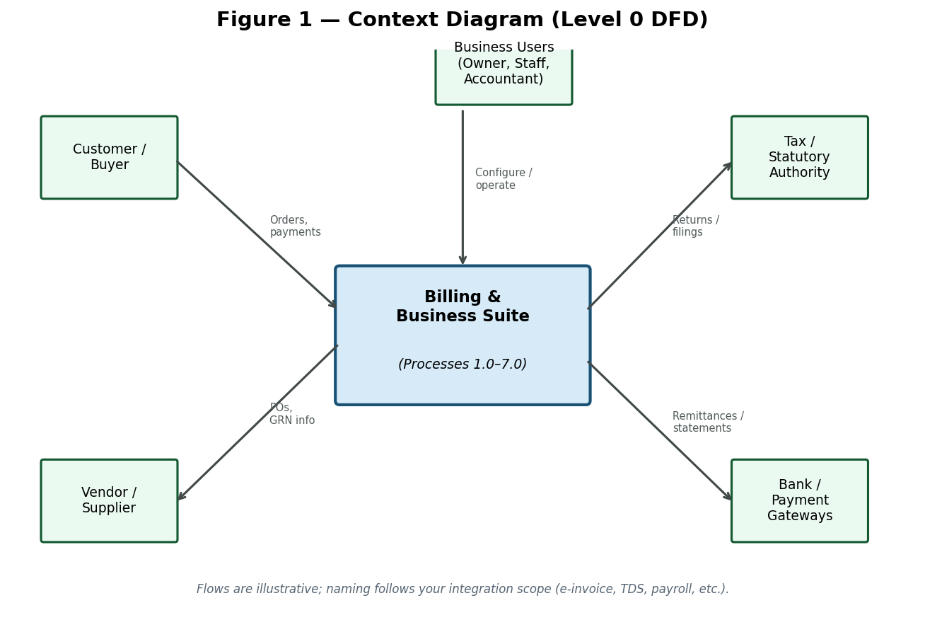

- Level 1 DFD: core processes and logical data stores.
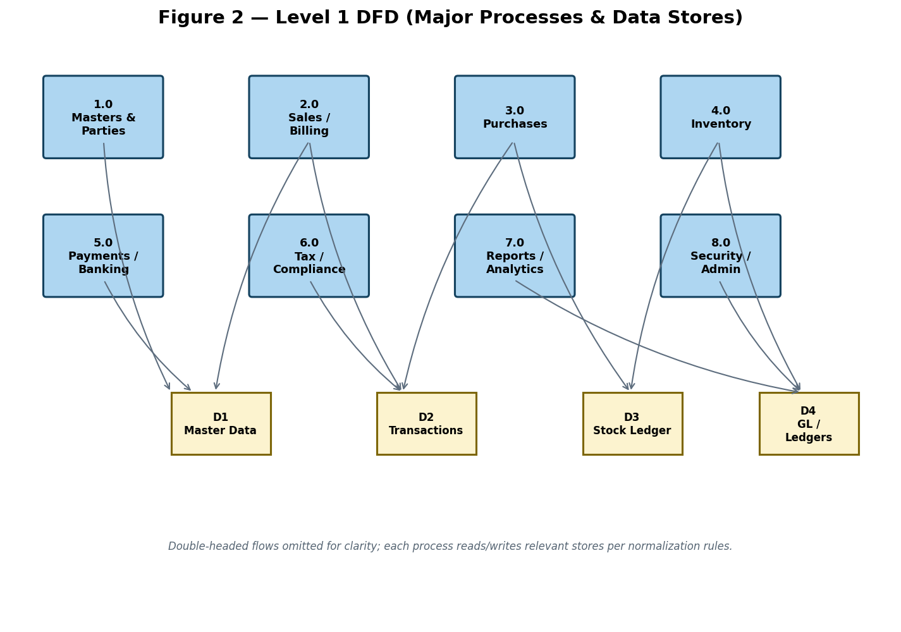

- Billing lifecycle: quotation through payment and returns.
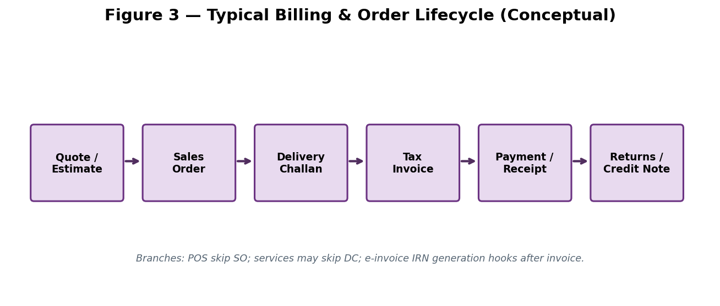

- Capability domain map (market superset).
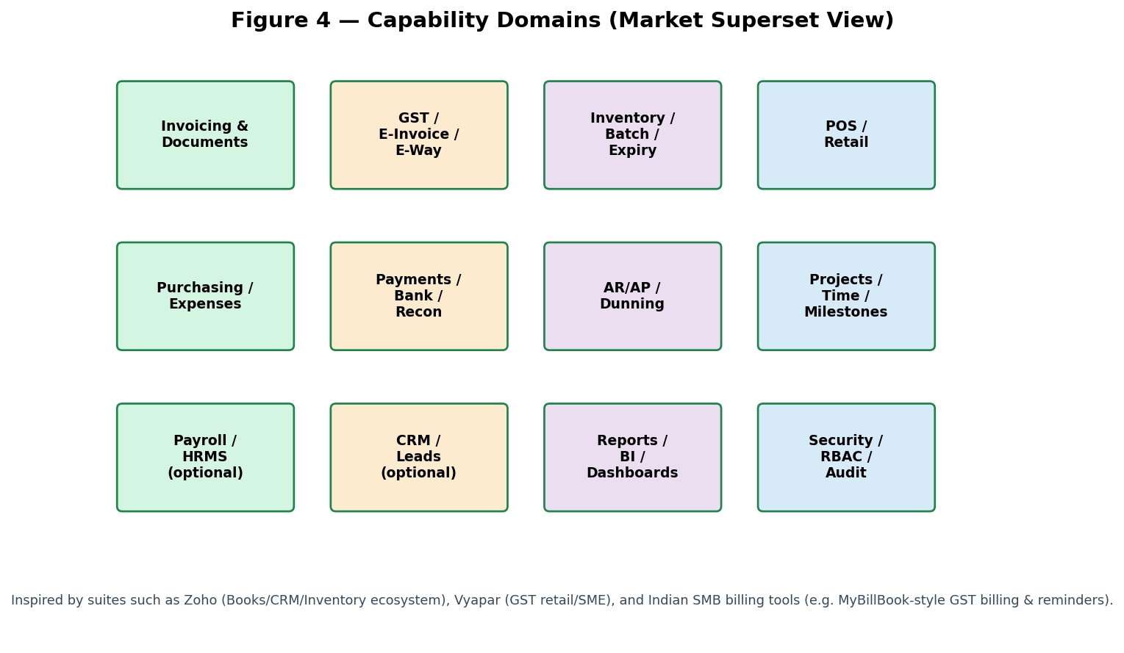

- Product catalog taxonomy (marketplace-style categories, types, variants).
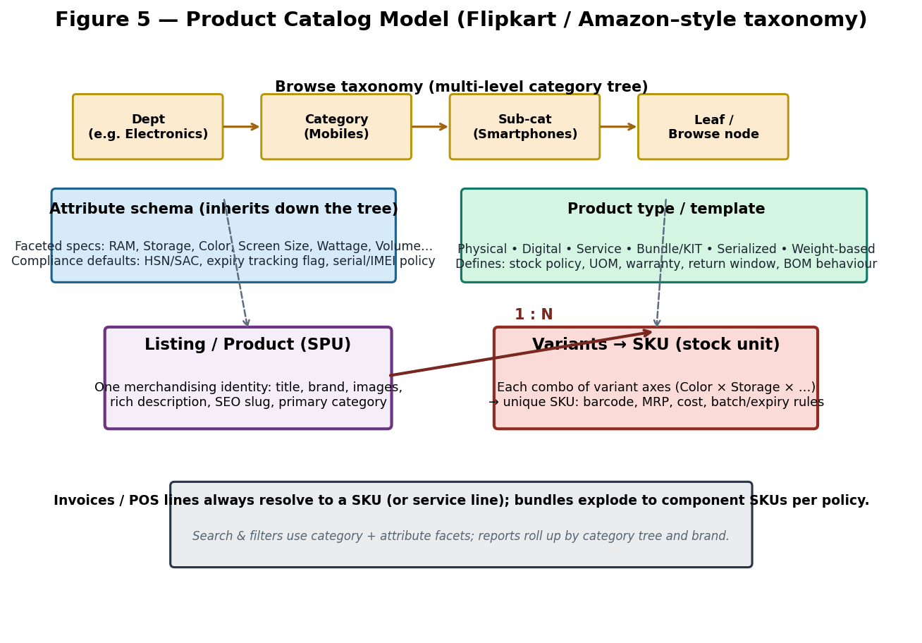

3. Superset feature catalog (must-have themes)
Consolidated themes spanning Zoho-style breadth (multi-app business suite), Vyapar-style GST retail depth, and typical Indian SMB billing (MyBillBook-like flows). Use as a checklist; prioritize by Phase.
Theme | Superset scope notes
Core documents | Invoice, quote/estimate, proforma, delivery challan, credit/debit note, receipt, purchase bill/GRN, PO, work orders.
Tax & compliance | GST/VAT slabs, HSN/SAC, TDS/TCS, e-invoice IRN/QR, e-way generation/cancel hooks, statutory registers.
Inventory | SKU, variants, batch/MRP/expiry, serial nos., multi-UOM, barcode/scanning, adjust/transfer, reorder alerts.
Parties & pricing | Customer/vendor masters, credit limits & stops, price lists, discounts, schemes, ship-to/bill-to.
Payments & banking | Cash/bank/UPI/card/cheque/wallet, split tenders, allocations, FX gains/losses if multi-currency.
AR/AP & collections | Outstanding, aging, dunning cadence, payment links, bulk reminders (SMS/WhatsApp/email).
Retail / POS | Quick billing, park/hold, returns/exchange, cashier shifts, thermal/A4, offline-capable.
Purchasing & expenses | Vendor bills, landed cost, GRNI, expense claims GST/non-GST, approvals.
Reporting & BI | Financial statements, registers, MIS dashboards, cohort/item profitability, scheduled exports.
Platform | Multi-org/fiscal years/branches/warehouses, RBAC, field-level audit, backups encryption.
Digital extensions | Online storefront/catalog orders, PG settlements import, OCR for expense snaps.
CRM / projects (optional) | Leads/deals pipeline; quotes tied to opportunities; time & milestone billing.
Subscriptions & recurring | Recurring invoices, usage tiers, proration, dunning for SaaS/service.
Integrations | Email SMTP, SMS gateways, accounting bridges, payment gateways, e-commerce carts.
HR/Payroll (optional) | Salary payouts, statutory deductions summaries feeding GL.
Catalog & taxonomy (marketplace-class) | Multi-level categories; product types (physical/digital/service/bundle); attribute schemas & facets; listing (SPU) vs SKU variants; brand; compatibility with search/filter UX like large marketplaces.

3.1 Product types & categories (Flipkart / Amazon–style handling)
Large marketplaces separate what customers browse (department → category → attributes/facets) from what warehouses stock (SKU = variant combination). Billing software should mirror that model so one catalogue supports electronics, apparel, grocery, pharmacy, digital goods, and services without hard-coding item shapes per industry.
- Core concepts (see Figure 5):
- Category tree — unlimited depth; optional multiple category placement per listing with one primary path for breadcrumbs.
- Product type / template — defines behaviour: stocked vs non-stocked, serialised, batch/expiry, weight/count pricing, digital fulfilment (license key/file), service (duration/milestone), bundle/KIT (static or configurable BOM).
- Attribute schema — per category or product type; drives specs on PDP, POS picker facets, and compliance (e.g. medicine schedule, wattage, storage GB). Inherited attributes override at lower levels.
- Listing (SPU) vs SKU — one merchandising product with images/long description; many SKUs for variant axes (e.g. Colour × Storage). Each SKU carries pricing, barcodes, dimensions, and inventory dimensions.
- Bundles — priced assembly exploding to component SKUs at sale or at shipment (configurable); optional gift-box vs multipack semantics.
- Operational hooks — category-level defaults for tax (HSN/SAC), low-stock alerts, return policy, and e-way threshold hints; still overridable per SKU.

4. Detailed functional requirements
FR-DOC-01 — Document authoring & templates
- Configurable numbering series per branch/document type with gaps/audit.
- Multiple print themes (A4/A5, thermal 2"/3"); logo, footer, terms.
- Convert estimate→SO→DC→invoice without re-keying; preserve linkage IDs.
- Digital share: PDF, email, WhatsApp deep-link placeholders.
FR-TAX-02 — Tax engine
- Line-level tax breakdown (CGST/SGST/IGST or VAT/sales tax per region).
- Place-of-supply rules for interstate/intrastate.
- E-invoice payload generation & IRN storage when jurisdiction mandates.
- Credit/debit note referencing original invoice for compliance.
FR-INV-03 — Inventory coupling
- Real-time stock reservation or deduction policy per document stage.
- Negative stock policy configurable per SKU/category.
- Batch/expiry picking logic for FEFO/FIFO hints.
- Physical stocktake workflow with variance posting.
FR-PAY-04 — Payments & settlement
- Split tenders on POS; partial invoice settlements.
- Vendor payments with TDS tracking placeholders.
- Cheque lifecycle (issued/received/cleared/bounced).
- UPI QR on invoice template + reconciliation reference capture.
FR-BANK-05 — Banking reconciliation
- Import CSV/OFX; suggest matches by amount/date/reference.
- Manual match UI with audit.
- Roll-forward unreconciled items.
FR-REP-06 — Reporting
- Trial balance, day book, cash/bank books.
- GST summary mimicking GSTR-1/3B data cuts (labels per country pack).
- Dashboard KPIs: sales, gross margin, stock aging, outstanding.
- Scheduled email reports optional.
FR-SEC-07 — Security & governance
- Role-based permissions down to action (create/approve/void).
- Immutable audit log for masters & financial docs.
- Company-level data isolation; encryption at rest for secrets.
- Backup/restore: local + cloud destination support.
FR-SYNC-08 — Connectivity
- Offline-first mobile/desktop sync model where required.
- REST/webhooks for orders/payments with idempotency keys.
- Webhook retries & DLQ monitoring.
FR-MAS-09 — Master data management
- Items linked to category tree, brands, and attribute schemas; alternate units; MRP tracking.
- Party KYC fields: GSTIN/PAN, MSME flag, default payment terms.
- Warehouse/bin hierarchy; transfer templates.
- Import/export CSV for bulk onboarding.
FR-POS-10 — Point of sale
- Keyboard shortcuts & barcode-first item entry.
- Shift open/close with cash denomination summary.
- Returns with reference to historical bill.
- Weighing scale integration hook (optional hardware profile).
FR-EWAY-11 — Logistics compliance
- E-way payload assembly from invoice/DC including transporter ID & vehicle.
- Part-B updates & cancellation lifecycle.
- Distance/pin validation per API provider rules.
FR-MCUR-12 — Multi-currency & overseas (Zoho Books–class)
- Transaction currency vs base currency with daily FX rate table.
- Realized/unrealized gain/loss postings optional module.
- Export packing list / commercial invoice templates.
FR-REC-13 — Recurring revenue
- Subscription schedules generating invoices on cron.
- Pause/resume; proration policies.
- Retry failed charges with customer notification templates.
FR-COLL-14 — Collections automation
- Configurable reminder templates per aging bucket.
- Bulk send with rate limiting per channel.
- Payment receipt auto-match via references/UPI RRNs.
FR-DASH-15 — Executive dashboards
- Configurable widgets: sales vs target, top SKUs, stock-outs.
- Role-specific landing layouts.
- Drill-down to voucher level.
FR-CAT-16 — Marketplace-class catalog, categories & product types
- Maintain navigational category tree (N-level); drag-drop reorder; deactivate without deleting historic transactions.
- Support multiple categories per listing with a single primary category for breadcrumb and SEO slug rules.
- Product types/templates: Physical (stocked), Digital (download/license, no stock or licence pool), Service (non-stock, timesheet/milestone optional), Bundle/KIT (BOM), Serialized, Perishable (batch/expiry mandatory).
- Variant builder: define variant axes (e.g. Color, Size); validate Cartesian SKUs; optional open 'misc' variant for clearance.
- Attribute schema inheritance from category/product type; facet types (enum, number, boolean, text); required vs optional; visibility on POS/web/catalog API.
- SKU-level overrides for tax (HSN/SAC), MRP, dimensions, reorder/min-max, serial tracking, shelf life.
- Brand and manufacturer as first-class masters; optional model/part numbers for electronics/spares compatibility lists.
- Tags/keywords distinct from browse categories for merchandising campaigns.
- Listing readiness workflow (draft → QC → published) optional for multi-operator catalogs.
- Invoice/POS lines always reference SKU or non-stock service line; bundles explode per defined policy with audit trail.
- Import/export: bulk category assignment, attribute columns per product type, variant matrix spreadsheet template.
- API: resolve slug/category facet filters to SKU IDs for cart/checkout integrations (marketplace-style).

5. Non-functional requirements
- NFR-PERF: P95 invoice save < 300 ms LAN; POS scan-to-bill under 2 s median.
- NFR-REL: RPO ≤ 15 minutes with automated backups; RTO target defined per deployment.
- NFR-ACC: Monetary calculations decimal-safe; rounding policy documented per currency.
- NFR-LEG: Localization packs for tax/document wording; timezone-aware timestamps.
- NFR-A11Y: WCAG-oriented targets for web UI where applicable.

6. Data dictionary (logical)
Maps to Figure 2 stores: D1 masters (parties, items, tax schemas, warehouses); D2 transactional headers/lines/payments; D3 quantity ledger & costing layers; D4 GL postings derived from sub-ledgers. Physical schema is implementation-specific.
Catalog extensions in D1: category_nodes (tree), product_types, attribute_definitions, products_listings (SPU), product_variants (SKU), listing_category_map, bundle_components. Transactions in D2 reference variant_id / SKU.

7. Traceability note
Map FR-* IDs to epics in your backlog. Phase 1 typically covers FR-DOC, FR-TAX subset, FR-INV basics, FR-PAY core, FR-REP minimal, FR-CAT-16 (categories + basic variants); Phase 2 adds POS depth, bank recon, e-invoice automation, advanced bundles/facets, CRM/project overlaps.

